

Kazakh-British Technical University

Power BI

Final Project
Full Name: Aibek Sayat
ID: 23B031193
PBI Group Time: 08:00



NovaMart Retail Group
Busness Background Description
- Company Profile
Company Name | NovaMart Retail Group
Industry | Multi-Category Retail (Brick & Mortar + Online)
Founded | 2019
Headquarters | Chicago, Illinois, USA
Operations | Regional stores across the United States, supported by a centralized data warehouse
Tagline | "Smart Retail. Smarter Decisions."

- Company Overview & Field of Activity
NovaMart Retail Group is a mid-sized American retail chain operating across multiple product categories including electronics, home goods, apparel, and groceries. The company serves both individual consumers and small business clients through a network of regional stores managed by a dedicated sales workforce.
NovaMart manages its sales operations through a structured hierarchy of regions, stores, product categories, and customer segments. All transactions are recorded in a centralized data warehouse that follows a Star Schema model, enabling fast and consistent analytical reporting across the organization.

- Business Process
The core business process analyzed in this report is Retail Sales Performance Management — the end-to-end process of tracking, evaluating, and optimizing sales activity across all stores, products, customers, and employees.
The process covers the following stages:
- A customer visits a NovaMart store (or online channel) and makes a purchase.
- The transaction is recorded with attributes: date, store location, product details, customer profile, employee responsible, quantity sold, sales amount, and cost.
- Sales and cost data flow into the centralized fact table (fact_sales), linked to dimension tables for Date, Product, Customer, Store, and Employee.

- Purpose of the Report
The primary purpose of this Power BI report is to provide NovaMart's management team with a clear, interactive, and real-time view of the company's sales performance across all dimensions — time, geography, product category, customer segment, and employee activity
Specifically, the report is designed to:
- Monitor overall revenue, cost, and gross profit trends over time.
- Identify top-performing and underperforming stores, products, and employees.
- Analyze customer purchasing behavior across different segments.
- Enable drill-through analysis from high-level KPIs to individual transaction details.
- Support strategic decision-making with dynamic, filterable visualizations.

- End Users of the Report
User Role | Primary Use
Sales Director | Monitor overall revenue, set targets, evaluate regional performance
Store Managers | Track store KPIs, analyze product mix, review employee contribution
Category Managers | Compare product category profitability and identify growth opportunities
Financial Analysts | Analyze cost vs. revenue, compute profit margins, detect anomalies
HR / Operations | Evaluate employee sales performance and identify training needs

- Business Questions & Problems Resolved
The report is structured to answer the following critical business questions:

6.1 Sales Performance
- Q1. What is our total revenue, cost, and gross profit for the selected period?
- Q2. How do sales compare to the same period last year (Year-over-Year growth)?
- Q3. Which months or quarters show the strongest and weakest sales performance?

6.2 Product Analysis
- Q4. Which product categories and subcategories generate the most revenue and profit?
- Q5. What is the profit margin by product line, and where are margins being compressed?
- Q6. Which products are underperforming and may require promotional attention?

6.3 Geographic & Store Performance
- Q7. Which stores and regions contribute the most to overall revenue?
- Q8. Are there geographic areas with high sales volume but low profitability?

6.4 Customer Insights
- Q9. How do different customer segments (e.g., Consumer, Corporate, Home Office) behave in terms of purchase frequency and average order value?
- Q10. Which customer segments are the most profitable?

6.5 Employee Performance
- Q11. Which employees (sales representatives) are driving the most sales?
- Q12. Are there performance gaps between employees in similar store contexts?

- Data Source
The data used in this report is sourced from the publicly available Retail Store Star Schema Dataset (Kaggle, shrinivasv). It is a synthetic dataset modeled as a data warehouse Star Schema, containing the following tables: 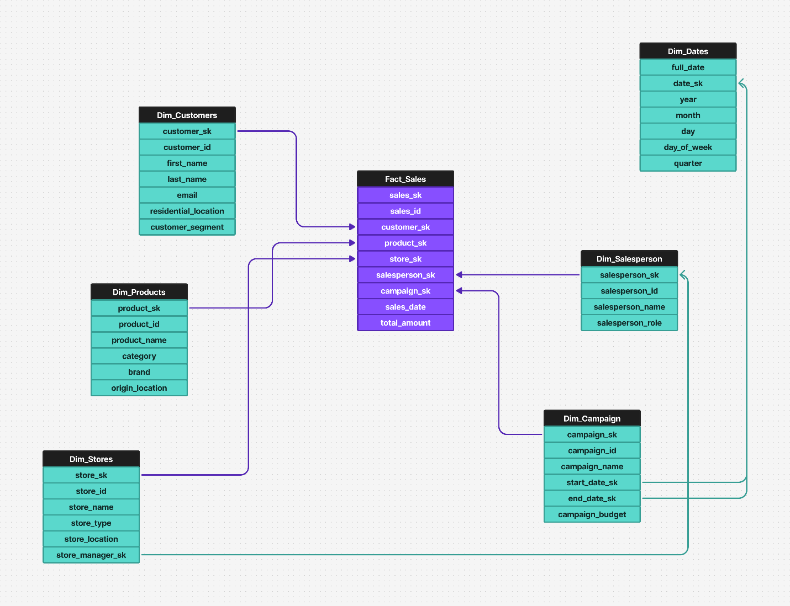
The dataset contains over 300,000 records spanning multiple years, providing sufficient depth for time-series analysis, hierarchical drill-down, and cross-dimensional comparisons.

Creating The Report in Power BI Desktop
Step 1 — Loading Data into Power BI Desktop
First I opened the PowerBI Desktop On the Home ribbon clicked Get Data Selected Text/Csv from the list Select my fact_sales_normalized.csv and click Open A preview window will appear showing the data. Click here Transform Data (not Load) to open Power Query Editor.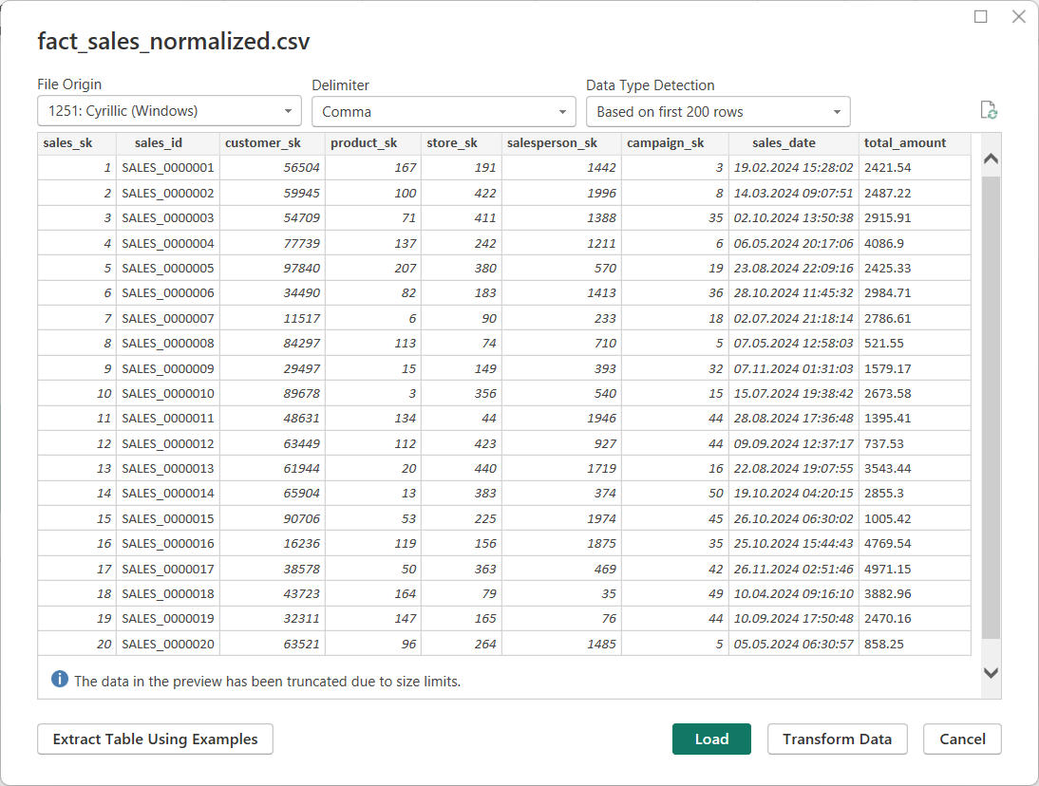
Then I repeated the same process for all remaining files one by one:
- dim_dates.csv
- dim_customers.csv
- dim_products.csv
- dim_stores.csv
- dim_salespersons.csv
- dim_campaigns.csv
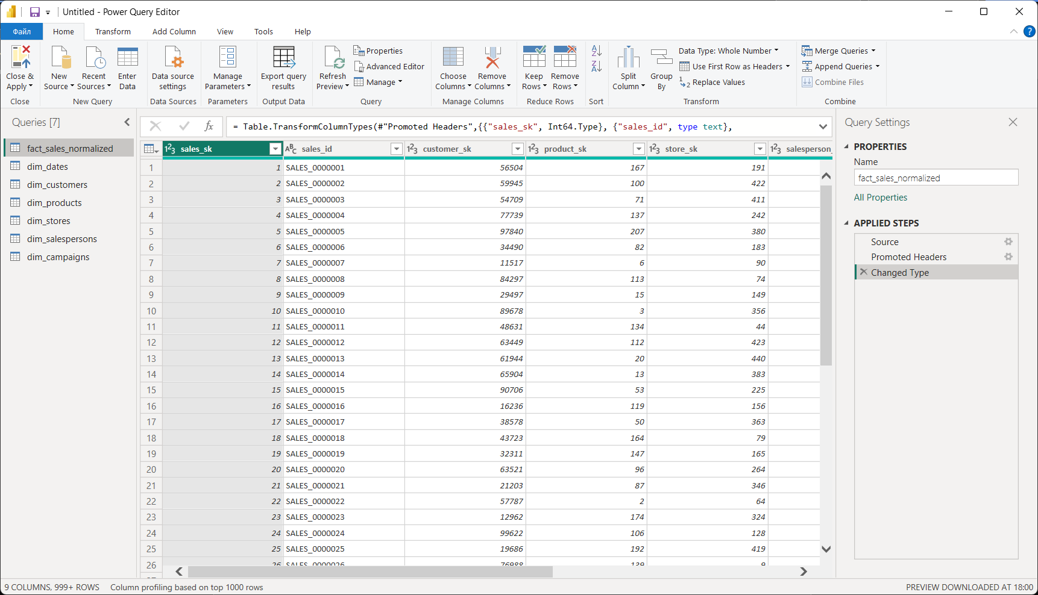

Step 2 — Data Cleaning and Transformation in Power Query Editor
2.1 Renaming Tables
I renamed the fact table from fact_sales_normalized to fact_sales for clarity and consistency throughout the data model. All dimension table names were kept as-is since they were already clean and descriptive. 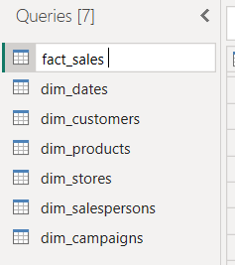
2.2 Checking data types
I checked if all the data types were correct, and changed the total_amount column type to decimal in fact_sales table. In other tables, all data types were correct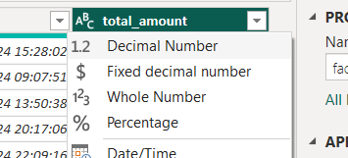

2.3 Data quality control
To assess data quality, I enabled the Column Quality and Column Distribution views in the Power Query Editor. This allowed me to visually inspect the percentage of valid, empty, and error values for each column. All tables showed 100% valid values with no errors or blanks detected, confirming that the dataset was clean and ready for modeling. 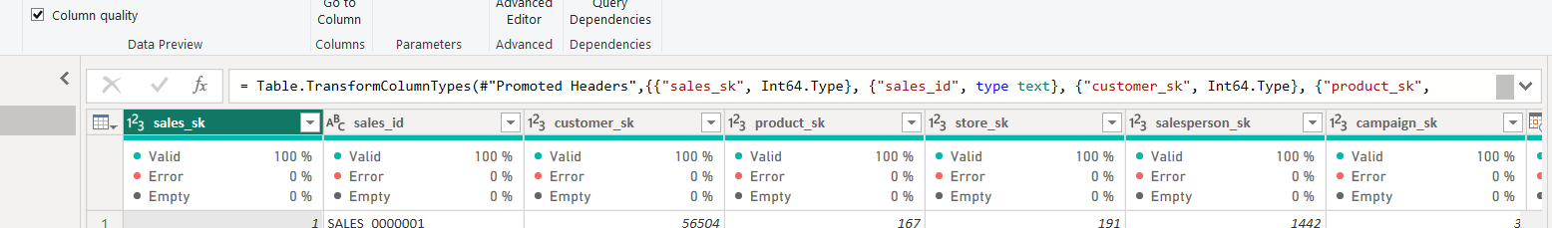
2.4 Removing Duplicates
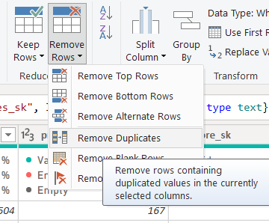

2.5 Close & Apply
After completing all cleaning and transformation steps, I clicked Close & Apply to load the processed data into the Power BI data model. All seven tables were successfully loaded and appeared in the Fields panel, ready for relationship building and DAX calculations. 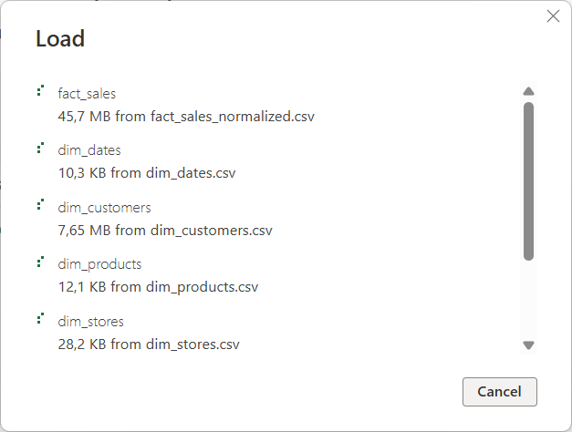

Step 3 – Model View
After loading all seven tables into Power BI Desktop, I navigated to the Model View to build the data relationships. Power BI automatically detected five relationships based on matching column names. I manually created the sixth relationship between fact_sales[sales_date] and dim_dates[full_date] to enable time intelligence calculations. All six relationships are Many-to-One (:1) with Single cross-filter direction, following Star Schema best practices. The final data model consists of one central fact table (fact_sales) connected to six dimension tables: dim_customers, dim_products, dim_stores, dim_salespersons, dim_campaigns, and dim_dates. 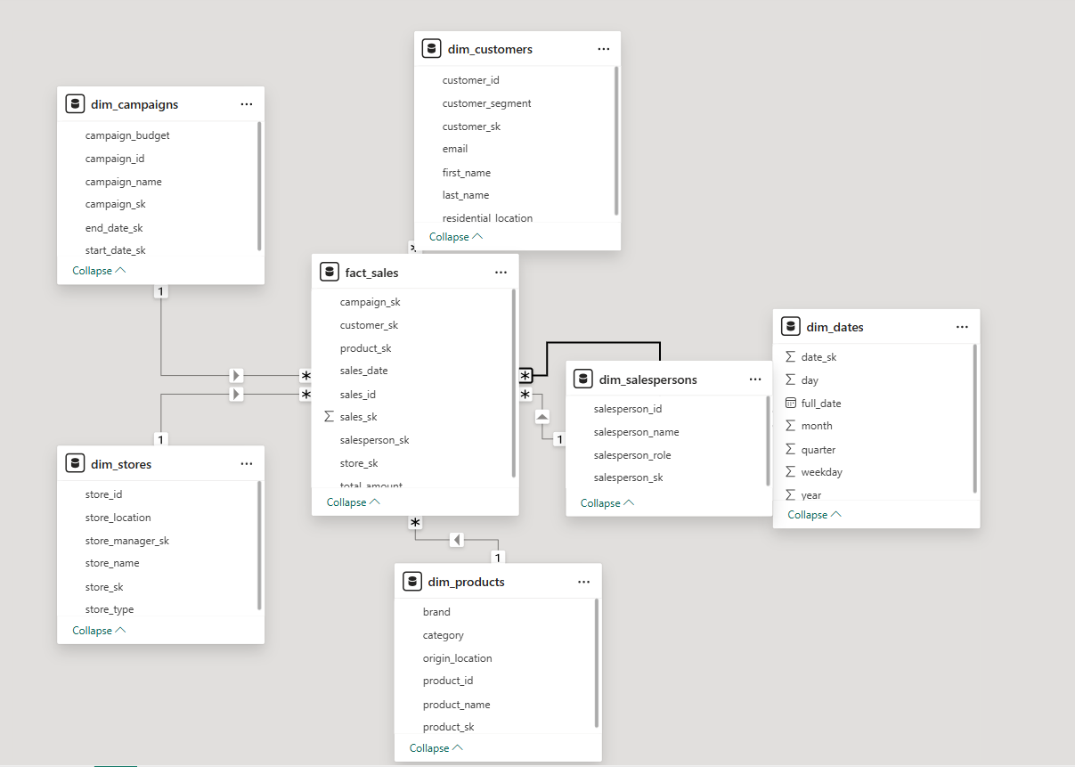

Step 4 – DAX
4.1 Calculated Columns
I created two calculated columns in the fact_sales table. Sales Amount Category classifies each transaction as High (≥1000), Medium (≥400), or Low (<400) based on total_amount. Sales Year extracts the year from sales_date for time-based filtering and analysis. The fact_sales table contains 3,000,000 rows covering 3 years (2022–2024).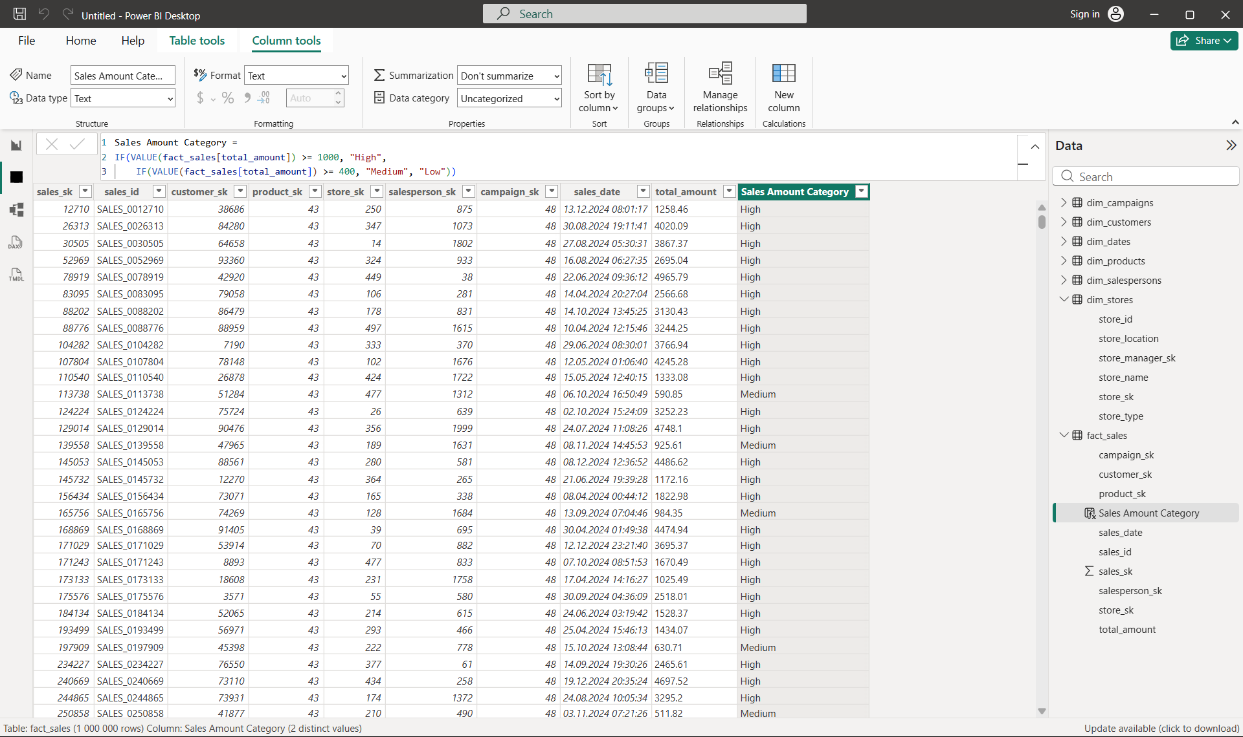
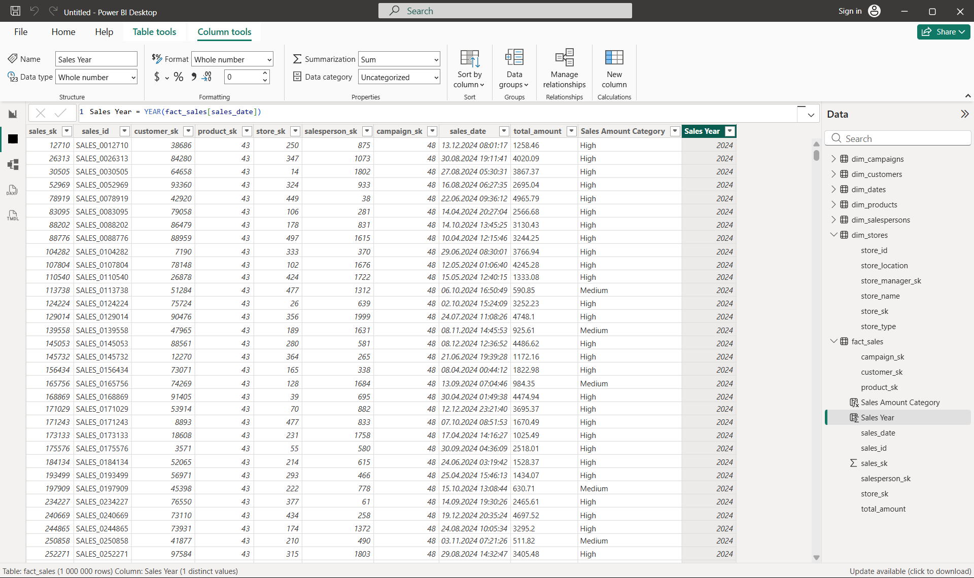

4.2 Measures
1) I created a Total Sales measure to calculate the sum of all sales transactions. 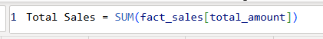
2) I created a Total Transactions measure to count the total number of sales records. 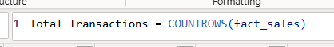
3) I created an Average Sale Amount measure to calculate the average transaction value.
4) I created a Top Category Sales 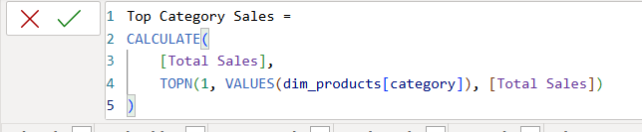

Step 5 – Creating Report Pages
5.1 Report structure
I planned and created four pages in the report. Three visible pages: Sales Overview (main KPIs and sales trends), Product & Store Analysis (product and store performance), and Customer & Campaign (customer segments and marketing campaigns). One hidden page: Detail View, which is used for drillthrough navigation from the main pages.

5.2 Sales Overview page
The Sales Overview page is the main landing page of the report. It contains four KPI cards: Total Sales, Total Transactions, Average Sale Amount, and Top Category Sales. A Line Chart displays monthly sales trends, a Bar Chart compares total sales by year, and a Year Slicer allows interactive filtering. This page gives the end user an immediate understanding of overall business performance. 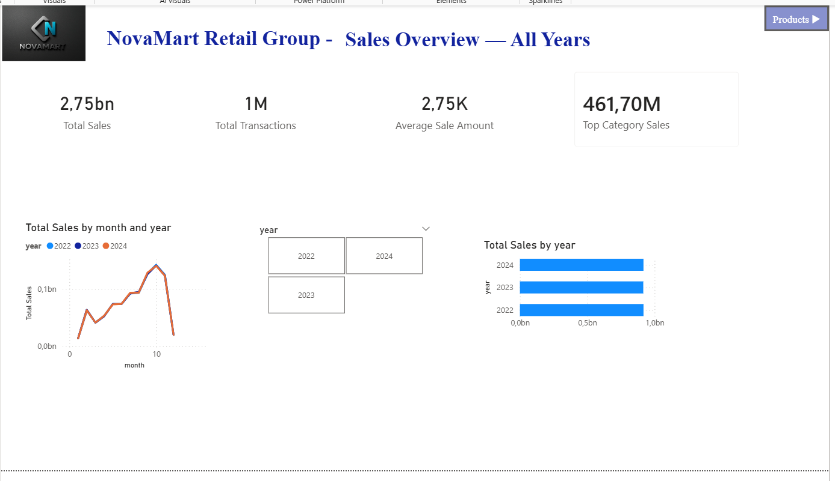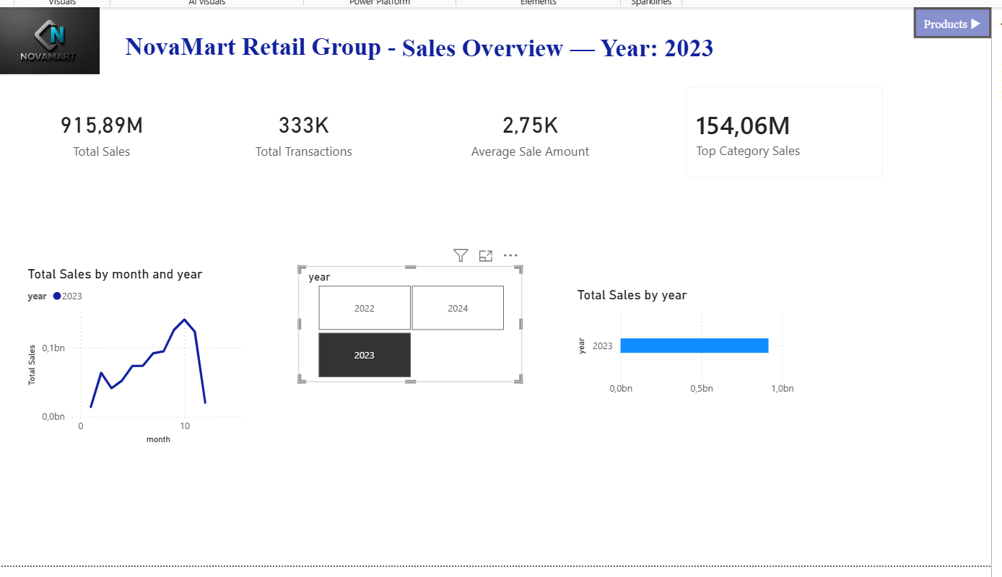

5.3 Product Store & Analysis
The Product & Store Analysis page provides a detailed breakdown of sales performance across products and stores. It includes a Bar Chart for sales by product category, a Bar Chart for top performing stores, a Pie Chart showing sales distribution by brand, a Donut Chart displaying transaction counts by sales category, and a Category Slicer for interactive filtering. 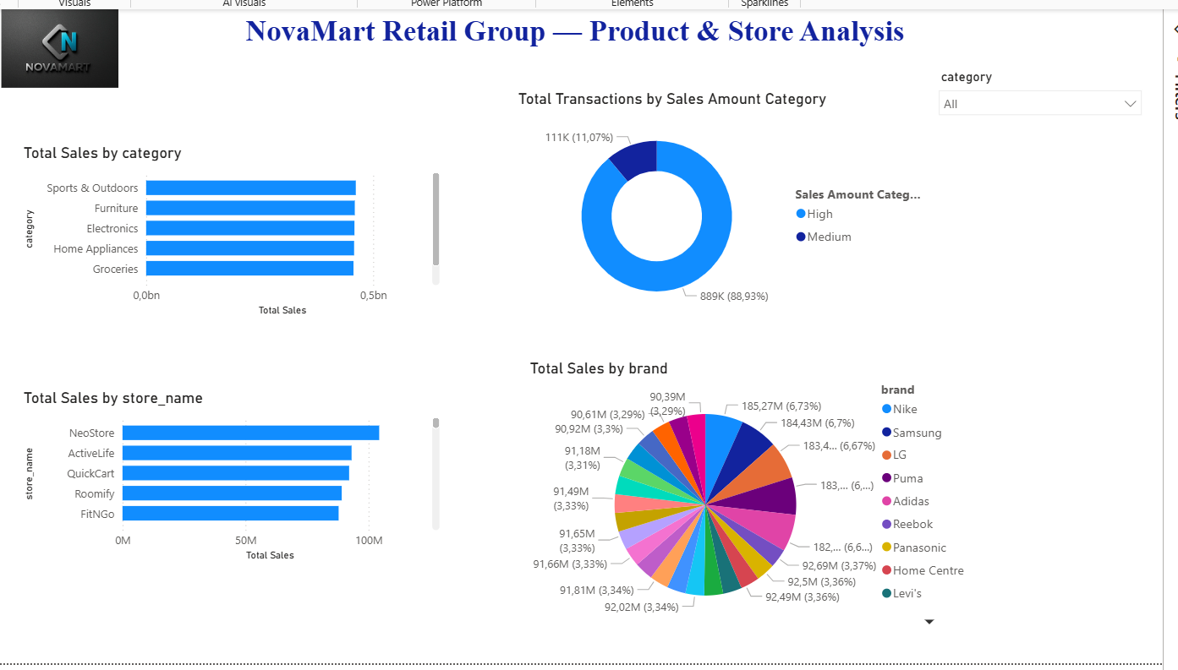
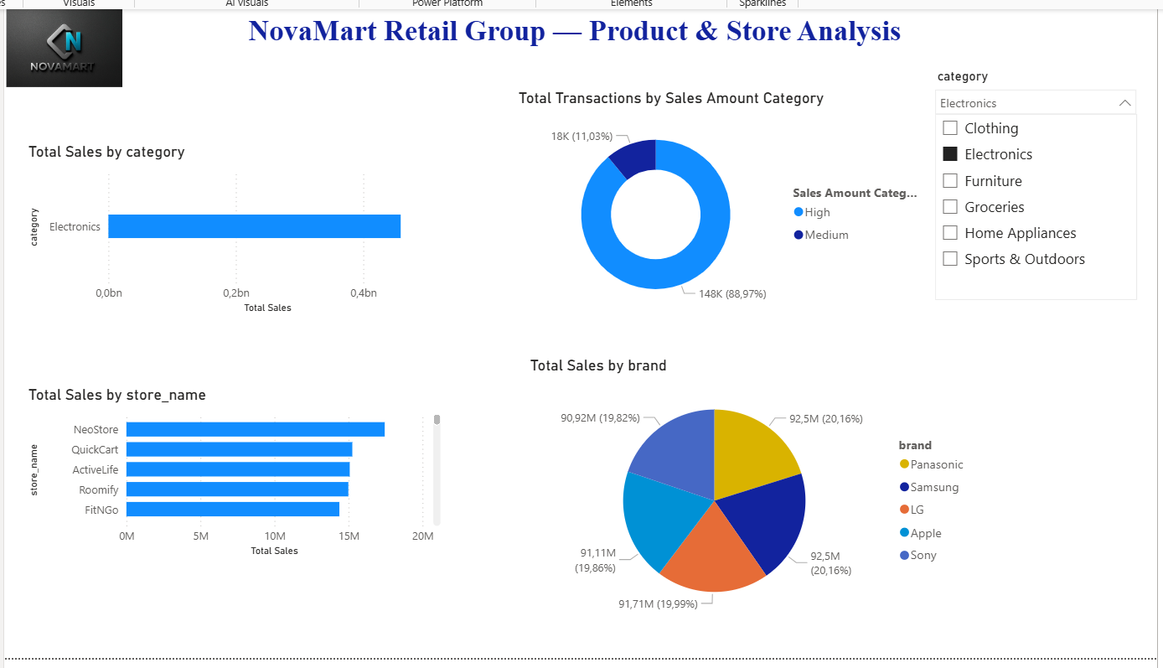
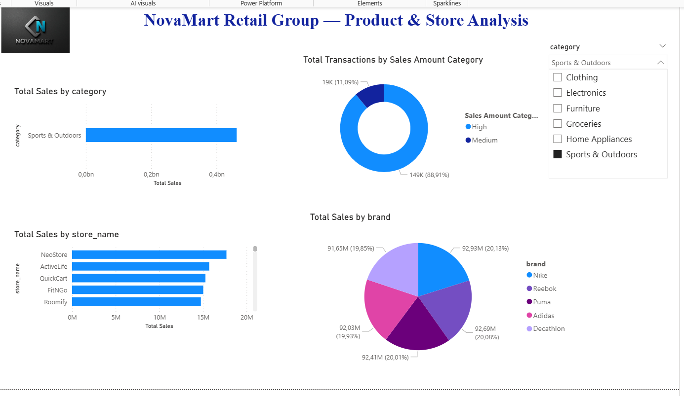

5.4 Customer & Campaign
The Customer & Campaign page analyzes customer behavior and marketing campaign effectiveness. It includes a Bar Chart for Total Sales by Customer Segment, a Bar Chart for Total Sales by Campaign, a performance Table with conditional formatting applied to the Total Sales column using a color gradient to highlight high and low values, and a Customer Segment Slicer for interactive filtering.
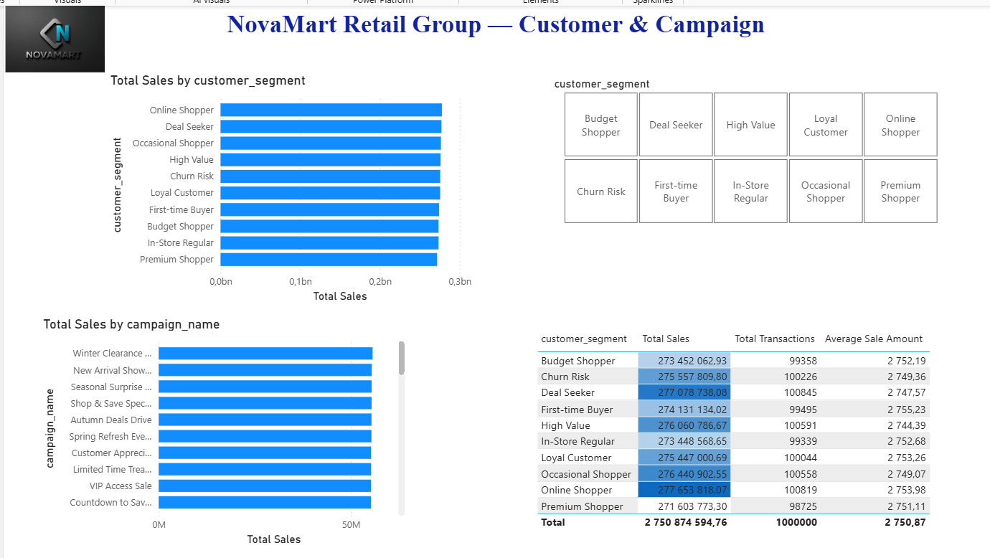

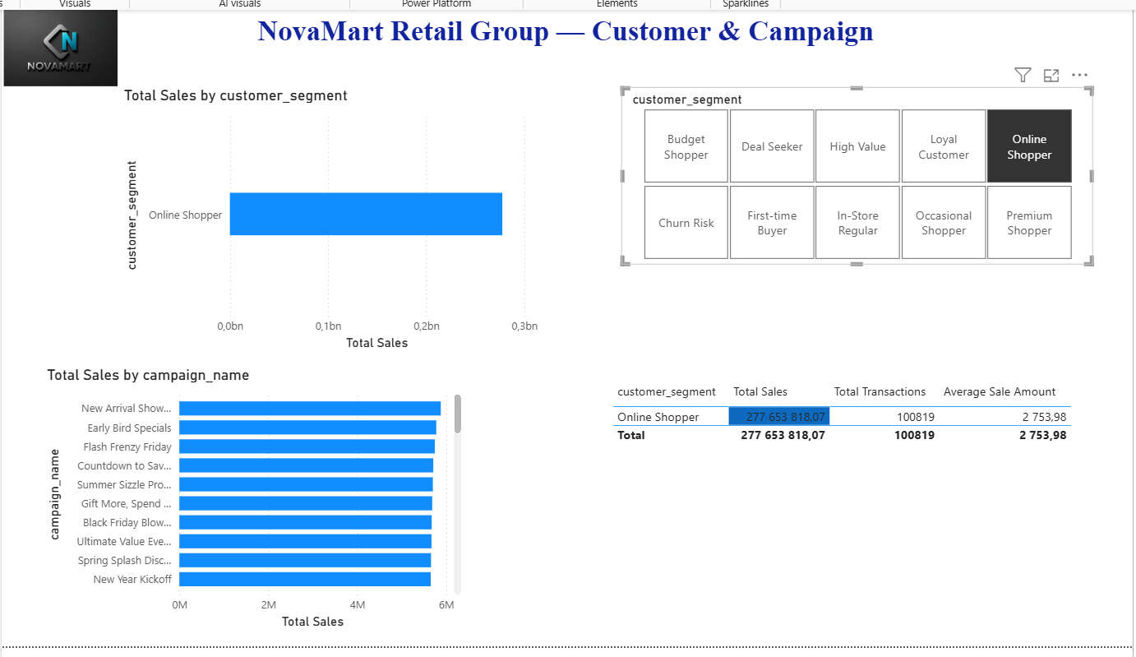
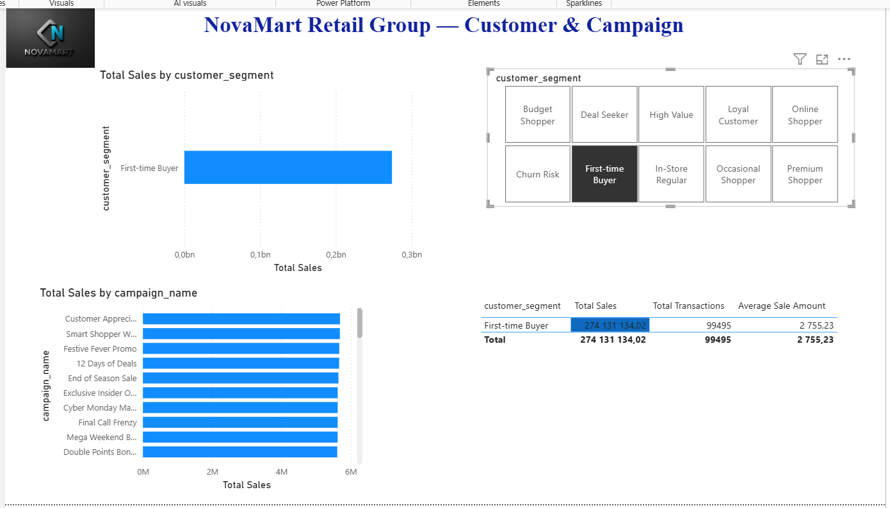

5.5 Detail View (Drillthrough)
I created a hidden Detail View page to support drillthrough navigation. The page contains a detailed transaction table showing sales_id, category, product_name, customer_segment, sales_date, total_amount, and Sales Amount Category. The drillthrough field is set to dim_products[category], allowing users to right-click any category visual on other pages and navigate directly to the filtered transaction details for that category. 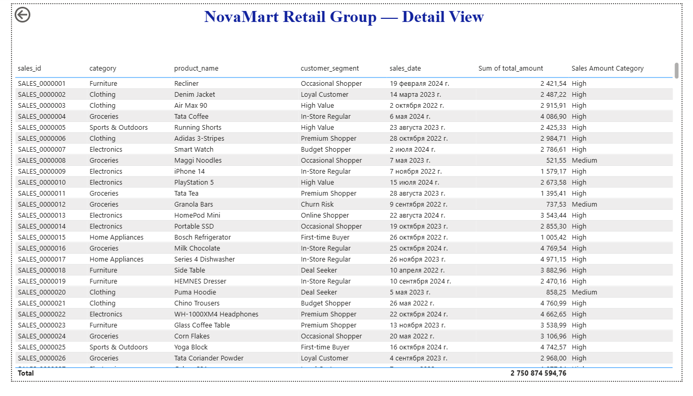
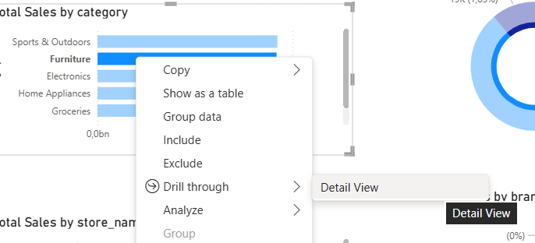
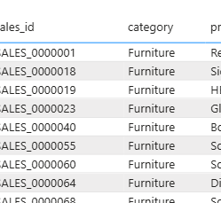

Step 6 – Other details from the requirements
- Requirement 7.6 — Dynamic title
I implemented a dynamic report title on the Sales Overview page using a DAX measure called Dynamic Title. The title automatically updates based on the year selected in the slicer — for example, displaying "Sales Overview — Year: 2023" when 2023 is selected, or "Sales Overview — All Years" when no filter is applied. This provides users with immediate context about the current filter selection.
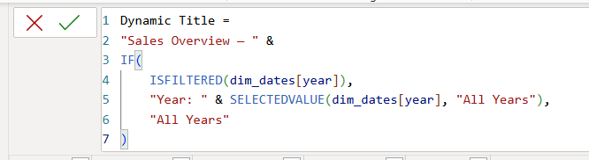
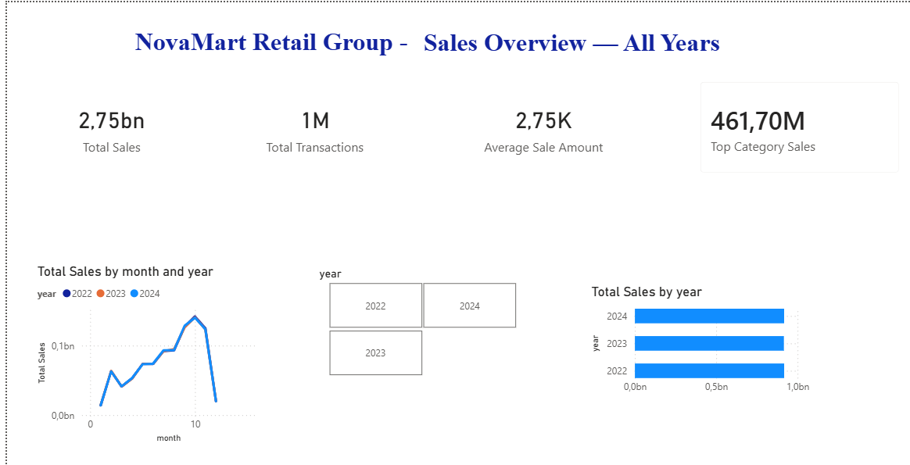
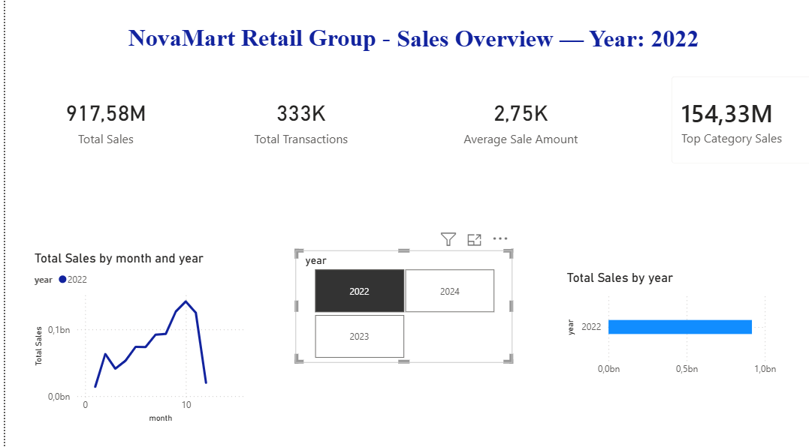
- Requirement 7.4 – Navigation button
I added the "Products ▶" button on the first page to go to the product analysis page. 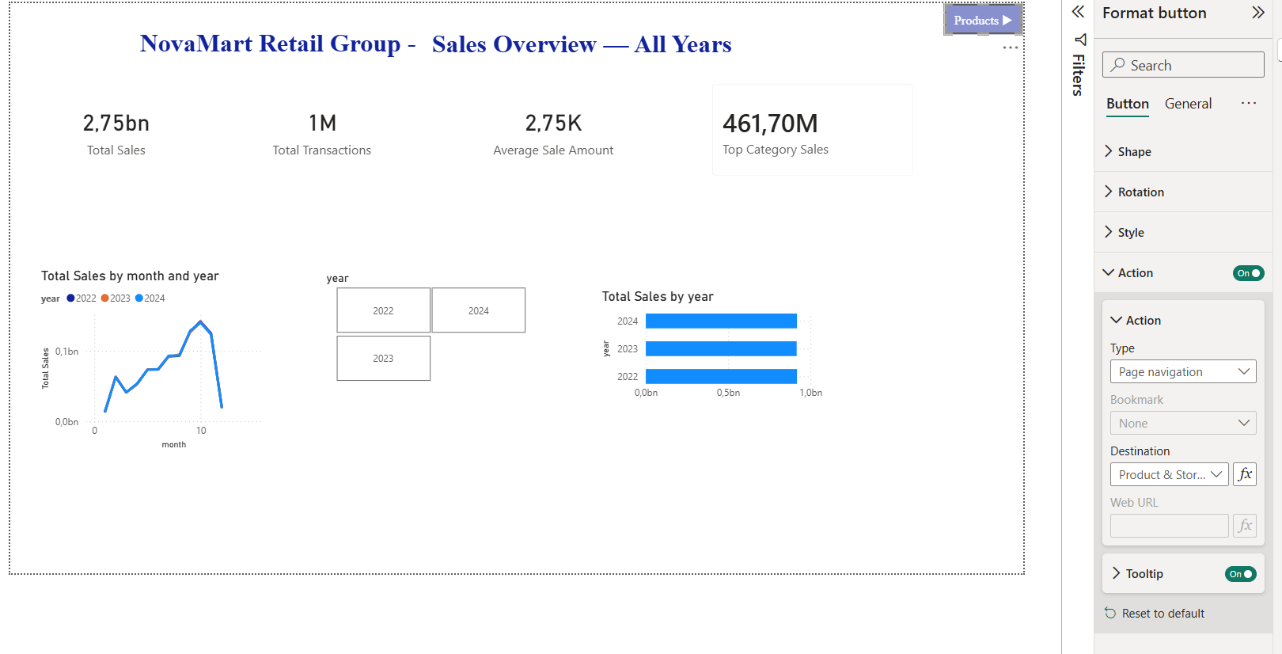

Step 7 – Publishing the Report in Power BI Service
