CREDIT CARD FRAUD DETECTION USING DATA SCIENCE

**Project Title:** Credit Card Fraud Detection using Data Science

**Objective:** The primary aim of this project is to develop a machine learning model that can effectively identify and prevent fraudulent credit card transactions, ultimately improving the security of financial transactions.

**Key Steps in the Project:**

**1. Data Collection:**

- Gather historical credit card transaction data, which includes both legitimate and fraudulent transactions.

- The dataset should include features such as transaction amount, time, and various other transaction-related attributes.

**2. Data Preprocessing:**

- Handle missing values and outliers.

- Normalize or scale numerical features.

- Encode categorical features if applicable.

**3. Exploratory Data Analysis (EDA):**

- Visualize the data to understand patterns and relationships.

- Explore the distribution of legitimate and fraudulent transactions.

- Identify any potential correlations between variables.

**4. Feature Selection and Engineering:**

- Select relevant features that contribute to fraud detection.

- Create new features if they provide valuable information, e.g., transaction frequency or transaction velocity.

**5. Model Selection:**

- Choose appropriate machine learning algorithms for classification, such as logistic regression, random forests, or support vector machines.

- Consider deep learning models like neural networks for more complex patterns.

**6. Data Splitting:**

- Divide the dataset into training and testing sets to evaluate model performance.

- Consider using techniques like stratified sampling to maintain the fraud-to-non-fraud class balance.

**7. Model Training:**

- Train the selected models on the training dataset.

- Tune hyperparameters to optimize model performance.

**8. Model Evaluation:**

- Evaluate model performance using metrics such as accuracy, precision, recall, F1-score, and ROC AUC.

- Assess the model's ability to detect fraudulent transactions while minimizing false positives.

**9. Deployment:**

- Deploy the trained model to monitor real-time credit card transactions.

- Implement an alert system that triggers when potential fraud is detected.

**10. Continuous Monitoring and Improvement:**

- Continuously monitor the model's performance.

- Retrain the model periodically to adapt to evolving fraud patterns.

Transaction data simulator

This section presents a transaction data simulator of legitimate and fraudulent transactions. This simulator will be used throughout the rest of this book to motivate and assess the eﬃciency of different fraud detection techniques in a reproducible way.

A simulation is necessarily an approximation of reality. Compared to the complexity of the dynamics underlying real-world payment card transaction data, the data simulator that we present below follows a simple design.

This simple design is a choice. First, having simple rules to generate transactions and fraudulent behaviors will help in interpreting the kind of patterns that different fraud detection techniques can identify. Second, while simple in its design, the data simulator will generate datasets that are challenging to deal with.

The simulated datasets will highlight most of the issues that practitioners of fraud detection face using real-world data. In particular, they will include class imbalance (less than 1% of fraudulent transactions), a mix of numerical and categorical features (with categorical features involving a very large number of values), non-trivial relationships between features, and time-dependent fraud scenarios.

## Design choices

### Transaction features

Our focus will be on the most essential features of a transaction. In essence, a payment card transaction consists of any amount paid to a merchant by a customer at a certain time. The six main features that summarise a transaction therefore are:

1. **The transaction ID: A unique identiﬁer for the transaction**
2. **The date and time: Date and time at which the transaction occurs**
3. **The customer ID: The identiﬁer for the customer. Each customer has a unique identiﬁer**
4. **The terminal ID: The identiﬁer for the merchant (or more precisely the terminal). Each terminal has a unique identiﬁer**
5. **The transaction amount: The amount of the transaction.**
6. **The fraud label: A binary variable, with the value** 0 **for a legitimate transaction, or the value** 1 **for a fraudulent transaction.**

**These features will be referred to as TRANSACTION_ID, TX_DATETIME, CUSTOMER_ID, TERMINAL_ID, TX_AMOUNT, and TX_FRAUD.**

The goal of the transaction data simulator will be to generate a table of transactions with these features. This table will be referred to as the labeled transactions table. Such a table is illustrated in Fig. 1.

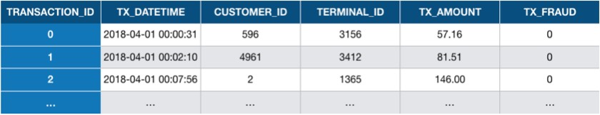

Fig. 1. Example of labeled transaction table. Each transaction is represented as a row in the table, together with its label (TX_FRAUD variable, 0 for legitimate, and 1 for fraudulent transactions).

# Customer proﬁles generation

Each customer will be deﬁned by the following properties:

 **Contents**

**2.1. Customer proﬁles generation 2.2. Terminal proﬁles generation**

* 1. **Association of customer proﬁles to**

**terminals**

* 1. **Generation of transactions 2.5. Fraud scenarios generation 2.6. Saving of dataset**

**CUSTOMER_ID: The customer unique ID**

**(x_customer_id,y_customer_id): A pair of real coordinates (x_customer_id,y_customer_id) in a 100 * 100 grid, that deﬁnes the geographical location of the customer**

(mean_amount, std_amount): The mean and standard deviation of the transaction amounts for the customer, assuming that the transaction amounts follow a normal distribution. The mean_amount will be drawn from a uniform distribution (5,100) and the std_amount will be set as the mean_amount divided by two.

mean_nb_tx_per_day: The average number of transactions per day for the customer, assuming that the number of transactions per day follows a Poisson distribution. This number will be drawn from a uniform distribution (0,4).

The generate_customer_profiles_table function provides an implementation for generating a table of customer proﬁles. It takes as input the number of customers for which to generate a proﬁle and a random state for reproducibility. It returns a DataFrame containing the properties for each customer.

### Transaction generation process

The simulation will consist of ﬁve main steps:

* + 1. **Generation of customer proﬁles: Every customer is different in their spending habits. This will be simulated by deﬁning some properties for each customer. The main properties will be their geographical location, their spending frequency, and their spending amounts. The customer properties will be represented as a table, referred to as the** customer proﬁle table**.**
    2. **Generation of terminal proﬁles: Terminal properties will simply consist of a geographical location. The terminal properties will be**

**represented as a table, referred to as the** terminal proﬁle table**.**

* + 1. **Association of customer proﬁles to terminals: We will assume that customers only make transactions on terminals that are within a radius of** *r* **of their geographical locations. This makes the simple assumption that a customer only makes transactions on terminals that are geographically close to their location. This step will consist of adding a feature ‘list_terminals’ to each customer proﬁle, that contains the set of terminals that a customer can use.**
    2. **Generation of transactions: The simulator will loop over the set of customer proﬁles, and generate transactions according to their properties (spending frequencies and amounts, and available terminals). This will result in a table of transactions.**
    3. **Generation of fraud scenarios: This last step will label the transactions as legitimate or genuine. This will be done by following three different fraud scenarios.**

The transaction generation process is illustrated below.

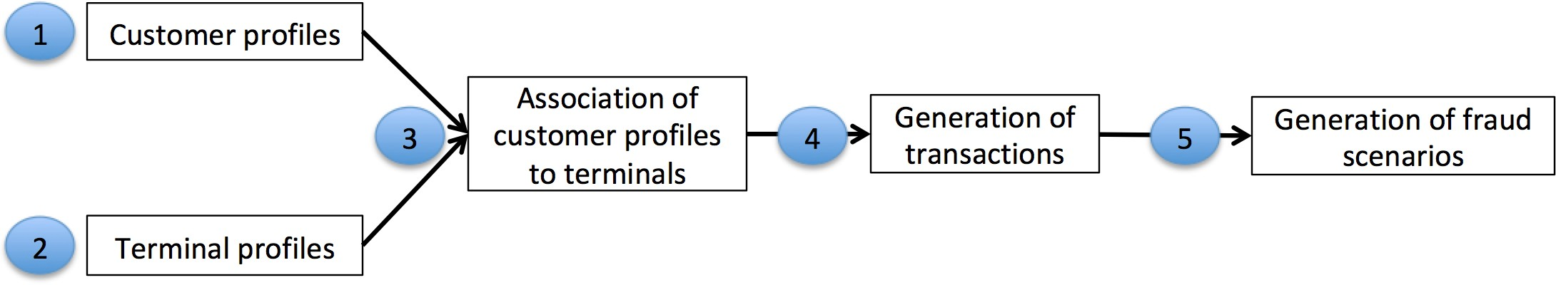

**Print to PDF**

Fig. 2. Transaction generation process. The customer and terminal proﬁles are used to generate

a set of transactions. The ﬁnal step, which generates fraud scenarios, provides the labeled transactions table.

The following sections detail the implementation for each of these steps.

As an example, let us generate a customer proﬁle table for ﬁve customers:

**n_customers = 5**

**customer_profiles_table = generate_customer_profiles_table(n_customers, random_state = 0) customer_profiles_table**

|  |  |  |  |  |  |
| --- | --- | --- | --- | --- | --- |
| CUSTOMER_ID | x_customer_id | y_customer_id | mean_amount | std_amount | mean_nb_tx_per_day |
| 0 **0** | **54.881350** | **71.518937** | **62.262521** | **31.131260** | **2.179533** |
| 1 **1** | **42.365480** | **64.589411** | **46.570785** | **23.285393** | **3.567092** |
| 2 **2** | **96.366276** | **38.344152** | **80.213879** | **40.106939** | **2.115580** |
| 3 **3** | **56.804456** | **92.559664** | **11.748426** | **5.874213** | **0.348517** |
| 4 **4** | **2.021840** | **83.261985** | **78.924891** | **39.462446** | **3.480049** |

# Terminal proﬁles generation

Each terminal will be deﬁned by the following properties:

**TERMINAL_ID: The terminal ID**

**(x_terminal_id,y_terminal_id): A pair of real coordinates (x_terminal_id,y_terminal_id) in a 100 * 100 grid, that deﬁnes the geographical location of the terminal**

The generate_terminal_profiles_table function provides an implementation for generating a table of terminal proﬁles. It takes as input the number of terminals for which to generate a proﬁle and a random state for reproducibility. It returns a DataFrame containing the properties for each terminal.

As an example, let us generate a customer terminal table for ﬁve terminals:

**n_terminals = 5**

**terminal_profiles_table = generate_terminal_profiles_table(n_terminals, random_state = 0) terminal_profiles_table**

|  |  |  |
| --- | --- | --- |
| TERMINAL_ID | x_terminal_id | y_terminal_id |
| 0 **0** | **54.881350** | **71.518937** |
| 1 **1** | **60.276338** | **54.488318** |
| 2 **2** | **42.365480** | **64.589411** |
| 3 **3** | **43.758721** | **89.177300** |
| 4 **4** | **96.366276** | **38.344152** |

# Association of customer proﬁles to terminals

Let us now associate terminals with the customer proﬁles. In our design, customers can only perform transactions on terminals that are within a radius of r of their geographical locations.

Let us ﬁrst write a function, called get_list_terminals_within_radius, which ﬁnds these terminals for a customer proﬁle. The function will take as input a customer proﬁle (any row in the customer proﬁles table), an array that contains the geographical location of all terminals, and the radius r. It will return the list of terminals within a radius of r for that customer.

As an example, let us get the list of terminals that are within a radius *r* = 50 of the last customer:

***# We first get the geographical locations of all terminals as a numpy array***

**x_y_terminals = terminal_profiles_table[['x_terminal_id','y_terminal_id']].values.astype(float)**

***# And get the list of terminals within radius of $50$ for the last customer***

**get_list_terminals_within_radius(customer_profiles_table.iloc[4], x_y_terminals=x_y_terminals, r=50)**

**[2, 3]**

The list contains the third and fourth terminals, which are indeed the only ones within a radius of 50 of the last customer.

**terminal_profiles_table**

|  |  |  |
| --- | --- | --- |
| TERMINAL_ID | x_terminal_id | y_terminal_id |
| 0 **0** | **54.881350** | **71.518937** |
| 1 **1** | **60.276338** | **54.488318** |
| 2 **2** | **42.365480** | **64.589411** |
| 3 **3** | **43.758721** | **89.177300** |
| 4 **4** | **96.366276** | **38.344152** |

For better visualization, let us plot

The locations of all terminals (in red)

The location of the last customer (in blue)

The region within radius of 50 of the ﬁrst customer (in green)

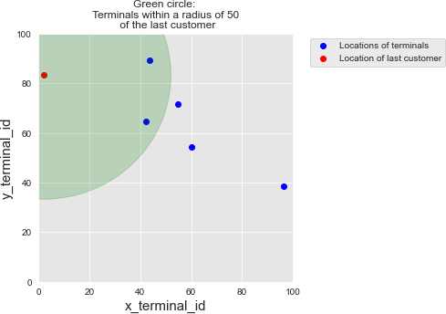

**terminals_available_to_customer_fig**

Computing the list of available terminals for each customer is then straightforward, using the panda apply function. We store the results as a new column available_terminals in the customer proﬁles table.

**customer_profiles_table['available_terminals']=customer_profiles_table.apply(lambda x : get_list_terminals_within_radius(x, x_y_terminals=x_y_terminals, r=50), axis=1)**

**customer_profiles_table**

|  |  |  |  |  |  |  |
| --- | --- | --- | --- | --- | --- | --- |
| CUSTOMER_ID | x_customer_id | y_customer_id | mean_amount | std_amount | mean_nb_tx_per_day | available_terminals |
| 0 **0** | **54.881350** | **71.518937** | **62.262521** | **31.131260** | **2.179533** | **[0, 1, 2, 3]** |
| 1 **1** | **42.365480** | **64.589411** | **46.570785** | **23.285393** | **3.567092** | **[0, 1, 2, 3]** |
| 2 **2** | **96.366276** | **38.344152** | **80.213879** | **40.106939** | **2.115580** | **[1, 4]** |
| 3 **3** | **56.804456** | **92.559664** | **11.748426** | **5.874213** | **0.348517** | **[0, 1, 2, 3]** |
| 4 **4** | **2.021840** | **83.261985** | **78.924891** | **39.462446** | **3.480049** | **[2, 3]** |

It is worth noting that the radius *r* controls the number of terminals that will be on average available for each customer. As the number of terminals is increased, this radius should be adapted to match the average number of available terminals per customer that is desired in a simulation.

# Generation of transactions

The customer proﬁles now contain all the information that we require to generate transactions. The transaction generation will be done by a function generate_transactions_table that takes as input a customer proﬁle, a starting date, and a number of days for which to generate transactions. It will return a table of transactions, which follows the format presented above (without the transaction label, which will be added in fraud scenarios generation).

Let us for example generate transactions for the ﬁrst customer, for ﬁve days, starting at the date 2018-04-01:

**transaction_table_customer_0=generate_transactions_table(customer_profiles_table.iloc[0],**

**start_date = "2018-04-01",**

**nb_days = 5)**

**transaction_table_customer_0**

|  |  |  |  |  |  |
| --- | --- | --- | --- | --- | --- |
| TX_DATETIME | CUSTOMER_ID | TERMINAL_ID | TX_AMOUNT | TX_TIME_SECONDS | TX_TIME_DAYS |
| 0 **2018-04-01 07:19:05** | **0** | **3** | **123.59** | **26345** | **0** |
| 1 **2018-04-01 19:02:02** | **0** | **3** | **46.51** | **68522** | **0** |
| 2 **2018-04-01 18:00:16** | **0** | **0** | **77.34** | **64816** | **0** |
| 3 **2018-04-02 15:13:02** | **0** | **2** | **32.35** | **141182** | **1** |
| 4 **2018-04-02 14:05:38** | **0** | **3** | **63.30** | **137138** | **1** |
| 5 **2018-04-02 15:46:51** | **0** | **3** | **13.59** | **143211** | **1** |
| 6 **2018-04-02 08:51:06** | **0** | **2** | **54.72** | **118266** | **1** |
| 7 **2018-04-02 20:24:47** | **0** | **3** | **51.89** | **159887** | **1** |
| 8 **2018-04-03 12:15:47** | **0** | **2** | **117.91** | **216947** | **2** |
| 9 **2018-04-03 08:50:09** | **0** | **1** | **67.72** | **204609** | **2** |
| 10 **2018-04-03 09:25:49** | **0** | **1** | **28.46** | **206749** | **2** |
| 11 **2018-04-03 15:33:14** | **0** | **2** | **50.25** | **228794** | **2** |
| 12 **2018-04-03 07:41:24** | **0** | **1** | **93.26** | **200484** | **2** |
| 13 **2018-04-04 01:15:35** | **0** | **0** | **46.40** | **263735** | **3** |
| 14 **2018-04-04 09:33:58** | **0** | **2** | **23.26** | **293638** | **3** |
| 15 **2018-04-05 16:19:09** | **0** | **1** | **71.96** | **404349** | **4** |
| 16 **2018-04-05 07:41:19** | **0** | **2** | **52.69** | **373279** | **4** |

We can make a quick check that the generated transactions follow the customer proﬁle properties:

The terminal IDs are indeed those in the list of available terminals (0, 1, 2 and 3)

The transaction amounts seem to follow the amount parameters of the customer (mean_amount=62.26 and std_amount=31.13)

The number of transactions per day varies according to the transaction frequency parameters of the customer (mean_nb_tx_per_day=2.18).

Let us now generate the transactions for all customers. This is straightforward using the pandas groupby and apply methods:

**transactions_df=customer_profiles_table.groupby('CUSTOMER_ID').apply(lambda x : generate_transactions_table(x.iloc[0], nb_days=5)).reset_index(drop=True)**

**transactions_df**

|  |  |  |  |  |  |  |
| --- | --- | --- | --- | --- | --- | --- |
|  | TX_DATETIME | CUSTOMER_ID | TERMINAL_ID | TX_AMOUNT | TX_TIME_SECONDS | TX_TIME_DAYS |
| 0 | **2018-04-01 07:19:05** | **0** | **3** | **123.59** | **26345** | **0** |
| 1 | **2018-04-01 19:02:02** | **0** | **3** | **46.51** | **68522** | **0** |
| 2 | **2018-04-01 18:00:16** | **0** | **0** | **77.34** | **64816** | **0** |
| 3 | **2018-04-02 15:13:02** | **0** | **2** | **32.35** | **141182** | **1** |
| 4 | **2018-04-02 14:05:38** | **0** | **3** | **63.30** | **137138** | **1** |
| ... | **...** | **...** | **...** | **...** | **...** | **...** |
| 60 | **2018-04-05 07:41:19** | **4** | **2** | **111.38** | **373279** | **4** |
| 61 | **2018-04-05 06:59:59** | **4** | **3** | **80.36** | **370799** | **4** |
| 62 | **2018-04-05 17:23:34** | **4** | **2** | **53.25** | **408214** | **4** |
| 63 | **2018-04-05 12:51:38** | **4** | **2** | **36.44** | **391898** | **4** |
| 64 | **2018-04-05 12:38:46** | **4** | **3** | **17.53** | **391126** | **4** |

65 rows × 6 columns

This gives us a set of 65 transactions, with 5 customers, 5 terminals, and 5 days.

## Scaling up to a larger dataset

We now have all the building blocks to generate a larger dataset. Let us write a generate_dataset function, that will take care of running all the previous steps. It will

take as inputs the number of desired customers, terminals and days, as well as the starting date and the radius r

return the generated customer and terminal proﬁles table, and the DataFrame of transactions.

 Note

In order to speed up the computations, one can use the parallel_apply function of the pandarallel module. This function replaces the panda apply function, and allows the distribution of the computation on all the available CPUs.

Let us generate a dataset that features

5000 customers

10000 terminals

183 days of transactions (which corresponds to a simulated period from 2018/04/01 to 2018/09/30)

The starting date is arbitrarily ﬁxed at 2018/04/01. The radius *r* is set to 5, which corresponds to around 100 available terminals for each customer.

It takes around 3 minutes to generate this dataset on a standard laptop.

**(customer_profiles_table, terminal_profiles_table, transactions_df)=\ generate_dataset(n_customers = 5000,**

**n_terminals = 10000, nb_days=183,**

**start_date="2018-04-01", r=5)**

**Time to generate customer profiles table: 0.062s Time to generate terminal profiles table: 0.041s Time to associate terminals to customers: 0.95s Time to generate transactions: 7e+01s**

A total of 1754155 transactions were generated.

**transactions_df.shape**

**(1754155, 7)**

Note that this number is low compared to real-world fraud detection systems, where millions of transactions may need to be processed every day. This will however be enough for the purpose of this book, in particular to keep reasonable executions times.

**transactions_df**

|  |  |  |  |  |  |  |  |
| --- | --- | --- | --- | --- | --- | --- | --- |
|  | TRANSACTION_ID | TX_DATETIME | CUSTOMER_ID | TERMINAL_ID | TX_AMOUNT | TX_TIME_SECONDS | TX_TIME_DAYS |
| 0 | **0** | **2018-04-01 00:00:31** | **596** | **3156** | **57.16** | **31** | **0** |
| 1 | **1** | **2018-04-01 00:02:10** | **4961** | **3412** | **81.51** | **130** | **0** |
| 2 | **2** | **2018-04-01 00:07:56** | **2** | **1365** | **146.00** | **476** | **0** |
| 3 | **3** | **2018-04-01 00:09:29** | **4128** | **8737** | **64.49** | **569** | **0** |
| 4 | **4** | **2018-04-01 00:10:34** | **927** | **9906** | **50.99** | **634** | **0** |
| ... | **...** | **...** | **...** | **...** | **...** | **...** | **...** |
| 1754150 | **1754150** | **2018-09-30 23:56:36** | **161** | **655** | **54.24** | **15810996** | **182** |
| 1754151 | **1754151** | **2018-09-30 23:57:38** | **4342** | **6181** | **1.23** | **15811058** | **182** |
| 1754152 | **1754152** | **2018-09-30 23:58:21** | **618** | **1502** | **6.62** | **15811101** | **182** |
| 1754153 | **1754153** | **2018-09-30 23:59:52** | **4056** | **3067** | **55.40** | **15811192** | **182** |
| 1754154 | **1754154** | **2018-09-30 23:59:57** | **3542** | **9849** | **23.59** | **15811197** | **182** |

1754155 rows × 7 columns

As a sanity check, let us plot the distribution of transaction amounts and transaction times.

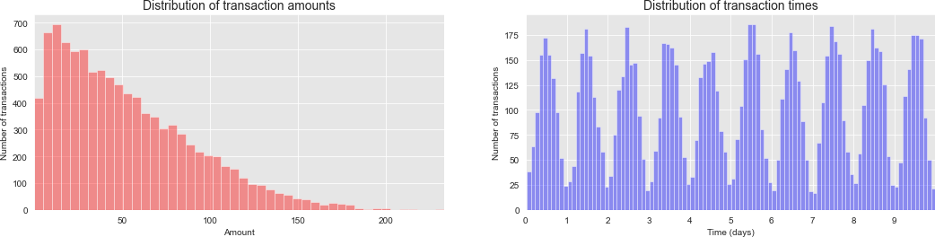

**distribution_amount_times_fig**

The distribution of transaction amounts has most of its mass for small amounts. The distribution of transaction times follows a gaussian distribution on a daily basis, centered around noon. These two distributions are in accordance with the simulation parameters used in the previous sections.

# Fraud scenarios generation

This last step of the simulation adds fraudulent transactions to the dataset, using the following fraud scenarios:

Scenario 1: Any transaction whose amount is more than 220 is a fraud. This scenario is not inspired by a real-world scenario. Rather, it will provide an obvious fraud pattern that should be detected by any baseline fraud detector. This will be useful to validate the implementation of a fraud detection technique.

Scenario 2: Every day, a list of two terminals is drawn at random. All transactions on these terminals in the next 28 days will be marked as fraudulent. This scenario simulates a criminal use of a terminal, through phishing for example. Detecting this scenario will be possible by adding features that keep track of the number of fraudulent transactions on the terminal. Since the terminal is only compromised for 28 days, additional strategies that involve concept drift will need to be designed to eﬃciently deal with this scenario.

Scenario 3: Every day, a list of 3 customers is drawn at random. In the next 14 days, 1/3 of their transactions have their amounts multiplied by 5 and marked as fraudulent. This scenario simulates a card-not-present fraud where the credentials of a customer have been leaked. The customer continues to make transactions, and transactions of higher values are made by the fraudster who tries to maximize their gains. Detecting this scenario will require adding features that keep track of the spending habits of the customer. As for scenario 2, since the card is only temporarily compromised, additional strategies that involve concept drift should also be designed.

Let us add fraudulent transactions using these scenarios:

**%time transactions_df = add_frauds(customer_profiles_table, terminal_profiles_table, transactions_df)**

**Number of frauds from scenario 1: 978 Number of frauds from scenario 2: 9099 Number of frauds from scenario 3: 4604**

**CPU times: user 1min 14s, sys: 210 ms, total: 1min 14s Wall time: 1min 15s**

Percentage of fraudulent transactions:

**transactions_df.TX_FRAUD.mean()**

**0.008369271814634397**

Number of fraudulent transactions:

**transactions_df.TX_FRAUD.sum()**

**14681**

A total of 14681 transactions were marked as fraudulent. This amounts to 0.8% of the transactions. Note that the sum of the frauds for each scenario does not equal the total amount of fraudulent transactions. This is because the same transactions may have been marked as fraudulent by two or more fraud scenarios.

Our simulated transaction dataset is now complete, with a fraudulent label added to all transactions.

**transactions_df.head()**

|  |  |  |  |  |  |  |  |  |
| --- | --- | --- | --- | --- | --- | --- | --- | --- |
| TRANSACTION_ID | TX_DATETIME | CUSTOMER_ID | TERMINAL_ID | TX_AMOUNT | TX_TIME_SECONDS | TX_TIME_DAYS | TX_FRAUD | TX_FRAUD_SCENARIO |
| 0 **0** | **2018-04-01 00:00:31** | **596** | **3156** | **57.16** | **31** | **0** | **0** | **0** |
| 1 **1** | **2018-04-01 00:02:10** | **4961** | **3412** | **81.51** | **130** | **0** | **0** | **0** |
| 2 **2** | **2018-04-01 00:07:56** | **2** | **1365** | **146.00** | **476** | **0** | **0** | **0** |
| 3 **3** | **2018-04-01 00:09:29** | **4128** | **8737** | **64.49** | **569** | **0** | **0** | **0** |
| 4 **4** | **2018-04-01 00:10:34** | **927** | **9906** | **50.99** | **634** | **0** | **0** | **0** |

**transactions_df[transactions_df.TX_FRAUD_SCENARIO==1].shape**

**(973, 9)**

**transactions_df[transactions_df.TX_FRAUD_SCENARIO==2].shape**

**(9077, 9)**

**transactions_df[transactions_df.TX_FRAUD_SCENARIO==3].shape**

**(4631, 9)**

Let us check how the number of transactions, the number of fraudulent transactions, and the number of compromised cards vary on a daily basis.

**fraud_and_transactions_stats_fig**

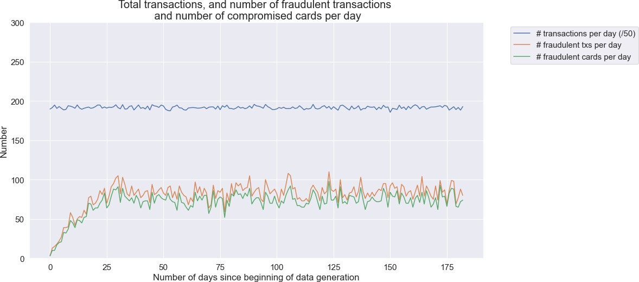

This simulation generated around 10000 transactions per day. The number of fraudulent transactions per day is around 85, and the number of fraudulent cards around 80. It is worth noting that the ﬁrst month has a lower number of fraudulent transactions, which is due to the fact that frauds from scenarios 2 and 3 span periods of 28 and 14 days, respectively.

The resulting dataset is interesting: It features class imbalance (less than 1% of fraudulent transactions), a mix of numerical and categorical features, non-trivial relationships between features, and time-dependent fraud scenarios.

Let us ﬁnally save the dataset for reuse in the rest of this book.

# Saving of dataset

Instead of saving the whole transaction dataset, we split the dataset into daily batches. This will allow later the loading of speciﬁc periods instead of the whole dataset. The pickle format is used, rather than CSV, to speed up the loading times. All ﬁles are saved in the DIR_OUTPUT folder. The names of the ﬁles are the dates, with the .pkl extension.

**DIR_OUTPUT = "./simulated-data-raw/"**

**if not os.path.exists(DIR_OUTPUT): os.makedirs(DIR_OUTPUT)**

**start_date = datetime.datetime.strptime("2018-04-01", "%Y-%m-*%d*") for day in range(transactions_df.TX_TIME_DAYS.max()+1):**

**transactions_day = transactions_df[transactions_df.TX_TIME_DAYS==day].sort_values('TX_TIME_SECONDS')**

**date = start_date + datetime.timedelta(days=day) filename_output = date.strftime("%Y-%m-*%d*")+'.pkl'**

***# Protocol=4 required for Google Colab***

**transactions_day.to_pickle(DIR_OUTPUT+filename_output, protocol=4)**