Game World GIS Map
Static Word Reference from leaflet_game_world_map(2).html
This document translates the interactive Leaflet map into a static reference while preserving the source dataset: regions, landmarks, NPCs, enemies, bosses, factions, and relationship links. Coordinates remain fictional CRS.Simple units.
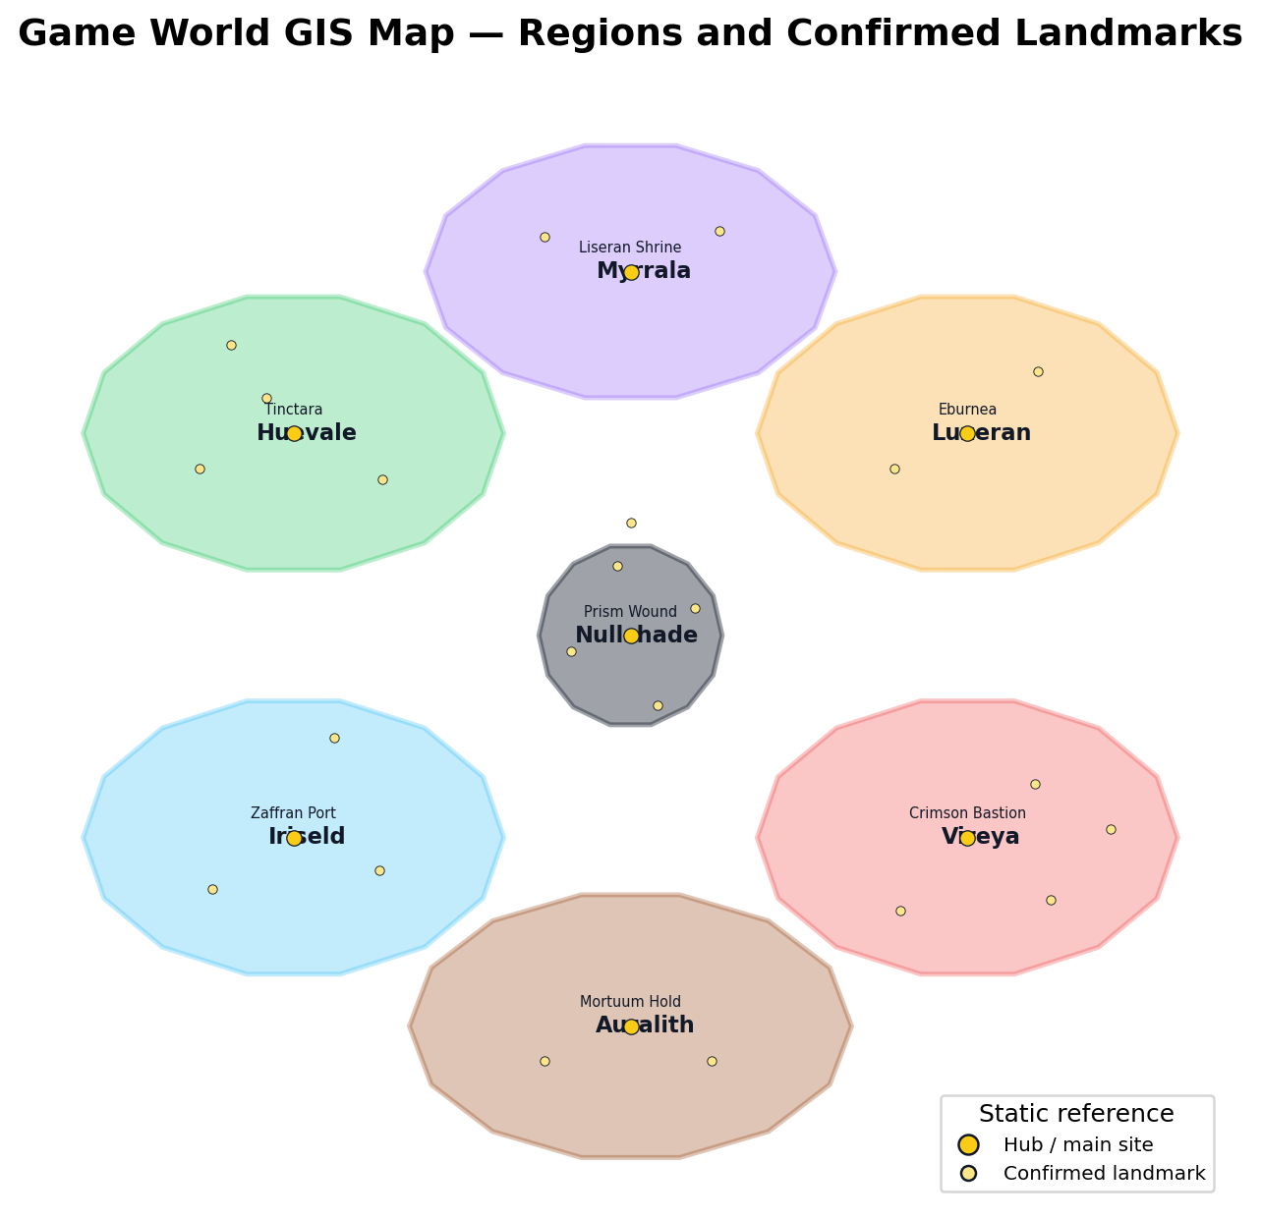

Source Structure
Source title | Game World GIS Map
Mapping library | Leaflet 1.9.4
Coordinate system | L.CRS.Simple / fictional map units
Map bounds | [[-235,-235],[225,235]]
Regions | 7
Landmarks | 56
Entities | 159 total — 47 NPCs, 70 enemies, 5 bosses, 37 factions
Relationship links | 262
Default visible layers | Regions, Landmarks, NPCs, Enemies & Bosses
Optional layers | Factions, Relationship Lines

Region Summary
Region | Subtitle | Hue | Regional law | Theme | Status
Nullshade | Colorless Core / Prism Wound | NULLSHADE | truth is spatially and mnemonically sealed | absence, contradiction, memory collapse | confirmed
Myrrala | The Blooming Veil | VIOLET | loadout changes the landscape | identity distortion, glamour, dream logic | confirmed
Huevale | The Verdant Frontier | VERDANT | vegetation regrows and reacts | living memory, adaptive growth, forest archives | confirmed
Luxeran | The Gilded Expanse | AURELIAN | mirages falsify the map | radiance, mirage, legitimacy, judgment | confirmed
Iriseld | The Tidespire Reach | COBALT | wind and gravity alter access; memory rides weather | storm-memory, sound, reflection, grief | confirmed
Vireya | The Ember Expanse | CRIMSON | heat, blood, and battle awaken dormant forces | war-memory, heat, blood, oath | confirmed
Auralith | The Dimming Hollow | EARTHEN | player action leaves ghosts behind | residue, ruin, soul-binding, fossil memory | confirmed

Relationship Layer Types
Relationship type | Count
anchor | 1
conceptual | 4
contains | 56
counter | 26
history | 2
hosts_boss | 5
hosts_enemy | 69
hosts_faction | 37
hosts_npc | 47
intrusion | 6
inversion | 1
prism_gate_route | 6
secret | 1
variant | 1

1. Nullshade — Colorless Core / Prism Wound
Hue | NULLSHADE
Regional law | truth is spatially and mnemonically sealed
Theme | absence, contradiction, memory collapse
Canonical status | confirmed
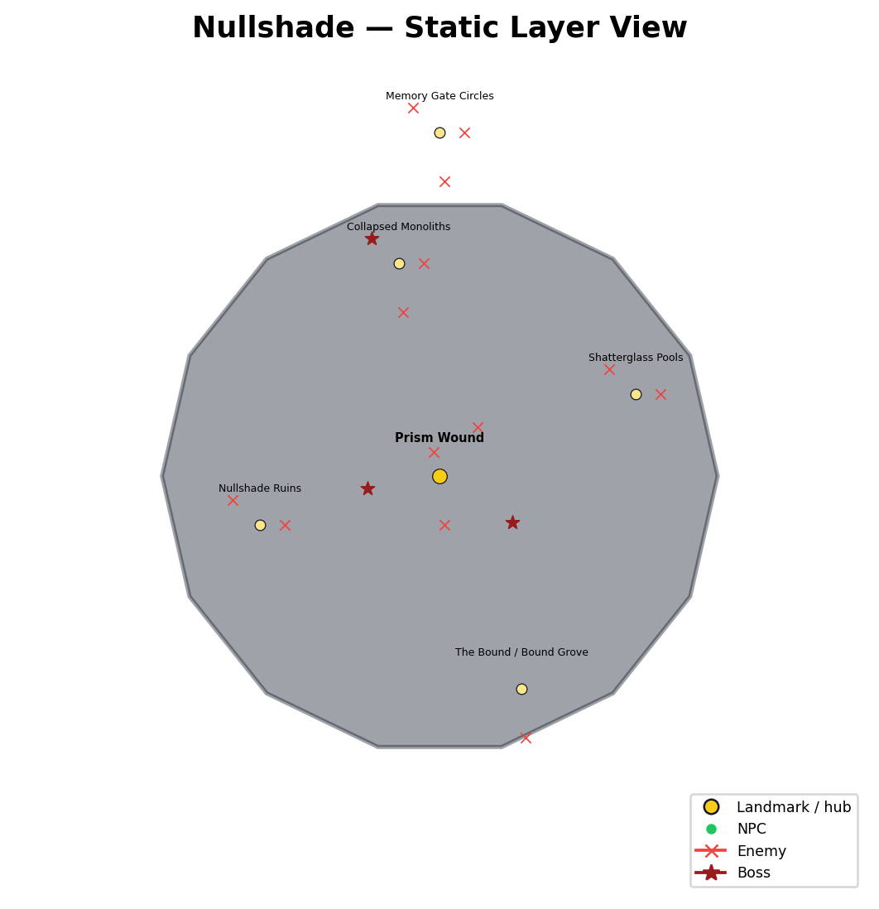

Landmarks
Name | Type | Description | Status | Coordinates
Prism Wound | main_site | true center / birthplace / wound | confirmed | 0, 0
Nullshade Ruins | landmark | late-game ruins | confirmed | -22, -6
Shatterglass Pools | landmark | reflection and replay pools | confirmed | 24, 10
Collapsed Monoliths | landmark | broken geometry / memory collapse | confirmed | -5, 26
The Bound / Bound Grove | landmark | witnesses frozen by failed coherence | confirmed | 10, -26
Memory Gate Circles | gate | inward route convergence | confirmed | 0, 42

Factions
Name | Home landmark | Geographic role | Status | Coordinates
The Mask | The Bound / Bound Grove | Order-imposed sealed story | strong_fit | 13, -26
Prismara Remnants | Prism Wound | primal harmony remnants | strong_fit | 3, 0
The Bound Witnesses | The Bound / Bound Grove | witnesses frozen by Mask or failed coherence | confirmed | 6.68, -22.96
Wound Immune Responses | Prism Wound | immune responses of the Wound | confirmed | -3.32, 3.04

Enemies
Name | Home landmark | Geographic role | Status | Coordinates
Prism Unform | Prism Wound | glitching spectral hue-shifter | confirmed | 0.52, -5.98
The Bound | The Bound / Bound Grove | awakened stone figures | confirmed | 10.52, -31.98
Nullshade Echo | Shatterglass Pools | reflection without mercy | confirmed | 27, 10
Null-Root | Collapsed Monoliths | failed void-growth | confirmed | -2, 26
Fractal Shardling | Collapsed Monoliths | broken geometry shard | confirmed | -4.48, 20.02
Wound Remnant | Prism Wound | shattering residue | confirmed | 4.57, 5.95
Nullshade Revenant | Nullshade Ruins | colorless revenant | confirmed | -19, -6
The Unhued Choir | Shatterglass Pools | song that removes color | confirmed | 20.68, 13.04
Memory Leech | Memory Gate Circles | HUD/control parasite | strong_fit | 3, 42
Tapestry Watcher — Nullshade Variant | Memory Gate Circles | prior-truth fracture | confirmed | -3.32, 45.04
Spectral Harvester | Nullshade Ruins | memory-harvest endgame entity | candidate | -25.32, -2.96
Memory Grafter | Prism Wound | memory rewrite entity | candidate | -0.78, 2.9
Nullborn Husks | Memory Gate Circles | early intrusion immune responses | strong_fit | 0.52, 36.02

Bosses
Name | Home landmark | Geographic role | Status | Coordinates
Silence Incarnate | Collapsed Monoliths | unblinking judgment | confirmed | -8.32, 29.04
The Seventh Hue | Prism Wound | optional mythic contradiction | confirmed | -8.86, -1.56
The Colorless Shape | Prism Wound | distorted build/loadout mirror | strong_fit | 8.86, -5.64

2. Myrrala — The Blooming Veil
Hue | VIOLET
Regional law | loadout changes the landscape
Theme | identity distortion, glamour, dream logic
Canonical status | confirmed
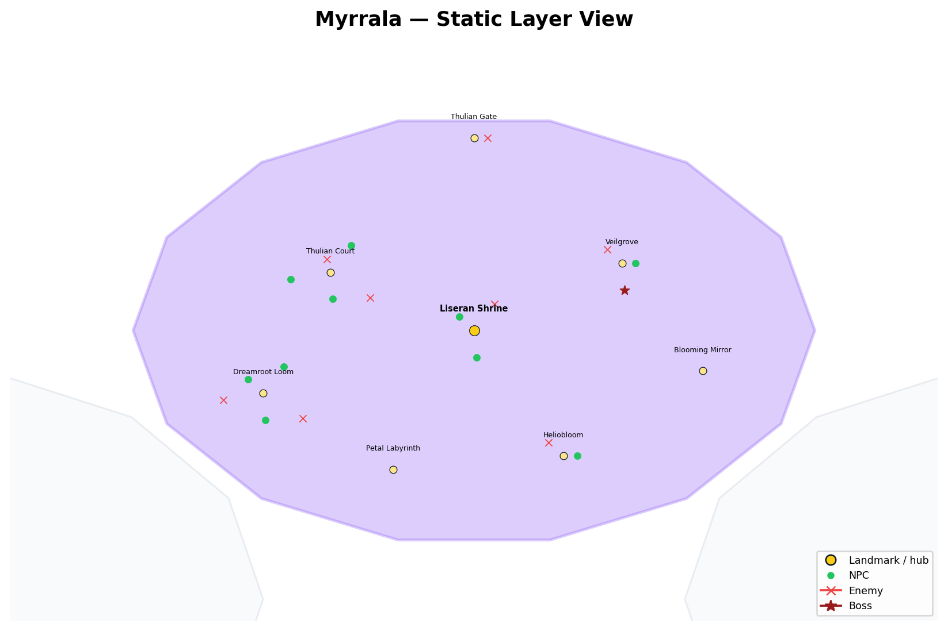

Landmarks
Name | Type | Description | Status | Coordinates
Liseran Shrine | hub | healing / dream-root threshold | confirmed | 0, 135
Thulian Court | landmark | glamour / public self / court authority | confirmed | -32, 148
Veilgrove | landmark | dream garden / glamour ecology | confirmed | 33, 150
Dreamroot Loom | sublocation | authored magic / woven identity | candidate_or_secondary | -47, 121
Thulian Gate | sublocation | truth gate / vow threshold | candidate_or_secondary | 0, 178
Blooming Mirror | sublocation | identity reflection | candidate_or_secondary | 51, 126
Heliobloom | sublocation | prophetic twilight flowers | candidate_or_secondary | 20, 107
Petal Labyrinth | sublocation | maze grown from blooming memories | candidate_or_secondary | -18, 104

Factions
Name | Home landmark | Geographic role | Status | Coordinates
Violet Order / Thulian Court | Thulian Court | identity / glamour / dream authorship | confirmed | -29, 148
Liseran Caretakers | Liseran Shrine | healing and shrine stewardship | strong_fit | 3, 135
Dreamroot Weavers | Dreamroot Loom | authored magic / woven identity | strong_fit | -44, 121
Fandango / Razzmatazz Performers | Thulian Court | rhythm, performance, artifact awakening | strong_fit | -35.32, 151.04

NPCs
Name | Home landmark | Geographic role | Status | Coordinates
Liseran Caretaker | Liseran Shrine | shrine keeper / healing lily | confirmed | -3.32, 138.04
Thulian Emissary | Thulian Court | court truth / incomplete mirror logic | confirmed | -31.48, 142.02
Fandango Duelstar | Thulian Court | duelist performer / singing blade | confirmed | -27.43, 153.95
Razzmatazz Sprite | Dreamroot Loom | artifact awakening / rhythm interaction | confirmed | -50.32, 124.04
Periwinkle Siren | Liseran Shrine | voice / charm / dream-water logic | confirmed | 0.52, 129.02
Quinacridone Blade | Dreamroot Loom | battle-paint / authored magic | confirmed | -46.48, 115.02
Heliotrope Devotee | Heliobloom | devotion / prophecy / purple light | confirmed | 23, 107
Wisteria Enchantress | Veilgrove | enchantment / hanging garden logic | confirmed | 36, 150
Mauveine Spark | Dreamroot Loom | unstable dream energy | confirmed | -42.43, 126.95
Pomp & Power Chancellor | Thulian Court | court command / nobles / weak minds | confirmed | -40.86, 146.44

Enemies
Name | Home landmark | Geographic role | Status | Coordinates
Doppelshade | Thulian Court | player clone / identity mimic | confirmed | -23.14, 142.36
Lilyborn Mirage | Liseran Shrine | lily-mist memory loop | confirmed | 4.57, 140.95
Bloomveil Widow | Veilgrove | glamour predator | confirmed | 29.68, 153.04
Glittering Grimoire | Dreamroot Loom | spell-history mimicry | confirmed | -55.86, 119.44
Chronopollen Sprite | Heliobloom | time/pollen distortion | confirmed | 16.68, 110.04
Fandancer Fragment | Thulian Court | performance / rhythm enemy | confirmed | -32.78, 150.9
Thulian Vowkeep | Thulian Gate | promise / vow logic | confirmed | 3, 178
Razzflare Imp | Dreamroot Loom | unstable artifact trickster | confirmed | -38.14, 115.36

Bosses
Name | Home landmark | Geographic role | Status | Coordinates
Veilshift Matron | Veilgrove | identity-stability test | confirmed | 33.52, 144.02

3. Huevale — The Verdant Frontier
Hue | VERDANT
Regional law | vegetation regrows and reacts
Theme | living memory, adaptive growth, forest archives
Canonical status | confirmed
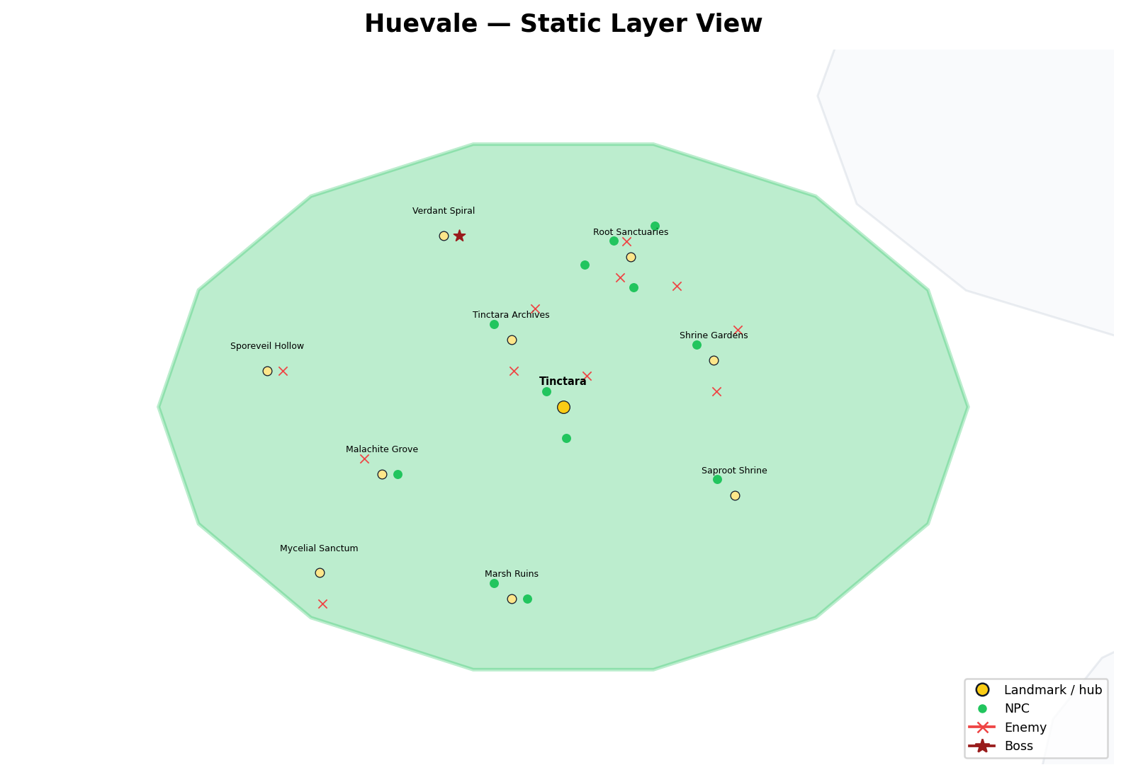

Landmarks
Name | Type | Description | Status | Coordinates
Tinctara | hub | moss-covered archive-city | confirmed | -125, 75
Tinctara Archives | landmark | living records / ceramic memory | confirmed | -135, 88
Malachite Grove | landmark | dream-poison / prophecy | confirmed | -160, 62
Saproot Shrine | landmark | curse / decay / root cult threshold | confirmed | -92, 58
Verdant Spiral | landmark | moth-witch / spiral growth | confirmed | -148, 108
Sporeveil Hollow | sublocation | spore and fungal disruption | candidate_or_secondary | -182, 82
Mycelial Sanctum | sublocation | fungal minds / spore cult | candidate_or_secondary | -172, 43
Root Sanctuaries | sublocation | root-bound truth | candidate_or_secondary | -112, 104
Shrine Gardens | sublocation | sacred flower beds | candidate_or_secondary | -96, 84
Marsh Ruins | sublocation | flooded groves / drowned monasteries | candidate_or_secondary | -135, 38

Factions
Name | Home landmark | Geographic role | Status | Coordinates
Verdant Order | Tinctara | druids / alchemists / balance | confirmed | -122, 75
Archivists of Celadon | Tinctara Archives | spell-record / ceramic memory | confirmed | -132, 88
Rootbound Orders | Root Sanctuaries | sacred groves / oath-grown boundaries | confirmed | -109, 104
Thornward Circle | Shrine Gardens | defensive grove alliance | candidate_or_secondary | -93, 84
Sapbound Covenant | Saproot Shrine | swamp cult / earth-blood doctrine | candidate_or_secondary | -89, 58
Rootwake Communion | Mycelial Sanctum | ancient plants / fungal minds | candidate_or_secondary | -169, 43
The Mycofen | Mycelial Sanctum | spore cult | candidate_or_secondary | -175.32, 46.04

NPCs
Name | Home landmark | Geographic role | Status | Coordinates
Celadon Archivist | Tinctara Archives | archive-city memory keeper | confirmed | -138.32, 91.04
Viridian Alchemist | Tinctara | swamp alchemy and glyphwork | confirmed | -128.32, 78.04
Malachite Oracle | Malachite Grove | dream-poison prophecy | confirmed | -157, 62
Xanadu Warden | Root Sanctuaries | guardian-guide of old gardens | confirmed | -115.32, 107.04
Limerick Druid | Root Sanctuaries | forest-song and spirit charm | confirmed | -111.48, 98.02
Skobeloff Diver | Marsh Ruins | flooded relic diver / trap revealer | confirmed | -132, 38
Smaragdine Knight | Shrine Gardens | nature attunement / beast calming | confirmed | -99.32, 87.04
Chartreuse Initiate | Tinctara | tonic / stamina / euphoric side effect | confirmed | -124.48, 69.02
Feldgrau Veteran | Marsh Ruins | stealth and ruin survival | confirmed | -138.32, 41.04
Harlequin Trickblade | Root Sanctuaries | mimic voices / dodge fate | confirmed | -107.43, 109.95
Saproot Cultist | Saproot Shrine | decay and curse protection | confirmed | -95.32, 61.04
Thalera the Rootborn | Root Sanctuaries | rootborn witness / Prism Gate threshold | confirmed | -120.86, 102.44

Enemies
Name | Home landmark | Geographic role | Status | Coordinates
Sapborn Stalker | Root Sanctuaries | root-burrow ambusher | confirmed | -103.14, 98.36
Boglight Mimic | Sporeveil Hollow | lure-light predator | confirmed | -179, 82
Verdant Maw | Shrine Gardens | stationary flower predator | confirmed | -95.48, 78.02
Sporekin | Mycelial Sanctum | spore and confusion hazard | confirmed | -171.48, 37.02
Thornwrithe Beast | Root Sanctuaries | bramble predator | confirmed | -112.78, 106.9
Limeroot Trickster | Root Sanctuaries | plantlife misdirection | confirmed | -114.08, 100.01
Chartreuse Husk | Tinctara | alchemical corruption | confirmed | -120.43, 80.95
Grovebound Sentinel | Tinctara Archives | shrine / archive guardian | confirmed | -134.48, 82.02
Fangbloom Wyrm | Shrine Gardens | hidden flower-bed constrictor | confirmed | -91.43, 89.95
Mossgrave Revenant | Malachite Grove | dream-poison knight specter | confirmed | -163.32, 65.04
Hue Leeches | Tinctara Archives | Color Charge / memory drain teaching enemy | confirmed | -130.43, 93.95

Bosses
Name | Home landmark | Geographic role | Status | Coordinates
Moth-Witch of the Verdant Spiral | Verdant Spiral | mini-boss / boss encounter | confirmed | -145, 108

4. Luxeran — The Gilded Expanse
Hue | AURELIAN
Regional law | mirages falsify the map
Theme | radiance, mirage, legitimacy, judgment
Canonical status | confirmed
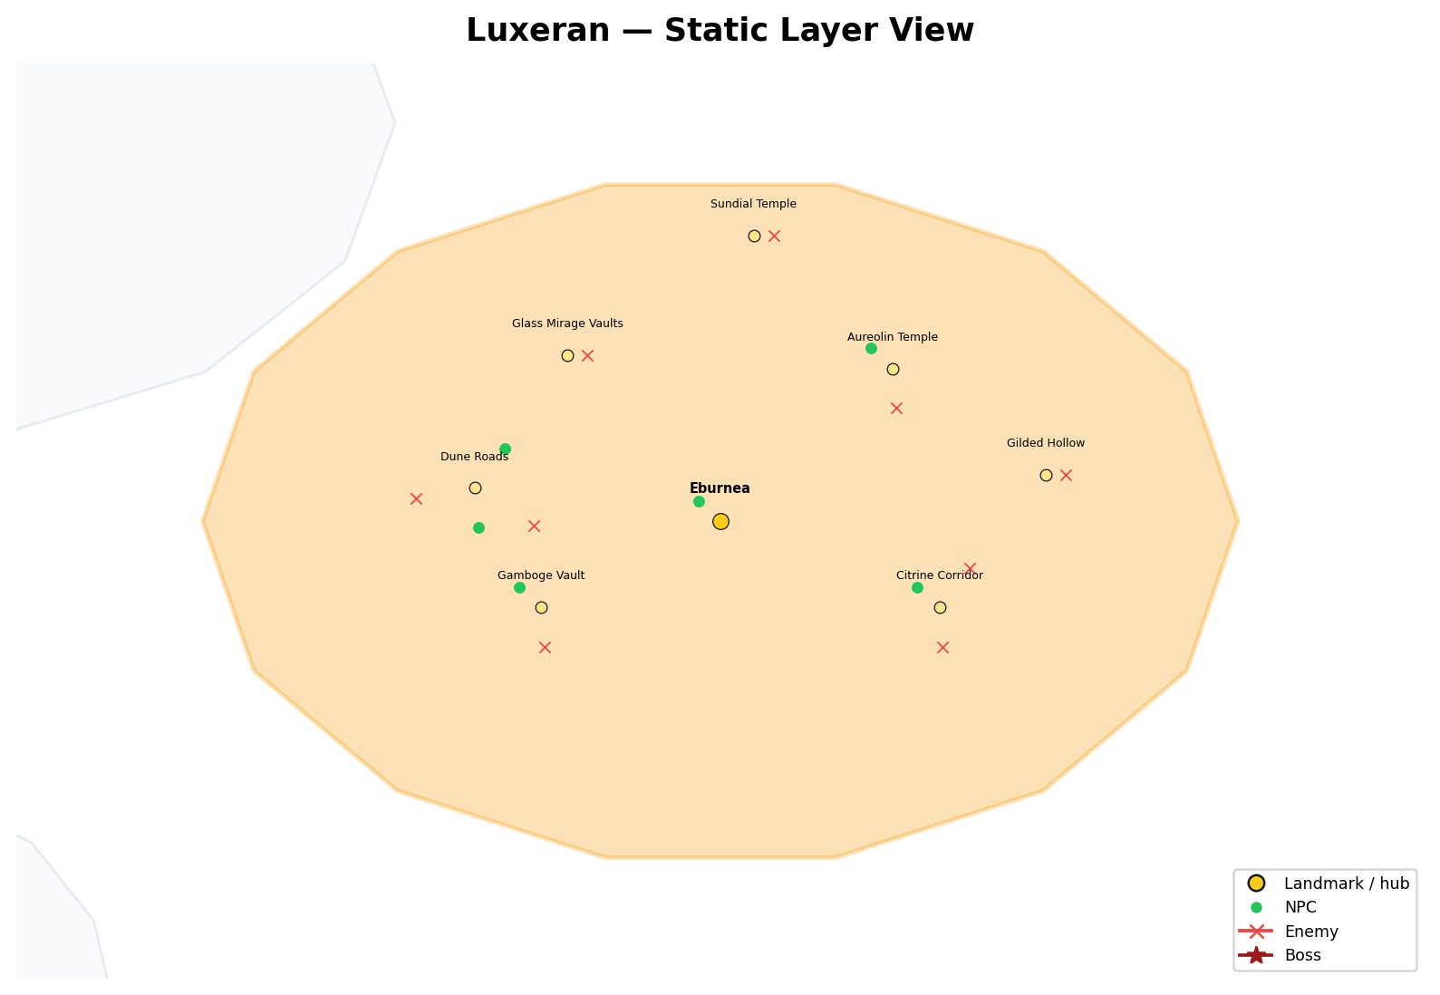

Landmarks
Name | Type | Description | Status | Coordinates
Eburnea | hub | gilded city / legitimacy economy | confirmed | 125, 75
Gamboge Vault | landmark | vault rite / mirage spirit | confirmed | 98, 62
Aureolin Temple | landmark | solar judgment temple | confirmed | 151, 98
Citrine Corridor | sublocation | lightcraft / radiant constructs | candidate_or_secondary | 158, 62
Glass Mirage Vaults | sublocation | false NPCs and false doors | candidate_or_secondary | 102, 100
Gilded Hollow | sublocation | permanent glare / hidden predators | candidate_or_secondary | 174, 82
Sundial Temple | sublocation | beam rhythm platforms | candidate_or_secondary | 130, 118
Dune Roads | sublocation | false trade routes / heat tracking | candidate_or_secondary | 88, 80

Factions
Name | Home landmark | Geographic role | Status | Coordinates
Aurelian Order | Aureolin Temple | light / trade / judgment / public truth | confirmed | 154, 98
Eburnean Priesthood | Eburnea | legitimacy / judgment | strong_fit | 128, 75
Gamboge Monks | Gamboge Vault | vault rites | strong_fit | 101, 62
Citrine Artisans | Citrine Corridor | lightcraft and market legitimacy | strong_fit | 161, 62
Desert Couriers | Dune Roads | trade route movement | strong_fit | 91, 80
Sun Hunters | Dune Roads | heat and desert tracking | strong_fit | 84.68, 83.04

NPCs
Name | Home landmark | Geographic role | Status | Coordinates
Eburnean Priestess | Eburnea | city / temple legitimacy | confirmed | 121.68, 78.04
Citrine Artisan | Citrine Corridor | craft / surface brilliance | confirmed | 154.68, 65.04
Gamboge Monk | Gamboge Vault | monastic light logic | confirmed | 94.68, 65.04
Fulvous Hunter | Dune Roads | desert hunter / heat movement | confirmed | 88.52, 74.02
Orangepeel Courier | Dune Roads | trade / speed / message routes | confirmed | 92.57, 85.95
Aureolin Flame | Aureolin Temple | fire/light devotion | confirmed | 147.68, 101.04

Enemies
Name | Home landmark | Geographic role | Status | Coordinates
Sunburnt Jackal | Dune Roads | heat/scent predator | confirmed | 79.14, 78.44
Mirage Revenant | Glass Mirage Vaults | fake NPC / chest mimic | confirmed | 105, 100
Cinnabar Scarab | Citrine Corridor | gleaming dust predator | confirmed | 158.52, 56.02
Ambercoil Asp | Dune Roads | desert coil hazard | confirmed | 96.86, 74.36
Gamboge Djinnling | Gamboge Vault | mirage spirit | confirmed | 98.52, 56.02
Hollow Prophet | Aureolin Temple | light-judgment caster | confirmed | 151.52, 92.02
Citrine Golem | Citrine Corridor | radiant construct | confirmed | 162.57, 67.95
Sunflare Marionette | Sundial Temple | beam rhythm puppet | strong_fit | 133, 118
Heliotropic Lurker | Gilded Hollow | sun-following ambusher | strong_fit | 177, 82

5. Iriseld — The Tidespire Reach
Hue | COBALT
Regional law | wind and gravity alter access; memory rides weather
Theme | storm-memory, sound, reflection, grief
Canonical status | confirmed
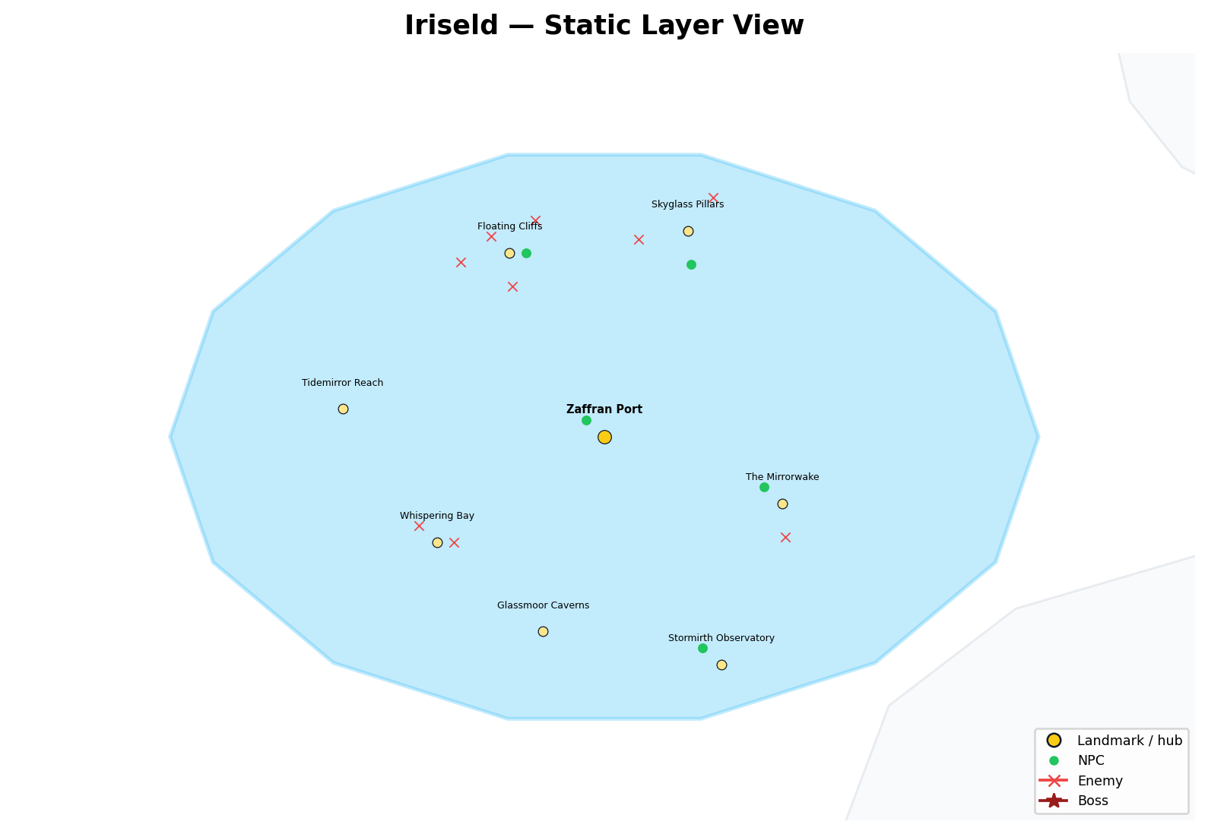

Landmarks
Name | Type | Description | Status | Coordinates
Zaffran Port | hub | harbor / glasswright culture | confirmed | -125, -75
Whispering Bay | landmark | drowned pages / sea-memory | confirmed | -155, -94
Skyglass Pillars | landmark | vertical traversal / storm glass | confirmed | -110, -38
The Mirrorwake | landmark | reflective duel / grief exposure | confirmed | -93, -87
Tidemirror Reach | sublocation | partly sunken reach | candidate_or_secondary | -172, -70
Glassmoor Caverns | sublocation | glass caverns / echo resonance | candidate_or_secondary | -136, -110
Floating Cliffs | sublocation | sky islands and aerial hazards | candidate_or_secondary | -142, -42
Stormirth Observatory | sublocation | weather genesis / cliff observatory | candidate_or_secondary | -104, -116

Factions
Name | Home landmark | Geographic role | Status | Coordinates
Cobalt Order | Zaffran Port | clarity / memory / storm logic | confirmed | -122, -75
Glasswrights | Skyglass Pillars | storm glass and memory sealing | strong_fit | -107, -38
Skydancers | Skyglass Pillars | wind traversal / storm hymn | strong_fit | -113.32, -34.96
Storm Seers | Stormirth Observatory | weather memory | strong_fit | -101, -116
Reflective Exiles | The Mirrorwake | grief reflection | candidate | -90, -87

NPCs
Name | Home landmark | Geographic role | Status | Coordinates
Zaffre Glasswright | Zaffran Port | memory-sealing glass / whisperpanes | confirmed | -128.32, -71.96
Cerulean Skydancer | Skyglass Pillars | storm hymn / wind traversal | confirmed | -109.48, -43.98
Glaucous Wing | Floating Cliffs | avian shapeshifter / cliff guardian | confirmed | -139, -42
Payne's Shade | The Mirrorwake | painter of illusions / impossible skies | confirmed | -96.32, -83.96
Eigengrau the Unseeing | Stormirth Observatory | blind seer / inward truth | confirmed | -107.32, -112.96

Enemies
Name | Home landmark | Geographic role | Status | Coordinates
Glassborne Echo | Skyglass Pillars | mirrored movement with delay | confirmed | -105.43, -32.05
Skycall Wraith | Floating Cliffs | glide denial / aerial shriek | confirmed | -145.32, -38.96
Stormwrit Hound | Floating Cliffs | lightning traversal hunter | confirmed | -141.48, -47.98
Tideworn Apostle | Whispering Bay | drowned knowledge / ink storm | confirmed | -152, -94
Mirrorwake Duelist | The Mirrorwake | reflective combat logic | confirmed | -92.48, -92.98
Feathered Null | Floating Cliffs | Nullshade-tainted aerial form | confirmed | -137.43, -36.05
Abyssal Current | Whispering Bay | submerged force / undertow | confirmed | -158.32, -90.96
Tempest Marionette | Skyglass Pillars | storm puppet / movement disruption | confirmed | -118.86, -39.56
Sorrowwing | Floating Cliffs | grief / aerial predator | confirmed | -150.86, -43.56

6. Vireya — The Ember Expanse
Hue | CRIMSON
Regional law | heat, blood, and battle awaken dormant forces
Theme | war-memory, heat, blood, oath
Canonical status | confirmed
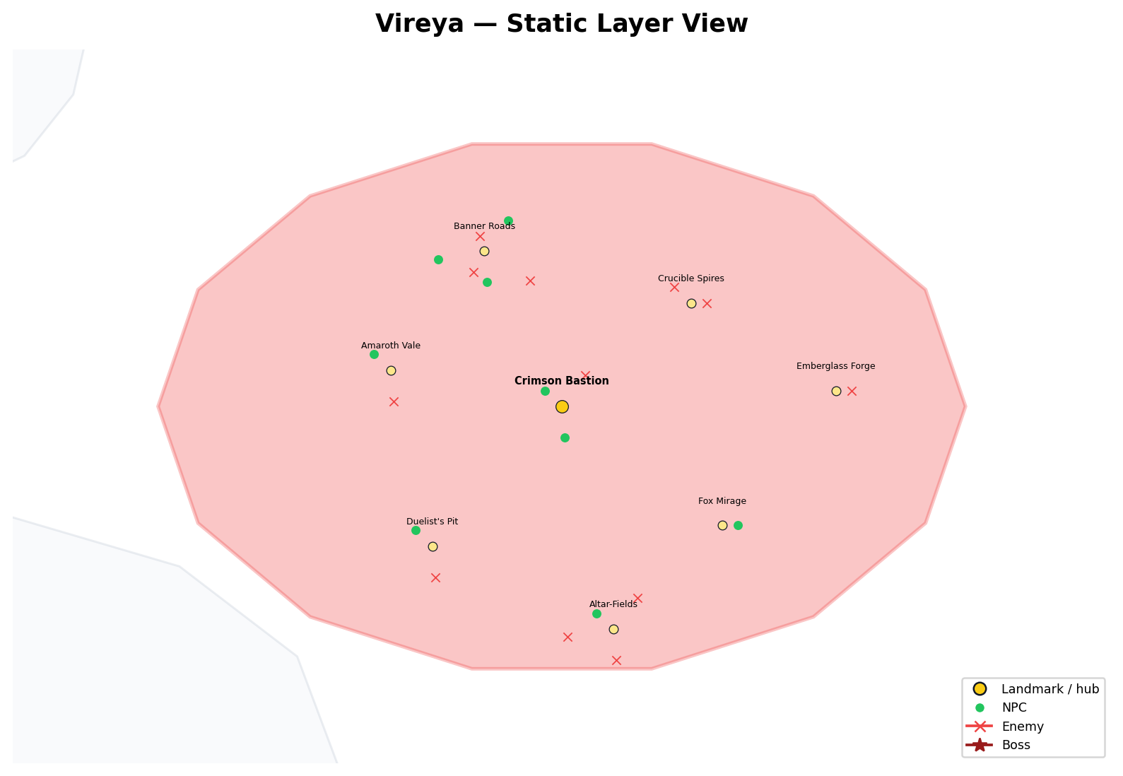

Landmarks
Name | Type | Description | Status | Coordinates
Crimson Bastion | hub | fortress-city / martial heart | confirmed | 125, -75
Duelist's Pit | landmark | duel-loop and ritual combat | confirmed | 100, -102
Fox Mirage | landmark | illusion-haunted volcanic valley | confirmed | 156, -98
Crucible Spires | landmark | molten siege / forge spires | confirmed | 150, -55
Emberglass Forge | landmark | volcanic glass / betrayal heat | confirmed | 178, -72
Banner Roads | sublocation | shattered standards / revenant routes | candidate_or_secondary | 110, -45
Amaroth Vale | sublocation | martyr-heroes buried and rising | candidate_or_secondary | 92, -68
Altar-Fields | sublocation | oath shrines and blood rites | candidate_or_secondary | 135, -118

Factions
Name | Home landmark | Geographic role | Status | Coordinates
Crimson Order | Crimson Bastion | action / sacrifice / courage | confirmed | 128, -75
Banner Houses | Banner Roads | ancestral martial authority | confirmed | 113, -45
Rebel Circles | Banner Roads | broken accords and rebellion | confirmed | 106.68, -41.96
Embersaints | Altar-Fields | flame-priests and sacrifice | confirmed | 138, -118
Duel Lineages | Duelist's Pit | combat as inheritance | confirmed | 103, -102
Bloodroot Cult Remnants | Amaroth Vale | martyr-blood awakening doctrine | confirmed | 95, -68

NPCs
Name | Home landmark | Geographic role | Status | Coordinates
Vermilion Duelist | Duelist's Pit | duel and combat culture | confirmed | 96.68, -98.96
Amaranth the Undying | Amaroth Vale | undying war figure | confirmed | 88.68, -64.96
Alizarin the Crimson Weaver | Crimson Bastion | blood/thread/war-memory logic | confirmed | 121.68, -71.96
Nacarat the Fox | Fox Mirage | trickster / volcanic illusion | confirmed | 159, -98
Falu Homesteader | Banner Roads | civilian survival / ash plains | confirmed | 110.52, -50.98
Coquelicot Banner | Banner Roads | banner and war-standard memory | confirmed | 114.57, -39.05
Cinnabar Mask | Altar-Fields | ritual deception / mask logic | confirmed | 131.68, -114.96
Sanguine Quartermaster | Crimson Bastion | battlefield ledgers and burial debts | strong_fit | 125.52, -80.98
Rustbanner Child | Banner Roads | scavenger-guide among wrecked standards | strong_fit | 101.14, -46.56

Enemies
Name | Home landmark | Geographic role | Status | Coordinates
Ashwrought Colossus | Crucible Spires | molten siege construct | strong_fit | 153, -55
Crimson Echo | Duelist's Pit | duel-loop ghost | confirmed | 100.52, -107.98
Lava-Fused Behemot | Crucible Spires | lava battlefield giant | confirmed | 146.68, -51.96
Glasslash Serpent | Emberglass Forge | volcanic glass betrayal serpent | strong_fit | 181, -72
Bannerbound Revenant | Banner Roads | standard-tethered revenant | strong_fit | 118.86, -50.64
Searblood Cultist | Altar-Fields | blood/fire cultist | strong_fit | 135.52, -123.98
Funeral Dancer | Altar-Fields | ritual death combat | strong_fit | 139.57, -112.05
Bloodroot Effigy | Amaroth Vale | martyr-bone golem | strong_fit | 92.52, -73.98
Red Widow | Banner Roads | war-haunted predator | strong_fit | 109.22, -42.1
Wickerborn | Altar-Fields | pyre effigy | strong_fit | 126.14, -119.56
Tyrian Echo | Banner Roads | mixed-hue war echo | strong_fit | 107.92, -48.99
Rustworn Judge | Crimson Bastion | old verdict / execution memory | strong_fit | 129.57, -69.05

7. Auralith — The Dimming Hollow
Hue | EARTHEN
Regional law | player action leaves ghosts behind
Theme | residue, ruin, soul-binding, fossil memory
Canonical status | confirmed
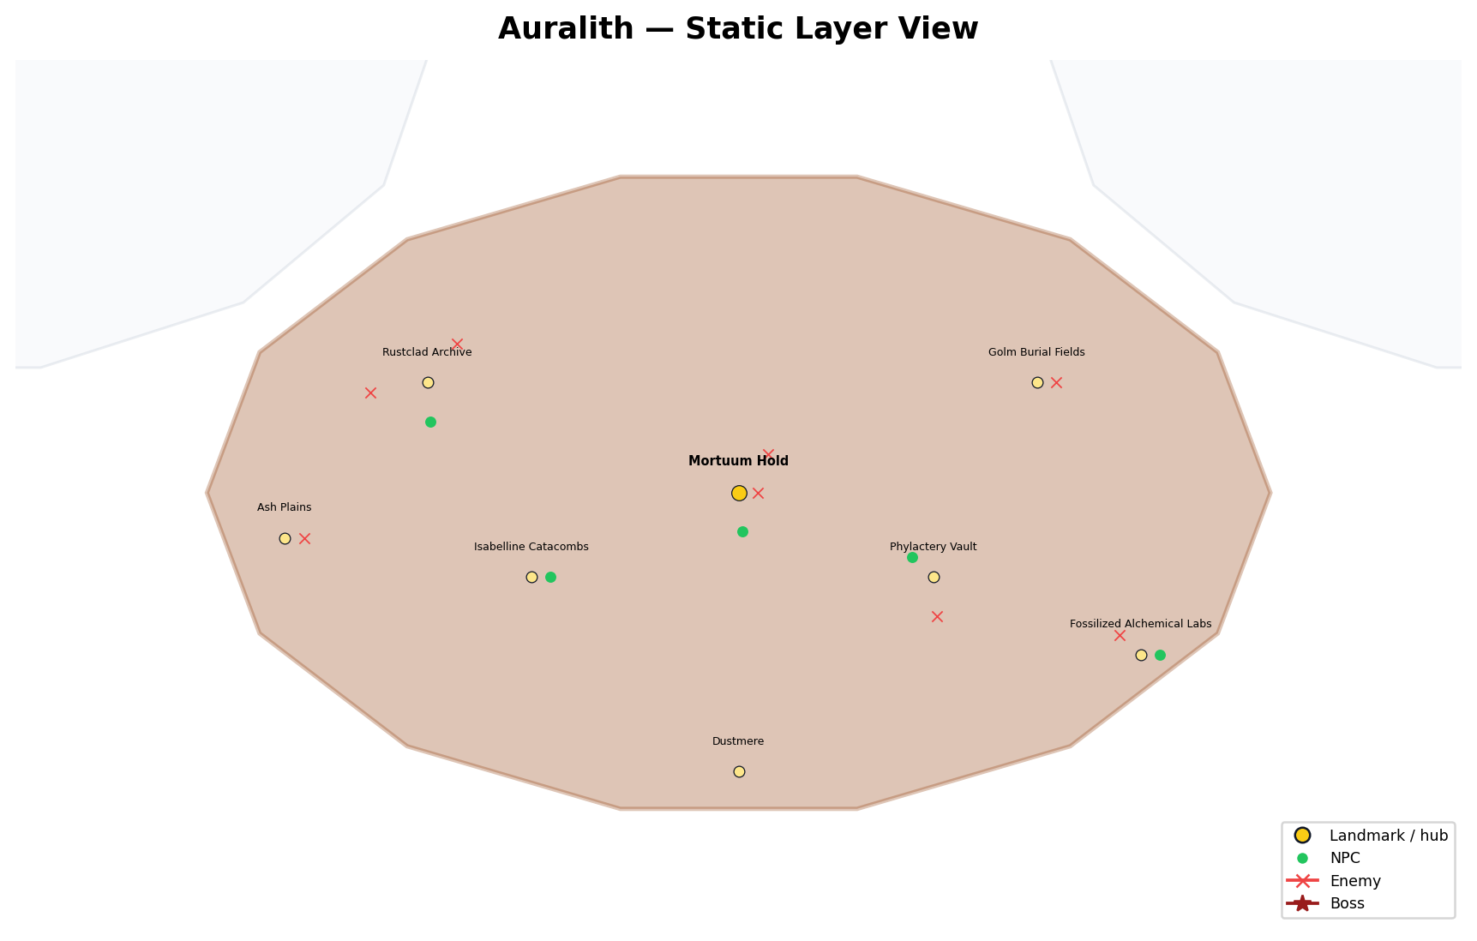

Landmarks
Name | Type | Description | Status | Coordinates
Mortuum Hold | hub | ruin authority / disciplined endings | confirmed | 0, -145
Isabelline Catacombs | landmark | mourning / burial memory | confirmed | -32, -158
Phylactery Vault | landmark | soul-binding / death state | confirmed | 30, -158
Rustclad Archive | sublocation | ash records / erased histories | candidate_or_secondary | -48, -128
Golm Burial Fields | sublocation | golems / old war memory | candidate_or_secondary | 46, -128
Dustmere | sublocation | dead lake / sunken memory vault | candidate_or_secondary | 0, -188
Fossilized Alchemical Labs | sublocation | failed preservation experiments | candidate_or_secondary | 62, -170
Ash Plains | sublocation | trauma fog / soot entities | candidate_or_secondary | -70, -152

Factions
Name | Home landmark | Geographic role | Status | Coordinates
Earthen Order | Mortuum Hold | transmutation / endings / residue | confirmed | 3, -145
Mortumic Circle | Phylactery Vault | death refined, not prevented | confirmed | 33, -158
The Ochranthium | Rustclad Archive | truth in clay / dust / amber | confirmed | -45, -128
Order of the Bound Flame | Mortuum Hold | fire as memory | confirmed | -3.32, -141.96
Tenebric Scribes | Rustclad Archive | chronicle erased things | confirmed | -51.32, -124.96

NPCs
Name | Home landmark | Geographic role | Status | Coordinates
Caput Mortuum Ascetic | Phylactery Vault | death/refinement philosophy | confirmed | 26.68, -154.96
Bistre Archivist | Rustclad Archive | prior events / residue records | confirmed | -47.48, -133.98
Isabelline Widow | Isabelline Catacombs | mourning / memory residue | confirmed | -29, -158
Burnt Sienna Sculptor | Fossilized Alchemical Labs | fossil memory / golem-core logic | confirmed | 65, -170
Mikado Warlord | Mortuum Hold | old authority / ruin command | confirmed | 0.52, -150.98

Enemies
Name | Home landmark | Geographic role | Status | Coordinates
Memory Husk | Rustclad Archive | past-self shell | confirmed | -43.43, -122.05
Sootshade Collector | Ash Plains | ash/parchment trauma entity | strong_fit | -67, -152
Alchemical Echo | Fossilized Alchemical Labs | failed alchemy residual state | confirmed | 58.68, -166.96
Wickborn Lantern | Soulfields | lantern / soulfield guide-or-threat | confirmed | 3, -145
Ochre Golem | Golm Burial Fields | fossilized memory-ore guardian | strong_fit | 49, -128
Caput Marionette | Phylactery Vault | death / puppet logic | strong_fit | 30.52, -163.98
Rustworn Judge | Mortuum Hold | old verdict / ruin judgment | strong_fit | 4.57, -139.05
Tapestry Watcher | Rustclad Archive | prior-truth / memory overwrite entity | confirmed | -56.86, -129.56

Relationship Links — Complete Appendix
All relationship-line features from the HTML source are listed below. The interactive source can toggle these lines on or off; this appendix preserves their names, relationship types, descriptions, status, and endpoint coordinates.
Link | Type | Description | Status | Endpoints
Nullshade → Prism Wound | contains | region contains landmark | derived | 0,0 → 0,0
Nullshade → Nullshade Ruins | contains | region contains landmark | derived | 0,0 → -22,-6
Nullshade → Shatterglass Pools | contains | region contains landmark | derived | 0,0 → 24,10
Nullshade → Collapsed Monoliths | contains | region contains landmark | derived | 0,0 → -5,26
Nullshade → The Bound / Bound Grove | contains | region contains landmark | derived | 0,0 → 10,-26
Nullshade → Memory Gate Circles | contains | region contains landmark | derived | 0,0 → 0,42
Huevale → Tinctara | contains | region contains landmark | derived | -125,75 → -125,75
Huevale → Tinctara Archives | contains | region contains landmark | derived | -125,75 → -135,88
Huevale → Malachite Grove | contains | region contains landmark | derived | -125,75 → -160,62
Huevale → Saproot Shrine | contains | region contains landmark | derived | -125,75 → -92,58
Huevale → Verdant Spiral | contains | region contains landmark | derived | -125,75 → -148,108
Huevale → Sporeveil Hollow | contains | region contains landmark | derived | -125,75 → -182,82
Huevale → Mycelial Sanctum | contains | region contains landmark | derived | -125,75 → -172,43
Huevale → Root Sanctuaries | contains | region contains landmark | derived | -125,75 → -112,104
Huevale → Shrine Gardens | contains | region contains landmark | derived | -125,75 → -96,84
Huevale → Marsh Ruins | contains | region contains landmark | derived | -125,75 → -135,38
Vireya → Crimson Bastion | contains | region contains landmark | derived | 125,-75 → 125,-75
Vireya → Duelist's Pit | contains | region contains landmark | derived | 125,-75 → 100,-102
Vireya → Fox Mirage | contains | region contains landmark | derived | 125,-75 → 156,-98
Vireya → Crucible Spires | contains | region contains landmark | derived | 125,-75 → 150,-55
Vireya → Emberglass Forge | contains | region contains landmark | derived | 125,-75 → 178,-72
Vireya → Banner Roads | contains | region contains landmark | derived | 125,-75 → 110,-45
Vireya → Amaroth Vale | contains | region contains landmark | derived | 125,-75 → 92,-68
Vireya → Altar-Fields | contains | region contains landmark | derived | 125,-75 → 135,-118
Iriseld → Zaffran Port | contains | region contains landmark | derived | -125,-75 → -125,-75
Iriseld → Whispering Bay | contains | region contains landmark | derived | -125,-75 → -155,-94
Iriseld → Skyglass Pillars | contains | region contains landmark | derived | -125,-75 → -110,-38
Iriseld → The Mirrorwake | contains | region contains landmark | derived | -125,-75 → -93,-87
Iriseld → Tidemirror Reach | contains | region contains landmark | derived | -125,-75 → -172,-70
Iriseld → Glassmoor Caverns | contains | region contains landmark | derived | -125,-75 → -136,-110
Iriseld → Floating Cliffs | contains | region contains landmark | derived | -125,-75 → -142,-42
Iriseld → Stormirth Observatory | contains | region contains landmark | derived | -125,-75 → -104,-116
Myrrala → Liseran Shrine | contains | region contains landmark | derived | 0,135 → 0,135
Myrrala → Thulian Court | contains | region contains landmark | derived | 0,135 → -32,148
Myrrala → Veilgrove | contains | region contains landmark | derived | 0,135 → 33,150
Myrrala → Dreamroot Loom | contains | region contains landmark | derived | 0,135 → -47,121
Myrrala → Thulian Gate | contains | region contains landmark | derived | 0,135 → 0,178
Myrrala → Blooming Mirror | contains | region contains landmark | derived | 0,135 → 51,126
Myrrala → Heliobloom | contains | region contains landmark | derived | 0,135 → 20,107
Myrrala → Petal Labyrinth | contains | region contains landmark | derived | 0,135 → -18,104
Luxeran → Eburnea | contains | region contains landmark | derived | 125,75 → 125,75
Luxeran → Gamboge Vault | contains | region contains landmark | derived | 125,75 → 98,62
Luxeran → Aureolin Temple | contains | region contains landmark | derived | 125,75 → 151,98
Luxeran → Citrine Corridor | contains | region contains landmark | derived | 125,75 → 158,62
Luxeran → Glass Mirage Vaults | contains | region contains landmark | derived | 125,75 → 102,100
Luxeran → Gilded Hollow | contains | region contains landmark | derived | 125,75 → 174,82
Luxeran → Sundial Temple | contains | region contains landmark | derived | 125,75 → 130,118
Luxeran → Dune Roads | contains | region contains landmark | derived | 125,75 → 88,80
Auralith → Mortuum Hold | contains | region contains landmark | derived | 0,-145 → 0,-145
Auralith → Isabelline Catacombs | contains | region contains landmark | derived | 0,-145 → -32,-158
Auralith → Phylactery Vault | contains | region contains landmark | derived | 0,-145 → 30,-158
Auralith → Rustclad Archive | contains | region contains landmark | derived | 0,-145 → -48,-128
Auralith → Golm Burial Fields | contains | region contains landmark | derived | 0,-145 → 46,-128
Auralith → Dustmere | contains | region contains landmark | derived | 0,-145 → 0,-188
Auralith → Fossilized Alchemical Labs | contains | region contains landmark | derived | 0,-145 → 62,-170
Auralith → Ash Plains | contains | region contains landmark | derived | 0,-145 → -70,-152
Tinctara → Verdant Order | hosts_faction | druids / alchemists / balance | confirmed | -125,75 → -122,75
Tinctara Archives → Archivists of Celadon | hosts_faction | spell-record / ceramic memory | confirmed | -135,88 → -132,88
Root Sanctuaries → Rootbound Orders | hosts_faction | sacred groves / oath-grown boundaries | confirmed | -112,104 → -109,104
Shrine Gardens → Thornward Circle | hosts_faction | defensive grove alliance | candidate_or_secondary | -96,84 → -93,84
Saproot Shrine → Sapbound Covenant | hosts_faction | swamp cult / earth-blood doctrine | candidate_or_secondary | -92,58 → -89,58
Mycelial Sanctum → Rootwake Communion | hosts_faction | ancient plants / fungal minds | candidate_or_secondary | -172,43 → -169,43
Mycelial Sanctum → The Mycofen | hosts_faction | spore cult | candidate_or_secondary | -172,43 → -175.32,46.04
Tinctara Archives → Celadon Archivist | hosts_npc | archive-city memory keeper | confirmed | -135,88 → -138.32,91.04
Tinctara → Viridian Alchemist | hosts_npc | swamp alchemy and glyphwork | confirmed | -125,75 → -128.32,78.04
Malachite Grove → Malachite Oracle | hosts_npc | dream-poison prophecy | confirmed | -160,62 → -157,62
Root Sanctuaries → Xanadu Warden | hosts_npc | guardian-guide of old gardens | confirmed | -112,104 → -115.32,107.04
Root Sanctuaries → Limerick Druid | hosts_npc | forest-song and spirit charm | confirmed | -112,104 → -111.48,98.02
Marsh Ruins → Skobeloff Diver | hosts_npc | flooded relic diver / trap revealer | confirmed | -135,38 → -132,38
Shrine Gardens → Smaragdine Knight | hosts_npc | nature attunement / beast calming | confirmed | -96,84 → -99.32,87.04
Tinctara → Chartreuse Initiate | hosts_npc | tonic / stamina / euphoric side effect | confirmed | -125,75 → -124.48,69.02
Marsh Ruins → Feldgrau Veteran | hosts_npc | stealth and ruin survival | confirmed | -135,38 → -138.32,41.04
Root Sanctuaries → Harlequin Trickblade | hosts_npc | mimic voices / dodge fate | confirmed | -112,104 → -107.43,109.95
Saproot Shrine → Saproot Cultist | hosts_npc | decay and curse protection | confirmed | -92,58 → -95.32,61.04
Root Sanctuaries → Thalera the Rootborn | hosts_npc | rootborn witness / Prism Gate threshold | confirmed | -112,104 → -120.86,102.44
Root Sanctuaries → Sapborn Stalker | hosts_enemy | root-burrow ambusher | confirmed | -112,104 → -103.14,98.36
Sporeveil Hollow → Boglight Mimic | hosts_enemy | lure-light predator | confirmed | -182,82 → -179,82
Shrine Gardens → Verdant Maw | hosts_enemy | stationary flower predator | confirmed | -96,84 → -95.48,78.02
Mycelial Sanctum → Sporekin | hosts_enemy | spore and confusion hazard | confirmed | -172,43 → -171.48,37.02
Root Sanctuaries → Thornwrithe Beast | hosts_enemy | bramble predator | confirmed | -112,104 → -112.78,106.9
Root Sanctuaries → Limeroot Trickster | hosts_enemy | plantlife misdirection | confirmed | -112,104 → -114.08,100.01
Tinctara → Chartreuse Husk | hosts_enemy | alchemical corruption | confirmed | -125,75 → -120.43,80.95
Tinctara Archives → Grovebound Sentinel | hosts_enemy | shrine / archive guardian | confirmed | -135,88 → -134.48,82.02
Shrine Gardens → Fangbloom Wyrm | hosts_enemy | hidden flower-bed constrictor | confirmed | -96,84 → -91.43,89.95
Malachite Grove → Mossgrave Revenant | hosts_enemy | dream-poison knight specter | confirmed | -160,62 → -163.32,65.04
Verdant Spiral → Moth-Witch of the Verdant Spiral | hosts_boss | mini-boss / boss encounter | confirmed | -148,108 → -145,108
Tinctara Archives → Hue Leeches | hosts_enemy | Color Charge / memory drain teaching enemy | confirmed | -135,88 → -130.43,93.95
Crimson Bastion → Crimson Order | hosts_faction | action / sacrifice / courage | confirmed | 125,-75 → 128,-75
Banner Roads → Banner Houses | hosts_faction | ancestral martial authority | confirmed | 110,-45 → 113,-45
Banner Roads → Rebel Circles | hosts_faction | broken accords and rebellion | confirmed | 110,-45 → 106.68,-41.96
Altar-Fields → Embersaints | hosts_faction | flame-priests and sacrifice | confirmed | 135,-118 → 138,-118
Duelist's Pit → Duel Lineages | hosts_faction | combat as inheritance | confirmed | 100,-102 → 103,-102
Amaroth Vale → Bloodroot Cult Remnants | hosts_faction | martyr-blood awakening doctrine | confirmed | 92,-68 → 95,-68
Duelist's Pit → Vermilion Duelist | hosts_npc | duel and combat culture | confirmed | 100,-102 → 96.68,-98.96
Amaroth Vale → Amaranth the Undying | hosts_npc | undying war figure | confirmed | 92,-68 → 88.68,-64.96
Crimson Bastion → Alizarin the Crimson Weaver | hosts_npc | blood/thread/war-memory logic | confirmed | 125,-75 → 121.68,-71.96
Fox Mirage → Nacarat the Fox | hosts_npc | trickster / volcanic illusion | confirmed | 156,-98 → 159,-98
Banner Roads → Falu Homesteader | hosts_npc | civilian survival / ash plains | confirmed | 110,-45 → 110.52,-50.98
Banner Roads → Coquelicot Banner | hosts_npc | banner and war-standard memory | confirmed | 110,-45 → 114.57,-39.05
Altar-Fields → Cinnabar Mask | hosts_npc | ritual deception / mask logic | confirmed | 135,-118 → 131.68,-114.96
Crimson Bastion → Sanguine Quartermaster | hosts_npc | battlefield ledgers and burial debts | strong_fit | 125,-75 → 125.52,-80.98
Banner Roads → Rustbanner Child | hosts_npc | scavenger-guide among wrecked standards | strong_fit | 110,-45 → 101.14,-46.56
Crucible Spires → Ashwrought Colossus | hosts_enemy | molten siege construct | strong_fit | 150,-55 → 153,-55
Duelist's Pit → Crimson Echo | hosts_enemy | duel-loop ghost | confirmed | 100,-102 → 100.52,-107.98
Crucible Spires → Lava-Fused Behemot | hosts_enemy | lava battlefield giant | confirmed | 150,-55 → 146.68,-51.96
Emberglass Forge → Glasslash Serpent | hosts_enemy | volcanic glass betrayal serpent | strong_fit | 178,-72 → 181,-72
Banner Roads → Bannerbound Revenant | hosts_enemy | standard-tethered revenant | strong_fit | 110,-45 → 118.86,-50.64
Altar-Fields → Searblood Cultist | hosts_enemy | blood/fire cultist | strong_fit | 135,-118 → 135.52,-123.98
Altar-Fields → Funeral Dancer | hosts_enemy | ritual death combat | strong_fit | 135,-118 → 139.57,-112.05
Amaroth Vale → Bloodroot Effigy | hosts_enemy | martyr-bone golem | strong_fit | 92,-68 → 92.52,-73.98
Banner Roads → Red Widow | hosts_enemy | war-haunted predator | strong_fit | 110,-45 → 109.22,-42.1
Altar-Fields → Wickerborn | hosts_enemy | pyre effigy | strong_fit | 135,-118 → 126.14,-119.56
Banner Roads → Tyrian Echo | hosts_enemy | mixed-hue war echo | strong_fit | 110,-45 → 107.92,-48.99
Crimson Bastion → Rustworn Judge | hosts_enemy | old verdict / execution memory | strong_fit | 125,-75 → 4.57,-139.05
Zaffran Port → Cobalt Order | hosts_faction | clarity / memory / storm logic | confirmed | -125,-75 → -122,-75
Skyglass Pillars → Glasswrights | hosts_faction | storm glass and memory sealing | strong_fit | -110,-38 → -107,-38
Skyglass Pillars → Skydancers | hosts_faction | wind traversal / storm hymn | strong_fit | -110,-38 → -113.32,-34.96
Stormirth Observatory → Storm Seers | hosts_faction | weather memory | strong_fit | -104,-116 → -101,-116
The Mirrorwake → Reflective Exiles | hosts_faction | grief reflection | candidate | -93,-87 → -90,-87
Zaffran Port → Zaffre Glasswright | hosts_npc | memory-sealing glass / whisperpanes | confirmed | -125,-75 → -128.32,-71.96
Skyglass Pillars → Cerulean Skydancer | hosts_npc | storm hymn / wind traversal | confirmed | -110,-38 → -109.48,-43.98
Floating Cliffs → Glaucous Wing | hosts_npc | avian shapeshifter / cliff guardian | confirmed | -142,-42 → -139,-42
The Mirrorwake → Payne's Shade | hosts_npc | painter of illusions / impossible skies | confirmed | -93,-87 → -96.32,-83.96
Stormirth Observatory → Eigengrau the Unseeing | hosts_npc | blind seer / inward truth | confirmed | -104,-116 → -107.32,-112.96
Skyglass Pillars → Glassborne Echo | hosts_enemy | mirrored movement with delay | confirmed | -110,-38 → -105.43,-32.05
Floating Cliffs → Skycall Wraith | hosts_enemy | glide denial / aerial shriek | confirmed | -142,-42 → -145.32,-38.96
Floating Cliffs → Stormwrit Hound | hosts_enemy | lightning traversal hunter | confirmed | -142,-42 → -141.48,-47.98
Whispering Bay → Tideworn Apostle | hosts_enemy | drowned knowledge / ink storm | confirmed | -155,-94 → -152,-94
The Mirrorwake → Mirrorwake Duelist | hosts_enemy | reflective combat logic | confirmed | -93,-87 → -92.48,-92.98
Floating Cliffs → Feathered Null | hosts_enemy | Nullshade-tainted aerial form | confirmed | -142,-42 → -137.43,-36.05
Whispering Bay → Abyssal Current | hosts_enemy | submerged force / undertow | confirmed | -155,-94 → -158.32,-90.96
Skyglass Pillars → Tempest Marionette | hosts_enemy | storm puppet / movement disruption | confirmed | -110,-38 → -118.86,-39.56
Floating Cliffs → Sorrowwing | hosts_enemy | grief / aerial predator | confirmed | -142,-42 → -150.86,-43.56
Thulian Court → Violet Order / Thulian Court | hosts_faction | identity / glamour / dream authorship | confirmed | -32,148 → -29,148
Liseran Shrine → Liseran Caretakers | hosts_faction | healing and shrine stewardship | strong_fit | 0,135 → 3,135
Dreamroot Loom → Dreamroot Weavers | hosts_faction | authored magic / woven identity | strong_fit | -47,121 → -44,121
Thulian Court → Fandango / Razzmatazz Performers | hosts_faction | rhythm, performance, artifact awakening | strong_fit | -32,148 → -35.32,151.04
Liseran Shrine → Liseran Caretaker | hosts_npc | shrine keeper / healing lily | confirmed | 0,135 → -3.32,138.04
Thulian Court → Thulian Emissary | hosts_npc | court truth / incomplete mirror logic | confirmed | -32,148 → -31.48,142.02
Thulian Court → Fandango Duelstar | hosts_npc | duelist performer / singing blade | confirmed | -32,148 → -27.43,153.95
Dreamroot Loom → Razzmatazz Sprite | hosts_npc | artifact awakening / rhythm interaction | confirmed | -47,121 → -50.32,124.04
Liseran Shrine → Periwinkle Siren | hosts_npc | voice / charm / dream-water logic | confirmed | 0,135 → 0.52,129.02
Dreamroot Loom → Quinacridone Blade | hosts_npc | battle-paint / authored magic | confirmed | -47,121 → -46.48,115.02
Heliobloom → Heliotrope Devotee | hosts_npc | devotion / prophecy / purple light | confirmed | 20,107 → 23,107
Veilgrove → Wisteria Enchantress | hosts_npc | enchantment / hanging garden logic | confirmed | 33,150 → 36,150
Dreamroot Loom → Mauveine Spark | hosts_npc | unstable dream energy | confirmed | -47,121 → -42.43,126.95
Thulian Court → Pomp & Power Chancellor | hosts_npc | court command / nobles / weak minds | confirmed | -32,148 → -40.86,146.44
Thulian Court → Doppelshade | hosts_enemy | player clone / identity mimic | confirmed | -32,148 → -23.14,142.36
Liseran Shrine → Lilyborn Mirage | hosts_enemy | lily-mist memory loop | confirmed | 0,135 → 4.57,140.95
Veilgrove → Bloomveil Widow | hosts_enemy | glamour predator | confirmed | 33,150 → 29.68,153.04
Dreamroot Loom → Glittering Grimoire | hosts_enemy | spell-history mimicry | confirmed | -47,121 → -55.86,119.44
Heliobloom → Chronopollen Sprite | hosts_enemy | time/pollen distortion | confirmed | 20,107 → 16.68,110.04
Thulian Court → Fandancer Fragment | hosts_enemy | performance / rhythm enemy | confirmed | -32,148 → -32.78,150.9
Veilgrove → Veilshift Matron | hosts_boss | identity-stability test | confirmed | 33,150 → 33.52,144.02
Thulian Gate → Thulian Vowkeep | hosts_enemy | promise / vow logic | confirmed | 0,178 → 3,178
Dreamroot Loom → Razzflare Imp | hosts_enemy | unstable artifact trickster | confirmed | -47,121 → -38.14,115.36
Aureolin Temple → Aurelian Order | hosts_faction | light / trade / judgment / public truth | confirmed | 151,98 → 154,98
Eburnea → Eburnean Priesthood | hosts_faction | legitimacy / judgment | strong_fit | 125,75 → 128,75
Gamboge Vault → Gamboge Monks | hosts_faction | vault rites | strong_fit | 98,62 → 101,62
Citrine Corridor → Citrine Artisans | hosts_faction | lightcraft and market legitimacy | strong_fit | 158,62 → 161,62
Dune Roads → Desert Couriers | hosts_faction | trade route movement | strong_fit | 88,80 → 91,80
Dune Roads → Sun Hunters | hosts_faction | heat and desert tracking | strong_fit | 88,80 → 84.68,83.04
Eburnea → Eburnean Priestess | hosts_npc | city / temple legitimacy | confirmed | 125,75 → 121.68,78.04
Citrine Corridor → Citrine Artisan | hosts_npc | craft / surface brilliance | confirmed | 158,62 → 154.68,65.04
Gamboge Vault → Gamboge Monk | hosts_npc | monastic light logic | confirmed | 98,62 → 94.68,65.04
Dune Roads → Fulvous Hunter | hosts_npc | desert hunter / heat movement | confirmed | 88,80 → 88.52,74.02
Dune Roads → Orangepeel Courier | hosts_npc | trade / speed / message routes | confirmed | 88,80 → 92.57,85.95
Aureolin Temple → Aureolin Flame | hosts_npc | fire/light devotion | confirmed | 151,98 → 147.68,101.04
Dune Roads → Sunburnt Jackal | hosts_enemy | heat/scent predator | confirmed | 88,80 → 79.14,78.44
Glass Mirage Vaults → Mirage Revenant | hosts_enemy | fake NPC / chest mimic | confirmed | 102,100 → 105,100
Citrine Corridor → Cinnabar Scarab | hosts_enemy | gleaming dust predator | confirmed | 158,62 → 158.52,56.02
Dune Roads → Ambercoil Asp | hosts_enemy | desert coil hazard | confirmed | 88,80 → 96.86,74.36
Gamboge Vault → Gamboge Djinnling | hosts_enemy | mirage spirit | confirmed | 98,62 → 98.52,56.02
Aureolin Temple → Hollow Prophet | hosts_enemy | light-judgment caster | confirmed | 151,98 → 151.52,92.02
Citrine Corridor → Citrine Golem | hosts_enemy | radiant construct | confirmed | 158,62 → 162.57,67.95
Sundial Temple → Sunflare Marionette | hosts_enemy | beam rhythm puppet | strong_fit | 130,118 → 133,118
Gilded Hollow → Heliotropic Lurker | hosts_enemy | sun-following ambusher | strong_fit | 174,82 → 177,82
Mortuum Hold → Earthen Order | hosts_faction | transmutation / endings / residue | confirmed | 0,-145 → 3,-145
Phylactery Vault → Mortumic Circle | hosts_faction | death refined, not prevented | confirmed | 30,-158 → 33,-158
Rustclad Archive → The Ochranthium | hosts_faction | truth in clay / dust / amber | confirmed | -48,-128 → -45,-128
Mortuum Hold → Order of the Bound Flame | hosts_faction | fire as memory | confirmed | 0,-145 → -3.32,-141.96
Rustclad Archive → Tenebric Scribes | hosts_faction | chronicle erased things | confirmed | -48,-128 → -51.32,-124.96
Phylactery Vault → Caput Mortuum Ascetic | hosts_npc | death/refinement philosophy | confirmed | 30,-158 → 26.68,-154.96
Rustclad Archive → Bistre Archivist | hosts_npc | prior events / residue records | confirmed | -48,-128 → -47.48,-133.98
Isabelline Catacombs → Isabelline Widow | hosts_npc | mourning / memory residue | confirmed | -32,-158 → -29,-158
Fossilized Alchemical Labs → Burnt Sienna Sculptor | hosts_npc | fossil memory / golem-core logic | confirmed | 62,-170 → 65,-170
Mortuum Hold → Mikado Warlord | hosts_npc | old authority / ruin command | confirmed | 0,-145 → 0.52,-150.98
Rustclad Archive → Memory Husk | hosts_enemy | past-self shell | confirmed | -48,-128 → -43.43,-122.05
Ash Plains → Sootshade Collector | hosts_enemy | ash/parchment trauma entity | strong_fit | -70,-152 → -67,-152
Fossilized Alchemical Labs → Alchemical Echo | hosts_enemy | failed alchemy residual state | confirmed | 62,-170 → 58.68,-166.96
Golm Burial Fields → Ochre Golem | hosts_enemy | fossilized memory-ore guardian | strong_fit | 46,-128 → 49,-128
Phylactery Vault → Caput Marionette | hosts_enemy | death / puppet logic | strong_fit | 30,-158 → 30.52,-163.98
Mortuum Hold → Rustworn Judge | hosts_enemy | old verdict / ruin judgment | strong_fit | 0,-145 → 4.57,-139.05
Rustclad Archive → Tapestry Watcher | hosts_enemy | prior-truth / memory overwrite entity | confirmed | -48,-128 → -56.86,-129.56
The Bound / Bound Grove → The Mask | hosts_faction | Order-imposed sealed story | strong_fit | 10,-26 → 13,-26
Prism Wound → Prismara Remnants | hosts_faction | primal harmony remnants | strong_fit | 0,0 → 3,0
The Bound / Bound Grove → The Bound Witnesses | hosts_faction | witnesses frozen by Mask or failed coherence | confirmed | 10,-26 → 6.68,-22.96
Prism Wound → Wound Immune Responses | hosts_faction | immune responses of the Wound | confirmed | 0,0 → -3.32,3.04
Prism Wound → Prism Unform | hosts_enemy | glitching spectral hue-shifter | confirmed | 0,0 → 0.52,-5.98
The Bound / Bound Grove → The Bound | hosts_enemy | awakened stone figures | confirmed | 10,-26 → 10.52,-31.98
Shatterglass Pools → Nullshade Echo | hosts_enemy | reflection without mercy | confirmed | 24,10 → 27,10
Collapsed Monoliths → Null-Root | hosts_enemy | failed void-growth | confirmed | -5,26 → -2,26
Collapsed Monoliths → Silence Incarnate | hosts_boss | unblinking judgment | confirmed | -5,26 → -8.32,29.04
Collapsed Monoliths → Fractal Shardling | hosts_enemy | broken geometry shard | confirmed | -5,26 → -4.48,20.02
Prism Wound → Wound Remnant | hosts_enemy | shattering residue | confirmed | 0,0 → 4.57,5.95
Nullshade Ruins → Nullshade Revenant | hosts_enemy | colorless revenant | confirmed | -22,-6 → -19,-6
Shatterglass Pools → The Unhued Choir | hosts_enemy | song that removes color | confirmed | 24,10 → 20.68,13.04
Prism Wound → The Seventh Hue | hosts_boss | optional mythic contradiction | confirmed | 0,0 → -8.86,-1.56
Prism Wound → The Colorless Shape | hosts_boss | distorted build/loadout mirror | strong_fit | 0,0 → 8.86,-5.64
Memory Gate Circles → Memory Leech | hosts_enemy | HUD/control parasite | strong_fit | 0,42 → 3,42
Memory Gate Circles → Tapestry Watcher — Nullshade Variant | hosts_enemy | prior-truth fracture | confirmed | 0,42 → -3.32,45.04
Nullshade Ruins → Spectral Harvester | hosts_enemy | memory-harvest endgame entity | candidate | -22,-6 → -25.32,-2.96
Prism Wound → Memory Grafter | hosts_enemy | memory rewrite entity | candidate | 0,0 → -0.78,2.9
Memory Gate Circles → Nullborn Husks | hosts_enemy | early intrusion immune responses | strong_fit | 0,42 → 0.52,36.02
Huevale → Memory Gate Circles | prism_gate_route | outer region route into Nullshade | derived | -125,75 → 0,42
Nullshade → Huevale | intrusion | Nullshade intrusion/exposure leaks into region | derived | 0,0 → -125,75
Vireya → Memory Gate Circles | prism_gate_route | outer region route into Nullshade | derived | 125,-75 → 0,42
Nullshade → Vireya | intrusion | Nullshade intrusion/exposure leaks into region | derived | 0,0 → 125,-75
Iriseld → Memory Gate Circles | prism_gate_route | outer region route into Nullshade | derived | -125,-75 → 0,42
Nullshade → Iriseld | intrusion | Nullshade intrusion/exposure leaks into region | derived | 0,0 → -125,-75
Myrrala → Memory Gate Circles | prism_gate_route | outer region route into Nullshade | derived | 0,135 → 0,42
Nullshade → Myrrala | intrusion | Nullshade intrusion/exposure leaks into region | derived | 0,0 → 0,135
Luxeran → Memory Gate Circles | prism_gate_route | outer region route into Nullshade | derived | 125,75 → 0,42
Nullshade → Luxeran | intrusion | Nullshade intrusion/exposure leaks into region | derived | 0,0 → 125,75
Auralith → Memory Gate Circles | prism_gate_route | outer region route into Nullshade | derived | 0,-145 → 0,42
Nullshade → Auralith | intrusion | Nullshade intrusion/exposure leaks into region | derived | 0,0 → 0,-145
Skobeloff Diver → Fangbloom Wyrm | counter | Skobeloff Lens reveals hidden/deceptive Huevale threats | derived | -132,38 → -91.43,89.95
Skobeloff Diver → Boglight Mimic | counter | trap/illusion reveal relationship | derived | -132,38 → -179,82
Limerick Druid → Verdant Maw | counter | Limerick Flute charm/bypass logic | derived | -111.48,98.02 → -95.48,78.02
Smaragdine Knight → Thornwrithe Beast | counter | beast calming / nature affinity | derived | -99.32,87.04 → -112.78,106.9
Saproot Cultist → Chartreuse Husk | counter | Saproot Idol protects from decay/curses | derived | -95.32,61.04 → -120.43,80.95
Sanguine Quartermaster → Bannerbound Revenant | counter | Sanguine Ledger reveals blood debts | derived | 125.52,-80.98 → 118.86,-50.64
Sanguine Quartermaster → Crimson Echo | counter | unpaid blood / duel-loop memory | derived | 125.52,-80.98 → 100.52,-107.98
Coquelicot Banner → Bannerbound Revenant | anchor | banner memory anchors revenants | derived | 114.57,-39.05 → 118.86,-50.64
Nacarat the Fox → Glasslash Serpent | conceptual | trickster / betrayal logic around volcanic illusion | derived | 159,-98 → 181,-72
Zaffre Glasswright → Abyssal Current | counter | Zaffre Vial handles memory-water / passage reveal | derived | -128.32,-71.96 → -158.32,-90.96
Payne's Shade → Mirrorwake Duelist | counter | Payne's Brush forces reflected targets into legibility | derived | -96.32,-83.96 → -92.48,-92.98
Payne's Shade → Glassborne Echo | counter | reveal/stabilize mirror logic | derived | -96.32,-83.96 → -105.43,-32.05
Cerulean Skydancer → Skycall Wraith | counter | aerial survival against glide denial | derived | -109.48,-43.98 → -145.32,-38.96
Thulian Emissary → Doppelshade | counter | Thulian Mirror reveals incomplete truth | derived | -31.48,142.02 → -23.14,142.36
Thulian Emissary → Veilshift Matron | counter | glamour break / boss reveal | derived | -31.48,142.02 → 33.52,144.02
Razzmatazz Sprite → Glittering Grimoire | counter | Razzmatazz Drum awakens/disrupts artifact states | derived | -50.32,124.04 → -55.86,119.44
Razzmatazz Sprite → Fandancer Fragment | counter | rhythm interaction | derived | -50.32,124.04 → -32.78,150.9
Quinacridone Blade → Glittering Grimoire | counter | authored magic / spell-history logic | derived | -46.48,115.02 → -55.86,119.44
Pomp & Power Chancellor → Thulian Vowkeep | counter | command / vow logic | derived | -40.86,146.44 → 3,178
Eburnean Priestess → Hollow Prophet | counter | Eburnean Dice / legitimacy trial logic | derived | 121.68,78.04 → 151.52,92.02
Eburnean Priestess → Mirage Revenant | counter | fate-break against mirage trials | derived | 121.68,78.04 → 105,100
Citrine Artisan → Citrine Golem | counter | lightcraft stabilizes radiant constructs | derived | 154.68,65.04 → 162.57,67.95
Gamboge Monk → Gamboge Djinnling | counter | vault rite / spirit logic | derived | 94.68,65.04 → 98.52,56.02
Bistre Archivist → Sootshade Collector | counter | Bistre Lantern reveals residue entities | derived | -47.48,-133.98 → -67,-152
Bistre Archivist → Memory Husk | counter | reveals prior events / past-self shell | derived | -47.48,-133.98 → -43.43,-122.05
Caput Mortuum Ascetic → Caput Marionette | counter | phylactery stabilizes death-adjacent state | derived | 26.68,-154.96 → 30.52,-163.98
Caput Mortuum Ascetic → Alchemical Echo | counter | alchemical/death stabilization | derived | 26.68,-154.96 → 58.68,-166.96
Burnt Sienna Sculptor → Ochre Golem | counter | fossil memory / golem logic | derived | 65,-170 → 49,-128
Tapestry Watcher → Tapestry Watcher — Nullshade Variant | variant | Nullshade variant of Auralith memory entity | derived | -56.86,-129.56 → -3.32,45.04
Memory Husk → Memory Leech | conceptual | memory-heavy enemy family | derived | -43.43,-122.05 → 3,42
Doppelshade → The Colorless Shape | conceptual | anti-self / build mirror escalation | derived | -23.14,142.36 → 8.86,-5.64
Glassborne Echo → Nullshade Echo | conceptual | reflection logic escalated by Nullshade | derived | -105.43,-32.05 → 27,10
Verdant Maw → Null-Root | inversion | failed void-growth inversion of plant hunger | derived | -95.48,78.02 → -2,26
Tyrian Echo → Prism Wound | history | Color War / mixed-hue wound thread | derived | 107.92,-48.99 → 0,0
Thalera the Rootborn → Tyrian Echo | history | betrayal echo connection | derived | -120.86,102.44 → 107.92,-48.99
The Seventh Hue → Tapestry Watcher | secret | secret contradiction / prior-truth thread | derived | -8.86,-1.56 → -56.86,-129.56

Interactive HTML Implementation Notes

Map initialization
const map=L.map('map',{crs:L.CRS.Simple,minZoom:-2,maxZoom:4,zoomSnap:.25}); const bounds=[[-235,-235],[225,235]]; map.fitBounds(bounds); L.rectangle(bounds,{color:'#334155',weight:1,fillOpacity:.05}).addTo(map);

Popup formatting
function popup(p){return '<b>'+p.name+'</b><br>'+Object.entries(p).filter(([k,v])=>k!='id'&&v).map(([k,v])=>'<b>'+k.replaceAll('_',' ')+'</b>: '+v).join('<br>')}

Region styling
function regionStyle(f){return {color:f.properties.region_color,fillColor:f.properties.region_color,fillOpacity:f.properties.name=='Nullshade'?.42:.23,weight:f.properties.name=='Nullshade'?3:2}}

Point styling
function pointStyle(f,ll){let t=f.properties.feature_type, fill='#fde68a', r=6;if(t=='NPC'){fill='#22c55e';r=5} if(t=='Enemy'){fill='#ef4444';r=5} if(t=='Boss'){fill='#991b1b';r=7} if(t=='Faction'){fill='#0ea5e9';r=6} if(['hub','main_site'].includes(t)){fill='#facc15';r=9} return L.circleMarker(ll,{radius:r,color:'#111827',weight:1,fillColor:fill,fillOpacity:.9})}

Relationship styling
function linkStyle(f){let t=f.properties.feature_type; let s={contains:['#64748b',.25,1,''],prism_gate_route:['#06b6d4',.75,2,'6 4'],hosts_npc:['#16a34a',.28,1,''],hosts_enemy:['#dc2626',.28,1,''],hosts_boss:['#991b1b',.45,1.5,''],hosts_faction:['#0284c7',.28,1,''],counter:['#db2777',.75,2,'4 4'],conceptual:['#6b7280',.6,1.5,'2 6'],variant:['#7c3aed',.75,2,'8 4'],intrusion:['#111827',.65,2,'3 5'],inversion:['#f97316',.75,2,'5 5'],history:['#a16207',.75,2,'7 4'],secret:['#000',.7,2,'1 5']}[t]||['#64748b',.35,1,'']; return {color:s[0],opacity:s[1],weight:s[2],dashArray:s[3]}}

GeoJSON helper
function gj(data,opt){return L.geoJSON(data,{coordsToLatLng:c=>L.latLng(c[1],c[0]),...opt})}

Region layer
const R=gj(regions,{style:regionStyle,onEachFeature:(f,l)=>{l.bindPopup(popup(f.properties));l.bindTooltip(f.properties.name,{permanent:true,direction:'center',className:'region-label'})}}).addTo(map);

Relationship layer
const Lks=gj(links,{style:linkStyle,onEachFeature:(f,l)=>l.bindPopup(popup(f.properties))});

Landmark layer
const Lm=gj(landmarks,{pointToLayer:pointStyle,onEachFeature:(f,l)=>l.bindPopup(popup(f.properties))}).addTo(map);

NPC layer
const N=gj({type:'FeatureCollection',features:entities.features.filter(f=>f.properties.feature_type=='NPC')},{pointToLayer:pointStyle,onEachFeature:(f,l)=>l.bindPopup(popup(f.properties))}).addTo(map);

Enemy / boss layer
const E=gj({type:'FeatureCollection',features:entities.features.filter(f=>['Enemy','Boss'].includes(f.properties.feature_type))},{pointToLayer:pointStyle,onEachFeature:(f,l)=>l.bindPopup(popup(f.properties))}).addTo(map);

Faction layer
const F=gj({type:'FeatureCollection',features:entities.features.filter(f=>f.properties.feature_type=='Faction')},{pointToLayer:pointStyle,onEachFeature:(f,l)=>l.bindPopup(popup(f.properties))});

Layer control
L.control.layers(null,{Regions:R,Landmarks:Lm,NPCs:N,'Enemies & Bosses':E,Factions:F,'Relationship Lines':Lks},{collapsed:false}).addTo(map);

Legend control
let leg=L.control({position:'bottomright'});leg.onAdd=()=>{let d=L.DomUtil.create('div','legend');d.innerHTML='<b>Game World GIS Map</b><br><span class="sw" style="background:#facc15"></span>Landmark / hub<br><span class="sw" style="background:#22c55e"></span>NPC<br><span class="sw" style="background:#ef4444"></span>Enemy<br><span class="sw" style="background:#991b1b"></span>Boss<br><span class="sw" style="background:#0ea5e9"></span>Faction<br><hr>Toggle layers in the top-right.<br>Coordinates are fictional CRS.Simple units.';return d};leg.addTo(map);

