# **WeRateDogs Analysis Insights**

In our life animals play a crucial role, especially dogs. In fact, everyone has their own preferences when it comes to petting their dogs. In order to get more insights, I have decided to conduct a small research on the dog rating from the Twitter account "WeRateDogs".

An average increase and the most preferred posts were discovered during the analysis. The first chart describes the highest rating scores among the dog tweets. An American representative dog Atticus was on the highest podium stage which might be named after the fictional character Atticus Finch in Harper Lee's award-winning novel in 1960, To Kill a Mockingbird.

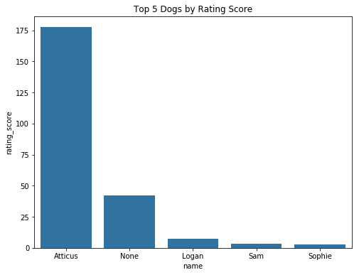

* The name “None” indicates the unknown entry

The second chart shows the distribution of WeRateDog post likes. The majority of posts had slightly more than 15K likes, whereas a few of them reached 120K likes. Additionally, the post with the most likes contained over 130K enjoys.

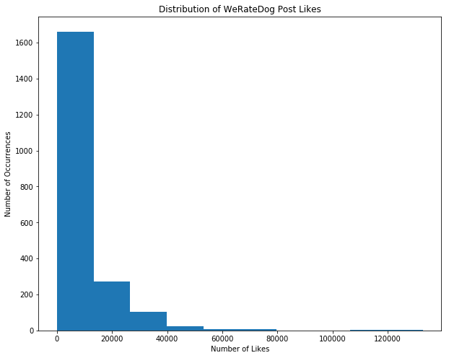

Apparently, the popularity of tweets is linked to retweets as much as likes. Over the period of 2015-2017, the average retweets counts have gradually increased. The line graph below demonstrates a 20-tweet moving average retweet number. The colossal number of post forwards occurred in 2017's first quarter.

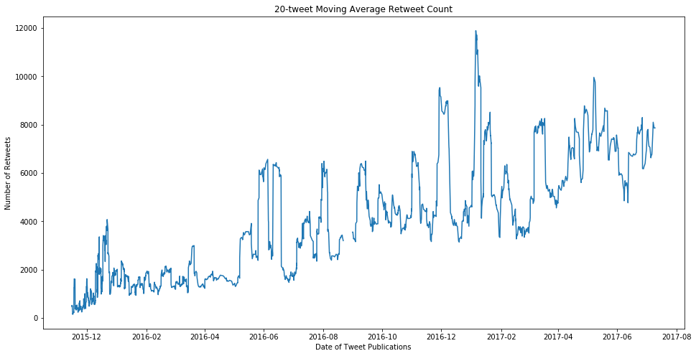

One of the captivating aspects of WeRateDogs is assigning stages to dogs. According to the pie chart below, "pupper" was the most common one making up 66,5%, followed by "doggo" with 24%, "puppo" with 7.2%, and "floof" with 2.4%.

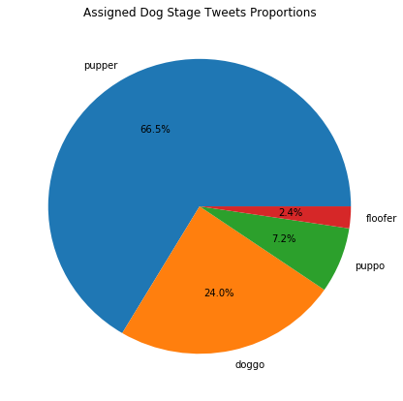

In conclusion, the research aimed to deliver the most crucial parts of "WeRateDogs" tweets. Moreover, the visuals were partially demonstrated to provide more accurate insights into findings. Thus, we can agree on the increasing popularity of this Twitter account.