POLULAR HOSPITAL
Pharmacy Module – Step-by-Step User Guide

Version 1.0 | October 2026
HPM Hospital Patient Management System

Table of Contents
1. Getting Started – Login
2. Pharmacy Masters (Setup)
3. Purchase Requisition
4. Receiving Challan (Stock Inward)
5. OPD Counter POS (Dispensing & Sales)
6. Sales Returns (Customer Refund)
7. Live Stock & Expiry Monitor
8. Inter-Store Transfer
9. Issue to Ward / Department
10. Stock Adjustment & Audit
11. Supplier Payment
12. Doctor Prescription
Appendix A. User Roles & Access
Appendix B. Common Errors & Solutions

1. Getting Started – Login
Before using any pharmacy feature you must log in with your assigned username and password.

Steps
- Open browser: Go to http://localhost:5180 (or the server address your IT gave you).
- Enter credentials: Type your Username (e.g. diagnostic) and Password. Then click Sign In.
- Open Pharmacy menu: Click the Pharmacy button in the top navigation bar. A dropdown shows three groups: Dispensary & Sales, Inventory & Stock, and Procurement & Suppliers.
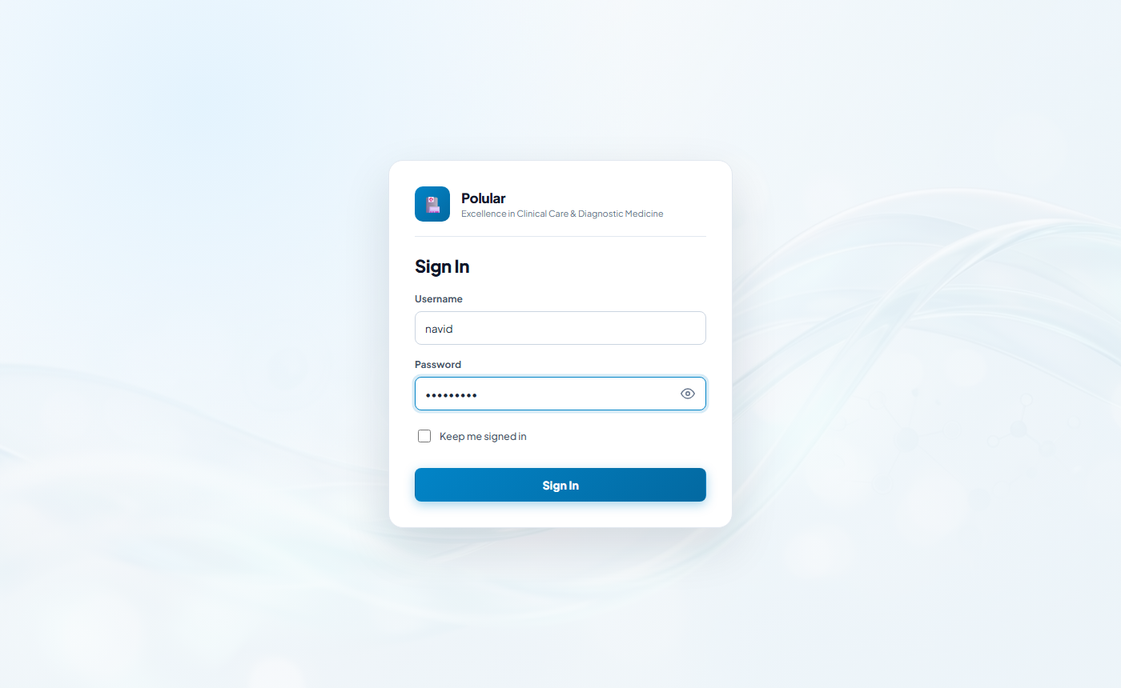
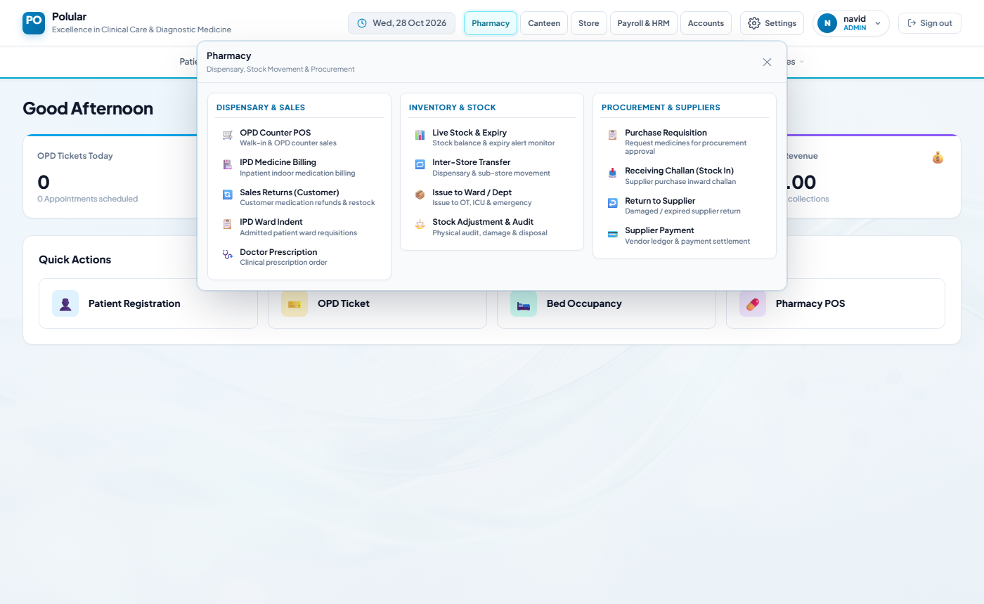
💡 Warning: If you do not see the Pharmacy menu your account may not have the Pharmacy Operator role. Ask your Administrator.

2. Pharmacy Masters (One-Time Setup)
Masters must be set up before you can receive stock or sell medicines. Navigate: Pharmacy menu → (any masters link) OR go to /pharmacy/masters.

2.1 Add a Medicine
- Go to Pharmacy Masters: Click the Medicines tab.
- Fill Medicine Name: Enter the brand name, e.g. Napa 500mg.
- Select Dosage Type: Choose Tablet, Syrup, Injection, etc.
- Enter Pack Size: Number of units per pack, e.g. 10 (strips of 10 tablets).
- Set Buy Rate & Sale Rate: Purchase cost and counter sale price per unit.
- Save: Click Save Medicine. The medicine now appears in the list below.
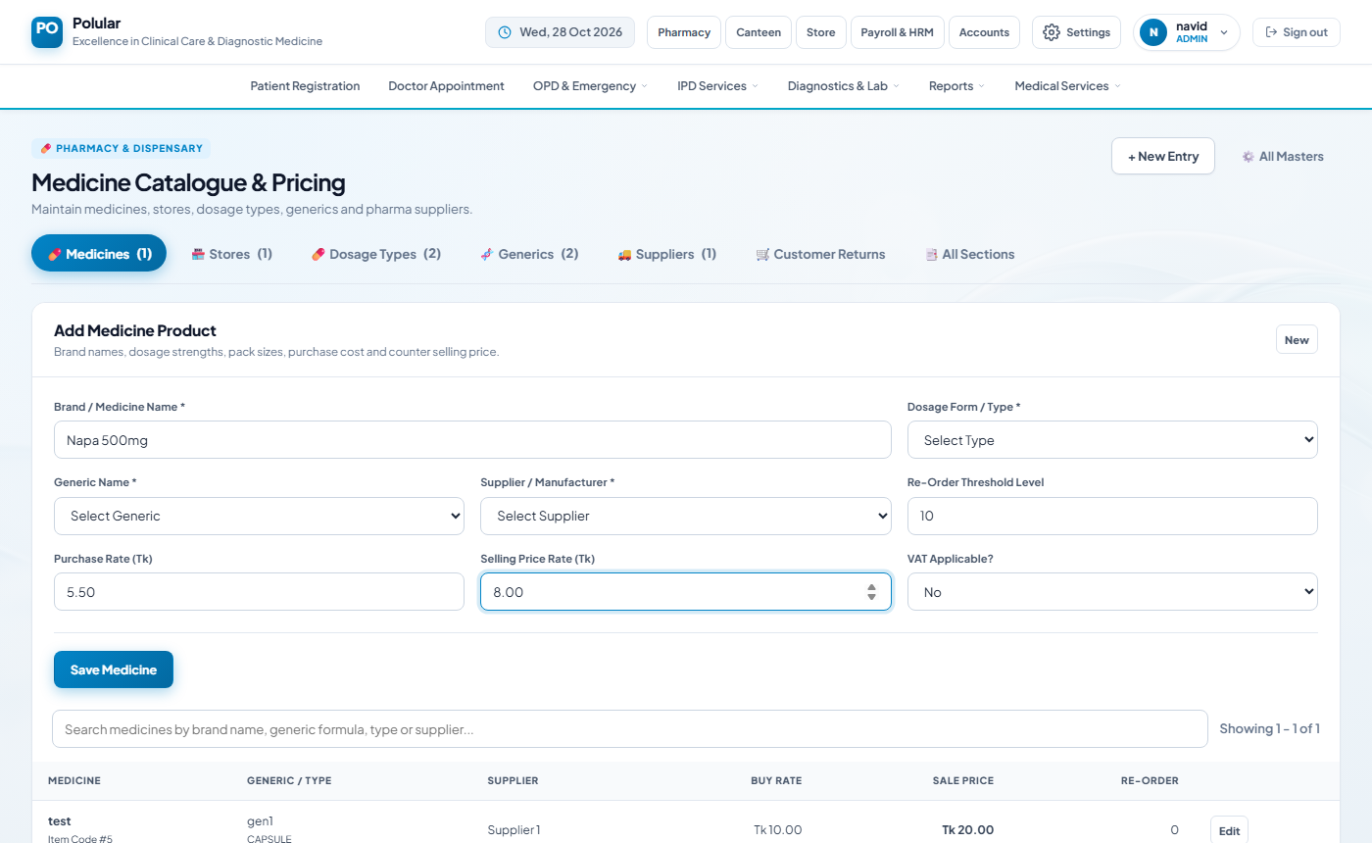

2.2 Add a Supplier
- Go to Suppliers tab: Click the Suppliers tab at the top of the page.
- Fill Supplier Name: Company name, address and contact number.
- Save: Click Save Supplier.
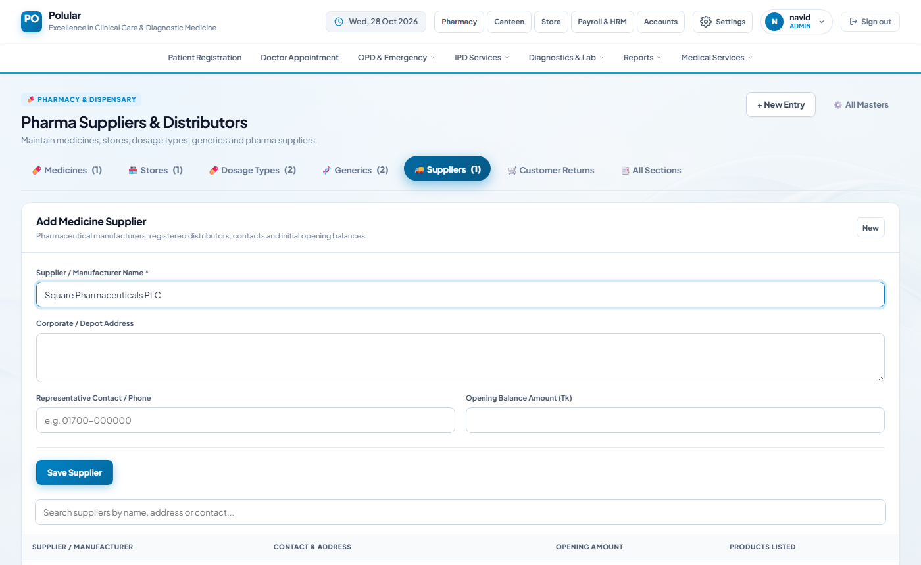

2.3 Add a Store
- Go to Stores tab: Click the Stores tab.
- Enter Store Name: E.g. 'Main Pharmacy' or 'ICU Sub-Store'.
- Mark Active: Tick the Active checkbox so it appears in drop-downs.
- Save: Click Save Store.
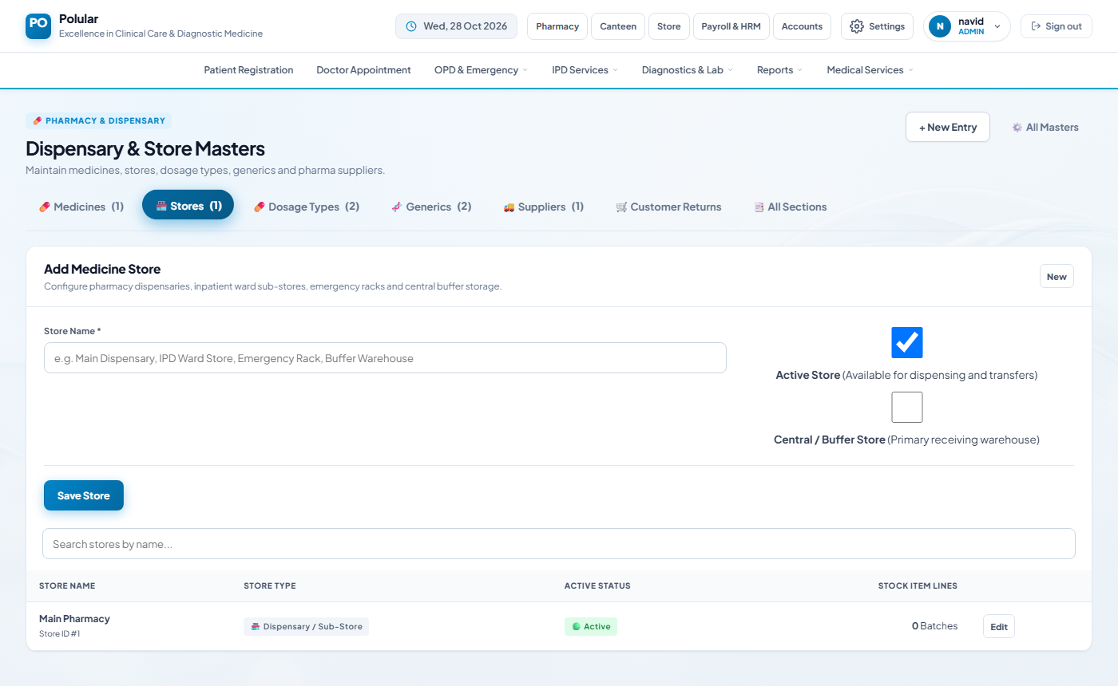

💡 Warning: You must add at least one Medicine, one Supplier, and one Store before any purchasing or selling can be done.

3. Purchase Requisition
The Pharmacy Operator creates a requisition to request medicines. The Administrator then approves or rejects it. Navigate: Pharmacy → Procurement & Suppliers → Purchase Requisition.

3.1 Pharmacy Operator – Create a Requisition
- Open page: Click Pharmacy menu → Purchase Requisition.
- Select Store: Choose which store needs the medicines (e.g. Main Pharmacy).
- Add Remarks (optional): Type a short note such as 'Monthly stock replenishment'.
- Select a Medicine: In the Medicine Items section pick a medicine from the drop-down.
- Enter Quantity: Type the number of units / packs needed.
- Enter Estimated Rate (optional): Type the expected unit price.
- Click + Add: The item appears in the table below. Repeat for more medicines.
- Submit Requisition: Click Submit Requisition. Status becomes Pending.
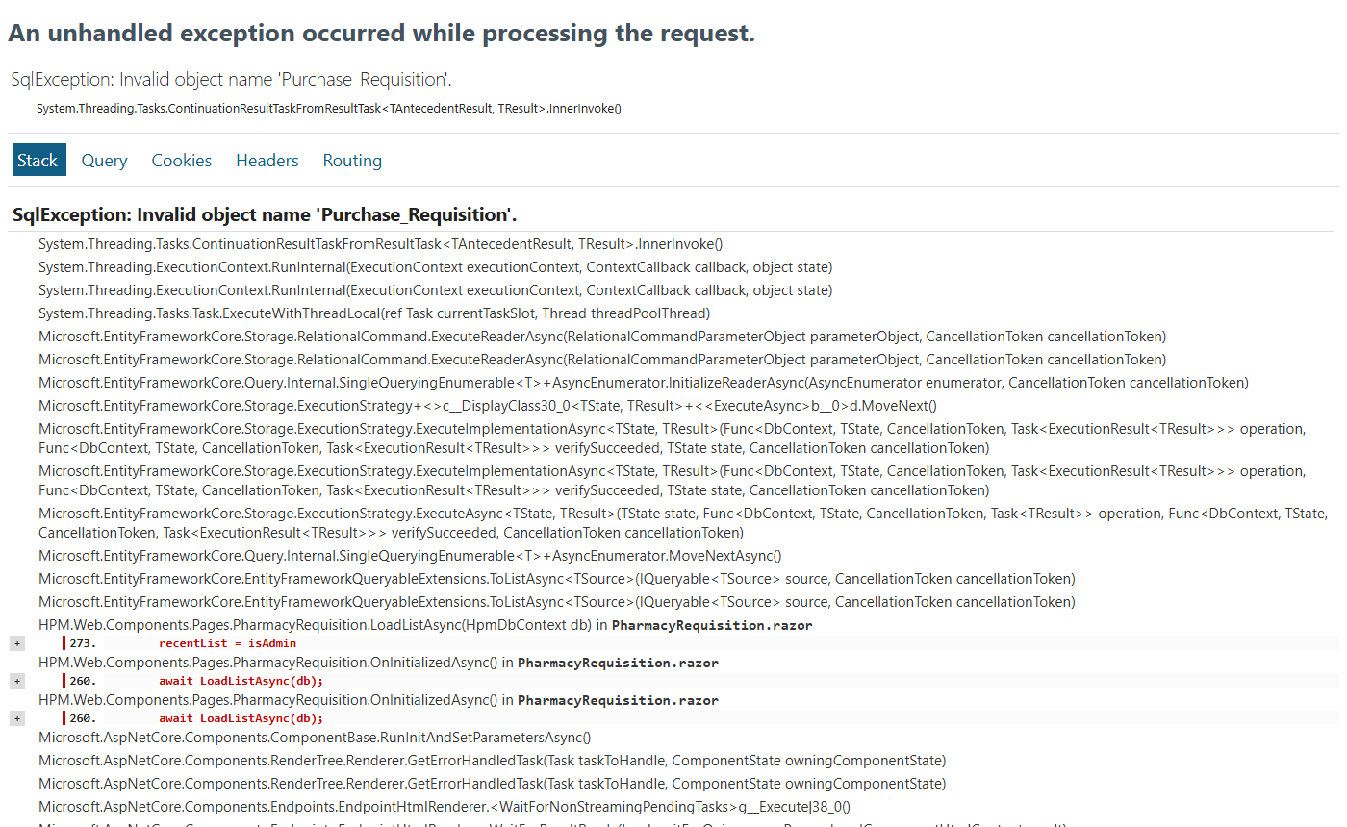

3.2 Administrator – Approve or Reject
- Log in as Administrator: Sign in with an admin account.
- Open Purchase Requisition: Pharmacy → Procurement & Suppliers → Purchase Requisition.
- Find the requisition: The list on the right shows all recent requisitions. Click View next to the Pending one.
- Review items: Check the medicine list, quantities and estimated rates.
- Add Review Note (optional): Type a comment in the Review Note field.
- Approve or Reject: Click ✓ Approve (green) or ✕ Reject (red). Status updates immediately.
💡 Note: Only Administrator can approve or reject. Pharmacy Operator can only create and view their own requisitions.

4. Receiving Challan (Stock Inward)
When medicines arrive from a supplier, record them here to update the stock balance. Navigate: Pharmacy → Procurement & Suppliers → Receiving Challan (Stock In).

- Select Supplier: Choose the supplier who delivered the medicines.
- Select Store: Choose the destination store.
- Enter Invoice No.: Type the supplier's invoice / delivery challan number.
- Enter Invoice Date: Pick the date on the supplier's invoice.
- Add medicine batch: Pick Medicine, enter Batch Number, Expiry Date, Quantity, Buy Rate, Sale Rate.
- Click + Add Item: Item is added to the challan list. Repeat for each medicine.
- Review totals: Check Discount and VAT fields if applicable.
- Post Challan: Click Post / Save. Stock balance is updated automatically.
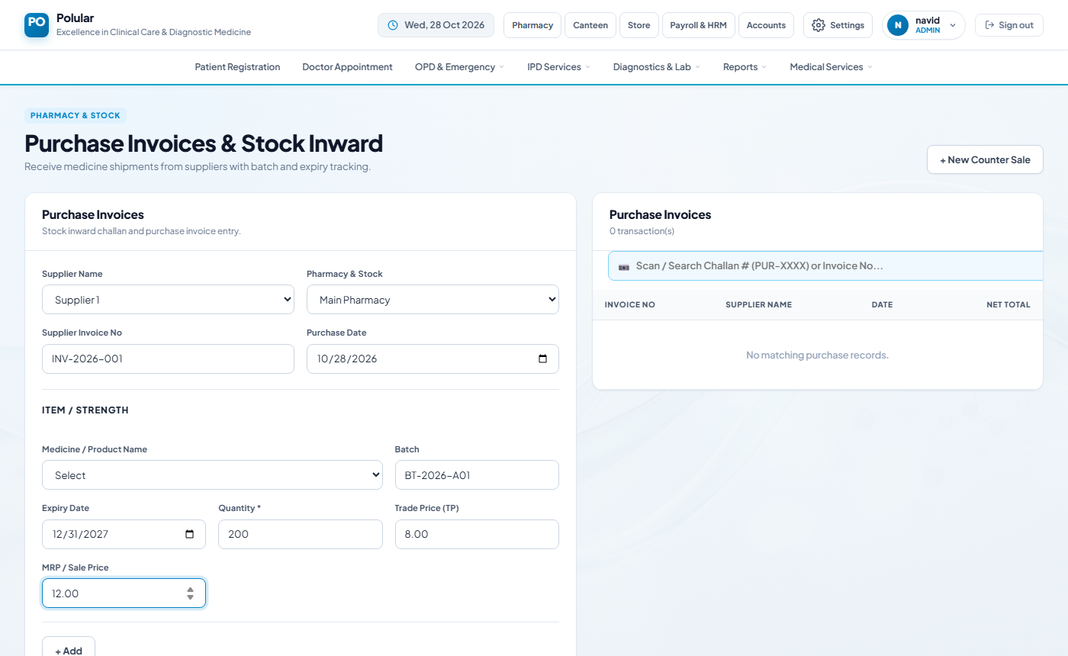
💡 Note: After posting you cannot edit the challan. Stock increases immediately in the selected store.
💡 Tip: Batch number and expiry date are required for FEFO (First Expiry First Out) dispensing.

5. OPD Counter POS – Dispensing & Sales
Sell medicines over the counter to walk-in or OPD patients. Navigate: Pharmacy → Dispensary & Sales → OPD Counter POS.

- Click + New Counter Sale: Clears any previous draft.
- Select Patient Category: OPD / Walk-in, IPD, or Emergency.
- Enter Patient Name: Type the customer or patient name.
- Enter Contact (optional): Mobile number for receipt SMS.
- Scan or Search Medicine: Scan a barcode OR type medicine name in the scan box. Matching suggestions appear.
- Select Medicine from list: Click the medicine to add it to the cart.
- Adjust Quantity: Change the Qty field in the cart row if needed.
- Add Discount (optional): Enter a discount amount or percentage.
- Review total: Check the final amount at the bottom.
- Click Confirm Sale: Payment is recorded. A printable receipt appears.
- Print Receipt: Click Print or use Ctrl+P to print the cash memo.
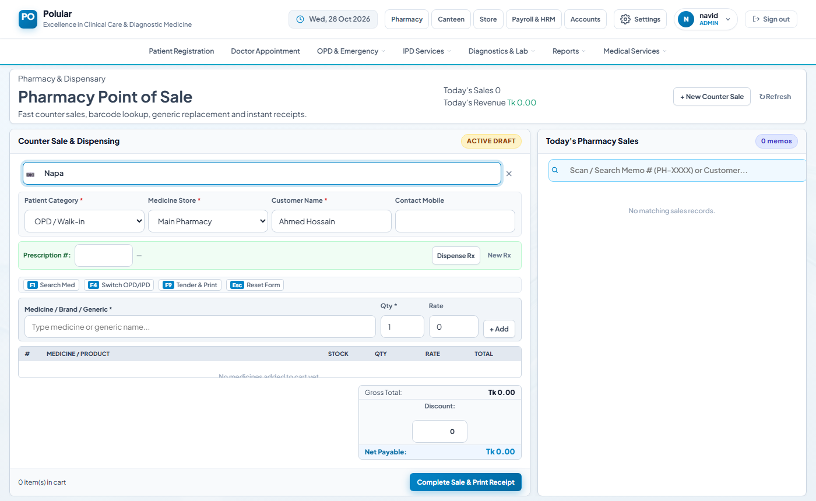
💡 Warning: If a medicine shows Out of Stock you need to receive stock first (Section 4).
💡 Tip: You can scan a prescription QR code (RX-XXXX) to auto-fill all prescribed medicines.

6. Sales Returns (Customer Refund)
Process a refund when a customer returns unused medicines. Navigate: Pharmacy → Dispensary & Sales → Sales Returns (Customer).

- Search original sale: Enter the original Cash Memo ID or patient name to find the sale.
- Select the bill: Click on the bill to load it.
- Select items to return: Tick the medicines being returned and enter the return quantity.
- Confirm Return: Click Process Return. Stock is added back; refund amount is shown.
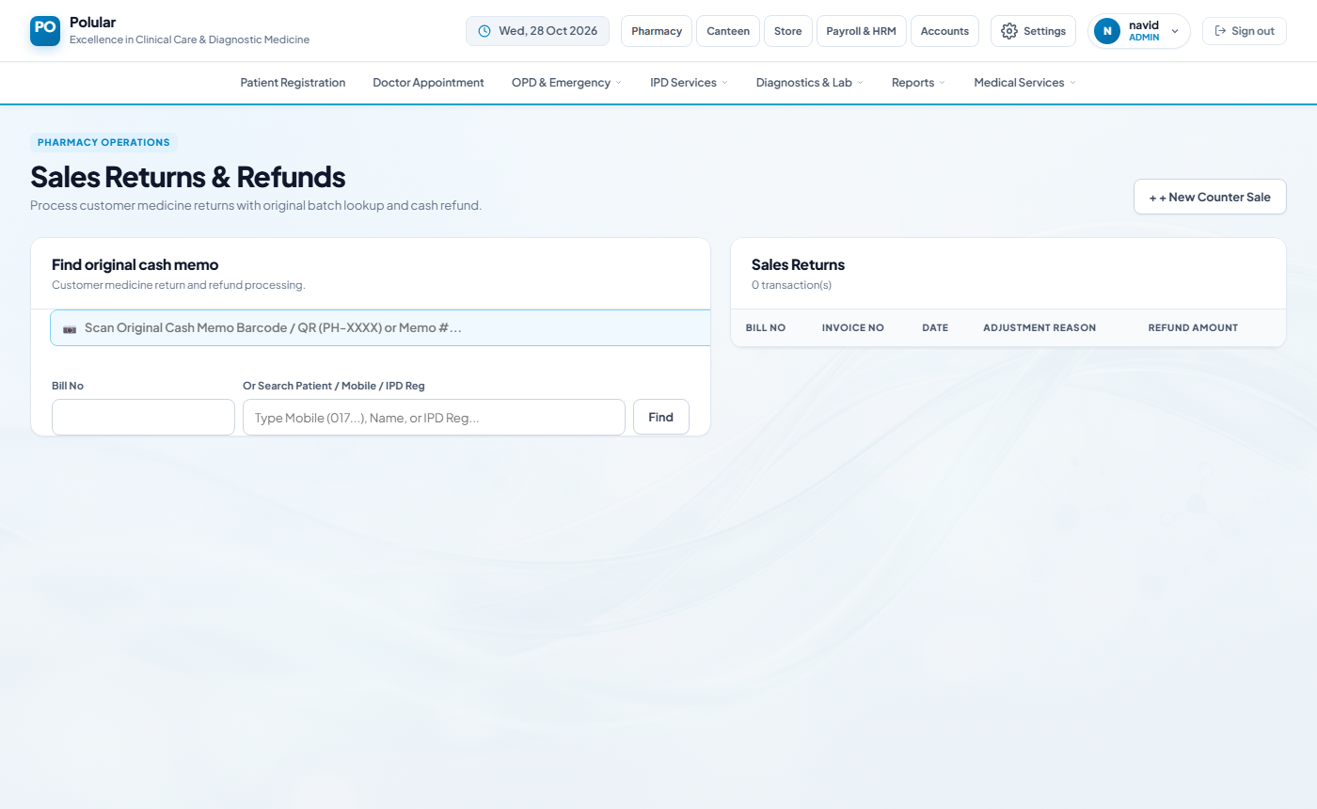
💡 Note: Returned stock goes back to the same store/batch it was sold from.

7. Live Stock & Expiry Monitor
See current stock balances across all stores and get alerts for medicines expiring soon. Navigate: Pharmacy → Inventory & Stock → Live Stock & Expiry.

- Open the page: All medicines and their current stock are listed.
- Filter by Store: Use the store drop-down to see one store at a time.
- Check Expiry column: Medicines expiring within 90 days are highlighted in orange or red.
- Export: Click Export to download the list as Excel if needed.
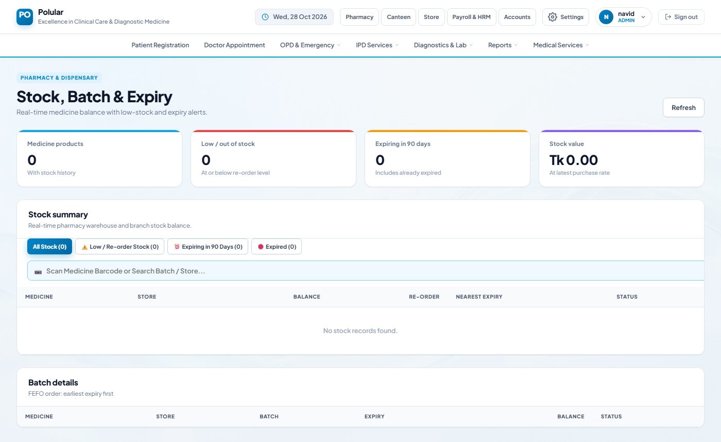
💡 Note: Review this page every week to catch near-expiry items before they cannot be sold.

8. Inter-Store Transfer
Move medicines from the main pharmacy to a sub-store (e.g. ICU, OT). Navigate: Pharmacy → Inventory & Stock → Inter-Store Transfer.

- Select Source Store: The store that will send stock (e.g. Main Pharmacy).
- Select Destination Store: The store that will receive stock (e.g. ICU Sub-Store).
- Add medicines: Pick medicine, batch and quantity to transfer.
- Post Transfer: Click Post. Stock moves instantly between the two stores.

9. Issue to Ward / Department
Dispense medicines to OT, ICU or Emergency without a cash sale. Navigate: Pharmacy → Inventory & Stock → Issue to Ward / Dept.

- Select Ward / Dept: Choose OT, ICU, Emergency, etc.
- Select Store: Choose the dispensing store.
- Add medicines: Pick medicine, batch and quantity to issue.
- Confirm Issue: Click Issue. Stock is deducted from the store.

10. Stock Adjustment & Audit
Correct stock counts after a physical audit or write off damaged / expired items. Navigate: Pharmacy → Inventory & Stock → Stock Adjustment & Audit.

- Select Store: Choose the store being audited.
- Find the medicine: Search or scroll to the medicine needing correction.
- Enter physical count: Type the actual counted quantity.
- Select Reason: Choose Damage, Expiry, Count Correction, etc.
- Save Adjustment: Click Save. Stock updates to the physical count.
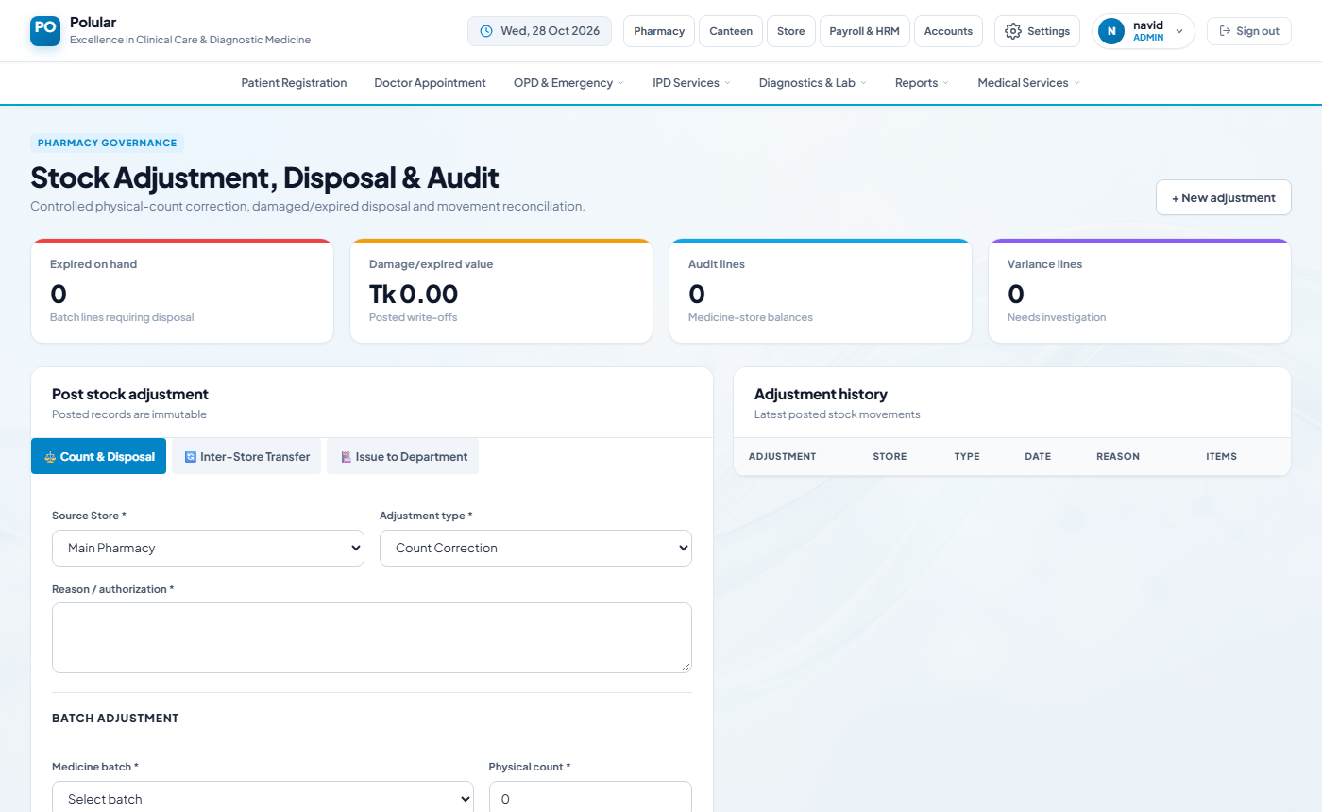
💡 Note: All adjustments are logged with user name and timestamp for audit purposes.

11. Supplier Payment
Record payments made to medicine suppliers. Navigate: Pharmacy → Procurement & Suppliers → Supplier Payment.

- Select Supplier: Choose the supplier you are paying.
- Enter Amount: Type the payment amount in Taka.
- Select Payment Mode: Cash, Bank Transfer, Cheque, etc.
- Enter Date: Pick the payment date.
- Save Payment: Click Save. The supplier ledger is updated.
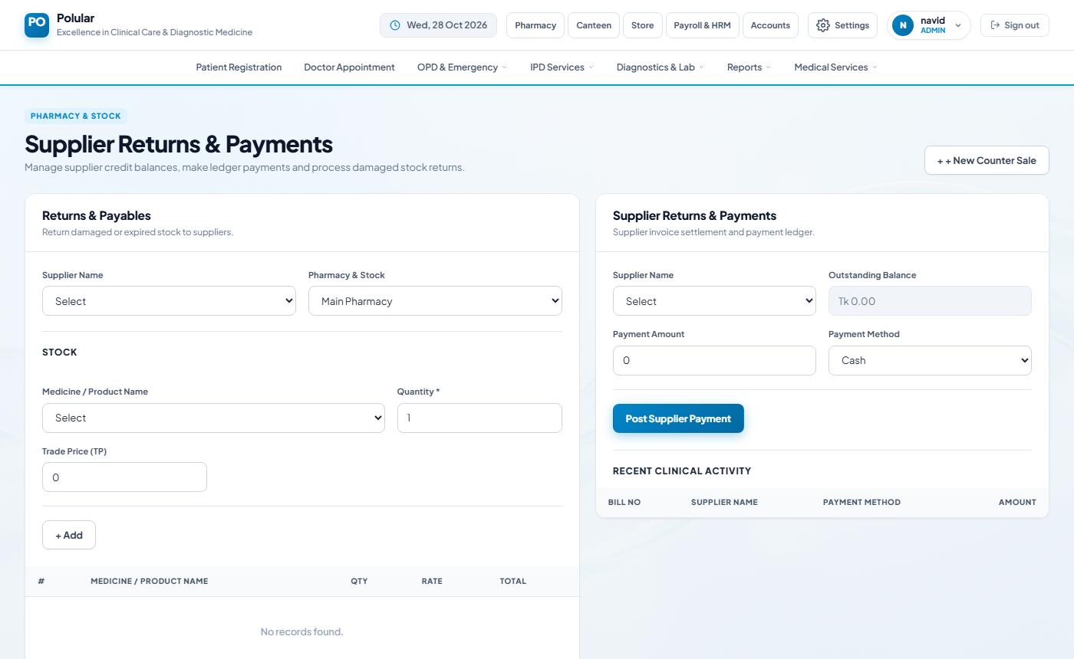

12. Doctor Prescription
A doctor creates a digital prescription. The Pharmacy Operator can scan the QR code at the POS to auto-fill the medicines. Navigate: Pharmacy → Dispensary & Sales → Doctor Prescription.

Doctor – Create Prescription
- Search patient: Enter patient registration number or name.
- Add medicines: Select each prescribed medicine, dose, frequency and duration.
- Submit Prescription: Click Submit. A QR code is generated (e.g. RX-00042).
- Print or show QR: Give the printed QR or code to the patient.

Pharmacy Operator – Dispense from Prescription
- Open POS: Pharmacy → OPD Counter POS.
- Scan QR code: Scan the prescription QR or type RX-00042 in the scan box.
- Review auto-filled cart: All medicines from the prescription appear in the cart.
- Confirm Sale: Adjust quantities if needed then click Confirm Sale.
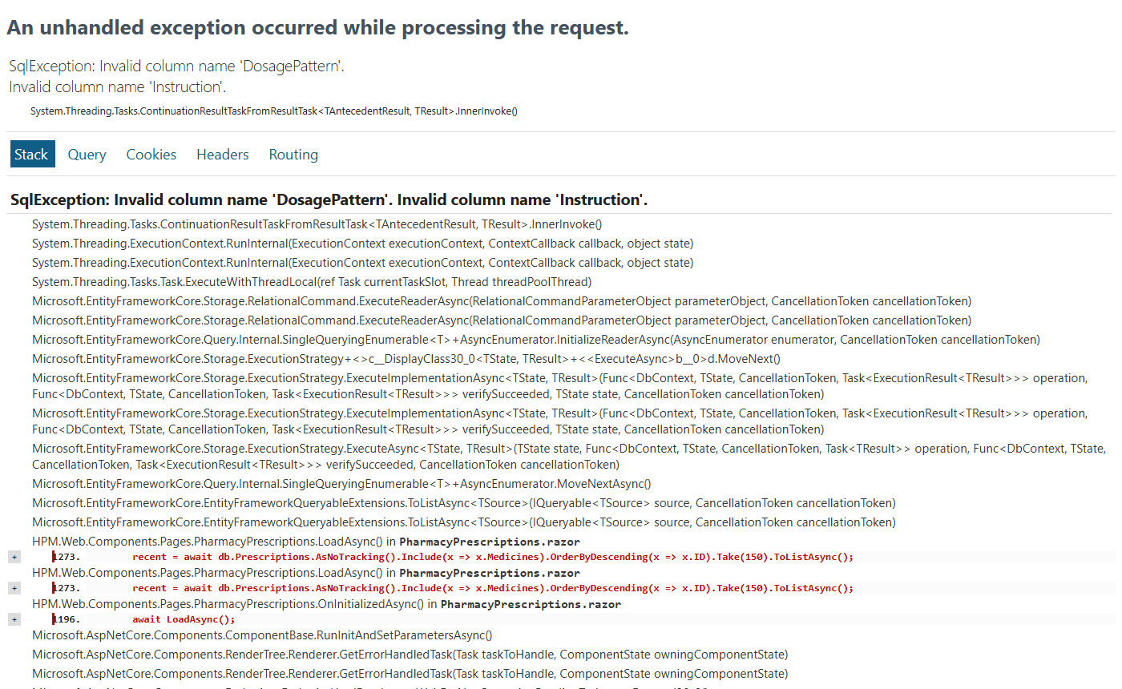

Appendix A – User Roles & Pharmacy Access
Role | What they can do in Pharmacy | Cannot do
Administrator | Everything – create, approve, reject, post, adjust | —
Pharmacy Operator | Masters, Purchase Requisition (create), Receiving Challan, POS, Stock transfers, Prescription dispensing | Approve/reject requisitions
Cashier | POS sales, Sales returns | Stock management, purchasing
Doctor | Create prescriptions, view stock | Purchasing, stock changes

Appendix B – Common Errors & Solutions
Error / Problem | Cause | Solution
Medicine not in drop-down | Not added in Masters | Add the medicine in Pharmacy Masters (Section 2)
Out of stock at POS | Stock not received or fully sold | Do a Receiving Challan (Section 4)
Cannot post challan – no supplier | Supplier not in Masters | Add supplier in Pharmacy Masters (Section 2)
Purchase Requisition – Approve button not visible | Logged in as Pharmacy Operator not Administrator | Log in with an Administrator account
Medicines near expiry still showing in POS | System uses FEFO – check batch | Do a Stock Adjustment to write off expired batch (Section 10)
'Select a store' validation error | No active store set up | Add and activate a store in Masters (Section 2.3)

