POLULAR HOSPITAL
Pharmacy Module — Complete Walkthrough Guide
With Live Screenshots | 29 October 2026

Step 1 — Login
Open your browser and go to the hospital system URL. Enter your username and password.
- Open browser: Navigate to http://localhost:5180
- Enter credentials: Type your Username and Password then click Sign In.
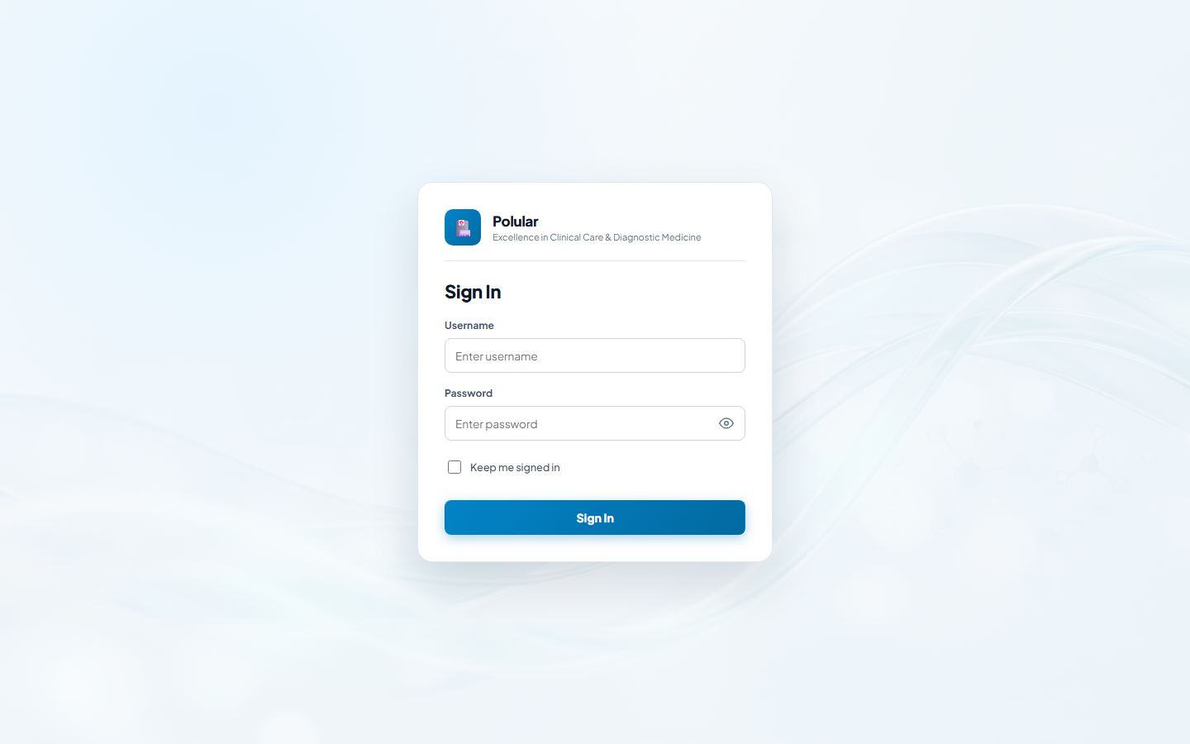
Login screen

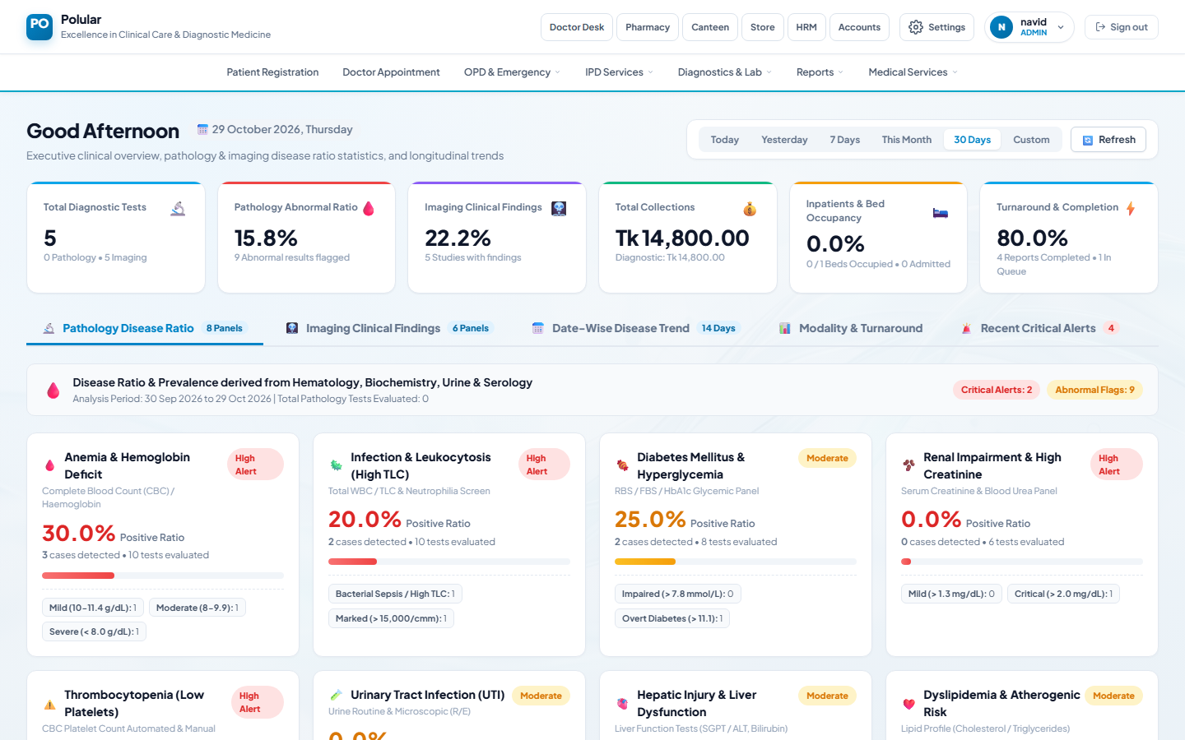
Dashboard after login

Step 2 — Open the Pharmacy Menu
The Pharmacy menu is in the top navigation bar. Click it to see all pharmacy modules grouped by function.
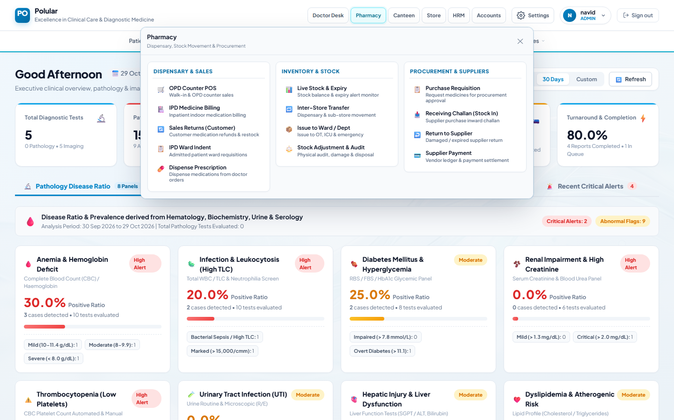
Pharmacy menu — three groups: Dispensary & Sales, Inventory & Stock, Procurement & Suppliers

Step 3 — Pharmacy Masters (One-Time Setup)
Before any stock or sales can be done, set up the master data: medicines, suppliers and stores.

3A Add a Medicine
- Go to Masters: Pharmacy → any masters link, or navigate to /pharmacy/masters
- Click Medicines tab: Shows the medicine list and add form.
- Fill Medicine Name: e.g. Napa 500mg
- Select Dosage Type: Tablet, Syrup, Injection, etc.
- Enter Buy Rate & Sale Rate: Purchase cost and counter selling price per unit.
- Click Save: Medicine is added and appears in the list.
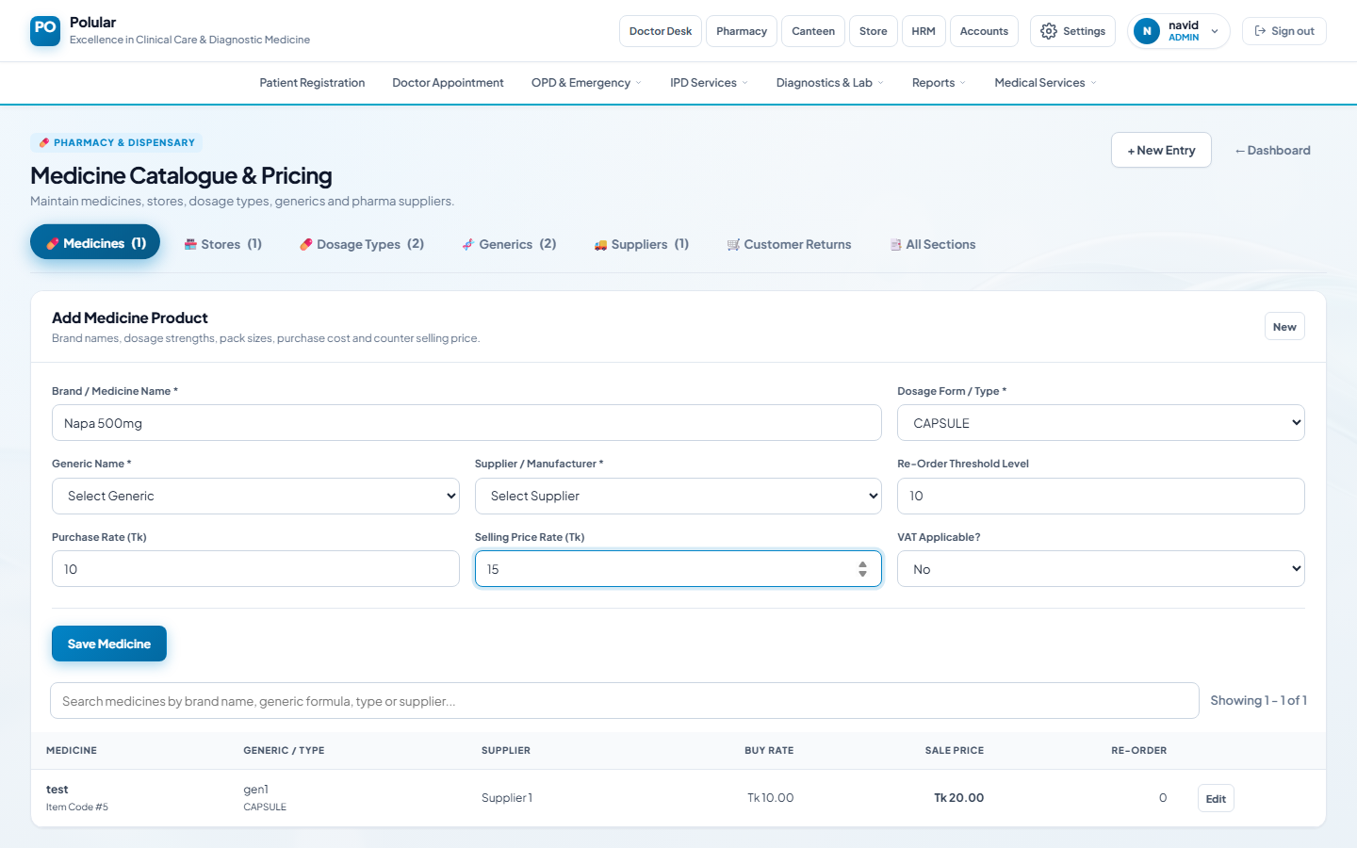
Medicine add form — filled in
Medicine saved — appears in list below

3B Add a Supplier
- Click Suppliers tab: Switch to the Suppliers section.
- Enter Name, Address, Contact: Fill supplier details.
- Save: Click Save Supplier.
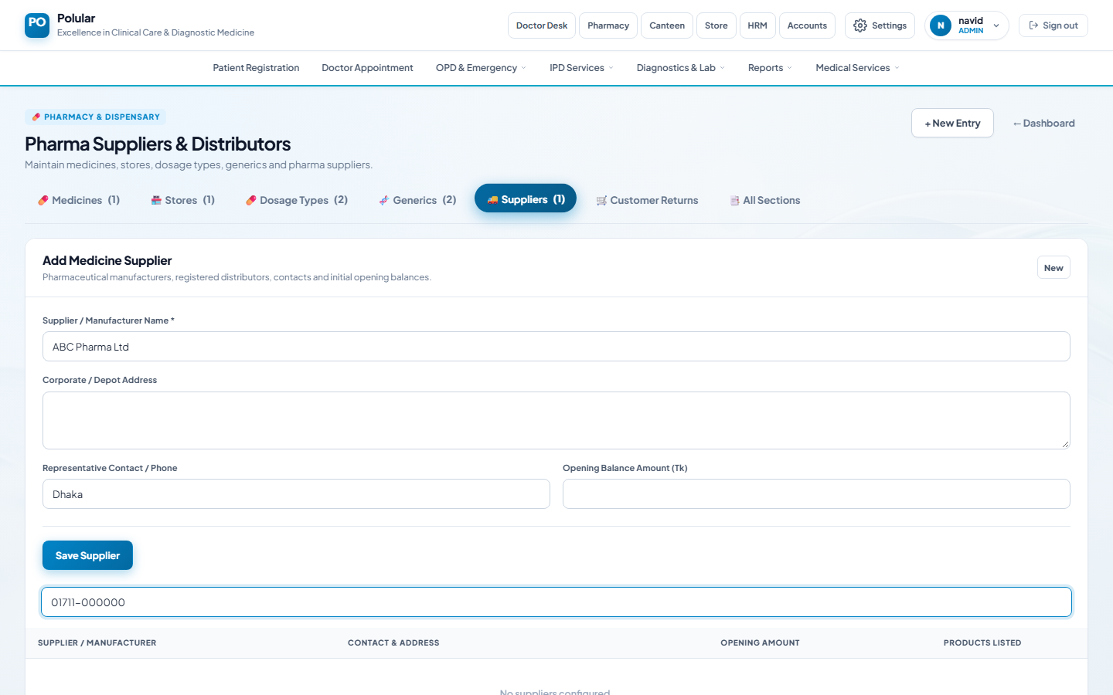
Supplier form filled
Supplier saved

3C Add a Store
- Click Stores tab: Switch to Stores section.
- Enter Store Name: e.g. Main Pharmacy
- Tick Active: Makes it available in all dropdowns.
- Save: Click Save Store.
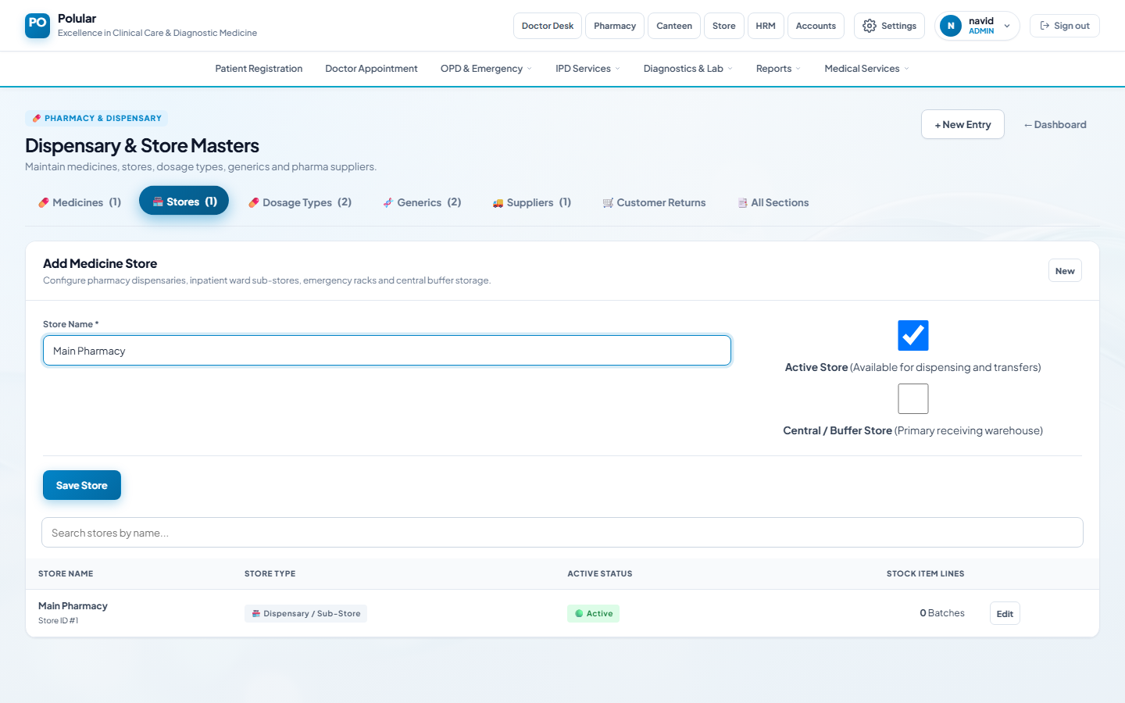
Store form filled
Store saved and active
💡 Note: You must complete Steps 3A, 3B and 3C before any purchasing or selling.

Step 4 — Purchase Requisition
The Pharmacy Operator requests medicines from the Administrator before purchasing.
- Open: Pharmacy → Procurement & Suppliers → Purchase Requisition
- Select Store: Choose which store needs the medicines.
- Select Medicine: Pick from the dropdown.
- Enter Quantity & Est. Rate: How many units needed and expected price.
- Click + Add: Item added to the list. Repeat for more medicines.
- Submit Requisition: Click Submit. Status becomes Pending.
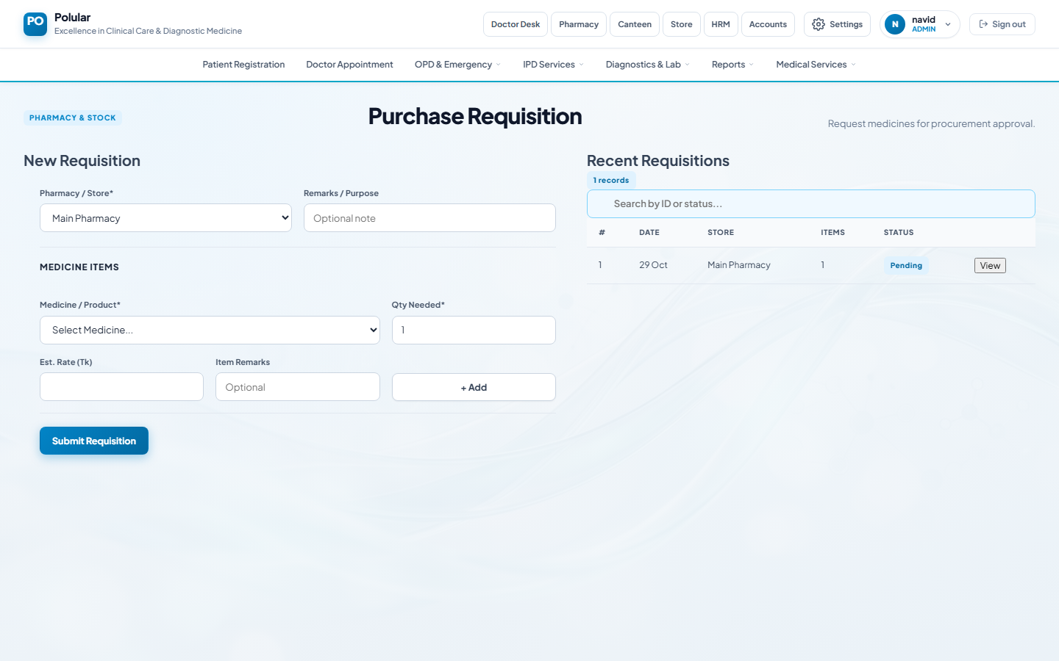
Purchase Requisition — empty form
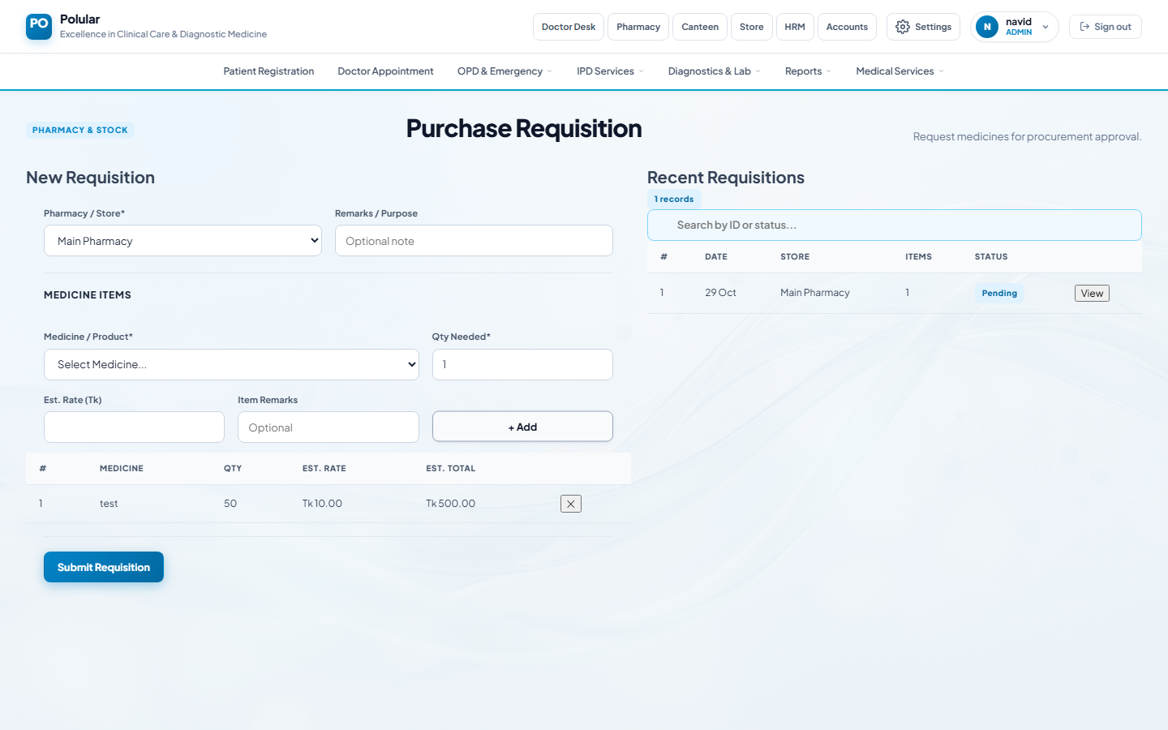
Medicine item added to requisition
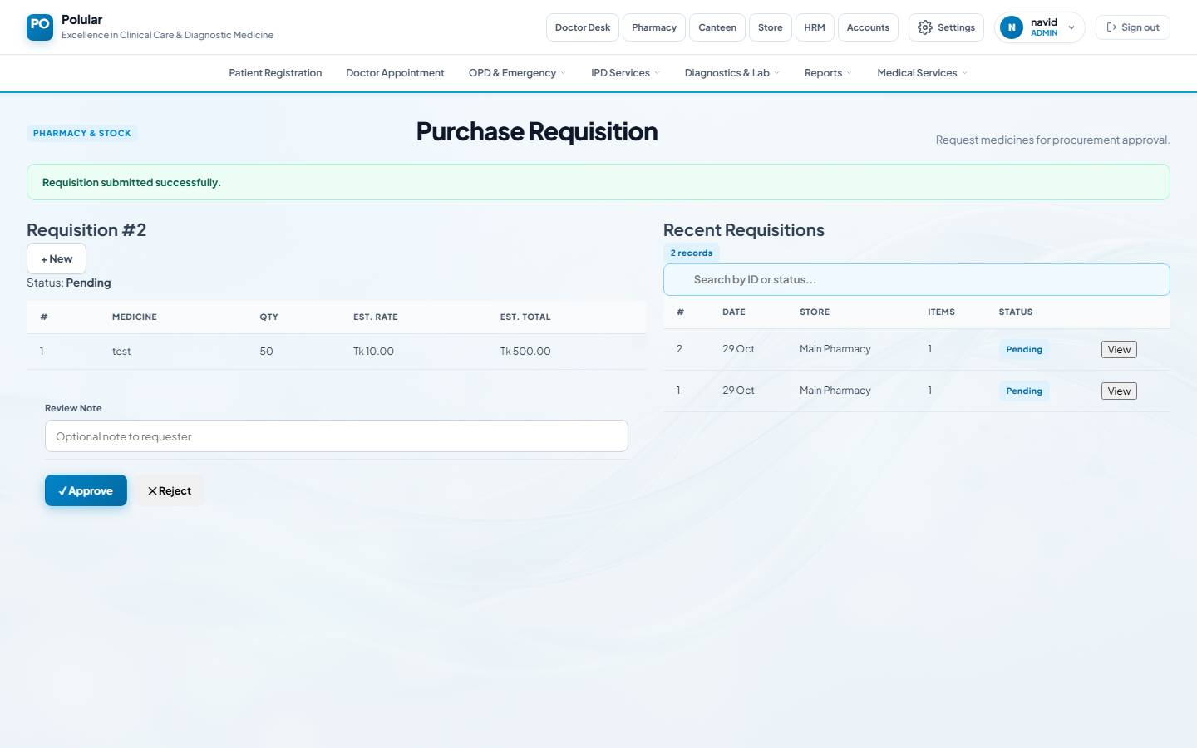
Requisition submitted — Status: Pending

Step 5 — Approve the Requisition (Administrator)
The Administrator reviews and approves or rejects the requisition.
- Log in as Administrator: Use an admin account.
- Open Purchase Requisition: Same page — Pharmacy → Purchase Requisition.
- Click View: Click View next to a Pending requisition in the list.
- Review items: Check medicines, quantities and rates.
- Approve or Reject: Click ✓ Approve or ✕ Reject. Status updates immediately.
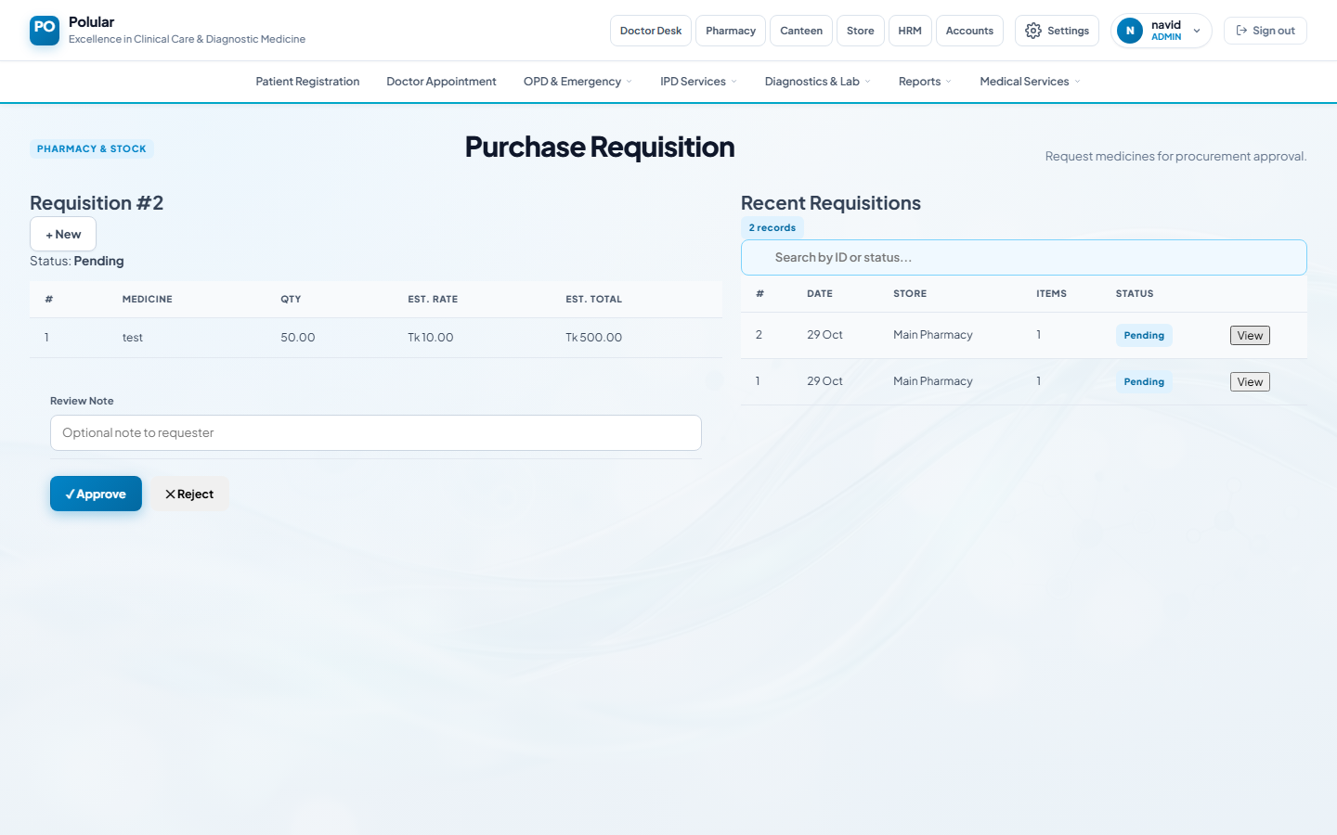
Admin view — Approve and Reject buttons visible
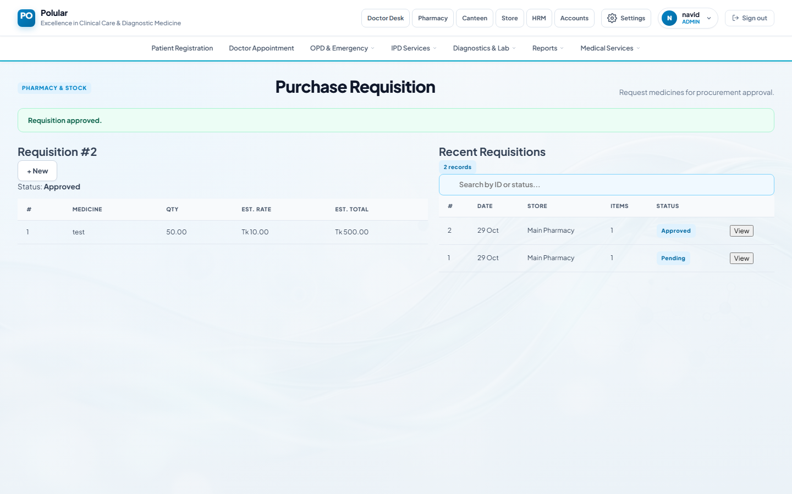
Requisition approved — Status: Approved

Step 6 — Receiving Challan (Stock Inward)
When medicines arrive from the supplier, record them to update stock balance.
- Open: Pharmacy → Procurement & Suppliers → Receiving Challan (Stock In)
- Select Supplier & Store: Choose who supplied the medicines and which store receives them.
- Enter Invoice No. & Date: From the supplier's delivery note.
- Add medicine item: Pick medicine, enter batch number, expiry date, quantity, buy rate and sale rate.
- Click + Add Item: Item added to challan. Repeat for each medicine.
- Post Challan: Click Post. Stock is updated immediately.
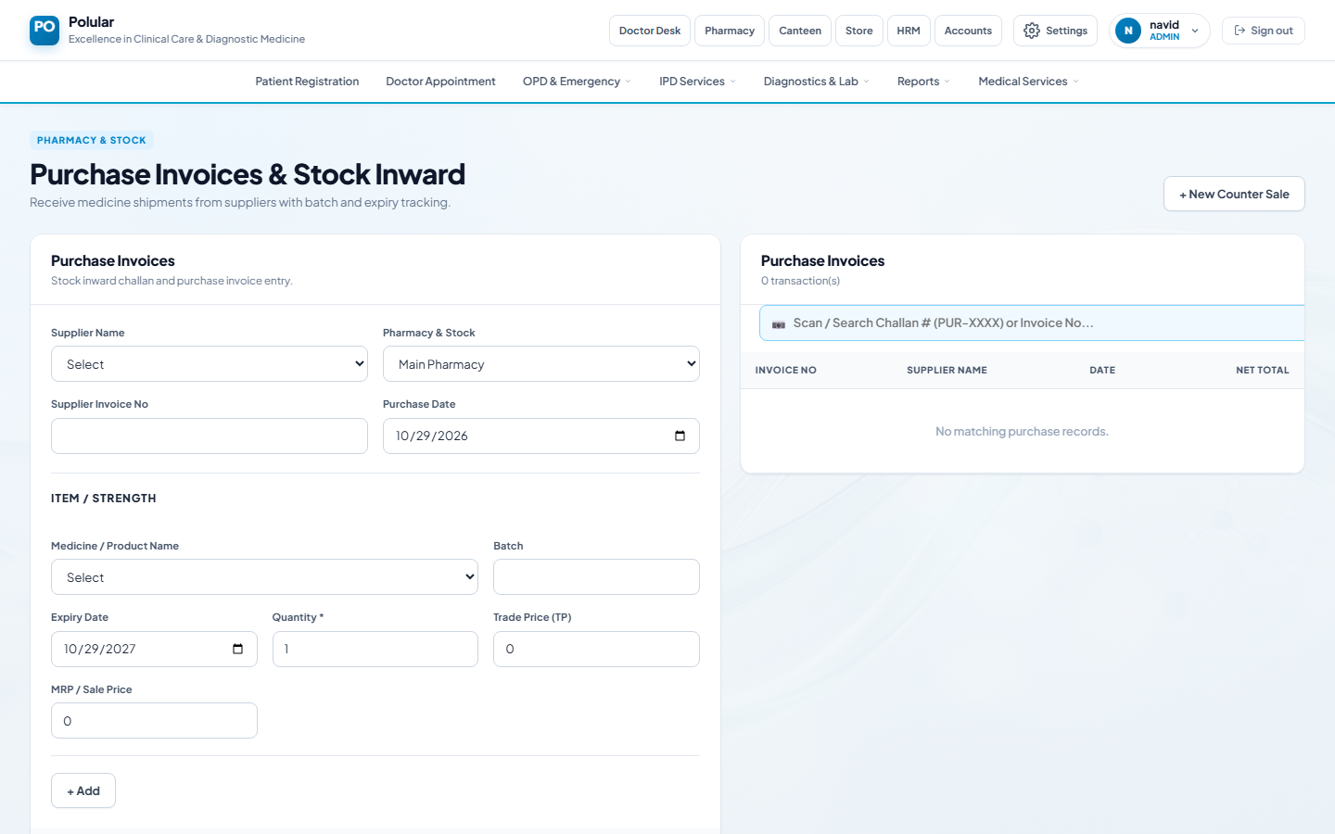
Receiving Challan — empty
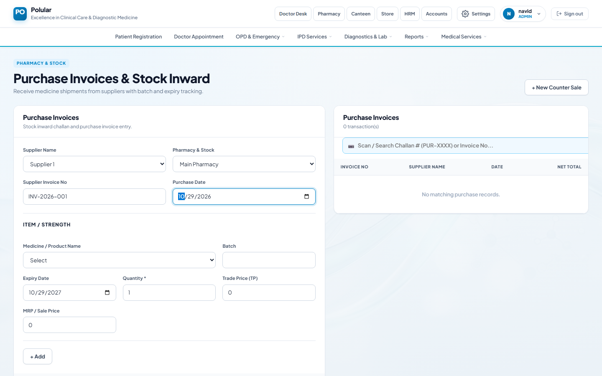
Header filled — supplier, store, invoice details
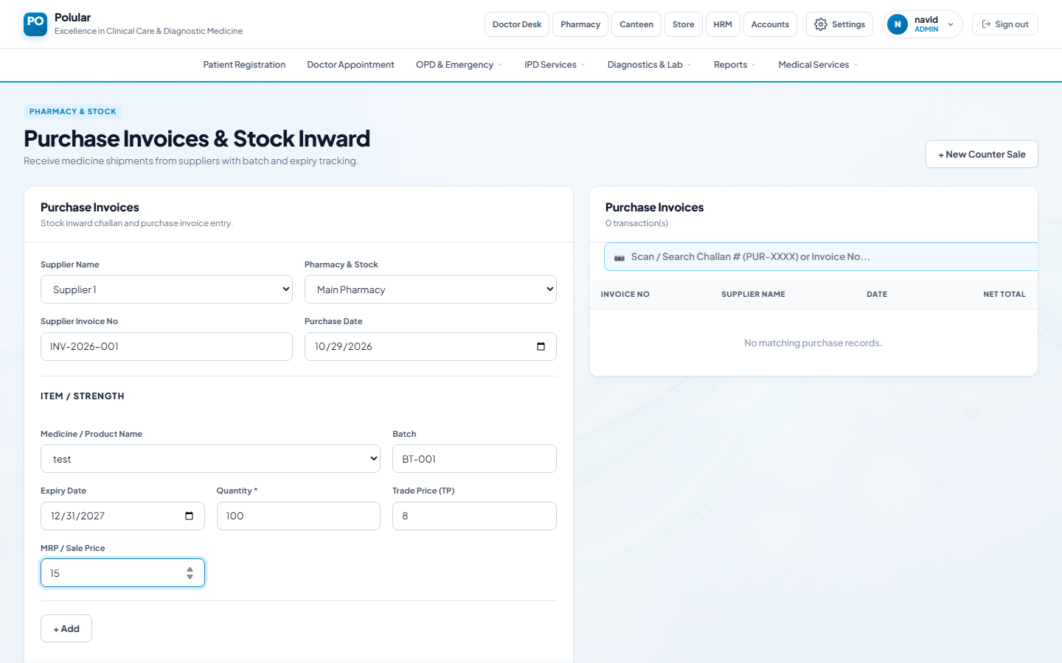
Medicine item details filled in
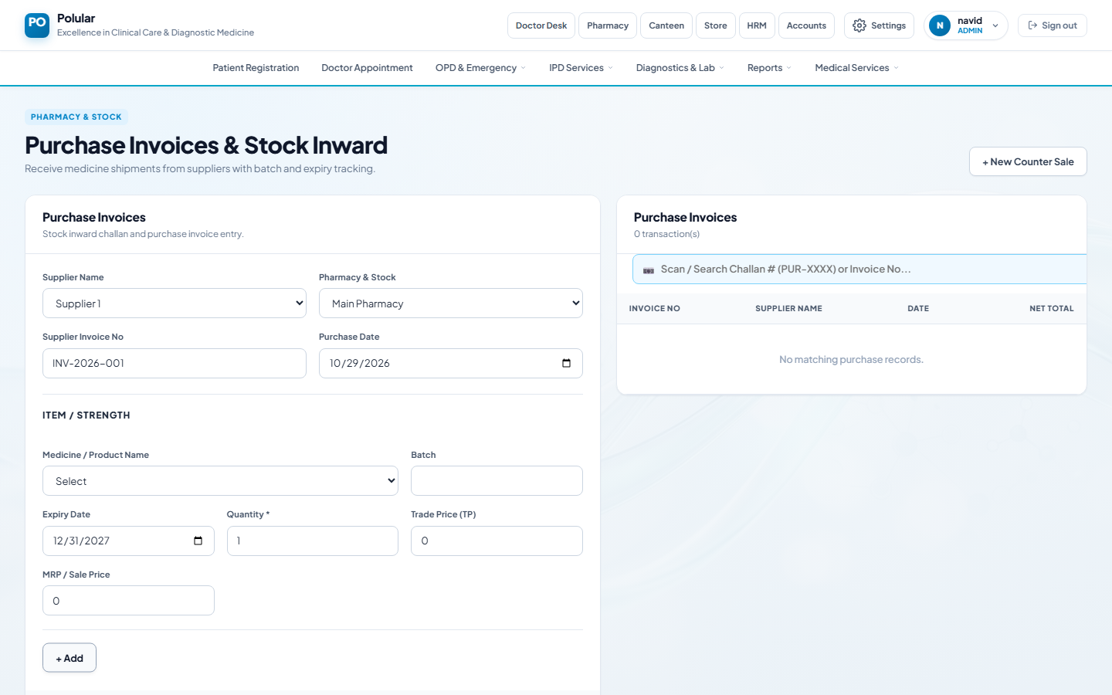
Item added to challan list
Challan posted — stock updated
💡 Note: After posting you cannot edit the challan. Stock increases immediately.

Step 7 — Live Stock & Expiry Monitor
Check current stock levels across all stores and see medicines expiring soon.
- Open: Pharmacy → Inventory & Stock → Live Stock & Expiry
- Filter by store: Use the store dropdown to view one store at a time.
- Check Expiry column: Near-expiry items are highlighted in orange/red.
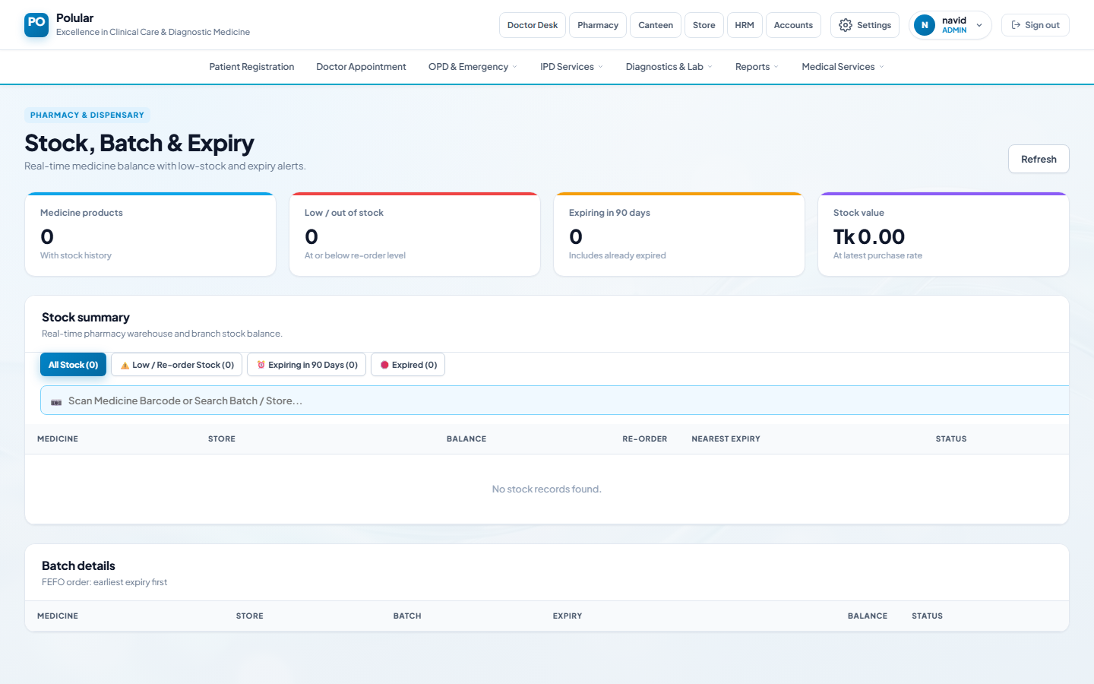
Live Stock — current balances with expiry alerts

Step 8 — OPD Counter POS (Sell Medicines)
Sell medicines over the counter to walk-in or OPD patients.
- Open: Pharmacy → Dispensary & Sales → OPD Counter POS
- Select Store: Choose the dispensing store (e.g. Main Pharmacy).
- Enter Customer Name: Type the patient or customer name.
- Search Medicine: Type medicine name — matching medicines appear as suggestions.
- Select medicine & set Qty: Click the suggestion, adjust quantity if needed.
- Click + Add: Medicine added to cart with stock and total shown.
- Complete Sale & Print Receipt: Click the button. Receipt is generated.
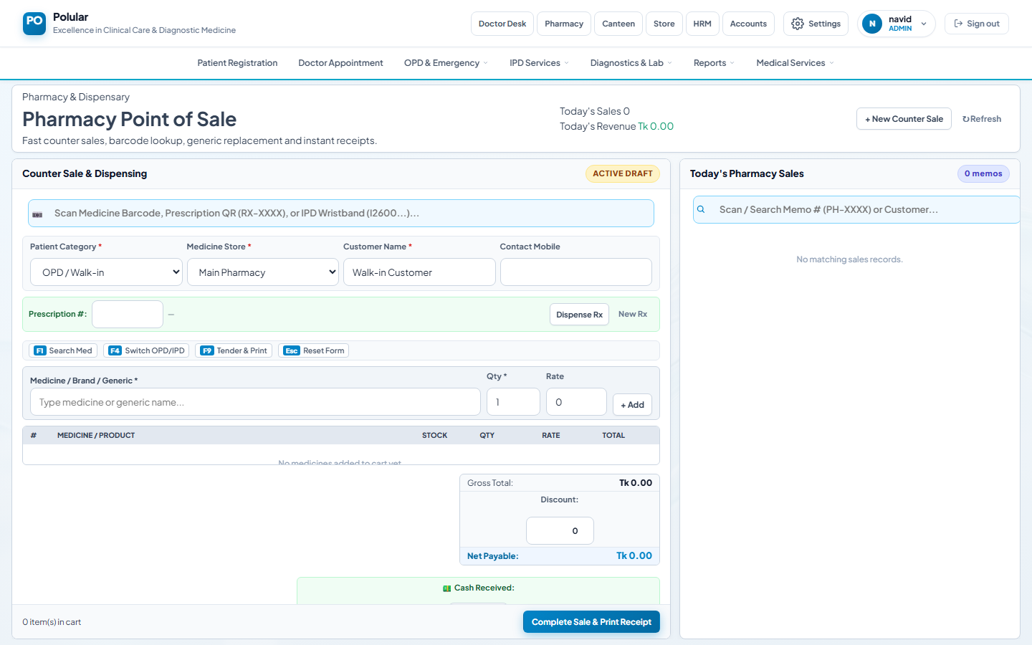
POS — empty, ready for new sale
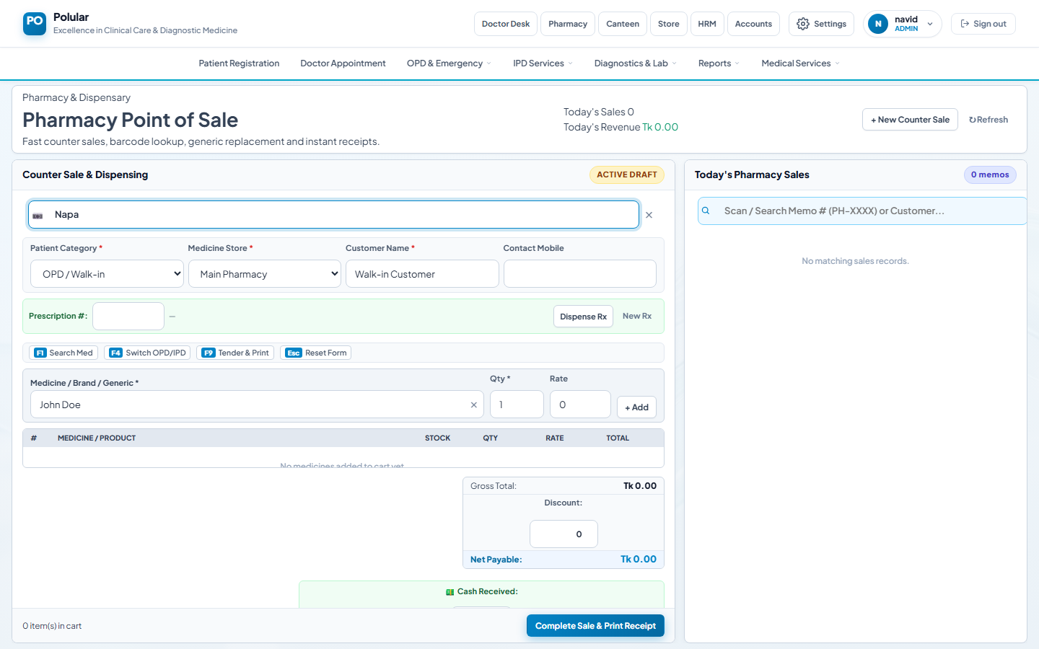
POS — medicine search with suggestions
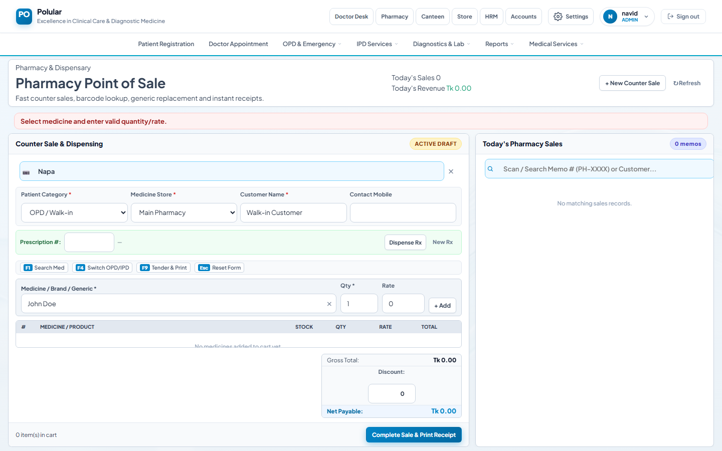
POS — medicine in cart with total
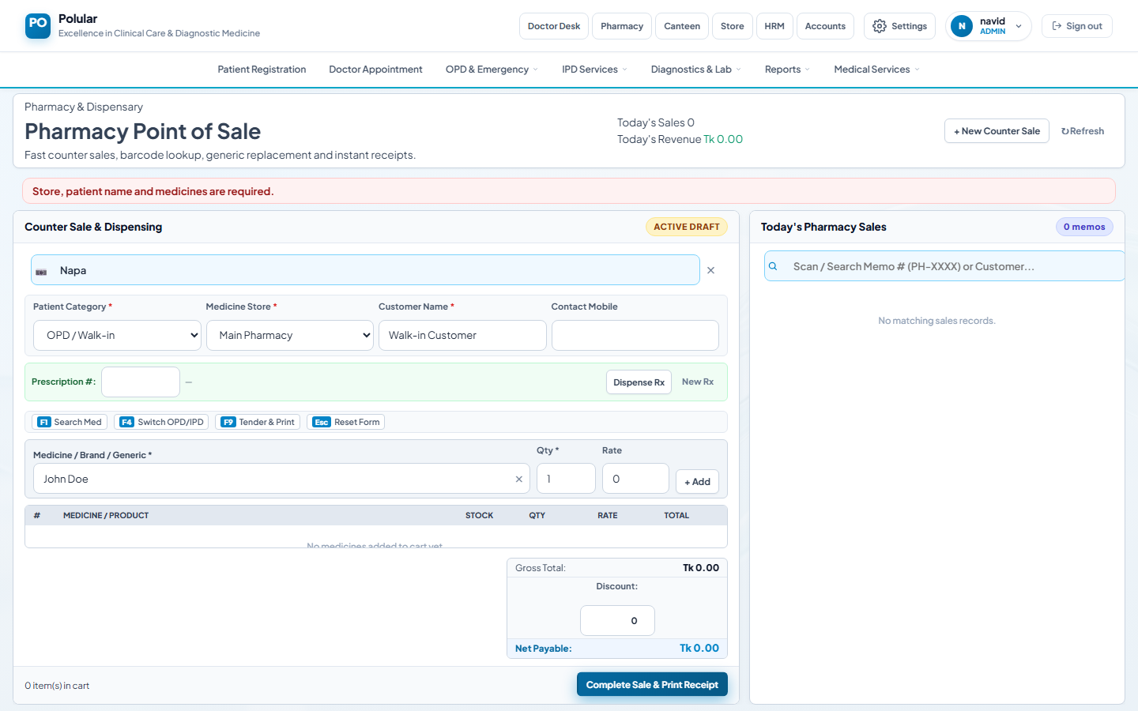
POS — sale completed, receipt ready to print
💡 Note: Medicines only appear in POS if stock has been received via Receiving Challan first.

Step 9 — Sales Returns (Customer Refund)
Process a refund when a customer returns unused medicines.
- Open: Pharmacy → Dispensary & Sales → Sales Returns (Customer)
- Search original bill: Enter Cash Memo ID or patient name.
- Select items to return: Tick medicines being returned and enter return qty.
- Process Return: Click Process Return. Stock restored, refund amount shown.
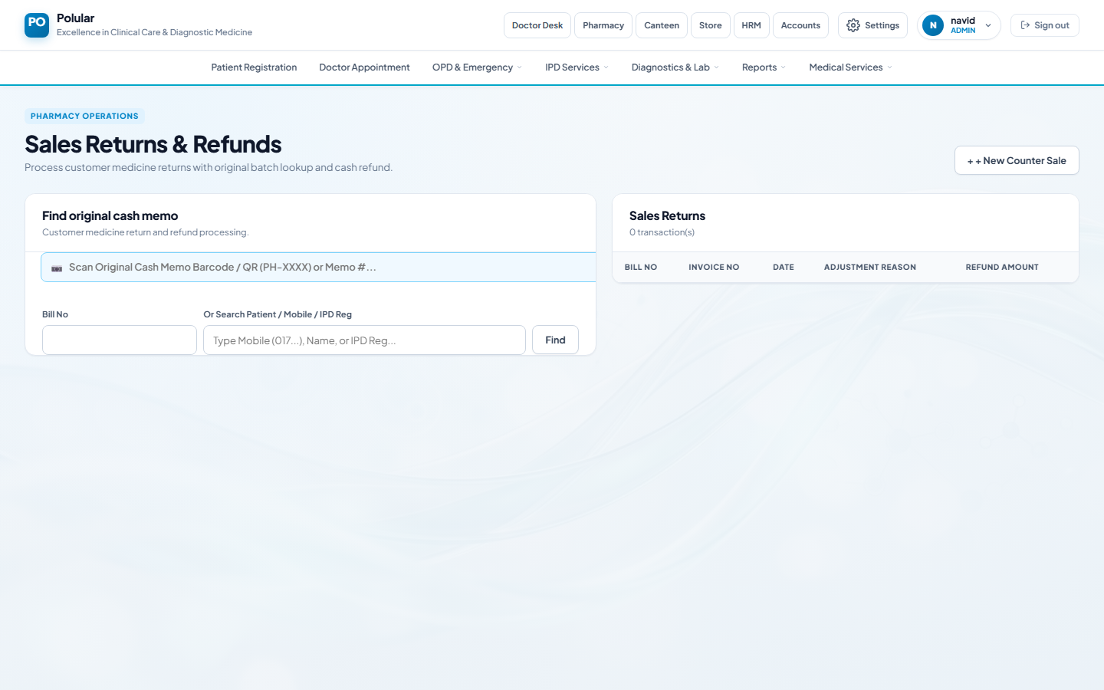
Sales Returns page

Step 10 — Stock Control (Inter-Store Transfer & Issue)
Transfer medicines between stores or issue to wards/departments.
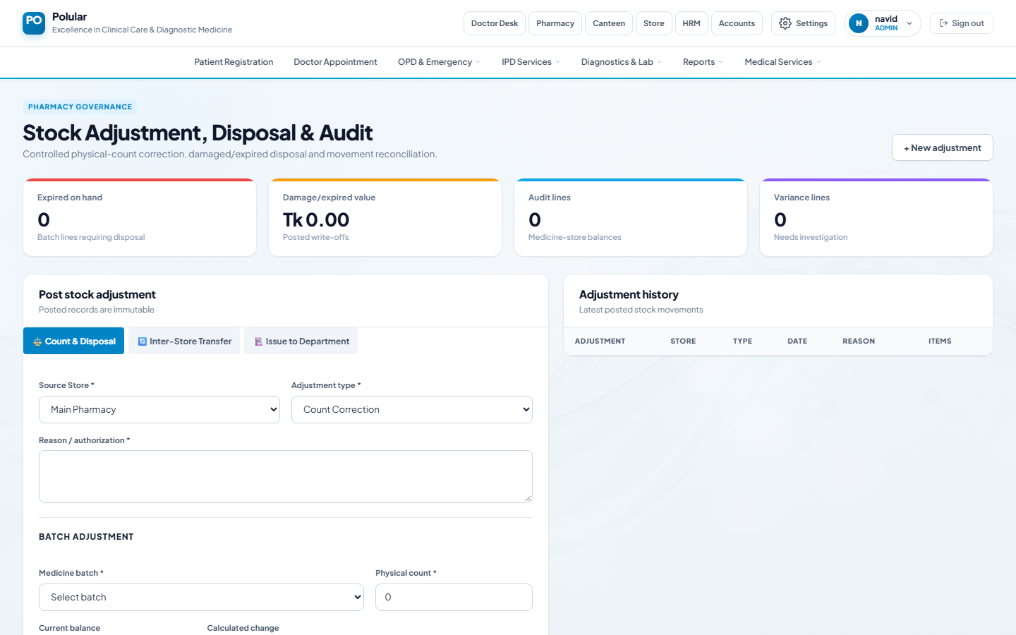
Stock Control — transfer and issue options

Step 11 — Stock Adjustment & Audit
Correct stock counts after a physical audit or write off damaged/expired items.
- Open: Pharmacy → Inventory & Stock → Stock Adjustment & Audit
- Select store & medicine: Find the medicine needing correction.
- Enter physical count: Type the actual quantity after counting.
- Select reason: Damage, Expiry, Count Correction, etc.
- Save: Stock updated. All adjustments logged with timestamp.

Stock Adjustment — physical count entry

Step 12 — Supplier Payment
Record payments made to medicine suppliers.
- Open: Pharmacy → Procurement & Suppliers → Supplier Payment
- Select Supplier: Choose the supplier being paid.
- Enter Amount & Payment Mode: Cash, Bank Transfer, Cheque, etc.
- Save: Supplier ledger updated.
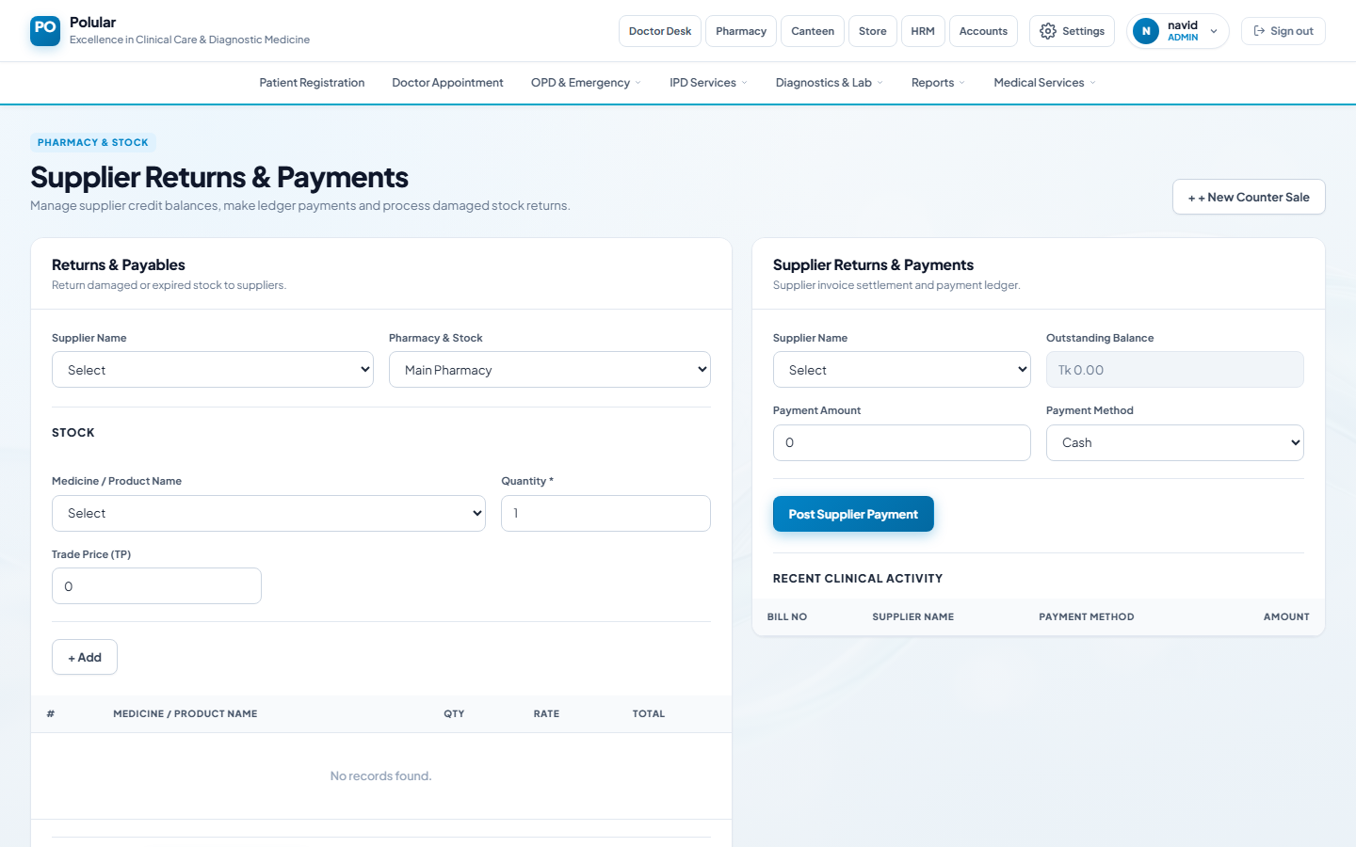
Supplier Payment form

Step 13 — Doctor Prescription
Doctors create digital prescriptions. Pharmacy Operators scan the QR to auto-fill the POS cart.
- Doctor creates Rx: Pharmacy → Doctor Prescription → search patient → add medicines → Submit.
- QR code generated: System generates QR code e.g. RX-00001.
- Operator scans at POS: Scan the QR at POS → all medicines auto-fill the cart.
- Complete sale: Adjust quantities if needed then click Complete Sale.
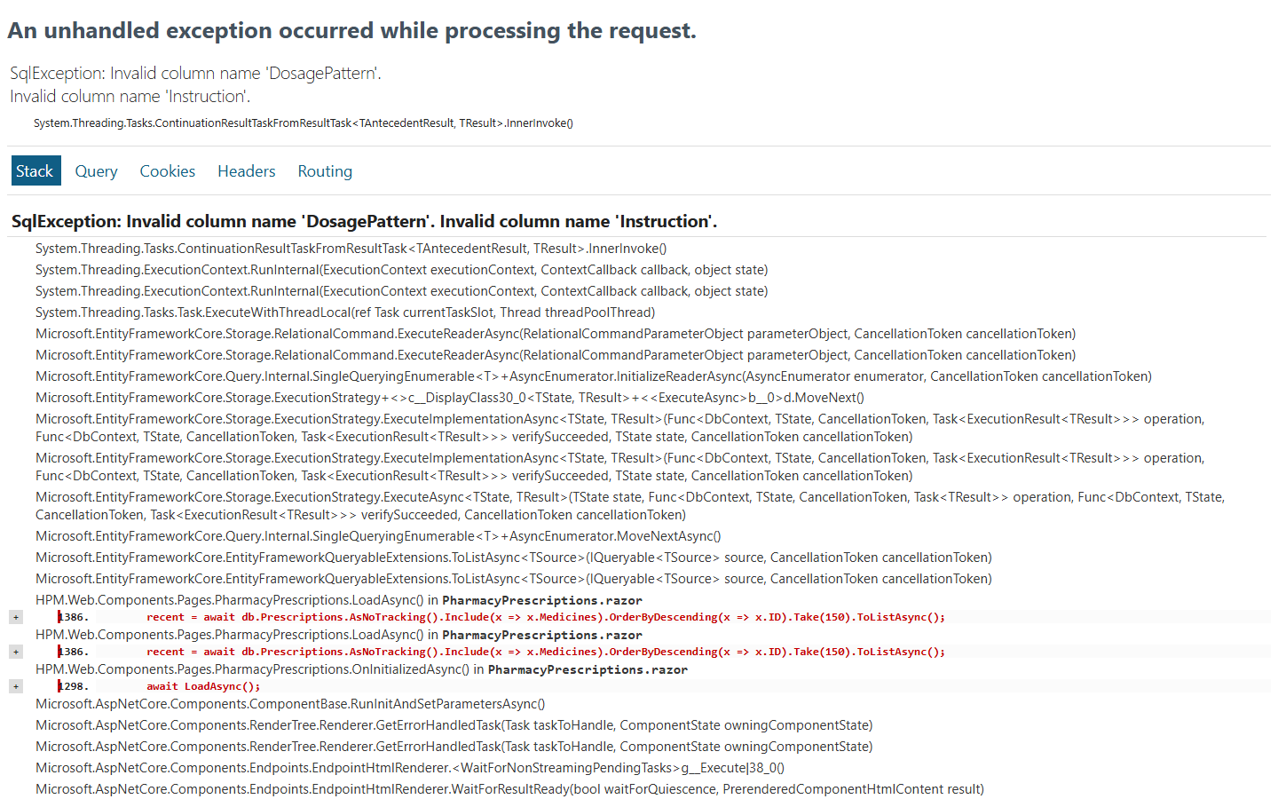
Doctor Prescriptions page

Step 14 — IPD Medicine Billing
Bill medicines dispensed to admitted (IPD) patients.
IPD Medicine Billing page

