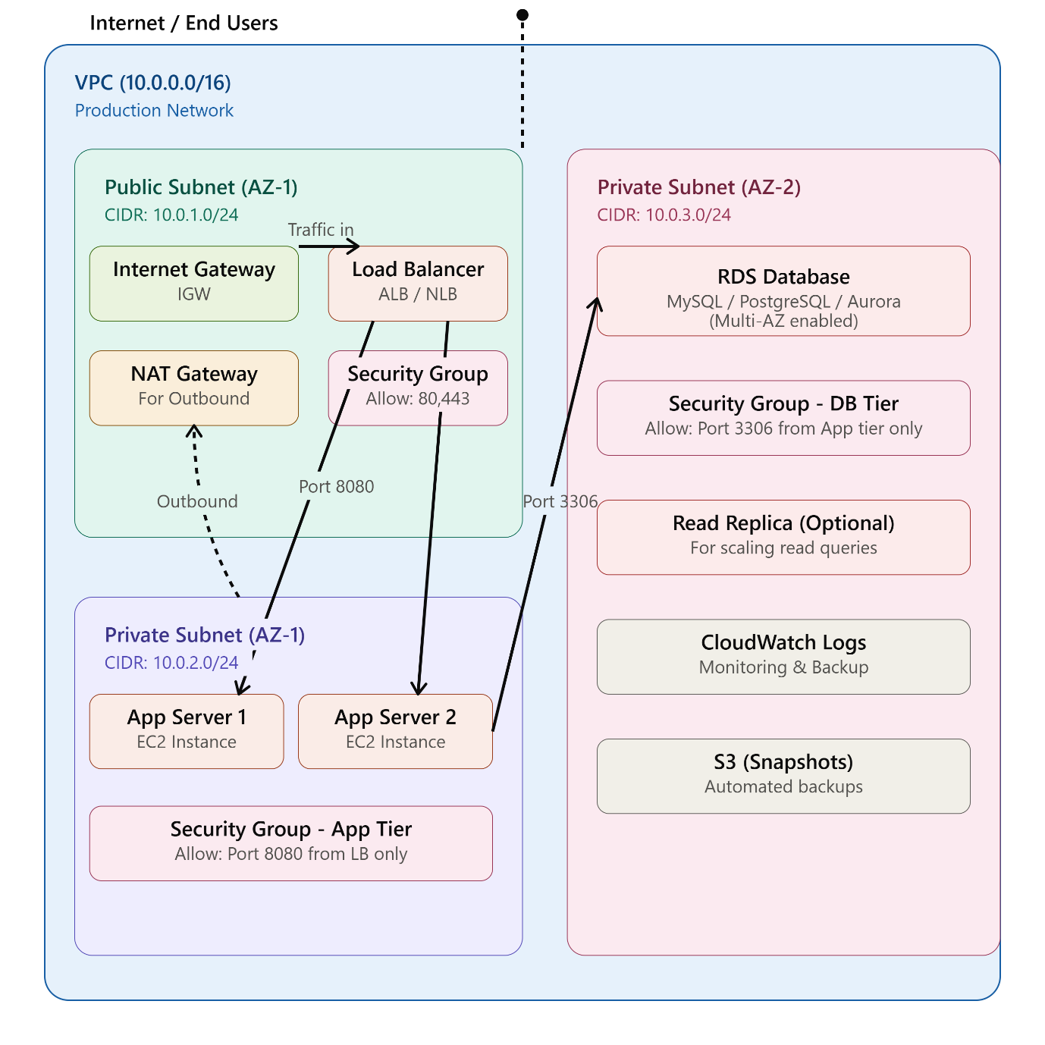

STEP-BY-STEP IMPLEMENTATION GUIDE
STEP 1: Create the VPC
AWS Console > VPC > Create VPC

VPC name: production-vpc
IPv4 CIDR block: 10.0.0.0/16
IPv6 CIDR block: (Leave blank)
Tenancy: Default
DNS hostnames: Enable
DNS resolution: Enable

Click: Create VPC

STEP 2: Create Internet Gateway (IGW)
AWS Console > VPC > Internet Gateways > Create Internet Gateway

Name: production-igw

Click: Create Internet Gateway

Then: Attach to VPC
- Select: production-vpc
- Click: Attach Internet Gateway
Purpose: Allows internet traffic to enter and exit the VPC

STEP 3: Create Public Subnet
AWS Console > VPC > Subnets > Create Subnet

VPC ID: production-vpc
Subnet name: public-subnet-az1
Availability Zone: us-east-1a (choose your AZ)
IPv4 CIDR block: 10.0.1.0/24
Enable auto-assign public IPv4 address: YES ✓

Click: Create Subnet

STEP 4: Create Private Subnets (App & Database)
For Application Tier:
VPC ID: production-vpc
Subnet name: private-app-subnet-az1
Availability Zone: us-east-1a
IPv4 CIDR block: 10.0.2.0/24
Enable auto-assign public IPv4 address: NO

Click: Create Subnet
For Database Tier:
VPC ID: production-vpc
Subnet name: private-db-subnet-az2
Availability Zone: us-east-1b (Different AZ for Multi-AZ)
IPv4 CIDR block: 10.0.3.0/24
Enable auto-assign public IPv4 address: NO

Click: Create Subnet

STEP 5: Create Route Tables
PUBLIC Route Table:
AWS Console > VPC > Route Tables > Create Route Table

Name: public-rt
VPC: production-vpc

Edit Routes:
Destination: 0.0.0.0/0
Target: Internet Gateway (production-igw)

Edit Subnet Associations:
- Add: public-subnet-az1
PRIVATE Route Table (for App Servers):
Name: private-app-rt
VPC: production-vpc

Edit Routes:
Destination: 0.0.0.0/0
Target: NAT Gateway (we'll create this next)

Edit Subnet Associations:
- Add: private-app-subnet-az1
PRIVATE Route Table (for Database):
Name: private-db-rt
VPC: production-vpc

(NO ROUTES - DB doesn't need outbound internet)

Edit Subnet Associations:
- Add: private-db-subnet-az2

STEP 6: Create NAT Gateway (For Outbound Traffic from Private Subnet)
AWS Console > EC2 > Elastic IPs > Allocate Elastic IP Address

Allocate this first, then:

AWS Console > VPC > NAT Gateways > Create NAT Gateway

Name: nat-gateway-az1
Subnet: public-subnet-az1 ⚠️ NAT goes in PUBLIC subnet
Elastic IP allocation ID: (select the one you just created)

Click: Create NAT Gateway

Wait for it to show "Available" status
Then update the private-app-rt route to point to this NAT Gateway

STEP 7: Create Security Groups
Security Group 1: Public (Load Balancer)
AWS Console > EC2 > Security Groups > Create Security Group

Name: sg-public-alb
Description: Allow HTTP/HTTPS from internet
VPC: production-vpc

Inbound Rules:
✓ HTTP | Port 80 | Source: 0.0.0.0/0 (Anywhere)
✓ HTTPS | Port 443 | Source: 0.0.0.0/0 (Anywhere)

Outbound Rules:
✓ All traffic | Destination: 0.0.0.0/0 (All)

Click: Create Security Group
Purpose: ✅ Allows end users from internet to access Load Balancer

Security Group 2: Private (Application Servers)
Name: sg-private-app
Description: Allow traffic from Load Balancer only
VPC: production-vpc

Inbound Rules:
✓ Custom TCP | Port 8080 | Source: sg-public-alb (Select from dropdown)
✓ SSH | Port 22 | Source: YOUR_IP (For maintenance)

Outbound Rules:
✓ All traffic | Destination: 0.0.0.0/0 (To DB & outbound)

Click: Create Security Group
Purpose: ✅ Allows traffic ONLY from Load Balancer to App Servers

Security Group 3: Private (Database)
Name: sg-private-db
Description: Allow database traffic from app servers only
VPC: production-vpc

Inbound Rules:
✓ MySQL/Aurora | Port 3306 | Source: sg-private-app (Select from dropdown)
OR
✓ PostgreSQL | Port 5432 | Source: sg-private-app

(Choose based on your database type)

Outbound Rules:
✗ (No outbound needed for DB)

Click: Create Security Group
Purpose: ✅ Allows traffic ONLY from App Servers to Database. Isolates DB completely.

STEP 8: Create Load Balancer (ALB)
AWS Console > EC2 > Load Balancers > Create Load Balancer

Choose: Application Load Balancer

Configuration:
Name: production-alb
Scheme: Internet-facing
IP address type: IPv4

Network Mapping:
VPC: production-vpc
Subnets:
✓ public-subnet-az1
✓ public-subnet-az1b (Add second AZ for high availability)

Security Groups:
✓ sg-public-alb

Listeners:
HTTP:80 → Forward to target group (we'll create)
HTTPS:443 → (Create certificate & set up later)

Create Target Group:
Name: app-tg
Protocol: HTTP
Port: 8080
VPC: production-vpc
Health check path: /health

Register targets: (Add EC2 instances from private subnet)

STEP 9: Create EC2 Instances (Application Servers)
AWS Console > EC2 > Instances > Launch Instances

Configuration:
AMI: Amazon Linux 2 (or Ubuntu)
Instance type: t3.medium (or appropriate size)
VPC: production-vpc
Subnet: private-app-subnet-az1
Security group: sg-private-app

Create 2 instances minimum (for high availability)

Note: Instances in private subnet won't have public IPs,
but they can access internet via NAT Gateway

STEP 10: Create RDS Database
AWS Console > RDS > Create Database

Database creation method: Standard create
Engine: MySQL 8.0 / PostgreSQL / Aurora (pick your choice)

DB instance identifier: production-db
Master username: admin
Master password: (Create strong password)

DB instance class: db.t3.micro (or larger)
Storage: 20 GB (adjust as needed)

VPC: production-vpc
DB subnet group: Create new
- Select: private-db-subnet-az1 and private-db-subnet-az2
Publicly accessible: NO ✓
VPC security group: sg-private-db

Multi-AZ: Enable ✓ (for production)
Backup retention: 30 days ✓
Enable encryption: Yes ✓

Click: Create Database

SUMMARY: Traffic Flow
🌐 INTERNET (End Users)
↓ Port 80/443

🔓 INTERNET GATEWAY (IGW)
↓

📊 LOAD BALANCER (sg-public-alb)
↓ Port 8080

🚀 APPLICATION SERVERS in PRIVATE SUBNET (sg-private-app)
↓ Port 3306/5432

🗄️ DATABASE in PRIVATE SUBNET (sg-private-db)
← ISOLATED - Only accepts from App tier

Security Best Practices Applied:
Layer | Security | How
Internet Entry | Only Port 80/443 allowed | IGW + ALB security group
App to Public | Not directly exposed | Private subnet + NAT
App to Database | Only specific port | DB security group restricts to app tier
Database Isolation | Completely private | No public IP, only app tier access
Outbound from App | Controlled | NAT Gateway masks source IP
Database Backup | Automated | RDS multi-AZ + S3 snapshots

Quick Troubleshooting:
❌ Apps can't reach database?
- Check: sg-private-db allows inbound from sg-private-app on port 3306
❌ Apps can't download packages from internet?
- Check: NAT Gateway exists, route table points to it, NAT has Elastic IP
❌ Users can't reach website?
- Check: IGW is attached, Load Balancer has public IP, sg-public-alb allows 80/443
Would you like me to create a detailed Terraform/CloudFormation script to automate this entire setup? 🚀

