PRINCIPLES OF
ARTIFICIAL INCUBATION
An independent reference guide to hatching eggs across species
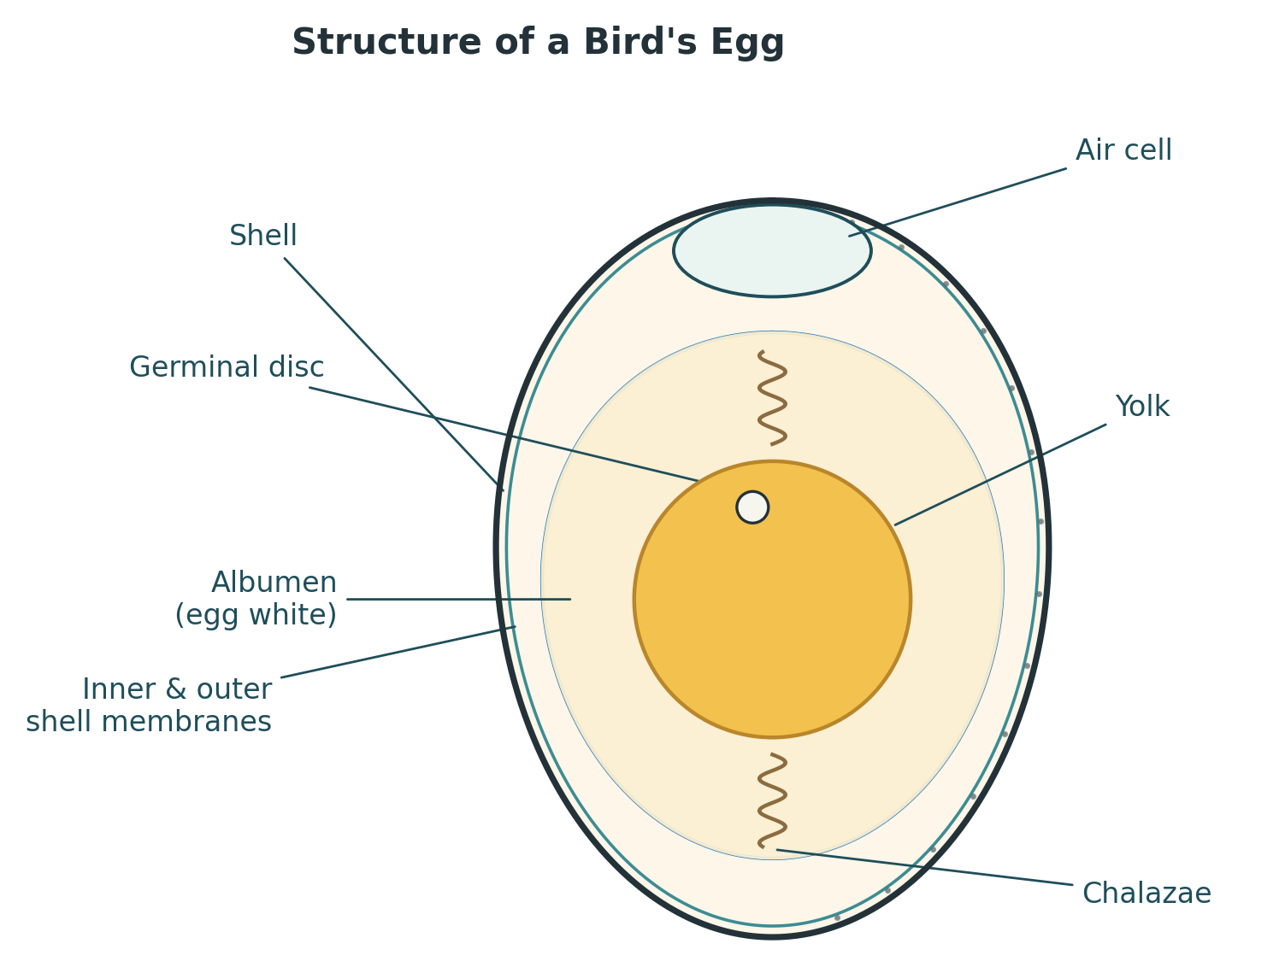

Compiled from published poultry-science, aviculture and ornithological literature
For general reference — always follow the specific instructions supplied with your incubator

Contents
1. Principles of Incubation 3
1.1 Five Environmental Requirements 3
1.2 Precocial and Altricial Development 3
2. The Egg 4
2.1 Structure of the Egg 4
2.2 Nutritional Foundations Before Laying 5
2.3 Embryo Development, Day by Day 5
2.4 Storage and Handling Before Incubation 6
3. Incubator Design 7
3.1 Still-Air Incubators 7
3.2 Forced-Draft Incubators 7
3.3 Contact and Radiant-Heat Incubation 8
3.4 Turning Mechanisms 8
3.5 Setting Up for Accuracy 8
4. Monitoring the Incubation 10
4.1 Candling 10
4.2 Measuring Humidity 10
4.3 Tracking Weight Loss 11
5. Troubleshooting Guide 13
6. Species Reference Table 14
Sources & Further Reading 16

1. Principles of Incubation
A bird egg laid outside the nest is not a dormant object — it is a self-contained life-support system for a growing embryo, and every part of that system depends on conditions the parent bird (or an incubator standing in for it) supplies from the outside. Whether the eggs in question belong to a backyard hen, a breeding pair of macaws, or a captive falcon, the underlying biology is shared, and successful incubation always comes back to controlling the same handful of variables well and consistently.

1.1 Five Environmental Requirements
Regardless of species, a developing embryo needs five things to be held within the right range for the whole incubation period:
- Temperature — the chemical reactions that drive embryonic growth only run at the correct pace within a narrow thermal window. Both the general air temperature in the incubator and, more importantly, the temperature at the centre of each egg need to stay inside that window.
- Turning — regularly re-angling the egg keeps the embryo moving through fresh albumen and stops it settling against and sticking to the membranes lining the inside of the shell.
- Humidity — the shell is porous, and the embryo must lose a predictable share of the egg's original water content by evaporation over the incubation period. Too little water loss leaves a chick swollen and poorly positioned for hatching; too much leaves it dehydrated and too weak to break out.
- Gas exchange — an actively growing embryo needs a continuous supply of oxygen and a way to shed carbon dioxide, so incoming air must be refreshed even while temperature and humidity are held steady.
- Cleanliness — a porous shell is also a route for bacteria and mould to get in, so both the egg-storage area and the incubator itself need to stay clean and free of contamination.
These five factors interact with one another — raising airflow to fix a humidity problem can disturb temperature uniformity, for instance — which is why incubator design (Section 3) and ongoing monitoring (Section 4) both matter as much as knowing the target numbers.

1.2 Precocial and Altricial Development
Newly hatched birds fall along a spectrum from precocial to altricial, describing how developed and self-sufficient a chick is at the moment it hatches.
Precocial chicks hatch relatively mature: eyes open, covered in down, able to leave the nest within a day or two, and capable of foraging for themselves within hours. Poultry and waterfowl are the classic examples.
Altricial chicks hatch far less developed: eyes closed, little or no down, entirely dependent on their parents for food, and unable to leave the nest for an extended period. Birds of prey and parrots are typical examples.
The distinction is not just descriptive — it has practical consequences for artificial incubation. In the nest, altricial species are typically turned more often and more vigorously than precocial ones, and breeders of parrots and raptors commonly carry that difference over into artificial incubation schedules, turning those eggs on a tighter cycle than a standard poultry setting would use (see Section 3.4). Real species fall along a continuum between the two extremes rather than sorting neatly into either camp, so the specific published guidance for a species or family is always a better starting point than the general rule.

2. The Egg

2.1 Structure of the Egg
A freshly laid egg already contains everything the embryo will draw on for the whole incubation period, packaged inside a shell that is simultaneously a barrier, a source of calcium, and a breathable membrane.

Cross-section of a generalised bird egg.
- Shell — a calcium-carbonate structure perforated by thousands of microscopic pores that allow gas and water vapour to pass in and out.
- Shell membranes — two thin protein membranes just inside the shell; they separate slightly at the blunt end soon after laying to form the air cell.
- Air cell — a pocket of air at the egg's broad end that grows steadily throughout incubation as water is lost through the shell, and which the chick eventually breaks into to take its first breath.
- Albumen (egg white) — mostly water and protein, it cushions the embryo, supplies part of its water and protein needs, and provides a reserve the embryo moves through as it grows.
- Chalazae — twisted protein cords that anchor the yolk roughly in the centre of the egg and let it rotate in place as the egg is turned.
- Yolk — the embryo's main energy reserve, rich in fats and other nutrients; it is gradually drawn into the embryo's body cavity in the final days before hatching.
- Germinal disc (blastoderm) — the small disc on the yolk's surface where, if fertilised, cell division begins.

2.2 Nutritional Foundations Before Laying
An egg cannot be improved after it is laid — everything the embryo needs is already determined by what the parent bird was eating in the weeks beforehand. Breeding stock kept short of key nutrients tend to produce eggs with reduced hatchability, weaker chicks, and poorer disease resistance, even when incubation conditions themselves are perfect. The nutrients most consistently linked to hatch quality in breeding-bird diets include vitamins A, D, E and K, the B-complex vitamins (thiamine, riboflavin, niacin, B6, pantothenic acid, biotin, folic acid and B12), and minerals such as calcium, phosphorus, manganese, magnesium and zinc — each contributing to a different part of embryonic development, from bone and shell formation to circulatory integrity.

2.3 Embryo Development, Day by Day
The timeline below uses the domestic hen's 21-day incubation period as a reference point, since it is the most thoroughly documented in the scientific literature; embryos of other species pass through broadly the same sequence of milestones, simply compressed or stretched to fit a shorter or longer incubation period (see the species table in Section 6).
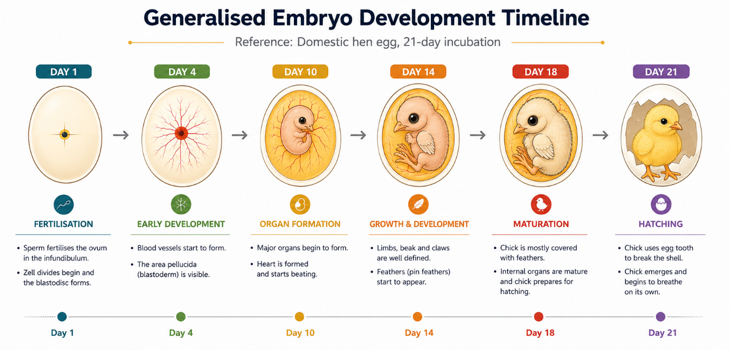

Simplified, generalised development milestones across a 21-day incubation.
Stage | What is happening
Day 1 | The fertilised germinal disc begins dividing. The primitive streak — the axis along which the head and spine will form — appears, and the first blood islands begin forming.
Day 2 | Blood islands link into a simple vascular network. A simple tubular heart forms and begins beating by roughly the 44th hour.
Day 3–4 | The embryo differentiates into three germ layers (ectoderm, mesoderm, endoderm) through a stage called gastrulation. Wing and leg buds appear, and the amniotic sac begins enclosing the embryo in fluid.
Day 5–6 | Reproductive organs and sex differentiation begin. Digits and the beak start to take shape, and the eye gains visible pigment.
Day 7–8 | The neck lengthens, visibly separating head from body. The upper and lower beak differentiate, the vitelline (yolk) membrane spreads to cover nearly the whole yolk, and eye pigmentation becomes clearly visible.
Day 9–10 | Claws and the first feather follicles appear. The allantois — the embryo's combined respiratory and waste-storage organ — grows rapidly, and the egg tooth begins forming.
Day 11–13 | Skeletal calcification begins. Scales, down and toenails appear.
Day 14 | The embryo repositions with its head tucked under the right wing, taking on a distinctly chick-like form.
Day 15–17 | Down grows in and gains colour. The albumen is nearly used up, and the beak turns toward the air cell in preparation for the first breath.
Day 18–19 | The yolk sac — the last major food reserve before hatching — begins drawing into the body cavity, and the amount of amniotic fluid falls sharply.
Day 20 | The yolk is fully internalised. The chick breaks into the air cell (internal pipping) and takes its first lung breath; the resulting build-up of carbon dioxide triggers the neck-muscle twitches that drive the hatching sequence.
Day 21 | External pipping begins, followed by a slow rotation inside the shell that chips a line around the egg's wide end until the cap detaches and the chick works itself free.

2.4 Storage and Handling Before Incubation
Eggs collected for hatching are rarely set immediately, and how they are handled between laying and incubation has a measurable effect on the final hatch rate.
- Temperature: hold fertile eggs at roughly 13–18°C (55–65°F). Refrigeration is too cold and increases embryo mortality; ordinary room temperature is generally too warm and allows uneven, partial development to begin.
- Humidity: aim for about 70–80% RH in the storage area to limit early moisture loss through the shell.
- Orientation and turning: store eggs pointed-end down. If they will be held for more than two or three days, tilt or turn the carton through roughly 90° once or twice a day so the yolk does not settle against and stick to the shell membrane.
- Time in storage: hatchability declines measurably once eggs pass about 7–10 days in storage, and drops more sharply beyond two weeks, so it pays to plan hatching schedules around the freshest eggs practical.
- Warming before setting: bring stored eggs up to near room temperature gradually, over several hours, before placing them in the incubator. Setting a cold egg directly into a warm incubator causes condensation on the shell, and that moisture is a route for bacterial contamination.
- Cleanliness: discard cracked, badly misshapen or heavily soiled eggs where possible. If a soiled egg must be cleaned, use wash water that is noticeably warmer than the egg, so that the egg's contents expand and push contamination outward through the pores rather than drawing dirty water in. Any washing also strips the shell's natural protective cuticle, leaving the egg more exposed to contamination afterward — so cleaning is a trade-off, not a free fix.
- Handling: handle every egg gently. A hard bump can rupture internal membranes or blood vessels without visibly damaging the shell, and the same care is worth taking once eggs are in the incubator, not just beforehand.

3. Incubator Design
An incubator's job is to reproduce, mechanically, the conditions a parent bird would otherwise provide by sitting on the nest. Machines are usually grouped by how they move air, because that single design choice shapes almost everything else about how the incubator behaves.

3.1 Still-Air Incubators
The simplest incubators are little more than an insulated box holding a heating element, a thermostat, an egg tray, a water reservoir for humidity, and a thermometer. Air movement relies entirely on natural convection: heated air rises toward the top of the box and cooler air sinks to replace it, so a still-air incubator develops a real temperature gradient from top to bottom rather than one uniform temperature throughout.
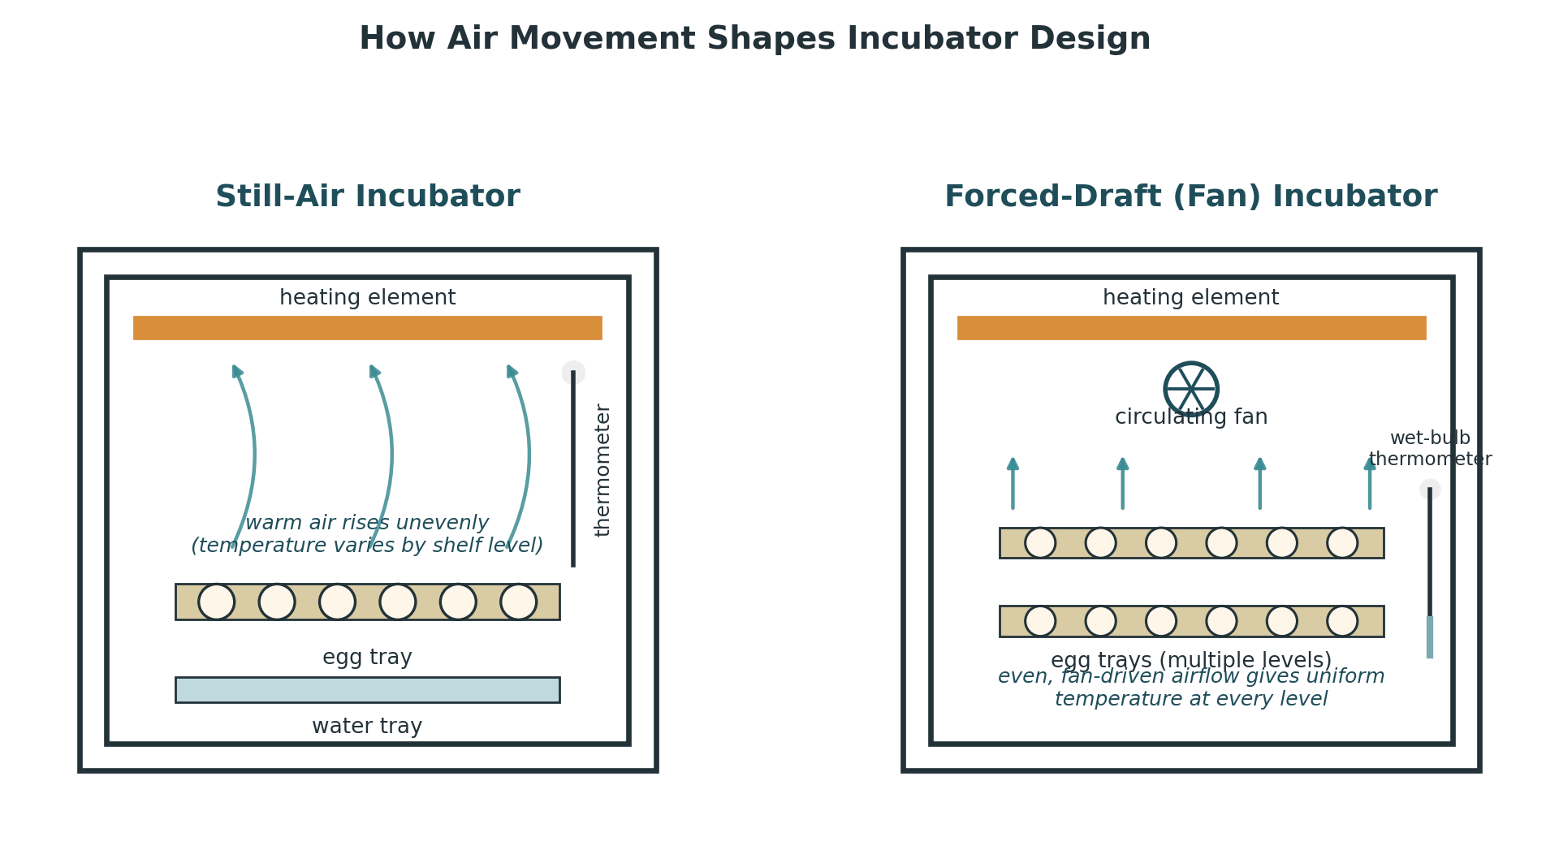
Natural convection in a still-air design compared with fan-driven mixing in a forced-draft design.
That gradient makes sensor placement critical: the thermostat sensor and thermometer bulb need to sit close to the top of the eggs, at roughly the height of the embryo itself, and still-air machines are typically run a degree or two warmer than the equivalent forced-draft target to compensate. A still-air incubator also needs to stay level, and works best with eggs of broadly similar size, since the gradient it relies on assumes a fairly uniform tray.

3.2 Forced-Draft Incubators
Adding a circulating fan solves the still-air incubator's biggest weakness: with air actively mixed, temperature stays close to uniform throughout the cabinet, so sensor placement is far less critical and eggs of different sizes can be set on multiple trays without one tray running noticeably hotter or cooler than another. The moving air also makes a wet-bulb thermometer usable for humidity measurement (Section 4.2), though the same airflow that evens out temperature also dries eggs faster, so humidity control matters more, not less, in a forced-draft machine.

3.3 Contact and Radiant-Heat Incubation
A newer category of incubator tries to mimic the nest more closely by warming eggs through direct contact with a heated surface, rather than surrounding them with heated air. A soft, temperature-controlled skin rests gently against the tops of the eggs, providing warmth over a small contact area much like a parent bird's brood patch, and is periodically lifted away — drawing in a burst of fresh air, just as a parent does when standing up or briefly leaving the nest.
Published research comparing this approach with conventional forced-air incubation has found a genuine biological difference, not just a design curiosity. In a forced-draft incubator, an egg's temperature stays close to uniform across its whole surface for most of incubation. Under contact or natural incubation, by contrast, heat enters over a small warm patch and is lost from the rest of the shell, producing a real temperature gradient across the egg — and that gradient shifts over time as the growing embryo's own circulation and metabolism begin to influence how heat moves through the egg, a pattern that early researchers did not expect and that is still being refined. In practice, contact-incubated eggs appear to tolerate small temperature swings a little better than conventionally incubated ones, though accurate temperature control still matters in either design.

3.4 Turning Mechanisms
Whatever the heating method, eggs need to be turned regularly, and incubator manufacturers have settled on a handful of mechanical approaches to do it automatically.
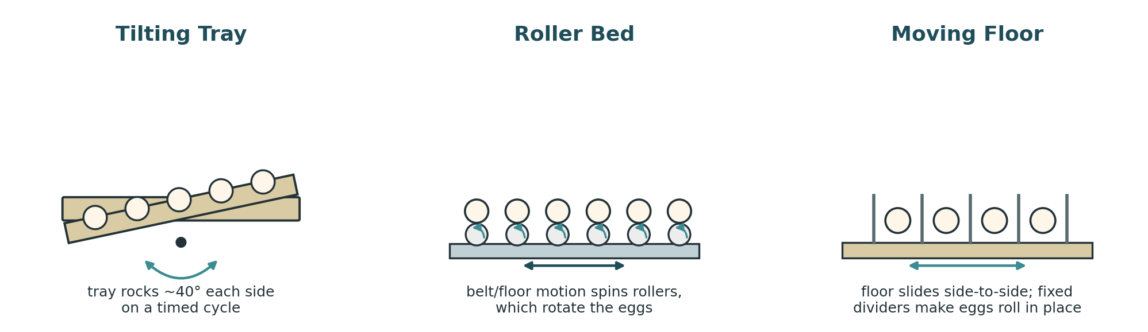
Three common automatic-turning mechanisms.
- Tilting trays — the most common commercial approach. Eggs sit upright in a tray that rocks through roughly 80° total (about 40° each way) on a timed cycle. It is efficient at scale and well suited to poultry-type eggs, but a poor match for how altricial species are turned in the nest.
- Roller beds — eggs rest on rollers that themselves sit on a moving floor or belt; as the floor shifts, the rollers spin and rotate the eggs in place. Small ridges on the rollers help stop an egg 'walking' sideways along the roller.
- Moving floors — used in smaller machines where eggs lie on a horizontal floor that slides side to side, with fixed dividers making the eggs roll rather than slide along with it. This works well for eggs that are roughly symmetrical end to end, such as duck eggs, but pointed eggs tend to bunch against the dividers.
- Troughs or channels — semicircular tilting channels sized for very small eggs, such as quail; the trade-off is a more limited turning angle than the other methods offer.

3.5 Setting Up for Accuracy
Temperature accuracy matters more than any other single setting. Commercial practice generally aims to hold the egg tray within about ±0.3°C (±0.5°F) of target, and small deviations sustained over hours — not just brief spikes — are what cause developmental problems, so a stable average matters more than chasing an exact instantaneous reading. Humidity is comparatively forgiving during the bulk of incubation but needs to be raised for the final days before hatching (often called lockdown), when higher humidity keeps the inner shell membrane pliable enough for the chick to tear through it rather than drying out and trapping the chick inside.

4. Monitoring the Incubation
Setting an incubator correctly at the start is only half the job — eggs need to be checked periodically so that temperature or humidity problems can be caught and corrected before they affect the whole batch.

4.1 Candling
Candling means shining a concentrated beam of light through the shell, usually in a darkened room, to see the egg's contents without opening it. It is the simplest way to track how fast the air cell is growing — a rough proxy for the rate of water loss — and to spot eggs that are infertile or have stopped developing so they can be removed before they spoil or, in rare cases, burst inside the incubator.
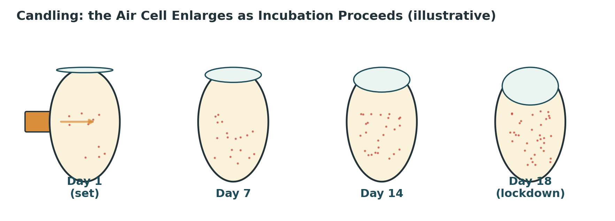
The air cell grows steadily larger over the course of incubation (illustrative).
If the air cell looks larger than expected for the day of incubation, too much water is being lost and humidity should be raised; if it looks smaller than expected, the reverse applies. What a candled egg shows also changes with the stage of incubation:
What you see | Likely meaning
Clear, no internal detail visible | Probably infertile, or a very early embryo death (checked after the first third of incubation)
Fine web of red vessels spreading from a central spot | Fertile and developing normally
A red or dark ring or blotch, with no vessel network | Early embryo death
Dark, indistinct mass filling much of the shell; air cell enlarging normally | Developing normally in later incubation — fine detail is naturally harder to see once the chick fills the shell
Little movement; dull, patchy appearance; poorly defined air-cell margin | Possible late-stage death — worth watching, not necessarily removing immediately
Dark body visible moving, bill projecting into the air cell | Close to hatching, typically within 24–48 hours

4.2 Measuring Humidity
Incubator humidity is usually measured one of two ways: a hygrometer, or a wet-bulb thermometer. Both require some air movement to read accurately, so neither gives a trustworthy reading in a still-air machine — in that case, egg weight loss (Section 4.3) is the more reliable guide.
- Hygrometers measure humidity directly. Mechanical (hair) hygrometers use a filament that changes length with humidity to move a dial; electronic hygrometers measure the change in electrical resistance or capacitance of a moisture-sensitive sensor and are generally more accurate. A cheap, uncalibrated hygrometer can be more misleading than having none at all, so it is worth checking one against a known reference before trusting it.
- Wet-bulb thermometers use a pair of thermometers, one with its bulb wrapped in a moist wick dipped into a small reservoir. Water evaporating from the wick cools that thermometer below the reading of the plain (dry-bulb) thermometer next to it; the drier the surrounding air, the faster the evaporation and the bigger that gap becomes. The gap converts to a relative-humidity percentage using a psychrometric relationship between temperature and evaporative cooling.
The table below gives that conversion for a dry-bulb incubation temperature of 37.5°C (99.5°F), calculated from standard psychrometric relationships. At a different dry-bulb temperature the same wet-bulb reading corresponds to a slightly different relative humidity, so treat this as a working reference rather than a universal constant.
Relative humidity | Wet-bulb °C | Wet-bulb °F
20% | 21.6 | 70.9
30% | 24.2 | 75.5
40% | 26.5 | 79.8
50% | 28.7 | 83.7
60% | 30.7 | 87.3
70% | 32.6 | 90.7
80% | 34.3 | 93.8
90% | 36.0 | 96.7
100% | 37.5 | 99.5

4.3 Tracking Weight Loss
Because water loss is what humidity control is actually trying to manage, directly weighing eggs through incubation is the most reliable way to check that conditions are correct — more reliable, in most cases, than any single humidity reading. Most eggs need to lose somewhere around 13–15% of their fresh weight by the time of internal pipping, though some species — many raptors and some parrot species among them — run a little higher, and the exact figure is best confirmed against published data or a breeder's own hatch records for that species.
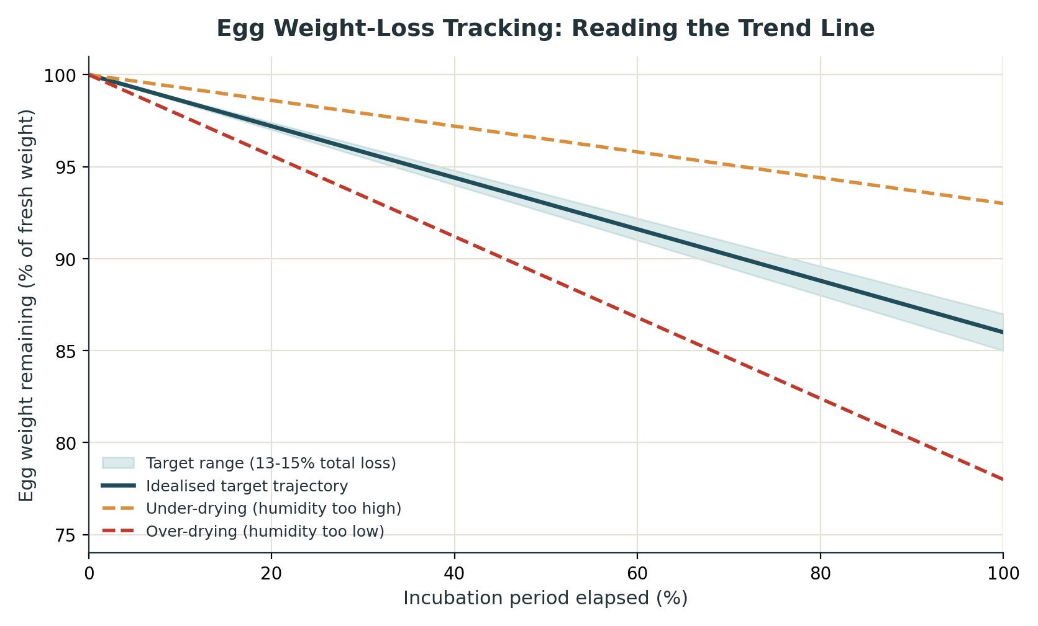
Reading the weight-loss trend against a target band, rather than a single reading, shows a humidity problem early.
Estimating fresh egg weight and daily target loss
When an egg's weight was not recorded at laying, Hoyt's (1979) widely used formulas estimate it from two simple measurements — length (L) and breadth/maximum diameter (B), both in centimetres: egg volume (cm3) is approximately 0.51 x L x B2, and fresh weight (g) is approximately Kw x L x B2, where Kw is a constant that varies by species and is typically close to 0.55-0.58 for chicken-type eggs; for other species it is best determined by weighing a small sample of freshly laid eggs and solving for Kw directly. Once fresh weight and a target percentage loss are known, daily target weight loss is simply (fresh weight x desired % loss) divided by the number of days to internal pipping — giving a day-by-day line to plot actual weighings against.

Source: Hoyt, D.F. (1979). "Practical Methods of Estimating Volume and Fresh Weight of Bird Eggs." The Auk, 96(1), 73–77.

5. Troubleshooting Guide
Most hatching problems trace back to one or more of the five environmental factors in Section 1.1 drifting out of range, or to conditions further back in the chain — breeder nutrition, egg storage, or handling — that no amount of incubator adjustment can fix after the fact. The table below groups the problems most commonly reported across species with their most frequently cited contributing factors; because several causes often overlap, the most useful diagnostic tool is usually a candled sample of eggs and a weight-loss trend (Section 4) rather than any single symptom in isolation.
Problem | Likely contributing factors
Chicks hatch late | Incubator temperature too low; oversized eggs; older breeding stock; extended storage before setting; weak embryos
Early or premature hatching, bloody navels | Incubator temperature too high
Slow, drawn-out hatch across the batch | Mixed egg sizes or ages in one batch; hot or cold spots in the incubator; inconsistent storage history
Sticky chicks, smeared with albumen | Temperature too low; humidity too high; inadequate turning; very large or old eggs
Chicks stuck in the shell, dry membranes | Low humidity during storage; poor turning; cracked shell or poor shell quality
Weak chicks at hatch | Hatching temperature too high; poor ventilation in the hatcher; contamination
Malpositioned chicks | Eggs set small-end up or on their side; inadequate or excessive turning; temperature out of range; nutritional deficiencies in the breeder flock; old breeding stock; rough handling or poor storage
Malformations, crooked toes, bent legs | Nutritional deficiencies in the breeder flock; jarring or rough handling of eggs; temperature out of range; poor storage conditions; inadequate turning
Small air cell, weight loss under target | Humidity too high; very thick or low-porosity shell; temperature too low
Large air cell, weight loss over target | Humidity too low; thin or highly porous shell; temperature too high
Exploding or heavily contaminated eggs | Dirty eggs at collection; improper washing; condensation or water contact on the shell; cross-contamination from an earlier spoiled egg
Eyes stuck closed, down matted at hatch | Hatcher temperature too high; chicks left in the hatcher too long after emerging; excessive air movement drying the down prematurely

6. Species Reference Table
The ranges below synthesise multiple published extension, avicultural and raptor-breeding sources rather than a single manufacturer's recommendation, and are meant as a starting point rather than a fixed prescription. Real variation between breeding lines, shell quality, local climate and even the specific incubator model means the numbers on the page always need to be checked against what a weight-loss trend and candling actually show for a given batch (Section 4) — and the manufacturer's instructions for a specific machine should take precedence over any general guide, including this one.
Reading this table
Temperatures are for forced-draft incubators; still-air machines typically need to run about 1–1.5°C (2–3°F) warmer at egg height to reach the same true egg-centre temperature (Section 3.1). “Main period” humidity applies from setting until the last few days before hatching, when it should be raised to the “hatch” figure shown.

Poultry & Gamebirds
Species | Incubation (days) | Temp, forced-air | Humidity, main period | Humidity, hatch
Chicken | 21 | 37.5°C (99.5°F) | 45–50% RH | 65–75% RH
Turkey | 28 | 37.5°C (99.5°F) | 45–55% RH | 65–70% RH
Guinea fowl | 26–28 | 37.5°C (99.5°F) | 45–50% RH | 65–70% RH
Pheasant | 23–28 | 37.3–37.5°C (99.1–99.5°F) | 40–50% RH | 55–65% RH
Chukar partridge | 23–24 | 37.5°C (99.5°F) | 40–45% RH | 55–65% RH
Peafowl | 28–30 | 37.5°C (99.5°F) | 45–55% RH | 65–70% RH
Coturnix quail | 17–18 | 37.5°C (99.5°F) | 45–55% RH | 65–70% RH
Bobwhite quail | 23–24 | 37.5–37.8°C (99.5–100°F) | 45–50% RH | 60–65% RH

Waterfowl
Species | Incubation (days) | Temp, forced-air | Humidity, main period | Humidity, hatch
Domestic duck | 28 | 37.5°C (99.5°F) | 55–60% RH | 70–80% RH
Muscovy duck | 35–37 | 37.5°C (99.5°F) | 45–55% RH | 55–65% RH
Goose | 28–34 | 37.2–37.5°C (99–99.5°F) | 50–55% RH | 75–80% RH

Parrots (Psittacines)
Published sources vary more widely for parrots than for poultry — some experienced breeders run large-egg species (macaws, Amazons) as low as 38% RH, others closer to 45–50%; the range shown reflects that spread. Smaller-egged species generally sit toward the higher end of the humidity range and larger-egged species toward the lower end.
Species | Incubation (days) | Temp, forced-air | Humidity, main period | Humidity, hatch
Budgerigar | 17–18 | 37.5°C (99.5°F) | 45–55% RH | 60–70% RH
Cockatiel | 18–21 | 37.2–37.5°C (99.0–99.5°F) | 50–56% RH | 65–70% RH
Lovebird | 21–23 | 37.3°C (99.1°F) | 45–55% RH | 60–70% RH
Conure (mid-size) | 23–25 | 37.3–37.5°C (99.1–99.5°F) | 45–52% RH | 60–70% RH
Amazon parrot | 24–29 | 37.3°C (99.1°F) | 38–45% RH | 60–65% RH
African grey | 26–28 | 37.3°C (99.1°F) | 40–50% RH | 60–65% RH
Macaw | 24–28 | 37.3–37.5°C (99.1–99.5°F) | 38–45% RH | 60–65% RH
Cockatoo | 24–30 | 37.3°C (99.1°F) | 40–50% RH | 60–65% RH

Birds of Prey (Raptors)
Raptor eggs are commonly incubated slightly warmer than typical poultry settings; several published studies on falcons and kestrels found improved hatch rates nearer 38–38.5°C than at standard poultry temperatures.
Species | Incubation (days) | Temp, forced-air | Humidity, main period | Humidity, hatch
Kestrel / small falcon | 27–31 | 37.5–38.5°C (99.5–101.3°F) | 50–55% RH | 60–65% RH
Peregrine / larger falcon | 29–33 | 37.2–37.8°C (99.0–100.0°F) | 50–55% RH | 60–65% RH
Owls (general guide) | 29–34 | 37.2–37.7°C (99.0–99.9°F) | 50–55% RH | 60–65% RH

Ratites
Ratite eggs are large, thick-shelled and slow to warm or cool, so swings in temperature or humidity take longer to show up — and take longer to correct — than in small eggs.
Species | Incubation (days) | Temp, forced-air | Humidity, main period | Humidity, hatch
Ostrich | 42–46 | 36.4–37.0°C (97.5–98.6°F) | 20–30% RH | 35–40% RH
Emu | 48–56 | 36.1–37.0°C (97.0–98.6°F) | 25–35% RH | 40–45% RH
Rhea | 36–44 | 36.5–37.0°C (97.7–98.6°F) | 35–45% RH | 50–55% RH

Sources & Further Reading
This guide was written independently and draws on a broad base of published, publicly available material rather than any single manufacturer's documentation, including:
- University agricultural-extension incubation guides, including Mississippi State University Extension, Virginia Tech, Alabama Cooperative Extension System, and Oregon State University Extension
- Hoyt, D.F. (1979), "Practical Methods of Estimating Volume and Fresh Weight of Bird Eggs," The Auk 96(1) — the egg volume and weight-estimation formulas used in Section 4.3
- Published avicultural literature on psittacine (parrot) egg incubation from breeder and research sources
- Published raptor-breeding and captive-propagation literature, including material from the Raptor Research Foundation and university-affiliated raptor centres
- General ornithology reference material on precocial/altricial development and avian embryology

Figures and diagrams throughout this document are original illustrations prepared for this guide and are not reproductions of any manufacturer's artwork.
This guide is provided for general reference. It is not a substitute for the specific instructions supplied with any given incubator, and where the two disagree, the manufacturer's documentation for that machine should be followed.

