1.

2. Offspring always differ in some ways from one another and from their parents. These differences are called variations.

However, now and then a variation occurs that does give an organism a better chance of surviving in a changing environment. Suppose that the climate of an area is changing and deeper snow is produced each winter. Clearly a variation that produced longer legs in a deer would increase that deer’s chances of surviving in that area. If this variation is passed on to the offspring of that deer, they, also, would have an increased chance of survival. Gradually the only deer of that type to be found in the deep snow area may be the long-legged types. The others would have moved away or died.

3. This is because of osmosis and the way that fish absorb water through their skin. Saltwater fish die in fresh water due to over hydration, and freshwater fish die in salt water due to dehydration.

Fish are adapted to handle this flow of water. Saltwater fish must frequently drink water to rehydrate their cells and accommodate for the moisture that is lost. Their gills and kidneys filter excess salt from the bloodstream, and the fish urinate out the waste. Because freshwater fish aren't adapted to drink water or process that much salt, they can quickly become dehydrated and die when placed in salt water.

4.

5. Radiocarbon dating is the process of determining the age of a sample by examining the amount of 14C remaining against its known half-life, 5,730 years. The reason this process works is because when organisms are alive, they are constantly replenishing their 14C supply through respiration, providing them with a constant amount of the isotope. However, when an organism ceases to exist, it no longer takes in carbon from its environment and the unstable 14C isotope begins to decay. From this science, we are able to approximate the date at which the organism lived on Earth. Radiocarbon dating is used in many fields to learn information about the past conditions of organisms and the environments present on Earth.

6.

7. Isotopes:  Isotopes are atoms of the same element that have different numbers of neutrons but the same number of protons and electrons. The difference in the number of neutrons between the various isotopes of an element means that the various isotopes have different masses. The superscript number to the left of the element abbreviation indicates the number of protons plus neutrons in the isotope. For example, among the [hydrogen isotopes](https://www.sciencedirect.com/topics/earth-and-planetary-sciences/hydrogen-isotopes), [deuterium](https://www.sciencedirect.com/topics/earth-and-planetary-sciences/deuterium) (denoted as 2H or D) has one neutron and one proton. This is approximately twice the mass of [protium](https://www.sciencedirect.com/topics/chemistry/protium" \o "Learn more about Protium(.) from ScienceDirect's AI-generated Topic Pages) (1H), whereas [tritium](https://www.sciencedirect.com/topics/earth-and-planetary-sciences/tritium) (3H) has approximately three times the mass of protium.

**Electronegativity**: The tendency of an atom in a molecule to attract the shared pair of electrons towards itself is known as **electronegativity**.

It is a dimensionless property because it is only a tendency. It basically indicates the net result of the tendencies of atoms in different elements to attract the bond-forming electron pairs. We measure electronegativity on several scales. The most commonly used scale was designed by Linus Pauling. According to this scale, fluorine is the most electronegative element with a value of 4.0 and cesium is the least electronegative element with a value of 0.7.

8. Main functions of Proteins

❑ Protein's main function is to build, maintain and repair all our body tissues, such as muscles, organs, skin and hair.

❑ Protein can also be used as energy source by body, but this usually only happens when carbohydrate and fat stores are in short supply.

Biological function of Protein:

1. Protein acts as storage material of food and energy.

2. Many proteins are enzymes that catalyze biochemical reactions, and are vital to metabolism.

3. Proteins are molecular instrument through which genetic information is expressed.

4. They act as antibodies to prevent disease.

5. The milk proteins help the growth of infant mammals.

6. Like other biological macromolecules such as polysaccharides, lipids and nucleic acids, proteins are essential parts of organisms and participate in virtually every process within cells.

7. Many proteins are enzymes that catalyze biochemical reactions and are vital to metabolism.

8. Proteins also have structural or mechanical functions, such as actin and myosin in muscle and the proteins in the cytoskeleton, which form a system of scaffolding that maintains cell shape.

9. Other proteins are important in cell signaling, immune responses, cell adhesion, and the cell cycle.

10. Proteins are also necessary in animals’ diets, since animals cannot synthesize all the amino acids they need and must obtain essential amino acids from food. Through the process of digestion, animals break down ingested protein into free amino acids that are then used in metabolism.

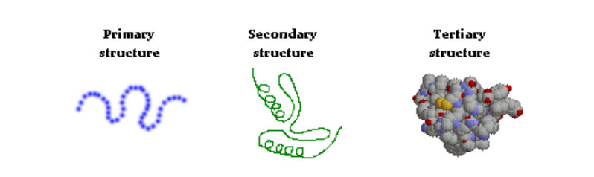

9.

10. 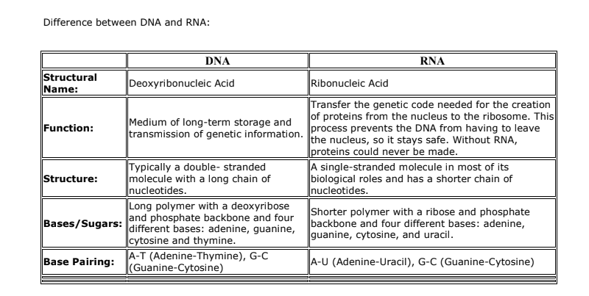

11.

12.

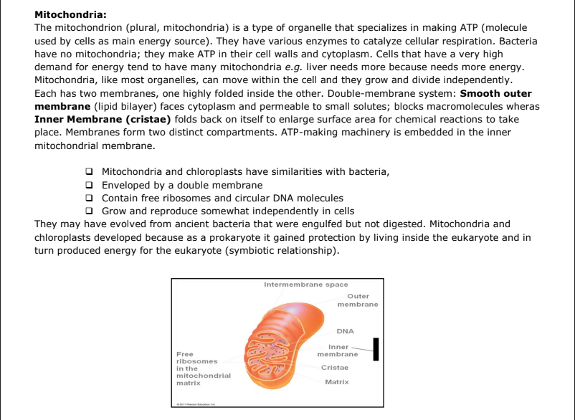

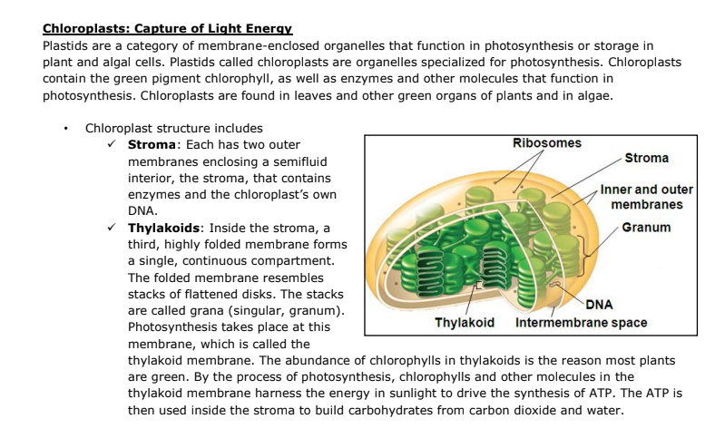

13.

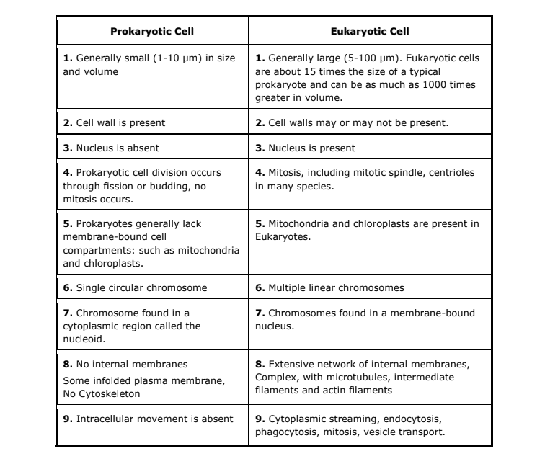

14. Lysosomes that bud from Golgi bodies take part in intracellular digestion. They contain powerful enzymes that can break down carbohydrates, proteins, nucleic acids, and lipids. Vesicles inside white blood cells or amoebas deliver ingested bacteria, cell parts, and other debris to lysosomes for destruction. The enzymes work best in the acidic environment inside the lysosome. Lysosomes break down worn out cell parts or molecules so they can be used to build new cellular structures. Some types of cell can engulf another cell by phagocytosis; this forms a food vacuole. A lysosome fuses with the food vacuole and digests the molecules Lysosomes also use enzymes to recycle the cell’s own organelles and macromolecules, a process called autophagy.

15.

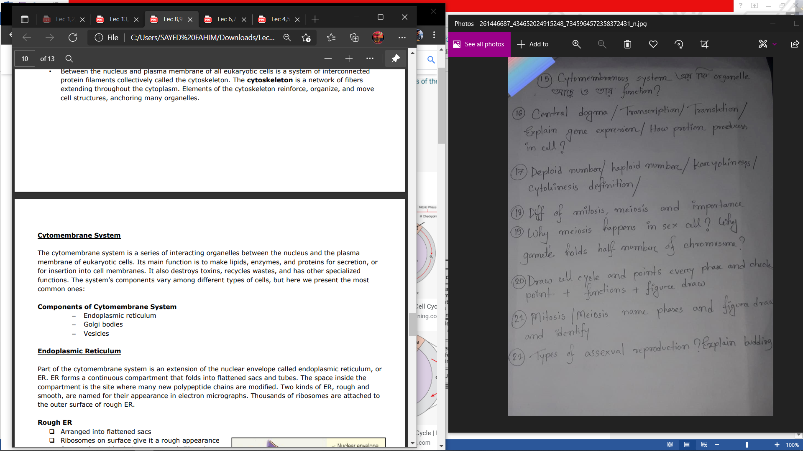

16.

17.

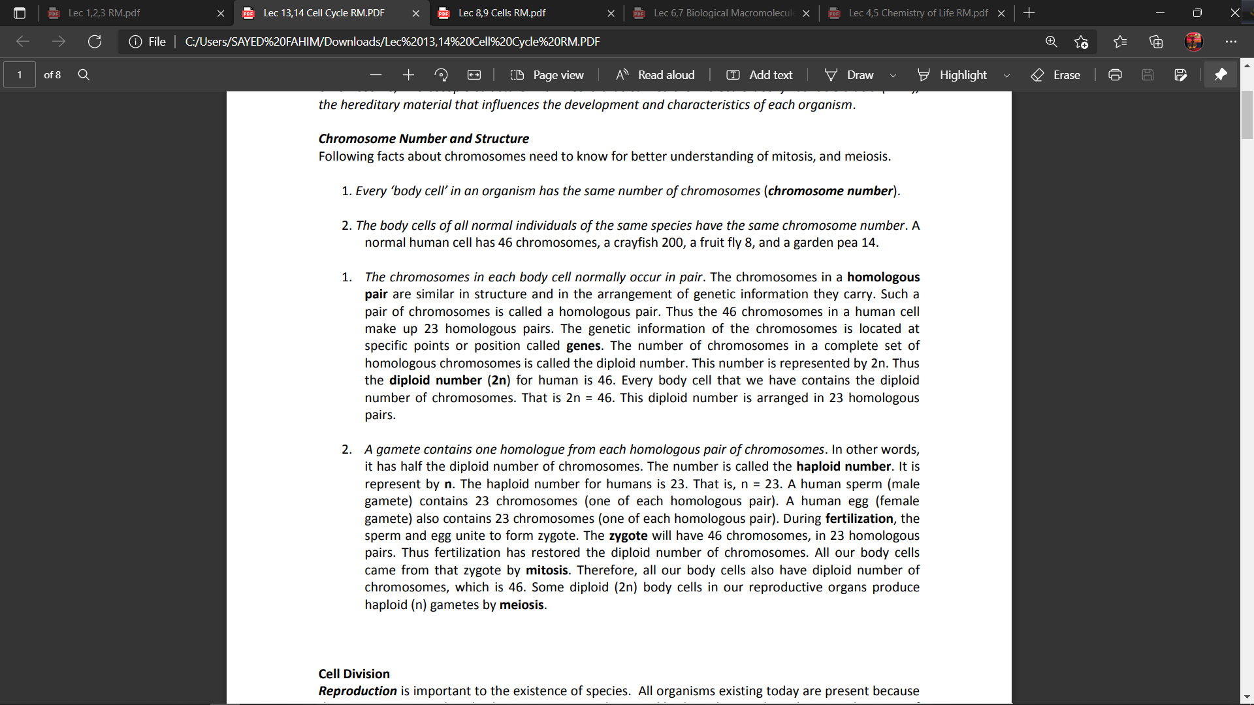

18.

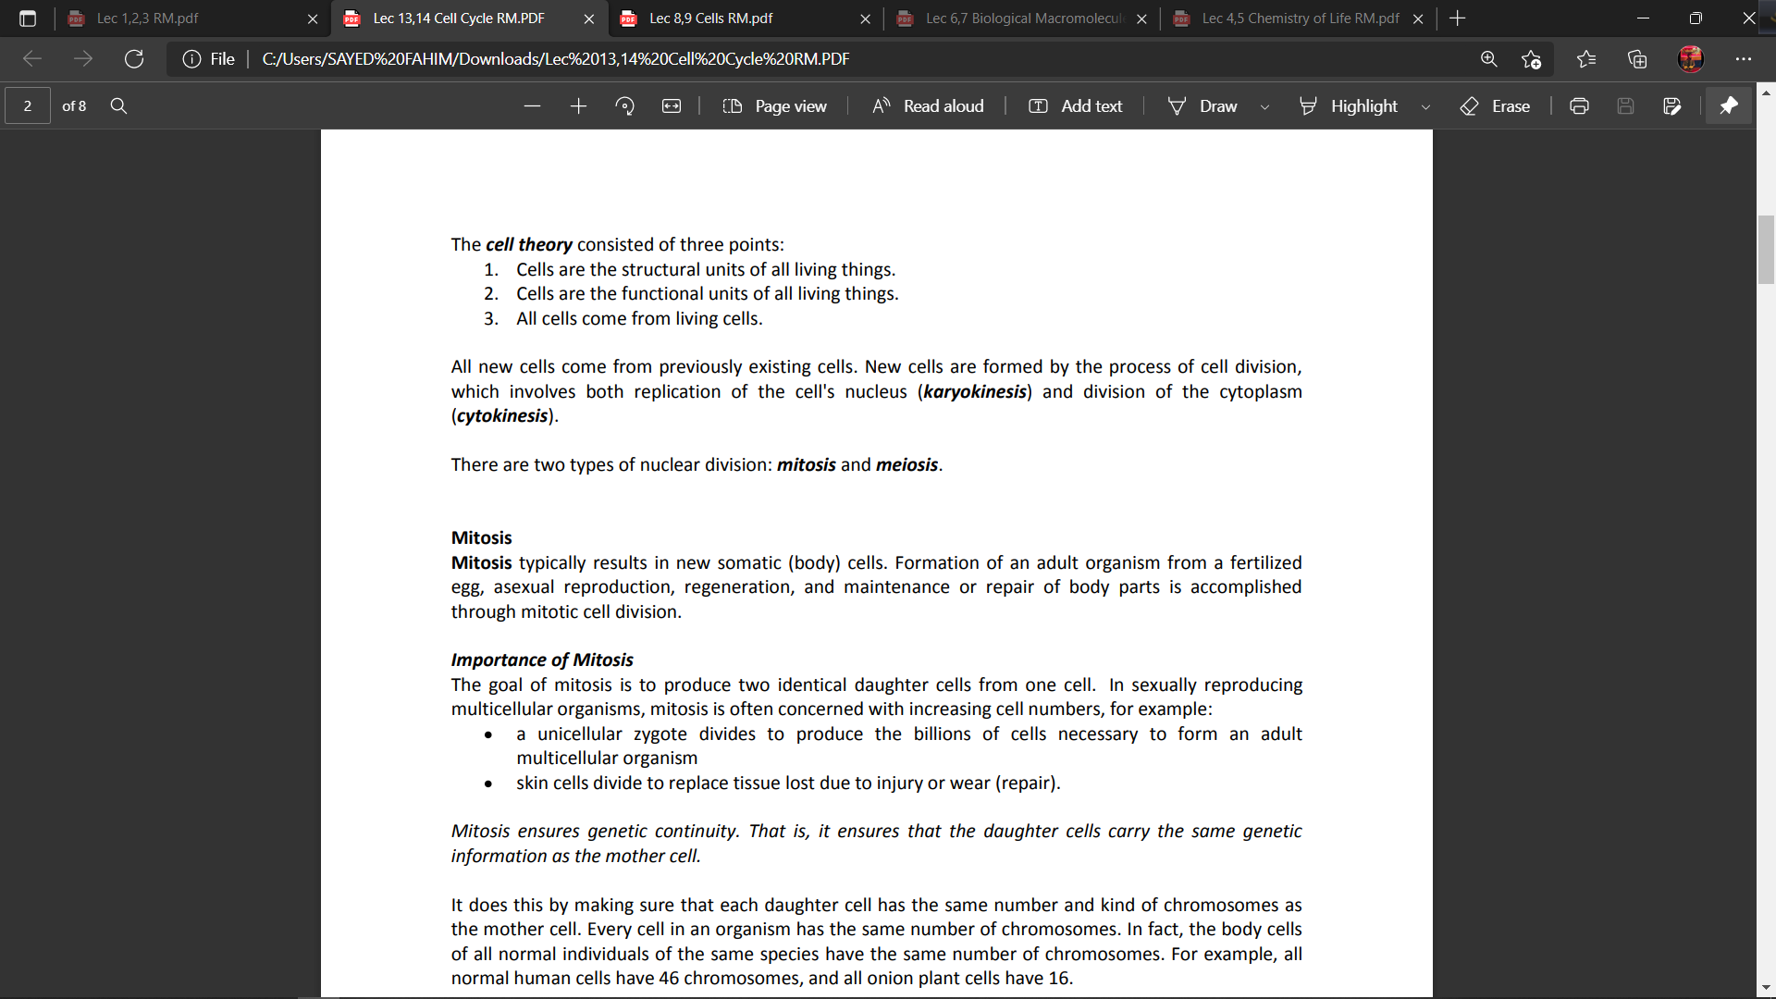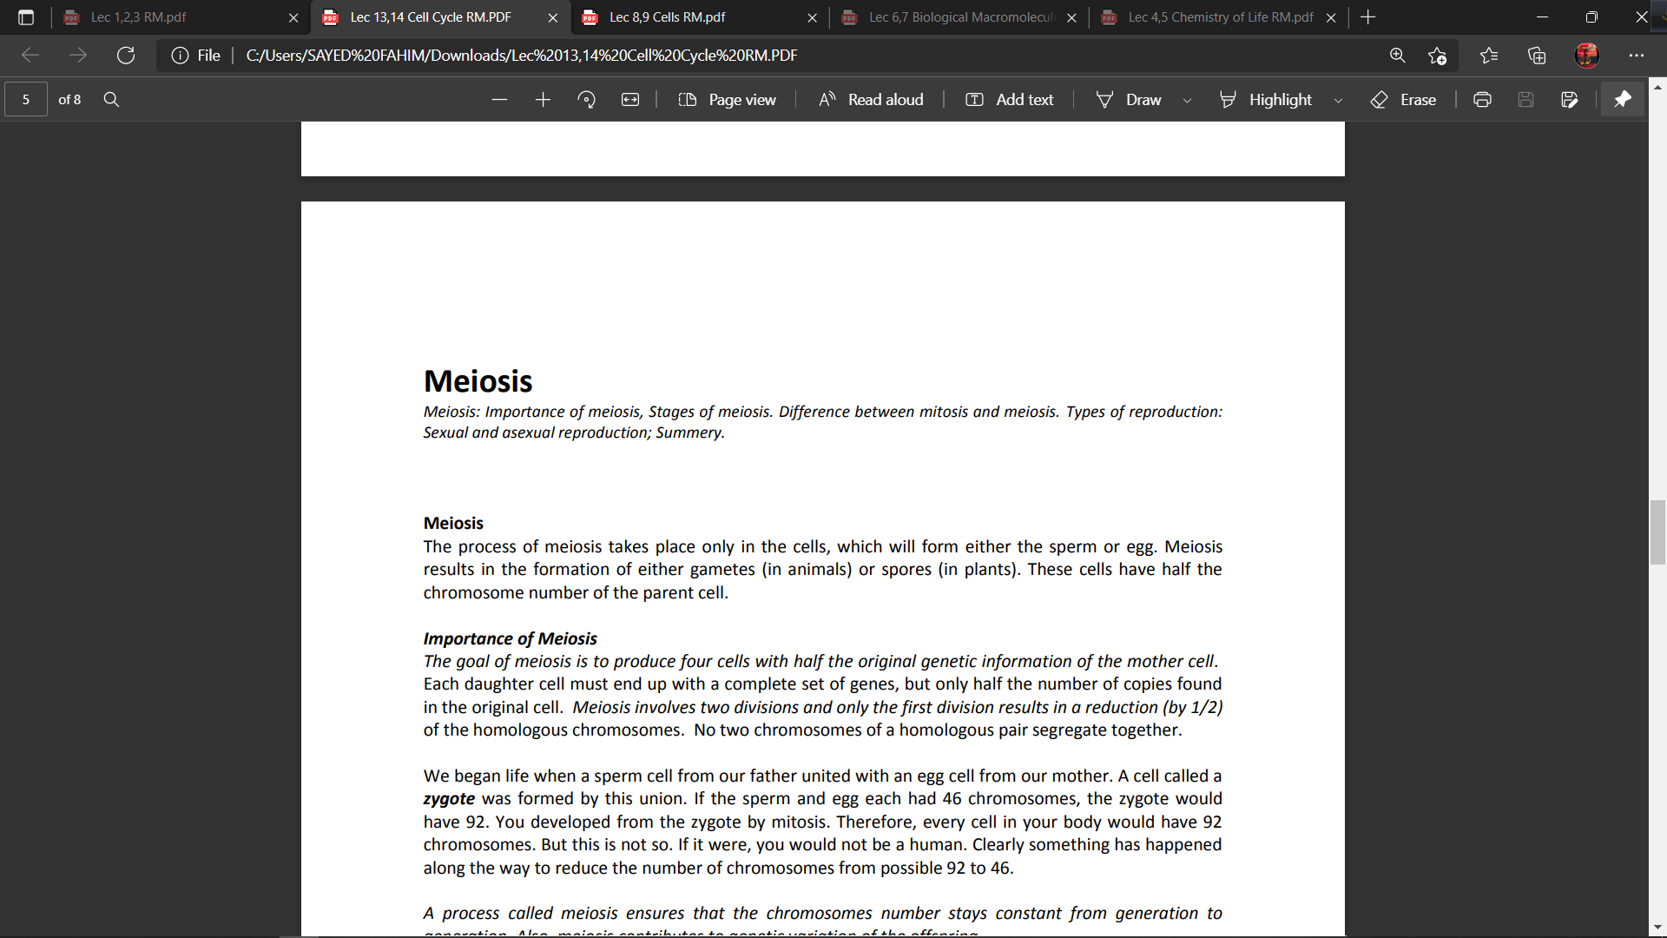

19.

20.

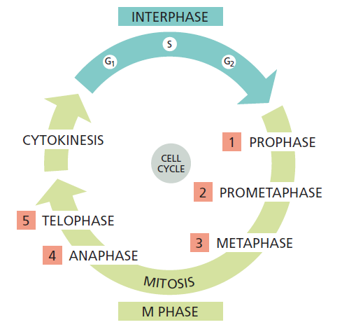

22.

