## **Submission**

Submit boilerplate.html and style.css as a **zip**.

## **Tasks**

You will need to modify boilerplate.html and create a style.css file. Each task will be worth 10 pts.

1. Create a CSS file named **style.css** and import it to the HTML page
2. Change the font color of heading to be **rgb(0,0,200);**
   * rgb is an acronym for red green blue.
3. Whenever the user hovers over the google link have the background turn black.
4. Change the background by adding the attribute **class=‘bg-light’** to the body element.
5. Fix the navigation (<nav>) bar by using the bootstrap class breadcrumb and breadcrumb-item class.
   * The last element in the <ol> list will also have the class **active**. This will make the link is not selectable.
6. Use two different bootstrap button styles for the buttons “Continue to checkout” and “Cancel”.
   * Use the bootstrap button styles primary and secondary
7. Under the list group justify the content as follows with bootstrap:
   * Laptop item justify content between
   * Desk item justify content start
   * Chair item justify content end
   * Total justify content around
   * Ensure class d-flex is used for all items
8. Encapsulate the header and the paragraph under it with a **<div>**
   * Have the div use the id attribute **mainheader**
   * Using the **mainheader** selector align the text to the center
9. In the password input field add the text placeholder **Password**
10. All **<h4>** elements where the parent is a **<ul>** element set a solid border and color black.

**Resources**

1. <https://getbootstrap.com/docs/4.3/layout/overview/>
   1. Use search bar on the top-left. Search for things such as: button or nav.
2. <https://www.w3schools.com/cssref/sel_hover.asp>
3. <https://www.w3schools.com/cssref/css_selectors.asp>
4. <https://developer.mozilla.org/en-US/docs/Web/CSS/Reference>

# **Original**

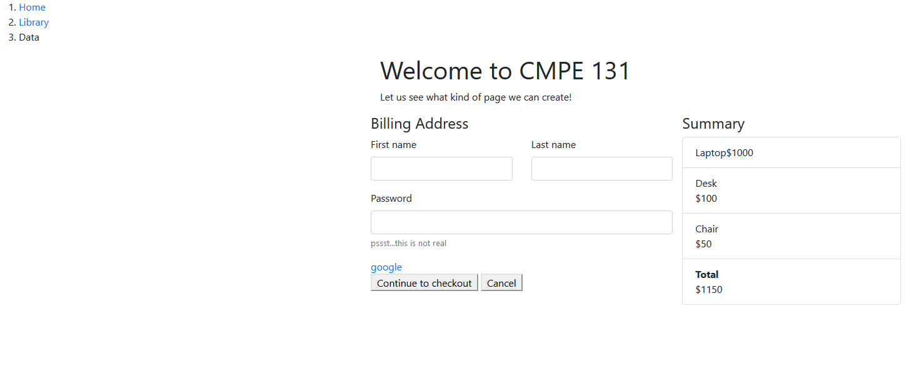

# **Stylized**

