**This ReadMe document will provide the steps to follow for execution of the automation code.**

**GitHub Repository consist of six files**

1. **SumoQuoteReg.py**
2. **SumoQuoteLogin.py**
3. **SumoQuoteReg.txt**
4. **SumoQuoteLogin.txt**
5. **SumoQuote Automated Videos Zip file**
6. **README file to explain the steps.**

**Code is scripted in Python Programming language with selenium automation tool to automate the execution ana automation screen recording video is attached to view the live execution.**

**Project Introduction**

* Project to automate the SumoQuote website that is used to create a new account.
* Once the account is created, user receives a verification email which will be verified manually.
* Proceed to sign in page to login with username and password.
* Populate all the required fields and submit according to the service required.

**Code Execution Procedure:**

**Step 1: SumoQuote - Registering a new account**

Open **SumoQuoteReg.py** file in a python IDE which has selenium web driver automation files to run the program.

There is a variable name “**email ID**” and it can be edited with a different email address as the program executed with an email id only once.

All other fields including the dropdown will be populated using the automation code and saved.

Below are the attached screenshots of fields getting filled automatically.

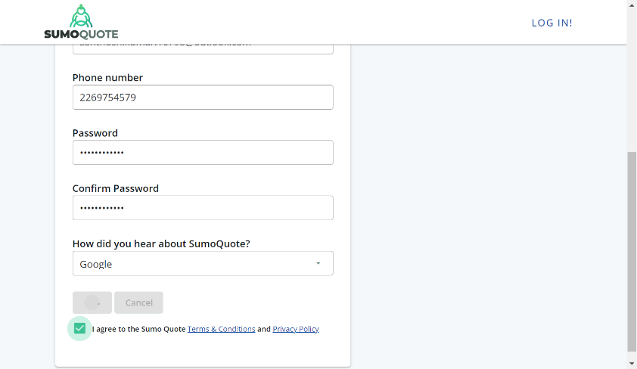

**Step 2: Email Verification**

Once user gets their information saved in the given website “https://sumoquoteweb-qa.azurewebsites.net/new-account”, they will receive a verification email which can be verified manually by clicking the “**verify my email**” button.

**Step 3: SumoQuote Login Page**

Once user’s email if verified, we can proceed to file “**SumoQuotelogin.py**” which will automate the remaining process.

User’s login details will be entered (email & password) and submit button is clicked. Email ID has a variable “**loginEmail**”, where the email can be changed according to the email given in the registration Process.

After login, the execution will proceed to the next page and get started button gets clicked. Once the get started button is clicked, execution will proceed to the next page and required fields will be populated.

There will be an option to upload the logo of the company. Below you can find the image that you can save in the system and enter the file path.



Once all the fields are populated automatically, it will create a complete and profile and stores the data. The login page will have the projects and the dashboard.

