International Islamic University Chittagong

Department of Computer Science and Engineering



Course Code : CSE 4878
Course Name : Machine Learning and Data Mining sessional

A Project Report on
“Predicting heart disease using machine learning”

Submitted To –

Mr. Shahidul Islam Khan Nayeem
(Associate Professor, Dept. of C.S.E, IIUC)

Submitted by – ( Group F )

ID | NAME | E-Mail
C163051 | Abdullah Mohammed | davidhalliday163051@gmail.com
C163071 | Abu Hasnat MD. Sayem | mdsayemhasnat@gmail.com
C163081 | Prantu Roy | pranturoy55@gmail.com
C163082 | MD. Syeed Hasin Sharek | syeed.sharek1995@gmail.com

Introduction :

Heart disease is the one of the most common disease. This disease is quite common now a days we used different attributes which can relate to this heart diseases well to find the better method to predict and we also used algorithms for prediction. Naive Bayes, algorithm is analyzed on dataset based on risk factors. We also used decision trees and combination of algorithms for the prediction of heart disease based on the above attributes.

Algorithm :

KNN : K-nearest neighbors (KNN) algorithm is a type of supervised ML algorithm which can be used for both classification as well as regression predictive problems. However, it is mainly used for classification predictive problems.

Random Forest : Random forest is a supervised learning algorithm. The "forest" it builds, is an ensemble of decision trees, usually trained with the “bagging” method. The general idea of the bagging method is that a combination of learning models increases the overall result.

Working Proccedure :

- Importing the libraries

import pandas as pd
import matplotlib.pyplot as plt
import seaborn as sns
import numpy as np

%matplotlib inline
sns.set_style("whitegrid")
plt.style.use("fivethirtyeight")

- Exploratory Data Analysis (EDA)
The goal here is to find out more about the data and become a subject matter export on the dataset you're working with.

df.info()
df.shape
pd.set_option("display.float", "{:.2f}".format)
df.describe()
df.target.value_counts()
df.target.value_counts().plot(kind="bar", color=["salmon", "lightblue"])
# Checking for messing values
df.isna().sum()
categorical_val = []
continous_val = []
for column in df.columns:
print('==============================')
print(f"{column} : {df[column].unique()}")
if len(df[column].unique()) <= 10:
categorical_val.append(column)
else:
continous_val.append(column)
categorical_val
plt.figure(figsize=(15, 15))

for i, column in enumerate(categorical_val, 1):
plt.subplot(3, 3, i)
df[df["target"] == 0][column].hist(bins=35, color='blue', label='Have Heart Disease = NO', alpha=0.6)
df[df["target"] == 1][column].hist(bins=35, color='red', label='Have Heart Disease = YES', alpha=0.6)
plt.legend()
plt.xlabel(column)
plt.figure(figsize=(15, 15))

for i, column in enumerate(continous_val, 1):
plt.subplot(3, 2, i)
df[df["target"] == 0][column].hist(bins=35, color='blue', label='Have Heart Disease = NO', alpha=0.6)
df[df["target"] == 1][column].hist(bins=35, color='red', label='Have Heart Disease = YES', alpha=0.6)
plt.legend()
plt.xlabel(column)
# Create another figure
plt.figure(figsize=(10, 8))

# Scatter with postivie examples
plt.scatter(df.age[df.target==1],
df.thalach[df.target==1],
c="salmon")

# Scatter with negative examples
plt.scatter(df.age[df.target==0],
df.thalach[df.target==0],
c="lightblue")

# Add some helpful info
plt.title("Heart Disease in function of Age and Max Heart Rate")
plt.xlabel("Age")
plt.ylabel("Max Heart Rate")
plt.legend(["Disease", "No Disease"]);

- Correlation Matrix :

A correlation matrix is a table showing correlation coefficients between sets of variables. Each random variable (Xi) in the table is correlated with each of the other values in the table (Xj). This allows you to see which pairs have the highest correlation.

# Let's make our correlation matrix a little prettier
corr_matrix = df.corr()
fig, ax = plt.subplots(figsize=(15, 15))
ax = sns.heatmap(corr_matrix,
annot=True,
linewidths=0.5,
fmt=".2f",
cmap="YlGnBu");
bottom, top = ax.get_ylim()
ax.set_ylim(bottom + 0.5, top - 0.5)
df.drop('target', axis=1).corrwith(df.target).plot(kind='bar', grid=True, figsize=(12, 8),
title="Correlation with target")

- Data Processing :

After exploring the dataset, I observed that I need to convert some categorical variables into dummy variables and scale all the values before training the Machine Learning models. First, I'll use the get_dummies method to create dummy columns for categorical variables.

categorical_val.remove('target')
dataset = pd.get_dummies(df, columns = categorical_val)
dataset.head()
print(df.columns)
print(dataset.columns)
from sklearn.preprocessing import StandardScaler

s_sc = StandardScaler()
col_to_scale = ['age', 'trestbps', 'chol', 'thalach', 'oldpeak']
dataset[col_to_scale] = s_sc.fit_transform(dataset[col_to_scale])
dataset.head()

- Applying machine learning algorithms :

from sklearn.metrics import accuracy_score, confusion_matrix, classification_report

def print_score(clf, X_train, y_train, X_test, y_test, train=True):
if train:
pred = clf.predict(X_train)
clf_report = pd.DataFrame(classification_report(y_train, pred, output_dict=True))
print("Train Result:\n================================================")
print(f"Accuracy Score: {accuracy_score(y_train, pred) * 100:.2f}%")
print("_______________________________________________")
print(f"CLASSIFICATION REPORT:\n{clf_report}")
print("_______________________________________________")
print(f"Confusion Matrix: \n {confusion_matrix(y_train, pred)}\n")

elif train==False:
pred = clf.predict(X_test)
clf_report = pd.DataFrame(classification_report(y_test, pred, output_dict=True))
print("Test Result:\n================================================")
print(f"Accuracy Score: {accuracy_score(y_test, pred) * 100:.2f}%")
print("_______________________________________________")
print(f"CLASSIFICATION REPORT:\n{clf_report}")
print("_______________________________________________")
print(f"Confusion Matrix: \n {confusion_matrix(y_test, pred)}\n")
from sklearn.model_selection import train_test_split

X = dataset.drop('target', axis=1)
y = dataset.target

X_train, X_test, y_train, y_test = train_test_split(X, y, test_size=0.3, random_state=42)

Now we've got our data split into training and test sets, it's time to build a machine learning model.
We'll train it (find the patterns) on the training set. And we'll test it (use the patterns) on the test set.

- K-nearest neighbors

from sklearn.neighbors import KNeighborsClassifier

knn_clf = KNeighborsClassifier()
knn_clf.fit(X_train, y_train)

print_score(knn_clf, X_train, y_train, X_test, y_test, train=True)
print_score(knn_clf, X_train, y_train, X_test, y_test, train=False)

test_score = accuracy_score(y_test, knn_clf.predict(X_test)) * 100
train_score = accuracy_score(y_train, knn_clf.predict(X_train)) * 100

results_df_2 = pd.DataFrame(data=[["K-nearest neighbors", train_score, test_score]],
columns=['Model', 'Training Accuracy %', 'Testing Accuracy %'])
results_df = results_df.append(results_df_2, ignore_index=True)
results_df

- Random Forest

from sklearn.ensemble import RandomForestClassifier
from sklearn.model_selection import RandomizedSearchCV

rf_clf = RandomForestClassifier(n_estimators=1000, random_state=42)
rf_clf.fit(X_train, y_train)

print_score(rf_clf, X_train, y_train, X_test, y_test, train=True)
print_score(rf_clf, X_train, y_train, X_test, y_test, train=False)

test_score = accuracy_score(y_test, rf_clf.predict(X_test)) * 100
train_score = accuracy_score(y_train, rf_clf.predict(X_train)) * 100

results_df_2 = pd.DataFrame(data=[["Random Forest Classifier", train_score, test_score]],
columns=['Model', 'Training Accuracy %', 'Testing Accuracy %'])
results_df = results_df.append(results_df_2, ignore_index=True)
results_df

- Features Importance According to Random Forest :

def feature_imp(df, model):
fi = pd.DataFrame()
fi["feature"] = df.columns
fi["importance"] = model.feature_importances_
return fi.sort_values(by="importance", ascending=False)

feature_imp(X, rf_clf).plot(kind='barh', figsize=(12,7), legend=False)

feature_imp(X, xgb_clf).plot(kind='barh', figsize=(12,7), legend=False)

Plot :

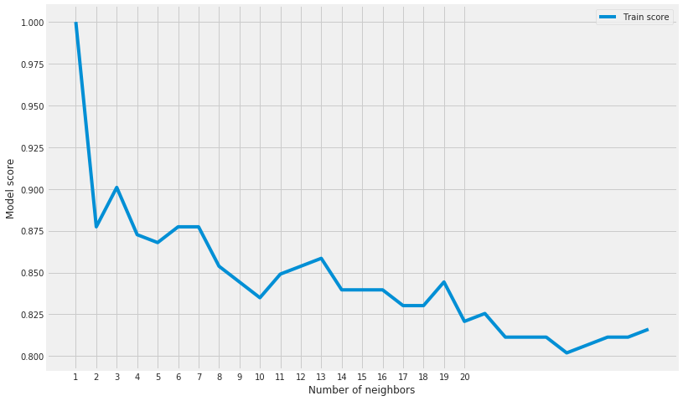

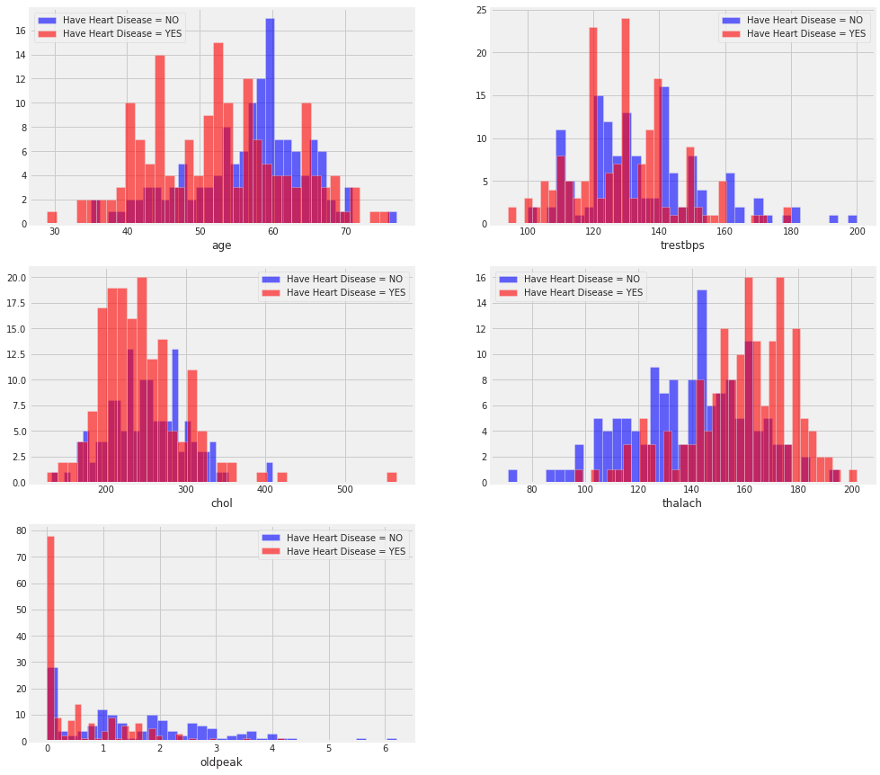

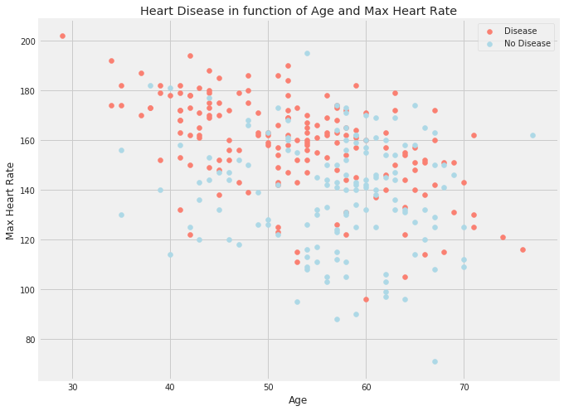

Conclusion :
Heart Diseases in humans are the most common. One of them, which is Heart Attack, is believed to be a peaceful death, too! These diseases are so common in humans, that for people older than 75, congestive heart failure occurs 10 times more often than in younger adults.

