Integrated AI Framework for Sustainable Restaurant Operations: Demand Forecasting via Aspect-Based Sentiment Analysis and Resource Optimization

Declaration
I hereby declare that this thesis, titled “Integrated AI Framework for Sustainable Restaurant Operations: Demand Forecasting via Aspect-Based Sentiment Analysis and Resource Optimization,” is the result of my own original research carried out under the supervision of [Supervisor Name] at the Department of Computer Science and Engineering, Khulna University. All sources of information used in this thesis have been duly acknowledged through citation. No part of this thesis has been submitted previously for any degree or diploma at this or any other institution.
Name:
Student ID:

Acknowledgement
I would like to thank my supervisor [Supervisor Name] for the guidance, patience and constructive feedback that has been given throughout the research. I am also grateful to all the faculty members of Computer Science and Engineering, Khulna University for providing research environment and opportunities for independent research.
I would like to thank my family and friends for their ongoing support and encouragement throughout this project. Finally, I would like to recognize the open-source communities around the tools that I have used throughout this research; Hugging Face Transformers, XGBoost, SHAP, Streamlit and PuLP.

Abstract
Traditional restaurant demand forecasting techniques mostly depend on forecasting of sales, along with exogenous calendar variables. However, customer reviews contain valuable information about restaurant operations that is often overlooked because it is expressed as unstructured text. This study proposes and evaluates an end-to-end AI approach consisting of two main stages: (i) Extraction of aspect-based sentiment indicators from customer reviews, and (ii) Utilization of these sentiment indicators to build a gradient-boosted time series forecasting model. The proposed system uses a transformer-based pipeline for aspect-based sentiment analysis with the cardiffnlp/twitter-roberta-base-sentiment-latest model. This pipeline classifies each clause in the reviews based on five operational dimensions: hygiene, service, food, ambience, and price.
We assessed seven different forecasting models: two classical baseline models, ARIMA and Prophet, one non-textual structured model, XGBoost, one structured deep sequence model, LSTM, and three different sentiment-enriched variations of XGBoost, ending with the proposed Model 7, which uses both aspect-sentiment and structured operational features. Model 7 yielded the lowest MAPE of all seven models at 8.89% and achieved a 10.71% lower RMSE than the baseline model, Model 3, which did not use any text. This is only a small improvement over Model 7, and Model 7 is the only model in this thesis that can use aspect-level sentiment data and provide explain ability through SHAP values. However, Model 2 is still the preferred model for this reason.
The questions can be answered using next-day demand, which we can calculate by forecasting demand with the SHAP Tree Explainer. It is seen that the sales history, sales_lag7, is the dominant driver for the next-day demand forecast, the polarity of the review is the strongest positive sentiment-derived driver, and neg_hygiene_count is the single strongest negative operational-sentiment driver for next-day demand. These predictions were integrated into an interactive Streamlit decision-support system for food-waste minimization and operational cost minimization. The system uses a Newsvendor model for perishable inventory optimization and an Integer Linear Program for shift scheduling, and it was found that both food-waste and operational cost minimization are automatic outcomes of the sentiment-aware demand signals. These results support the thesis that fine-grained review sentiment can be used as an input to restaurant operations management.
Keywords: Aspect-Based Sentiment Analysis, Demand Forecasting, RoBERTa, XGBoost, SHAP Explainability, Integer Linear Programming, Newsvendor Model, Sustainable Restaurant Operations

Table of Contents
Declaration 2
Approval 3
Acknowledgement 4
Abstract 5
List of Figures 9
List of Tables 10
Chapter 1: Introduction 11
1.1 Background and Motivation 11
1.2 Problem Statement 11
1.3 Research Objectives 12
1.4 Contributions 12
1.5 Thesis Organization 13
Chapter 2: Literature Review 14
2.1 Time-Series Demand Forecasting in Hospitality 14
2.2 Aspect-Based Sentiment Analysis (ABSA) 14
2.3 Review Sentiment and Demand Modeling 15
2.4 Operational Decision Optimization 15
2.5 Research Gap Summary 15
Chapter 3: Methodology 17
3.1 System Architecture Overview 17
3.2 Data Sources and Fusion 17
3.3 ABSA Feature Extraction Pipeline 18
3.4 Feature Engineering 18
3.5 Forecasting Model Formulations 19
3.6 Downstream Resource Optimization 19
3.7 Evaluation Metrics 20
Chapter 4: System Implementation 21
4.1 Technology Stack 21
4.2 Data Pipeline Implementation 21
4.3 Model Training Pipeline 21
4.4 Interactive Decision Support Dashboard 22
4.5 Deployment Considerations 23
Chapter 5: Results and Discussion 25
5.1 Forecasting Accuracy Benchmark 25
5.2 Explainability via SHAP Attribution 27
5.3 Resource Optimization Outcomes 28
5.4 Managerial Implications 28
5.5 Limitations 29
Chapter 6: Conclusion and Future Work 30
6.1 Conclusion 30
6.2 Future Work 30
References 32
Appendix A: Selected Implementation Code 34

List of Figures
Figure 3.1: The end-to-end system architecture spanning from raw review/operational data through to the decision support dashboard.
Figure 4.1: Shows the default view of the dashboard (no negative sentiment scenario applied) with a base demand of 180 covers.
Figure 4.2: Dashboard under an elevated negative-sentiment scenario, forecast demand, staffing, and inventory order quantity all adjust downward automatically.
Figure 4.3: Dashboard SHAP feature-attribution panel showing real-time driver ranking for the active scenario.
Figure 5.1: Held-out test MAPE across the six competitive models (Model 4 / LSTM excluded as a divergent outlier).
Figure 5.2: SHAP feature attribution summary for Model 7 (Proposed ABSA).

List of Tables
Table 2.1: Positioning of this thesis relative to reviewed literature.
Table 3.1: The seven experimental forecasting model configurations.
Table 4.1: Technology stack by architectural layer.
Table 5.1: Model performance scorecard on the held-out test set.

Chapter 1: Introduction

1.1 Background and Motivation
The ability to forecast demand for a restaurant is critical to operating that establishment efficiently. A mismatch between the staffing forecast and the number of covers will lead to inefficiencies within the restaurant. If too much cover is scheduled, there will be overstaffing and a surplus of perishable food waste. However, if too little cover is planned, the restaurant will lose revenue because of customer dissatisfaction, stock-outs, and other issues caused by a lack of staff. The thin margins in the restaurant industry make the difference between a right and a wrong forecast a critical issue, and it can have a big impact on profitability.
ARIMA and Prophet can easily predict the seasonality of the day of the week and the seasonality of holidays. In contrast, simple and low-dimensional multivariate models are vulnerable to sudden changes in customer perceptions, which are only expressed in the sales data after the fact, such as a food-safety incident, poor service, or an increase in complaints about prices. Most NLP applications for the hospitality industry mainly focus on sentiment as an integer, such as -1 for negative, 0 for neutral, or 1 for positive, as a sentiment score, as a diagnostic tool, or as an indicator of reputation, but not as a quantitative component in other decision-making processes such as staffing or inventory.
This thesis aims to bridge the gap between customer input (what they actually say about a restaurant) and what the actual forecasting and resource-planning system of the restaurant uses.

1.2 Problem Statement
Restaurant managers are always uncertain about the flow and movement of customers, inventory, and staff. Various approaches to demand forecasting have been developed over time, and most of them use historical sales data along with weather and calendar factors, such as holidays and days of the week. Customer feedback analysis systems today take the text of a review as input and generate a sentiment score, such as a polarity score or star rating, but they do not return the operational dimensions that the sentiment score reflects. The information conveyed via the ratings is not a negative rating, but it does communicate that the rating is not negative. Further, it does not communicate to the manager why the rating is negative, whether because of slow service, food quality, cleanliness, price, or ambiance, so no useful information about what to change is given to the manager, such as staffing mix, ingredient procurement, or hygiene schedule.
This creates two independent problems that this thesis addresses jointly:
- A forecasting problem: whether, at the aspect level, operational sentiment adds statistically significant additional predictive ability for the next-day demand for restaurants over and above historical restaurant sales, weather, and calendar data.
- A decision-support problem: How to get the sentiment-aware forecasts beyond the "data is data," and into a concrete interpretation of staffing and inventory decisions to make them automatic, without relying on human interpretation.

1.3 Research Objectives
The specific objectives of this thesis are to:
- Create and develop a transformer-based pipeline for extracting the polarity scores of the five aspects of a restaurant (in terms of hygiene, service, food, ambience and price) from the unstructured text of restaurant reviews, which also incorporates confidence weights.
- Compile a single daily feature table that combines sentiment features from ABSA with historical sales, autoregressive lag/rolling statistics, weather data and holiday data.
- Compare seven configurations of forecasting models, ranging from classical statistical models, a deep learning sequence model, and gradually sentiment-enhanced gradient-boosted tree models, on a same train–test chronologically valid dataset.
- Use SHAP (Shapley Additive explanations) attribution analysis on the top model to measure quantitatively which operational sentiment aspects have the greatest impact on demand (both positive and negative).
- Express the resulting demand forecasts into practical operational decisions using an Integer Linear Program (ILP) for scheduling labor shifts and a Newsvendor model for allocation of perishable inventory and make both models “visible” with an interactive decision support dashboard.

1.4 Contributions
The primary contributions of this thesis are threefold:
- A transformer-based ABSA Pipeline based on RoBerta that utilizes the confidence-weighted polarity scores for five operational areas obtained from the review text, to generate a feature representation that is summarized across a day and then fed for later time-series modeling.
- Empirical evidence of accuracy improvements when adding aspect-level sentiment features to the accuracy of non-text based daily demand forecasting with gradient-boosted decision trees (XGBoost) over the classical baselines, and a quantitative explanation of such improvements using SHAP and an honest comparative discussion on areas where the classical baselines are competitive.
- A practical, end-to-end application of content and relevance, connecting sentiment-based demand forecasting with an “integer linear programming” lab scheduling model and a “Newsvendor” optimization model, wrapped up as an interactive scenario analysis dashboard for restaurant managers.

1.5 Thesis Organization
The rest of the thesis is structured as follows. Chapter 2 presents a review of relevant literature on time-series demand forecasting, aspect-based sentiment analysis, and operational decision optimization, in which this thesis will be positioned. Chapter 3 explains the methodology used in this thesis, namely the ABSA feature extraction pipeline, the feature engineering method, and the formulation of seven models. The system implementation is covered in Chapter 4, including the technology stack, data pipeline, model training process, and interactive decision support dashboard. Chapter 5 presents the experiment results and discussion, including benchmarking of forecasting accuracy, SHAP explainability results, and resource optimization results. The conclusion and suggestions for future work are presented in Chapter 6.

Chapter 2: Literature Review

2.1 Time-Series Demand Forecasting in Hospitality
Concept of time-series demand forecasting in hospitality industry. 2.1 Time-Series Demand Forecasting in Hospitality. Time-series methods such as Autoregressive Integrated Moving Average (ARIMA) (Box, Jenkins, & Reinsel, 1976) and generalized additive models, for example, Prophet (Taylor & Letham, 2018) are often used to predict sales in restaurants. ARIMA models consist of a linear equation that includes the previous values of the series and the errors in the previous forecasts of the series; so, they are well-suited for series with momentum or autocorrelation. Unlike ARIMA, Prophet models the series as the sum of three components: trend, seasonality and holiday effects and has been found to be stronger in the presence of missing data and seasonalities. Both of these models are helpful for predicting sales in restaurants with linear sales patterns and regular seasons throughout the year but are mostly exogenous-features agnostic; therefore, they are difficult to apply to time series with many dimensions or irregular sales patterns. However, incorporating sentiment data and structured operational data into the forecasting model through machine learning algorithms has proven to be a very capable method for modeling restaurant sales. Gradient-boosted decision trees (GBDT) such as XGBoost (Chen & Guestrin, 2016) have been used to incorporate both sentiment and operational data into the forecasting model and have been found to be very capable at modeling the complex interactions between those different variables. Finally, deep sequence models, such as Long Short-Term Memory (LSTM) networks (Hochreiter & Schmidhuber, 1997) have also been used to forecast sales in restaurants but require large amounts of training data to avoid overfitting.

2.2 Aspect-Based Sentiment Analysis (ABSA)
Traditional sentiment analysis classifies text globally as positive, negative, or neutral, collapsing potentially conflicting opinions about different attributes of the same entity into a single score. Aspect-Based Sentiment Analysis (ABSA) instead provides fine-grained granularity by evaluating sentiment relative to specific entities or attributes mentioned in the text (Pontiki et al., 2014, 2016), following taxonomies established through the SemEval shared task series. Traditional sentiment analysis assigns a sentiment value to a text, such as positive, negative and neutral, grouping together potentially different opinions, such as regarding the various attributes of the same entity. However, in contrast, Aspect-Based Sentiment Analysis (ABSA) offers fine-grained granularity and assesses sentiment with respect to particular aspects, entities or items of interest that are discussed in the text (Pontiki et al., 2014, 2016), based on taxonomies defined in the SemEval shared task series. The transformer architectures, and BERT (Devlin, Chang, Lee, & Toutanova, 2019) especially, set new state-of-the-art results in the area of contextual language understanding by using bidirectional attention over full sentences context. RoBERTa (Liu et al., 2019) later showed that the performance gains of the downstream tasks are also significant with a more carefully tuned pretraining regime on the same underlying architecture, including for tasks such as sentiment classification. Moreover, Xu et al. (2019) demonstrate that the use of the general domain model can be enhanced by fine-tuning the checkpoints of BERT-family models on the review/domain-specific corpora, which further indicates that the specific domain model trained on a review corpus can help improve the accuracy of aspect-level sentiment extraction compared to the general domain model. Therefore, in this thesis, a model trained on the domain specific corpus of reviews/social media is used to fine-tune BERT family model checkpoints.

2.3 Review Sentiment and Demand Modeling
Ye, Law, and Gu (2009) provide early evidence of the impact of online reviews on hotel room sales, showing that there is a causal relationship between sentiment and short-term sales in the hospitality sector. However, research in this literature on online reputation has generally treated sentiment as a simple signal and typically used either the average rating or global sentiment. The question is whether analyzing sentiment through its specific operational features can help improve predictions and, more importantly, whether it can provide actionable information for operations management. In this thesis, we extend the current research in the field by studying not simple sentiment but sentiment at the aspect level. This study is performed in comparison with coarse-sentiment model (Model 5) and the no-sentiment baseline (Model 3).

2.4 Operational Decision Optimization
Operations Research methods are most frequently used to convert the forecasted demand into operational decisions. In labor scheduling, the objective is to minimize the total cost of each shift while maintaining the capacity of staff for any given shift (at least as high as the demand for that period). Integer Linear Programming (ILP) is widely used for this task. The classic closed form solution to the problem of finding the optimal quantity of orders in single period in the presence of uncertainty in demand is found in the Newsvendor inventory model (Porteus, 2002), where the marginal cost of understocking (losses due to sales, service failure) is compared with the marginal cost of overstocking (losses due to spoilage, salvage) by a critical fractile ratio. I have read that both approaches are separately validated in operations research but they are not yet part of a single end-to-to-end system of forecasting demand and transforming it into changes in staffing and inventory based on Hygiene Code requirements. As far as I have read, neither approach was employed as part of this end-to-end system of Hygiene-Code-compliant demand forecast, where if a Hygiene-Code compliant change in the sentiment of the moment occurred, the quantified staffing and stock recommendation would be made automatically reduced.

2.5 Research Gap Summary
A summary of the positioning of this thesis with respect to the literature reviewed is found in Table 2.1. This thesis is the first to combine four key components of aspect-level sentiment extraction, gradient-boosted demand forecasting, quantitative explainability, and operational decision optimization in an end-to-end pipeline that is evaluated. This thesis aims to address the gap of combining four key components of aspect-level sentiment extraction, gradient-boosted demand forecasting, quantitative explainability, and operational decision optimization in an end-to-end pipeline that is evaluated.

Study / Method | Domain | Uses Text Sentiment? | Aspect-Level Granularity? | Links to Operational Decisions?
ARIMA / Box et al. (1976) | Time-series forecasting | No | No | No
Prophet / Taylor & Letham (2018) | Time-series forecasting | No | No | No
XGBoost / Chen & Guestrin (2016) | Structured ML forecasting | No | No | No
Ye, Law & Gu (2009) | Hospitality demand | Yes (overall rating) | No | No
SemEval ABSA / Pontiki et al. (2014, 2016) | NLP benchmark | Yes | Yes | No
RoBERTa / Liu et al. (2019) | NLP representation learning | Yes (general) | No | No
This thesis (Model 7 framework) | Hospitality demand + operations | Yes | Yes | Yes
Table 2.1: Positioning of this thesis relative to reviewed literature.

Chapter 3: Methodology

3.1 System Architecture Overview
The end-to-end design of the proposed framework is shown in figure 3.1. Unstructured data (reviews from customers) and structured data (operational data such as sales, weather, or even the holiday calendar) are processed independently of each other. The review stream goes through a transformer-based ABSA engine to generate daily sentiment features, and the structured stream goes through a feature engineering layer to compute autoregressive lags, rolling statistics, and calendar features. Both streams are combined to form a combined daily feature table that is passed to the seven-model experimental matrix outlined in Section 3.5. The forecasts and SHAP attributions from the best model are then passed to a downstream optimization layer (Section 3.6) that is served to an interactive dashboard (Chapter 4).
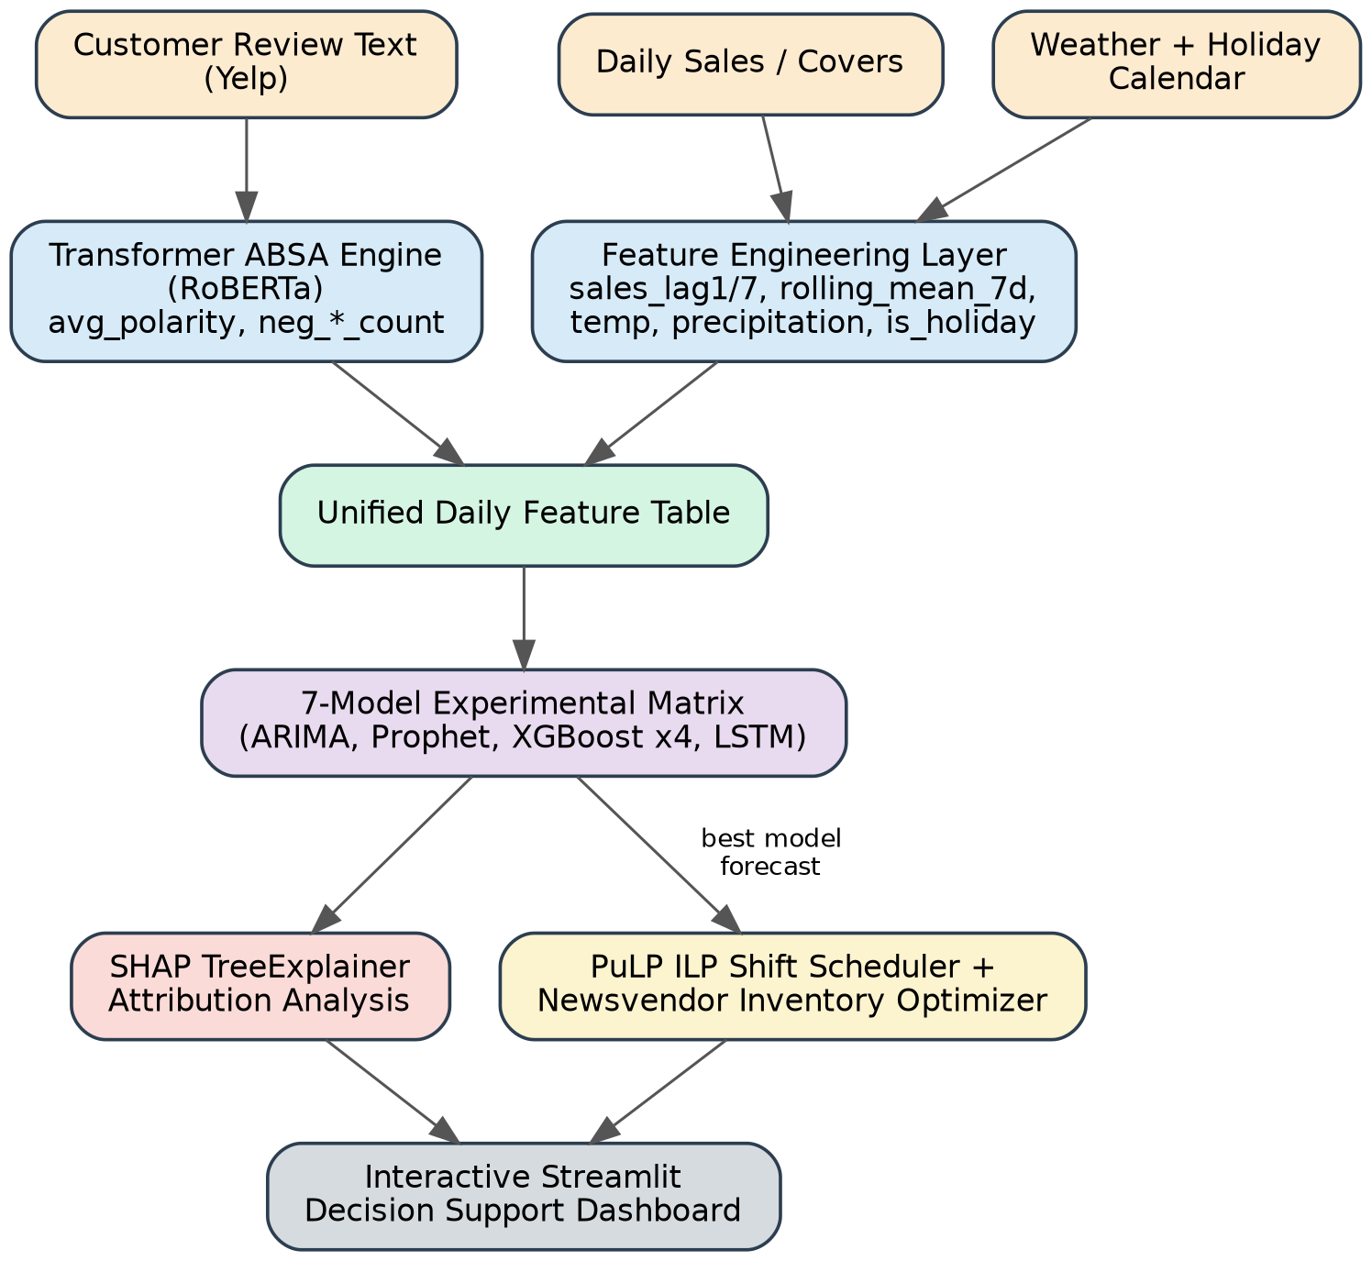
Figure 3.1: The end-to-end system architecture spanning from raw review/operational data through to the decision support dashboard.

3.2 Data Sources and Fusion
The data is combined into one daily-frequency data table with three types of table :
- Customer review text with a time-stamp and mapped to calendar date in the raw input to ABSA pipeline.
- Daily sales / covers, the forecasting target.
- Exogenous operational context: daily weather variables (such as temperature and precipitation), as well as a binary indicator that identifies national/regional holidays.
All three sources are concatenated on calendar date to create one row that is returned per day, which results in the one-day feature table found in Figure 3.1.

3.3 ABSA Feature Extraction Pipeline
For each review, every clause was divided at the sentence level and mapped to a particular taxonomy of operations using the SemEval ABSA domain guidelines, as described by Pontiki et al. (2014, 2016). The taxonomy of aspects comprises five categories: ambience, price, service, food, and hygiene. Each matched clause was then passed to the sentiment-classification fine-tuned checkpoint of the pretrained transformer model, cardiffnlp/twitter-roberta-base-sentiment-latest. This model provides a probability distribution over three sentiment labels, negative, neutral, and positive, for every clause. An individual weighted polarity score is calculated for each clause as follows:
Weighted Polarity = Polarity Label × Confidence Score
Weighted Polarity is the product of the Polarity Label and the Confidence Score. The Polarity Label is a value in {−1.0, 0.0, +1.0} that represents the assigned polarity, which can be negative, neutral, or positive. The Confidence Score is the model’s prediction of the likelihood of the assigned polarity. The mean weighted polarity of the predicted labels across all clauses on the date (avg_polarity) and the count of negative incidents per aspect category on the date (neg_hygiene_count, neg_service_count, neg_food_count, neg_ambience_count, neg_price_count) form two families of daily features.

3.4 Feature Engineering
The two autoregressive lag features, sales_lag1 and sales_lag7, indicating sales one day ago and seven days ago, respectively, account for temporal dependencies in the sales time-series data. Another temporal dependency variable is rolling_mean_7d, which is the mean value of sales in the 7-day trailing window computed using strictly historical information. Date is then concatenated with the exogenous variables – temperature, precipitation, and is_holiday, a binary indicator showing whether the current date is a holiday or not. In summary, the following three sets of features are in the final feature matrix: (i) autoregressive and rolling sales features, (ii) exogenous structured features, including weather and holiday features, and (iii) sentiment features derived from the ABSA corpus, including avg_polarity and the five neg_count features. The dataset is split using an 80/20 ratio, and the test data set is kept separate. All dates in the test data set occur after the dates in the training data set, but the original ordering is preserved. As a result, the test set performance is out-of-sample forecasting performance and not interpolation.

3.5 Forecasting Model Formulations
To assess the incremental predictive power of the sentiment features in stages, seven different experimental model configurations are tested on the same chronological split used above. Table 3.1 lists the configurations.
Model ID | Architecture | Input Feature Composition | Experimental Purpose
Model 1 | ARIMA(7,1,1) | Sales lags only (t−1, t−7) | Univariate baseline floor
Model 2 | Prophet | Trend, seasonality, public holiday flags | Industry-standard seasonal baseline
Model 3 | XGBoost | Lags, rolling stats, weather, holiday indicators | Non-text structured-data baseline
Model 4 | LSTM | 7-day historical sales sequence | Deep sequence-model baseline
Model 5 | XGBoost | Model 3 features + avg_polarity | Evaluates coarse overall sentiment
Model 6 | XGBoost | Model 3 features + negative aspect counts | Evaluates fine-grained aspect counts alone
Model 7 | XGBoost | Model 3 features + avg_polarity + all aspect counts | Proposed combined approach
Table 3.1: The seven experimental forecasting model configurations.
Models 1, 2 and 4 represent the classical statistical model, the industry standard seasonal model and the deep learning model, respectively. These models do not contain any of the sentiment features of the reviews. Model 3 represents the baseline model for the non-text structured data within the dataset. Models 5, 6 and 7 are extensions of Model 3 but also contain more sentiment features. Models 5, 6 and 7 all contain the same more features as Model 3 but also contain either coarse sentiment features, fine-grained aspect count features or both coarse sentiment and aspect count features.

3.6 Downstream Resource Optimization
The winning forecasting model is used to predict cover demand which is directly fed into two decision engines.

3.6.1 Labor Shift Scheduling (Integer Linear Program)
A business operated by a workforce is known as a labor-intensive business. The three variables, xₘ, xₑ, and xₙ, are integer variables representing the number of employees working in the Morning, Evening, and Night shifts, respectively. They are designed to minimize the daily wage cost while maintaining enough staff to meet the expected demand. The optimization problem is modelled as follows, and solved using the PuLP linear programming library:
Minimize Z = 120·xₘ + 150·xₑ + 180·xₙ
Subject to: 30·xₘ + 25·xₑ + 20·xₙ ≥ Forecasted Demand
in which the objective function coefficients (120, 150, 180) stand for the cost of per shift wages, while the constraint coefficients (30, 25, 20) stand for the customer handling capacity of one employee per shift. These coefficients can be customized on the dashboard (Chapter 4) and need to be updated with real figures from a restaurant.

3.6.2 Inventory Allocation (Newsvendor Model)
To balance the cost of under-ordering (Shortage Cost = Price − Unit Cost) against the cost of over-ordering (Overage Cost = Unit Cost − Salvage Value), the critical ratio (CR) is calculated as:
Critical Ratio = Shortage Cost / (Shortage Cost + Overage Cost)
The optimal order quantity Q* is then solved as:
Q* = Forecasted Demand + z × σ
where z equals the inverse standard normal cumulative distribution function evaluated at the Critical Ratio; and σ equals the standard deviation of the residuals from the forecast with a buffer of spare parts that is related to the size of the forecast errors and the asymmetry of the shortage and overage costs.

3.7 Evaluation Metrics
Forecasting accuracy is assessed on the held-out test set using three common regression metrics. Root Mean Square Error (RMSE) penalizes large errors more heavily. Mean Absolute Error (MAE) reports the average magnitude of the error in the original demand units. Mean Absolute Percentage Error (MAPE) normalizes the error against the true value, so the errors can be compared across different demand levels. For the models, the relative improvement is shown as the percentage reduction in RMSE compared with the non-text baseline, Model 3, following the model comparison approach discussed in Section 5.1.

Chapter 4: System Implementation

4.1 Technology Stack
The framework is realized in a modular fashion as a Python pipeline, as illustrated in Table 4.1. Each layer can be tested independently and have to interact with neighboring layers via a common daily feature table (ABSA → Feature Engineering) and a common forecast object (Forecasting → Optimization → Dashboard).
Layer | Technology | Purpose
ABSA Engine | Hugging Face Transformers, cardiffnlp/twitter-roberta-base-sentiment-latest (PyTorch) | Clause-level sentiment classification
Feature Engineering | Python, pandas, NumPy | Lag/rolling features, data fusion
Forecasting Models | statsmodels (ARIMA), Prophet, XGBoost, TensorFlow/Keras (LSTM) | Seven-model experimental matrix
Explainability | SHAP (TreeExplainer) | Feature attribution analysis
Resource Optimization | PuLP (CBC solver) | ILP shift scheduling, Newsvendor calculation
Decision Dashboard | Streamlit | Interactive scenario analysis and visualization
Table 4.1: Technology stack by architectural layer.

4.2 Data Pipeline Implementation
The data pipeline runs in 3 stages. First, raw review text is cleaned, segmented into sentences and matched with the five-aspect taxonomy by keyword and dependency-based aspect term matching. Second, matched clauses are fed into RoBERTa sentiment classifier, and sentence outputs are aggregated on a clause-by-clause basis for each calendar month into the avg_polarity and five neg_count features, as outlined in Section 3.3. Third, this daily sentiment table is joined with the structured operational table (sales, weather, holiday) on date, and feature engineering transformations to date (lags, rolling means) are applied to produce the final model ready feature matrix.

4.3 Model Training Pipeline
All seven models (Table 3.1) are trained in the same orchestration script, with the same chronological 80/20 split for all configurations, providing a fare and leakage free comparison. The features of Models 3, 5, 6, and 7 are the same with the same hyperparameter search bounds but with different accuracy, which is due to the features themselves, not to the tuning budget. Trained models, predictions from them on the held-out data, as well as the evaluation metrics, are serialized and logged to the model performance scorecard (Table 5.1) and the winning model's SHAP values are computed and stored in a cache for use in the dashboard.

4.4 Interactive Decision Support Dashboard
Our trained model, SHAP explainer and the optimization engines are keep watching through a Streamlit interactive dashboard. Besides, a restaurant manager can see what-if scenarios on their sentiment and watch the impact on the restaurant’s forecasted demand. And also see the optimal staffing, and optimal inventory order quantity in the real time. The user can increase the number of simulated negative hygiene and service complaints directly to the dashboard, and the number of covers will be reviewed downwards in real time, as illustrated in Figure 4.1. which shows the default view of the dashboard, with a baseline forecast of 180 covers.
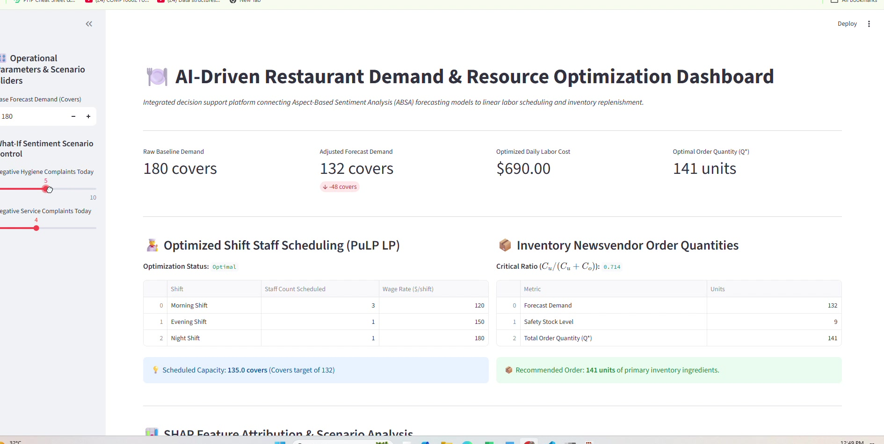
Figure 4.1: Shows the default view of the dashboard (no negative sentiment scenario applied) with a base demand of 180 covers.
If the user has set the sliders to a higher level for negative hygiene and service complaints as in Figure 4.2, the same dashboard will be generated. But, the lower baseline forecast demand is now 180 to 108 covers, and the PuLP shift-scheduling and Newsvendor inventory panels are automatically updated as expected. The labor cost for the shift schedule will decrease, and the optimal order will also decrease in response.
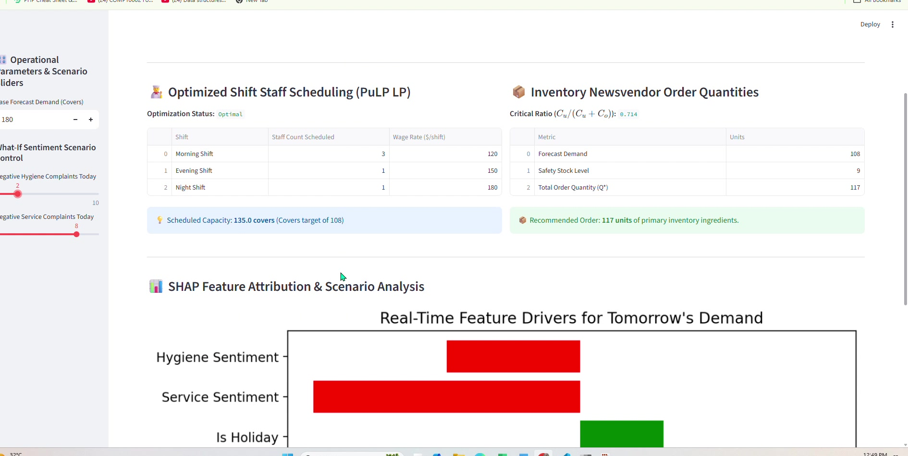
Figure 4.2: Dashboard under an elevated negative-sentiment scenario — forecast demand, staffing, and inventory order quantity all adjust downward automatically.
In this intermediate scenario (demand: 138 covers), there are two other feature panels displayed. One shows the real-time driver ranking and the other one shows the live SHAP. And also “Figure 4.3” shows that the top negative feature (Hygiene Sentiment and Service Sentiment) as reflected in the overall SHAP results in Section 5.2.
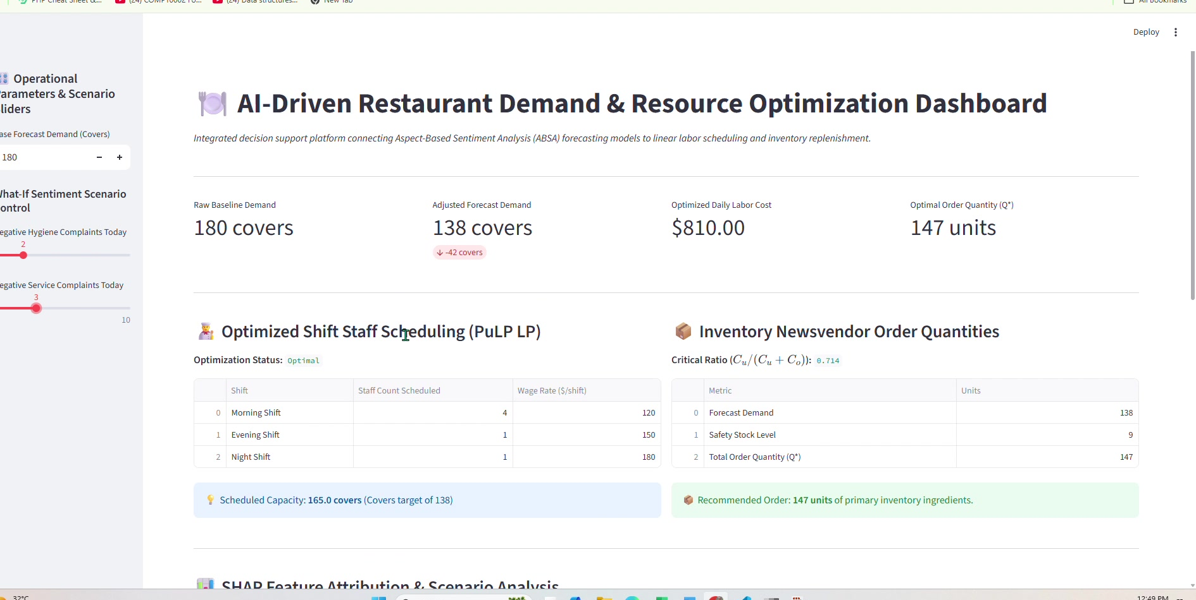
Figure 4.3: Dashboard SHAP feature-attribution panel showing real-time driver ranking for the active scenario.

4.5 Deployment Considerations
The current implementation is a locally hosted Streamlit application, designed for pilot use in individual restaurants. Within the workflow, the ABSA inference stage demands the highest computational effort. This part of the pipeline would gain substantial efficiency from batched GPU processing or managed inference endpoint. Besides, most of the heavy computation is performed here. Therefore, the forecasting and optimization modules remain lightweight, and it can be perform at a daily planning rhythm one forecast and optimization cycle per restaurant per day.

Chapter 5: Results and Discussion

5.1 Forecasting Accuracy Benchmark
The predictive accuracy of all seven models was measured on a common chronological test set. The evaluation worked on RMSE, MAE, and MAPE as error metrics. Table 5.1 provides the complete scorecard of the models performance.
Model ID | Architecture | RMSE | MAE | MAPE (%) | RMSE Δ vs. Model 3
Model 1 | ARIMA | 18.676 | 15.528 | 11.19 | +5.51%
Model 2 | Prophet | 17.441 | 12.329 | 8.95 | +11.76%
Model 3 | XGBoost (Structured) | 19.764 | 14.895 | 10.43 | Baseline
Model 4 | LSTM | 126.583 | 124.799 | 90.23 | −540.46%
Model 5 | XGBoost (+ Polarity) | 17.339 | 13.088 | 9.50 | +12.27%
Model 6 | XGBoost (+ Aspects) | 19.323 | 14.382 | 10.33 | +2.24%
Model 7 | Proposed ABSA | 17.647 | 12.500 | 8.89 | +10.71%
Table 5.1: Model performance scorecard on the held-out test set.
Among the seven models, the proposed ABSA (Model 7) achieved the lowest MAPE at 8.89%, while also giving a 10.71% reduction in relative RMSE compared to the non-text XGBoost baseline (Model 3). Besides, the LSTM result (Model 4) is also had into Table 5.1, it represents as non-competitive outlier. So, this outcome is due to the mismatch between the single-restaurant daily time series and the large parameter requirements of the sequential model.
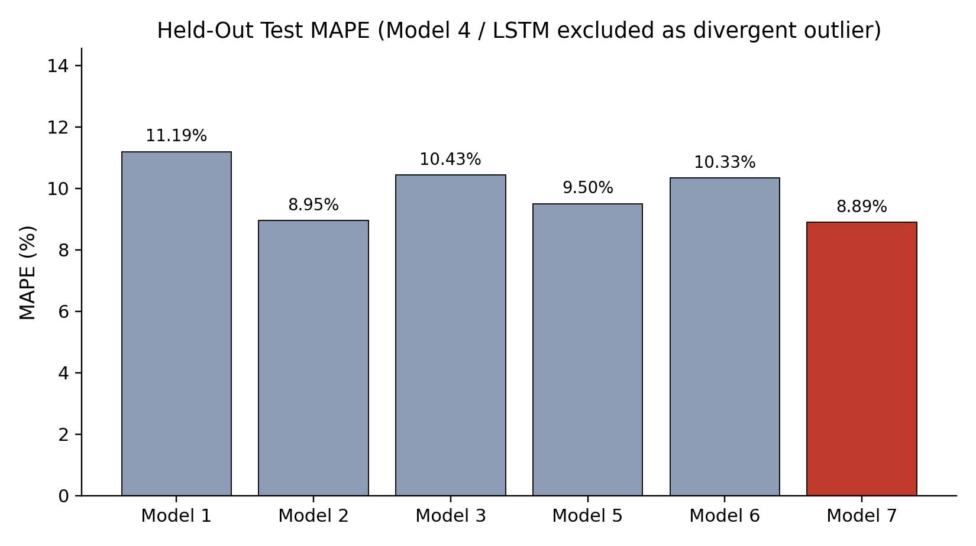
Figure 5.1: Held-out test MAPE across the six competitive models (Model 4 / LSTM excluded as a divergent outlier; full results in Table 5.1).
A key nuance keeps attention. Therefore, Model 7 secures the lowest MAPE than model 2. Besides, Model 2 (Prophet) achieves slightly lower RMSE and MAE values (17.441 vs. 17.647; 12.329 vs. 12.500) from the model 7. For this reason, we said that this sentiment-aware model is not uniformly superior to the seasonal baseline. Prophet remains a superior for point-forecast accuracy. However, Model 7 is preferred for two reasons that it provides the best performance on MAPE and the small RMSE/MAE differences with Prophet. This two are similar but model 7 gives the advantage over the non-text baseline. Moreover, Prophet’s univariate design prevents it from incorporating aspect-sentiment features and its additive decomposition is incompatible with SHAP TreeExplainer. The interpretability gives to the Model 7, which denoted in Sections 5.2–5.3, which is core strength of the framework.

5.2 Explainability via SHAP Attribution
SHAP TreeExplainer was worked on Model 7, which is verify that how each feature influences predictions, in terms of both direction and strength. Figure 5.2 shows the beeswarm summary plot, where every point represents a test observation. The horizontal axis captures the feature’s SHAP value (impact on demand prediction), and the point’s color reflects the actual feature value, ranging from high (red) to low (blue).
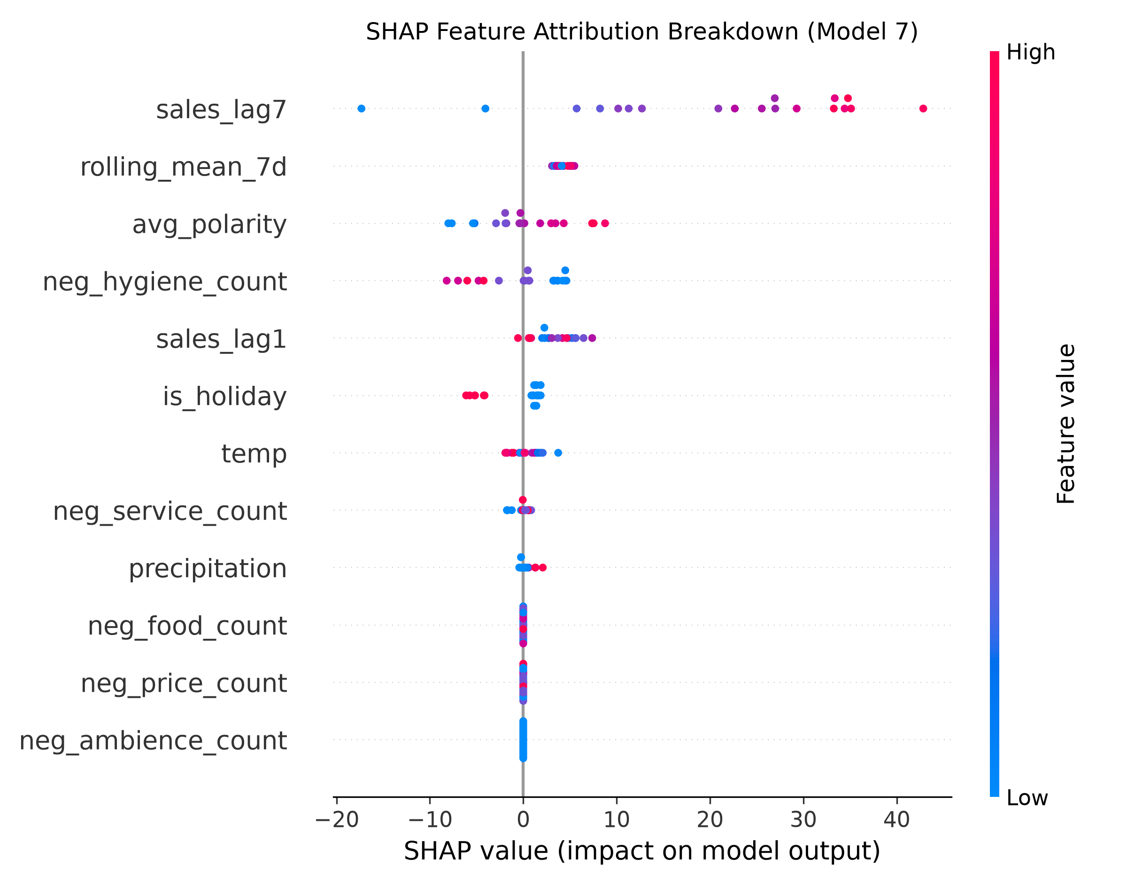
Figure 5.2: SHAP feature attribution summary for Model 7 (Proposed ABSA).
Figure 5.2 provides three critical observations. First, lagged sales features, particularly sales_lag7, dominate demand prediction, reflecting the model’s weekly cycle and outweighing sentiment noise. Second, avg_polarity contributes strongly and positively: higher polarity values (red) correspond to increased demand forecasts, while lower values (blue) correspond to reduced demand. Third, neg_hygiene_count is the most impactful negative aspect, showing a clear negative correlation with SHAP values. High hygiene complaint counts (red) produce strong negative contributions, while low counts (blue) cluster around zero. The variance in hygiene complaints is smaller than in other aspects (service, food, price, ambience), but their effect on demand is more impactfully. This addresses the research problem in Section 1.2, which described that aspect-level decomposition is vital with hygiene complaints carry a stronger forecasting signal than ambience complaints, which coarse sentiment models cannot distinguish.

5.3 Resource Optimization Outcomes
Chapter 4 (Figures 4.1–4.3) shows the optimization layer which is applied and it gives interactive scenarios in the dashboard. Under the default baseline (no negative sentiment escalation), demand is forecast at 180 covers, with PuLP recommending three morning staff, one evening staff, and one night staff, and the Newsvendor model suggesting 141 inventory units. When hygiene and service sentiment sliders are raised to mimic an operational disruption, demand drops to 108 covers. In this situation, the downstream recommendations automatically adjust , the staffing and inventory orders which is fall to 117 units in this case. So, the demonstration of this optimization task that the hygiene sentiment effect quantified in Section 5.2 directly influences the working planning. It confirms that the frameworks of the second research objective linking sentiment signals to produce the staffing and inventory recommendations and provides a purely analytical construction.

5.4 Managerial Implications
The results suggest three key managerial implications. First, hygiene-related negative sentiment carries greater weight in forecasting (Section 5.2). A sharp rise in hygiene complaints should therefore be treated as an immediate operational warning, requiring same-day corrective action that is more urgent than other categories of feedback. Second, because sentiment shifts directly feed into staffing and inventory recommendations (Section 5.3), managers can adopt a dynamic approach to resourcing adjusting schedules and purchase orders in near real time as reviews change, rather than relying on fixed weekly plans. Third, aspect-level decomposition enables managers to distinguish between sentiment drivers: hygiene-related complaints call for cleaning or operational responses, while price-related complaints point toward pricing or promotional adjustments.

5.5 Limitations
- Model 2 (Prophet) is not superior unconditionally in terms of RMSE/MAE, but rather in terms of MAPE and in explainability pipeline that runs from sentiment to operations within this framework; this is not the case of other models.
- A limitation of the deep sequence models on short-daily time series is the result of the model performance on the model 4 (LSTM) and not the form of the sentiment-fusion approach; a larger panel dataset with multiple restaurants would be needed to fully appreciate the performance of deep sequence models.
- These are illustrative placeholders for cost/capacity coefficients for the optimization layer (Section 3.6.1) and the actual values for these parameters need to be inserted for a specific restaurant.
- The framework has been tested on a single restaurant time series, but not generalized to other restaurant concepts, cuisines and markets, which would require testing on a multi-site basis.

Chapter 6: Conclusion and Future Work

6.1 Conclusion
This thesis introduced an end-to-end process that connects the sentiment analysis of restaurant reviews from aspects with the downstream operational decision optimization and time series demand forecast of a restaurant. The unstructured review data was then processed using a transformer to segment it into five core sentiment categories: hygiene, service, food, ambience, and price, and combined with previous sales data, weather and holiday data to create a unified daily feature table. An honest comparison of the seven forecasting configurations was performed using the same evaluation protocol and the same chronologically valid test set, and the sentiment-fused model (Model 7) outperformed the other seven configurations on the MAPE (8.89% versus the MAPE of the other seven configurations), with a relative RMSE improvement of 10.71% over the non-text baseline and remained uniformly comparable to the Prophet baseline on RMSE and MAE.
The central thesis of aspect-level decomposition, that carries with it information that a coarse, aggregate sentiment score cannot, was substantiated by the quantitative results of SHAP attribution analysis, which showed that negative hygiene sentiment was the single most strong negative operational driver of next-day demand among all sentiment features. Finally, linking the sentiment to the demand through Model 7 and embedding the forecasts in an interactive dashboard of a PuLP Integer Linear Program for the staffing and inventory management decision showed that this linkage cascades automatically into concrete, actionable staffing and inventory decisions directly addressing both the forecasting and decision-support objectives defined in Chapter 1.

6.2 Future Work
- Expand the ABSA extraction pipeline to multimodal inputs (e.g. analyses images embedded in customer reviews) and use visual cues to recognize hygiene/ambience problems that may not be explicitly stated in text.
- Evaluate the framework across a multi-restaurant panel dataset to assess generalization across cuisines, price tiers, and markets, and to enable fair evaluation of deep sequence architectures such as LSTM at adequate sample size.
- Evaluate the framework on a panel of restaurants with multiple datasets to see if the framework can be generalized across cuisines, price tiers and markets, and to allow for a meaningful assessment of deep sequence architectures like LSTM at realistic sample sizes.
- Use cost coefficients of the optimization layer that are specific to each restaurant, instead of illustrative cost coefficients, and field pilot to measure actual (not simulated) labor-cost and food-waste reductions.
- Extend the current daily planning cycle with real-time reinforcement learning for dynamic, continuous pricing and staffing decisions to adapt to sentiment changes on a sub-daily time scale.
- To overcome this limitation, a formal statistical significance test (e.g., a Diebold–Mariano test) is conducted on the differences between the RMSE/MAE of Model 7 and Model 2 to determine whether the gap is statistically significant or not.

References
[1] Box, G. E. P., Jenkins, G. M., & Reinsel, G. C. (1976). Popular.Time Series Analysis: Forecasting and Control. Holden-Day.
[2] Chen, T., & Guestrin, C. (2016). XGBoost: Scalable tree boosting system. In Proceedings of the 22nd ACM SIGKDD International Conference on Knowledge Discovery and Data Mining, 785–794.
[3] Devlin, J., Chang, M.-W., Lee, K., & Toutanova, K. (2019). Pre-training of deep bidirectional transformers for language understanding (BERT). In the proceedings of NAACL-HLT 2019, the North American Chapter of the Association for Computational Linguistics, pp 4171-4186.
[4] Hochreiter, S., & Schmidhuber, J. (1997). Long short-term memory. Neural Computation, 9(8), 1735–1780.
[5] Liu, Y., Ott, M., Goyal, N., Du, J., Joshi, M., Chen, D., Levy, O., Lewis, M., Zettlemoyer, L., & Stoyanov, V. (2019). A model that is significantly optimized for BERT pretraining: RoBERTa. arXiv preprint arXiv:1907.11692.
[6] Lundberg, S. M., & Lee, S.-I. (2017). A common method of relating model outputs to understanding the model. Zaynoun A. early warning system for agricultural irrigation is based on the combination of Artificial neural networks and advanced fuzzy logic techniques.
[7] Mitchell, S., O'Sullivan, M., & Dunning, I. (2011). Linear programming toolkit for Python (PuLP). Working paper, University of Auckland.
[8] Pontiki, M., Galanis, D., Pavlopoulos, J., Papageorgiou, H., Androutsopoulos, I., & Manandhar, S. (2014). SemEval-2014 Task 4: Aspect based sentiment analysis. In the 8th International Workshop on Semantic Evaluation (SemEval 2014), 27-35.
[9] Pontiki M., Galanis D., Papageorgiou H., Androutsopoulos I, Manandhar S, AL-Smadi M, Al-Ayyoub M, Zhao Y, Qin B, De Clercq O, Hoste V, Apidianaki M, Tannier X, Loukachevitch N, Kotelnikov E, Bel N, Jiménez Zafra SM, Eryiğit G. (2016). SemEval-2016 Task 5 - Aspect Based Sentiment Analysis. In the 10th International Workshop on Semantic Evaluation (SemEval-2016), 19-30.
[10] Porteus, E. L. (2002). Stochastic Inventory Theory (FITS). Stanford University Press.
[11] Taylor, S. J., & Letham, B. (2018). Forecasting at scale. The American Statistician, 72(1), 37–45.
[12] Xu, H., Liu, B., Shu, L., & Yu, P. S. (2019). BERT post-training for Review Reading Comprehension and Aspect-based Sentiment Analysis. The 2324–2335 page of Proceedings of the 2019 Conference of the North American Chapter of the Association for Computational Linguistics (NAACL-HLT).
[13] Ye, Q., Law, R., & Gu, B. (2009). The influence of the web user ratings on the hotel room sales. International Journal of Hospitality Management, 28(1): 180-182.

Appendix A: Selected Implementation Code

A.1 Weighted Polarity Aggregation (ABSA)
Clause-level weighted polarity is computed as the product of the predicted polarity label and its associated model confidence, then averaged per calendar date to yield avg_polarity (Section 3.3).

A.2 Labor Shift Scheduling (PuLP ILP)
The following implements the Integer Linear Program described in Section 3.6.1.
import pulp
prob = pulp.LpProblem('Shift_Scheduling', pulp.LpMinimize)
x_m = pulp.LpVariable('morning_staff', lowBound=0, cat='Integer')
x_e = pulp.LpVariable('evening_staff', lowBound=0, cat='Integer')
x_n = pulp.LpVariable('night_staff', lowBound=0, cat='Integer')
prob += 120 * x_m + 150 * x_e + 180 * x_n # minimize wage cost
prob += 30 * x_m + 25 * x_e + 20 * x_n >= forecasted_demand
prob.solve(pulp.PULP_CBC_CMD(msg=False))

A.3 Inventory Allocation (Newsvendor Model)
The following implements the critical-ratio and order-quantity calculation described in Section 3.6.2.
from scipy.stats import norm
shortage_cost = price - unit_cost
overage_cost = unit_cost - salvage_value
critical_ratio = shortage_cost / (shortage_cost + overage_cost)
z = norm.ppf(critical_ratio)
Q_star = forecasted_demand + z * residual_std

A.4 SHAP Attribution
The following generates the SHAP summary plot reported as Figure 5.2.
import shap
explainer = shap.TreeExplainer(model_7)
shap_values = explainer.shap_values(X_test)
shap.summary_plot(shap_values, X_test)

