

**AMERICAN INTERNATIONAL UNIVERSITY-BANGLADESH (AIUB)**

Faculty of Engineering

BAE 2101: Computer Aided Design and Drafting

# Title

Design a civil plan/layout of an industrial warehouse with electrical fitting & fixture according to BNBC using AutoCAD.

# Objectives

In this experiment, students will design the **civil plan/layout for an industrial warehouse of a food industry (including storage zones, loading docks, and offices)** in AutoCAD with Electrical Fittings according to Bangladesh National Building Code.

# Experiment to Solve

The experiment should be designed by the students following below mentioned requirements:

|  |  |  |  |
| --- | --- | --- | --- |
| 1. | Draw an **Industrial Warehouse Layout** of total 20000 SFT (approx.)  using AutoCAD Software. | [P1] | **20**  **points** |
| 2. | Draw the **Fittings** for the layout consist of necessary electrical fittings  applying BNBC. | [P4]  [P5] | **10**  **points** |

1. **Lab Project Submission**

|  |  |  |  |
| --- | --- | --- | --- |
| **Course Name:** | COMPUTER AIDED DESIGN & DRAFTING | **Course Code:** | BAE 2101 |
| **Semester:** | Fall 2024-25 | **Section:** |  |
| **Faculty:** |  | **OEL/Project** | 1 |
| **Assessment:** | **OEL (CO2 & CO3), POI: P.e.1.C6** | | |
| **Submission**  **Deadline:** |  | | |

|  |  |  |  |  |  |
| --- | --- | --- | --- | --- | --- |
| **Category** | **Unsatisfactory (1-5)** | **Below Average**  **(6-10)** | **Good (11-15)** | **Excellent (16-20)** | **Secured Marks** |
| Industrial Warehouse Layout | The layout is either copied or very poor with major errors. | The layout is below average or incomplete with major errors. | The layout is drawn partially as per requirement with minor  errors. | The layout is unique and drawn as per requirements with proper dimensions. |  |
| **Comments** |  | **Total Marks:** | | |  |

|  |  |  |  |  |  |
| --- | --- | --- | --- | --- | --- |
| **Category** | **Unsatisfactory**  **(0-3)** | **Below Average**  **(5)** | **Good**  **(7)** | **Excellent**  **(8-10)** | **Secured**  **Marks** |
| Electric Fittings | The fittings are incomplete or copied | The fittings are drawn or placed inappropriately without maintaining BNBC | The fittings are drawn and placed appropriately with partially complying to  BNBC | The fittings are placed appropriately and maintaining BNBC |  |
| **Comments** |  | **Total Marks:** | | |  |

**Group: 01**

|  |  |  |  |  |
| --- | --- | --- | --- | --- |
| **SL #** | **ID** | **Student Name** | **Department** | **Marks** |
| 01 | 24-56372-1 | MD SIFAT HASSAN | CSE |  |
| 02 | 24-56377-1 | MD. MOHAIMANUL HAQUE | CSE |  |
| 03 | 22-48023-2 | MD. AL-IMRAN SAYEM | CSE |  |
| 04 | 22-48055-2 | ABRAR RAFID SHARIAR | CSE |  |
|  |  |  |  |  |

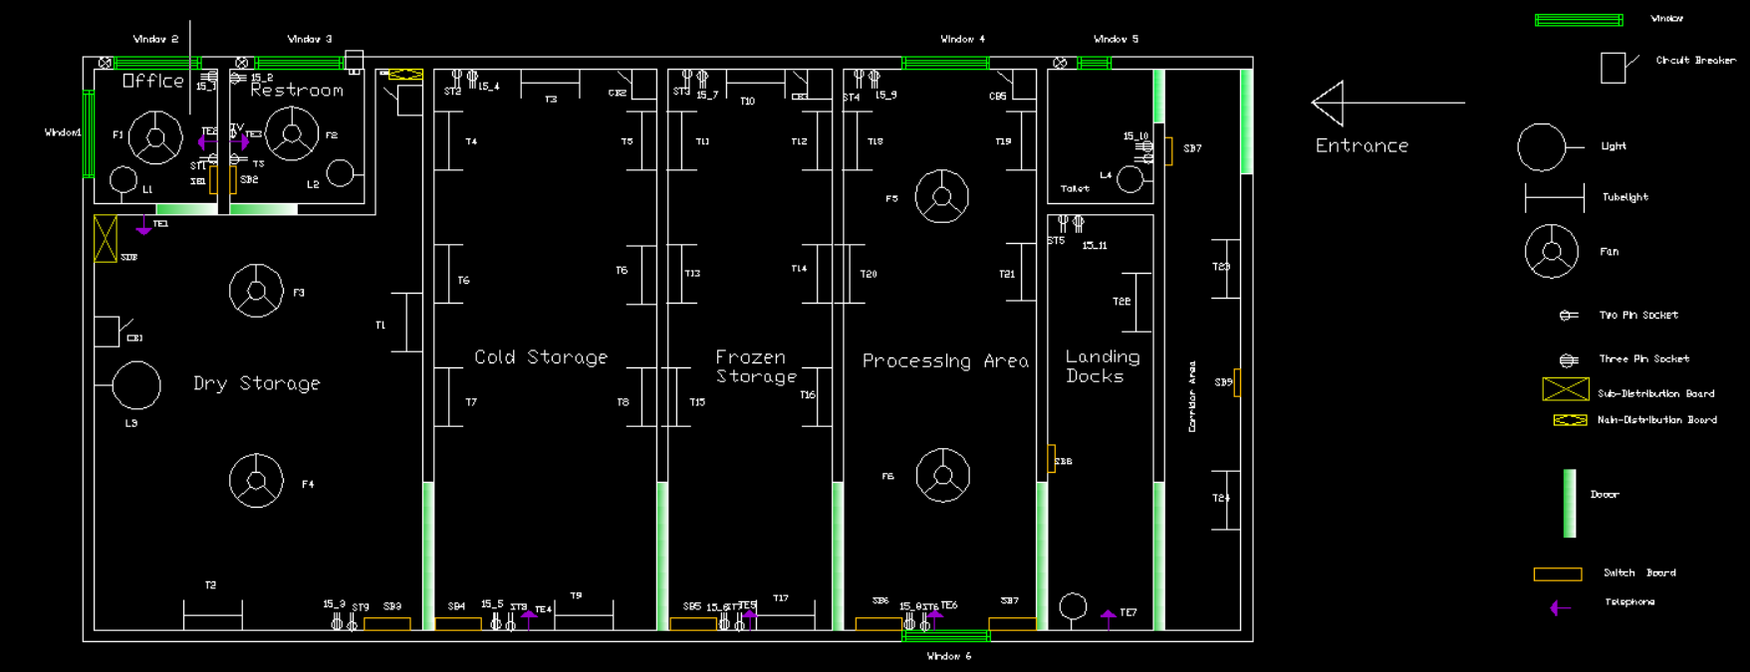**ATTACH SCREENSHOTS BELOW:**

