******AMERICAN INTERNATIONAL UNIVERSITY-BANGLADESH**

**Department of Computer Science**

**OEL Lab Report Cover Sheet**

**Title:** Speed control system based on a obstacle distance.

|  |  |  |  |
| --- | --- | --- | --- |
| **Date of Perform:** | **20 MAY 2025** | **Date of Submission:** | **27 MAY 2025** |
| **Course Title:** | **Microprocessor and Embedded Systems Lab** | | |
| **Course Code:** | **EEE4103** | **Section:** | **Q** |
| **Semester:** | **Spring 2024-25** | **Degree Program:** | **BSc in CSE** |
| **Course Teacher:** | **PROTIK PARVEZ SHEIKH** | | |

**Declaration and Statement of Authorship:**

1. I/we hold a copy of this Assignment/Case Study, which can be produced if the original is lost/damaged.
2. This Assignment/Case Study is my/our original work; no part has been copied from any other student’s work or any other source except where due acknowledgment is made.
3. No part of this Assignment/Case Study has been written for me/us by any other person except where such collaboration has been authorized.

by the concerned teacher and is acknowledged in the assignment.

1. I/we have not previously submitted or am submitting this work for any other course/unit.
2. This work may be reproduced, communicated, compared, and archived to detect plagiarism.
3. I/we permit a copy of my/our marked work to be retained by the Faculty Member for review by any internal/external examiners.
4. I/we understand that Plagiarism is the presentation of the work, idea, or creation of another person as though it is your own. It is a form of cheating and is a very serious academic offense that may lead to expulsion from the University. Plagiarized material can be drawn from, and presented in, written, graphic, and visual forms, including electronic data, and oral presentations. Plagiarism occurs when the origin of the source is not appropriately cited.
5. I/we also understand that enabling plagiarism is the act of assisting or allowing another person to plagiarize or copy my/our work.

*\* Student(s) must complete all details except the faculty use part.*

** Please submit all assignments to your course teacher or the office of the concerned teacher.

|  |  |  |  |  |  |  |
| --- | --- | --- | --- | --- | --- | --- |
| **Group # 08** | | | | | | |
|  |  |  |  | | |  |
| **Sl No** | **Name** | **ID** | **PROGRAM** | | | **SIGNATURE** |
| 1 | MD. AL-IMRAN SAYEM | 22-48023-2 | BSc in CSE | | |  |
| 2 | MD TANJIL TASHRIK ZIM | 22-48021-2 | BSc in CSE | | |  |
| 3 | MD. ABRAR RAFID SHARIAR | 22-48055-2 | BSc in CSE | | |  |
| 4 | HUMAIRA ZANNAT | 22-47789-2 | BSc in CSE | | |  |
| 5 | SANJUKTA DAS | 22-47801-2 | BSc in CSE | | |  |
| ***Faculty use only*** | | | | | | |
| FACULTY COMMENTS | | | | **Marks Obtained** |  | |
|  | | | |
| **Total Marks** |  | |

**Title:** Speed control system based on a obstacle distance.

**Abstract:**

The objective of this experiment is to detect and measure the distance from the obstacle to the object and automatically control the speed based on the distance. When an obstacle is detected within 10 cm, a LED will turn on and the motor will rotate.

**Theory and Methodology:**

Arduino is a open-source platform for creating interactive electronic project . It consists both programable microcontroller and a piece of software that runs on your computer.

**UNO R3 Overview of the Board (Arduino)**

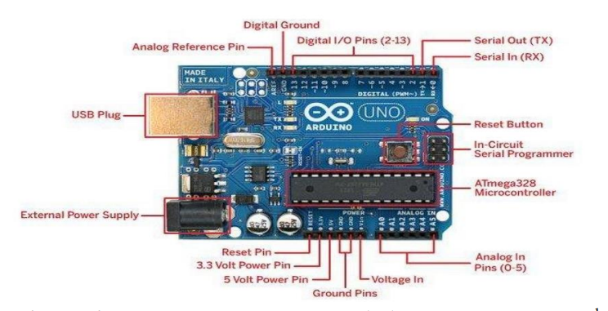

Your explanation is clear and mostly correct, but it can be improved for better readability, accuracy, and professionalism—especially for a report. Here's a polished version of your text with some corrections and enhancements:

**UNO R3 Board Overview (Arduino)**

The **HC-SR04** is an ultrasonic ranging module that consists of a transmitter, receiver, and control circuitry. It has four pins: **VCC**, **GND**, **Trigger**, and **Echo**. The module automatically emits a 40 kHz ultrasonic pulse and listens for the reflected signal.

When the Arduino sends a HIGH signal to the **Trigger** pin, the module emits an ultrasonic burst. This pulse travels through the air, reflects off an object, and returns to the **Echo** pin. The Arduino measures the time interval (in microseconds) between sending the pulse and receiving the echo.

The distance to the object is calculated by the formula:

Distance (cm) =

or in inches,

Distance (in)=

The division by 2 accounts for the fact that the measured time is for the pulse to travel to the object and back, so we take half of it to find the one-way distance.

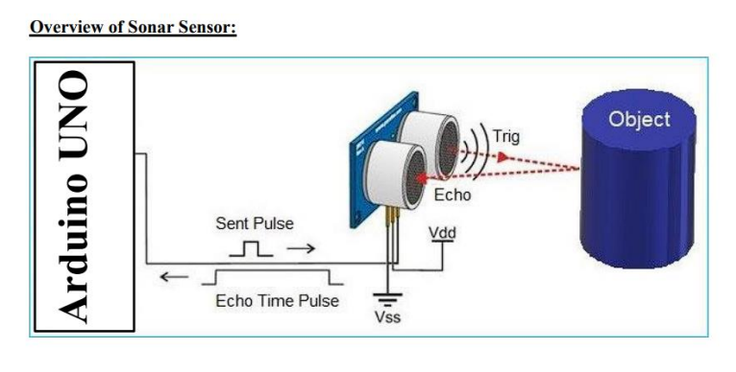

Motor speed varies according to duty cycle. Duty cycle is function of one time period. The duty cycle is commonly expressed as a percentage or ratio. A period is a time it takes for a signal to complete on and off cycle.

Duty cycle=(Ton/T) X 100%

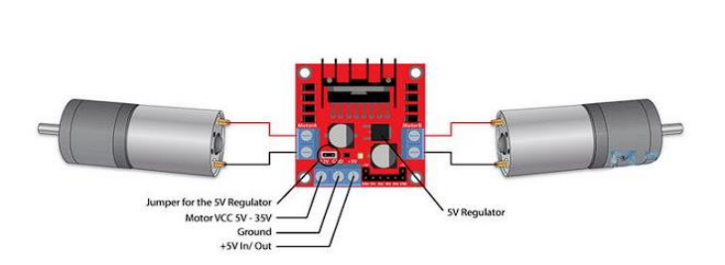

Suppose the duty is zero and the motor does not run.and when the duty cycle is 100% the motor moves on maximum RPM . the motor running after giving some fixed voltage that is called threshold voltage.

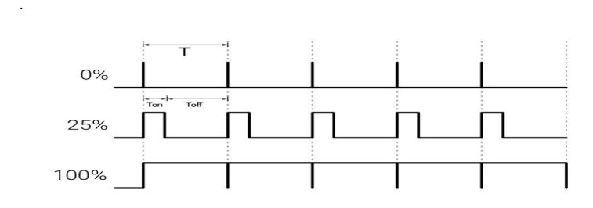

The L298 driver is a dual H-bridge motor driver which allows speed abd direction control of 2 DC motors at the same time. The module has two terminals. The VCC for motor and a 5V pin which can wither be an input output. Nexts are the logic unit. The input 1 and the input 2 pins are used for controlling rotation direction of the motor.

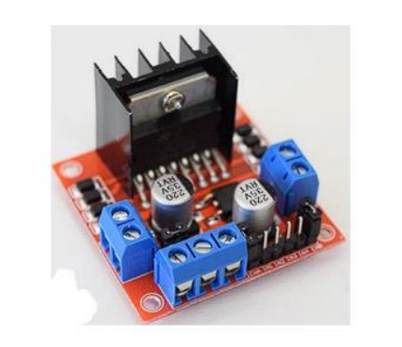

**Apparatus:**  
01.Arduino Mega

02.LED Indicator

03.Ultrasonic Sensor

04.DC Motors

05.Breadboard

06.Jumper wires

# Hardware Set-Up:

# 

**Program/Lab Code:**

const int echoPin = 6; // Echo Pin of Ultrasonic Sensor

const int trigPin = 7; // Trigger Pin of Ultrasonic Sensor

const int LED = 4; // LED at Pin 4

#define MOTOR_EN_1_2 10

#define MOTOR_IN1 9

#define MOTOR_IN2 8

#define normal 255

int Speed;

void Forward_Rev(void) {

analogWrite(MOTOR_EN_1_2, Speed);

digitalWrite(MOTOR_IN1, HIGH);

digitalWrite(MOTOR_IN2, LOW);

}

void Brake(void) {

digitalWrite(MOTOR_IN1, HIGH);

digitalWrite(MOTOR_IN2, HIGH);

}

void setup()

{

Serial.begin(9600); // Starting Serial Communication

pinMode(trigPin, OUTPUT); // initialising pin 7 as output

pinMode(echoPin, INPUT); // initialising pin 6 as input

pinMode(LED, OUTPUT); // initialising pin 4 as output

pinMode(MOTOR_EN_1_2, OUTPUT);

pinMode(MOTOR_IN1, OUTPUT);

pinMode(MOTOR_IN2, OUTPUT);

}

void loop()

{

Speed = normal; // Normal Speed

long duration, inches, cm;

digitalWrite(trigPin, LOW);

delayMicroseconds(2);

digitalWrite(trigPin, HIGH);

delayMicroseconds(10);

digitalWrite(trigPin, LOW);

duration = pulseIn(echoPin, HIGH); // using pulsin function to determine total time

inches = microsecondsToInches(duration); // calling method

cm = microsecondsToCentimeters(duration); // calling method

if(cm<10)

{ Serial.print(inches);

Serial.print("in, ");

Serial.print(cm);

Serial.print("cm");

Serial.println();

digitalWrite(LED, HIGH);

Forward_Rev();

//delay(500);

}

else

{

Brake();

//delay(500);

digitalWrite(LED, LOW);

}

delay(100);

}

long microsecondsToInches(long microseconds) // method to covert microsec to inches

{

return microseconds / 74 / 2;

}

long microsecondsToCentimeters(long microseconds) // method to covert microsec to cm

{

return microseconds / 29 / 2;

}

**Discussion:**

We learned how to automatically adjust the motor speed based on the obstacle distance as determined by the ultrasonic sensor in this OEL project. We also studied the L298N driver's role in the motor system. We wired an ultrasonic sensor and a motor to the Arduino board for the experiment. The necessary program is then written into the Arduino Mega. Some data were logged into the data collection database during the trial.

**Conclusion:**

This experiment sought to develop an automatic speed control system based on obstacle distance. We could observe from the data gathering table that the motor's speed varied according to the distance of the obstacles. The motor turned at the proper speed when the distance was short, but it was off when the distance was long. Therefore, it can be determined that the experiment's goal was accomplished.