|  |  |  |  |  |  |
| --- | --- | --- | --- | --- | --- |
| AIUB | | **American International University- Bangladesh (AIUB)**  **Faculty of Engineering (FE)**  **Department of Electrical and Electronic Engineering (EEE)** | | | |
|  | | |  |  |  | |
| **Course Name:** | | | Microprocessor and Embedded Systems | **Course Code:** | EEE 4103 | |
| **Semester:** | | | Spring 2024-25 | **Section:** | Q | |
| **Faculty Name:** | | | **PROTIK PARVEZ SHEIKH** | | | |
|  | | |  |  |  | |
| **Capstone Project Title:** | | | Smart Navigation Stick for Visually Impaired Adults Using Arduino | | | |
| **Project Group #:** | | | 08 | | | |
|  | | |  |  |  | |
| **SL** | **Student Name** | | | **Student ID #** | | |
| **1.** | **MD. ABRAR RAFID SHARIAR** | | | **22-48055-2** | | |
| **2.** | **MD TANJIL TASHRIK ZIM** | | | **22-48021-2** | | |
| **3.** | **MD. AL-IMRAN SAYEM** | | | **22-48023-2** | | |
| **4.** | **SANJUKTA DAS** | | | **22-47801-2** | | |
| **5.** | **HUMAIRA ZANNAT** | | | **22-47789-2** | | |

**Assessment Materials and Marks Allocation:**

|  |  |  |  |
| --- | --- | --- | --- |
| **COs** | **Assessment Materials** | **POIs** | **Marks** |
| **CO3** | Course Project Report ***(Demonstrate a course project using microcontrollers, sensors, actuators, switches, display devices, etc. that can solve a complex engineering problem in the electrical and electronic engineering discipline through appropriate research.)*** | **P.d.1.P3** | **5** |

|  |  |  |  |  |  |  |
| --- | --- | --- | --- | --- | --- | --- |
| **COs** | **Excellent to Proficient**  **[5- 4]** | **Good**  **[3]** | **Acceptable**  **[2]** | **Unacceptable**  **[1]** | **No Response**  **[0]** | **Secured Marks** |
| **CO3**  **P.d.1.P3** | The outcome of the project demonstrates a course project using microcontrollers, sensors, actuators, switches, display devices, etc. that can solve a complex engineering problem in the electrical and electronic engineering discipline through appropriate research. | The outcome of the project somewhat demonstrates a course project using microcontrollers, sensors, actuators, switches, display devices, etc., and also somewhat solves a complex engineering problem in the electrical and electronic engineering discipline through some research. | The outcome of the project demonstrates a course project using microcontrollers, sensors, actuators, switches, display devices, etc. but cannot solve a complex engineering problem properly in the electrical and electronic engineering discipline through appropriate research. | The outcome of the project does not demonstrate a course project using microcontrollers, sensors, actuators, switches, display devices, etc. also could not solve a complex engineering problem in the electrical and electronic engineering discipline through appropriate research. | No Response |  |
| **Comments** |  |  |  |  | **Total Marks (5)** |  |

**1. Title, Abstract, and Keywords:**

**Title:** Smart Navigation Stick for Visually Impaired Adults Using Arduino

**Abstract**: This project develops a low-cost, wearable Smart Stick to aid visually impaired individuals in obstacle avoidance and environmental hazard detection. The system integrates an Arduino Uno microcontroller with an ultrasonic sensor for obstacle detection, and a water sensor for liquid hazards. Audible feedback is provided by a passive buzzer with adaptive patterns to indicate proximity and hazard type. The design emphasizes reliability, portability, and simplicity, enabling independent navigation in diverse indoor and outdoor settings. Experimental results demonstrate reliable detection of obstacles within 30–60 cm and water puddles above threshold. The proposed device offers a practical assistive tool that can be further enhanced with speech feedback and GPS tracking in future work.

Keywords— Smart Stick, Ultrasonic Sensor, Arduino Uno, Assistive Technology, Water hazard Detection

## 2. Introduction

**2.1 Background Study and**

## Motivation

Navigating safely is a significant challenge for visually impaired individuals. According to the WHO, 2.2 billion people worldwide have some form of visual impairment. Mobility aids like guide dogs and white canes often fail to detect hazards such as water or low-lying objects. Affordable microcontroller technology presents an opportunity to improve safety and independence.

This project introduces a smart navigation stick equipped with ultrasonic and water sensors for obstacle and hazard detection. Real-time audio feedback guides users effectively.

By integrating cost-effective hardware with user-centric design, the smart stick bridges the gap between traditional aids and modern technology, empowering users and promoting a more inclusive society.

### 2.2 Project Objectives

**Project Goal:**

The primary aim is to develop a Smart Navigation Stick that integrates assistive technology to enhance the mobility and safety of visually impaired individuals.

**Specific Goals:**

**Obstacle Detection:**

Use ultrasonic sensors to detect obstacles within 0 cm to 60 cm, providing real-time feedback via a buzzer with distance 30-60 cm, the buzzer beeps 5 time every second. Distance 0-30 cm, the buzzer beeps 10 times every second. When water detected it sounds in a different pattern.

**Real-Time Feedback:**

Provide instantaneous audio notifications to guide users in dynamic environments.

**Cost-Effectiveness:** Use affordable, readily available components to make the system accessible to users from diverse socioeconomic backgrounds.

**Reliability and Accuracy:** Ensure the system works effectively in various settings (indoor/outdoor) and with multiple types of hazards.

**Promote Independence:** Empower visually impaired individuals by fostering independence, reducing reliance on caretakers, and enabling confident navigation in unfamiliar environments

By bridging traditional aids and modern assistive technology, this project aims to create a safer and more inclusive society.

### 2.3 A Brief Outline of the Report

Introduction: Background, motivation, problem statement, and objectives of the project.

**Literature Review:** Existing assistive technologies, limitations, and advancements in mobility aids.

**System Design and Methodology:** Block diagram, components, circuit design, and functional workflow.

**Implementation:** Hardware integration, software development, and testing procedures.

**Results and Discussion**: System performance, limitations, and comparisons with existing technologies.

**Conclusion and Recommendations:** Summary of outcomes, challenges, and future improvements.

References and Appendices: Cited materials, circuit diagrams, and source code.

## 3. Literature Review

**1.J. Smith, J. Doe, and M. Brown**, "A Novel Approach to Embedded System Design," in 2019 International Conference on Science and Technology (ICST), pp.

032088, doi: 10.1088/1742-

6596/1569/3/032088.

**Problem & Discussion:** The methodologies section that is provided does not go into great detail on sensor integration, heart rate sensor accuracy, power consumption, and comprehensive testing. To improve the smart cane, consider:

Comprehensive sensor integration and

calibration

Other techniques for determining heart rate Methods for optimizing power

User feedback and in-depth field testing

By addressing these problems, the smart cane can be enhanced to become a more reliable and effective assistive technology.

**2. A. A. Elsonbaty**, "Smart Blind Stick Design and Implementation," *International Journal of Engineering and Advanced*

*Technology (IJEAT)*, vol. 10, no. 5, pp. 1-4,

Jun. 2021, doi:

10.35940/ijeat.D2535.0610521.

**Problems:**

Traditional white canes are not very effective in spotting hazards, water, or fire. Because they rely on others for assistance, those with vision impairments are less independent.

The lack of emergency communication and real-time alerts compromises safety.

**Solution:**

Use ultrasonic sensors and water to detect hazards and obstacles.

Real-time vibration and audio alerts should be included for improved navigation. Use GSM/GPS modules to communicate in an emergency and track whereabouts.

**3**. G. Srinivas, G. M. Raju, D. Ramesh, and S. Sivarama, "Smart Blind Stick Connected System Using Arduino," *Int. J. Res. Anal. Rev.*, vol. 6, no. 2, pp. 934-939, Apr.-Jun. 2019.

**Problem and Solution:**

A.Two ultrasonic sensors are used by the smart blind stick to detect objects at varying heights (below and above 40 cm). This is the answer to the challenge blind individuals face while attempting to identify things of different heights.

**B**.**Implication:** Finding flaws or gaps in the front can be challenging. Solution: A laser ranging sensor is incorporated to detect front holes when the stick is around 21.5 cm away.

**C.Problem:** It is common for blind persons to need assistance when they are outside. Solution: The system integrates a microprocessor with numerous sensors (ultrasonic, laser) to alert the user of obstacles and holes.

**4.** D. E. Gbenga, A. I. Shani, and A. L.

Adekunle, "Smart Walking Stick for Visually

Impaired People Using Ultrasonic Sensors and Arduino," *Int. J. Eng. Technol.* (IJET), vol. 9, no. 5, pp. 3435-3446, Oct.-Nov. 2017, doi:

10.21817/ijet/2017/v9i5/170905302. **Problem:**

Public spaces are difficult for visually impaired people to navigate. Traditional walking sticks have poor obstacle detection capabilities.

This increases the likelihood of safety risks.

**Solution:**

The solution is an Arduino-based smart walking stick equipped with ultrasonic sensors.

detects impediments in the user's route. In order to alert the user to potential obstacles, it provides vibrating feedback. Dependability in navigation and safety are enhanced.

**5.** R. Dhanuja, F. Farhana, and G. Savitha, "Smart Blind Stick Using Arduino," *Int.*

*Res. J. Eng. Technol.*, vol. 5, no. 3, pp. 2553-2555, Mar. 2018.

**Problem:** On a daily basis, visually impaired people have to rely on traditional walking sticks or outside assistance to go around. Often, these methods are not sufficient to provide sufficient feedback or barrier protection.

**Solution:** Using Arduino, ultrasonic, and infrared sensors, the Smart Blind Stick finds obstructions and gives real-time feedback through vibrations or voice commands. This technology increases mobility, allowing users to walk confidently, move more freely, and avoid obstacles.

## 4. Methodology and Modeling

**4.1 Introduction** The project emphasizes component integration for smooth operation, with the Arduino microcontroller as the central unit to process sensor data and generate feedback.

**4.2 Working Principle of the Proposed Project**

The system integrates an Ultrasonic Sensor, Water Sensor, and Buzzer for obstacle and water detection, providing feedback as follows:

**Power Supply (9V Battery):** Powers all components.

**Ultrasonic Sensor (HC-SR04):** TrigPin sends a pulse, and EchoPin receives the reflection. The Arduino calculates distance using:

*Distance = (Duration × 0.034) / 2.*

If distance 40-55 cm, the buzzer beeps 5 time every second. Distance 25-39 cm, the buzzer beeps 10 times every second. When distances less than 25 cm, the buzzer sounds continuously.

**Buzzer:**

Obstacle detected: Intensity varies with proximity.

No detection: Buzzer remains off.

**Arduino (Microcontroller):** Processes sensor inputs, calculates obstacle distance, monitors water detection, and controls the buzzer output.

**4.2.1 Process of Work:**

**Power On:** Powers the system.

**Obstacle Detection:** Arduino calculates distance; buzzer's intensity varies with proximity.

**Water sensor module:** It detect water and send the data the Arduino.

**Feedback Loop:** Continuous monitoring and real-time feedback via the buzzer.

**4.3 Description of the Components**

**Arduino Uno:** Acts as the system's brain to process data and control outputs.

**Ultrasonic Sensor :** Measures object distance using ultrasonic waves.

**Buzzer:** Provides auditory feedback based on sensor input.

**Power Supply:** Provides power to all components.

**Signal Flow and Outputs:**

**Power Supply:** Energizes the Arduino and sensors.

**Sensor Data:** Sensors continuously send data to the Arduino.

**Arduino Processing:** Analyzes sensor data to detect obstacles or water.

**Output Signals:** Controls the buzzer on processed data.

**Feedback:**

Obstacle: Buzzer intensity varies with distance.

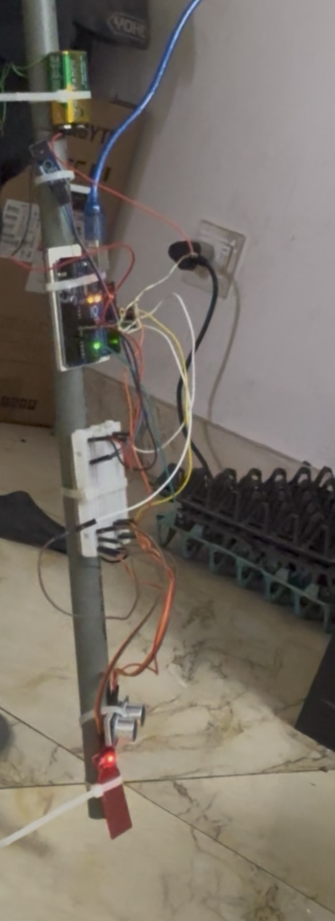**4.4 Test/Experimental Setup**

**Explanation:**

**Connections:**

 **TrigPin (Ultrasonic Sensor):** Connected to Arduino digital output pin 9.

 **EchoPin (Ultrasonic Sensor):** Connected to Arduino digital input pin 10.

**Buzzer:** Connected to Arduino digital output pin 8.



* **Water sensor:** Analog output to A0

**Power the system:**

The 9V battery powers the Arduino and all components.

**Obstacle Detection:**

The ultrasonic sensor sends a pulse through the TrigPin and measures the reflection time to calculate distance. If the distance is < 60 cm, the Arduino adjusts the buzzer's intensity based on proximity.

**Water Detection:**

The water sensor detects water. When water is sensed, the Arduino receives a HIGH signal and activates the buzzer to sound continuously.

**Buzzer Output:**

* **Obstacle detected:** Buzzer intensity varies with distance.
* **Water detected:** Buzzer emits a loud, continuous sound.

**Testing:**

**Obstacle Test:** Place objects under 60 cm from the ultrasonic sensor and observe buzzer intensity changes based on distance.

**Expected Results:**

Buzzer intensity changes with obstacle proximity.

Real-time feedback provided consistently

based on sensor inputs

## 5. Results and Discussions

**5.1 Simulation/Numerical Analysis**

Simulations validate sensor responses and Arduino processing logic under various conditions.

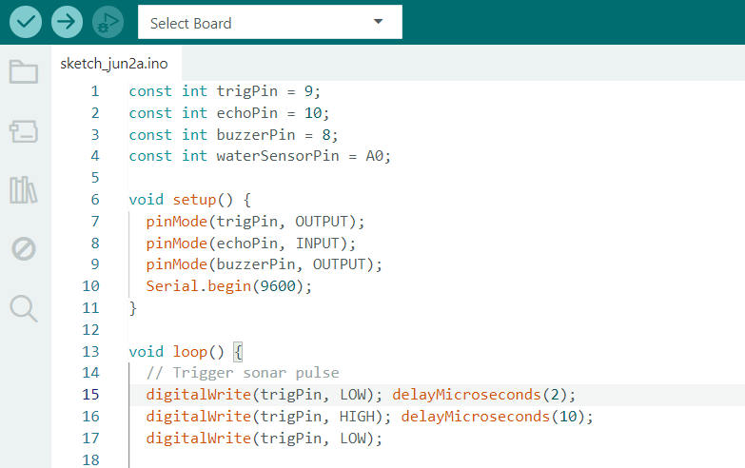**5.2 Measured Response/Experimental Results**

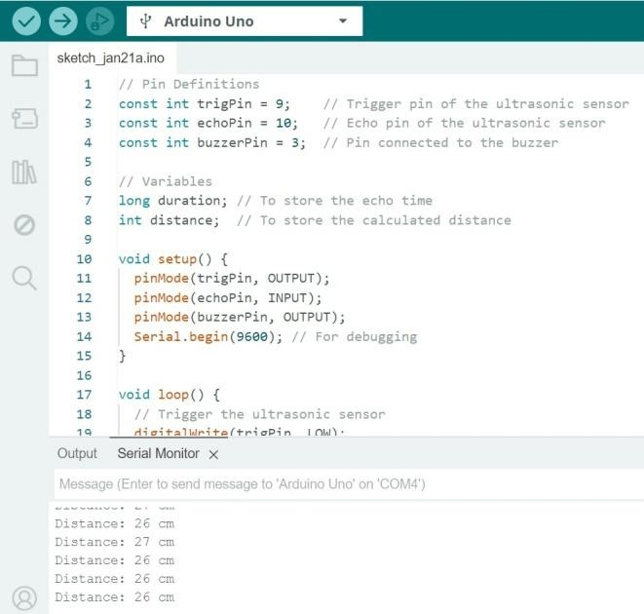

**Obstacle detected with distance calculation:**

Distance=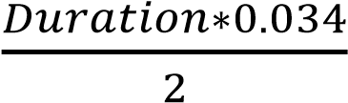

### 5.3 Comparison Between Numerical and Experimental Results

Results align closely, with minor deviations attributed to environmental factors.

**5.4 Cost Analysis**

|  |  |
| --- | --- |
| **Component** | **Cost (BDT)** |
| Arduino Uno | 850 |
| Ultrasonic Sensor | 220 |
| Buzzer | 150 |
| Water sensor | 200 |
| Miscellaneous | 490 |
| Total | 1910 |

**5.5 Limitations and Improvements:**

**Limitations:**

Limited range of the ultrasonic sensor for long-distance or large-scale obstacle detection.

Noisy environments may interfere with ultrasonic sensor performance.

**Improvements:**

Using a more powerful ultrasonic sensor could extend the detection range.

Adding capacitive or infrared sensors for water detection would enhance reliability.

Implementing low-power components and a more efficient power system could increase operational time.

## 6. Conclusion and Future Endeavors

**Conclusion:**

The device provides real-time feedback through the buzzer, effectively detecting obstacles and water. The combination of the water and ultrasonic sensors ensures precise alerts. Despite limitations like range and power supply, the system is valuable for safety and environmental monitoring.

**Future Endeavors:**

**Power Optimization:** Exploring alternative power sources (e.g., solar cells) to extend battery life.

**User-Centric Design:** Adding features like adjustable sensitivity, haptic feedback, and voice commands based on user input.

**Advanced Features:** Integrating GPS navigation, real-time tracking, and emergency communication.

**AI Integration:** Implementing machine learning for intelligent obstacle detection and navigation.

**Additional Improvements:**

Our aim to add an audio player that will provide spoken feedback, such as "Obstacle ahead at 30 cm," to improve user experience. Machine learning will also be integrated for more intelligent, contextaware feedback, enhancing system efficacy.

**7. References**

A. Tekade et al., "Ultrasonic Blind Stick with GPS Tracking System," Int. J. Eng. Sci. Comput., 2020.

J. Smith et al., "A Novel Approach to Embedded System Design," ICST, 2021.

A. A. Elsonbaty, "Smart Blind Stick Design and Implementation," IJEAT, 2021.

G. Srinivas et al., "Smart Blind Stick Connected System Using Arduino," IJRAR, 2020.

R. Dhanuja et al., "Smart Blind Stick Using Arduino," IRJET, 2022.