
BUSINESS PLAN: CELLUPULP BD LTD.
Strategic Import Substitution for Bangladesh’s Hygiene Sector
April 2026

Table of Contents

1. Introduction
The Pitch
Bangladesh’s hygiene sector is currently crippled by a heavy reliance on imported wood fluff pulp, exacerbated by global dollar liquidity crises. CelluPulp BD offers a localized, sustainable solution by utilizing jute and bamboo to produce hygiene-grade pulp right here in Bangladesh.

2. Business Model
CelluPulp BD operates on a B2B 'Secondary Supplier' model, targeting Tier 1 and Tier 2 hygiene brands. Our cost leadership and local currency transactions provide a significant competitive edge.
Component | Description
Value Proposition | 15-25% cost reduction and elimination of LC/Forex risks.
Key Partners | Farmer cooperatives and domestic FMCG converters.

3. Market Analysis
The market for hygiene products in Bangladesh is seeing a 15% CAGR, creating a massive opportunity for local raw material production.
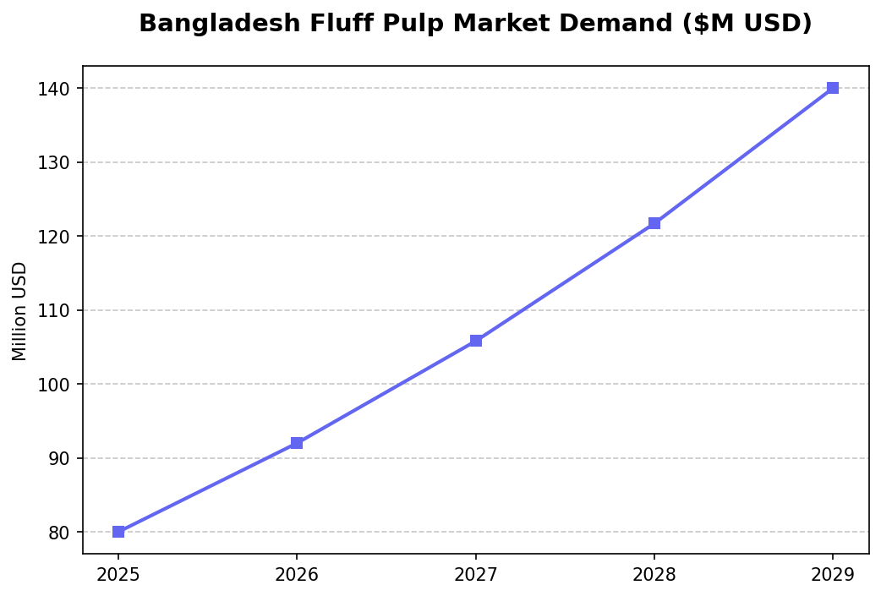
Figure 1: Market Demand Forecast ($M USD)
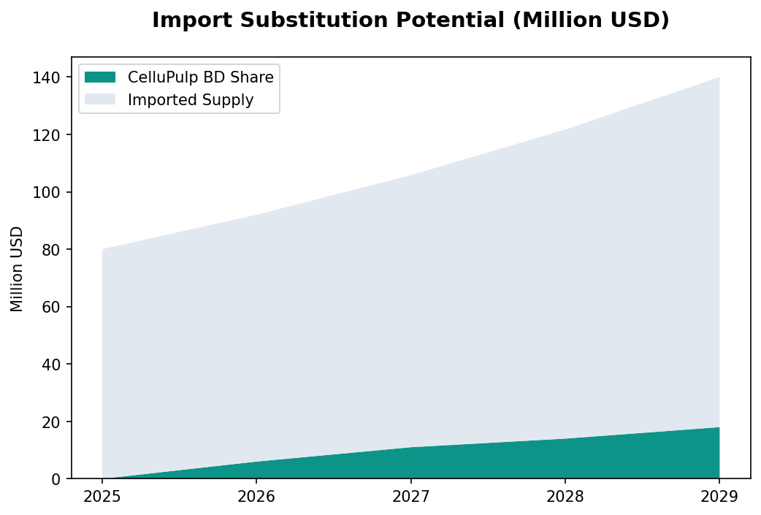
Figure 2: Localization Potential and Share

4. Financial Plan
The financial outlook reflects a typical industrial J-curve, with profitability achieved in Year 3 as capacity utilization reaches optimal levels.
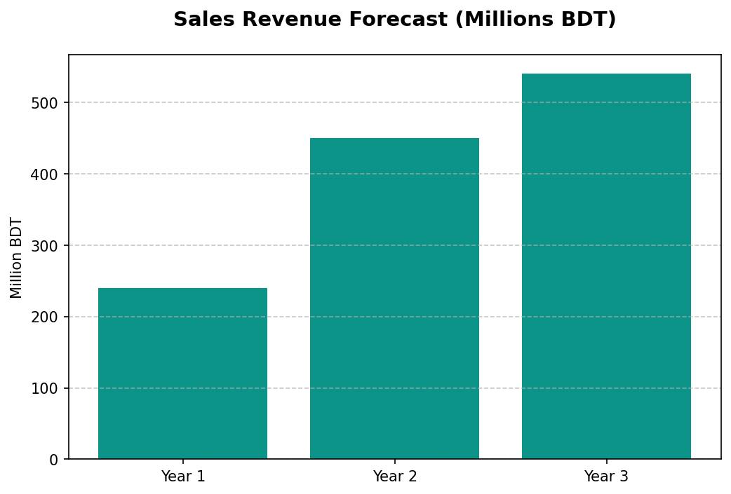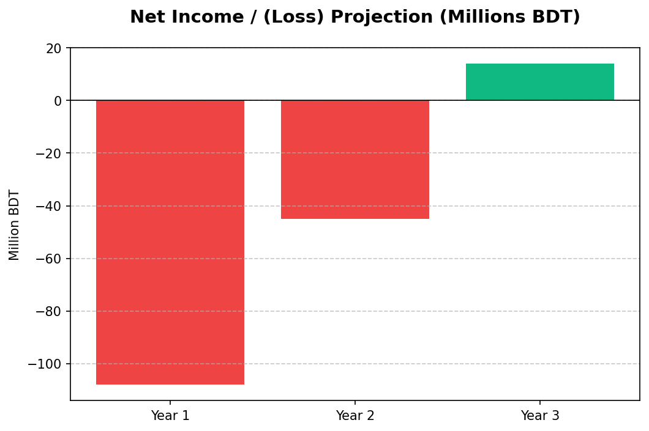
Figure 3: Revenue and Profitability Projections

4.1 Sales Forecast Table
Metric | Year 1 | Year 2 | Year 3
Capacity Util. | 40% | 75% | 90%
Revenue (M BDT) | 240.0 | 450.0 | 540.0
Net Income (M BDT) | (108.0) | (45.0) | 14.0

Bibliography
Bangladesh Bank. (2026). Economic Data: Inflation and Forex Rates. Dhaka: BB Statistics Department.
FMCG Industry Reports. (2025). Import Estimates for Fluff Pulp (HS Code Volumes). Dhaka: Market Insights.
BEZA. (2025). Industrial Tariff and Land Lease Guidelines for Economic Zones. Dhaka: Prime Minister's Office.



