**CSC 3020 – Java Programming**

**Homework 1 – [your name]**

**25 points – Due January 24, 10am**

**Late deadline is January 26, 11:59pm, but 20% off**

**a)** Save this document with your name and the homework number somewhere in the file name.

**b)** Type/paste your answers into the document.

**c)** Submit this document and your .java file(s) to the Blackboard item where you downloaded this document. Do not submit a zip file but individually attach your files.

**1) [4 points]** Using your Java development tool (probably Eclipse), list the steps to create a runnable JAR file.

**2) [10 points]** You've been hired by *Snow Superstars* to write a Java console application that calculates and shows the total and average snowfall for three winter months. Configure the application in your development tool to receive the following three program arguments:

● Integer snowfall for month 1 in inches.

● Integer snowfall for month 2 in inches.

● Integer snowfall for month 3 in inches.

Loop through the arguments array and print the index and value of each argument. Convert each argument from string to integer using **Integer.parseInt(args[n])** and calculate the total and average snowfall. Format the total and average snowfall in two columns using escape sequences. The first column is a label and the second column is a value with units. The output should look like this:

**Welcome to Snow Superstars**

**--------------------------**

**Index Argument**

**0 2**

**1 6**

**2 5**

**Total: 13 inch(es)**

**Average: 4.333333333333333 inch(es)**

**End of Snow Superstars**

*[your program code here]\**

**If possible, format your code like this:**

**Font “Courier New”**

**Font size “9”**

**Bold**

*[your program output here]\*\**

**3) [11 points]** You've been hired by *Spherical Stunts* to write a Java console application that prompts for and reads a radius from the user, and calculates the following values:

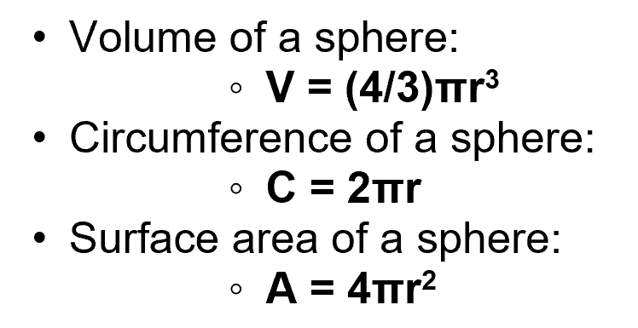

Use **Math.PI** for π. Show the radius, volume, circumference, and surface area. Format the output in three columns with a label in the first column, a value in the second column, and the units in the third column. Use method **printf** to format the output. Declare constants for the formal specifiers. Format all real numbers to three decimal places. The output should look like this:

**Welcome to Spherical Stunts**

**---------------------------**

**Enter the radius in cm: 4**

**Radius: 4.000 cm**

**Volume: 268.083 cm^3**

**Circumference: 25.133 cm**

**Surface area: 201.062 cm^2**

**End of Spherical Stunts**

*[your program code here]\**

**If possible, format your code like this:**

**Font “Courier New”**

**Font size “9”**

**Bold**

*[your program output here]\*\**

* **Copying-and-pasting application code to a Word document**

1) From the program editor window, press **CTRL-A** and press **CTRL-C**.

2) From within the Word document, press **CTRL-V**.

** **Copying-and-pasting application output to a Word document**

1) From the Eclipse main screen, maximize the Console window.

2) From the Console window, press **ALT-PrintScreen**.

3) From within the Word document, press **CTRL-V**.