**CSC 3020 – Java Programming**

**Homework 1 – [your name]**

**25 points – Due January 24, 10am**

**Late deadline is January 26, 11:59pm, but 20% off**

**a)** Save this document with your name and the homework number somewhere in the file name.

**b)** Type/paste your answers into the document.

**c)** Submit this document and your .java file(s) to the Blackboard item where you downloaded this document. Do not submit a zip file but individually attach your files.

**1) [4 points]** Using your Java development tool (probably Eclipse), list the steps to create a runnable JAR file.

1) From the Eclipse main screen, right-click the project name and select Export …

2) From the Export screen, select Java / Runnable JAR file and click Next.

3) From the Runnable JAR File Export screen, select an export destination (folder and file name), and click Finish.

**2) [10 points]** You've been hired by *Snow Superstars* to write a Java console application that calculates and shows the total and average snowfall for three winter months. Configure the application in your development tool to receive the following three program arguments:

● Integer snowfall for month 1 in inches.

● Integer snowfall for month 2 in inches.

● Integer snowfall for month 3 in inches.

Loop through the arguments array and print the index and value of each argument. Convert each argument from string to integer using **Integer.parseInt(args[n])** and calculate the total and average snowfall. Format the total and average snowfall in two columns using escape sequences. The first column is a label and the second column is a value with units. The output should look like this:

**Welcome to Snow Superstars**

**--------------------------**

**Index Argument**

**0 2**

**1 6**

**2 5**

**Total: 13 inch(es)**

**Average: 4.333333333333333 inch(es)**

**End of Snow Superstars**

**//======================================================================**

**//**

**// Title: Snow Superstars**

**// Course: CSC 3020**

**// Homework: 1-2**

**// Author: Dan Ouellette**

**// Date: 24 January 2018**

**// Description:**

**// This Java console application calculates and shows the total and**

**// average snowfall for three winter months. It receives three program**

**// arguments, loops through them and prints the index and value of each**

**// one. It then calculates and shows the total and average snowfall.**

**//**

**//======================================================================**

**package wsu.HW01_02;**

**//======================================================================**

**// class HW01_02**

**//======================================================================**

**public class HW01_02**

**{**

**// -----------------------------------------------------------------**

**// main**

**// -----------------------------------------------------------------**

**public static void main(String[] args)**

**{**

**// Declare variables**

**int month1;**

**int month2;**

**int month3;**

**int total;**

**double average;**

**// Show application header**

**System.out.println("Welcome to Snow Superstars");**

**System.out.println("--------------------------\n");**

**// Loop to show arguments**

**System.out.println("Index\tArgument");**

**for (int i = 0; i < args.length; i++)**

**System.out.println(i + "\t" + args[i]);**

**System.out.println();**

**// Save arguments in variables**

**month1 = Integer.parseInt(args[0]);**

**month2 = Integer.parseInt(args[1]);**

**month3 = Integer.parseInt(args[2]);**

**// Calculate total and average**

**total = month1 + month2 + month3;**

**average = total / 3.;**

**// Show total and average**

**System.out.println("Total:\t\t" + total + " inch(es)");**

**System.out.println("Average:\t" + average + " inch(es)");**

**System.out.println();**

**// Show application close**

**System.out.println("End of Snow Superstars");**

**}**

**}**

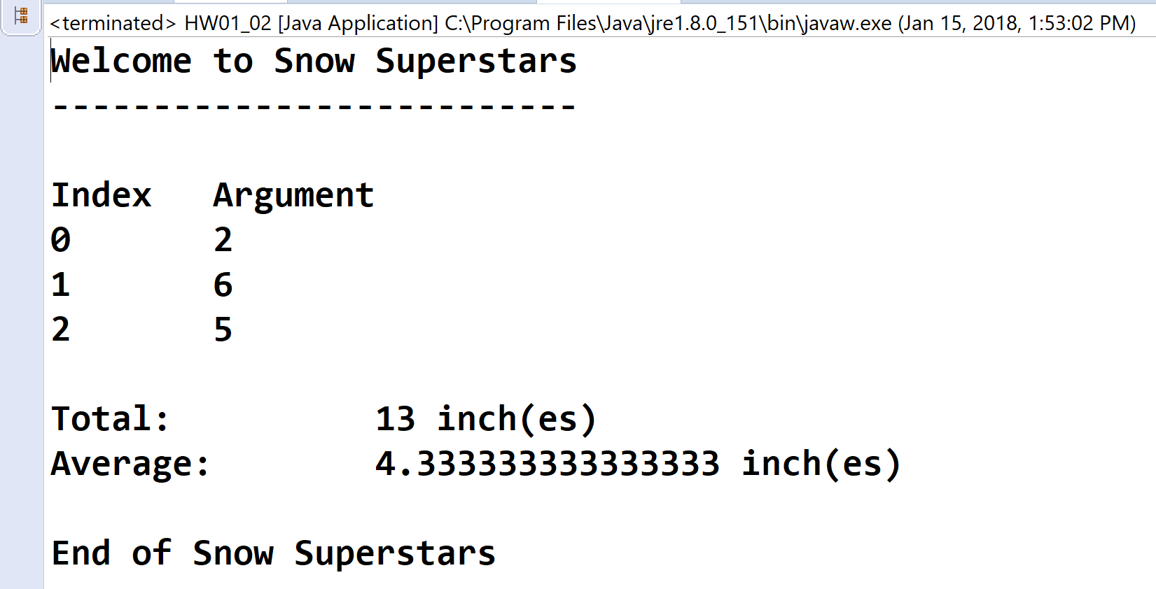

**3) [11 points]** You've been hired by *Spherical Stunts* to write a Java console application that prompts for and reads a radius from the user, and calculates the following values:

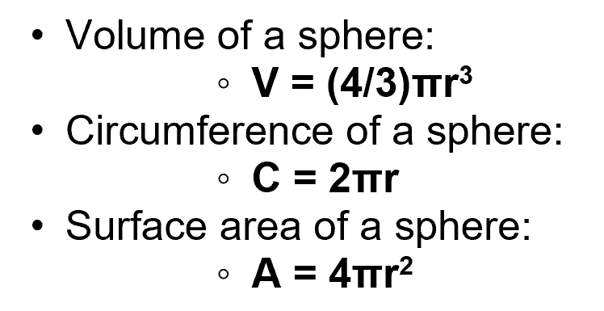

Use **Math.PI** for π. Show the radius, volume, circumference, and surface area. Format the output in three columns with a label in the first column, a value in the second column, and the units in the third column. Use method **printf** to format the output. Declare constants for the formal specifiers. Format all real numbers to three decimal places. The output should look like this:

**Welcome to Spherical Stunts**

**---------------------------**

**Enter the radius in cm: 4**

**Radius: 4.000 cm**

**Volume: 268.083 cm^3**

**Circumference: 25.133 cm**

**Surface area: 201.062 cm^2**

**End of Spherical Stunts**

**//======================================================================**

**//**

**// Title: Spherical Stunts**

**// Course: CSC 3020**

**// Homework: 1-3**

**// Author: Dan Ouellette**

**// Date: 24 January 2018**

**// Description:**

**// This Java console application prompts for and reads a radius from**

**// the user. It then calculates and shows the following values for a**

**// sphere:**

**// -Volume**

**// -Circumference**

**// -Surface area**

**//**

**//======================================================================**

**package wsu.HW01_03;**

**//Import classes**

**import java.util.Scanner;**

**//======================================================================**

**// class HW01_03**

**//======================================================================**

**public class HW01_03**

**{**

**//------------------------------------------------------------------**

**// main**

**//------------------------------------------------------------------**

**public static void main(String[] args)**

**{**

**// Declare constants**

**final String COLFMTS = "%-14s";**

**final String COLFMTF = "%14.3f";**

**// Declare variables**

**double radius;**

**Scanner keyboard = new Scanner(System.in);**

**double volume;**

**double circ;**

**double surface;**

**// Show application header**

**System.out.println("Welcome to Spherical Stunts");**

**System.out.println("---------------------------\n");**

**// Prompt for and get radius**

**System.out.print("Enter the radius in cm: ");**

**radius = keyboard.nextDouble();**

**// Calculate volume, circumference, and surface area**

**volume = (4 / 3.) * Math.PI * radius * radius * radius;**

**circ = 2 * Math.PI * radius;**

**surface = 4 * Math.PI * radius * radius;**

**// Show volume, circumference, and surface area**

**System.out.println();**

**System.out.printf(COLFMTS + COLFMTF + " " + COLFMTS + "%n",**

**"Radius:", radius, "cm");**

**System.out.printf(COLFMTS + COLFMTF + " " + COLFMTS + "%n",**

**"Volume:", volume, "cm^3");**

**System.out.printf(COLFMTS + COLFMTF + " " + COLFMTS + "%n",**

**"Circumference:", circ, "cm");**

**System.out.printf(COLFMTS + COLFMTF + " " + COLFMTS + "%n", "" +**

**"Surface area:", surface, "cm^2");**

**// Show application close**

**System.out.println("\nEnd of Spherical Stunts");**

**}**

**}**

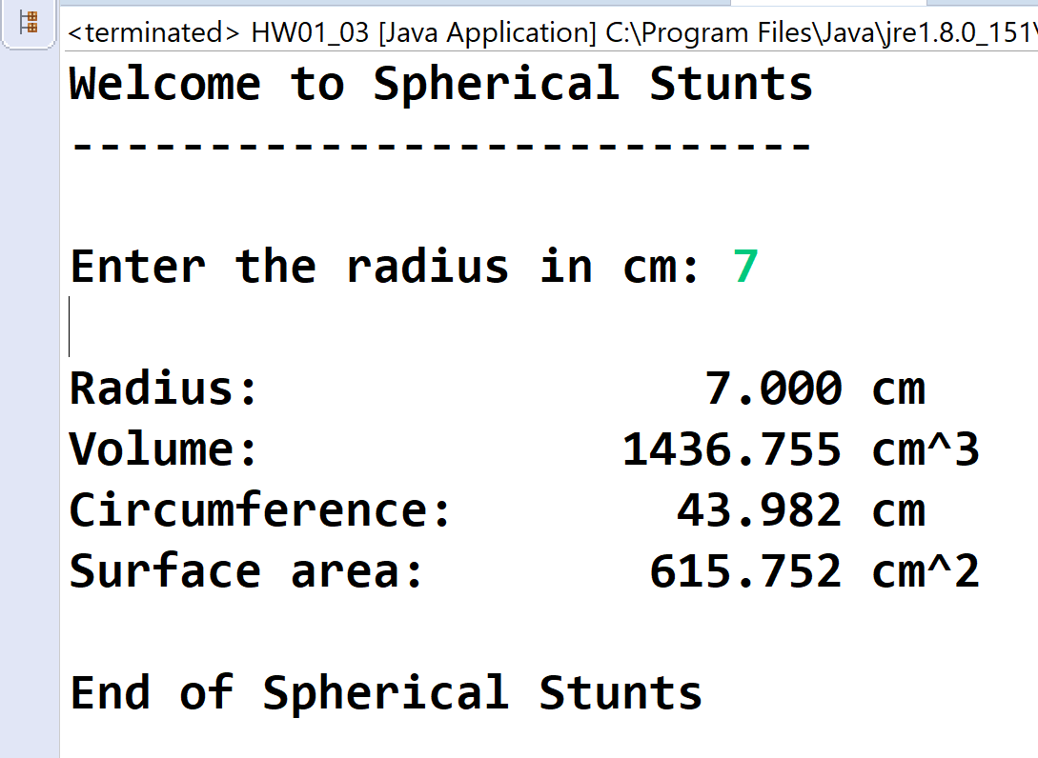

* **Copying-and-pasting application code to a Word document**

1) From the program editor window, press **CTRL-A** and press **CTRL-C**.

2) From within the Word document, press **CTRL-V**.

** **Copying-and-pasting application output to a Word document**

1) From the Eclipse main screen, maximize the Console window.

2) From the Console window, press **ALT-PrintScreen**.

3) From within the Word document, press **CTRL-V**.