Application Processor Card (APP)

Hardware Design Document (HDD)

Revision 1.0

Ownership Disclaimer
This document contains proprietary and confidential material that is the sole property of Compressor Controls Corporation. The information contained herein is intended for internal use by Compressor Controls Corporation employees and is not intended for distribution outside of the company. As an unpublished work of trade secrets, the recipient shall keep this document confidential. Any re-use, copying, or distribution, either in whole or in part, of this material without the express written consent of Compressor Controls Corporation is strictly forbidden.
Copyright © 2011 by Compressor Controls Corporation. All rights reserved.
Revision History

Revision | Date | Description | Author
1.0 | 7-Sep-11 | First Release | Akhilesh Jaiswal

Approvals

Product Manager Date

Table of Contents
1 Introduction 5
1.1 Purpose 5
1.2 Audience 5
1.3 Scope 5
2 General Description 6
2.1 Board Features 6
2.2 Implementation Block Diagram 7
3 Description of Functional Blocks 8
3.1 Processor 8
3.2 DDR-3 SODIMM 9
3.3 NAND Flash 11
3.4 MRAM 11
3.5 SPI Flash 12
3.6 Micro SD Card Interface 12
3.7 DUART 12
3.8 Enhanced Triple Speed Ethernet Controller (eTSEC) Interface 13
3.9 QUICC Engine RMII1 and RMII5 Interface 16
3.10 EtherCAT Slave Interface 18
3.11 QUICC Engine SER3 and SER7 Interface 18
3.12 USB 18
3.13 I2C 19
3.14 CPLD 20
3.15 Hot Swap Control 23
3.16 Power 23
3.17 Debug Support 25
3.18 Front Panel LEDs 27
3.19 Backplane Connectors 28
4 Schematic Design 32
4.1 Design Tool 32
5 Board Layout Design 32
5.1 Board Thickness 32
5.2 Board Stack-up 32

Introduction

Purpose
The objective of this document is to describe the hardware design of Application Processor Card (APP Card).

Audience
This document is targeted at Personnel involved in development and testing of board at Mindteck as well as CCC.

Scope
The scope of this document is to describe APP card hardware design in brief. The document details the various functional level block diagrams. Also this document details about the board power budget analysis, any kind of mathematical / simulation analysis.

General Description

Board Features

Sr. No. | Feature | Description
1 | Processor | QorIQ P1021 from Freescale
2 | DDR-3 | 204 pin SODIMM Module
3 | NAND Flash | 1GB Nand flash
4 | MRAM | 1MBit MRAM (x8)
5 | SPI Flash | 128 MBit
6 | SD Card | Top mounting Micro SD card
7 | UART ports | Four UART ports to backplane
8 | 10/100 Ethernet | Two 10/100 Ethernet ports to backplane
9 | EtherCAT Master | Two EtherCAT Master ports to backplane
10 | EtherCAT Slave | One EtherCAT slave interface using ET1100
11 | SGMII | One SGMII Interface to backplane
12 | USB OTG | One USB OTG with on-board mini connector
13 | I2C | Two separate I2C interfaces connecting EEPROMs, RTC, Temperature sensor
15 | CPLD | One CPLD to control power/reset sequencing
16 | Hot-swap Control | Hot-swap compatible
17 | Power | Multiple on-board power
18 | Debug support | COP connector, debug RS-232 port, debug LEDs, manual reset, test points

Implementation Block Diagram

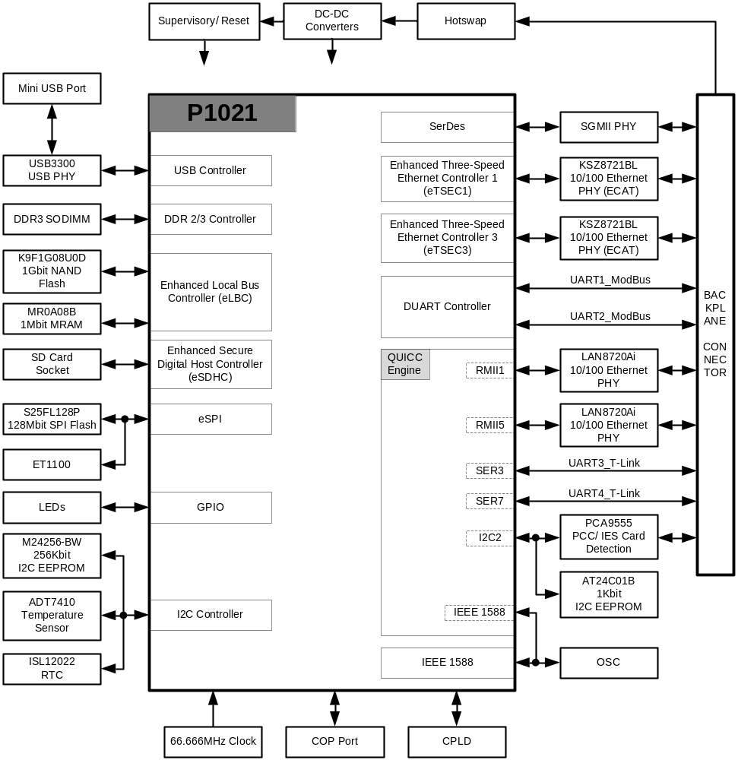

Description of Functional Blocks

Processor
P1021 QorIQ processor from Freescale is used as main processing unit. The P1021 integrates dual PowerPC™ e500v2 processor cores with the system logic required for networking, wireless infrastructure, and telecommunications applications. It is a member of the Ultra Low End Dual Core QorIQ™ family that combines system-level support for industry-standard interfaces with processors that implement the PowerPC architecture. The PowerPC cores in the P1021 with its 32 Kbytes of instruction and data cache, implement enhanced PowerPC core instruction set architecture and provide hardware and software debugging support.
The key features include

• Dual e500v2 cores with a large L2 cache of 256 Kbytes
• One 32-bit DDR2/DDR3 memory controller with ECC support
• Three-speed (10/100/1000 Mbps) Ethernet controllers
• Flexible enhanced local bus controller
• PCI Express
• SGMII
• USB 2.0 host and device controller
• Enhanced SD/MMC controller
• eSPI controller
• Dual I2C controller
• DUART
• QUICC Engine
• Security engine controller

The P1021 incorporates a single RISC QUICC Engine™ block that provides termination, inter-working, and switching between a wide range of communication protocols including ATM, Ethernet, POS, HDLC, and the IEEE Std.1588™ Precise Time Protocol.

P1021 Critical Performance Parameters

The following list describes the critical performance parameters:

• e500v2 core frequency of 800 MHz at VDD = 1.0 V
• Power consumption of less than 5 W at 800 MHz core speed at VDD = 1.0 V
• 45-nm SOI process technology
• Data rate of up to 800 Mbps for DDR2 and DDR3
• Maximum QUICC Engine block frequency of 400 MHz
• Supply voltages:
— Core: 1.0 V
— PCI Express, SGMII: 1.0 V
— Ethernet: 3.3 or 2.5 V (subject to protocol)
— Local bus: 3.3, 2.5, or 1.8 V (Board supports only 3.3 V)
— DDR: 1.8 V for DDR2, 1.5 V for DDR3 (conforms to JEDEC standard)
— 8-bits of GPIO, I2C, DUART: 3.3 V
— SPI, SD/MMC, USB: 3.3 V, 2.5 V, or 1.8 V (Board supports only 3.3 V)
• Operating junction temperature (Tj) range: –40° C to 125° C
• Package: 31 × 31 mm 689-pin TEPGBA II (thermally-enhanced plastic BGA)

P1021 Clocking

The diagram below shows the processor P1021 clocking implementation on board

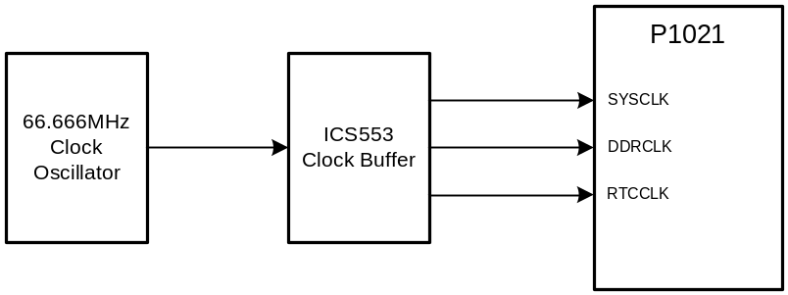

DDR-3 SODIMM
The DDR3 SDRAM interface is implemented with a single, ready-for-operation, 204-pin standard SODIMM socket that supports unbuffered DDR3 SODIMM modules.
The DDR3 SDRAM module operates in 32-bit mode with a clock rate of up to 333MHz MHz (667 MHz data rate) with ECC.
There are four clock pairs MCK[0:3]+/- available on P1021 for DDR3 interface with flexibility of using any of these. On APP card, clock pairs MCK[2:3]+/- are used. Selection of these pairs is done mainly to help routing.
DDR3 ECC support is provided by connecting MECC[0:7], MDQS8,
MDQS8#, and MDQM8 of the memory controller to DQ[32:39], DQS8,
DQS8#, and DQM8 of SODIMM.
DDR3 memory needs active low reset on power on. On APP card, this reset is driven from CPLD. Reset generation logic is shown below. R8 is pulled up to GVDD (1.5V) as DDR3 memory runs on this power.

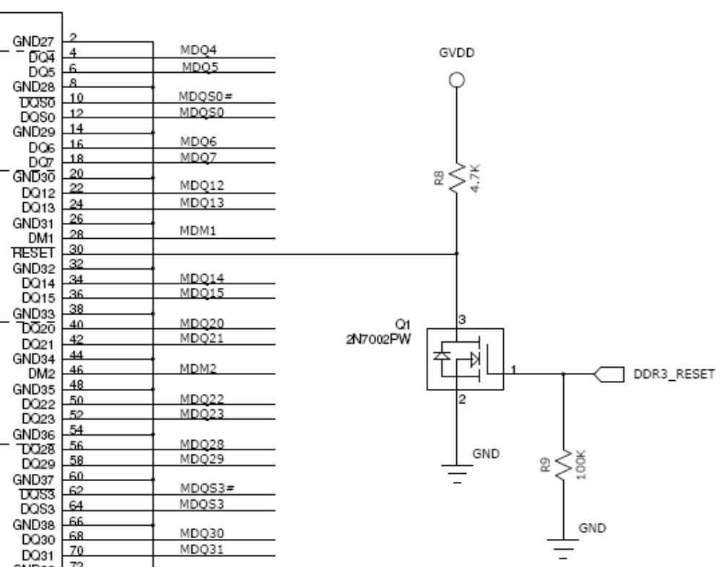

Implementation of the Serial presence-detect (SPD) function is done by connecting the SODIMM’s SPD memory to the P1021 device’s I2C1 interface.

NAND Flash
1 Gigabit NAND Flash is implemented on external local bus interface of P1021. To help debug activities, NAND flash socket is assembled on the board. NAND flash socket is footprint compatible NAND flash IC. As P1021 supports big endian, its LAD[7:0] lines are connected to IO[0:7] of flash device.

MRAM
128K x 8 MRAM memory is implemented on external local bus interface of P1021. There are two limitations while implementing MRAM circuit on APP card.

- Only 16 address lines can be used on eLBC which can cater to max 64K. This is due to QE implementation on APP card which have pins shared with eLBC
- Only x8 implementation can be used due to pin multiplexing of ENET5_RXD[1] and LWE1#/LBS1# on PB9 pin. As RMII5 is implemented on APP card, LWE1#/LBS1# is not available. In this case x16 devices on local bus can’t be used.

On APP card LAD[0:15] of P1021 are used for interfacing to MRAM device. LA[16:31] can’t be used for this purpose as these lines are used for QE Ethernet and serial port implementations. In order to do so It is required to explicitly set LBCR[ABSWP]=1 so that the address LSBs will be driven on LAD[0:15]. And the address multiplexing in case ABSWP=1 is:

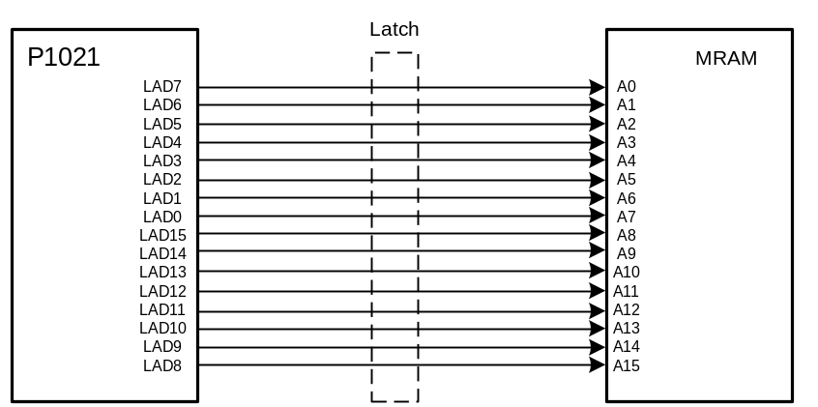

SPI Flash
128MBit SPI flash is implemented on eSPI Bus. SPI_CS0 is used for selecting this device. The P1021 has the ability to boot from an SPI serial Flash device in addition to supporting other peripheral devices conforming to SPI standard.

Micro SD Card Interface
The enhanced SD host controller (eSDHC) provides an interface between host system and SD/MMC cards.. For the P1021, booting from on-chip ROM is supported through the eSDHC. A micro SD card socket is provided on the bottom side of the board. This socket support top loading of the micro SD card. Below is the SD card interface diagram

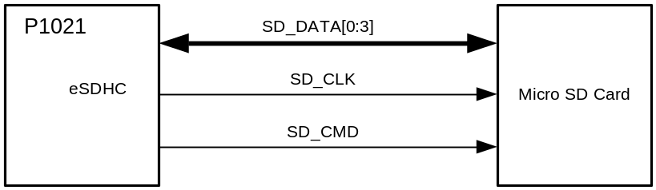

DUART
The P1021 has two UART controllers.
The P1021 DUART consists of two independent UARTs and has these distinctive features:

• Full-duplex operation
• Software-programmable baud generators:
• Clear-to-send (CTS) and ready-to-send (RTS) modem control functions
• Software-selectable serial interface data format that includes:
• Overrun, parity, and framing error detection

UART0 signals are not muxed with any other functional signals.
UART1 is muxed with QUICC Engine PortB bit [14–17]. A mux/demux is used to select between the functionalities.
Both UART signals are routed to backplane connectors

For debug activities UART0 is provided with an option to implement RS232 port on APP card.

RX lines of UART0 and UART1 are buffered in order to avoid any kind of damage to the P1021. This buffer is enabled only after all the power rails are settled and processor reset is released.

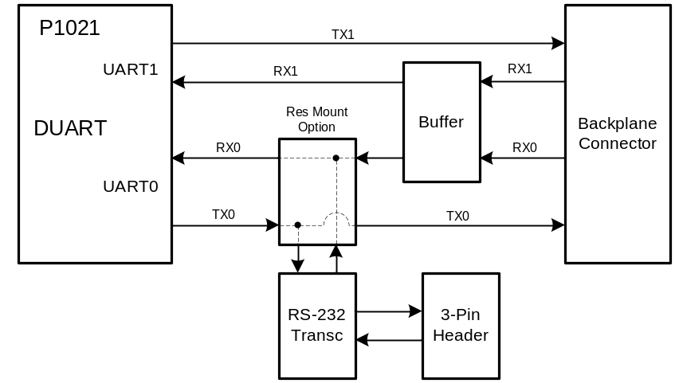

Enhanced Triple Speed Ethernet Controller (eTSEC) Interface
The P1021 processor supports three eTSEC ports. eTSEC1 supports GMII/RGMII/RTBI/MII/RMII MAC modes; eTSEC2 supports only SGMII; and eTSEC3 supports RGMII/RTBI/RMII.
On the APP card, eTSEC1 and eTSEC3 are implemented in RMII mode while eTSEC2 in SGMII mode. Two on board 10/100 Ethernet PHYs (KSZ8721BL from Micrel) are used to connect to eTSEC1 and eTSEC3 MACs. These PHYs are configured using management interface signals MDC and MDIO.

The diagram below shows the implementation of eTSEC ports on the card

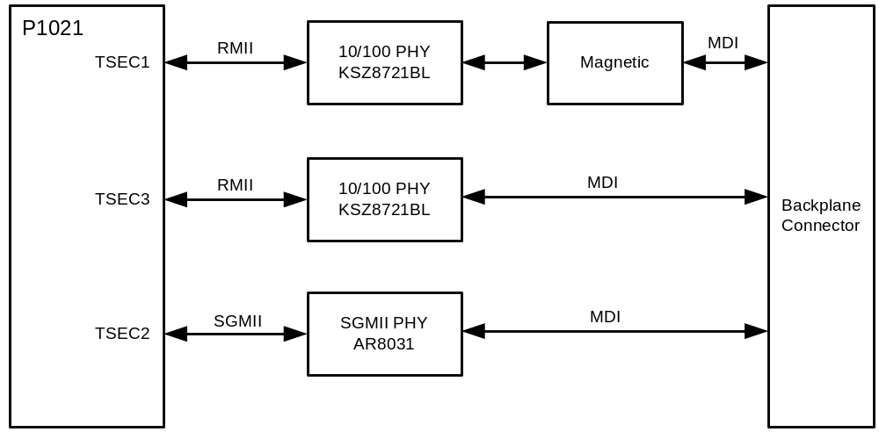

PHY Addresses

TSEC1 PHY: 0x01
TSEC3 PHY: 0x11
TSEC2 PHY: 0x00

RMII Interface

This section describes the reduced media-independent interface (RMII) intended to be used between the PHYs and the GMII MAC. The RMII is a reduced-pin alternative to the IEEE802.3u MII. The RMII reduces the number of signals required to interconnect the MAC and the PHY from a maximum of 18 signals (MII) to 10 signals. To accomplish this objective, the data paths are halved in width and clocked at twice the MII clock frequency, while clocks, carrier sense and error signals have been partly combined.
For 100 Mbps operation, the reference clock operates at 50 MHz, whereas for 10 Mbps operation, the clock remains at 50MHz, but only every 10th cycle is used.
The diagram below depicts the basic components of the reduced media-independent interface and the signals required to establish an eTSEC’s connection with a PHY (KSZ8721BL).

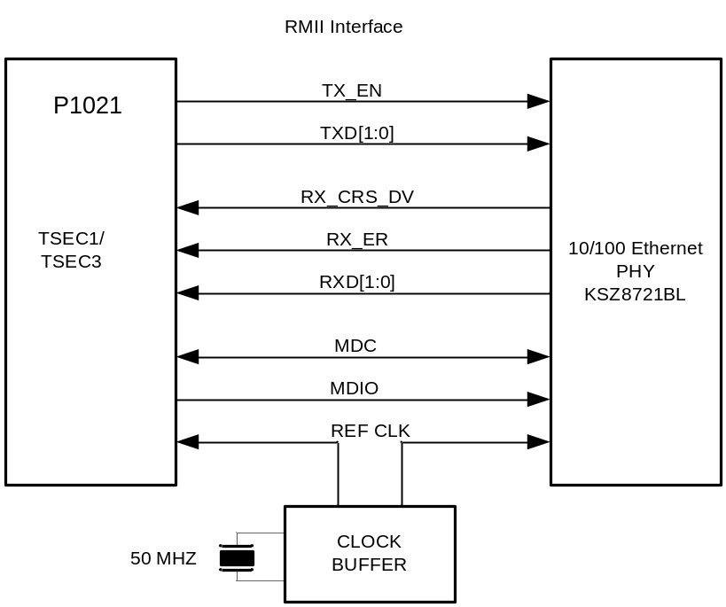

SGMII Interface

This section describes the serial gigabit media-independent interface (SGMII) intended to be used between a SerDes PHY (AR8031) and the eTSEC2 to implement a serial gigabit version of a media-independent interface.
SGMII communication using the eTSEC2 is accomplished through the SerDes interface.
Diagram below depicts the basic components of the SGMII including the signals required to establish eTSEC2 module connection with PHY device (AR8031).

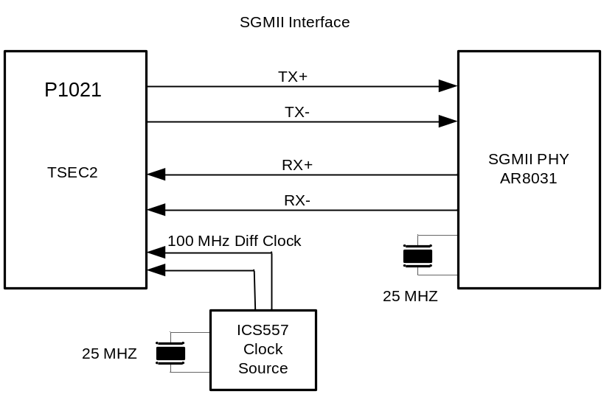

QUICC Engine RMII1 and RMII5 Interface
The diagram below shows block level implementation of QUICC Engine Ethernet ports RMII1 and RMII5

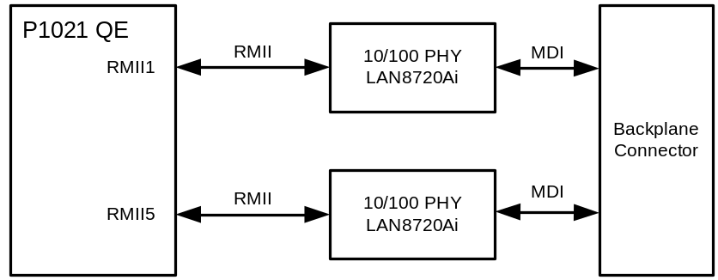

PHY Addresses

RMII1 PHY: 0x0
RMII5 PHY: 0x1

RMII Interface

This section describes the reduced media-independent interface (RMII) intended to be used between the PHYs and the RMII1/RMII5 MAC block of QUICC Engine. The RMII is a reduced-pin alternative to the IEEE802.3u MII. The RMII reduces the number of signals required to interconnect the MAC and the PHY from a maximum of 18 signals (MII) to 10 signals. To accomplish this objective, the data paths are halved in width and clocked at twice the MII clock frequency, while clocks, carrier sense and error signals have been partly combined.
For 100 Mbps operation, the reference clock operates at 50 MHz, whereas for 10 Mbps operation, the clock remains at 50MHz, but only every 10th cycle is used.
The diagram below depicts the basic components of the reduced media-independent interface and the signals required to establish an eTSEC’s connection with a PHY (LAN8721Ai).

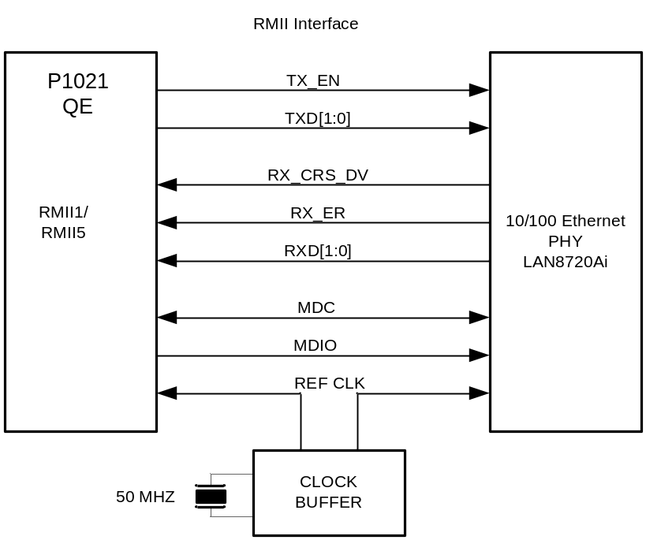

EtherCAT Slave Interface
EtherCAT slave interface is implemented using ET1100 on SPI bus of P1021. SPI_CS1 is used as chip select for this interface. ET1100 needs 25MHz crystal for its operation. ET1100 is used in EBus mode. The EBus signals (TX+/- and RX+/-) are routed to backplane connector. There is a 16KBit EEPROM is connected to ET1100 on its local I2C bus. This EEPROM is used for power on configuration of ET1100.

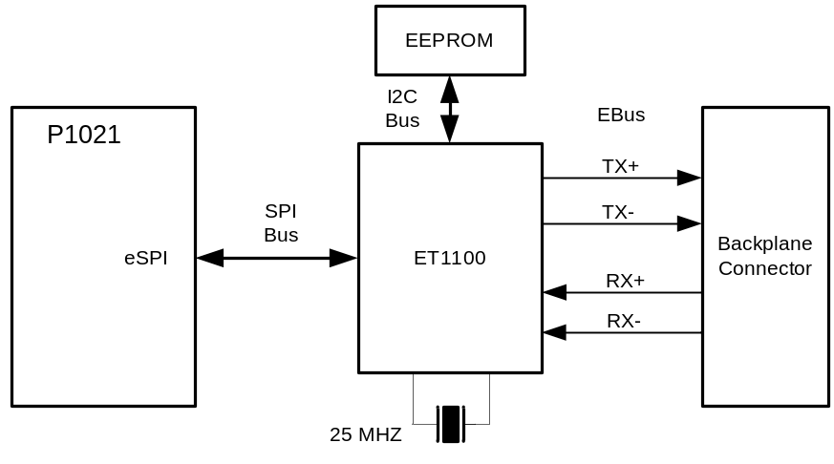

QUICC Engine SER3 and SER7 Interface
Serial interfaces SER3 and SER7 from QUICC Engine are implemented on board. These ports are directly connected to backplane connector.

USB
The P1021 USB 2.0 controller provides point-to-point connectivity complying with the USB specification, Rev 2.0. The USB controller can be configured to operate as a standalone host or device. To complete the USB interface, an external PHY (SMSC’s USB3300) is employed and connected to the processor’s ULPI signals. The
USB3300 PHY is used. The board features:

• High-speed (480 Mbps), full-speed (12 Mbps), and low-speed (1.5 Mbps) operation
• Host, device, and OTG modes
• Mini-AB connector provided in the board

The P1021 supports two USB ports where one port is non-multiplexed and the other is multiplexed with local bus. APP card has a PHY connected to the non-multiplexed port. The other port is not used

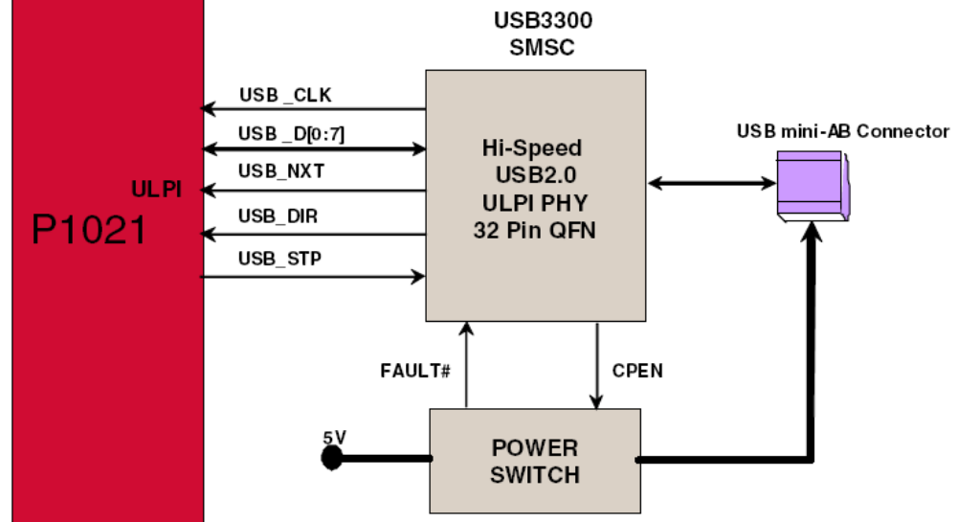

I2C
Figure below shows a block diagram of the I2C interfaces implemented on APP card.

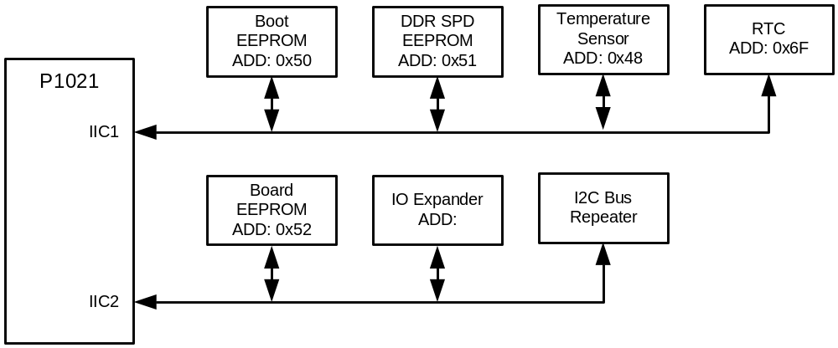

The block diagram illustrates intended I2C1 (non-muxed) bus usage:

• Used with boot sequencer EEPROM
• Read DDR SPD EEPROMs; provides correct information for using SODIMM
• Read board temperature near the P1021
• Obtain Real Time Clock information for application program synchronization

The I2C2 (muxed) bus is intended for use with an on-board BRD EEPROM storing board-related information such as history updates and PCB and CPU revisions. The I2C2 bus is multiplexed with the QUICC Engine bus, and an appropriate mux/demux is used to select between the functionalities.

CPLD
A CPLD part EPM3064 from Altera is used on board. Here is the list of functions implemented in CPLD

- Power sequencing
- System power good generation
- Reset generation
- P1021 power-on reset configuration control
- Clock control

25MHz clock is supplied to CPLD. There is an option provided to supply 66.666MHz to CPLD.

The table below lists details of the signals implemented on the CPLD

SR NO | SIGNAL | DIR | ACTIVE STATE | Function
1 | CPU_HRESET# | OUT | LOW | On PGOOD_SYS: Should be asserted LOW for 200uS and then deassert.  ALWAYS: Pass COP_HRESET# to this pin such that changes in COP_HRESET# is reflected in CPU_RESET#
2 | CPU_SRESET# | OUT | LOW | On PGOOD_SYS: Should be asserted LOW for 100uS and then deassert.  ALWAYS: Pass COP_SRESET# to this pin such that changes in COP_SRESET# is reflected in CPU_SRESET#
3 | CPU_HRESET_REQ# | IN | LOW
4 | CPU_TRST# | OUT | LOW | On PGOOD_SYS: Should be asserted LOW for 100uS and then deassert.  ALWAYS: Pass COP_TRST# to this pin such that changes in COP_TRST# is reflected in CPU_TRST#
5 | COP_HRESET# | IN | LOW
6 | COP_SRESET# | IN | LOW
7 | COP_TRST# | IN | LOW
8 | DDR3_RESET | OUT | HIGH | Drive HIGH at power up. When CPU_HRESET# is deasserted HIGH, start driving it LOW
9 | SGMII_PHY_RESET# | OUT | LOW | Drive LOW at power up. After a delay of 100us from CPU_HRESET# going HIGH, start driving it HIGH
10 | ENET_PHY_RESET# | OUT | LOW | Drive LOW at power up. After a delay of 100us from CPU_HRESET# going HIGH, start driving it HIGH
11 | TSEC_PHY_RESET# | OUT | LOW | Drive LOW at power up. After a delay of 100us from CPU_HRESET# going HIGH, start driving it HIGH
12 | MUX_EN1# | OUT | LOW | Should be made LOW after PGOOD_SYS becomes HIGH
13 | MUX_EN2# | OUT | LOW | Should be made LOW after PGOOD_SYS becomes HIGH
14 | MUX_SEL1 | OUT | HIGH | At power up, drive it LOW. Drive it HIGH within 5 system clock cycles (66.666MHz) from the CPU_HRESET# going HIGH
15 | MUX_SEL2 | OUT | HIGH | At power up, drive it LOW. Drive it HIGH within 5 system clock cycles (66.666MHz) from the CPU_HRESET# going HIGH
16 | BUF_EN# | OUT | LOW | At power up, drive it LOW. Drive it HIGH within 5 system clock cycles (66.666MHz) from the CPU_HRESET# going HIGH
17 | PWR_ON_GVDD | OUT | HIGH | At power up, drive it LOW. Drive it HIGH after sampling PGOOD_VDD_CPU HIGH
18 | PWR_OFF_VDD_CPU | OUT | HIGH | RESERVE. Keep it in Z state
19 | PWR_GOOD_DDR3 | IN | HIGH (OD)
20 | SD_1588_CLK_EN | OUT | HIGH | RESERVE. Keep it in Z state
21 | PGOOD_SYS | OUT | HIGH | Should be asserted HIGH after PGOOD_VDD_CPU and PWR_GOOD_DDR3 are HIGH
22 | PGOOD_VDD_CPU | IN | HIGH
23 | CPLD_RESET# | IN | LOW

CPLD JTAG Header

Pin | Function | Pin | Function
1 | TCK | 2 | GND
3 | TDO | 4 | VCC
5 | TMS | 6 | NC
7 | NC | 8 | NC
9 | TDI | 10 | GND

Hot Swap Control
A hot-swap circuit is used to make this board ready for live insertion and removal in the system. The circuit also provides oring of the two input voltages 6.5A and 6.5B. This circuit is enabled only when it sit properly in the backplane.

Power
Power delivery diagram along with system power good generation circuit is shown below.

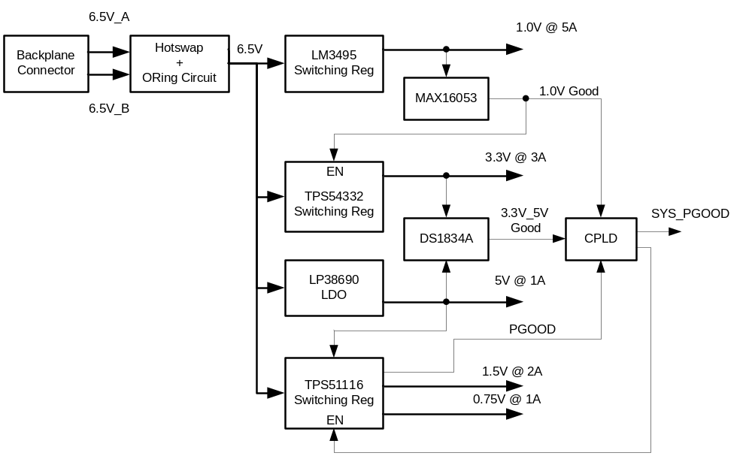

Board Power Requirement

Sr No | Component | Condition | Typ Current  (A) | Max Current  (A) | Typ Power  (W) | Max Power  (W)
1V Requirement
1 | P1012 Core | P1012 Core @ 800MHz |  | 2.7 |  | 2.7
 |  | PCI Express, x4 Link (SVDD) | 0.229 | 0.321 | 0.11
 |  | SGMII (SVDD) | 0.096 | 0.134 | 0.096
 | Current at 1V |  |  | 3.155
1.5V Requirement
1 | P1012 (GVDD) | DDR3 75% utilization @ 667MHz | 0.547 | 0.765 | 0.82
2 | DDR3 SODIMM 1GB @ 667MHz | All banks interleaved read current |  | 2
 | Current at 1.5V |  |  | 2.765
0.75V Requirement
1 | DDR3 SODIMM 1GB @ 667MHz | Termination Voltage Vtt |  | 0.6
 | Current at 0.75V |  |  | 0.600
3.3V Requirement
1 | P1012 | eLBC (BVDD) | 0.014 | 0.020 | 0.047
 |  | eTSEC (RGMII) (LVDD) | 0.075 | 0.105 | 0.248
 |  | eSDHC (CVDD) | 0.004 | 0.006 | 0.014
 |  | USB (CVDD) | 0.004 | 0.005 | 0.012
 |  | eSPI (CVDD) | 0.003 | 0.004 | 0.01
 |  | I2C (OVDD) | 0.001 | 0.001 | 0.002
 |  | DUART (OVDD) | 0.002 | 0.003 | 0.006
 |  | IEEE 1588 (LVDD) | 0.002 | 0.003 | 0.007
 |  | QUICC Engine (BVDD) | 0.024 | 0.034 | 0.08
2 | S25FL128P0XNFI001 SPI Flash | Active Page Program Current |  | 0.026
3 | S29GL01GP11TFIR10 NOR Flash | Active Read Current | 0.06 | 0.11
4 | MR4A16BCMA35 MRAM | AC active supply current - write modes1 | 0.11 | 0.154
5 | M24256-BWMN6TP EEPROM | Supply current (Write) |  | 0.005
6 | AT24C01BN-SH-B EEPROM | Supply current (Write) | 0.002 | 0.003
7 | LAN8720Ai Ethernet PHY | 100BASE-T /W TRAFFIC (2 Nos) | 0.1 | 0.108 | 0.164 | 0.179
8 | USB3300 USB PHY | FS Transmit 3.3V Current | 0.036 | 0.042
9 | KSZ8721BLI Ethernet PHY | Normal 100BASE-TX (2 Nos) | 0.302 | 0.423
10 | SD Card |  |  | 0.2
11 | LED | (12 Nos) |  | 0.12
12 | CPLD |  |  | 0.3
 | Current at 3.3V |  |  | 1.672
5V Requirement
1 | USB Port |  |  | 0.5
 | Current at 5V |  |  | 0.500

Power Sequencing

The processor P1021 requires that its power rails be applied in a specific sequence in order to ensure proper device operation. These requirements are as follows for power up:
1. VDD, VDDC, AVDD, BVDD, LVDD, CVDD, OVDD, SVDD_SRDS and, XVDD_SRDS

2. GVDD

All supplies must be at their stable values within 50 ms.
Items on the same line have no ordering requirement with respect to one another. Items on separate lines must be ordered sequentially such that voltage rails on a previous step must reach 90% of their value before the voltage rails on the current step reach 10% of theirs.

Here is list of list of voltages used for P1021

- VDD, VDDC, AVDD, SVDD_SRDS, XVDD_SRDC => 1.0V
- BVDD, LVDD, CVDD, OVDD => 3.3V
- GVDD => 1.5V

Debug Support

JTAG COP Header

The JTAG header provides a connection between the P1021 device and an external, compatible JTAG converter. The default is the CodeWarrior USB TAP.
The diagram below shows COP connector physical pinouts

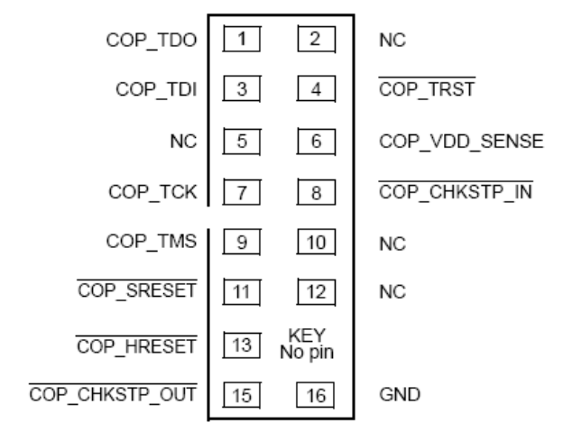
Debug RS-232 Port

An RS-232 port is provided on board just for debug purpose only. This is implemented using DUART port0 of P1021. The access to this port is available through 3-pin header. Below is the pin assignment for this header (J8).

PIN # | SIGNAL
1 | TX
2 | RX
3 | GND

Debug LEDs

There are two LEDs provided to help debugging of the board. These are defined as below.

LED | Color | Description
LED1 (D26) | Green | User Programmable
LED2 (D27) | Green | User Programmable

Manual Reset Switch

There is a manual switch (SW1) provided on board to reset the board. This switch is accessible on the front panel. Whenever it is pressed (activated), CPLD gets reset which in turn generates the system reset.

Test Points/ Jumpers

Test points are provided for probing important signals, power and ground nets during debugging/ testing.

Front Panel LEDs

Table below describes the LEDs used on front panel

Name | Description | Controlled by | Label | Color | No of LEDs
STATUS
Power | Power Supply(ies) status ok | HW (CPLD) | POWER | Blue | 3
Active | Card is controlling output channels | SW | ACTIVE | Green | 1
Ready | Card is healthy and has no detectable faults | SW | READY | Green | 1
Alarm | Card has a detectable non-critical issue | SW | ALARM | Yellow | 1
Fault | Card has a critical error | SW/HW | FAULT | Red | 1
CPU | CPU is active/heartbeat | SW | CPU | Green | 1
Learn | Card in initializing/booting/learning from peer | SW | LEARN | Green | 1
COMMUNICATIONS
Ecat LINKACT(x) | EtherCAT Link/Activity | HW (U15) |  | Green | 1
Ecat LINKACT(x) | EtherCAT Speed | HW (U15) |  | Yellow | 1
Serial Tx/Rx | Serial port activity - 2/port | HW (U1) | Tx/Rx | Green | 8
Ethernet | Ethernet Activity - 2/port | HW (U13, U14) |  | Green | 2
Ethernet | Ethernet Speed | HW (U13, U14) |  | Yellow | 2

All status LEDs excluding “Power” are directly driven by the processor.
Power LEDs are driven by the CPLD after confirming all the on board rails are within the specified limit. Below the circuit used to drive power LEDs.

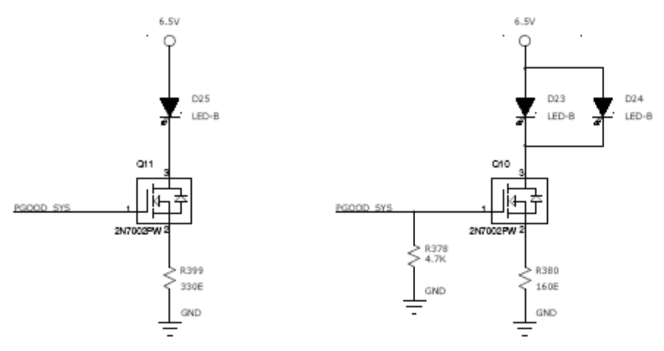

Backplane Connectors
This section gives the details of the backplane connectors used on the board.

Connector : 1 (54 Pins Connector)
Pin No. | Signal Name | Description
A1 | APP_IES+ | MII interface Transmit data to IES (+)
B1 | APP_IES- | MII interface Transmit data to IES(-)
C1 | GND | Ground
D1 | IES_APP+ | MII interface Receive data from IES(+)
E1 | IES_APP- | MII interface Receive data from IES(-)
F1 | GND | Ground
G1 | APP_ECAT+ | MII interface Transmit data to ECAT(+)
H1 | APP_ECAT- | MII interface Transmit data to ECAT(-)
I1 | GND | Ground
A2 | GND | Ground
B2 | ECAT_APP+ | MII interface Receive data from ECAT(+)
C2 | ECAT_APP- | MII interface Receive data from ECAT(-)
D2 | GND | Ground
E2 | NC | NC
F2 | NC | NC
G2 | GND | Ground
H2 | APP_IES_EBUS+ | EBUS interface Transmit data to opposite IES(+)
I2 | APP_IES_EBUS- | EBUS interface Transmit data to opposite IES(-)
A3 | IES_APP_EBUS+ | EBUS interface Receive data from opposite IES(+)
B3 | IES_APP_EBUS- | EBUS interface Receive data from opposite IES(-)
C3 | GND | Ground
D3 | APP_MBUS_1_DE | Transmit Enable to MOD BUS Port 1
E3 | APP_MBUS_2_DE | Transmit Enable to MOD BUS Port 2
F3 | GND | Ground
G3 | APP_TLINK_1_DE | Transmit Enable to Train Link Port 1
H3 | APP_TLINK_2_DE | Transmit Enable to Train Link Port 2
I3 | GND | Ground
A4 | GND | Ground
B4 | TLINK_APP_2 | Receive Data 2 from Train Link
C4 | APP_TLINK_2 | Transmit Data 2 to Train Link
D4 | GND | Ground
E4 | APP-A_E4 | Connector Short Pin
F4 | NC | NC
G4 | GND | Ground
H4 | TLINK_APP_1 | Receive Data 1 from Train Link
I4 | APP_TLINK_1 | Transmit Data 1 to Train Link
A5 | APP_MBUS_2 | Transmit Data 2 to MODBUS
B5 | MBUS_APP_2 | Receive Data 2 from MODBUS
C5 | GND | Ground
D5 | APP_MBUS_1 | Transmit Data 1 to MODBUS
E5 | MBUS_APP_1 | Receive Data 1 from MODBUS
F5 | GND | Ground
G5 | APP_APP_3- | GBE between APPs
H5 | APP_APP_3+ | GBE between APPs
I5 | GND | Ground
A6 | GND | Ground
B6 | APP_APP_2- | GBE between APPs
C6 | APP_APP_2+ | GBE between APPs
D6 | GND | Ground
E6 | APP_APP_1- | GBE between APPs
F6 | APP_APP_1+ | GBE between APPs
G6 | GND | Ground
H6 | APP_APP_0- | GBE between APPs
I6 | APP_APP_0+ | GBE between APPs

Connector :2 (72 Pins Connector)
Pin No. | Signal Name | Description
A1 | APP_EEC1+ | 10/100 Eth Interface Transmit to EEC1(+)
B1 | APP_EEC1- | 10/100 Eth Interface Transmit to EEC1(-)
C1 | GND | Ground
D1 | EEC_APP-1+ | 10/100 Eth Interface Receive from EEC1(+)
E1 | EEC_APP-1- | 10/100 Eth Interface Receive from EEC1(-)
F1 | GND | Ground
G1 | APP_EEC2+ | 10/100 Eth Interface Transmit to EEC2(+)
H1 | APP_EEC2- | 10/100 Eth Interface Transmit to EEC2(-)
I1 | GND | Ground
A2 | GND | Ground
B2 | EEC_APP-2+ | 10/100 Eth Interface Receive from EEC2(+)
C2 | EEC_APP-2- | 10/100 Eth Interface Receive from EEC2(-)
D2 | GND | Ground
E2 | GND | Ground
F2 | 2V5_APP_EEC-1 | 2.5V supply to EEC1 port
G2 | GND | Ground
H2 | 2V5_APP_EEC-2 | 2.5V supply to EEC2 port
I2 | GND | Ground
A3 | NC | NC
B3 | GND | Ground
C3 | NC | NC
D3 | GND | Ground
E3 | APP_IES_SCL-A | I2C Clock
F3 | GND | Ground
G3 | APP_IES_SDA-A | I2C Data
H3 | GND | Ground
I3 | NC | NC
A4 | GND | Ground
B4 | NC | NC
C4 | GND | Ground
D4 | NC | NC
E4 | APP-A_E4 | Connector Short Pin
F4 | NC | NC
G4 | GND | Ground
H4 | APP_IES_DET | APP board detect signal from same side IES
I4 | GND | Ground
A5 | APP_IES_DET_OPP | APP board detect signal from opp. Side IES
B5 | GND | Ground
C5 | NC | NC
D5 | GND | Ground
E5 | NC | NC
F5 | GND | Ground
G5 | NC | NC
H5 | GND | Ground
I5 | NC | NC
A6 | GND | Ground
B6 | NC | NC
C6 | GND | Ground
D6 | IES_APP_DET_OPP | Opposite side IES board detect from APP
E6 | GND | Ground
F6 | IES_APP_DET | Same side IES board detect from APP
G6 | GND | Ground
H6 | GND | Physical Slot addr 0
I6 | GND | Ground
A7 | NC | Physical Slot addr 1
B7 | GND | Ground
C7 | PCC_APP_OPP4 | Signal 4 input from opp side PCC
D7 | GND | Ground
E7 | PCC_APP_OPP3 | Signal 3 input from opp side PCC
F7 | GND | Ground
G7 | PCC_APP_OPP2 | Signal 2 input from opp side PCC
H7 | GND | Ground
I7 | PCC_APP_OPP1 | Signal 1 input from opp side PCC
A8 | GND | Ground
B8 | PCC_APP4 | Signal 4 input from same side PCC
C8 | GND | Ground
D8 | PCC_APP3 | Signal 3 input from same side PCC
E8 | GND | Ground
F8 | PCC_APP2 | Signal 2 input from same side PCC
G8 | GND | Ground
H8 | PCC_APP1 | Signal 1 input from same side PCC
I8 | GND | Ground

Schematic Design

Design Tool
Schematic entry is done PAD9.3

Board Layout Design

Board Thickness
Thickness of the Board designed is 1.6mm±10% [0.063” ± 10%]

Board Stack-up
The Main Board is designed with four layer stack-up with no blind or buried vias. Most of the components are placed top side of the board except for few discrete which are placed on bottom.

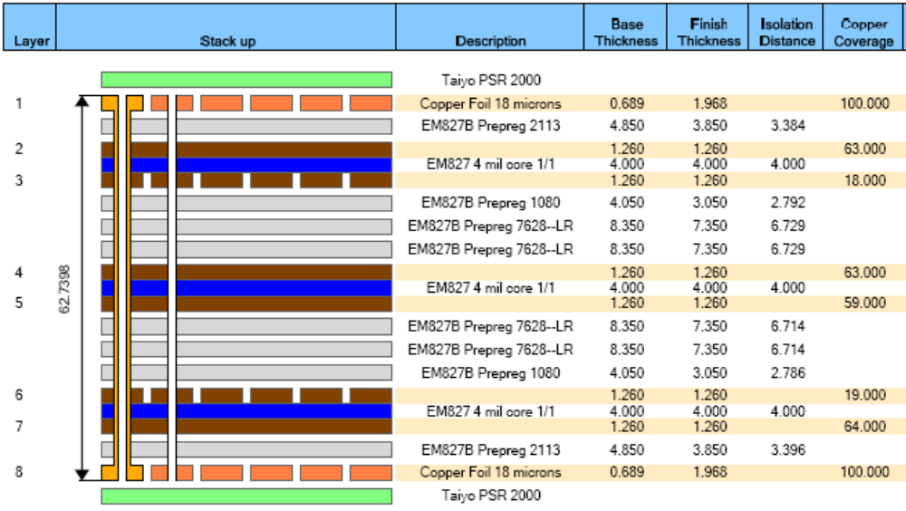

Appendix - A

Power-on Reset strapping options on APP card

System PLL Ratio
Functional Signals | Value (Binary) | CCB Clock : SYSCLK Ratio | APP Inplementation
LA[29:31]  No Default | 000 | 4:1 | LA29: Pull-down (R228: GND)  LA30: Pull-up (R220: 3.3V; R227: DNI)  LA31: Pull-down (R279: GND; R278: DNI)
LA[29:31]  No Default | 001 | 5:1
LA[29:31]  No Default | 010 | 6:1
LA[29:31]  No Default | other | Reserved
DDR PLL Ratio
Functional Signals | Value (Binary) | DDR Complex : DDRCLK Ratio | APP Inplementation
TSEC_1588_CLK_OUT,  TSEC_1588_PULSE_OUT1,  TSEC_1588_PULSE_OUT2  No Default | 000 | 3:1 | TSEC_1588_CLK_OUT: Pull-up (R299: 3.3V; R233: DNI)  TSEC_1588_PULSE_OUT1: Pull-down (R311: GND; R300: DNI)  TSEC_1588_PULSE_OUT2: Pull-down (R312: GND; R301: DNI)
 | 001 | 4:1
 | 010 | 6:1
 | 011 | 8:1
 | 100 | 10:1
 | 101 | Reserved
 | 110 | Reserved
 | 111 | Synchronous mode
e500 Core0 PLL Ratios
Functional Signals | Value (Binary) | e500 Core:CCB Clock Ratio | APP Inplementation
LBCTL, LALE, LGPL2/LOE/LFRE  No Default | 000 | Reserved | LBCTL: Pull-up (R283: 3.3V; R291: DNI)  LALE: Pull-down (R292: GND; R284: DNI)  LGPL2/LOE/LFRE: Pull-down (R293: GND; R285: DNI)
LBCTL, LALE, LGPL2/LOE/LFRE  No Default | 001 | Reserved
LBCTL, LALE, LGPL2/LOE/LFRE  No Default | 010 | 1:1
LBCTL, LALE, LGPL2/LOE/LFRE  No Default | 011 | 3:2 (1.5:1)
LBCTL, LALE, LGPL2/LOE/LFRE  No Default | 100 | 2:1
LBCTL, LALE, LGPL2/LOE/LFRE  No Default | 101 | 5:2 (2.5:1)
LBCTL, LALE, LGPL2/LOE/LFRE  No Default | 110 | 3:1
LBCTL, LALE, LGPL2/LOE/LFRE  No Default | 111 | Reserved
e500 Core1 PLL Ratios
Functional Signals | Value (Binary) | e500 Core:CCB Clock Ratio | APP Inplementation
LWE0, UART_SOUT1, READY_P1  No Default | 000 | Reserved | LWE0: Pull-up (R286: 3.3V; R294: DNI)  UART_SOUT1: Pull-down (R267: GND; R250: DNI)  READY_P1: Pull-down (R247: GND; R246: DNI)
LWE0, UART_SOUT1, READY_P1  No Default | 001 | Reserved
LWE0, UART_SOUT1, READY_P1  No Default | 010 | 1:1
LWE0, UART_SOUT1, READY_P1  No Default | 011 | 3:2 (1.5:1)
LWE0, UART_SOUT1, READY_P1  No Default | 100 | 2:1
LWE0, UART_SOUT1, READY_P1  No Default | 101 | 5:2 (2.5:1)
LWE0, UART_SOUT1, READY_P1  No Default | 110 | 3:1
LWE0, UART_SOUT1, READY_P1  No Default | 111 | Reserved
Boot ROM Location
Functional Signals | Value (Binary) | Meaning | APP Inplementation
TSEC3_TXD[2:0],  TSEC1_TX_ER  Default (1111) | 0000 | PCI Express 1 | TSEC3_TXD2: Pull-up (R315: 3.3V; R305: DNI)  TSEC3_TXD1: Pull-down (R254: GND; R253: DNI)  TSEC3_TXD0: Pull-down (R252: GND; R251: DNI)  TSEC1_TX_ER: Pull-down (R304: GND; R219: DNI)
TSEC3_TXD[2:0],  TSEC1_TX_ER  Default (1111) | 0001 | PCI Express 2
TSEC3_TXD[2:0],  TSEC1_TX_ER  Default (1111) | 0010 | Reserved
TSEC3_TXD[2:0],  TSEC1_TX_ER  Default (1111) | 0011 | Reserved
TSEC3_TXD[2:0],  TSEC1_TX_ER  Default (1111) | 0100 | DDR controller
TSEC3_TXD[2:0],  TSEC1_TX_ER  Default (1111) | 0101 | Reserved
TSEC3_TXD[2:0],  TSEC1_TX_ER  Default (1111) | 0110 | On-chip boot ROM—SPI configuration
TSEC3_TXD[2:0],  TSEC1_TX_ER  Default (1111) | 0111 | On-chip boot ROM—eSDHC configuration
TSEC3_TXD[2:0],  TSEC1_TX_ER  Default (1111) | 1000 | Local bus FCM—8-bit NAND flash small page
TSEC3_TXD[2:0],  TSEC1_TX_ER  Default (1111) | 1001 | Reserved
TSEC3_TXD[2:0],  TSEC1_TX_ER  Default (1111) | 1010 | Local bus FCM—8-bit NAND flash large page
TSEC3_TXD[2:0],  TSEC1_TX_ER  Default (1111) | 1011 | Reserved
TSEC3_TXD[2:0],  TSEC1_TX_ER  Default (1111) | 1100 | Reserved
TSEC3_TXD[2:0],  TSEC1_TX_ER  Default (1111) | 1101 | Local bus GPCM—8-bit ROM
TSEC3_TXD[2:0],  TSEC1_TX_ER  Default (1111) | 1110 | Local bus GPCM—16-bit ROM
TSEC3_TXD[2:0],  TSEC1_TX_ER  Default (1111) | 1111 | Local bus GPCM—16-bit ROM (default)
Host/Agent Configuration
Functional Signals | Value (Binary) | Meaning | APP Inplementation
LWE1, LA[18:19]  Default (111) | 000 | P1021 acts as an agent on all its PCI Express interfaces | LWE1: Pull-up (R107: 3.3V)  LA18: Pull-up (R235: 3.3V)  LA19: Pull-up (R258: 3.3V)
LWE1, LA[18:19]  Default (111) | 001 | P1021 acts as an agent on PCI Express 1 and acts as a host on PCI Express 2.
LWE1, LA[18:19]  Default (111) | 010 | P1021 acts as a host on PCI Express 1 and acts as an agent on PCI Express 2.
LWE1, LA[18:19]  Default (111) | 011 - 110 | Reserved
LWE1, LA[18:19]  Default (111) | 111 | P1021 acts as the host processor/root complex for all PCI Express interfaces (default).
I/O Port Selection
Functional Signals | Value (Binary) | Meaning | APP Inplementation
TSEC1_TXD[3:1],  CFG_IO_PORTS3  Default (1111) | 0000 | PCI Express 1 (×1) (2.5Gbps) → SerDes lane 0  SerDes lanes 1–3 powered down | TSEC1_TXD3: Pull-up (R229: 3.3V)  TSEC1_TXD2: Pull-up (R256: 3.3V)  TSEC1_TXD1: Pull-up (R265: 3.3V)  CFG_IO_PORTS3: Pull-down (R232: GND)
TSEC1_TXD[3:1],  CFG_IO_PORTS3  Default (1111) | 0001 | SerDes lanes 0–3 powered down
TSEC1_TXD[3:1],  CFG_IO_PORTS3  Default (1111) | 0100-0101 | Reserved
TSEC1_TXD[3:1],  CFG_IO_PORTS3  Default (1111) | 0110 | PCI Express 1 (×4) (2.5 Gbps) → SerDes lanes 0–3
TSEC1_TXD[3:1],  CFG_IO_PORTS3  Default (1111) | 0111-1101 | Reserved
TSEC1_TXD[3:1],  CFG_IO_PORTS3  Default (1111) | 1110 | PCI Express 1 (x1) (2.5 Gbps) → SerDes lane 0  PCI Express 2 (x1) (2.5 Gbps) → SerDes lane 1  SGMII eTSEC2 (x1) (1.25Gbps) → SerDes lane 2  SGMII eTSEC3 (x1) (1.25Gbps) → SerDes lane 3
TSEC1_TXD[3:1],  CFG_IO_PORTS3  Default (1111) | 1111 | PCI Express 1 (x2) (2.5 Gbps) → SerDes lanes 0–1  SGMII eTSEC2 (x1) (1.25Gbps) → SerDes lane 2  SGMII eTSEC3 (x1) (1.25Gbps) → SerDes lane 3 (see Note)  (default)
CPU Boot Configuration
Functional Signals | Value (Binary) | Meaning | APP Inplementation
LA27, LA16  Default (11) | 00 | CPU boot holdoff mode for both cores. The e500 cores are prevented from booting until configured by an external master | LA27: Pull-up (R240: 3.3V; R241: DNI)  LA16: Pull-down (R238: GND; R237: DNI)
LA27, LA16  Default (11) | 01 | e500 core 1 is allowed to boot without waiting for configuration by an external master, while e500 core 0 is prevented from booting until configured by an external master or the other core
LA27, LA16  Default (11) | 10 | e500 core 0 is allowed to boot without waiting for configuration by an external master, while e500 core 1 is prevented from booting until configured by an external master or the other core
LA27, LA16  Default (11) | 11 | Both e500 cores are allowed to boot without waiting for configuration by an external master (default)
Boot Sequencer Configuration
Functional Signals | Value (Binary) | Meaning
LGPL3/LFWP,  LGPL5  Default (11) | 00 | Reserved | LGPL3: Pull-up (R287: 3.3V; R295: DNI)  LGPL5: Pull-up (R289: 3.3V; R297: DNI)
LGPL3/LFWP,  LGPL5  Default (11) | 01 | Normal I2C addressing mode is used. Boot sequencer is enabled and loads configuration information from a ROM on the I2C1 interface. A valid ROM must be present
LGPL3/LFWP,  LGPL5  Default (11) | 10 | Extended I2C addressing mode is used. Boot sequencer is enabled and loads configuration information from a ROM on the I2C1 interface. A valid ROM must be present
LGPL3/LFWP,  LGPL5  Default (11) | 11 | Boot sequencer is disabled. No I2C ROM is accessed (default)
DDR SDRAM Type
Functional Signals | Value (Binary) | Meaning | APP Inplementation
CFG_DRAM_TYPE  Default (1) | 0 | DDR2  1.8 V, CKE low at reset | CFG_DRAM_TYPE: Pull-up (R225: 3.3V)
CFG_DRAM_TYPE  Default (1) | 1 | DDR3  1.5 V, CKE low at reset (default) | CFG_DRAM_TYPE: Pull-up (R225: 3.3V)
SerDes Reference Clock Configuration
Functional Signals | Value (Binary) | Meaning | APP Inplementation
TSEC_1588_ALARM_OUT1  Default (1) | 0 | SerDes expects a 125 MHz reference clock frequency | TSEC_1588_ALARM_OUT1: Pull-up (R274: 3.3V)
TSEC_1588_ALARM_OUT1  Default (1) | 1 | SerDes expects a 100 MHz reference clock frequency (default) | TSEC_1588_ALARM_OUT1: Pull-up (R274: 3.3V)
eTSEC3 SGMII Mode
Functional Signals | Value (Binary) | Meaning | APP Inplementation
TSEC_1588_ALARM_OUT2  Default (1) | 0 | eTSEC3 Ethernet interface operates in SGMII mode and uses SGMII SerDes lane 3 pins | TSEC_1588_ALARM_OUT2: Pull-up (R290: 3.3V)
TSEC_1588_ALARM_OUT2  Default (1) | 1 | eTSEC3 Ethernet interface operates in standard parallel interface mode and uses the TSEC3_* pins (default) | TSEC_1588_ALARM_OUT2: Pull-up (R290: 3.3V)
eTSEC1 Width
Functional Signals | Value (Binary) | Meaning | APP Inplementation
EC_MDC  Default (1) | 0 | eTSEC1 Ethernet interface operates in reduced pin mode (either RGMII or RMII mode) | EC_MDC: Pull-down (R255: GND)
EC_MDC  Default (1) | 1 | eTSEC1 Ethernet interface operates in standard width MII mode (default) | EC_MDC: Pull-down (R255: GND)
eTSEC1 Protocol
Functional Signals | Value (Binary) | Meaning | APP Inplementation
TSEC1_TXD0,  TSEC3_TXD3  Default (11) | 00 | Reserved | TSEC1_TXD0: Pull-down (R262: GND)  TSEC3_TXD3: Pull-up (R314: 3.3V)
TSEC1_TXD0,  TSEC3_TXD3  Default (11) | 01 | The eTSEC1 controller operates using the MII protocol (or RMII if configured in reduced mode as described in “eTSEC1 Width”).
TSEC1_TXD0,  TSEC3_TXD3  Default (11) | 10 | The eTSEC1 controller operates using the RGMII protocol if configured in reduced mode as described in “eTSEC1 Width”
TSEC1_TXD0,  TSEC3_TXD3  Default (11) | 11 | Reserved
eTSEC3 Protocol
Functional Signals | Value (Binary) | Meaning | APP Inplementation
UART_RTS0,  UART_RTS1  Default (11) | 00 | Reserved | UART_RTS0: Pull-down (R271: GND)  UART_RTS1: Pull-up (R249: 3.3V)
UART_RTS0,  UART_RTS1  Default (11) | 01 | The eTSEC3 controller operates using the RMII protocol if not configured to operate in SGMII mode
UART_RTS0,  UART_RTS1  Default (11) | 10 | The eTSEC3 controller operates using the RGMII protocol if not configured to operate in SGMII mode
UART_RTS0,  UART_RTS1  Default (11) | 11 | Reserved
Memory Debug Configuration
Functional Signals | Value (Binary) | Meaning | APP Inplementation
CFG_MEM_DEBUG  Default (1) | 0 | Debug information from the enhanced local bus controller (eLBC) is driven on the MSRCID and MDVAL signals | CFG_MEM_DEBUG: Pull-up (R226: 3.3V; R234: DNI)
CFG_MEM_DEBUG  Default (1) | 1 | Debug information from the DDR SDRAM controller is driven on the MSRCID and MDVAL signals (default) | CFG_MEM_DEBUG: Pull-up (R226: 3.3V; R234: DNI)
DDR Debug Configuration
Functional Signals | Value (Binary) | Meaning | APP Inplementation
CFG_DDR_DEBUG  Default (1) | 0 | Debug information is driven on the ECC pins instead of normal ECC I/O. ECC signals from memory devices must be disconnected. | CFG_DDR_DEBUG: Pull-up (R280: 3.3V; R281: DNI)
CFG_DDR_DEBUG  Default (1) | 1 | Debug information is not driven on ECC pins. ECC pins function in their normal mode (default) | CFG_DDR_DEBUG: Pull-up (R280: 3.3V; R281: DNI)
General-Purpose POR Configuration
Functional Signals | Value (Binary) | Meaning | APP Inplementation
LAD[0:15]  No Default |  | General-purpose POR configuration vector to be placed in GPPORCR. | Not Implemented
Engineering Use POR Configuration
Functional Signals | Value (Binary) | Meaning | APP Inplementation
LA[20:22],  UART_SOUT[0], MSRCID[4]  Default (1_1111) | 1_1111 | Default operation | LA20: pull-up (R239: 3.3V)  LA21: pull-up (R260: 3.3V)  LA22: pull-up (R236: 3.3V)  UART_SOUT[0]: pull-up (R248: 3.3V)  MSRCID[4]: pull-up (R302: 3.3V)
LA[20:22],  UART_SOUT[0], MSRCID[4]  Default (1_1111) | 0_0000-1_1110 | Reserved
eLBC ECC Enable Configuration
Functional Signals | Value (Binary) | Meaning | APP Inplementation
MSRCID0  Default (1) | 0 | eLBC ECC checking is disabled. | MSRCID0: pull-down (R296: GND; R110: DNI)
MSRCID0  Default (1) | 1 | Default operation: eLBC ECC checking is enabled | MSRCID0: pull-down (R296: GND; R110: DNI)
System Speed
Functional Signals | Value (Binary) | Meaning | APP Inplementation
LA28  Default (1) | 0 | Reserved | LA28: pull-up (R221: 3.3V)
LA28  Default (1) | 1 | SYSCLK frequency is at or above 66 MHz (default) | LA28: pull-up (R221: 3.3V)
Platform Speed
Functional Signals | Value (Binary) | Meaning | APP Inplementation
LA23  Default (1) | 0 | Platform clock frequency is above 267 MHz and below 300 MHz | LA23: pull-up (R223: 3.3V; R231: DNI)
LA23  Default (1) | 1 | Platform clock frequency is at or above 300 MHz (default) | LA23: pull-up (R223: 3.3V; R231: DNI)
Core 0 Speed
Functional Signals | Value (Binary) | Meaning | APP Inplementation
LA24  Default (1) | 0 | Core 0 clock frequency is less than 500 MHz | LA24: pull-up (R222: 3.3V; R224: DNI)
LA24  Default (1) | 1 | Core 0 clock frequency is greater than or equal to 500 MHz (default) | LA24: pull-up (R222: 3.3V; R224: DNI)
Core 1 Speed
Functional Signals | Value (Binary) | Meaning | APP Inplementation
LA25  Default (1) | 0 | Core 1 clock frequency is less than 500 MHz | LA25: pull-up (R244: 3.3V; R245: DNI)
LA25  Default (1) | 1 | Core 1 clock frequency is greater than or equal to 500 MHz (default) | LA25: pull-up (R244: 3.3V; R245: DNI)
DDR Speed
Functional Signals | Value (Binary) | Meaning | APP Inplementation
LA26  Default (1) | 0 | DDR data rate is less than 500 MHz | LA26: pull-up (R242: 3.3V; R243: DNI)
LA26  Default (1) | 1 | DDR data rate is greater than or equal to 500 MHz (default) | LA26: pull-up (R242: 3.3V; R243: DNI)

Appendix - B

