CCCNGP Backplane

Hardware Design Document
Rev-1.0

09-Sept-11

Ownership Disclaimer
This document contains proprietary and confidential material that is the sole property of Compressor Controls Corporation. The information contained herein is intended for internal use by Compressor Controls Corporation employees and is not intended for distribution outside of the company. As an unpublished work of trade secrets, the recipient will keep this document confidential. Any re-use, copying, or distribution, either in whole or in part, of this material without the express written consent of Compressor Controls Corporation is strictly forbidden.
Copyright © 2011 by Compressor Controls Corporation. All rights reserved.

Revision History

Rev. | Date | Revised By | Change Description
1.0 | 09-Sept-2011 | Vinay Nayak | First Release

Approvals

Approved by: Date: _______________

Table of Contents

1 Introduction 5
1.1 Purpose 5
1.2 Audience 5
1.3 Scope 5
1.4 Acronyms 5
1.5 References 6
2 General Description 6
2.1 Board features 6
2.2 Implementation block diagram 7
2.3 Description of functional Blocks 8
2.3.1 Power Interface to Backplane 8
2.3.2 PCC Board interface 8
2.3.3 APP Board interface 9
2.3.4 IES Board interface 13
2.3.5 IOP-AM Board interface 17
2.3.6 IOP-DM Board interface 18
2.3.7 FTC-AM Board interface 22
2.3.8 FTC-DM Board interface 22
2.3.9 External Serial Port Card interface 27
2.3.10 External TCP/IP Ethernet Card interface 31
2.3.11 ECAT board interface 32
3 Backplane Power Tree Architecture 35
4 PCB Design related 39
4.1 PCB dimension and Stack up used 39
4.2 Placement and Layout Guidelines 39
5 Mechanical Design details 39
6 Product Integration 40
Product Integration Sequence 40
Product Integration Environment 40
Product Integration Procedures and Criteria 40
7 Design Assumptions/Risk Factors 40

Introduction

Purpose
The purpose of this document is to describe the hardware design details of the Backplane. The document is prepared based on product requirement specifications and hardware requirement specifications prepared for Backplane.

Audience
The intended users of this document are hardware developers, software developers, test engineers, project leaders / program managers and management of Mindteck and Compressor Controls Corporation.

Scope
The scope of this document will be to describe the hardware design details of the Backplane and their supported functionalities meeting the overall system requirements.

This document describes the hardware design details of backplane, which will include connectors used on the backplane, connectors placement, interface between the various daughter cards, PCB size, layout guidelines etc. The main power input to the NGP system through the backplane power connector. The various boards namely Power Conversion Card (PCC), Application Processor (APP) board, Industrial Ethernet Switch (IES) board, I/O Processor (IOP) boards, Field Termination Card (FTC), SAC, External TCP/IP Ethernet Card (EEC) are plugged on to the backplane. These requirements are derived based on the requirements of NGP hardware system and also based on the reference documents provided by CCC.

Acronyms
Acronym | Definition
APP | Application Processor Card
NGP | New Generation Platform
PCC | Power Conversion Card
IOP | Input/Output Processor
FTC | Field Termination Card
EES | External TCP/IP Ethernet Switch
EEC | External TCP/IP Ethernet Card (EEC)
CAC | Communication Accessory Card

References
[1] Detailed Functional Specification for NGP Hardware, Part 1, Rev-3
[2] Backplane Card Hardware Requirement Specifications

General Description

Board features
Backplane will be like the backbone of the entire NGP hardware system. Even though this backplane may not be playing the major role in the functionality of the entire system, this will provide the connectivity between various boards present in the system. The backplane will be the base of the NGP hardware on which the various boards will be plugged using appropriate connectors. The various boards plugged on the backplane are PCC, APP, IES, IOP, FTC and communication accessory cards. The backplane mainly avoids the cabling between various boards for the communication between them.

The communication accessory cards will include External TCP/IP Ethernet Card (EEC) and External Serial Port Card also called as SAC.

NGP will accept the external redundant 24VDC power supplies through a 14 positions terminal block mounted on the backplane to power the entire chassis. There will be an isolated input terminal for the external redundant 24VDC that will be routed to power the analog FTC boards. Similarly there will be an isolated input terminal for the external redundant 24VDC that will be routed to power the digital FTC boards.

As mentioned the backplane supports the communication between various boards plugged onto the backplane. The major interfaces supported are the EtherCAT interface, Ethernet interface, RS485 serial interface and other digital and analog interfaces.

Implementation block diagram
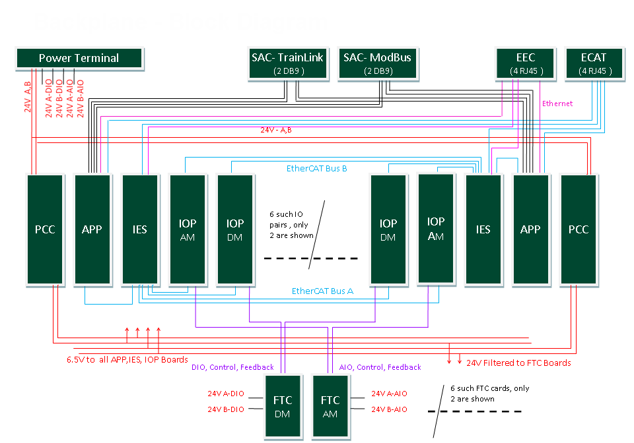

Description of functional Blocks

Power Interface to Backplane

Power connector is used to draw the power from the external power supply module. The power connector used will be 14 positions terminal block. NGP will accept the external redundant 24VDC power through this interface and supplies to all chassis cards. This connector also has isolated input terminals for external redundant 24VDC for powering the field side of Analog Input transmitters at the I/O terminals. Similarly there will be isolated input terminals for external redundant 24VDC for powering the field side of Digital I/O at the I/O terminals.

The detailed pins description of power interface connector to the backplane is described below

Backplane Main Power Connector Pins Naming
Connector : Part Number 20020620-M141A01LF
Pin No. | Signal Name | Description
1 | DGND | Digital Ground
2 | DIO_24V_B | 24V ( B Side) Supply for Digital section
3 | DGND | Digital Ground
4 | DIO_24V_A | 24V ( A Side) Supply for Digital section
5 | AGND | Analog Ground
6 | AIO_24V_B | 24V ( B Side) Supply for Analog section
7 | AGND | Analog Ground
8 | AIO_24V_A | 24V ( A Side) Supply for Analog section
9 | GND | Ground
10 | 24V_B | 24V ( B Side) Supply
11 | GND | Ground
12 | 24V_A | 24V ( A Side) Supply
13 | CHGND | Chasse Ground
14 | CHGND | Chasse Ground

PCC Board interface

The PCC board will be plugged on the backplane through PCC board interface connector. This board receives redundant 24VDC power (range 18V-36V) and provides 5VDC ( 30A) output and also provides filtered 24VDC output. The part number of this connector will be 51740-10400804CALF and manufactured by FCI. There are two such connectors, one for A side PCC and second for B side PCC.

The detailed pins description of PCC board interface connector to the backplane is described below

Backplane Connector Pins Naming on PCC Board
Connector P/No: 51740-10400804CALF
Pin No. | Signal Name | Description
P1 | 24V_A | 24V ( A side) supply
P2 | 24V_B | 24V ( B side) supply
P3 | GND | Ground
P4 | 24V_F | 24V Filtered output
P5 | GND | Ground
P6 | GND | Ground
P7 | 6V5 | 6.5V supply out
P8 | 6V5 | 6.5V supply out
A1 | PCC_APP_IO1 | PCC to same side APP IO1
B1 | PCC_APP_IO2 | PCC to same side APP IO2
C1 | PCC_APP_IO3 | PCC to same side APP IO3
D1 | PCC_APP_IO4 | PCC to same side APP IO4
A2 | PCC_APP_IO1(Opp) | PCC to opp side APP IO1
B2 | PCC_APP_IO2(Opp) | PCC to opp side APP IO2
C2 | PCC_APP_IO3(Opp) | PCC to opp side APP IO3
D2 | PCC_APP_IO4(Opp) | PCC to opp side APP IO4

APP Board interface

The APP board will be plugged on the backplane through APP board interface connectors. For mounting each side APP board on the backplane two signals connectors, one power connector and two guide pins will be used. Out of two signal connectors one is 54 pins Airmax series Press-Fit connector from FCI and the part number will be 10043546-101LF. The other signal connector is 72 pins Airmax series Press-Fit connector from FCI and the part number will be 10045271-101LF. The 4 pin power connector from FCI with part number 10028916-4554P00LF will be used to power the APP board. The guide pin used on the backplane will be 10037910-102LF from FCI.

The various signals interfaced between the backplane and the APP board are detailed in the below table

Backplane Connector Pins Naming on APP Board
Connector 1 : 10043546-101LF (54 Pins Conn)
Pin No. | Signal Name | Description
A1 | APP_MBUS_1 | Transmit Data 1 to MODBUS
B1 | GND | Ground
C1 | GND | Ground
D1 | APP_APP_0+ | GBE between APPs
E1 | APP_APP_0- | GBE between APPs
F1 | GND | Ground
G1 | APP_APP_1+ | GBE between APPs
H1 | APP_APP_1- | GBE between APPs
I1 | GND | Ground
A2 | GND | Ground
B2 | APP_MBUS_2 | Transmit Data 2 to MODBUS
C2 | GND | Ground
D2 | MBUS_2_APP | Receive Data 2 from MODBUS
E2 | GND | Ground
F2 | 2V5_APP_EEC-1 | 2.5V supply to EEC1 port
G2 | GND | Ground
H2 | APP_APP_2- | GBE between APPs
I2 | APP_APP_2+ | GBE between APPs
A3 | NC | NC
B3 | NC | NC
C3 | GND | Ground
D3 | APP_MBUS_1_DE | Transmit Enable to MOD BUS Port 1
E3 | APP_MBUS_2_DE | Transmit Enable to MOD BUS Port 2
F3 | GND | Ground
G3 | NC | NC
H3 | NC | NC
I3 | GND | Ground
A4 | GND | Ground
B4 | IES_APP_EBUS+ | EBUS interface Receive data from opposite IES(+)
C4 | IES_APP_EBUS- | EBUS interface Receive data from opposite IES(-)
D4 | GND | Ground
E4 | APP_E4 | Connector Short Pin to HotSwap EN
F4 | 2V5_APP_EEC-2 | 2.5V supply to EEC2 port
G4 | GND | Ground
H4 | APP_APP_3+ | GBE between APPs
I4 | APP_APP_3- | GBE between APPs
A5 | APP_IES_EBUS+ | EBUS interface Transmit data to opposite IES(+)
B5 | APP_IES_EBUS- | EBUS interface Transmit data to opposite IES(-)
C5 | GND | Ground
D5 | GND | Ground
E5 | MBUS_1_APP | Receive Data 1 from MODBUS
F5 | GND | Ground
G5 | APP_EEC_1+ | 10/100 Eth Interface Transmit to EEC1(+)
H5 | APP_EEC_1- | 10/100 Eth Interface Transmit to EEC1(-)
I5 | GND | Ground
A6 | GND | Ground
B6 | EEC_2_APP+ | 10/100 Eth Interface Receive from EEC2(+)
C6 | EEC_2_APP- | 10/100 Eth Interface Receive from EEC2(-)
D6 | GND | Ground
E6 | APP_EEC_2- | 10/100 Eth Interface Transmit to EEC2(-)
F6 | APP_EEC_2+ | 10/100 Eth Interface Transmit to EEC2(+)
G6 | GND | Ground
H6 | EEC_1_APP+ | 10/100 Eth Interface Receive from EEC1(+)
I6 | EEC_1_APP- | 10/100 Eth Interface Receive from EEC1(-)

Connector 2 :10045271-101LF (72 Pins Conn)
Pin No. | Signal Name | Description
A1 | IES_APP- | MII interface Receive data from IES(-)
B1 | IES_APP+ | MII interface Receive data from IES(+)
C1 | GND | Ground
D1 | APP_IES- | MII interface Transmit data to IES(-)
E1 | APP_IES+ | MII interface Transmit data to IES (+)
F1 | GND | Ground
G1 | NC | NC
H1 | NC | NC
I1 | GND | Ground
A2 | GND | Ground
B2 | APP_IES_SCL | I2C Clock
C2 | GND | Ground
D2 | APP_IES_SDA | I2C Data
E2 | GND | Ground
F2 | NC | NC
G2 | GND | Ground
H2 | NC | NC
I2 | GND | Ground
A3 | NC | NC
B3 | GND | Ground
C3 | NC | NC
D3 | GND | Ground
E3 | APP_TLINK_1 | Transmit Data 1 to Train Link
F3 | GND | Ground
G3 | TLINK_1_APP | Receive Data 1 from Train Link
H3 | GND | Ground
I3 | APP_TLINK_1_DE | Transmit Enable to Train Link Port 1
A4 | GND | Ground
B4 | APP_TLINK_2 | Transmit Data 2 to Train Link
C4 | GND | Ground
D4 | TLINK_2_APP | Receive Data 2 from Train Link
E4 | GND | Ground
F4 | APP_TLINK_2_DE | Transmit Enable to Train Link Port 2
G4 | GND | Ground
H4 | APP_DET_IES | APP board detect signal to same side IES
I4 | GND | Ground
A5 | APP_DET_IES_OPP | APP board detect signal to opp. Side IES
B5 | GND | Ground
C5 | NC | NC
D5 | GND | Ground
E5 | NC | NC
F5 | GND | Ground
G5 | APP_B_ID | APP Physical address (Note 1)
H5 | GND | Ground
I5 | APP_A_ID | APP Physical address (Note 2)
A6 | GND | Ground
B6 | IES_OPP_DET_APP | Opposite side IES board detect from APP
C6 | GND | Ground
D6 | IES_DET_APP | Same side IES board detect from APP
E6 | GND | Ground
F6 | PCC_OPP_APP_IO4 | Signal 4 input from opp side PCC
G6 | GND | Ground
H6 | PCC_OPP_APP_IO3 | Signal 3 input from opp side PCC
I6 | GND | Ground
A7 | PCC_OPP_APP_IO2 | Signal 2 input from opp side PCC
B7 | GND | Ground
C7 | PCC_OPP_APP_IO1 | Signal 1 input from opp side PCC
D7 | GND | Ground
E7 | PCC_APP_IO4 | Signal 4 input from same side PCC
F7 | GND | Ground
G7 | PCC_APP_IO3 | Signal 3 input from same side PCC
H7 | GND | Ground
I7 | PCC_APP_IO2 | Signal 2 input from same side PCC
A8 | GND | Ground
B8 | ECAT_APP+ | MII interface Receive data from ECAT(+)
C8 | ECAT_APP- | MII interface Receive data from ECAT(-)
D8 | GND | Ground
E8 | APP_ECAT- | MII interface Transmit data to ECAT(-)
F8 | APP_ECAT+ | MII interface Transmit data to ECAT(+)
G8 | GND | Ground
H8 | PCC_APP_IO1 | Signal 1 input from same side PCC
I8 | GND | Ground
Notes
1 | On the backplane APP_A_ID pin is connected to GND for A side APP and NC for B side APP.
2 | On the backplane APP_B_ID pin is connected to GND for B side APP and NC for A side APP.

IES Board interface

The IES board will be plugged on the backplane through IES board interface connectors. For mounting each side IES board on the backplane two signals connectors, one power connector and two guide pins will be used. The signal connectors used will be of 72 pins Airmax series Press-Fit connector from FCI and the part number will be 10045271-101LF. The 4 pin power connector from FCI with part number 10028916-4554P00LF will be used to power the IES board. The guide pin used on the backplane will be 10037910-102LF from FCI.

The various signals interfaced between the backplane and the IES board are detailed in the below tables

Backplane Connector Pins Naming on IES Board
Connector 1 : 10045271-101LF(72 Pins Conn)
Pin No. | Signal Name | Description
A1 | APP_IES+ | MII interface Receive data from APP(+)
B1 | APP_IES- | MII interface Receive data from APP(-)
C1 | GND | Ground
D1 | IES_APP+ | MII interface Transmit data to APP(+)
E1 | IES_APP- | MII interface Transmit data to APP(-)
F1 | GND | Ground
G1 | IES_IOP1+ | Transmit data to IOP2A
H1 | IES_IOP1- | Transmit data to IOP2A
I1 | GND | Ground
A2 | GND | Ground
B2 | IOP_IES1- | Receive data from IOP2A
C2 | IOP_IES1+ | Receive data from IOP2A
D2 | GND | Ground
E2 | IES_IOP3- | Transmit data to IOP1A
F2 | IES_IOP3+ | Transmit data to IOP1A
G2 | GND | Ground
H2 | IOP_IES3- | Receive data from IOP1A
I2 | IOP_IES3+ | Receive data from IOP1A
A3 | IES_IOP4+ | Transmit data to IOP2B
B3 | IES_IOP4- | Transmit data to IOP2B
C3 | GND | Ground
D3 | IOP_IES4- | Receive data from IOP2B
E3 | IOP_IES4+ | Receive data from IOP2B
F3 | GND | Ground
G3 | IES_IOP6- | Transmit data to IOP1B
H3 | IES_IOP6+ | Transmit data to IOP1B
I3 | GND | Ground
A4 | GND | Ground
B4 | IOP_IES6- | Receive data from IOP1B
C4 | IOP_IES6+ | Receive data from IOP1B
D4 | GND | Ground
E4 | IES_E4 | Short pin
F4 | GND | Ground
G4 | GND | Ground
H4 | IES_IOP7+ | Transmit data to IOP4A
I4 | IES_IOP7- | Transmit data to IOP4A
A5 | IOP_IES7+ | Receive data from IOP4A
B5 | IOP_IES7- | Receive data from IOP4A
C5 | GND | Ground
D5 | IES_IOP9+ | Transmit data to IOP3A
E5 | IES_IOP9- | Transmit data to IOP3A
F5 | GND | Ground
G5 | IOP_IES9+ | Receive data from IOP3A
H5 | IOP_IES9- | Receive data from IOP3A
I5 | GND | Ground
A6 | GND | Ground
B6 | IES_IOP10+ | Transmit data to IOP4B
C6 | IES_IOP10- | Transmit data to IOP4B
D6 | GND | Ground
E6 | IOP_IES10+ | Receive data from IOP4B
F6 | IOP_IES10- | Receive data from IOP4B
G6 | GND | Ground
H6 | IES_IOP12+ | Transmit data to IOP3B
I6 | IES_IOP12- | Transmit data to IOP3B
A7 | IOP_IES12+ | Receive data from IOP3B
B7 | IOP_IES12- | Receive data from IOP3B
C7 | GND | Ground
D7 | IES_IOP13- | Transmit data to IOP6A
E7 | IES_IOP13+ | Transmit data to IOP6A
F7 | GND | Ground
G7 | IOP_IES13+ | Receive data from IOP6A
H7 | IOP_IES13- | Receive data from IOP6A
I7 | GND | Ground
A8 | GND | Ground
B8 | IES_IOP15+ | Transmit data to IOP5A
C8 | IES_IOP15- | Transmit data to IOP5A
D8 | GND | Ground
E8 | IOP_IES15+ | Receive data from IOP5A
F8 | IOP_IES15- | Receive data from IOP5A
G8 | GND | Ground
H8 | GND | Ground
I8 | GND | Ground
Connector 2:10045271-101LF (72 Pins Conn)
Pin No. | Signal Name | Description
A1 | IES_IOP16+ | Transmit data to IOP6B
B1 | IES_IOP16- | Transmit data to IOP6B
C1 | GND | Ground
D1 | IOP_IES16+ | Receive data from IOP6B
E1 | IOP_IES16- | Receive data from IOP6B
F1 | GND | Ground
G1 | IES_IOP18+ | Transmit data to IOP5B
H1 | IES_IOP18- | Transmit data to IOP5B
I1 | GND | Ground
A2 | GND | Ground
B2 | IOP_IES18- | Receive data from IOP5B
C2 | IOP_IES18+ | Receive data from IOP5B
D2 | GND | Ground
E2 | IES_APP_EBUS- | EBUS interface Transmit data to opposite APP
F2 | IES_APP_EBUS+ | EBUS interface Transmit data to opposite APP
G2 | GND | Ground
H2 | APP_IES_EBUS- | EBUS interface Receive data from opposite APP
I2 | APP_IES_EBUS+ | EBUS interface Receive data from opposite APP
A3 | GND | Ground
B3 | GND | Ground
C3 | GND | Ground
D3 | IES_ECAT_EXP+ | MII interface Transmit data to ECAT for Expansion ( RJ45)
E3 | IES_ECAT_EXP- | MII interface Transmit data to ECAT for Expansion ( RJ45)
F3 | GND | Ground
G3 | ECAT_IES_EXP+ | MII interface Receive data from ECAT for Expansion ( RJ45)
H3 | ECAT_IES_EXP- | MII interface Receive data from ECAT for Expansion ( RJ45)
I3 | GND | Ground
A4 | GND | Ground
B4 | NC | NC
C4 | NC | NC
D4 | GND | Ground
E4 | IES_E4_HotSwap | Short pin
F4 | NC | NC
G4 | GND | Ground
H4 | GND | Ground
I4 | APP_IES_DET | APP board detect signal from same side IES
A5 | ECAT_IES_SW- | MII interface Receive data from ECAT
B5 | ECAT_IES_SW+ | MII interface Receive data from ECAT
C5 | GND | Ground
D5 | IES_ECAT_SW- | MII interface Transmit data to ECAT
E5 | IES_ECAT_SW+ | MII interface Transmit data to ECAT
F5 | GND | Ground
G5 | CHASISID4 | Switch Reading 4
H5 | CHASISID3 | Switch Reading 3
I5 | CHASISID2 | Switch Reading 2
A6 | CHASISID1 | Switch Reading 1
B6 | NC | NC
C6 | NC | Slot Physical Address 1
D6 | IES_APP_DET | IES board detect signal from same side APP
E6 | APP_IES_SDA | I2C Data
F6 | APP_IES_SCL | I2C Clock
G6 | NC | NC
H6 | APP_OPP_IES_DET | Opp side APP board detect signal from IES
I6 | IES_OPP_APP_DET | Opp side IES board detect signal from APP
A7 | NC | NC
B7 | NC | NC
C7 | NC | NC
D7 | NC | NC
E7 | NC | NC
F7 | NC | NC
G7 | NC | NC
H7 | NC | NC
I7 | NC | NC
A8 | NC | NC
B8 | NC | NC
C8 | NC | NC
D8 | NC | NC
E8 | NC | NC
F8 | 3V3_IES | 3.3V supply to ECAT Board
G8 | 3V3_IES | 3.3V supply to ECAT Board
H8 | NC | NC
I8 | NC | NC

IOP-AM Board interface

There will be maximum of 6 pairs of IOP-AM boards in the NGP system. If the number of IOP-AM boards pairs used are less than 6 , then the remaining IOP pairs will be of type IOP-DM boards. Each of these IOP-AM boards will be plugged on to the backplane through IOP interface connectors.

The each of the IOP-AM board will communicate with the IES board through EtherCAT interface. There are two channels of EtherCAT from IOP-AM, one to each side of the NGP system.

For mounting each of the IOP-AM board on the backplane two signals connectors, one power connector and two guide pins will be used. The signal connectors used will be of 72 pins Airmax series Press-Fit connector from FCI and the part number will be 10045271-101LF. The 4 pin power connector from FCI with part number 10028916-4554P00LF will be used to power the IES board. The guide pin used on the backplane will be 10037910-102LF from FCI.

IOP-DM Board interface

There will be maximum 6 pairs of IOP-DM boards in the NGP system. If the number of IOP-DM boards pairs used are less than 6 , then the remaining IOP pairs will be of type IOP-AM boards. Each of these IOP-DM boards will be plugged onto the backplane through IOP interface connectors.

The each of the IOP-DM board will communicate with the IES board through EtherCAT interface. There are two channels of EtherCAT from IOP-DM, one to each side of the NGP system.

For mounting each of the IOP-DM board on the backplane two signals connectors, one power connector and two guide pins will be used. The signal connectors used will be of 72 pins Airmax series Press-Fit connector from FCI and the part number will be 10045271-101LF. The 4 pin power connector from FCI with part number 10028916-4554P00LF will be used to power the IES board. The guide pin used on the backplane will be 10037910-102LF from FCI.

Out of 6 IOP boards pairs , they can be combination of both IOP-AM and IOP-DM boards.

The various signals interfaced between the backplane and the IOP board are detailed in the below table. IOP board can be either IOP-AM or IOP-DM type.

Backplane Connector Pins Naming on IOP Board
Connector 1 : 10045271-101LF (72 Pins Conn)
Pin No. | Signal Name | Description
A1 | IO1+ | IO Pair between IOP and FTC
B1 | IO1- | IO Pair between IOP and FTC
C1 | NC
D1 | IO2+ | IO Pair between IOP and FTC
E1 | IO2- | IO Pair between IOP and FTC
F1 | NC
G1 | IO3+ | IO Pair between IOP and FTC
H1 | IO3- | IO Pair between IOP and FTC
I1 | NC
A2 | NC
B2 | IO4+ | IO Pair between IOP and FTC
C2 | IO4- | IO Pair between IOP and FTC
D2 | NC
E2 | IO5+ | IO Pair between IOP and FTC
F2 | IO5- | IO Pair between IOP and FTC
G2 | NC
H2 | IO6+ | IO Pair between IOP and FTC
I2 | IO6- | IO Pair between IOP and FTC
A3 | IO7+ | IO Pair between IOP and FTC
B3 | IO7- | IO Pair between IOP and FTC
C3 | NC
D3 | IO8+ | IO Pair between IOP and FTC
E3 | IO8- | IO Pair between IOP and FTC
F3 | NC
G3 | IO9+ | IO Pair between IOP and FTC
H3 | IO9- | IO Pair between IOP and FTC
I3 | NC
A4 | NC
B4 | IO10+ | IO Pair between IOP and FTC
C4 | IO10- | IO Pair between IOP and FTC
D4 | NC
E4 | IOP_E4 | E4 Short Pin
F4 | NC
G4 | NC
H4 | IO11+ | IO Pair between IOP and FTC
I4 | IO11- | IO Pair between IOP and FTC
A5 | IO12+ | IO Pair between IOP and FTC
B5 | IO12- | IO Pair between IOP and FTC
C5 | NC
D5 | IO13+ | IO Pair between IOP and FTC
E5 | IO13- | IO Pair between IOP and FTC
F5 | NC
G5 | IO14+ | IO Pair between IOP and FTC
H5 | IO14- | IO Pair between IOP and FTC
I5 | NC
A6 | NC
B6 | IO15+ | IO Pair between IOP and FTC
C6 | IO15- | IO Pair between IOP and FTC
D6 | NC
E6 | IO16+ | IO Pair between IOP and FTC
F6 | IO16- | IO Pair between IOP and FTC
G6 | NC
H6 | IO17+ | IO Pair between IOP and FTC
I6 | IO17- | IO Pair between IOP and FTC
A7 | IO18+ | IO Pair between IOP and FTC
B7 | IO18- | IO Pair between IOP and FTC
C7 | NC
D7 | IO19+ | IO Pair between IOP and FTC
E7 | IO19- | IO Pair between IOP and FTC
F7 | NC
G7 | IO20+ | IO Pair between IOP and FTC
H7 | IO20- | IO Pair between IOP and FTC
I7 | NC
A8 | NC
B8 | IO21+ | IO Pair between IOP and FTC
C8 | IO21- | IO Pair between IOP and FTC
D8 | NC
E8 | IO22+ | IO Pair between IOP and FTC
F8 | IO22- | IO Pair between IOP and FTC
G8 | NC
H8 | IO23+ | IO Pair between IOP and FTC
I8 | IO23- | IO Pair between IOP and FTC
Connector 2 : 10045271-101LF (72 Pins Conn)
Pin No. | Signal Name | Description
A1 | AIO_24V | Redundant 24V Analog Power
B1 | AIO_24V | Redundant 24V Analog Power
C1 | AIO_24V | Redundant 24V Analog Power
D1 | AIO_24V | Redundant 24V Analog Power
E1 | A_GND | Analog Ground
F1 | A_GND | Analog Ground
G1 | A_GND | Analog Ground
H1 | A_GND | Analog Ground
I1 | NC
A2 | DIO_24V | Redundant 24V Digital Power
B2 | DIO_24V | Redundant 24V Digital Power
C2 | DIO_24V | Redundant 24V Digital Power
D2 | DIO_24V | Redundant 24V Digital Power
E2 | D_GND | Digital Ground
F2 | D_GND | Digital Ground
G2 | D_GND | Digital Ground
H2 | D_GND | Digital Ground
I2 | 24V_F | Filtered 24V supply
A3 | 24V_F | Filtered 24V supply
B3 | 24V_F | Filtered 24V supply
C3 | 24V_F | Filtered 24V supply
D3 | 24V_F | Filtered 24V supply
E3 | 24V_F | Filtered 24V supply
F3 | 24V_F | Filtered 24V supply
G3 | Board_ID1 | IOP Board ID 1
H3 | Board_ID2 | IOP Board ID 2
I3 | Board_ID3 | IOP Board ID 3
A4 | Board_ID4 | IOP Board ID 4
B4 | IOP_SLOT_ID1
C4 | IOP_SLOT_ID2
D4 | IOP_SLOT_ID3
E4 | Short Pin
F4 | IOP_SLOT_ID4
G4 | CLEAR
H4 | IOP_SHARE_1
I4 | IOP_SHARE_2
A5 | IOP_SHARE_3
B5 | IOP_SHARE_4
C5 | PEER_CONTROL
D5 | IO30+ | IO Pair between IOP and FTC
E5 | IO30- | IO Pair between IOP and FTC
F5 | GND | Ground
G5 | IO29+ | IO Pair between IOP and FTC
H5 | IO29- | IO Pair between IOP and FTC
I5 | GND | Ground
A6 | AnB
B6 | IO28+ | IO Pair between IOP and FTC
C6 | IO28- | IO Pair between IOP and FTC
D6 | GND | Ground
E6 | IO27+ | IO Pair between IOP and FTC
F6 | IO27- | IO Pair between IOP and FTC
G6 | GND | Ground
H6 | IO26+ | IO Pair between IOP and FTC
I6 | IO26- | IO Pair between IOP and FTC
A7 | IES-B_IOP+ | Receive data from IES-B
B7 | IES-B_IOP- | Receive data from IES-B
C7 | GND | Ground
D7 | IO25+ | IO Pair between IOP and FTC
E7 | IO25- | IO Pair between IOP and FTC
F7 | GND | Ground
G7 | IO24+ | IO Pair between IOP and FTC
H7 | IO24- | IO Pair between IOP and FTC
I7 | GND | Ground
A8 | GND | Ground
B8 | IOP_IES-B+ | Transmit data to IES-B
C8 | IOP_IES-B- | Transmit data to IES-B
D8 | GND | Ground
E8 | IES-A_IOP+ | Receive data from IES-A
F8 | IES-A_IOP- | Receive data from IES-A
G8 | GND | Ground
H8 | IOP_IES-A+ | Transmit data to IES-A
I8 | IOP_IES-A- | Transmit data to IES-A

FTC-AM Board interface

Field I/O wiring will terminate to a card called FTC, that plugs into the backplane directly without any cables. These cards will be unique to the chassis mounted I/O card that may connect to. There will be a common connector, pin out and routing from the field termination cards to I/O card backplane slots regardless of type (IOP-AM or IOP-DM).

There will be maximum of 6 FTC-AM boards in the NGP system. Each of these FTC-AM boards is plugged on to the backplane through FTC interface connector.

For mounting each of the IOP-AM board on the backplane two signals connectors will be used. The signal connectors used will be of 96 pins Airmax series Press-Fit connector from FCI and the part number will be 10052842-101LF.

FTC-DM Board interface

There will be maximum of 6 FTC-DM boards in the NGP system. Each of these FTC-DM boards will be plugged on to the backplane through FTC interface connector.

For mounting each of the IOP-DM board on the backplane two signals connectors will be used. The signal connectors used will be of 96 pins Airmax series Press-Fit connector from FCI and the part number will be 10052842-101LF.

For any FTC board the corresponding IOP board will be of same type (Analog or Digital).

The various signals interfaced between the backplane and the FTC board are detailed in the below table. FTC board can be either FTC-AM or FTC-DM type.

Backplane Connector Pins Naming on FTC Board
Connector : 1 (96 Pins Conn) P/No: 10052842-101LF
Pin No. | Signal Name | Description
A1 | IO1_A+ | IO Pair between IOP (A Side) and FTC
B1 | IO1_A- | IO Pair between IOP (A Side) and FTC
C1 | NC
D1 | IO2_A+ | IO Pair between IOP (A Side) and FTC
E1 | IO2_A- | IO Pair between IOP (A Side) and FTC
F1 | NC
G1 | IO3_A+ | IO Pair between IOP (A Side) and FTC
H1 | IO3_A- | IO Pair between IOP (A Side) and FTC
I1 | NC
J1 | IO4_A+ | IO Pair between IOP (A Side) and FTC
K1 | IO4_A- | IO Pair between IOP (A Side) and FTC
L1 | Board_ID1 | FTC Board ID 1
A2 | Board_ID2 | FTC Board ID 2
B2 | IO5_A+ | IO Pair between IOP (A Side) and FTC
C2 | IO5_A- | IO Pair between IOP (A Side) and FTC
D2 | NC
E2 | IO6_A+ | IO Pair between IOP (A Side) and FTC
F2 | IO6_A- | IO Pair between IOP (A Side) and FTC
G2 | NC
H2 | IO7_A+ | IO Pair between IOP (A Side) and FTC
I2 | IO7_A- | IO Pair between IOP (A Side) and FTC
J2 | NC
K2 | IO8_A+ | IO Pair between IOP (A Side) and FTC
L2 | IO8_A- | IO Pair between IOP (A Side) and FTC
A3 | IO9_A+ | IO Pair between IOP (A Side) and FTC
B3 | IO9_A- | IO Pair between IOP (A Side) and FTC
C3 | NC
D3 | IO10_A+ | IO Pair between IOP (A Side) and FTC
E3 | IO10_A- | IO Pair between IOP (A Side) and FTC
F3 | NC
G3 | IO11_A+ | IO Pair between IOP (A Side) and FTC
H3 | IO11_A- | IO Pair between IOP (A Side) and FTC
I3 | NC
J3 | IO12_A+ | IO Pair between IOP (A Side) and FTC
K3 | IO12_A- | IO Pair between IOP (A Side) and FTC
L3 | Board_ID3 | FTC Board ID 3
A4 | Board_ID4 | FTC Board ID 4
B4 | IO13_A+ | IO Pair between IOP (A Side) and FTC
C4 | IO13_A- | IO Pair between IOP (A Side) and FTC
D4 | NC
E4 | IO14_A+ | IO Pair between IOP (A Side) and FTC
F4 | IO14_A- | IO Pair between IOP (A Side) and FTC
G4 | NC
H4 | IO15_A+ | IO Pair between IOP (A Side) and FTC
I4 | IO15_A- | IO Pair between IOP (A Side) and FTC
J4 | NC
K4 | IO16_A+ | IO Pair between IOP (A Side) and FTC
L4 | IO16_A- | IO Pair between IOP (A Side) and FTC
A5 | IO17_A+ | IO Pair between IOP (A Side) and FTC
B5 | IO17_A- | IO Pair between IOP (A Side) and FTC
C5 | NC
D5 | IO18_A+ | IO Pair between IOP (A Side) and FTC
E5 | IO18_A- | IO Pair between IOP (A Side) and FTC
F5 | NC
G5 | IO19_A+ | IO Pair between IOP (A Side) and FTC
H5 | IO19_A- | IO Pair between IOP (A Side) and FTC
I5 | NC
J5 | IO20_A+ | IO Pair between IOP (A Side) and FTC
K5 | IO20_A- | IO Pair between IOP (A Side) and FTC
L5 | IO21_A+ | IO Pair between IOP (A Side) and FTC
A6 | IO27_A+ | IO Pair between IOP (A Side) and FTC
B6 | IO22_A+ | IO Pair between IOP (A Side) and FTC
C6 | IO22_A- | IO Pair between IOP (A Side) and FTC
D6 | IO23_A+ | IO Pair between IOP (A Side) and FTC
E6 | IO23_A- | IO Pair between IOP (A Side) and FTC
F6 | IO24_A+ | IO Pair between IOP (A Side) and FTC
G6 | IO24_A- | IO Pair between IOP (A Side) and FTC
H6 | IO25_A+ | IO Pair between IOP (A Side) and FTC
I6 | IO25_A- | IO Pair between IOP (A Side) and FTC
J6 | IO26_A+ | IO Pair between IOP (A Side) and FTC
K6 | IO26_A- | IO Pair between IOP (A Side) and FTC
L6 | IO21_A- | IO Pair between IOP (A Side) and FTC
A7 | IO27_A- | IO Pair between IOP (A Side) and FTC
B7 | IO28_A+ | IO Pair between IOP (A Side) and FTC
C7 | IO28_A- | IO Pair between IOP (A Side) and FTC
D7 | IO29_A+ | IO Pair between IOP (A Side) and FTC
E7 | IO29_A- | IO Pair between IOP (A Side) and FTC
F7 | IO30_A+ | IO Pair between IOP (A Side) and FTC
G7 | IO30_A- | IO Pair between IOP (A Side) and FTC
H7 | AIO_24V_A | 24V_A Analog Supply
I7 | AIO_24V_A | 24V_A Analog Supply
J7 | AIO_24V_B | 24V_B Analog Supply
K7 | AIO_24V_B | 24V_B Analog Supply
L7 | A_GND | Analog Ground
A8 | A_GND | Analog Ground
B8 | AIO_24V | 24V Analog Supply ( OR'ed output)
C8 | AIO_24V | 24V Analog Supply ( OR'ed output)
D8 | DIO_24V_A | 24V_A Digital Supply
E8 | DIO_24V_A | 24V_A Digital Supply
F8 | DIO_24V_B | 24V_B Digital Supply
G8 | DIO_24V_B | 24V_B Digital Supply
H8 | D_GND | Digital Ground
I8 | D_GND | Digital Ground
J8 | DIO_24V | 24V Digital Supply ( OR'ed output)
K8 | DIO_24V | 24V Digital Supply ( OR'ed output)
L8 | GND | Ground
Connector :2 (96 Pins Conn) P/No: 10052842-101LF
Pin No. | Signal Name | Description
A1 | IO1_B+ | IO Pair between IOP (B Side) and FTC
B1 | IO1_B- | IO Pair between IOP (B Side) and FTC
C1 | NC
D1 | IO2_B+ | IO Pair between IOP (B Side) and FTC
E1 | IO2_B- | IO Pair between IOP (B Side) and FTC
F1 | NC
G1 | IO3_B+ | IO Pair between IOP (B Side) and FTC
H1 | IO3_B- | IO Pair between IOP (B Side) and FTC
I1 | NC
J1 | IO4_B+ | IO Pair between IOP (B Side) and FTC
K1 | IO4_B- | IO Pair between IOP (B Side) and FTC
L1 | NC
A2 | NC
B2 | IO5_B+ | IO Pair between IOP (B Side) and FTC
C2 | IO5_B- | IO Pair between IOP (B Side) and FTC
D2 | NC
E2 | IO6_B+ | IO Pair between IOP (B Side) and FTC
F2 | IO6_B- | IO Pair between IOP (B Side) and FTC
G2 | NC
H2 | IO7_B+ | IO Pair between IOP (B Side) and FTC
I2 | IO7_B- | IO Pair between IOP (B Side) and FTC
J2 | NC
K2 | IO8_B+ | IO Pair between IOP (B Side) and FTC
L2 | IO8_B- | IO Pair between IOP (B Side) and FTC
A3 | IO9_B+ | IO Pair between IOP (B Side) and FTC
B3 | IO9_B- | IO Pair between IOP (B Side) and FTC
C3 | NC
D3 | IO10_B+ | IO Pair between IOP (B Side) and FTC
E3 | IO10_B- | IO Pair between IOP (B Side) and FTC
F3 | NC
G3 | IO11_B+ | IO Pair between IOP (B Side) and FTC
H3 | IO11_B- | IO Pair between IOP (B Side) and FTC
I3 | NC
J3 | IO12_B+ | IO Pair between IOP (B Side) and FTC
K3 | IO12_B- | IO Pair between IOP (B Side) and FTC
L3 | NC
A4 | NC
B4 | IO13_B+ | IO Pair between IOP (B Side) and FTC
C4 | IO13_B- | IO Pair between IOP (B Side) and FTC
D4 | NC
E4 | IO14_B+ | IO Pair between IOP (B Side) and FTC
F4 | IO14_B- | IO Pair between IOP (B Side) and FTC
G4 | NC
H4 | IO15_B+ | IO Pair between IOP (B Side) and FTC
I4 | IO15_B- | IO Pair between IOP (B Side) and FTC
J4 | NC
K4 | IO16_B+ | IO Pair between IOP (B Side) and FTC
L4 | IO16_B- | IO Pair between IOP (B Side) and FTC
A5 | IO17_B+ | IO Pair between IOP (B Side) and FTC
B5 | IO17_B- | IO Pair between IOP (B Side) and FTC
C5 | NC
D5 | IO18_B+ | IO Pair between IOP (B Side) and FTC
E5 | IO18_B- | IO Pair between IOP (B Side) and FTC
F5 | NC
G5 | IO19_B+ | IO Pair between IOP (B Side) and FTC
H5 | IO19_B- | IO Pair between IOP (B Side) and FTC
I5 | NC
J5 | IO20_B+ | IO Pair between IOP (B Side) and FTC
K5 | IO20_B- | IO Pair between IOP (B Side) and FTC
L5 | IO21_B+ | IO Pair between IOP (B Side) and FTC
A6 | IO27_B+ | IO Pair between IOP (B Side) and FTC
B6 | IO22_B+ | IO Pair between IOP (B Side) and FTC
C6 | IO22_B- | IO Pair between IOP (B Side) and FTC
D6 | IO23_B+ | IO Pair between IOP (B Side) and FTC
E6 | IO23_B- | IO Pair between IOP (B Side) and FTC
F6 | IO24_B+ | IO Pair between IOP (B Side) and FTC
G6 | IO24_B- | IO Pair between IOP (B Side) and FTC
H6 | IO25_B+ | IO Pair between IOP (B Side) and FTC
I6 | IO25_B- | IO Pair between IOP (B Side) and FTC
J6 | IO26_B+ | IO Pair between IOP (B Side) and FTC
K6 | IO26_B- | IO Pair between IOP (B Side) and FTC
L6 | IO21_B- | IO Pair between IOP (B Side) and FTC
A7 | IO27_B- | IO Pair between IOP (B Side) and FTC
B7 | IO28_B+ | IO Pair between IOP (B Side) and FTC
C7 | IO28_B- | IO Pair between IOP (B Side) and FTC
D7 | IO29_B+ | IO Pair between IOP (B Side) and FTC
E7 | IO29_B- | IO Pair between IOP (B Side) and FTC
F7 | IO30_B+ | IO Pair between IOP (B Side) and FTC
G7 | IO30_B- | IO Pair between IOP (B Side) and FTC
H7 | DIO_24V_B | 24V_B Digital Supply
I7 | DIO_24V_A | 24V_A Digital Supply
J7 | AIO_24V_B | 24V_B Analog Supply
K7 | AIO_24V_A | 24V_A Analog Supply
L7 | 24V_F | 24V Filtered Supply
A8 | 24V_F | 24V Filtered Supply
B8 | 24V_F | 24V Filtered Supply
C8 | 24V_F | 24V Filtered Supply
D8 | GND | Ground
E8 | GND | Ground
F8 | GND | Ground
G8 | GND | Ground
H8 | NC
I8 | A_GND | Analog Ground
J8 | A_GND | Analog Ground
K8 | D_GND | Digital Ground
L8 | D_GND | Digital Ground

External Serial Port Card interface

The external serial port card is the communication accessory card that provides connectivity from the chassis to the external devices via RS-485 communications.

There are two External Serial port cards in the system. Four full duplex RS485 channels, two from each of the APP board are terminated to each ESC. This card is called MOD BUS board. To the other ESC four half duplex RS-485 channels, two from each of the APP board are terminated. This card is called TRAIN LINK board.

In both the cases four serial ports, two from the “A” APP (Port 1A and 2A) and two from the “B” APP (Port 1B and 2B) are taken through the backplane to ESC.

For mounting each of the external serial port card on the backplane a 54 pins Airmax series Press-Fit connector from FCI will be used and the part number will be 10052842-101LF. The guide pin used on the backplane with the external serial port card will be 10037910-102LF from FCI.

The detailed pins description is provided in the below table for TRAIN LINK board.

Backplane Connector Pins Naming on TRAIN LINK Board
Connector : 10043546-101LF (54 Pins Conn)
Pin No. | Signal Name | Description
A1 | GND | Ground
B1 | 6V5_A | 6.5V ( A side ) Supply
C1 | GND | Ground
D1 | 6V5_B | 6.5V ( B side ) Supply
E1 | APP-B_TLINK_1 | Receive Data 1 from APP-B
F1 | APP-B_TLINK_1_DE | DE for Receive Data 1 from APP-B
G1 | NC
H1 | TLINK_APP-B_1 | Transmit Data 1 to APP-B
I1 | APP-A_TLINK_1 | Receive Data 1 from APP-A
A2 | GND | Ground
B2 | 6V5_A | 6.5V ( A side ) Supply
C2 | GND | Ground
D2 | 6V5_B | 6.5V ( B side ) Supply
E2 | GND | Ground
F2 | GND | Ground
G2 | GND | Ground
H2 | APP-A_TLINK_1_DE | DE for Receive Data 1 from APP-A
I2 | NC
A3 | GND | Ground
B3 | 6V5_A | 6.5V ( A side ) Supply
C3 | GND | Ground
D3 | 6V5_B | 6.5V ( B side ) Supply
E3 | GND | Ground
F3 | GND | Ground
G3 | GND | Ground
H3 | TLINK_APP-A_1 | Transmit Data 1 to APP-A
I3 | APP-B_TLINK_2 | Receive Data 2 from APP-B
A4 | GND | Ground
B4 | 6V5_A | 6.5V ( A side ) Supply
C4 | GND | Ground
D4 | 6V5_B | 6.5V ( B side ) Supply
E4 | GND | Ground
F4 | GND | Ground
G4 | GND | Ground
H4 | GND | Ground
I4 | APP-B_TLINK_2_DE | DE for Receive Data 2 from APP-B
A5 | GND | Ground
B5 | 6V5_A | 6.5V ( A side ) Supply
C5 | GND | Ground
D5 | 6V5_B | 6.5V ( B side ) Supply
E5 | GND | Ground
F5 | GND | Ground
G5 | GND | Ground
H5 | GND | Ground
I5 | NC
A6 | GND | Ground
B6 | 6V5_A | 6.5V ( A side ) Supply
C6 | GND | Ground
D6 | 6V5_B | 6.5V ( B side ) Supply
E6 | TLINK_APP-A_2 | Transmit Data 2 to APP-A
F6 | NC
G6 | APP-A_TLINK_2_DE | DE for Receive Data 2 from APP-A
H6 | APP-A_TLINK_2 | Receive Data 2 from APP-A
I6 | TLINK_APP-B_2 | Transmit Data 2 to APP-B

The detailed pins description is provided in the below table for MOD BUS board.

Backplane Connector Pins Naming on MOD BUS Board
Connector : 10043546-101LF (54 Pins Conn)
Pin No. | Signal Name | Description
A1 | GND | Ground
B1 | 6V5_A | 6.5V ( A side ) Supply
C1 | GND | Ground
D1 | 6V5_B | 6.5V ( B side ) Supply
E1 | APP-B_MBUS_1 | Receive Data 1 from APP-B
F1 | APP-B_MBUS_1_DE | DE for Receive Data 1 from APP-B
G1 | NC
H1 | MBUS_APP-B_1 | Transmit Data 1 to APP-B
I1 | APP-A_MBUS_1 | Receive Data 1 from APP-A
A2 | GND | Ground
B2 | 6V5_A | 6.5V ( A side ) Supply
C2 | GND | Ground
D2 | 6V5_B | 6.5V ( B side ) Supply
E2 | GND | Ground
F2 | GND | Ground
G2 | GND | Ground
H2 | APP-A_MBUS_1_DE | DE for Receive Data 1 from APP-A
I2 | NC
A3 | GND | Ground
B3 | 6V5_A | 6.5V ( A side ) Supply
C3 | GND | Ground
D3 | 6V5_B | 6.5V ( B side ) Supply
E3 | GND | Ground
F3 | GND | Ground
G3 | GND | Ground
H3 | MBUS_APP-A_1 | Transmit Data 1 to APP-A
I3 | APP-B_MBUS_2 | Receive Data 2 from APP-B
A4 | GND | Ground
B4 | 6V5_A | 6.5V ( A side ) Supply
C4 | GND | Ground
D4 | 6V5_B | 6.5V ( B side ) Supply
E4 | GND | Ground
F4 | GND | Ground
G4 | GND | Ground
H4 | GND | Ground
I4 | APP-B_MBUS_2_DE | DE for Receive Data 2 from APP-B
A5 | GND | Ground
B5 | 6V5_A | 6.5V ( A side ) Supply
C5 | GND | Ground
D5 | 6V5_B | 6.5V ( B side ) Supply
E5 | GND | Ground
F5 | GND | Ground
G5 | GND | Ground
H5 | GND | Ground
I5 | NC
A6 | GND | Ground
B6 | 6V5_A | 6.5V ( A side ) Supply
C6 | GND | Ground
D6 | 6V5_B | 6.5V ( B side ) Supply
E6 | MBUS_APP-A_2 | Transmit Data 2 to APP-A
F6 | NC
G6 | APP-A_MBUS_2_DE | DE for Receive Data 2 from APP-A
H6 | APP-A_MBUS_2 | Receive Data 2 from APP-A
I6 | MBUS_APP-B_2 | Transmit Data 2 to APP-B

External TCP/IP Ethernet Card interface

The EEC provides RJ-45 connectors for four Ethernet ports, two from the “A” APP and two from the “B” APP via backplane connector.

For mounting the EEC baord on the backplane a 54 pins Airmax series Press-Fit connector from FCI will be used and the part number will be 10052842-101LF. The guide pin used on the backplane with the external serial port card will be 10037910-102LF from FCI.

The detailed pins description is provided in the below table.

Backplane Connector Pins Naming on EEC Board
Connector : 10043546-101LF (54 Pins Conn)
Pin No. | Signal Name | Description
A1 | GND | Ground
B1 | GND | Ground
C1 | GND | Ground
D1 | EEC_APP-A_2- | 10/100 Eth Interface Transmit to APP
E1 | EEC_APP-A_2+ | 10/100 Eth Interface Transmit to APP
F1 | GND | Ground
G1 | APP-A_EEC_2- | 10/100 Eth Interface Receive from APP
H1 | APP-A_EEC_2+ | 10/100 Eth Interface Receive from APP
I1 | GND | Ground
A2 | GND | Ground
B2 | 2V5_APP_EEC_A2 | 2.5V Supply from APP
C2 | 2V5_APP_EEC_A2 | 2.5V Supply from APP
D2 | GND | Ground
E2 | GND | Ground
F2 | GND | Ground
G2 | GND | Ground
H2 | EEC_APP-B_2- | 10/100 Eth Interface Transmit to APP
I2 | EEC_APP-B_2+ | 10/100 Eth Interface Transmit to APP
A3 | GND | Ground
B3 | GND | Ground
C3 | 2V5_APP_EEC_B2 | 2.5V Supply from APP
D3 | 2V5_APP_EEC_B2 | 2.5V Supply from APP
E3 | GND | Ground
F3 | GND | Ground
G3 | APP-B_EEC_2- | 10/100 Eth Interface Receive from APP
H3 | APP-B_EEC_2+ | 10/100 Eth Interface Receive from APP
I3 | GND | Ground
A4 | GND | Ground
B4 | GND | Ground
C4 | GND | Ground
D4 | GND | Ground
E4 | GND | Ground
F4 | GND | Ground
G4 | 2V5_APP_EEC_B1 | 2.5V Supply from APP
H4 | 2V5_APP_EEC_B1 | 2.5V Supply from APP
I4 | GND | Ground
A5 | GND | Ground
B5 | GND | Ground
C5 | GND | Ground
D5 | EEC_APP-B_1+ | 10/100 Eth Interface Transmit to APP
E5 | EEC_APP-B_1- | 10/100 Eth Interface Transmit to APP
F5 | GND | Ground
G5 | APP-B_EEC_1+ | 10/100 Eth Interface Receive from APP
H5 | APP-B_EEC_1- | 10/100 Eth Interface Receive from APP
I5 | GND | Ground
A6 | GND | Ground
B6 | 2V5_APP_EEC_A1 | 2.5V Supply from APP
C6 | 2V5_APP_EEC_A1 | 2.5V Supply from APP
D6 | GND | Ground
E6 | EEC_APP-A_1- | 10/100 Eth Interface Transmit to APP
F6 | EEC_APP-A_1+ | 10/100 Eth Interface Transmit to APP
G6 | GND | Ground
H6 | APP-A_EEC_1- | 10/100 Eth Interface Receive from APP
I6 | APP-A_EEC_1+ | 10/100 Eth Interface Receive from APP

ECAT board interface

The EACT board provides RJ-45 connectors for four ECAT ports.

For mounting the EEC board on the backplane a 54 pins Airmax series Press-Fit connector from FCI will be used and the part number will be 10052842-101LF. The guide pin used on the backplane with the external serial port card will be 10037910-102LF from FCI.

The detailed pins description is provided in the below table.

Backplane Connector Pins Naming on ECAT Board
Connector : 10043546-101LF (54 Pins Conn)
Pin No. | Signal Name | Description
A1 | GND | Ground
B1 | APP-B_DET_FROM_IES-A_CAC | APP-B board detect
C1 | GND | Ground
D1 | IES-B_ECAT_EXP+ | MII interface Receive data from IES
E1 | IES-B_ECAT_EXP- | MII interface Receive data from IES
F1 | GND | Ground
G1 | ECAT_IES-B_EXP+ | MII interface Transmit data to IES
H1 | ECAT_IES-B_EXP- | MII interface Transmit data to IES
I1 | GND | Ground
A2 | GND | Ground
B2 | IES-A_ECAT_EXP- | MII interface Receive data from IES
C2 | IES-A_ECAT_EXP+ | MII interface Receive data from IES
D2 | GND | Ground
E2 | ECAT_IES-A_EXP+ | MII interface Transmit data to IES
F2 | ECAT_IES-A_EXP- | MII interface Transmit data to IES
G2 | GND | Ground
H2 | ECAT_IES-B_SW- | MII interface Transmit data to IES
I2 | ECAT_IES-B_SW+ | MII interface Transmit data to IES
A3 | 3V3_B_IES | 3.3V Supply from IES
B3 | 3V3_B_IES | 3.3V Supply from IES
C3 | 3V3_B_IES | 3.3V Supply from IES
D3 | 3V3_B_IES | 3.3V Supply from IES
E3 | GND | Ground
F3 | GND | Ground
G3 | IES-B_ECAT_SW- | MII interface Receive data from IES
H3 | IES-B_ECAT_SW+ | MII interface Receive data from IES
I3 | GND | Ground
A4 | 3V3_A_IES | 3.3V Supply from IES
B4 | 3V3_A_IES | 3.3V Supply from IES
C4 | 3V3_A_IES | 3.3V Supply from IES
D4 | 3V3_A_IES | 3.3V Supply from IES
E4 | GND | Ground
F4 | GND | Ground
G4 | GND | Ground
H4 | ECAT_APP-B+ | MII interface Transmit data to APP
I4 | ECAT_APP-B- | MII interface Transmit data to APP
A5 | GND | Ground
B5 | GND | Ground
C5 | GND | Ground
D5 | IES-A_ECAT_SW- | MII interface Receive data from IES
E5 | IES-A_ECAT_SW+ | MII interface Receive data from IES
F5 | GND | Ground
G5 | APP-B_ECAT+ | MII interface Receive data from APP
H5 | APP-B_ECAT- | MII interface Receive data from APP
I5 | GND | Ground
A6 | APP-A_DET_FROM_IES-B_CAC | APP-A board detect
B6 | ECAT_IES-A_SW+ | MII interface Transmit data to IES
C6 | ECAT_IES-A_SW- | MII interface Transmit data to IES
D6 | GND | Ground
E6 | APP-A_ECAT+ | MII interface Receive data from APP
F6 | APP-A_ECAT- | MII interface Receive data from APP
G6 | GND | Ground
H6 | ECAT_APP-A+ | MII interface Transmit data to APP
I6 | ECAT_APP-A- | MII interface Transmit data to APP

The Ether CAT interface between the ECAT board and IES/APP boards is shown in the below figure.

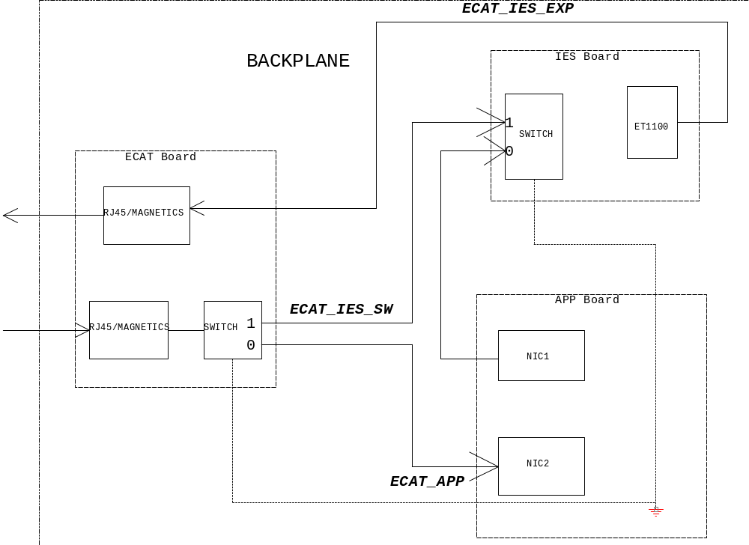

Backplane Power Tree Architecture

The external redundant 24VDC power supplies enters to the NGP Backplane though isolated input terminals to power all chassis cards ( 24V_A and 24V_B), analog FTC/IOP section ( AIO_24V_A and AIO_24V_B)and digital FTC/IOP sections ( DIO_24V_A and DIO_24V_B)as shown in Fig 1.

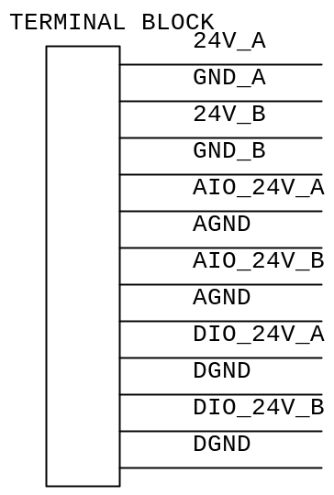

Fig . 1 : Power Terminal Block

PCC are used to generate 24V filtered power and 6.5V power as shown in Fig 2. The 24V filtered outputs of both the PCCs are shorted on the backplane to have a single 24V_F. The diode at the output of each PCC makes the ORing circuit.
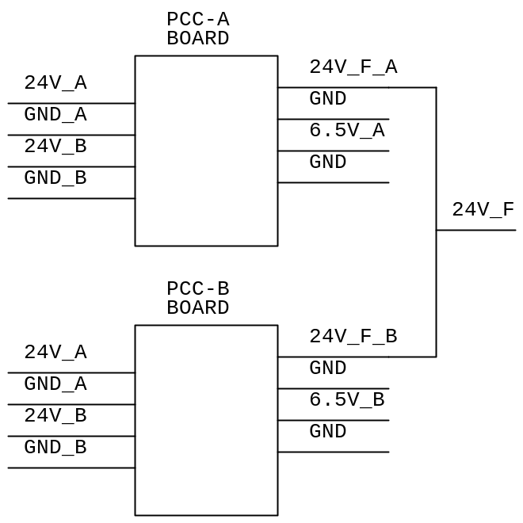

Fig 2 : PCC Board

FTC will provide the ORing functionality for various redundant 24V inputs as shown in Fig 3. The ORed single outputs are used to power the FTC (internally) and IOP boards.
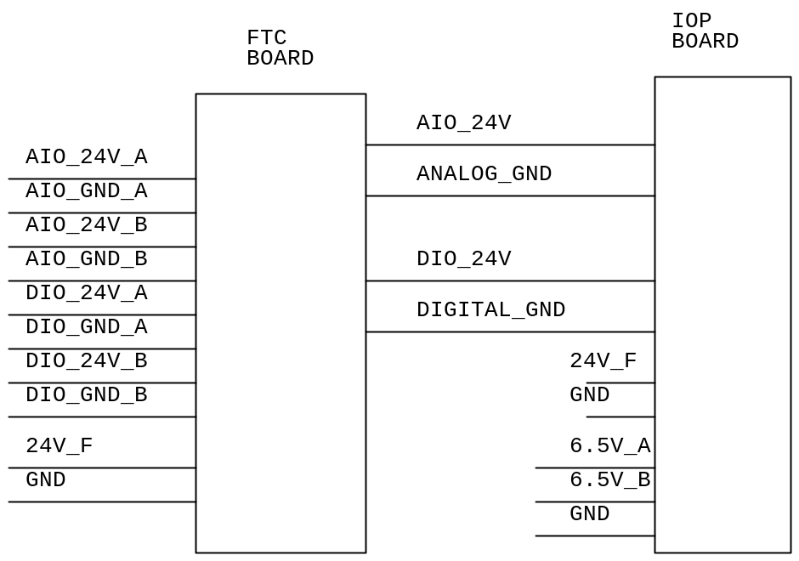

Fig 3 : IOP and FTC Boards Power

APP, IOP and MOD BUS/TRAIN LINK boards provide ORing functionality of redundant 6.5V inputs as shown in Fig 4.

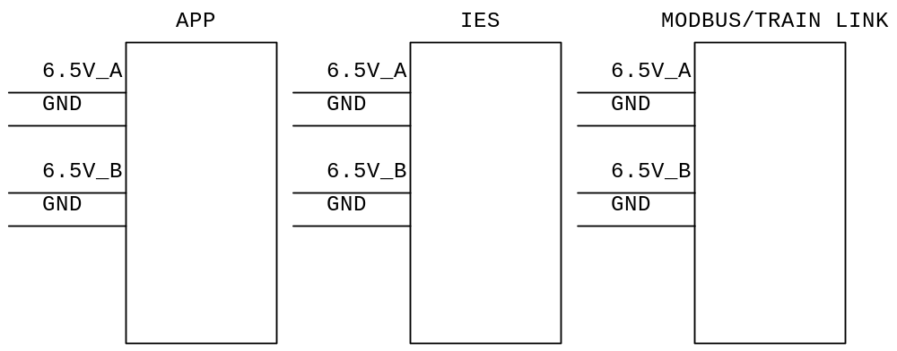

Fig 4: APP, IOP and MODBUS/TRAIN LINK Boards Power

Handling Hot Swap Enable in boards with 2 connectors:

In the daughter boards ( Pluggable board) where the 2 signal connectors are used, it will be required to make sure that E4 (shortest pin) of both the connectors are used. For that the connection should be as shown in the below diagram. This makes sure that when both the connector’s short pins are connected properly, then only the Enable pin of the Hot swap controller will be triggered.

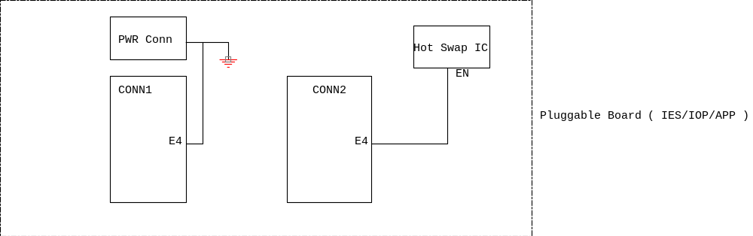

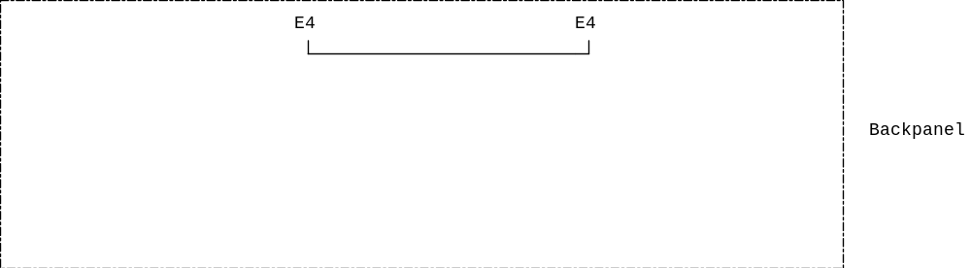

PCB Design related

PCB dimension and Stack up used
Backplane PCB is 431.8mm x 304.7mm size and 3mm thickness PCB. PCB is 10 layers PCB and impedance controlled. The PCB stack up details is as in the embedded document below



Placement and Layout Guidelines

- All the connectors to be placed as per the mechanical data provided in the DXF file.
- The reference pin of each connector should match with the corresponding daughter card’s same reference pin.
- Decoupling capacitors for the various power rails to be placed as close as possible to the corresponding pins of the power connector.
- Differential pair (TX+/- or RX+/-) should be routed away from all other signals and close together to meet the trace width and trace space as given in the stack up details.
- Route each differential pair on the same PCB layer.
- Keep both traces of each differential pair as identical to each other as possible.
- Ensure that all the critical signals should have an unbroken reference ground plane.
- Avoid via and pad in the path on any critical signal as via and pad will induce unwanted capacitance and inductance which can cause reflection and distortion.
- Ensure the various power signals have enough trace width to carry the required current. 24V_A and 24V_B should carry 48A , 6.5V_A and 6.5V_b should carry up to 36A and each of 24V_DIO_A, 24V_DIO_B, 24V_AIO-A and 24V_AIO_B should be able to carry 6A current.

Mechanical Design details

The reference to place all the connectors on the backplane are taken from the mechanical drawing file. This mechanical drawing is embedded below.



Product Integration

Product Integration Sequence

After backplane assembly and basic hardware testing the backplane will be fixed to the mechanical enclosure. The various daughter boards can be fixed on to the corresponding position on the backplane.

Product Integration Environment

Under normal lab conditions

Product Integration Procedures and Criteria

Under normal lab conditions, precautions should be taken for ESD while handling the printed circuit board assembly.

Design Assumptions/Risk Factors

- It is assumed that 24V_A and 24V_B should carry 48A, 6.5V_A and 6.5V_B should carry up to 36A and each of 24V_DIO_A, 24V_DIO_B, 24V_AIO-A and 24V_AIO_B should be able to carry 6A current based on the power budget calculation for the various daughter cards.

- It is assumed that the mechanical drawing attached is the final.

