External EtherCat Card (ECAT)

Hardware Design Document
Rev-0.1
07-SEPTEMBER-11

Ownership Disclaimer
This document contains proprietary and confidential material that is the sole property of Compressor Controls Corporation. The information contained herein is intended for internal use by Compressor Controls Corporation employees and is not intended for distribution outside of the company. As an unpublished work of trade secrets, the recipient shall keep this document confidential. Any re-use, copying, or distribution, either in whole or in part, of this material without the express written consent of Compressor Controls Corporation is strictly forbidden.
Copyright © 2011 by Compressor Controls Corporation. All rights reserved.

Revision History

Rev. | Date | Revised By | Change Description
0.1 | 07-Sept-2011 | Amith John Thomas | Initial Draft

Approvals

Approved by: Date: _______________
Approved by: Date: _______________
Approved by: Date: _______________
Approved by: Date: _______________

Table of Contents

1 Introduction 5
1.1 Purpose 5
1.2 Audience 5
1.3 Scope 5
1.4 Acronyms 5
1.5 References 5
2 General Description 6
2.1 System Overview 6
2.2 Product Functions 6
2.3 High Level Block Diagram 7
3 Electrical Specifications 8
3.1 MUX- ADG774A 8
3.2 Magnetics 8
3.3 Backplane Connector 9
3.4 M12 Circular Connector. 10
4 Power 10
5 Electrical Protection 11
6 Layout Guidelines 11
7 PCB Stack up 11

Introduction

Purpose
The purpose of this document is to describe the hardware design of the External EtherCat Card designed for the New Generation Platform (NGP) Hardware system..

Audience
This document is meant for use by the Hardware development team and Management of Compression Controls Corporation and Mindteck.

Scope
The scope of the document is to capture the hardware design of the External EtherCat Card in detail. It includes the components chosen, power consumption, layout guidelines and all other aspects of the design.

Acronyms
Acronym | Definition
CAC | Communication Accessory Card
ECAT | EtherCat
PCB | Printed Circuit Board
CCC | Compressor Controls Corporation
ESD | Electrostatic Discharge
REV | Revision
RoHS | Restriction of Hazarded Substances

References
[1] Detailed Functional Specification for NGP Hardware.
[2] Hardware Requirement Specifications, Rev-0.3.
[3] Datasheet of the MUX, ADG774.
[4]Various e-mails exchanged between CCC and Mindteck.

General Description

System Overview
New Generation Platform (NGP) is a fully redundant, duplex, highly available, fault tolerant control system intended to handle a number of digital, analog and frequency IOs in industrial applications

Product Functions
The ECAT card provides connectivity of the system to external devices via EtherCat communication protocol. It receives six EtherCat ports, one from each APP cards, and two from each IES cards. The ECAT card selects between the signals from APP-A and IES-A, as well as that from the APP-B and IES-B. The selection is done using a MUX. The selection is based on the presence or absence of the APP cards. The MUX selects the EtherCat signals from the APP if APP is present, else the signals from the IES. The selected signals are then routed to the output M12 connectors. The card accommodates four circular M12 connectors for four ports (two from IES cards and, the other two, either from APP or from the IES). The card also provides magnetics for all the four ports

High Level Block Diagram

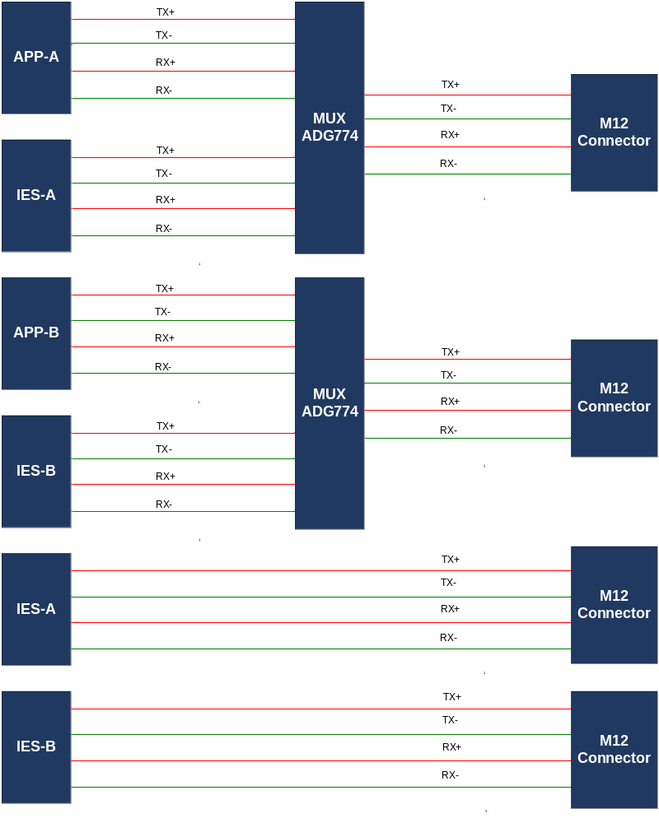 Figure1. Block Diagram

Electrical Specifications

MUX- ADG774
ADG774, a 2X1 quad channel MUX is employed in the design. It receives two sets of ethercat signals (one set comprises of TX+, TX-, RX+ and RX-), one from APP and the other from IES. It selects between the two sets and outputs either one. There are 2 such MUX (for APP-A, IES-A and APP-B, IES-B) on the board.
The select pin, ‘IN’ of the MUX is connected to the APP via backplane, where it is grounded. It is also pulled up to 3.3V through a resistor. So, whenever APP is connected, the IN pin is pulled low, otherwise pulled high. Accordingly the respective channels are selected- selects channels from APP when IN is pulled low; selects channel from IES when it is pulled high.

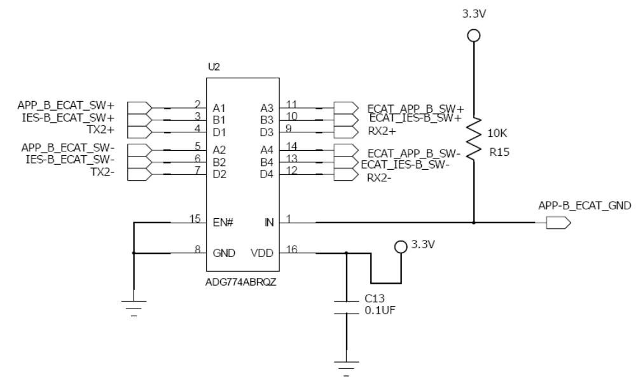

Magnetics
Magnetics are provided on the EtherCat lines, near the M12 connector. The 2.5V bias voltage for the magnetics are also provided on the magnetics centre tap. HX1188NL from PULSE is used in the design.

Backplane Connector
A 54-position right angled connector, 10039851-111LF (from FCI) will be employed for the backplane connectivity.
The pin description for the connector is shown below.

 | Pin | Signal | Pin | Signal
 | A1 | GND | E4 | Unused
 | A2 | GND | E5 | IES-A_ECAT_SW+
 | A3 | 3.3V_B_IES | E6 | APP_A_ECAT_SW+
 | A4 | 3.3V_A_IES | F1 | GND
 | A5 | GND | F2 | ECAT_IES-A_EXP-
 | A6 | APP-A_ECAT_GND | F3 | GND
 | B1 | APP-B_ECAT_GND | F4 | GND
 | B2 | IES-A_ECAT_EXP- | F5 | GND
 | B3 | 3.3V_B_IES | F6 | APP_A_ECAT_SW-
 | B4 | 3.3V_A_IES | G1 | ECAT_IES-B_EXP+
 | B5 | GND | G2 | GND
 | B6 | ECAT_IES-A_SW+ | G3 | IES-B_ECAT_SW-
 | C1 | GND | G4 | GND
 | C2 | IES-A_ECAT_EXP+ | G5 | APP_B_ECAT_SW+
 | C3 | 3.3V_B_IES | G6 | GND
 | C4 | 3.3V_A_IES | H1 | ECAT_IES-B_EXP-
 | C5 | GND | H2 | ECAT_IES-B_SW-
 | C6 | ECAT_IES-A_SW- | H3 | IES-B_ECAT_SW+
 | D1 | IES-B_ECAT_EXP+ | H4 | ECAT_APP_B_SW+
 | D2 | GND | H5 | APP_B_ECAT_SW-
 | D3 | 3.3V_B_IES | H6 | ECAT_APP_A_SW+
 | D4 | 3.3V_A_IES | I1 | GND
 | D5 | IES-A_ECAT_SW- | I2 | ECAT_IES-B_SW+
 | D6 | GND | I3 | GND
 | E1 | IES-B_ECAT_EXP- | I4 | ECAT_APP_B_SW-
 | E2 | ECAT_IES-A_EXP+ | I5 | GND
 | E3 | GND | I6 | ECAT_APP_A_SW-

Table1. Backplane Connector Pin out

M12 Circular Connector.
The circular connector, SAL-12D-FKW4 from CONEC is used for the external wiring of the EtherCat signals.
The pin mapping of the connector is as per the table below.

 | Pin | Signal
 | 1 | TX+
 | 2 | TX-
 | 3 | RX+
 | 4 | RX-

Table2. M12 Connector Pin out

Power
The ECAT card is powered by 3.3VDC, obtained by ORing the two 3.3V rails (3.3V_IES-A and 3.3V_IES-B) received from each IES card over the backplane connector. The magnetic centre tap requires 2.5V bias voltage, which is generated on board using an LDO, ADP1706A.
The table shows the maximum power requirement for the various voltage rails.

 | Voltage | Current | Power
 | 3.3 | 330 mA | 1089 mW
 | 2.5 | 320 mA | 800 mW

Table3. Power Budget Calculation

Electrical Protection
The ground strap pins of the M12 connectors are connected to the chassis ground, which in is turn connected to the system ground.
Also, the magnetics isolate the ethercat lines from any voltage glitches on the output section.

Layout Guidelines

- The EtherCat lines, TX+/- and RX1+/- are routed as differential pairs with a trace width of 4mils and a spacing of 8.39mils to achieve a differential impedance of 100Ohms.
- Adequate spacing should be maintained between the TX and RX pairs(approx 12mils)
- Each differential pair should have the same reference plane through out the trace.
- The magnetics for each EtherCat port should be placed as close as possible to the connector.
- All layers should be devoid of any plane or trace beneath the magnetics.
- Chassis ground (CHGND) should have a minimum 50 mil clearance (Target clearance of 100mil) from all other signals.

PCB Stack up
The board is four layered with a thickness of 1.6 mm. The stack up details is described below.

 | Layer | Usage | Thickness (mm)
 | Copper plating layer 1 |  | 0.0325
 | Copper foil layer 1 | Signal | 0.0175
 | Prepreg 1 - 2
 | Copper foil layer 2 | Plane | 0.035
 | Core 2 - 3
 | Copper foil layer 3 | Plane | 0.035
 | Prepreg 3 - 4
 | Copper foil layer 4 | Signal | 0.0175
 | Copper plating layer 4 |  | 0.0325

Table4. Board Stack-up Details

