External Ethernet Card (EEC)

Hardware Design Document
Rev-0.1
07-SEPTEMBER-11

Ownership Disclaimer
This document contains proprietary and confidential material that is the sole property of Compressor Controls Corporation. The information contained herein is intended for internal use by Compressor Controls Corporation employees and is not intended for distribution outside of the company. As an unpublished work of trade secrets, the recipient shall keep this document confidential. Any re-use, copying, or distribution, either in whole or in part, of this material without the express written consent of Compressor Controls Corporation is strictly forbidden.
Copyright © 2011 by Compressor Controls Corporation. All rights reserved.

Revision History

Rev. | Date | Revised By | Change Description
0.1 | 07-Sept-2011 | Amith John Thomas | Initial Draft

Approvals

Approved by: Date: _______________
Approved by: Date: _______________
Approved by: Date: _______________
Approved by: Date: _______________

Table of Contents

1 Introduction 5
1.1 Purpose 5
1.2 Audience 5
1.3 Scope 5
1.4 Acronyms 5
1.5 References 5
2 General Description 6
2.1 System Overview 6
2.2 Product Functions 6
2.3 High Level Block Diagram 7
3 Electrical Specifications 8
3.1 Magnetics 8
3.2 RJ-45 Connector. 8
3.3 Backplane Connector 9
4 Power 10
5 Electrical Protection 10
6 Layout Guidelines 10
7 PCB Stack up 11

Introduction

Purpose
The purpose of this document is to describe the hardware design of the External Ethernet Card designed for the New Generation Platform (NGP) Hardware system..

Audience
This document is meant for use by the Hardware development team and Management of Compression Controls Corporation and Mindteck.

Scope
The scope of the document is to capture the hardware design of the External Ethernet Card in detail. It includes the components chosen, power consumption, layout guidelines and all other aspects of the design.

Acronyms
Acronym | Definition
CAC | Communication Accessory Card
EEC | External Ethernet Card.
PCB | Printed Circuit Board
CCC | Compressor Controls Corporation
ESD | Electrostatic Discharge
REV | Revision
RoHS | Restriction of Hazarded Substances

References
[1] Detailed Functional Specification for NGP Hardware.
[2] Hardware Requirement Specifications, Rev-0.3.
[3]Various e-mails exchanged between CCC and Mindteck.

General Description

System Overview
New Generation Platform (NGP) is a fully redundant, duplex, highly available, fault tolerant control system intended to handle a number of digital, analog and frequency IOs in industrial applications

Product Functions
The EEC provides Ethernet communication between the APP and the PC. It receives four Ethernet ports, two from each APP card via backplane connector. The external connectivity is provided by four RJ-45 connectors, one for each Ethernet port. The EEC also houses magnetics for each Ethernet port. The magnetics receive the 2.5V biasing voltage directly from the corresponding PHYs, placed on the APPs.

High Level Block Diagram

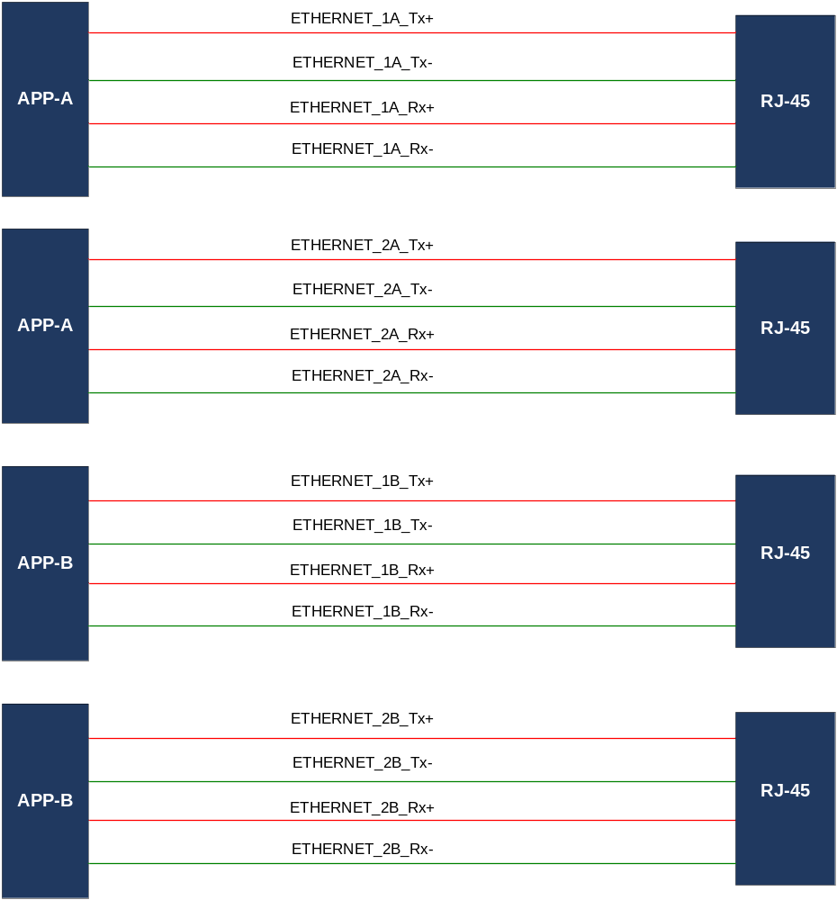

Figure1. Block Diagram

Electrical Specifications

Magnetics
Magnetics are provided on the Ethernet lines, near the RJ-45 connectors. They receive the Ethernet signals from the backplane connector and send it to the output RJ-45 connectors. The magnetics receive the 2.5V biasing voltage directly from the corresponding PHYs, placed on the APPs.

RJ-45 Connector.
A 2 port RJ-45 connector, RJHSE-5380-02 from AMPHENOL is used for the external wiring of the Ethernet signals.
The pin mapping of the connector is as per the table below.

 | Pin | Signal
 | 1 | TX+
 | 2 | TX-
 | 3 | RX+
 | 4 | Connected to termination resistor
 | 5 | Connected to termination resistor
 | 6 | RX-
 | 7 | Connected to termination resistor
 | 8 | Connected to termination resistor
 | 9 | TX+
 | 10 | TX-
 | 11 | RX+
 | 12 | Connected to termination resistor
 | 13 | Connected to termination resistor
 | 14 | RX-
 | 15 | Connected to termination resistor
 | 16 | Connected to termination resistor

Table2. RJ-45 Connector Pin out

Backplane Connector
A 54-position right angled connector, 10039851-111LF (from FCI) will be employed for the backplane connectivity.
The pin description for the connector is shown below.

 | Pin | Signal | Pin | Signal
 | A1 | GND | E4 | Unused
 | A2 | GND | E5 | EEC_APP-B1-
 | A3 | GND | E6 | EEC_APP-A1-
 | A4 | GND | F1 | GND
 | A5 | GND | F2 | GND
 | A6 | GND | F3 | GND
 | B1 | GND | F4 | GND
 | B2 | 2.5_APP_A2 | F5 | GND
 | B3 | GND | F6 | EEC_APP-A1+
 | B4 | GND | G1 | APP-A_EEC2-
 | B5 | GND | G2 | GND
 | B6 | 2.5_APP_A1 | G3 | APP-B_EEC2-
 | C1 | GND | G4 | 2.5_APP_B1
 | C2 | 2.5_APP_A2 | G5 | APP-B_EEC1+
 | C3 | 2.5_APP_B2 | G6 | GND
 | C4 | GND | H1 | APP-A_EEC2+
 | C5 | GND | H2 | EEC_APP-B2-
 | C6 | 2.5_APP_A1 | H3 | APP-B_EEC2+
 | D1 | EEC_APP-A2- | H4 | 2.5_APP_B1
 | D2 | GND | H5 | APP-B_EEC1-
 | D3 | 2.5_APP_B2 | H6 | APP-A_EEC1-
 | D4 | GND | I1 | GND
 | D5 | EEC_APP-B1+ | I2 | EEC_APP-B2+
 | D6 | GND | I3 | GND
 | E1 | EEC_APP-A2+ | I4 | GND
 | E2 | GND | I5 | GND
 | E3 | GND | I6 | APP-A_EEC1+

Table1. Backplane Connector Pin out

Power
The EEC board requires just 2.5V bias voltages for the magnetics centre tap. It is routed directly from the corresponding PHYs on the APP boards via backplane connector.

Electrical Protection
The ground strap pins of the RJ-45 connectors are connected to the chassis ground, which in is turn connected to the system ground.
Also, the magnetics isolate the Ethernet lines from any voltage glitches on the output section.

Layout Guidelines

- The Ethernet lines, TX+/- and RX1+/- are routed as differential pairs with a trace width of 4mils and a spacing of 8.39mils to achieve a differential impedance of 100Ohms.
- Adequate spacing should be maintained between the TX and RX pairs(approx 12mils)
- Each differential pair should have the same reference plane through out the trace.
- The magnetics for each Ethernet port should be placed as close as possible to the connector.
- All layers should be devoid of any planes or traces beneath the magnetics.
- Chassis ground (CHGND) should have a minimum 50 mil clearance (Target clearance of 100mil) from all other signals.

PCB Stack up
The board is four layered with a thickness of 1.6 mm. The stack up details is described below.

 | Layer | Usage | Thickness (mm)
 | Copper plating layer 1 |  | 0.0325
 | Copper foil layer 1 | Signal | 0.0175
 | Prepreg 1 - 2
 | Copper foil layer 2 | Plane | 0.035
 | Core 2 - 3
 | Copper foil layer 3 | Plane | 0.035
 | Prepreg 3 - 4
 | Copper foil layer 4 | Signal | 0.0175
 | Copper plating layer 4 |  | 0.0325

Table4. Board Stack-up Details

