# **Shigabutdinov Ruslan T2CCO-2113**

# **Introduction**

When we needed to choose one of the topics of site, I chose food store, because it`s familiar to thing I already made in past.

Main part

My site is made for online delivery food from restaurants to basic humans, who has internet and cash.

My project has 3 html pages: index, login and product, and have one css file for each page.

In index page I have favorite fast-food companies, and option to choose your city to deliver.

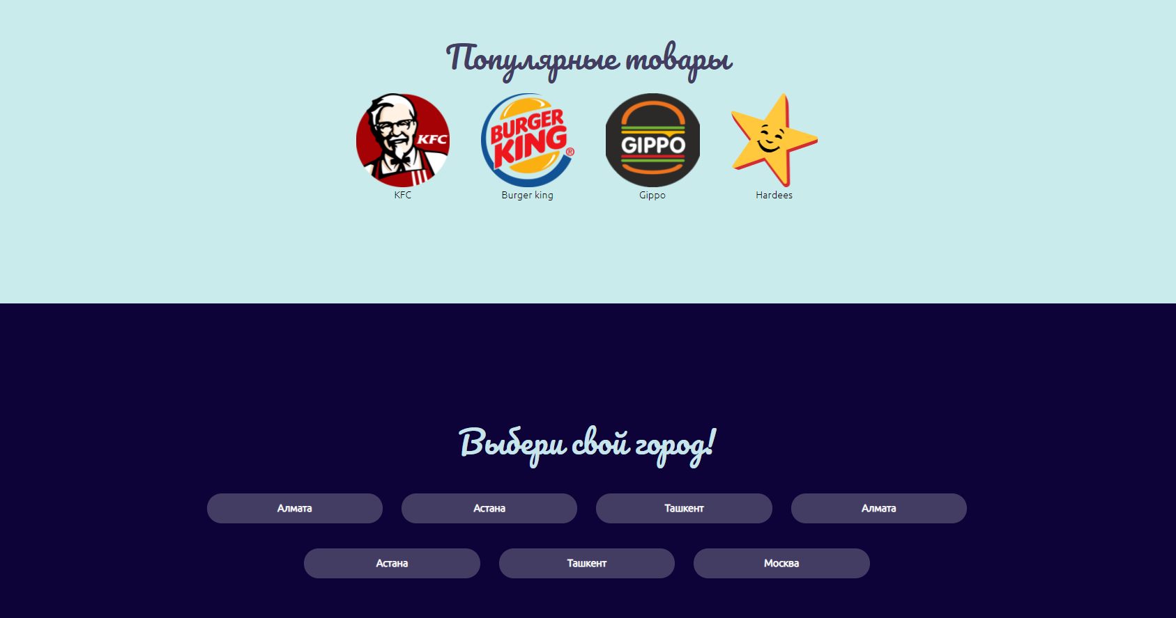

On all pages we have navbar, which have search bar, all companies and all categories of food pages.



You also can register to site.

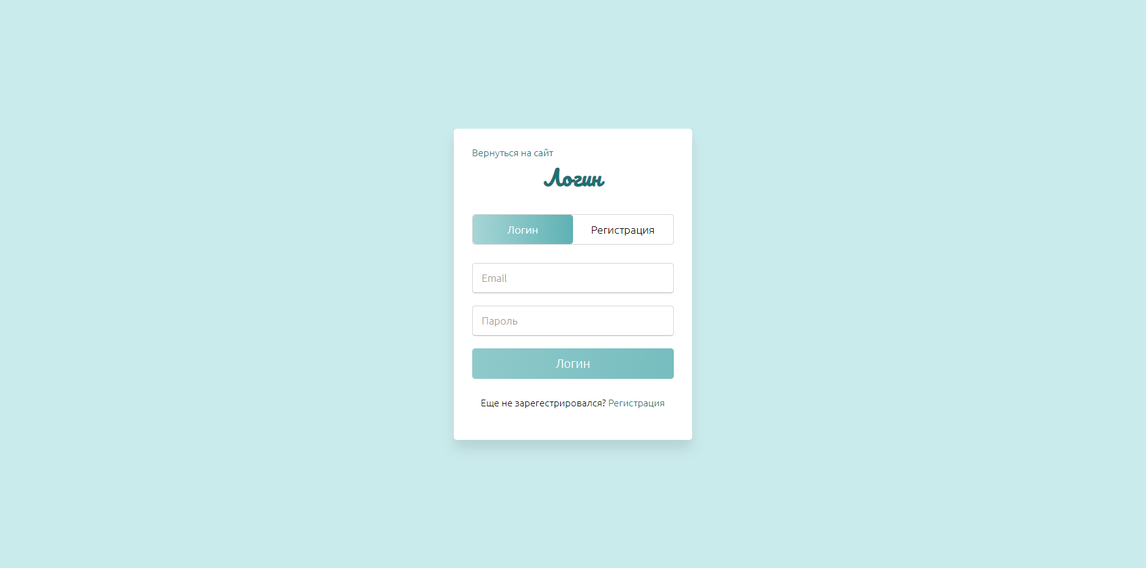

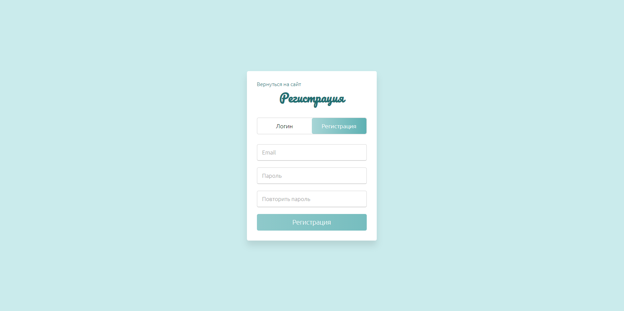

I added JavaScript, so I can have login and registration on a single page, with an interesting design.

If you choose one of the popular company, you can see name. image, description and rating of the shop.

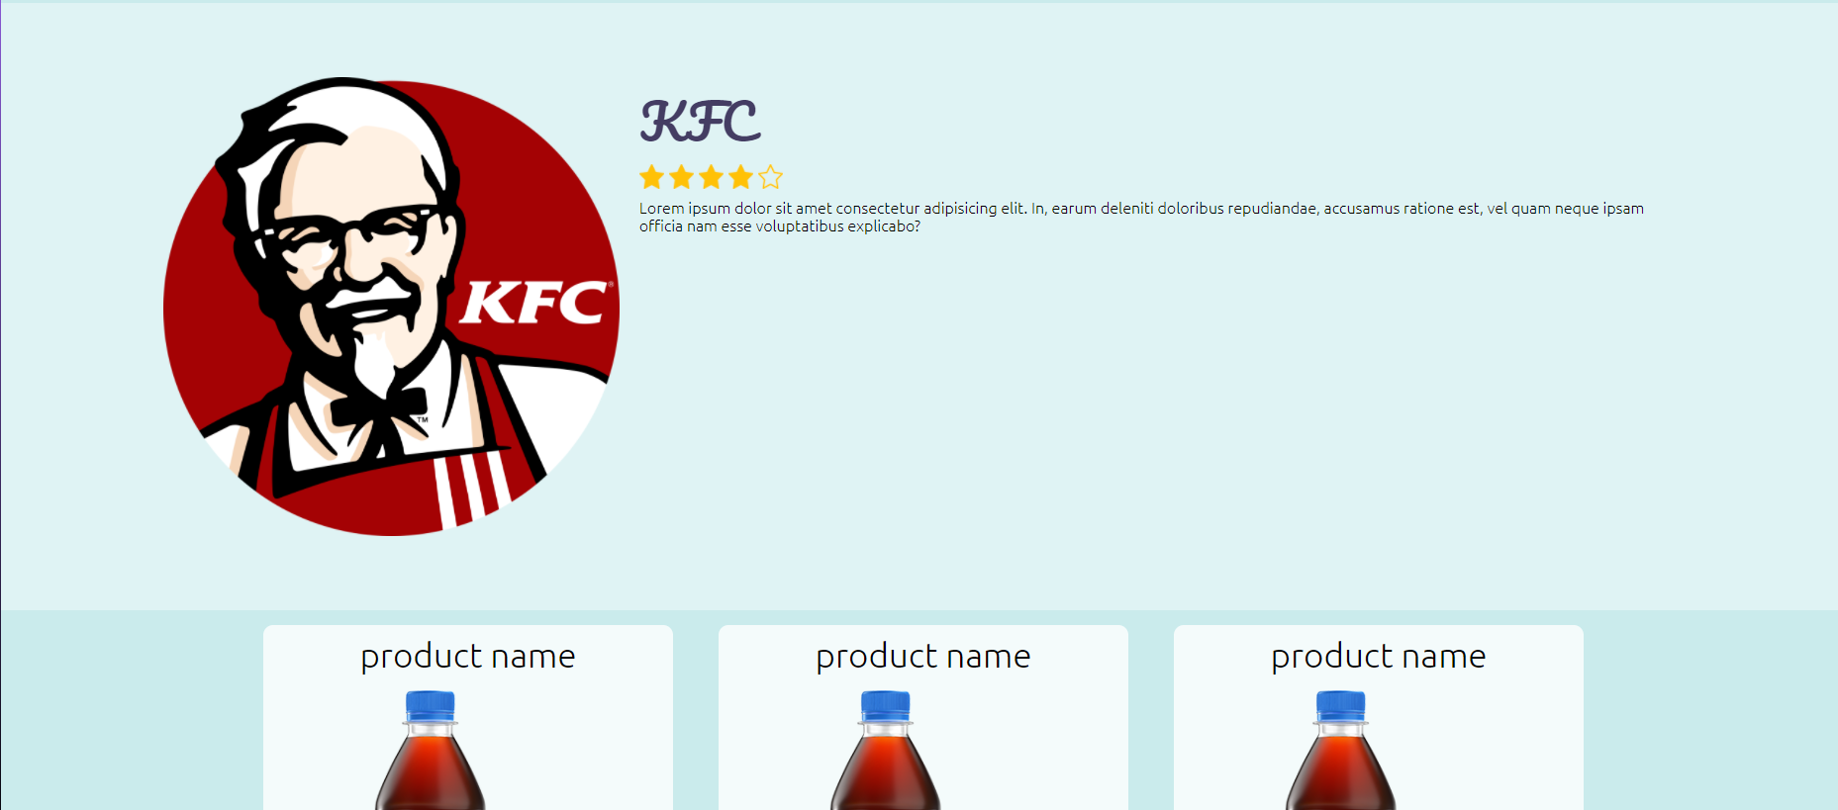

After common company information you can see products, that he sells.

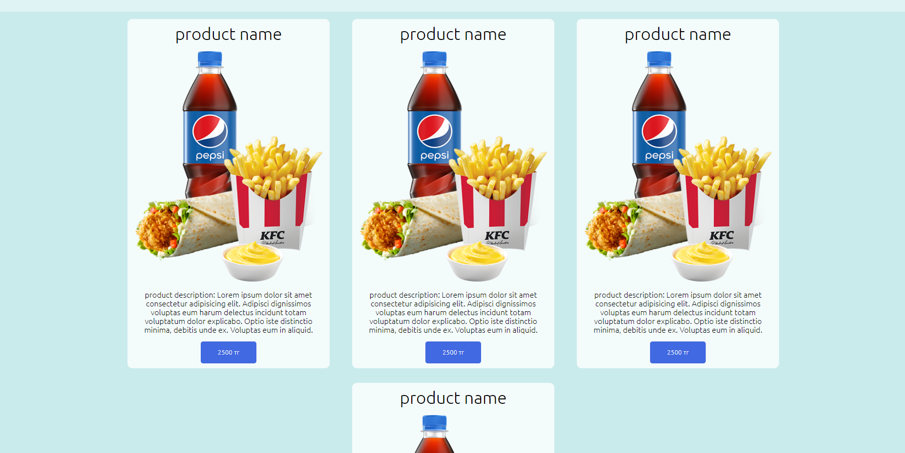

I done my site in light blue colors, because I think it`s not so boring as white, and I try to save color pallet not so splashy.

In admin panel I have table with all products.

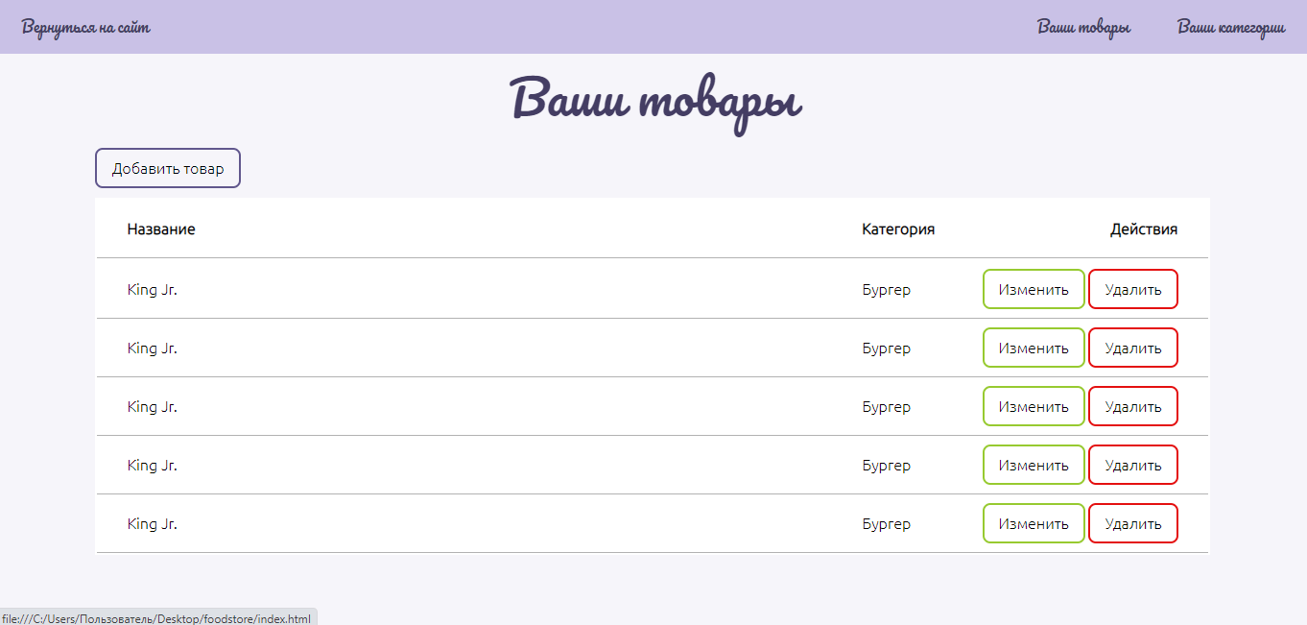

Create and edit all categories

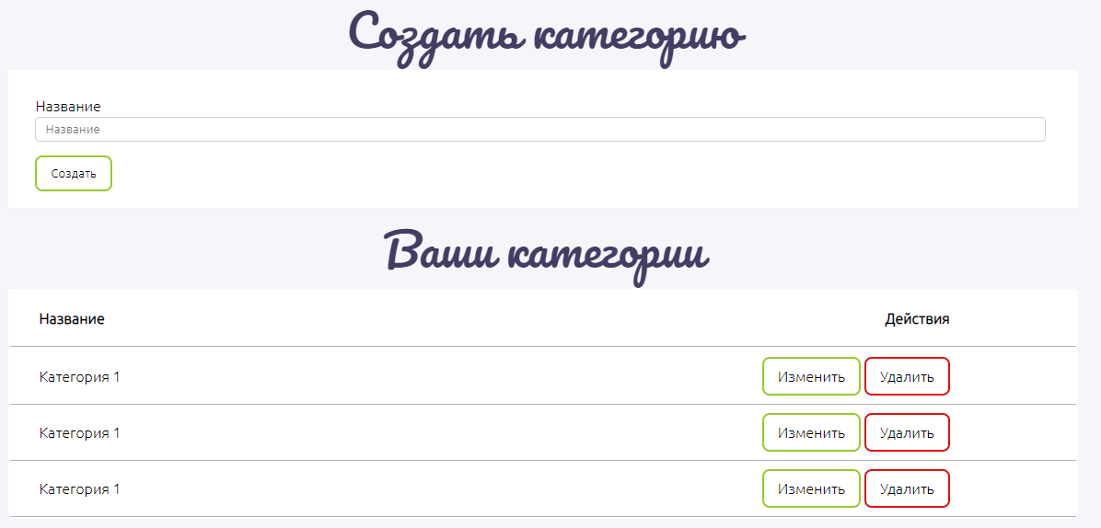

In my project I have at least 12 pages, all with CSS, and one page with Javasctipt.

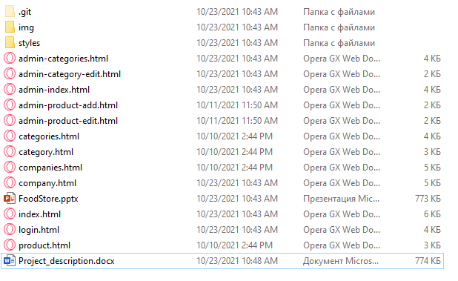

[Github page!](https://github.com/SaylerGaming/food-store)