WEEK 3 TASK
ADVANCED DATA ANALYSIS AND VISUALIZATION IN LOGISTICS
E-Commerce Delivery Optimization – Hypothetical Logistics Analysis

1. Introduction
Logistics performance depends on timely deliveries, efficient transportation, controlled operating costs, and effective resource allocation. This project demonstrates how Python-based data analysis and visualization can be used to understand logistics operations and support data-driven decisions.

2. Objective
- Simulate a realistic logistics dataset for analysis.
- Perform exploratory data analysis using Python and Pandas.
- Study central tendency, distributions, and correlations.
- Create eight visualizations covering distributions, relationships, comparisons, and correlations.
- Identify operational bottlenecks and major cost drivers.
- Provide practical recommendations for improving logistics performance.

3. Dataset Description
A hypothetical dataset containing 300 delivery records was generated using NumPy and Pandas. The data represents e-commerce shipments across four regions, three vehicle types, and different weather conditions.
Variable | Type | Description
Order_ID | Categorical | Unique shipment identifier
Region | Categorical | North, South, East, or West
Vehicle_Type | Categorical | Bike, Van, or Truck
Distance_km | Numeric | Delivery distance in kilometres
Delivery_Time_hr | Numeric | Delivery time in hours
Shipment_Volume | Numeric | Number of packages in shipment
Package_Weight_kg | Numeric | Total package weight
Transportation_Cost | Numeric | Estimated transportation cost
Weather | Categorical | Clear, Rainy, or Stormy
Delivery_Status | Categorical | On Time or Delayed

4. Methodology
- Generate a reproducible hypothetical dataset with 300 observations.
- Inspect data types, descriptive statistics, and possible data-quality issues.
- Calculate mean, median, standard deviation, minimum, and maximum for numerical variables.
- Analyze distributions using histograms.
- Analyze relationships using scatter plots.
- Compare operational groups using bar charts.
- Measure linear relationships using a correlation matrix.
- Translate statistical patterns into logistics insights and recommendations.

5. Exploratory Data Analysis
The dataset contains 300 rows and 10 columns. There are 0 missing values and 0 duplicate rows in the simulated dataset.
Descriptive Statistics:
Metric | Mean | Median | Std Dev | Minimum | Maximum
Distance_km | 43.06 | 37.30 | 25.85 | 5.00 | 120.00
Delivery_Time_hr | 1.56 | 1.44 | 0.78 | 0.40 | 4.81
Shipment_Volume | 8.78 | 9.00 | 2.63 | 3.00 | 17.00
Package_Weight_kg | 12.77 | 12.00 | 5.40 | 2.90 | 29.60
Transportation_Cost | 716.67 | 656.83 | 293.67 | 160.14 | 1720.49

6. Visualizations and Interpretation

Figure 1: Delivery Time Distribution
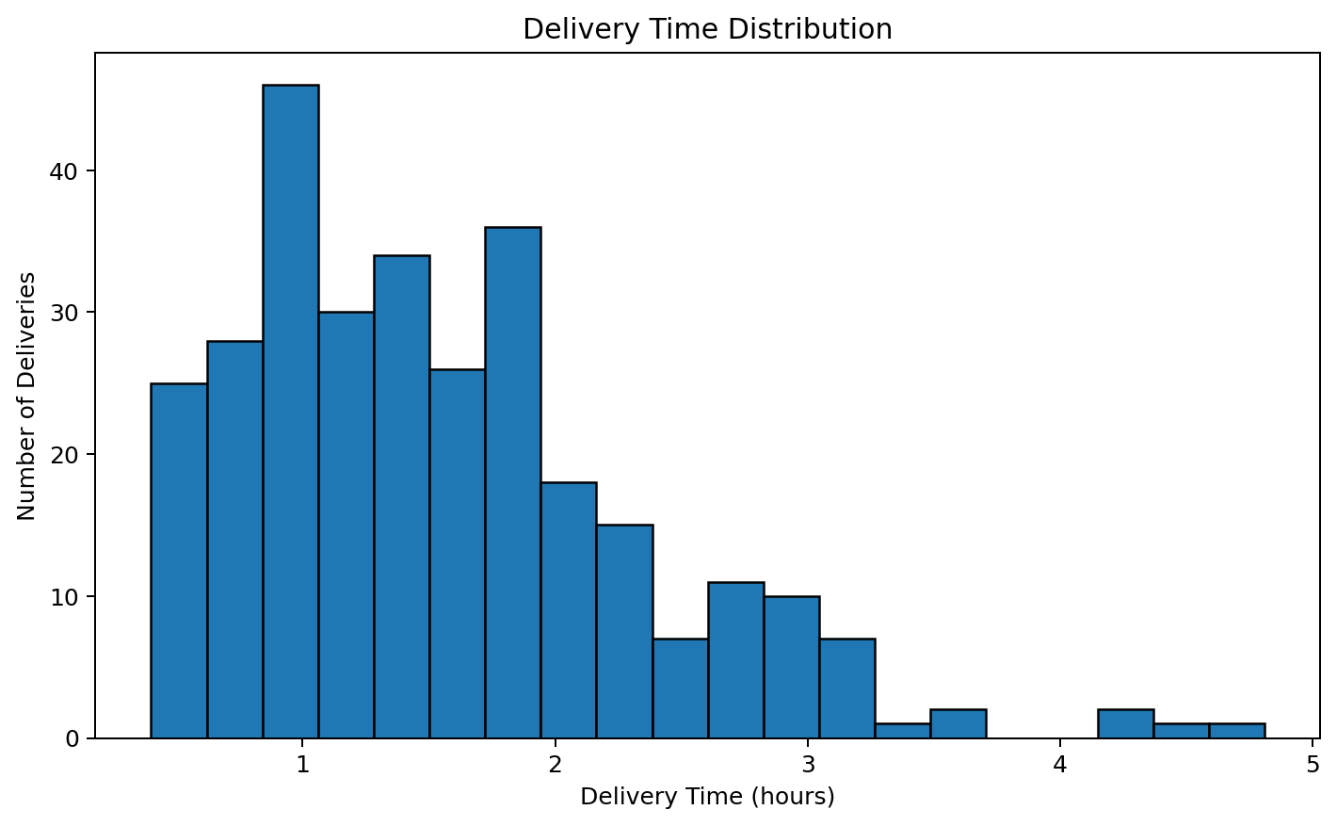
Interpretation: The histogram shows how delivery times are spread across shipments. Most observations are concentrated around the lower-to-middle delivery-time range, while longer deliveries occur less frequently. This helps identify the typical service time and unusual long deliveries.
Why this visualization: A histogram is appropriate because it shows the frequency and shape of a numerical distribution.

Figure 2: Transportation Cost Distribution
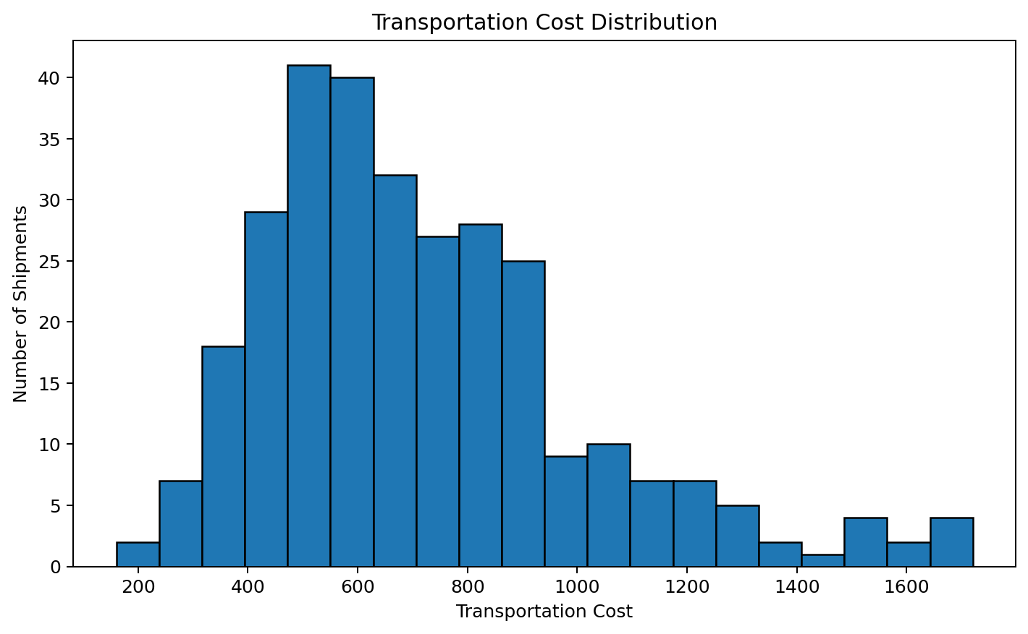
Interpretation: The cost distribution shows the range of transportation expenses across shipments. Higher-cost shipments generally represent longer distances, heavier packages, or larger vehicle requirements.
Why this visualization: A histogram helps logistics managers understand normal cost levels and identify unusually expensive shipments.

Figure 3: Distance vs Delivery Time
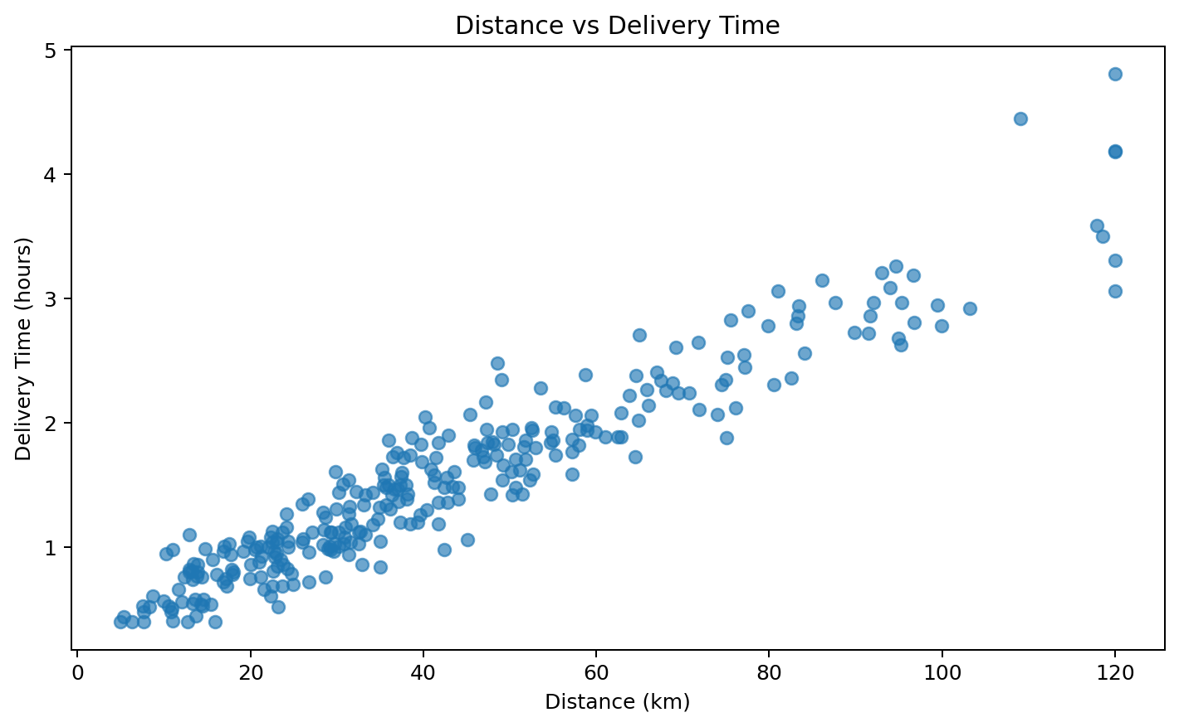
Interpretation: The scatter plot indicates a positive relationship: as delivery distance increases, delivery time generally increases. Weather and vehicle differences create some variation around the overall relationship.
Why this visualization: A scatter plot is suitable for examining the relationship between two continuous numerical variables.

Figure 4: Distance vs Transportation Cost
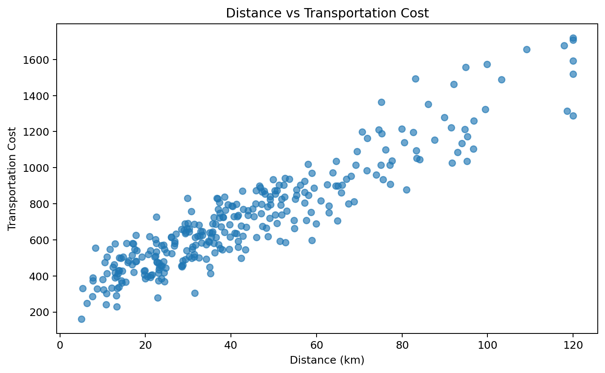
Interpretation: Transportation cost generally rises with distance. This indicates that distance is an important cost driver and that route planning can directly influence logistics expenditure.
Why this visualization: A scatter plot clearly shows the direction and strength of a numerical relationship.

Figure 5: Average Transportation Cost by Vehicle Type
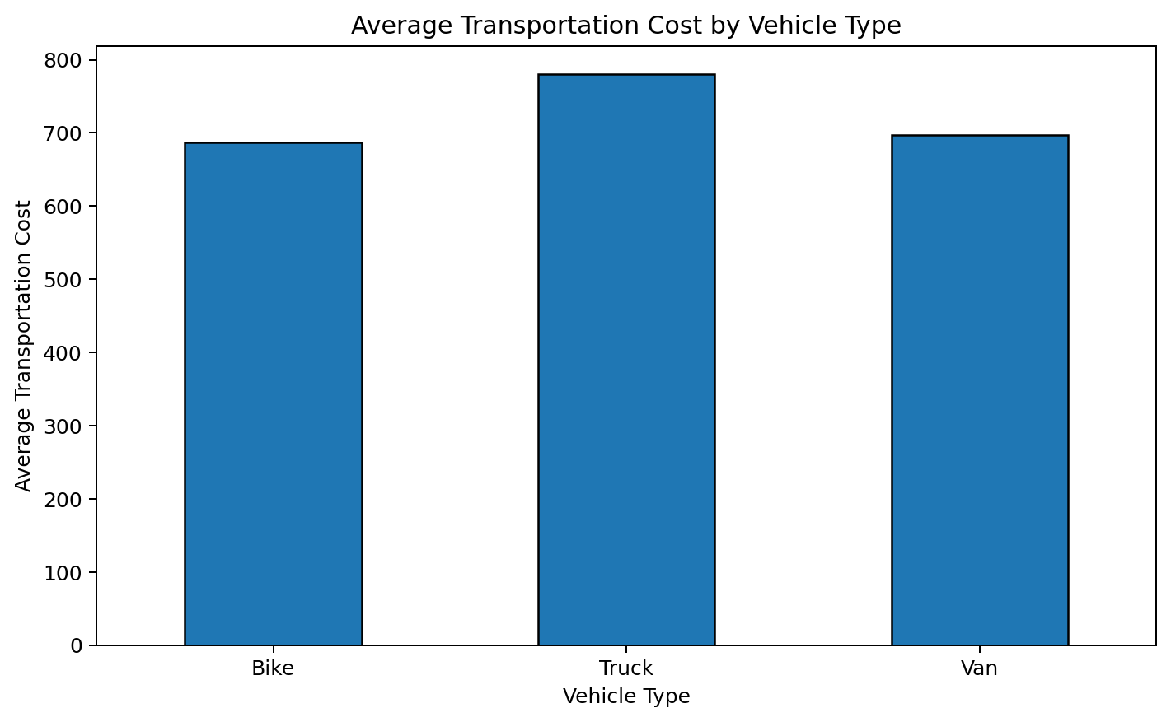
Interpretation: The chart compares average cost across vehicle categories. Larger vehicles have higher average operating costs in the simulated dataset, although they may be useful for high-volume shipments.
Why this visualization: A bar chart is suitable for comparing averages across discrete vehicle categories.

Figure 6: Average Delivery Time by Region
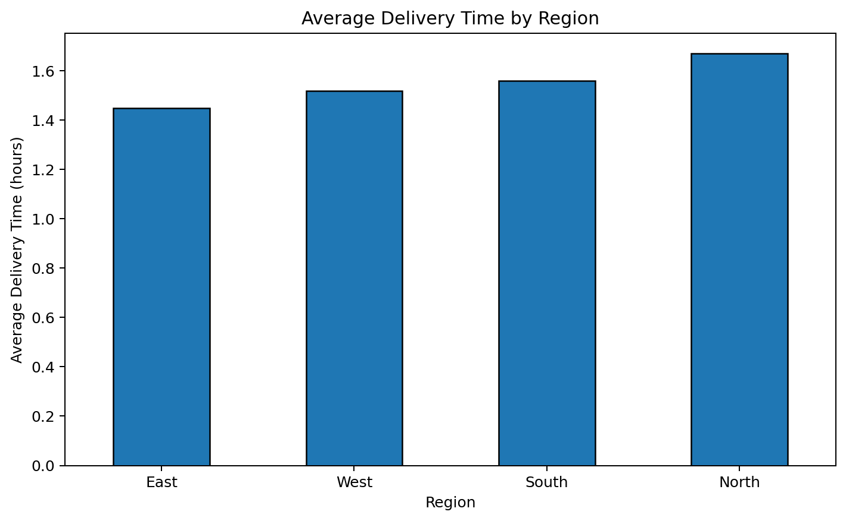
Interpretation: The regional comparison identifies the relative delivery-time performance of each region. The slowest region has an average delivery time of approximately 1.67 hours, while the fastest is approximately 1.45 hours.
Why this visualization: A bar chart makes differences between regions easy to compare and prioritize.

Figure 7: On-Time vs Delayed Deliveries
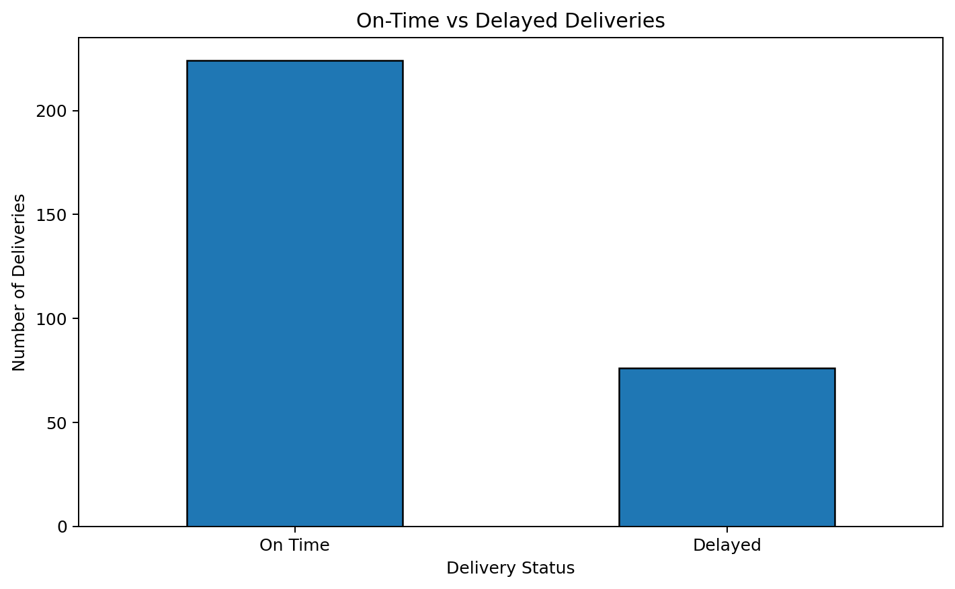
Interpretation: The dataset contains 224 on-time deliveries and 76 delayed deliveries. The chart provides a simple view of overall delivery reliability.
Why this visualization: A bar chart is effective for comparing counts of categorical outcomes.

Figure 8: Correlation Heatmap
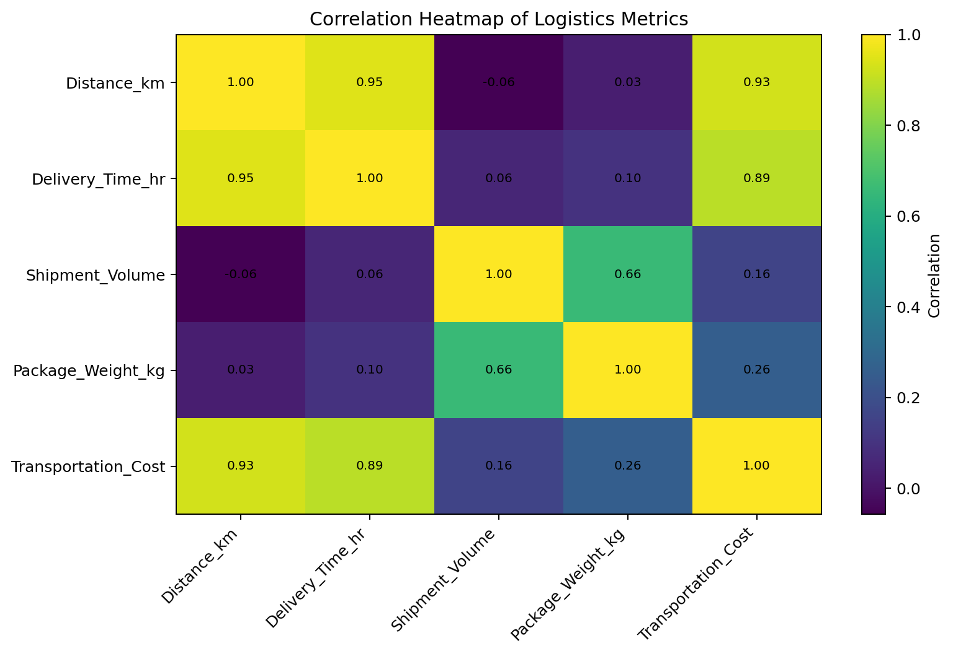
Interpretation: The heatmap summarizes pairwise linear relationships among numerical logistics variables. Strong positive relationships indicate variables that tend to increase together and can help identify cost and efficiency drivers.
Why this visualization: A correlation heatmap is useful when several numerical variables must be compared simultaneously.

7. Key Analytical Insights
- Distance is positively associated with delivery time (correlation ≈ 0.95), showing that longer routes generally require more time.
- Distance is positively associated with transportation cost (correlation ≈ 0.93), making route length an important cost driver.
- Package weight also has a positive relationship with transportation cost (correlation ≈ 0.26), indicating that heavier shipments can increase operating expense.
- Vehicle type affects average transportation cost, so selecting vehicles based on shipment requirements can improve resource utilization.
- Regional delivery-time differences suggest that some areas may require route optimization, better allocation, or additional delivery capacity.
- Delivery delays should be monitored by region, vehicle type, and weather to identify recurring operational bottlenecks.

8. Logistics Performance Interpretation
The analysis shows that logistics performance is influenced by several connected factors rather than one variable alone. Distance affects both delivery time and cost. Package weight and shipment volume increase the transportation requirements. Vehicle selection changes operating cost and can influence delivery efficiency. Weather can also increase delivery time, especially when conditions are adverse. Therefore, logistics planning should combine route, shipment, vehicle, and operational data.

9. Recommendations
- Use route optimization for long-distance deliveries to reduce travel time and transportation costs.
- Assign vehicles according to shipment volume and package weight instead of using the same vehicle type for every shipment.
- Monitor regions with consistently high delivery times and investigate route or capacity bottlenecks.
- Include weather conditions in delivery planning and provide additional time buffers during adverse weather.
- Track transportation cost per kilometre and per shipment to identify inefficient routes.
- Use delivery-delay dashboards to continuously monitor operational performance.
- Repeat the analysis on real historical data to validate these simulated findings before making operational changes.

10. Conclusion
This Week 3 project demonstrates how exploratory data analysis and visualization can convert logistics data into actionable business information. The analysis highlights distance, package characteristics, vehicle selection, regional performance, and delivery conditions as important areas for monitoring. Python tools such as Pandas, NumPy, and Matplotlib provide an effective foundation for logistics analytics and data-driven decision-making.

11. Python Tools Used
- Python – primary programming language.
- NumPy – numerical simulation and random data generation.
- Pandas – data manipulation, grouping, descriptive statistics, and correlation analysis.
- Matplotlib – creation of the eight visualizations.
- python-docx – automated generation of the final DOCX report.

12. Python Code
import numpy as np
import pandas as pd
import matplotlib.pyplot as plt
# Load the simulated logistics dataset
df = pd.read_csv("week3_logistics_dataset.csv")
# Basic EDA
print(df.shape)
print(df.info())
print(df.describe())
print(df.isnull().sum())
# Correlation analysis
numeric_cols = [
"Distance_km", "Delivery_Time_hr",
"Shipment_Volume", "Package_Weight_kg",
"Transportation_Cost"
]
print(df[numeric_cols].corr())
# Example visualizations
plt.hist(df["Delivery_Time_hr"], bins=20, edgecolor="black")
plt.title("Delivery Time Distribution")
plt.xlabel("Delivery Time (hours)")
plt.ylabel("Number of Deliveries")
plt.show()
plt.scatter(df["Distance_km"], df["Delivery_Time_hr"], alpha=0.65)
plt.title("Distance vs Delivery Time")
plt.xlabel("Distance (km)")
plt.ylabel("Delivery Time (hours)")
plt.show()
df.groupby("Vehicle_Type")["Transportation_Cost"].mean().plot(
kind="bar", edgecolor="black"
)
plt.title("Average Transportation Cost by Vehicle Type")
plt.show()
# Other charts in the report are generated using the same
# Matplotlib approach with hist(), scatter(), plot(kind="bar"),
# and imshow() for the correlation matrix.

