WEEK 4 TASK
PREDICTIVE MODELING AND OPTIMIZATION IN LOGISTICS SYSTEMS
E-Commerce Delivery Optimization

1. Introduction
Predictive analytics can help logistics organizations anticipate delivery delays, allocate resources, improve route planning, and provide more reliable delivery estimates. This project develops a machine-learning model to predict delivery time using operational and shipment-related variables.

2. Problem Definition
The prediction problem is to estimate Delivery_Time_hr for an e-commerce shipment before or during the delivery process. The predicted delivery time can be used to identify high-risk shipments and support proactive logistics decisions.
- Target variable: Delivery_Time_hr.
- Prediction type: Supervised regression.
- Input variables: region, vehicle type, distance, shipment volume, package weight, transportation cost, and weather.
- Business goal: improve delivery planning and reduce the risk of late deliveries.

3. Dataset Description
The dataset contains 300 hypothetical logistics records and 10 columns. It is based on the logistics dataset used in the previous analysis and is used here for predictive modeling.
Feature | Type | Purpose
Region | Categorical | Delivery region
Vehicle_Type | Categorical | Vehicle used for delivery
Distance_km | Numeric | Delivery distance
Shipment_Volume | Numeric | Number of packages
Package_Weight_kg | Numeric | Shipment weight
Transportation_Cost | Numeric | Estimated transport cost
Weather | Categorical | Weather during delivery
Delivery_Time_hr | Target | Time taken for delivery

4. Data Preparation
- The dataset was loaded using Pandas.
- Numerical variables were median-imputed and standardized.
- Categorical variables were filled using the most frequent category and converted using one-hot encoding.
- The data was divided into 80% training data and 20% testing data.
- A fixed random state of 42 was used for reproducibility.

5. Model Selection
Two regression approaches were evaluated: Linear Regression and Random Forest Regression. Linear Regression provides a simple and interpretable baseline and works well when relationships are approximately linear. Random Forest was selected as a stronger non-linear model because logistics delivery time can depend on interacting factors such as distance, vehicle type, weather, and shipment characteristics.

6. Model Training and Evaluation
The models were trained on the training set and evaluated on unseen test data. Three metrics were used: MAE, RMSE, and R-squared.
- MAE (Mean Absolute Error): average absolute prediction error in hours. Lower is better.
- RMSE (Root Mean Squared Error): gives greater penalty to larger prediction errors. Lower is better.
- R² (R-squared): indicates how much variation in delivery time is explained by the model. Higher is better.

7. Model Performance
Model | MAE (hr) | RMSE (hr) | R²
Linear Regression | 0.154 | 0.199 | 0.887
Random Forest | 0.177 | 0.233 | 0.845
Tuned Random Forest | 0.178 | 0.237 | 0.839
The tuned Random Forest achieved an MAE of 0.178 hours, an RMSE of 0.237 hours, and an R² of 0.839 on the test set. Its five-fold cross-validation MAE was 0.184 hours. These results indicate that the model can provide useful estimates for the simulated dataset.

8. Hyperparameter Tuning and Validation
Five-fold cross-validation was used to estimate how consistently the Random Forest model performs across different subsets of the data. GridSearchCV was then used to test combinations of the number of trees, maximum tree depth, and minimum samples required for splitting. The configuration with the best cross-validated MAE was selected.
Best hyperparameters: {'model__max_depth': None, 'model__min_samples_split': 5, 'model__n_estimators': 200}

9. Visualization 1: Actual vs Predicted Delivery Time
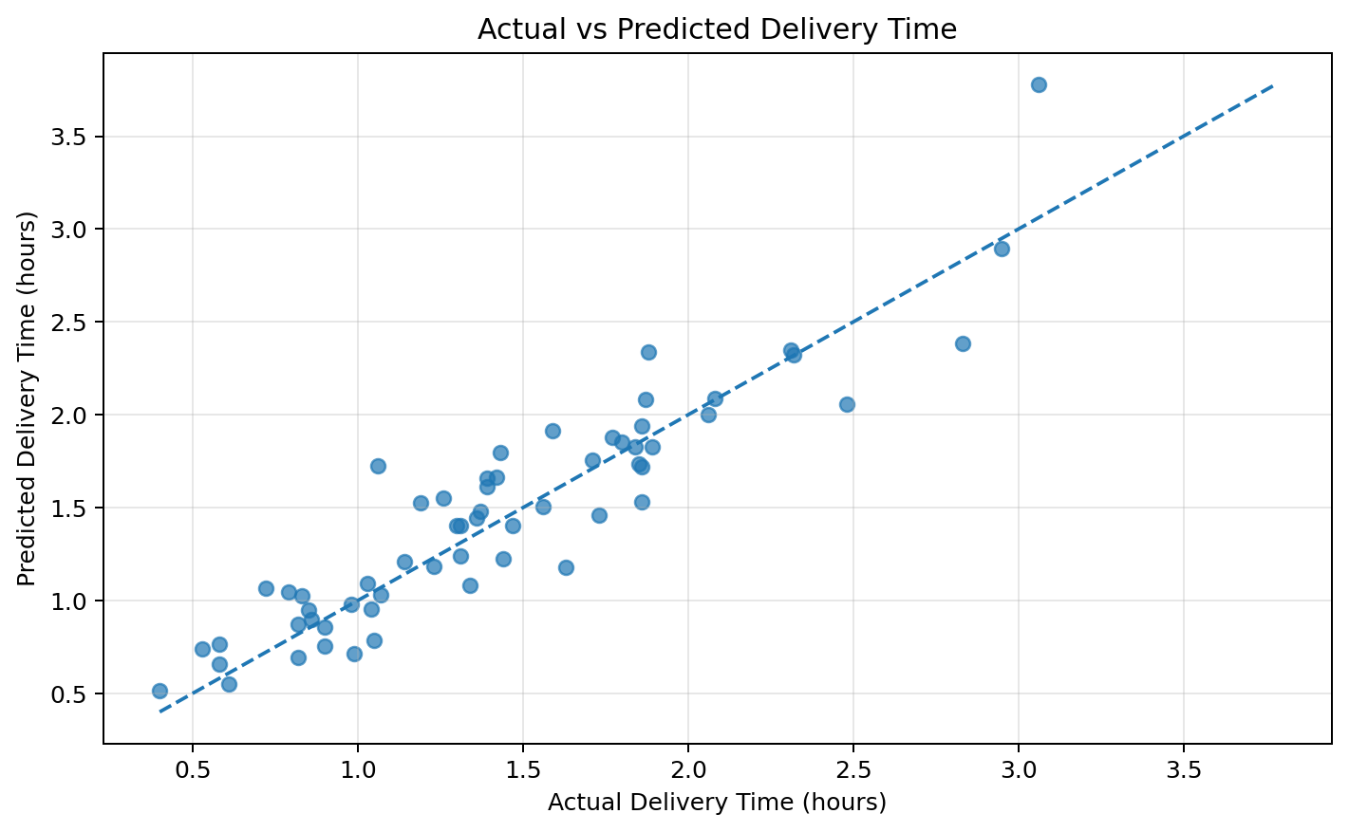
Interpretation: Points closer to the diagonal reference line represent more accurate predictions. The plot provides a direct visual comparison between actual and predicted delivery times.

10. Visualization 2: Prediction Residuals
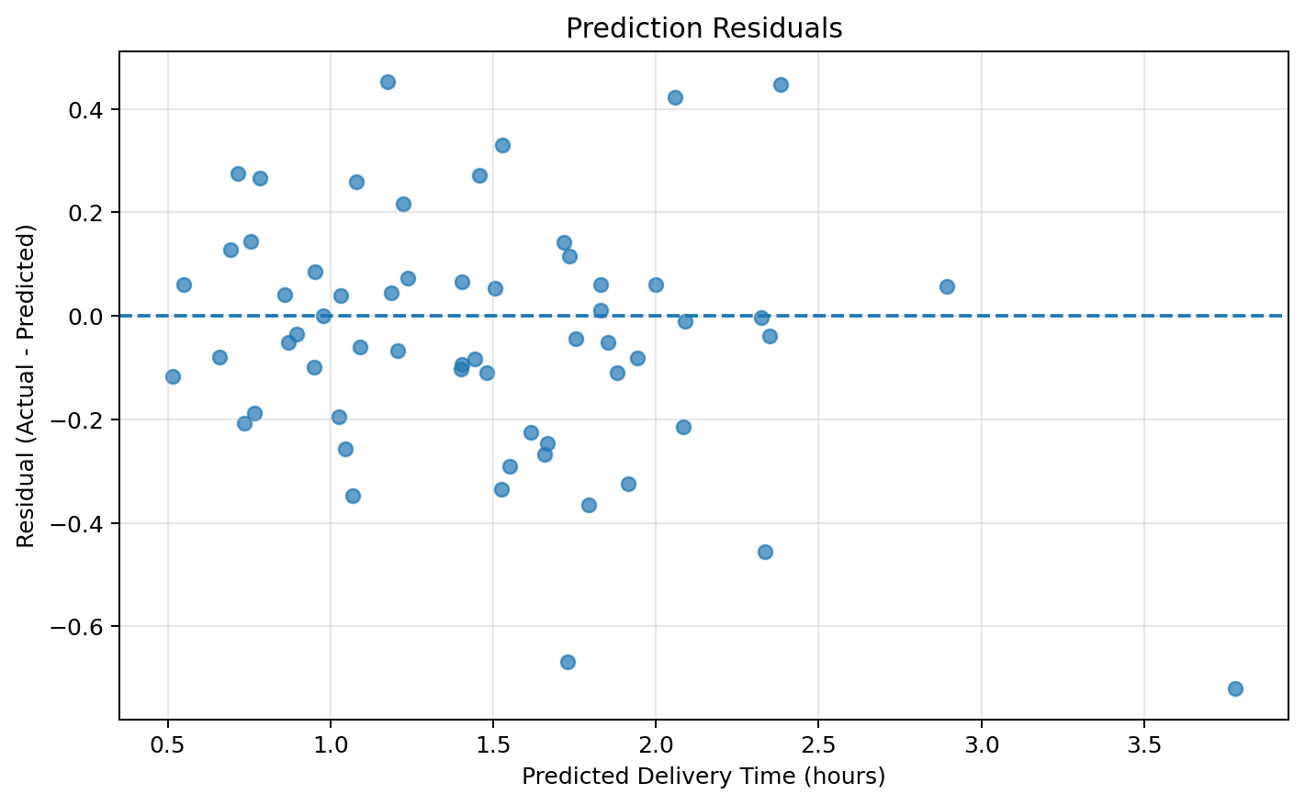
Interpretation: Residuals show the difference between actual and predicted delivery time. A relatively balanced spread around zero indicates that the model does not consistently overpredict or underpredict across the test observations.

11. Visualization 3: Model Comparison
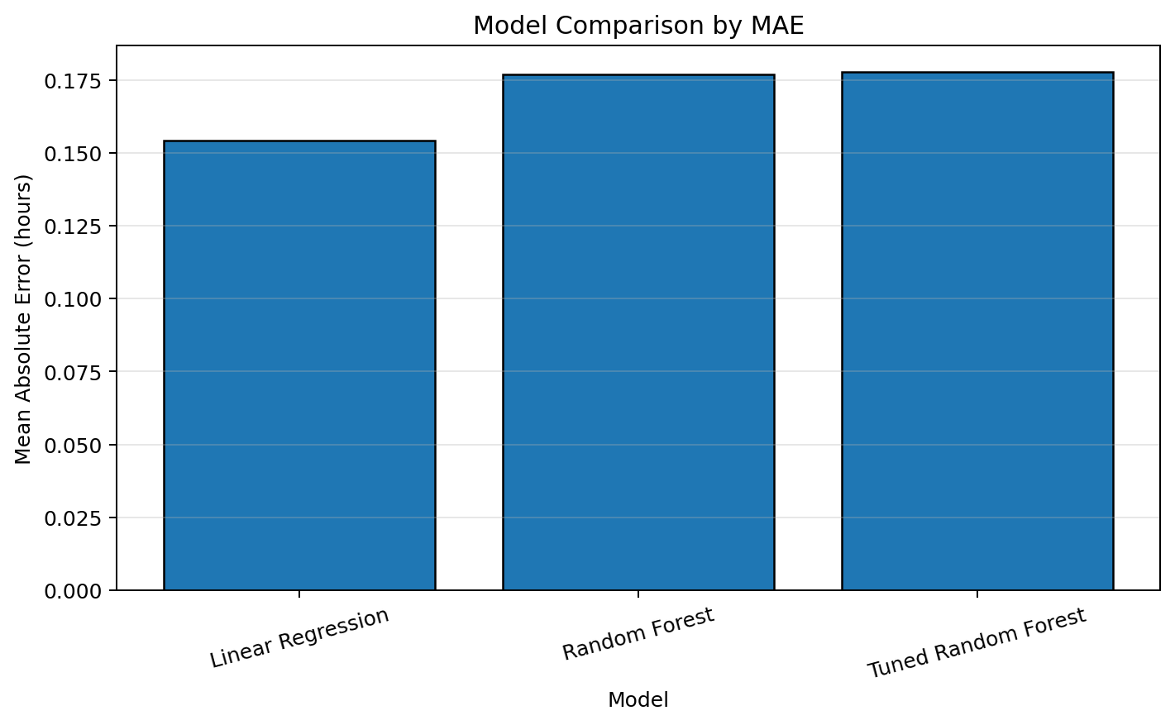
Interpretation: The chart compares the Mean Absolute Error of the three models. The model with the smallest bar has the lowest average prediction error and is preferred for this task.

12. Visualization 4: Feature Importance
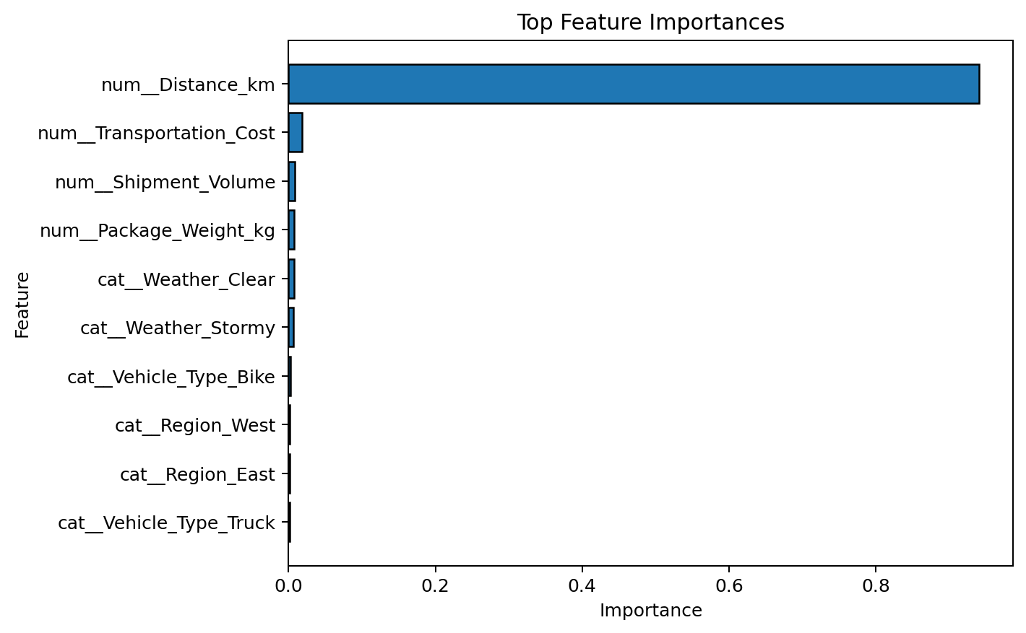
Interpretation: Feature importance shows which input variables contributed most to the Random Forest's predictions. These variables should receive particular attention when designing logistics improvements.

13. Optimization Strategies
- Route Optimization: Prioritize route optimization for shipments predicted to have high delivery times.
- Vehicle Allocation: Assign suitable vehicles based on distance, package weight, and shipment volume.
- Weather-Aware Planning: Add time buffers and alternative routes when adverse weather is expected.
- Risk-Based Prioritization: Flag shipments whose predicted delivery time is above the normal average.
- Regional Monitoring: Compare prediction patterns by region to identify recurring operational bottlenecks.
- Cost-Time Trade-off: Use predicted delivery time together with transportation cost to select efficient delivery plans.

14. Predictive Insights
The feature-importance analysis indicates that the model relies most heavily on a combination of num__Distance_km, num__Transportation_Cost, num__Shipment_Volume, num__Package_Weight_kg, cat__Weather_Clear. These variables can therefore be monitored when planning deliveries and identifying potential delays.
In the test set, approximately 40.0% of shipments were predicted to have delivery times at or above the overall average. These shipments can be treated as higher-risk cases for proactive monitoring.

15. Recommendations
- Create a predictive delivery-time dashboard for operations teams.
- Use model predictions to prioritize high-risk shipments before delays occur.
- Combine predictions with route and vehicle information to improve dispatch decisions.
- Use weather forecasts as an additional planning input.
- Retrain the model periodically when new real delivery records become available.
- Track MAE and RMSE over time to detect model performance degradation.
- For production use, validate the model on real historical data before making operational decisions.

16. Python Tools and Libraries Used
- Python – model development and analysis.
- Pandas – data loading and manipulation.
- NumPy – numerical calculations.
- Scikit-learn – preprocessing, regression models, cross-validation, hyperparameter tuning, and evaluation.
- Matplotlib – model performance and feature-importance visualizations.

17. Python Code
# Train-test split
X_train, X_test, y_train, y_test = train_test_split(
X, y, test_size=0.20, random_state=42
)
# Random Forest pipeline
rf_model = Pipeline([
("preprocessor", preprocessor),
("model", RandomForestRegressor(
n_estimators=200,
random_state=42
))
])
rf_model.fit(X_train, y_train)
predictions = rf_model.predict(X_test)
# Evaluation
mae = mean_absolute_error(y_test, predictions)
rmse = np.sqrt(mean_squared_error(y_test, predictions))
r2 = r2_score(y_test, predictions)
print("MAE:", mae)
print("RMSE:", rmse)
print("R2:", r2)
# Hyperparameter tuning
grid_search = GridSearchCV(
rf_model,
param_grid,
cv=5,
scoring="neg_mean_absolute_error",
n_jobs=-1
)
grid_search.fit(X_train, y_train)
best_model = grid_search.best_estimator__

18. Conclusion
This Week 4 project demonstrates the use of predictive modeling to estimate logistics delivery time and convert model results into operational optimization strategies. Linear Regression was used as a baseline and Random Forest was evaluated as a non-linear ensemble method. Model performance was measured using MAE, RMSE, and R², while five-fold cross-validation and hyperparameter tuning were used to improve reliability. The resulting predictions can support route planning, vehicle allocation, weather-aware scheduling, and proactive identification of high-risk deliveries. The approach provides a foundation for applying predictive analytics to real-world logistics operations.

