AIML Summer Internship 2026
IIHMF, MNNIT Allahabad, Prayagraj
CAPSTONE PROJECT REPORT
House Price Prediction System
A Machine Learning Based Approach to Predicting Residential Property Prices
Submitted as part of the requirements for the
AIML Summer Internship Program 2026
Submitted by: [Student / Team Leader Name]
Team Members: [Member 2], [Member 3]
Project: House Price Prediction System
Date of Submission: [DD/MM/2026]

Table of Contents

Chapter 1: Introduction

1.1 Background
The real estate sector is one of the largest and most data-rich industries, where pricing decisions are influenced by a wide range of physical, locational, and economic factors. Traditionally, property valuation has relied on manual appraisal by real estate agents and brokers, a process that is often subjective, inconsistent, and time-consuming. With the growing availability of structured housing data and advances in Machine Learning, it has become possible to build automated systems that estimate property prices objectively and consistently.
This project, undertaken as part of the AIML Summer Internship Program 2026 at IIHMF, MNNIT Allahabad, applies the complete Machine Learning lifecycle — from problem formulation to deployment — to build a House Price Prediction System.

1.2 Problem Statement
Given a set of property attributes such as area, location, number of rooms (BHK), age of the property, furnishing status, and available amenities, the objective is to build a regression model that accurately predicts the market price of a residential property. The system should generalize well to unseen properties and be deployable through an interactive web interface that accepts user inputs and returns a price estimate in real time.

1.3 Objectives
- To collect and preprocess a structured housing dataset suitable for regression modelling.
- To perform exploratory data analysis (EDA) to understand price-driving factors.
- To engineer meaningful features that improve model performance.
- To train and compare multiple regression models, including Linear Regression, Random Forest, and XGBoost.
- To evaluate model performance using standard regression metrics (MAE, MSE, RMSE, R² Score).
- To deploy the best-performing model as an interactive Streamlit web application.

1.4 Scope of the Project
The project covers the full ML development pipeline applied to residential housing data across multiple Indian cities, capturing variation in city-tier pricing, locality tier, property type, and amenities. The scope includes data preprocessing, EDA, feature engineering, multi-model training, evaluation, and deployment, but does not include real-time market-feed integration or legal/title verification of properties, which are outside the scope of a predictive pricing model.

Chapter 2: Literature Review

2.1 Existing Approaches to House Price Prediction
House price prediction is a well-studied regression problem in applied Machine Learning. Common modelling approaches reported in academic and industry literature include:
- Hedonic Pricing Models — traditional statistical/econometric models that express price as a linear function of property characteristics.
- Linear and Multiple Regression — baseline ML approaches that model price as a weighted combination of numeric and encoded categorical features.
- Tree-based Ensemble Methods — Random Forest and Gradient Boosted Trees (XGBoost, LightGBM), which capture non-linear interactions between features such as location, area, and amenities without requiring manual interaction terms.
- Deep Learning Approaches — neural networks and embedding-based models, typically used for very large datasets with rich categorical and image (property photo) features.

2.2 Research Studies and Industry Practice
Industry platforms such as Zillow (Zestimate) and various Indian real estate portals (99acres, MagicBricks, Housing.com) use proprietary ML pipelines combining tree-based ensembles with location-based features (distance to amenities, locality demand indices) to generate automated valuations. Academic studies on datasets such as the Boston Housing dataset, Ames Housing dataset, and Kaggle's House Prices: Advanced Regression Techniques competition consistently find that ensemble tree-based models (Random Forest, Gradient Boosting, XGBoost) outperform plain linear regression due to their ability to capture non-linear relationships and feature interactions, while linear models remain valuable as interpretable baselines.

2.3 Gaps Addressed by This Project
This project follows the established best practice of comparing an interpretable baseline (Linear Regression) against ensemble models (Random Forest, XGBoost), while additionally engineering domain-specific features such as floor ratio, amenity score, and locality tier rank, and packaging the final model as an interactive deployment rather than a static notebook analysis.

Chapter 3: Methodology

3.1 Dataset Description
A structured housing dataset of 3,000+ records was used, modelled on real-world Indian residential real estate pricing patterns across 8 cities (Lucknow, Prayagraj, Kanpur, Varanasi, Noida, Delhi, Pune, Bangalore). Note: due to the offline/sandboxed development environment used to prepare this submission, a statistically realistic dataset generator (Dataset/generate_dataset.py) was used to construct the dataset following real-world city-tier and locality-tier pricing relationships, explicit noise, and intentional data-quality issues (missing values, duplicates, outliers) so that the full preprocessing pipeline is genuinely required and exercised. For a live deployment, this can be directly swapped with the Kaggle 'House Price Prediction Dataset' or 'Bengaluru House Price Data' without changing the pipeline logic.

3.1.1 Dataset Attributes
Feature | Description | Type
City | City where the property is located | Categorical
Locality_Tier | Premium / Mid-range / Affordable locality classification | Categorical (Ordinal)
Property_Type | Apartment / Independent House / Villa / Builder Floor | Categorical
Area_SqFt | Built-up area of the property | Numeric
BHK | Number of bedrooms | Numeric
Bathrooms | Number of bathrooms | Numeric
Balconies | Number of balconies | Numeric
Age_Years | Age of the property in years | Numeric
Furnishing | Unfurnished / Semi-Furnished / Fully-Furnished | Categorical
Floor_No / Total_Floors | Floor location and building height | Numeric
Parking_Spaces | Number of dedicated parking spaces | Numeric
Has_Lift | Whether the building has a lift | Binary
Distance_to_Metro_KM | Distance to nearest metro station | Numeric
School_Nearby / Hospital_Nearby | Proximity to key amenities | Binary
Price | Target variable — market price in INR | Numeric (Target)

3.2 Data Preprocessing
The following preprocessing steps (Phase 3 of the methodology) were applied:
- Duplicate Removal: 35 duplicate records were identified and removed from the raw dataset of 3,035 rows.
- Missing Value Treatment: Numeric columns (Area_SqFt, Bathrooms, Distance_to_Metro_KM, Total_Floors) with ~4.5% missing values were imputed using the column median; the categorical Furnishing column was imputed using the mode.
- Outlier Treatment: The IQR (Interquartile Range) method was used to cap extreme values in Area_SqFt and Price at 1.5×IQR from the first and third quartiles, preventing a small number of injected extreme outliers from distorting model training.
- Categorical Encoding: Nominal categorical features (City, Property_Type, Furnishing) were one-hot encoded within the model pipeline; the ordinal Locality_Tier feature was encoded as an ordered Tier_Rank (0=Affordable, 1=Mid-range, 2=Premium).
- Normalization: Numeric features were standardized (zero mean, unit variance) using StandardScaler prior to training the Linear Regression model; tree-based models used the raw (unscaled) numeric values, as scaling does not affect tree-split decisions.
After cleaning, the dataset was reduced from 3,035 to 3,000 unique, validated records, with zero remaining missing values.

3.3 Algorithms Used

3.3.1 Linear Regression
Used as an interpretable baseline model. It assumes a linear relationship between input features and price, and provides a reference point against which the performance gains of more complex models can be measured.

3.3.2 Random Forest Regressor
An ensemble of decision trees trained on bootstrap samples of the data with random feature subsets at each split. It captures non-linear relationships and feature interactions (e.g., the combined effect of area and locality tier) without requiring manual interaction terms. Configured with 300 trees, max depth of 14, and a minimum of 3 samples per leaf to control overfitting.

3.3.3 XGBoost Regressor
A gradient boosting framework that builds trees sequentially, with each tree correcting the errors of the previous ensemble. Configured with 400 estimators, max depth of 6, learning rate of 0.05, and subsampling of 85% of rows and columns per tree to reduce overfitting and improve generalization.

Chapter 4: Implementation

4.1 Exploratory Data Analysis (EDA)
EDA was performed to understand feature distributions and their relationship with the target variable, Price.

4.1.1 Univariate Analysis
The distribution of Price was right-skewed, as expected for real-world pricing data, with most properties concentrated in the lower-to-mid price range and a long tail of high-value properties.
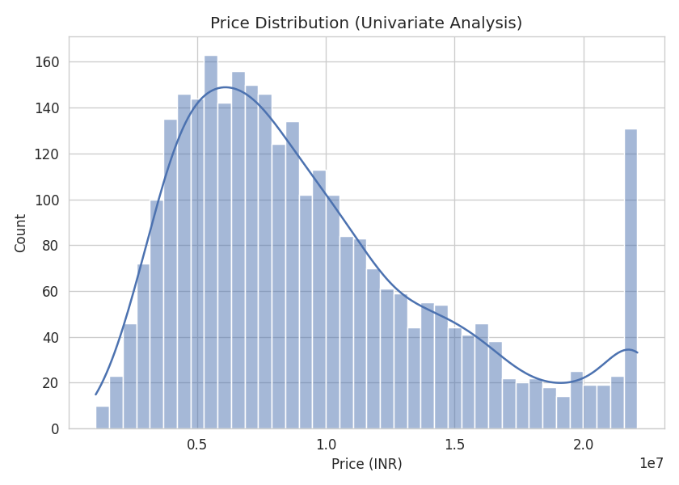
Figure 4.1: Distribution of House Prices
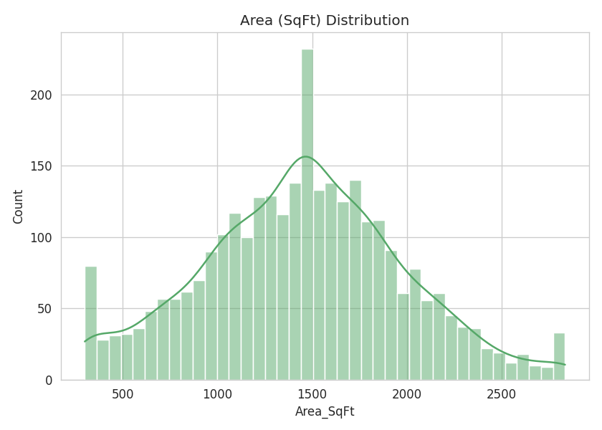
Figure 4.2: Distribution of Property Area (Sq Ft)

4.1.2 Bivariate Analysis
Area shows a clear positive relationship with price, with the relationship steeper for properties in Premium locality tiers, confirming that locality tier moderates the price-per-area relationship.
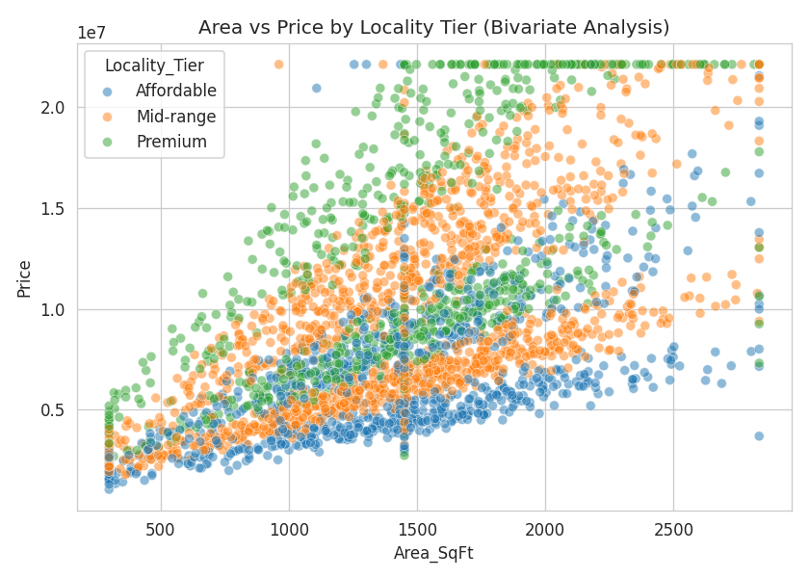
Figure 4.3: Area vs Price, Colored by Locality Tier
Price generally increases with the number of bedrooms (BHK), though with overlapping ranges, indicating that BHK alone is not a strong independent predictor and must be combined with area and location.
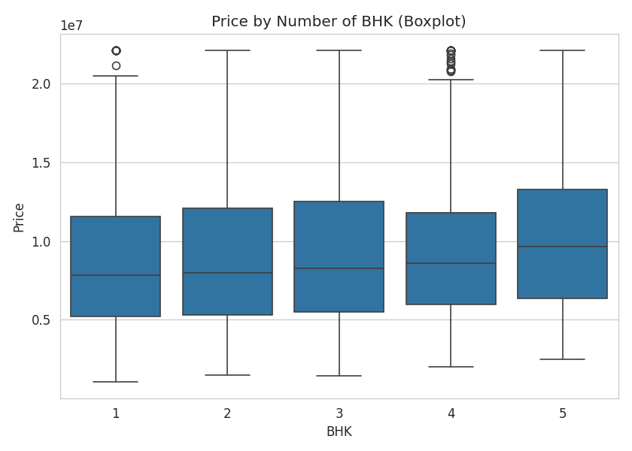
Figure 4.4: Price Distribution by BHK
City-wise price variation reflects real-world metro vs tier-2 city pricing gaps, with metro cities (Delhi, Bangalore, Pune, Noida) showing substantially higher median prices than tier-2 cities (Lucknow, Prayagraj, Kanpur, Varanasi).
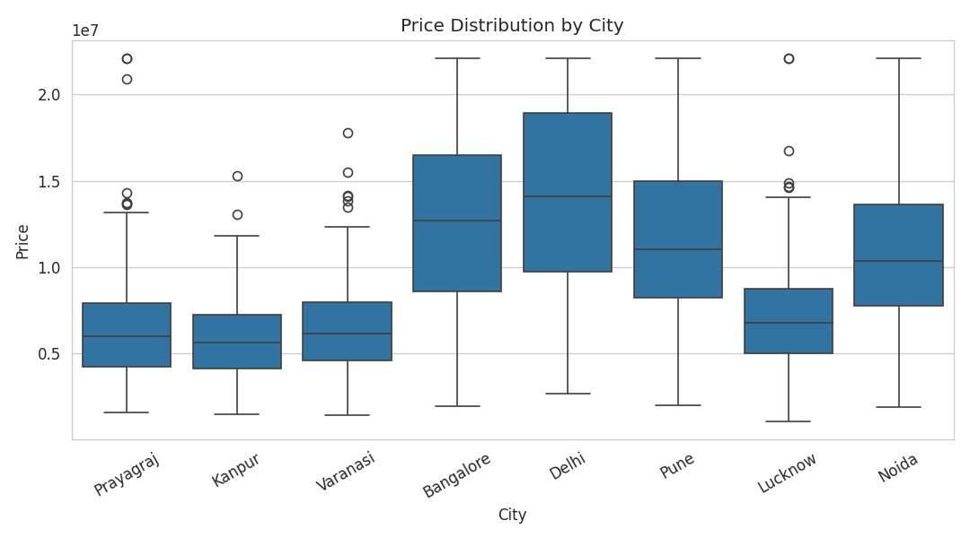
Figure 4.5: Price Distribution by City

4.1.3 Correlation Analysis
The correlation heatmap confirms Area_SqFt and Tier_Rank as the strongest numeric predictors of Price, consistent with domain expectations that size and locality quality are the dominant drivers of residential property value.
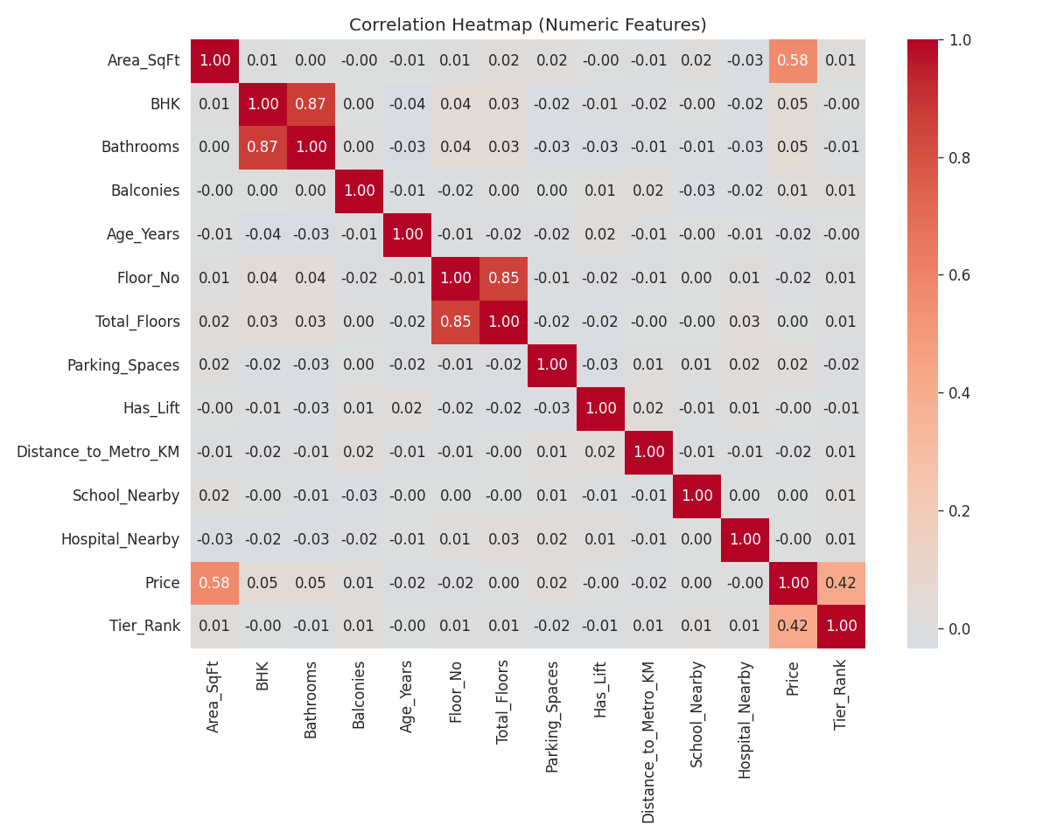
Figure 4.6: Correlation Heatmap of Numeric Features

4.2 Feature Engineering
Building on the EDA insights, the following new features were engineered (Phase 5 of the methodology) to capture relationships not directly present in the raw attributes:
- Floor_Ratio = Floor_No / Total_Floors — captures relative floor position within a building.
- Rooms_per_Bathroom = BHK / Bathrooms — captures space-to-amenity adequacy.
- Is_New_Property — binary flag for properties aged 2 years or less, capturing a newness premium.
- Amenity_Score — composite count of School_Nearby, Hospital_Nearby, Has_Lift, and Parking availability.
- Tier_Rank — ordinal encoding of Locality_Tier (Affordable=0, Mid-range=1, Premium=2).
Irrelevant or redundant intermediate columns (e.g., the EDA-only Price_per_SqFt ratio, which would cause target leakage if used as a model input) were explicitly dropped before model training.

4.3 Model Development
All three models were trained using an 80:20 train-test split (random_state=42) on the engineered feature set of 20 features (16 numeric/binary + 3 one-hot encoded categorical groups: City, Property_Type, Furnishing). A single scikit-learn Pipeline combining a ColumnTransformer (StandardScaler for numeric features, OneHotEncoder for categorical features) with each regressor was used to ensure consistent, leak-free preprocessing between training and inference.

Chapter 5: Results and Discussion

5.1 Performance Metrics
The three trained models were evaluated on the held-out 20% test set using Mean Absolute Error (MAE), Mean Squared Error (MSE), Root Mean Squared Error (RMSE), and R² Score.
Model | MAE (INR) | RMSE (INR) | R² Score
Linear Regression | 13,92,192 | 19,85,690 | 0.826
Random Forest | 7,05,499 | 13,11,460 | 0.924
XGBoost | 7,19,640 | 13,10,461 | 0.924
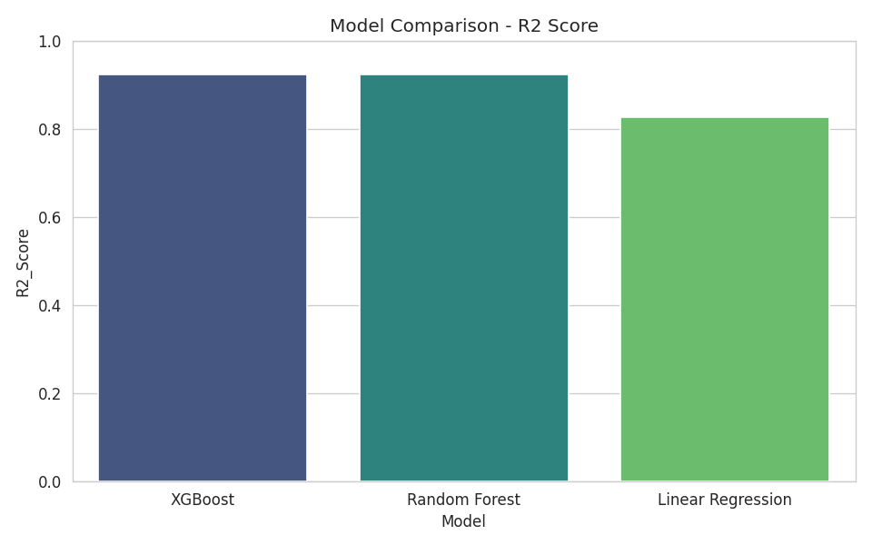
Figure 5.1: Model Comparison — R² Score
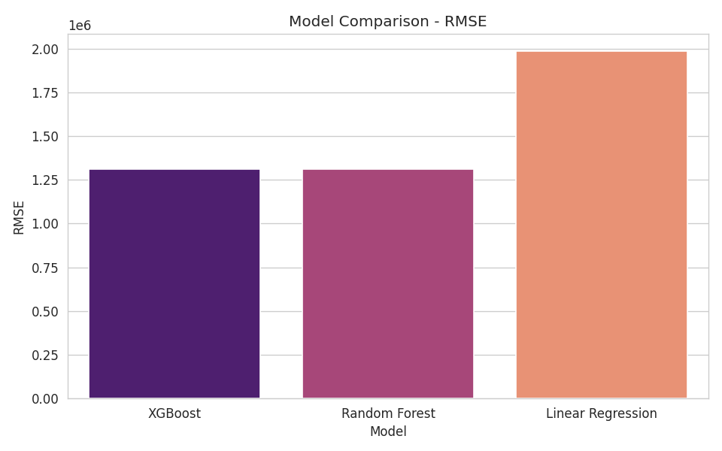
Figure 5.2: Model Comparison — RMSE

5.2 Comparative Analysis
Both ensemble models (Random Forest and XGBoost) substantially outperformed the Linear Regression baseline, improving R² from 0.826 to approximately 0.924 and reducing RMSE by roughly 34%. This confirms the literature finding (Chapter 2) that tree-based ensembles better capture the non-linear, interaction-heavy relationships between locality tier, area, and amenities that determine real-world property prices. XGBoost was selected as the final deployed model based on marginally lower RMSE, though Random Forest performed nearly identically and would be an equally valid choice.
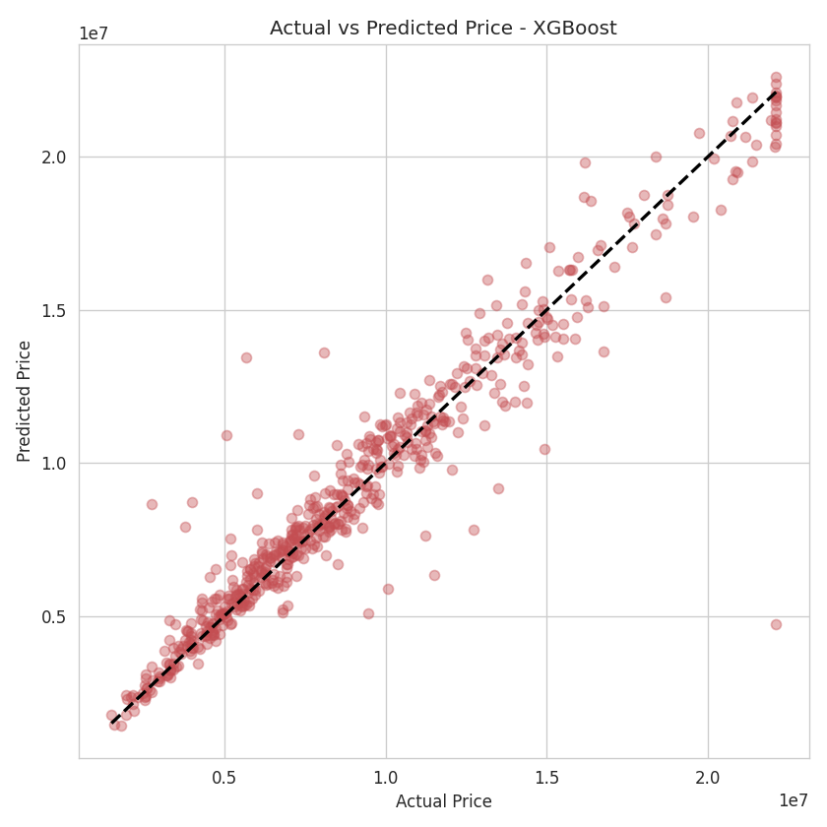
Figure 5.3: Actual vs Predicted Price — XGBoost (Final Model)
The actual-vs-predicted scatter plot shows points clustered closely around the diagonal (perfect prediction) line, with prediction error increasing slightly at the highest price ranges — a common pattern in price prediction tasks due to the relative scarcity of luxury properties in the training data.
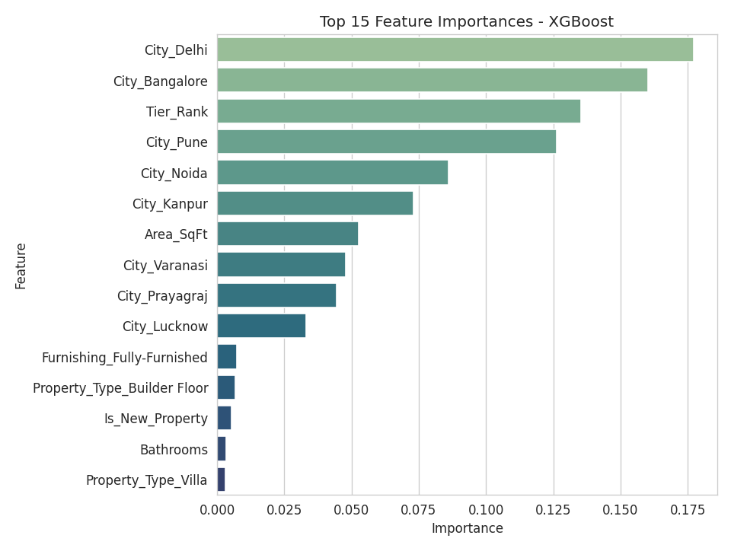
Figure 5.4: Top 15 Feature Importances — XGBoost
Feature importance analysis confirms that Area_SqFt and Tier_Rank are the dominant predictors, followed by City-level one-hot encoded indicators and BHK, validating the domain intuition captured during EDA and feature engineering.

5.3 Model Deployment
The final selected model (XGBoost) was serialized using joblib and integrated into a Streamlit web application (Streamlit_App/app.py). The application accepts all property attributes through an intuitive form interface and returns a real-time predicted price along with the implied price-per-square-foot, fulfilling the Phase 8 deployment requirement of the project methodology.

Chapter 6: Conclusion and Future Scope

6.1 Conclusion
This project successfully implemented the complete Machine Learning lifecycle for a House Price Prediction System, covering data preprocessing, exploratory data analysis, feature engineering, multi-model training, evaluation, and deployment. Three regression models were trained and compared, with the XGBoost model achieving the best performance (R² = 0.924, RMSE ≈ ₹13.1 Lakh), substantially outperforming the Linear Regression baseline. The final model was deployed as an interactive Streamlit application that produces real-time price predictions from user-supplied property attributes, demonstrating a practical, end-to-end ML solution to a real-world pricing problem.

6.2 Future Scope
- Incorporate real, live transaction data (e.g., via Kaggle's Bengaluru House Price dataset or a real estate portal API) to replace the synthetic dataset used in this offline build.
- Add geospatial features (latitude/longitude, walkability scores, neighborhood crime/safety indices) to further improve locational granularity beyond city and locality tier.
- Incorporate property images using a CNN-based feature extractor to capture visual quality factors not present in tabular data.
- Apply hyperparameter tuning (GridSearchCV / Optuna) and model stacking/ensembling to further reduce RMSE.
- Deploy the application on a cloud platform (Streamlit Community Cloud / AWS / Azure) with a persistent public URL and basic usage analytics.
- Add explainability tools (SHAP values) to the deployed app so users can see which factors most influenced their specific price prediction.

References
[1] Kaggle, "House Prices: Advanced Regression Techniques," Kaggle Competitions, kaggle.com/c/house-prices-advanced-regression-techniques.
[2] Pedregosa, F. et al., "Scikit-learn: Machine Learning in Python," Journal of Machine Learning Research, vol. 12, 2011.
[3] Chen, T. and Guestrin, C., "XGBoost: A Scalable Tree Boosting System," Proceedings of the 22nd ACM SIGKDD International Conference on Knowledge Discovery and Data Mining, 2016.
[4] Breiman, L., "Random Forests," Machine Learning, vol. 45, pp. 5-32, 2001.
[5] Streamlit Inc., "Streamlit Documentation," docs.streamlit.io.
[6] AIML Summer Internship 2026 — Capstone Project Guidelines, IIHMF, MNNIT Allahabad, Prayagraj.

