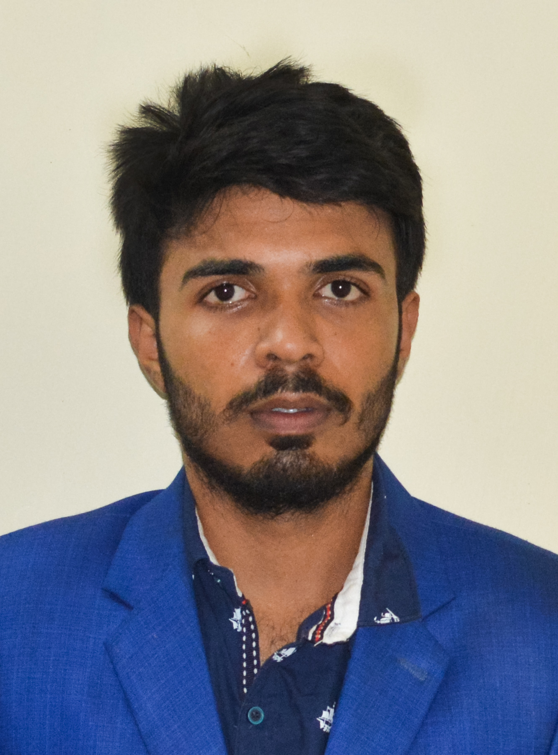
CURRICULUM VITAE
OF
SAYMAN RABBI

MAILING ADDRESS:
Rangpur,CO Bazar,Rangpur
Cell: 01799874356
Email: mdrabbi.asm@gmail.com

CAREER OBJECTIVE:

I am hard working and energetic. I believe that hard working and honesty is the key of success in life. I am willing to build up my career in such a profession where I can utilize my qualities and develop my career.

EDUCATION QUALIFICATION:
B.S.C in CSE (Running student)

Institute : Bangladesh University.
Batch no : 57.
Semister : 3rd semister

Higher Secondary Certificate(H.S.C)

Institute : Rangpur government college
Group : Science
Result : 3.75
Board : Dinajpur
Passing Year : 2018

Secondary School Certificate (S.S.C)

Institute : Border Guard Publick School & college
Group : Science
Result : GPA-5
Board : Dinajpur
Passing Year : 2016

Language Proficiency:

Language | Reading | Writing | Speaking | Listening
Bengali | Excellent | Excellent | Excellent | Excellent
English | Excellent | Excellent | Excellent | Excellent

work experince :

Complet Computer Course, Data Entry , Microsoft excel , Power Point
Website Developer ( Running Course).

Personal attributes:

- Friendly & Communication.
- I behave in maintaining high standard of work
- I am willing to learn and execute new techniques
- Good Team Work Positive Approach
- Always ready to cope up with new and challenging environment
PERSONAL INFORMATION:
- Name : Md. Sayman Rabbi
- Father’s Name : Md. Abul Kalam Azad
- Mother’s Name : Most. Samsun Nahar
- Permanent Address : Rangpur Sadar, Rangpur

- Date of Birth : 3/01/2001
- Gender : Male
- Religion : Islam
- Nationality : Bangladeshi (By Birth)
- Marital Status : Unmarried
- Height : 5'-7"
- Blood Group : B (+)^{ve}

DECLARATION:

I have an ability to work at high pace on one’s own initiative, I am also the undersigned hereby declare that I will be responsible for any wrong information provided here.

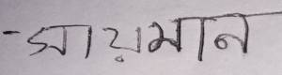

(Md. SAYMAN RABBI)

