**PERSONS TABLE**

1. **CREATE DATABASE**

create database DBMS2025;

1. **DISPLAY DATABASES**

SHOW DATABASES;

1. **USE DATABASE**

USE DBMS2025;

1. **CREATE TABLE**

CREATE TABLE Persons

(

P_Id int, LastName varchar(255),

FirstName varchar(255),

Address varchar(255),

City varchar(255)

);

1. **Display tables**

Show tables.

1. **INSERT VALUES**

INSERT VALUES TO TABLES:

METHOD 1: INSERT INTO PERSONS VALUES(P_ID,LASTNAME,FIRSTNAME,ADDRESS,CITY)VALUES (1,’SHARMA’,’RAJESH’,’123 MG ROAD’,’BANGALORE’);

METHOD 2: INSERT INTO PERSONS VALUES(2,’VERMA’,’ANITHA’,456 GANDHINAGAR’.’MUMBAI’);

METHOD 3:

1. **DISPLAY CONTENT OF TABLE**

select * from persons;

1. **UPDATE ADDRESS TO “420 VIJAYANAGAR” FOR A PERSON WHOSE FIRST NAME IS AMIT**

update persons set address="420 Vijayanagar" where firstname="amit";



1. **DELETE A ROW WHOSE LASTNAME IS BOSE**

DELETE FROM Persons WHERE LastName="bose";



1. **DISPLAY ONLY LASTNAME AND FIRSTNAME FROM PERSONS**

SELECT LastName,FirstName FROM Persons;

1. **DISPLAY DISTINCT CITIES**

SELECT DISTINCT City FROM Persons ;

1. **DISPLAY DETAILS OF PEOPLE WHO ARE FROM BANGALORE**

SELECT * FROM Persons WHERE City='Bangalore';

1. **DISPLAY DETAIL OF PEOPLE WHOSE FIRST NAME IS “NEHA”**

SELECT * FROM Persons WHERE FirstName='neha';

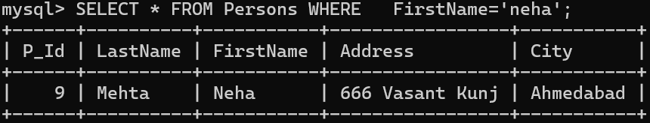

**14. DISPLAY DETAIL OF PEOPLE WHOSE FIRST NAME IS “PRIYA” AND LASTNAME IS “NAIR”**

SELECT * FROM Persons WHERE FirstName='Priya' AND LastName='nair' ;

**15. DISPLAY DETAILS OF PEOPLE WHOSE FIRST NAME IS “SNEHA” OR “SURESH”**

SELECT * FROM Persons WHERE FirstName='sneha' OR FirstName='suresh';

**16. DISPLAY DETAIL OF PEOPLE WHOSE LASTNAME IS “KUMAR” AND FIRSTNAME IS “SUNIL”OR “SNEHA”**

SELECT * FROM Persons WHERE LastName='Kumar' AND (FirstName='sunil' OR FirstName='sneha’);



**17. ARRANGE IN ASCENDING ORDER OF LASTNAMES**

SELECT * FROM Persons ORDER BY LastName ;

**18.ARRANGE IN DESCENDING ORDER OF LASTNAME**

SELECT * FROM Persons ORDER BY LastName DESC;

**19.DISPLAY THE COUNT OF CITIES**

select count(city) from persons;

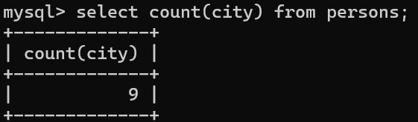

**20. DISPLAY THE COUNT DISTINCT CITIES**

select count(distinct city) from persons;

**21. DISPLAY FIRST THREE RECORDS**

select * from persons limit 3;

**22. DISPLAY DETAIL OF PEOPLE WHO STAY IN CITY WHICH STARTS WITH “B”**

SELECT * FROM Persons WHERE City LIKE 'B%';

**23. DISPLAY DETAIL OF PEOPLE WHO STAY IN CITY WHICH ENDS WITH “R”**

SELECT * FROM Persons WHERE City LIKE '%r';

**24. DISPLAY DETAIL OF PEOPLE WHO STAY IN CITY WHICH CONTAINS “AB”**

SELECT * FROM Persons WHERE City LIKE '%ab%';

**25. DISPLAY DETAIL OF PEOPLE WHO STAY IN CITY WHICH DOES NOT CONTAIN “AB”**

SELECT * FROM Persons WHERE City NOT LIKE '%ab%';

**26. DISPLAY DETAIL OF PEOPLE WHOSE LASTNAME IS THREE LETTERS AND ENDS WITH “AS”**

SELECT * FROM Persons WHERE LastName LIKE '_as';

**27. DISPLAY DETAIL OF PEOPLE WHOSE FIRSTNAME IS FOUR LETTERS HAVING FIRST AND THIRD LETTER AS N AND H.**

SELECT * FROM Persons WHERE FirstName LIKE 'N_H_';

**28. USE IN KEYWORD AND DISPLAY DETAILS OF PEOPLE WHOSE LASTNAME IS EITHER “SHARMA” OR “VERMA”.**

SELECT * FROM Persons WHERE LastName IN ('SHARMA’,'VERMA');

**29. ADD A NEW COLUMN CALLED AS AGE**

Alter table persons add column age(30);

**30. UPDATE THE VALUE OF AGE TO 21 FOR ALL**

Update persons set age=21;

**31. UPDATE THE AGE AS 18 TO PEOPLE WHO STAY IN BANGALORE**

Update persons set age=18 where city=”Bengaluru”

**32. LIST THE PERSONS NAME WHOSE PID IS BETWEEN 3 AND 6.**

SELECT FIRSTNAME FROM PERSONS WHERE P_ID BETWEEN 3 AND 6;

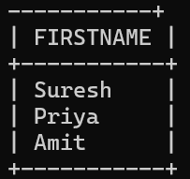

**33. DISPLAY THE FIRSTNAME OF PEOPLE WHOSE LASTNAME IS BETWEEN A AND M.**

SELECT FIRSTNAME FROM PERSONS WHERE LASTNAME BETWEEN 'A' AND 'M';

**34. DISPLAY THE FIRSTNAME WHERE LASTNAME IS NOT BETWEEN A AND M.**

SELECT FIRSTNAME FROM PERSONS WHERE LASTNAME NOT BETWEEN

'A' AND 'M';

**35. DISPLAY THE FIRSTNAME FROM PERSONS WHOSE LASTNAME BETWEEN ‘GUPTA’ AND ‘MEHTA’**

SELECT FIRSTNAME FROM PERSONS WHERE LASTNAME BETWEEN 'GUPTA' AND 'MEHTA';

**36. DISPLAY THE FIRSTNAME FROM PERSONS WHOSE LASTNAME IS NOT BETWEEN 'GUPTA' AND 'MEHTA'**

SELECT FIRSTNAME FROM PERSONS WHERE LASTNAME NOT BETWEEN

'GUPTA' AND 'MEHTA';

