Final CPIT-210
First question: computer prototype micro program (lecture 16)
Second question: cash in direct git the line and the tag and then choices hit or miss
Third question: I/O with interepet and without (lecture 18)
Forth question: the doctor give you mathematical equation and you git it in 3- address , 2-address , and 1-address
Fifth question: about procedure call
Sixth and last question is about program execution.

CPIT-210 FINAL

First question: computer prototype Micro Program just like this
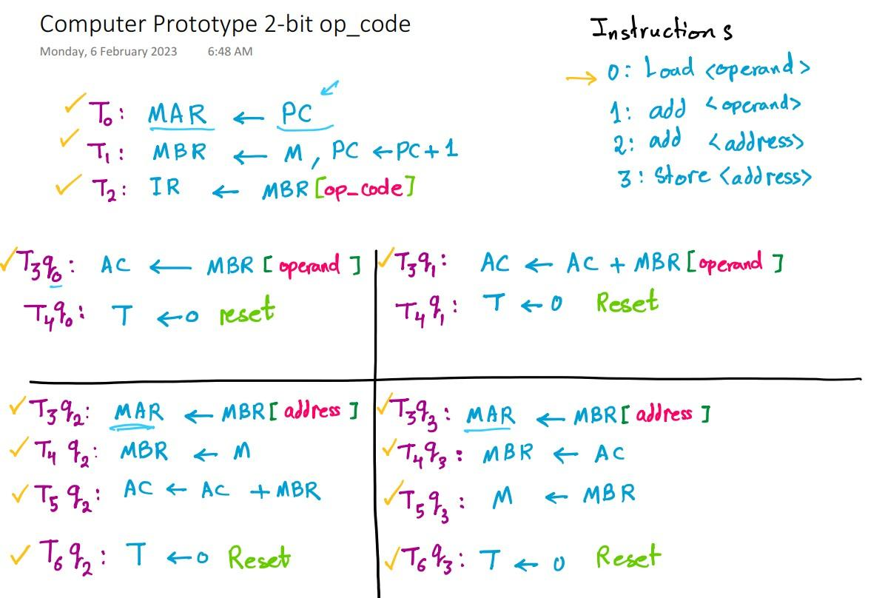

Second Question:

Third Question: Computer I/O and the sequence of executing and the time for the executing
One without interrupt and one more time with interrupt. An example in Lecture 18

Forth Question: you were given an mathematical equation and you will solve it using 3-address, 2-address, and 1-address – All of them-
An example is Lecture 22

Fifth Question: procedure call using stack and the state of the stack after every call and return. Almost the same as the example is Lecture 22

Sixth Question: this question is about program executing and the state of the memory after every call and instructions. Example in chapter 3 (Buses-cust)
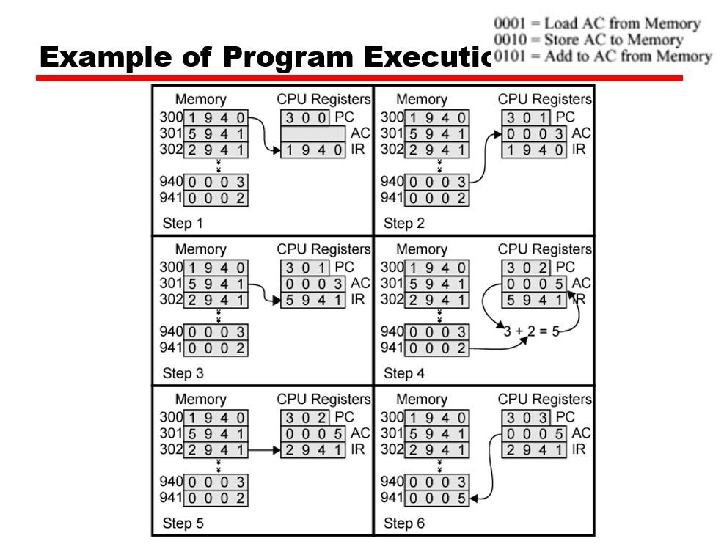

credit: Moath

