Computer Organization & Architecture
Homework
………………………………………………………………………………………………………
Question 1:
Given the program execution between microprocessor and memory below with 6 steps. the step 1 is done. You are demanded to finalize the other 5 steps.
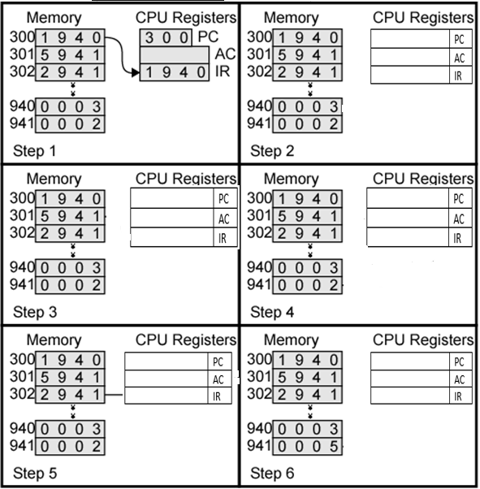

Question 2: Write a Code to calculate the following expression for address machine. [3 Marks]

X = ((E/F) * C) / ((A*B +D) -G)
Using: Two - address machines

Answer :

Two - address machines | Comments

Question 3: Read properly the table below of Addressing Modes and match Mode by the correct Algorithm by adding numbers N (1,2….7) + suitable Character (A, B…. G):
Mode | Match Mode with correct Algorithm Number | Algorithm
- Immediate | 1+………… | - LA=(PC)+A
- Register operand | 2+………… | - LA=(SR)+(B)
- Displacement | 3+………... | - LA=(SR)+(I)*S+A
- Base | 4+………… | - LA=(SR)+(I)*S+(B)+A
- Base with displacement | 5+…….….. | - LA=(SR)+(B)+A
- Scaled index with displacement | 6+…….….. | - Operand=A
- Base with index and displacement | 7+…………. | - LA=(SR)+A
- Base with scaled index and displacement | 8+………… | - LA=R
- Relative | 9+…………. | - LA=(SR)+(B)+(I)+A

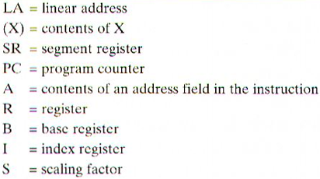

Question 4: – Direct Mapping
A computer system uses 32-bit memory addresses. It has a 4K-byte cache organized in a Direct-mapped manner with 64 bytes per cache block. Assume that the size of each memory word is 1 byte
- Calculate the number of bits in each: Tag, Block, Word fields of the memory address

- Indicate the Physical Address split [Tag, set number, Block offset(word)] of the memory data : AFF2

Tag | Set number | Block offset (Word)

Question 5: - Associative Mapping
Assume a processor using 8-ways set Associative Mapping having a Byte addressable main memory size: 512 MB , a block size 128 byte with Tag bits =11 a cache size = 1MB and a Block size equal 256 B
For such system calculate the following:
Physical address bits :

- Using Block size to calculate block offset

- Number of main memory blocks

- Number of sets

- Number of lines

- Tag directory Size

- Physical Address split [Tag, set number, Block offset(word)]
Tag | Set number | Block offset (Word)

- Cache size :

Question 6: Finalize the given addressing mode table. You are asked to fill the Effective address, the content address and then, explain the scene field.
