Faculty of Computing and Information Technology
King AbdulAziz University
Ministry of Higher Education
Kingdom of Saudi Arabia
كلية الحاسبات وتقنية المعلومات
جامعة الملك عبد العزيز
وزارة التعليم العالي
المملكة العربية السعودية
CPIT 260 – Lab 3

Name: ID:

For this lab, you are required to install and login into the Linux system. Therefore, take snapshoots only for your answers to the exercises mentioned in the lab experiment

Lab 3: File Contents
Objective: Familiarize with Linux environment, basic commands, and navigation.
- Task 1: Display file contents
  - Use cat to concatenate file contents and display on terminal.
  - Use more to display pages of the file.
  - Use less to display
  - Use Head to display file from the beginning.
  - Use Tail to display file from the end
- Task 2: Search file contents
  - Use grep command
  - Use diff command

Displaying the contents of a file on the screen

clear (clear screen)
Before you start the next section, you may like to clear the terminal window of the previous commands so the output of the following commands can be clearly understood.

At the prompt, type
clear

This will clear all text and leave you with the prompt at the top of the window.

cat (concatenate)
The command cat can be used to display 1the contents of a file on the screen. Type:
cat science.txt

As you can see, the file is longer than than the size of the window, so it scrolls past making it unreadable.

less
The command less writes the contents of a file onto the screen a page at a time. Type
less science.txt

Press the space bar if you want to see another page, type q if you want to quit reading. As you can see, less is used in preference to cat for long files.

head
The head command writes the first ten lines of a file to the screen. First clear the screen then type
head science.txt

Then type
head -5 science.txt

What difference did the -5 do to the head command?

tail
The tail command writes the last ten lines of a file to the screen. Clear the screen and type
tail science.txt

Exercise 3a:

Display content of file passwd under the /etc directory.

What is the purpose of the ctrl Q and ctrl s keys?

Display only the first 15 lines in the passwd file

Display only the last 15 lines in the passwd file

Searching the contents of a file

Simple searching using less
Using less, you can search though a text file for a keyword (pattern). For example, to search through science.txt for the word 'science', type
less science.txt

then, still in less (i.e. don't press q to quit), type a forward slash (/) followed by the word to search for, e.g.
/science

As you can see, less finds and highlights the keyword. Type n to search for the next occurrence of the word.

grep
grep is one of many standard UNIX utilities. It searches files for specified words or patterns. First clear the screen, then type
grep science science.txt

As you can see, grep has printed out each line that contains the word science. Or has it?

Try typing
grep Science science.txt

The grep command is case sensitive; it distinguishes between Science and science. To ignore upper/lower case distinctions, use the -i option, i.e. type
grep -i science science.txt
Often when there is a lot of text it is useful to highlight the matches (this is a default setting on ALICE / SPECTRE now but may not be on other systems)
grep --color -i science science.txt

To search for a phrase or pattern, you must enclose it in single quotes (the apostrophe symbol). For example to search for the phrase spinning top, type
grep -i 'spinning top' science.txt

Some of the other options of grep are:

-v display those lines that do NOT match
-n precede each matching line with the line number
-c print only the total count of matched lines

Try some of them and see the different results. Don't forget, you can use more than one option at a time, for example, the number of lines without the words science or Science is
grep -ivc science science.txt

wc (word count)
A handy little utility is the wc command, short for word count. To do a word count on
science.txt, type
wc -w science.txt

To find out how many lines the file has, type
wc -l science.txt

To find out how many characters the file has, type
wc -m science.txt

Exercise 3b:

Display those users in the /etc/passwd who has /bin/bash as login shell.

- How can you count the number of these users found above?

2.3 diff Default Output
The following are instructions for interpreting the default diff output:
- Lines starting with <. Refers to the content in the first file.
- Lines starting with >. Refers to the content in the second file.
- Line numbers. Correspond to the first file.
- A symbol. Symbols indicate how the first file needs to be edited to match the second file. The output displays:
  - a (add)
  - c (change)
  - d (delete)
- Line numbers corresponding to the second file.
example1.txt | example2.txt
Apple  Orange  Banana  Watermelon  Chery | Orange  Peach  Apple  Banana  Melon  Cherry

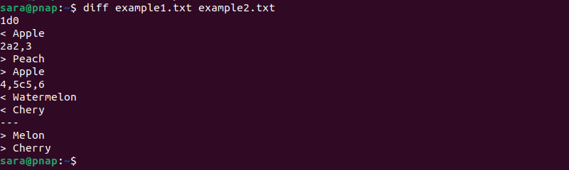
The output lists instructions on how to modify the first file to have the same content as in example2.txt.
The following is the output explanation for our sample files:
- 1d0. The first line (1) from the first file should be deleted (d). If not, it appears in line 0 in the second file.
- < Apple. The content you need to delete (as referred to with 1d0).
- 2a2,3. In line 2 of the first file, add (a) lines 2 and 3 (2,3) from the second file.
- > Peach, > Apple. The content you need to add (as referred to with 2a2,3).
- 4c5. The fourth line (4) from the first file should be changed (c) to the fifth line (5) from the second file.
- < Watermelon. The content you need to change.
- > Melon. What you need to change it to.
Exercise 3c:
- Compare the files with the comm command
Summary

cat file | Display or concatenate a file
less file | display a file a page at a time
head file | display the first few lines of a file
tail file | display the last few lines of a file
grep 'keyword' file | search a file for keywords
Diff file1 files2 | Compare files

