Faculty of Computing and Information Technology
King AbdulAziz University
Ministry of Higher Education
Kingdom of Saudi Arabia
كلية الحاسبات وتقنية المعلومات
جامعة الملك عبد العزيز
وزارة التعليم العالي
المملكة العربية السعودية
CPIT 260 – Lab 5

Name: ID:

For this lab, you are required to install and login into the Linux system. Therefore, take snapshoots only for your answers to the exercises mentioned in the lab experiment

Lab 5: Files name matching
Objective: practice the substitute matching symbols for file and directory names ..
- Task 1: Substitute symbols
  - Wild characters.
  - * symbol
  - ? symbol
  - [ ] symbols.
- Task 2: File types
  - Use the file command
  - Learn long listing of the ls command.

Wildcards

The characters *, ?, and [ ]
- matches everything
- ? matches any single character
- [ ] matches any of the letters or numbers, or a range of letters or numbers inside the brackets
BASH expands the wildcards before the command is run. The character * will match against none or more character(s) in a file (or directory) name. For example, in your unixstuff directory, type
ls list*

This will list all files in the current directory starting with list....

Try typing
ls *list

This will list all files in the current directory ending with list

The character ? will match exactly one character. So ls ?ouse will match files like
house and mouse, but not grouse. Try typing
ls ?list ls list?

If you need to match a limit number of patterns you can use {pattern1,pattern2,etc}
ls list{1,2}

This can be used with most commands:
mkdir newdir{1,2,3,4,5}

The previous command would create 5 new directories
ls reda[1-3]

Will match all files in current directory which starts with the string reda and followed by 1 or 2 or 3 only. Like reda1 reda2c reda311122 but never reda4c or redasalama

Exercise 5a:

Explain the following commands and give examples of its expected output

$ ls *.log

$ ls armed*

$ ls s[0-9]*

$ ls s[0-9][0-9]_*

$ ls [a-z][0-9][0-9]???reda

$ ls s?mohamed

Filename conventions
We should note here that a directory is merely a special type of file. So, the rules and conventions for naming files apply also to directories.

In naming files, characters with special meanings such as / * & % , should be avoided. Also, avoid using spaces within names. The safest way to name a file is to use only alphanumeric characters, that is, letters and numbers, together with _ (underscore) and . (dot).

File names conventionally start with a lower-case letter and may end with a dot followed by a group of letters indicating the contents of the file. For example, all files consisting of C code may be named with the ending .c, for example, prog1.c. Then in order to list all files containing C code in your home directory, you need only type ls
*.c in that directory.

What is that file?

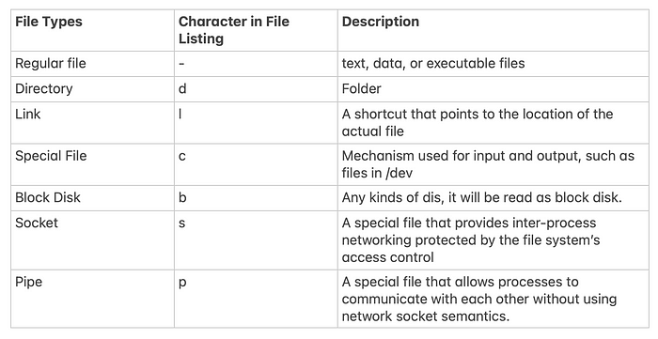

Using File

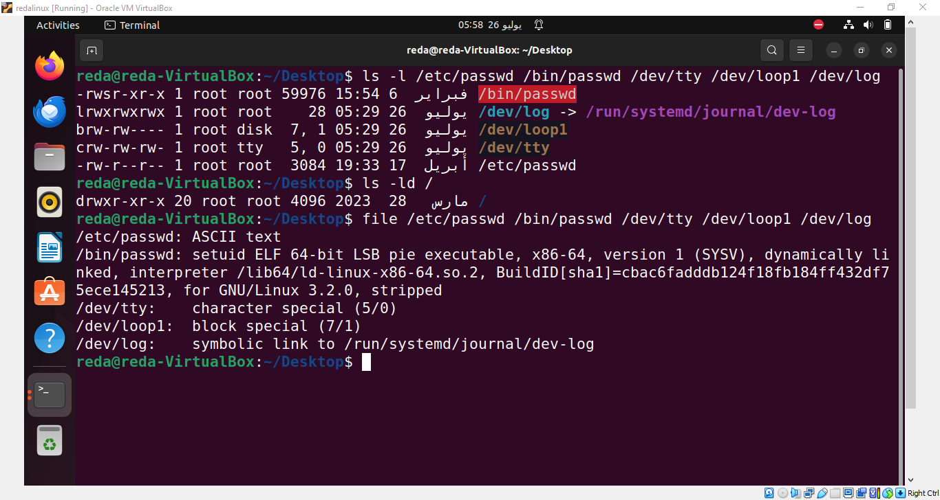

Exercise 5b:

Check some file types of your own choice and put their names and types here.
Summary

* | match any number of characters
? | match one character
man command | read the online manual page for a command
whatis command | brief description of a command
apropos keyword | match commands with keyword in their man pages
file | Find file type

