Faculty of Computing and Information Technology
King AbdulAziz University
Ministry of Higher Education
Kingdom of Saudi Arabia
كلية الحاسبات وتقنية المعلومات
جامعة الملك عبد العزيز
وزارة التعليم العالي
المملكة العربية السعودية
CPIT 260 – Lab 6

Name: ID:

For this lab, you are required to install and login into the Linux system. Therefore, take snapshoots only for your answers to the exercises mentioned in the lab experiment

Lab 6: File Ownership and Access Permissions
Objective: Understand Linux file system file access permissions.
- Task 1: File Permissions
  - Use Ls -l to determine file attributes (type, owner, group, dates, size..etc
  - Use chmod to change file permissions (e.g., make a file executable).
  - Use Umask to change file ownership.

Viewing file and directory permissions
In your unixstuff directory, type
ls -l

You will see that you now get lots of details about the contents of your directory, similar to the example below.


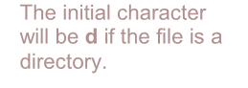


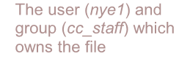


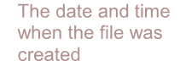

The initial character will be d if the file is a directory.
The user (nye1) and group (cc_staff) which owns the file
The date and time when the file was created
-rwxrw-r—- 1 nye1 cc_staff 700 2008-07-27 20:45 file1

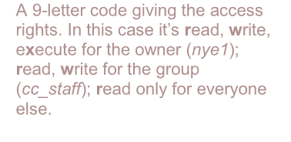


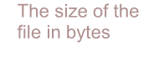


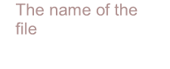


A 9-letter code giving the access rights. In this case it’s read, write, execute for the owner (nye1); read, write for the group (cc_staff); read only for everyone else.

The size of the file in bytes

The name of the file

Each file (and directory) has associated access rights, which may be found by typing ls -l.

In the left-hand column is a 10-symbol string consisting of the symbols d, r, w, x, -, and, occasionally, s or S. If d is present, it will be at the left hand end of the string, and indicates a directory: otherwise - will usually be the starting symbol of the string, indicating a normal file.

The 9 remaining symbols indicate the permissions, or access rights, and are taken as three groups of 3.

- The left group of 3 gives the file permissions for the user that owns the file (or directory) (nye1 in the above example);
- The middle group gives the permissions for the group of people to whom the file (or directory) belongs (cc_staff in the above example);

- The rightmost group gives the permissions for everyone else.

The symbols r, w, etc., have slightly different meanings depending on whether they refer to a simple file or to a directory.

Access rights on files
- r (or -), indicates read permission (or otherwise), that is, the presence or absence of permission to read and copy the file
- w (or -), indicates write permission (or otherwise), that is, the permission (or otherwise) to change a file
- x (or -), indicates execution permission (or otherwise), that is, the permission to execute a file, where appropriate

Access rights on directories
- r allows users to list files in the directory;
- w means that users may delete files from the directory or move files into it;
- x means the right to access files in the directory. This implies that you may read files in the directory provided you have read permission on the individual files.

So, in order to read a file, you must have execute permission on the directory containing that file, and hence on any directory containing that directory as a subdirectory, and so on, up the tree.

Some examples

-rwxrwxrwx | a file that everyone can read, write and execute (and delete).
-rw------- | a file that only the owner can read and write - no-one else can read or write and no-one has execution rights.

Changing access rights (chmod)
Only the owner of a file can use chmod to change the permissions of a file. The options of chmod are as follows

Symbol | Meaning
U | User
G | Group
O | Other
A | All
R | Read
W | write (and delete)
X | execute (and access directory)
+ | add permission
- | take away permission

For example, to remove read write and execute permissions on the file biglist for the group and others, type
chmod go-rwx biglist

This will leave the other permissions unaffected.

To give read and write permissions on the file biglist to all,
chmod a+rw biglist

Using octal numbers to give owner all rights, group read and write and others only read permissions on the file biglist
chmod 764 biglist

umask command is used to set default permissions for newly created

The umask command specifies the permissions that the user does not want to be given out to the newly created file or directory.

umask works by doing a Bitwise AND with the bitwise complement(where the bits are inverted, i.e. 1 becomes 0 and 0 becomes 1) of the umask.

The bits which are set in the umask value, refer to the permissions, which are not assigned by default, as these values are subtracted from the maximum permission for files/directories.

How to calculate umask value?
umask

To change umask
Umask 0742

Exercise 6a:
Try changing access permissions on the file science.txt and on the directory backups
To check that the permissions have changed, use:
ls -l

Linux Permissions Basics
- Question 1 : connected as devconnected. Here is the output of my ls command.
Will I be able to write into the file some modifications?
Answer
- Question 2 : connected as Bob (which is not part of the devconnected group). Here is the output of the ls command.
Bob wants to move my .profile (located in the devconnected folder) file to the root directory.
Will he be able to do it?
Answer
- Question 3 : connected as Bob (still not part of the devconnected group). Here is the output of the ls command.
Bob wants to go into the devconnected directory.
Can he do it?
Answer
- Question 4 : connected as devconnected. Here is the output of the ls command.
Can I do it?
Answer
- Which file contains a list of users on a Linux system?
Answer

Binary Numeral System
- Question 5 : Convert the binary number 1010001 to the decimal system.
Answer
- Question 6 : Convert the binary number 11011 to the decimal system.
Answer
- Question 7 : Convert the decimal number 12 to the binary numeral system.
Answer

Chmod command
- Question 8 : What permissions will the following command give : “chmod 777” ?
Answer
- Question 9 : What permissions will the following command give : “chmod 444” ?
Answer
- Question 10 : What permissions will the following command give : “chmod 641” ?
Answer

Linux permission mask
- Question 11 : what command should be executed to see the permission mask on Linux?
Answer
- Question 12 : what is the role of the mask on Linux?
Answer
- Question 13 : Given this value for a mask, what permissions will be granted to files on my host?
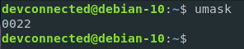
Answer
- Question 14 : given the same mask, what permissions will be granted to directories on my host?
Answer

Directory permissions
- Question 15 : what does it mean for a user to have the “execute” right on a directory?
Answer
- Question 16 : similarly, what does it mean for a user to have write permissions on a directory?
Answer
- Question 17 : what is used on Linux to create share folders, allowing users to add files to a directory, but preventing them to delete entries that they don’t own?
Answer
- Question 18 : A file is set with the following permissions in a directory with the sticky bit activated. Will I be able to delete the file logged as “devconnected”?
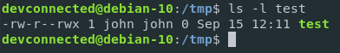
Answer
- Question 19 : logged as john, will I be able to go through this directory? (john is not part of the devconnected group)
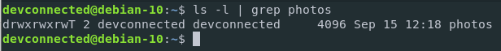
Answer

Summary
ls -lag | list access rights for all files
chmod [options] file | change access rights for named file

