Faculty of Computing and Information Technology
King AbdulAziz University
Ministry of Higher Education
Kingdom of Saudi Arabia
كلية الحاسبات وتقنية المعلومات
جامعة الملك عبد العزيز
وزارة التعليم العالي
المملكة العربية السعودية
CPIT 260 – Lab 7

Name: ID:

For this lab, you are required to install and login into the Linux system. Therefore, take snapshoots only for your answers to the exercises mentioned in the lab experiment

Lab 7: User management
Objective: understand and practice the ownership of files.
- Task 2: Managing Users and Groups
  - Change user of a file
  - Change group of a file
  - Create a new user using useradd.
  - Add the user to a new group using groupadd.
  - Set user ID bit
  - Set group ID bit GUID
To check the group or ownership of Linux files and directories in the current location, run the following command:
Ls -l
The following command changes the ownership of a file sample from root to the user test:
chown test sample
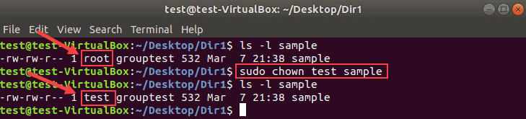
Use the same format to change the ownership for both files and directories.
Change the Owner of a File With UID
Instead of a username, you can specify a user ID to change the ownership of a file.
For example:
chown 1002 sample2
Make sure there is no user with the same name as the numeric UID. If there is, the chown command gives priority to the username, not the UID.
Note: To check a user’s ID, run id -u USERNAME from the terminal.
id
echo $USER
In the following example, root will be the new owner of files sample2 and sample3.
chown root sample2 sample3
How to Change the Group of a File
With chown, you can change a group for a file or directory without changing the owning user. The result is the same as using the chgrp command.
Run the chown command using the colon and a group name:
chown :NewGroup FILE
The following example changes the group of the file sample3 from grouptest to group3.
chown :group3 sample3
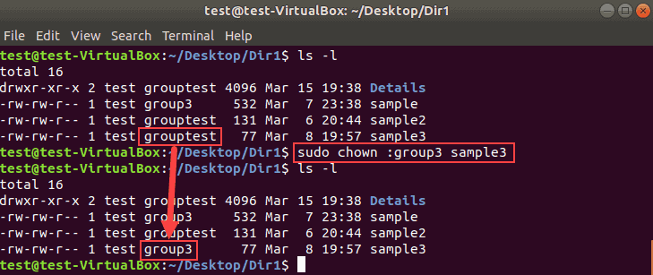
Change Owner and the Group
To assign a new owner of a file and change its group at the same time, run the chown command in this format:
chown linuxuser:group3 sample3
n the following example, we will recursively change the owner and the group for all files and directories in Dir1.
chown -R linuxuser:group3 Dir1
Users can be people or non-people, but as far as the OS is concerned both are almost identical.
$ whoami # your username
$ who # who is logged in?
$ w # who is here and what are they doing?
$ id # user ID, group ID, and groups you're in
Not just people: Apache, Mailman, ntp. “system users”
Users have
- Username
- UID
- Group
- Shell
- Usually (but not always) password
- Usually (but not always) home directory
All of this information is stored in a file called /etc/passwd.
To add, delete, and change the password of a user respectively run the following commands:
$ useradd <user_name> # vs adduser, the friendly Ubuntu version
$ userdel <user_name>
$ passwd
o add a group, or the permissions of a user/group run groupmod, usermod, and groupmod respectively. Similarly to /etc/passwd, /etc/group carries group information.
$ groupadd
$ usermod
$ groupmod
$ cat /etc/group
root:x:0:
daemon:x:1:
bin:x:2:
sys:x:3:
adm:x:4:
tty:x:5:
# group name:password or placeholder:GID:member,member,member
$ sudo groupadd devops
Passwords
/etc/shadow, not /etc/passwd
user@localhost ~ $ ls -l /etc/ | grep shadow
-rw-r----- 1 root shadow 1503 Nov 12 17:37 shadow

$ sudo su -
$ cat /etc/shadow
daemon:*:15630:0:99999:7:::
bin:*:15630:0:99999:7:::
sys:*:15630:0:99999:7:::
mail:*:15630:0:99999:7:::
Root/Superuser
- UID 0
- sudo

Acting as another user
$ su joe # become user joe, with THEIR password
$ su # become root, with root's password
$ sudo su - # become root, with your password
$ sudo su joe # become user joe with your password
The way you act as root is one of two ways:
- su root Is like logging in as root. Prompts you for the root user’s password.
- sudo <command> runs a single command as root. Prompts you for your password, but requires you to be on the sudoers list.

Exercise 7a:

- Create a user on your system for yourself, with your preferred username.
- Give your user sudo powers.
- Change your password.
- Use su to get into your user account.
- Create a directory called bootcamp in your home directory.
- Create a group called devops.
Special Permissions in Linux

SUID Permission

user + s (pecial)

A file with SUID always executes as the user who owns the file, regardless of the user passing the command. If the file owner doesn't have execute permissions, then use an uppercase S here.

Now, to see this in a practical light, let's look at the /usr/bin/passwd command. This command, by default, has the SUID permission set:

[tcarrigan@server ~]$ ls -l /usr/bin/passwd
-rwsr-xr-x. 1 root root 33544 Dec 13 2019 /usr/bin/passwd

Note the s where x would usually indicate execute permissions for the user.

To set the SUID permission on a file, execute the following command:

chmod 4755 script.sh

SGID Permission

group + s (pecial)
Commonly noted as SGID, this special permission has a couple of functions:
- If set on a file, it allows the file to be executed as the group that owns the file (similar to SUID)
- If set on a directory, any files created in the directory will have their group ownership set to that of the directory owner

[tcarrigan@server article_submissions]$ ls -l
total 0
drwxrws---. 2 tcarrigan tcarrigan 69 Apr 7 11:31 my_articles

chmod 2755 shared

Sticky Bit
The sticky bit is a special permission that can only be set on directories. When the sticky bit is enabled on a directory, it restricts the ability to delete or rename files within that directory to the file owner, the directory owner, and the superuser. It ensures that each user can only remove or modify their files, even if they have write permissions on the directory.
sticky bit's usefulness is the /tmp directory,

chmod 1777 public

Exercise 7b:

- Question 1 : what command is used on Linux in order to change the owner of a file or directory?
Answer
- Question 2 : what command is used on Linux in order to change the group of a file or directory?
Answer
- Question 3 : what option should be specified for the chgrp command to be apply recursively on directories and children?
Answer
- Question 4 : what option should be specified for the chgrp command to write all changes done to the standard output?
Answer
- Question 5 : how would you shortly describe the SUID?
Answer
- Question 6 : what popular command is executed on Linux with the SUID enabled?
Answer
- Question 7 : what command would you run to set the SUID for a file on your host?
Answer
- Question 8 : how would you shortly describe the GUID?
Answer
- Question 9 : what command would you run to set the GUID for a file on your host?
Answer
- Question 10 : if a directory with ” r w x r w x r w x” permissions is copied using the cp command, will the permissions be the same on the new directory ?
Answer
- Question 11 : what is the difference between a lowercase “t” and an uppercase “T” for the sticky bit?
Answer

Summary

Chown | Change owner of a file
Chgrp | change group of a file
Sudo | run privilege command
Adduser | Add new user
Addgroup | Add new group
Umask | Change default access permission mask
Suid | Chmod
Sguid | Chmod

