Please, write your name, id and section here
Notes:
- You must solve the exam by yourself. Any form of cheating will result in receiving 0 in the exam.
- Write the solution for each question in a paper and put the image for the solution in available space after the question.
1. (20 points) A program is executed on processor A with clock rate of 2.0 GHz, CPI of 2.5 and CPU time of 3 ms.
a. Find the clock cycle time for processor A.
b. Find the number of clock cycles utilized.
c. Compute the instruction-count of the executed program.
d. It is required to design computer B that is faster than computer A by 1.67 and with the same CPI as computer A. What should be the clock rate of computer B.
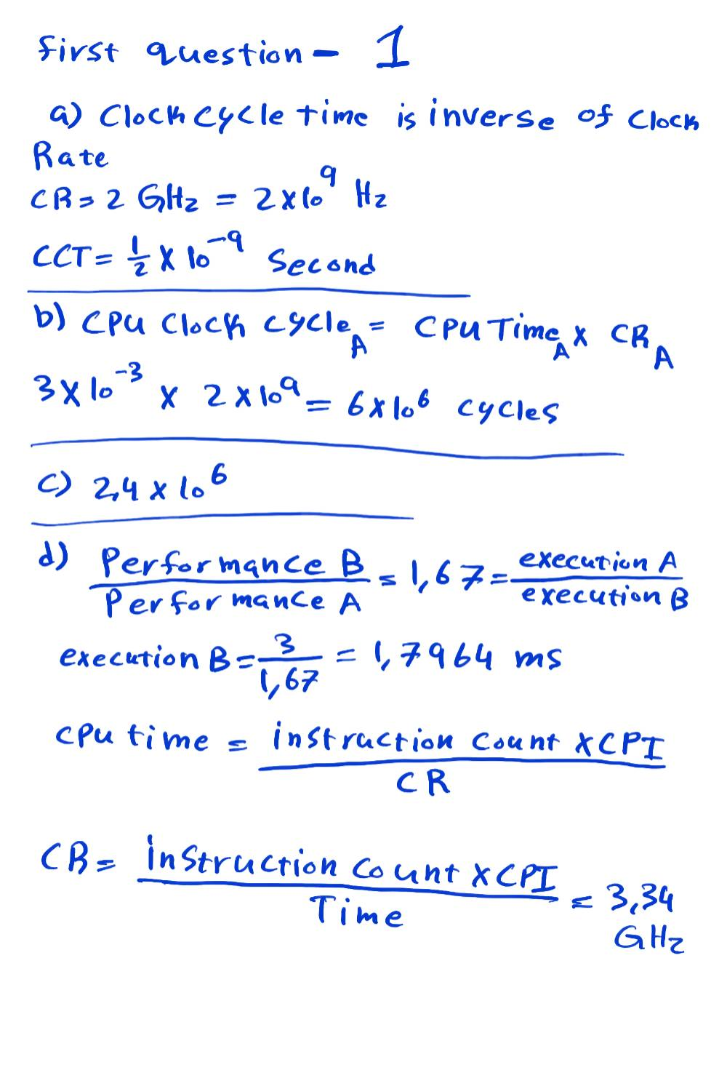

2. (10 points) Represent the decimal number: -3.925 x 10¹ as single-precision floating point number.
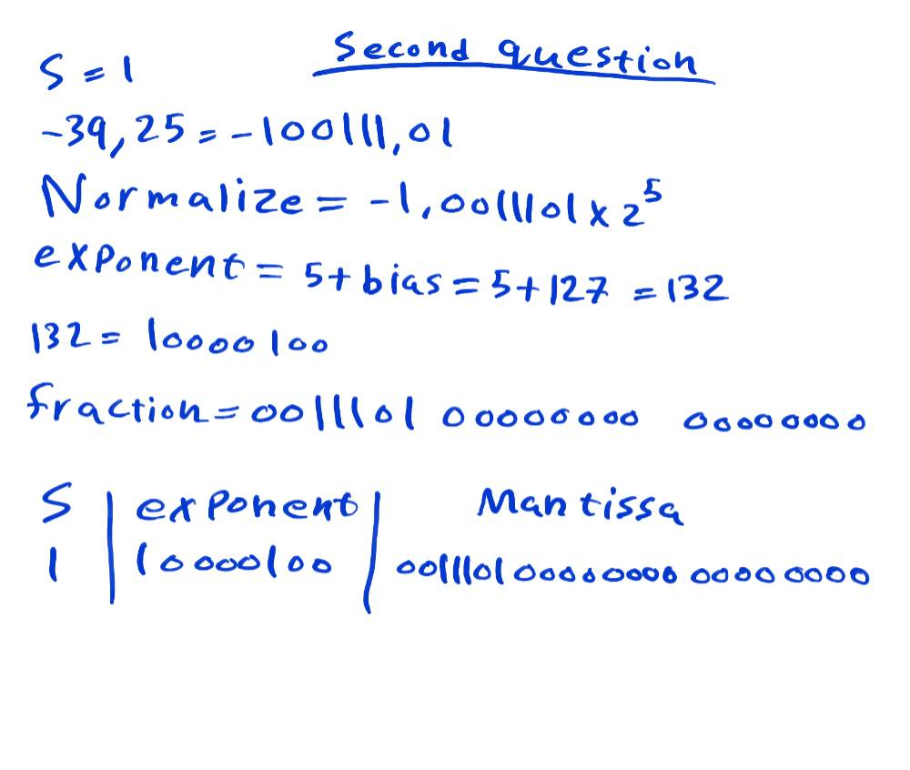

3. (10 points) A partial digital ALU that can perform some arithmetic and logical operations is shown below. Show how to perform the binary subtraction operation: 1 - 0.
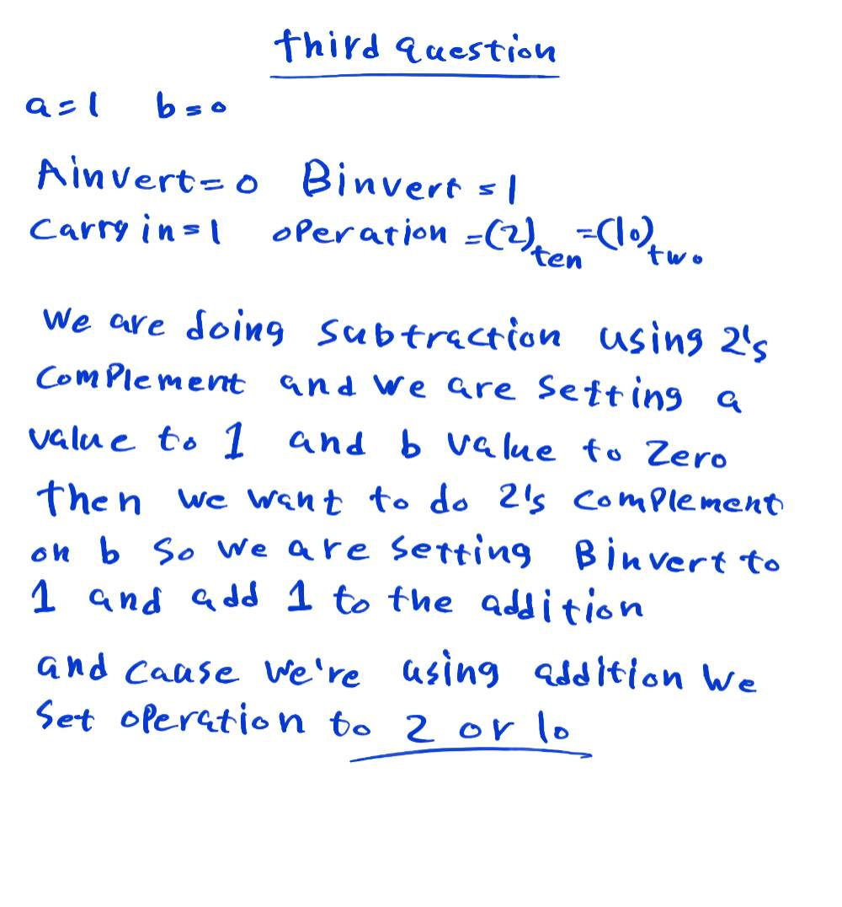

4. (20 Points) The single-cycle 32-bit architecture is shown in the next figure.
Answer the following questions with respect to the execution of a store-word (sw) instruction:
a. Can you use only one common memory during execution of this instruction? Justify your answer.
b. What is the use of the main ALU for this instruction (sw).?
c. List all Asserted control signals during the execution of this instruction (sw).
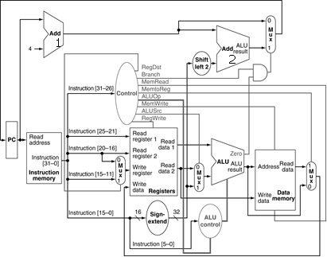

5. (20 points) A 5-stages pipelined architecture with only one two instruction and data memories used during the execution of the following MIPS assembly program:
1: add $t0, $s1, $s2
2: lw $t1, 12($s0)
3: sub $s3, $t1, $t2
4: add $s4, $t0, $t4
a. Draw the pipelined physical diagram with all necessary stalls and forwarding paths.
b. What is total number of clock cycles needed to execute this program?
c. Without changing the hardware, can you make this program to run faster? Explain your answer.
d. Compute the speedup.
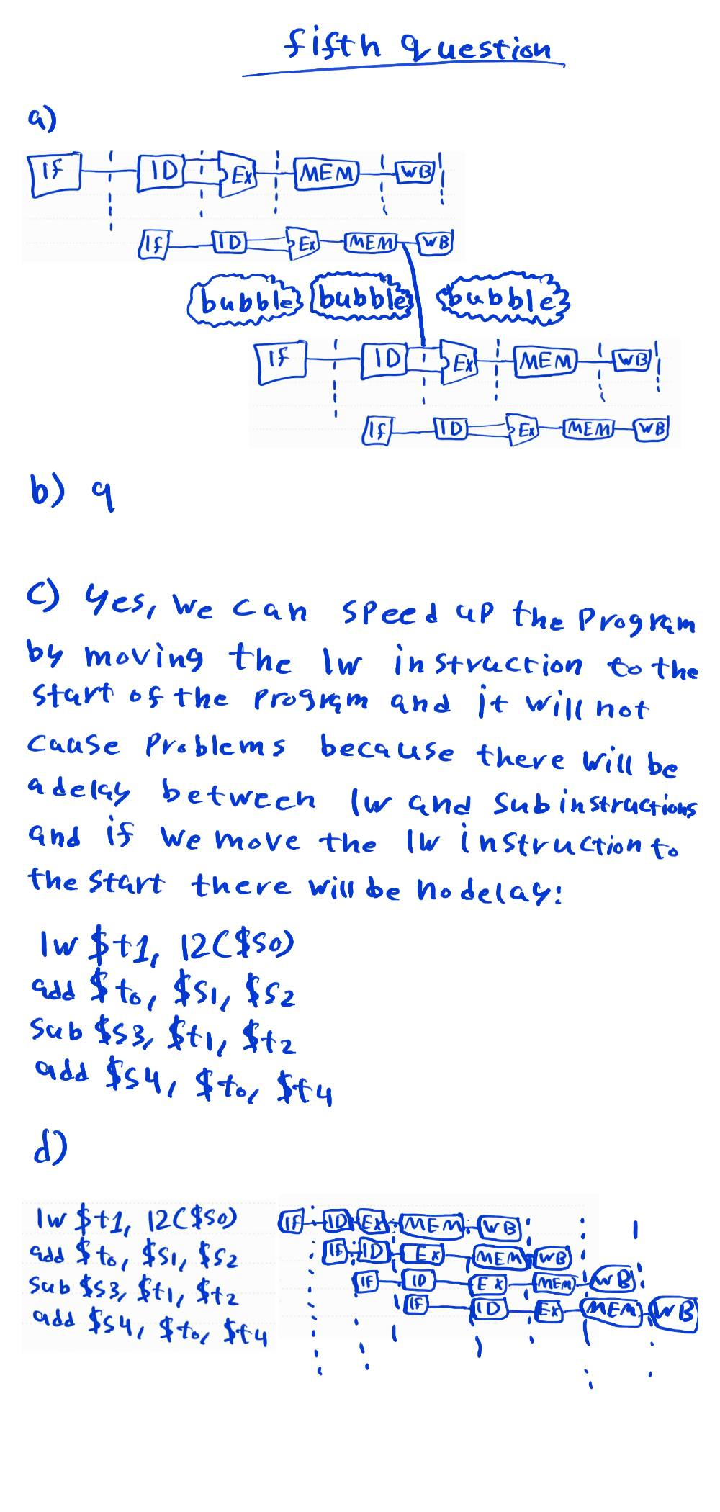

6. (20 Points) A cache memory of size 8 blocks and 1 word is stored per block. The current state of the cache and its contents are given in the following table.
a. Compute the hit ratio for the following inorder memory accesses: 0, 1, 2, 3, 7, 31, 7, 85.
b. Explain the reasons for designing cache memory to be larger than the needed data size.

Index | V | Tag | Data (hex)
000 | Y | 0000 | 00000000
001 | Y | 0001 | AABC78D1
010 | N | xxxx | xxxxxxxx
011 | Y | 0111 | 11100B01
100 | Y | 0000 | 11101111
101 | Y | 1010 | FFFFFFFF
110 | N | xxxx | xxxxxxxx
111 | Y | 0000 | 1234ABCD



