King AbdulAziz University
Faculty of Computing & Information Technology
Computer Science Department
Final Lab Exam (16-5-2024)
Course: CPCS-214 Computer Organization and Architecture
Term: 2024 Second Semester
Time: 90 Minutes (9 - 11)

Student ID: ----------------------------------------------------------- Section: ------------------------------
Student Name: -------------------------------------------------------
Lab Instructor: ------------------------------------
Computer No. : 612b61L ___ P___

Instructions:
- Student must complete their task and upload the solution within 90 mins.
- If Mars is not installed in your PC, use the link below to download it:
https://courses.missouristate.edu/kenvollmar/mars/index.htm
- Submission Link will close after 90 minutes
- Renamed template with your information: Section-ID-FinalExam, Example: (BCR-123456-FinalExam).
- Upload two files on Blackboard: This file after filling page 3 below and the .asm file.
- Instructor will guide you to the Exam folder path on BB.
- Make sure to add your name / ID / Section / course name / Lab Final Exam, as comments at the beginning of your program.
- Mobile Phones should be switched off during the exam.
- Browsing Internet during the exam is not allowed. Only Access to BB is allowed for uploading the Exam Solution at the ending of exam.
- During exam keep saving your work.
- In case of any issue, contact the instructor immediately.
- Before leaving the Lab, kindly sign in the section Submission of Exam on BB in the question Paper.
- In case student didn't sign she will be responsible by herself for any mishap.

Write a MIPS Assembly code that reads 10 integer numbers into an array. Then, double the values of every odd number in the array. Finally, the program displays the array after editing it.
- Your program should read these 10 numbers and save them into an array.
- Create a subroutine called DoubleOdd to find odd numbers in the array and double them.
Note:
- Write comments with your information.
- Your code should include comments before any reading, writing or branching instruction that explain what will happen at that point.
- Write comments with content for every register.
Sample output

Enter a list of 10 numbers: 5 4 8 3 14 17 21 54 6 33
The list after doubling odd numbers:
10 4 8 6 14 34 42 54 6 66

System Services
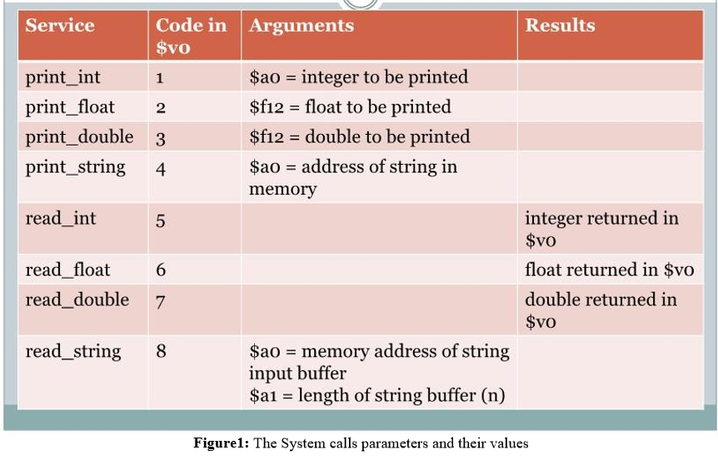

Answer Sheet

- Copy and paste your code here:

- Take a screenshot of your output and past it here:

