
King Abdulaziz University
Faculty of Computing & Information Technology
Computer Science Department
Comprehensive Final Exam (Spring 2025)
CPCS-223 (Analysis and Design of Algorithms)
(Wednesday May 21, 2025, 23-11-1446)
SOLUTION
Total Marks : 100 Time : 120 minutes
Student ID:
Student Name:

Instructors:
CS 1
CS 2
CS 3

Dr. Muhammad Umair
Dr. Ahmed Harboui
Mr. Aman Ullah

Question | CLO | SO | Max. Marks | Obt. Marks
01 | 5 | 1 | 20
02 | 7 | 1 | 10
03 | 7 | 1 | 20
04 | 3 | 1 | 10
05 | 10 | 1 | 20
06 | 14 | 2 | 20
Total Marks: |  |  | 100

Q. No. 1
CLO5 | SO1 | Marks: 20

(a) Using the exhaustive search approach, solve the assignment problem for the following cost matrix. Find the optimal assignment that minimizes the total cost.

Task / Person | P1 | P2 | P3
T1 | 10 | 15 | 9
T2 | 15 | 12 | 16
T3 | 13 | 8 | 11

Solution: (09 pts)
Assignment (T1, T2, T3) to (P?, P?, P?) | Cost Calculation | Total Cost
(P1, P2, P3) | 10 + 12 + 11 | 33
(P1, P3, P2) | 10 + 16 + 8 | 34
(P2, P1, P3) | 15 + 15 + 11 | 41
(P2, P3, P1) | 15 + 16 + 13 | 44
(P3, P1, P2) | 9 + 15 + 8 | 32
(P3, P2, P1) | 9 + 12 + 13 | 34

Optimal Assignment: (2 pt)
(P3, P1, P2)
Minimum Total Cost: (1 pt)
32

(b) Maximum Subarray Sum
You are given an array of integers, which can be both positive and negative. Your task is to find the subarray (contiguous part of the array) that has the maximum sum. Use the exhaustive search approach to find the subarray with the highest sum.

b.1 For an array of length n, how many different subarrays can be formed? (4 pts)
(provide a formula to calculate the total number of subarray)
n(n+1)/2

b.2 Given the array:
2 | -1 | 3 | 4 | -2 | 6 | -1

Using the exhaustive search approach, solve the problem and find the subarray with the maximum sum.

Answer:

The maximum subarray: [2, -1, 3, 4, -2, 6] (2 pts)

The maximum subarray sum: 12 (2 pts)

Q. No. 2
CLO7 | SO1 | Marks: 10

Using the Johnson-Trotter algorithm (decrease and conquer), generate all permutations of the numbers 1, 2, 3 (in initial order: 1 2 3). You must Fill in the following table with the 6 permutations in the order they are generated by the Johnson-Trotter algorithm. (9 pts)

Solution: (0.5 each)
Permutation  No. | 1st character | 2nd character | 3rd character
1 | 1 | 2 | 3
2 | 1 | 3 | 2
3 | 3 | 1 | 2
4 | 3 | 2 | 1
5 | 2 | 3 | 1
6 | 2 | 1 | 3

This algorithm generates all permutations using the minimal number of swaps (only one adjacent swap per step). However, what is the main limitation of this algorithm? (1 pts)

Johnson-Trotter does not generate permutations in lexicographic order.

CLO7 | SO1 | Marks: 20

Q. No. 3:

(a) Apply Decrease and Conquer Russian peasant algorithm using to find the multiplication of 47 and 26. . (9 pts)
Solution: 0.5 for each + Final Answer 1pt
n | m
47 | 26 | (+26)
23 | 52 | (+52)
11 | 104 | +104
5 | 208 | +208
2 | 416 | 0
1 | 832 | +832
Final Answer: |  | 1222

(b) Apply Decrease and Conquer interpolation search algorithm to find the value v = 16 in the following array A: . (11 pts)

0 | 1 | 2 | 3 | 4 | 5 | 6 | 7 | 8
10 | 12 | 16 | 30 | 40 | 50 | 60 | 70 | 81
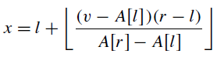

Solution: (11pts) 0.5 for each + Found 0.5 pt

l | r | v | A[l] | A[r] | X | A[X]
0 | 8 | 16 | 10 | 81 | 0 | 10
1 | 8 | 16 | 12 | 81 | 1 | 12
2 | 8 | 16 | 16 | 81 | 2 | 16
 |  |  |  |  |  | Found
CLO3 | SO1 | Marks: 10

Q. No. 4:

Given the recurrence relation:

T(n)=9T(n/3)+n²

Use the Master Theorem to determine the asymptotic complexity of T(n). and clearly state which case of the Master Theorem applies. Conclude with the final complexity.

Solution:
T(n)=Θ(n²logn) 10 pts if correct
If incorrect
a=9 2 pts
b=3 2 pts
f(n)=n² 2 pts
log_{b}a=log₃9=2 2 pts

CLO10 | SO1 | Marks: 20

Q. No. 5:

Insert these nodes into an empty AVL tree in order:
10, 20, 30, 25, 28, 27, 5

For each insertion, Show the tree structure and Add the balance factor for each node.

Solution: 2pts for each insertion or update except the first insertion

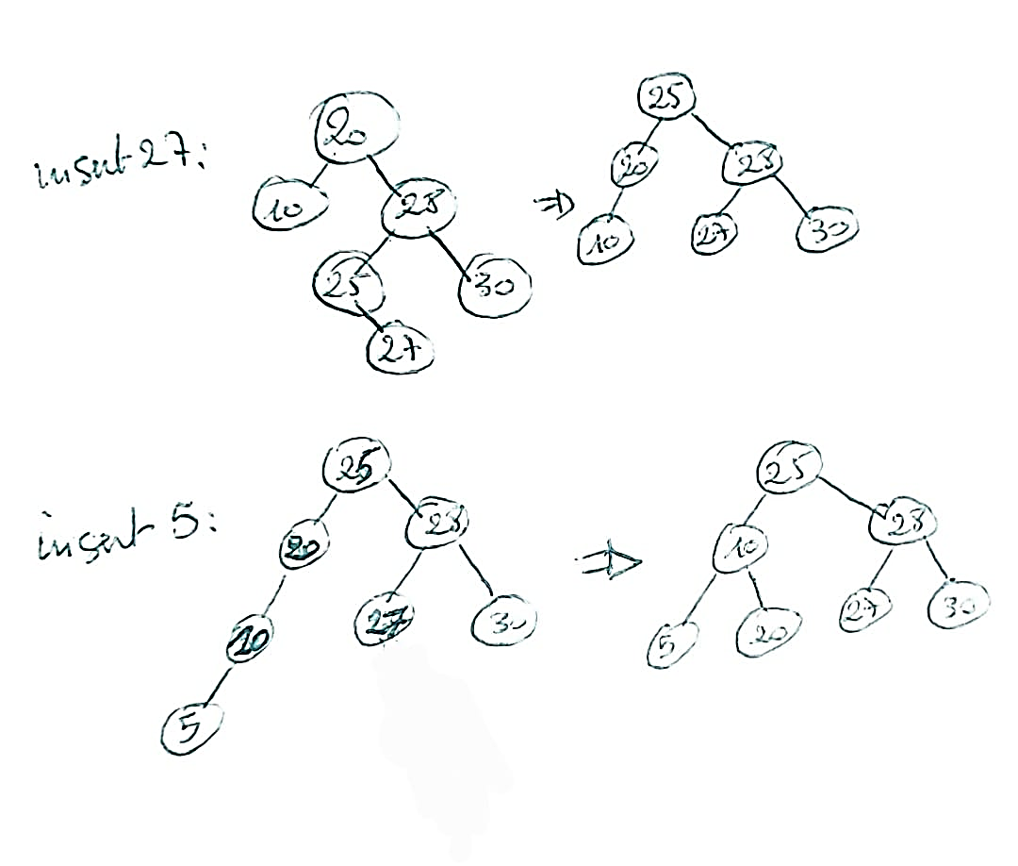
2p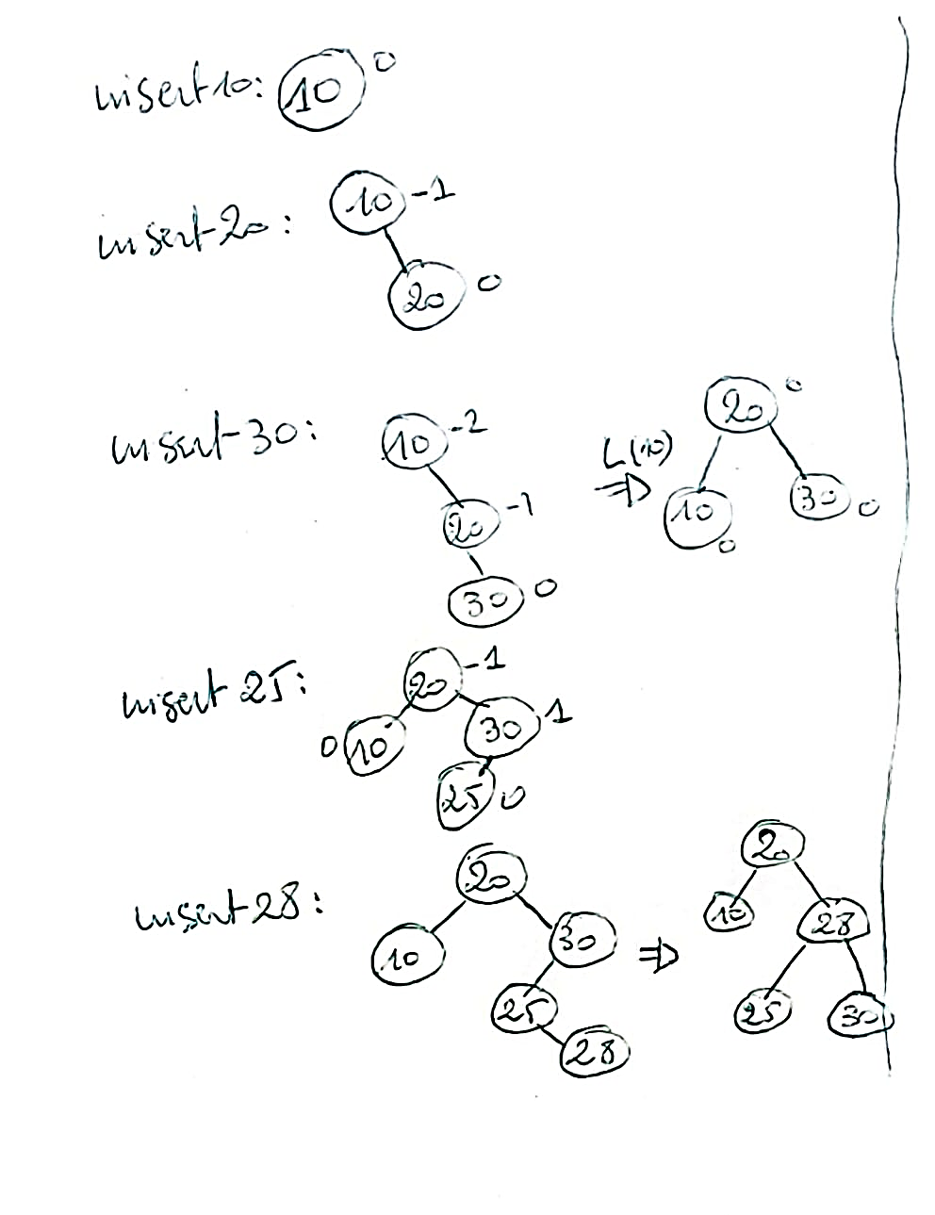

CLO14 | SO2 | Marks: 20

Q. No. 6:

Design a recursive algorithm to return the height (maximum depth) of any binary search tree. A tree with only one node has height 0. An empty tree has height -1.

Solution:

ALGORITHM: TreeHeight(root) {

instruction | If correct | If partially correct
if (root == null) { | 4 pts | 2 pts if partially correct for |= null
return -1; } | 4 pts | 2 pts if incorrect value
leftHeight = TreeHeight(root.Left()); | 4 pts | 2 pts if minor error
rightHeight = TreeHeight(root.Right()); | 4 pts | 2 pts if minor error
return 1 + max(leftHeight, rightHeight); | 4 pts | 2 pts if incomplete or wrong formula  (forgot 1+)

0 pt for each incorrect or missing isntruction
}

