Google Capstone Project: How Can Bellabeat, A Wellness Technology Company Play It Smart

Sandeep Singh

### Steps-1: Ask

We define the issue, the goals of our case study, and the intended result in this step.

#### 1.0 Background

Since 2013, Bellabeat has been a high-tech manufacturer of gorgeously crafted smart devices for women with a focus on their health. Bellabeat has quickly expanded and established itself as a tech-driven wellness brand for women by educating and empowering women with knowledge about their own health and habits.

Urka Sren, co-founder and chief creative officer, is sure that examination of non-Bellabelt customer data, such as usage data from Fitbit fitness trackers, will find further development prospects.

#### 1.2 Business Task:

Examine FitBit fitness tracker data to learn how users interact with the FitBit app and identify trends for Bellabeat marketing strategy.

#### 1.3 Business Objectives:

* What patterns have been found?
* How might Bellabeat customers be affected by these trends?
* How can these developments affect Bellabeat’s marketing plan?

#### 1.4 Deliverables

* A concise description of the business task
* A list of all the data sources that were used, along with documentation of any data cleaning or manipulation, and a summary of the analysis
* supporting images and important findings
* Recommendations for high-level material based on the analysis

#### 1.5 Key Stakeholders

* Bellabeat’s cofounder and chief creative officer, Urka Sren
* Mathematician, co-founder of Bellabeat, and essential member of the Bellabeat management team, Sando Mur
* The Bellabeat analytics team for marketing: Data analysts overseeing Bellabeat’s marketing plan.

### Steps-2 : Prepare

We identify the data being used and its constraints during the Prepare step.

#### Step 2.1 Information on Data Source:

* 18 csv files containing data from the FitBit fitness tracker are freely accessible on Kaggle.
* generated by survey participants using Amazon Mechanical Turk between March 12 and May 12, 2016.
* 30 FitBit users gave their permission for personal tracker data to be submitted.
* The information gathered includes minute-by-minute records of physical activity, heart rate, sleep patterns, daily activities, and steps.

#### 2.2 Limitation of Data Set

* Data was gathered in 2016 five years ago. Since then, users’ routines for everyday activity, eating, exercising, and sleeping may have changed. Data might not be current or pertinent.
* A sample size of 30 FitBit users does not accurately represent the fitness market as a whole.
* We are unable to verify the integrity or correctness of the data because it is acquired through a survey.

#### 2.3 Is Data ROCCC?

A good data source is ROCCC which stands for Reliable, Original, Comprehensive, Current, and Cited.

* Reliable — LOW — Not reliable as it only has 30 respondents
* Original — LOW — Third party provider (Amazon Mechanical Turk)
* Comprehensive — MED — Parameters match most of Bellabeat products’ parameters
* Current — LOW — Data is 5 years old and may not be relevant
* Cited — LOW — Data collected from third party, hence unknown

Overall, the dataset is regarded as having low quality data, and it is not advised to base business suggestions on it.

#### 2.4 Data Selection

The next file is chosen and copied for examination.

#### 2.5 Tool

We are using R for data Cleaning, transformation and Visualization

‘dailyActivity_merged.csv’

### Step-3 Process

Here, we will process the data by cleaning it and making sure it is accurate, pertinent, comprehensive, free of error, and free of outliers by carrying out the following actions:

* Examine and watch the data
* Examine and deal with any missing or null values.
* Data transformation: format the data type
* Carrying out a preliminary statistical analysis

install.packages("Rtools", repos = "http://cran.us.r-project.org")

## Installing package into 'C:/Users/Sandeep SIngh/Documents/R/win-library/4.1'  
## (as 'lib' is unspecified)

install.packages("tidyverse", repos = "http://cran.us.r-project.org")

## Installing package into 'C:/Users/Sandeep SIngh/Documents/R/win-library/4.1'  
## (as 'lib' is unspecified)

## package 'tidyverse' successfully unpacked and MD5 sums checked  
##   
## The downloaded binary packages are in  
## C:\Users\Sandeep SIngh\AppData\Local\Temp\RtmpKcH5MP\downloaded_packages

install.packages("plotrix", repos = "http://cran.us.r-project.org")

## Installing package into 'C:/Users/Sandeep SIngh/Documents/R/win-library/4.1'  
## (as 'lib' is unspecified)

## package 'plotrix' successfully unpacked and MD5 sums checked  
##   
## The downloaded binary packages are in  
## C:\Users\Sandeep SIngh\AppData\Local\Temp\RtmpKcH5MP\downloaded_packages

install.packages("treemap", repos = "http://cran.us.r-project.org")

## Installing package into 'C:/Users/Sandeep SIngh/Documents/R/win-library/4.1'  
## (as 'lib' is unspecified)

## package 'treemap' successfully unpacked and MD5 sums checked  
##   
## The downloaded binary packages are in  
## C:\Users\Sandeep SIngh\AppData\Local\Temp\RtmpKcH5MP\downloaded_packages

#### 3.1 Preparing the Environment

The R libraries are installed.

#### Importing data set

dataset<- read.csv("dailyActivity_merged.csv",header=TRUE,sep = ",")

#### 3.3 Cleaning and modifying data

1 Observe and get acquainted with the data 2 Verify any missing or empty values. 3 Run a sanity check on the data. ##### Previewing using glimpse function on daily_activity to familiarise with the data

str(dataset)

## 'data.frame': 940 obs. of 15 variables:  
## $ Id : num 1.5e+09 1.5e+09 1.5e+09 1.5e+09 1.5e+09 ...  
## $ ActivityDate : chr "4/12/2016" "4/13/2016" "4/14/2016" "4/15/2016" ...  
## $ TotalSteps : int 13162 10735 10460 9762 12669 9705 13019 15506 10544 9819 ...  
## $ TotalDistance : num 8.5 6.97 6.74 6.28 8.16 ...  
## $ TrackerDistance : num 8.5 6.97 6.74 6.28 8.16 ...  
## $ LoggedActivitiesDistance: num 0 0 0 0 0 0 0 0 0 0 ...  
## $ VeryActiveDistance : num 1.88 1.57 2.44 2.14 2.71 ...  
## $ ModeratelyActiveDistance: num 0.55 0.69 0.4 1.26 0.41 ...  
## $ LightActiveDistance : num 6.06 4.71 3.91 2.83 5.04 ...  
## $ SedentaryActiveDistance : num 0 0 0 0 0 0 0 0 0 0 ...  
## $ VeryActiveMinutes : int 25 21 30 29 36 38 42 50 28 19 ...  
## $ FairlyActiveMinutes : int 13 19 11 34 10 20 16 31 12 8 ...  
## $ LightlyActiveMinutes : int 328 217 181 209 221 164 233 264 205 211 ...  
## $ SedentaryMinutes : int 728 776 1218 726 773 539 1149 775 818 838 ...  
## $ Calories : int 1985 1797 1776 1745 1863 1728 1921 2035 1786 1775 ...

#### Cleaning Column Names

dataset<-clean_names(dataset)  
colnames(dataset)

## [1] "id" "activity_date"   
## [3] "total_steps" "total_distance"   
## [5] "tracker_distance" "logged_activities_distance"  
## [7] "very_active_distance" "moderately_active_distance"  
## [9] "light_active_distance" "sedentary_active_distance"   
## [11] "very_active_minutes" "fairly_active_minutes"   
## [13] "lightly_active_minutes" "sedentary_minutes"   
## [15] "calories"

#### Finding Out Basic Information of Data

No. of Rows and Columns * Columns Names * Non Null Count * Data Type

#### Finding Data Type of Each Column

str(dataset)

## 'data.frame': 940 obs. of 15 variables:  
## $ id : num 1.5e+09 1.5e+09 1.5e+09 1.5e+09 1.5e+09 ...  
## $ activity_date : chr "4/12/2016" "4/13/2016" "4/14/2016" "4/15/2016" ...  
## $ total_steps : int 13162 10735 10460 9762 12669 9705 13019 15506 10544 9819 ...  
## $ total_distance : num 8.5 6.97 6.74 6.28 8.16 ...  
## $ tracker_distance : num 8.5 6.97 6.74 6.28 8.16 ...  
## $ logged_activities_distance: num 0 0 0 0 0 0 0 0 0 0 ...  
## $ very_active_distance : num 1.88 1.57 2.44 2.14 2.71 ...  
## $ moderately_active_distance: num 0.55 0.69 0.4 1.26 0.41 ...  
## $ light_active_distance : num 6.06 4.71 3.91 2.83 5.04 ...  
## $ sedentary_active_distance : num 0 0 0 0 0 0 0 0 0 0 ...  
## $ very_active_minutes : int 25 21 30 29 36 38 42 50 28 19 ...  
## $ fairly_active_minutes : int 13 19 11 34 10 20 16 31 12 8 ...  
## $ lightly_active_minutes : int 328 217 181 209 221 164 233 264 205 211 ...  
## $ sedentary_minutes : int 728 776 1218 726 773 539 1149 775 818 838 ...  
## $ calories : int 1985 1797 1776 1745 1863 1728 1921 2035 1786 1775 ...

####Finding Unique ID

dataset %>%   
 distinct(id)

## id  
## 1 1503960366  
## 2 1624580081  
## 3 1644430081  
## 4 1844505072  
## 5 1927972279  
## 6 2022484408  
## 7 2026352035  
## 8 2320127002  
## 9 2347167796  
## 10 2873212765  
## 11 3372868164  
## 12 3977333714  
## 13 4020332650  
## 14 4057192912  
## 15 4319703577  
## 16 4388161847  
## 17 4445114986  
## 18 4558609924  
## 19 4702921684  
## 20 5553957443  
## 21 5577150313  
## 22 6117666160  
## 23 6290855005  
## 24 6775888955  
## 25 6962181067  
## 26 7007744171  
## 27 7086361926  
## 28 8053475328  
## 29 8253242879  
## 30 8378563200  
## 31 8583815059  
## 32 8792009665  
## 33 8877689391

#### Finding Null and Missing Values

sum(is.na(dataset))

## [1] 0

#### From the Above observation , we noted that

1. There Zero Null or Missing Values
2. Data has 15 Columns 940 Rows
3. ActivityData is wrongly classified as Object dtype and has to be converted into datatime64 dtype
4. Instead of the predicted 30 unique IDs, there are 33 unique IDs. It’s possible that some users made more IDs while the survey was being conducted.

Once the corrupt data has been located, we will manipulate or change the data.

1.Activity Date should be changed to datatime64 dtype. 2.Change Activity Date’s format to yyyy-mm-dd. 3.For additional research, create a new column called DayOfTheWeek by producing dates as days of the week. 4.Adding the total of the VeryActiveMinutes, FairlyActiveMinutes, LightlyActiveMinutes, and SedentaryMinutes columns will give you TotalMins.

By changing the new column TotalMins in number 4 to the number of hours, create a new column called TotalHours. Rename and rearrange the columns.

Prior to converting ActivityDate to yyyy-mm-dd, we will first convert ActivityDate from an object to a datatime64 dtype. Then we check to see whether ActivityDate has changed to yyyy-mm-dd and Datatime64 Dtype.

#### Converting Activity Date to datetime64 and format to YYYY-MM-DD

View(dataset)

dataset$activity_date <- as.Date(dataset$activity_date, format = "%m/%d/%Y")

### Printing First Ten Rows of Dataset to check the changes

head(dataset)

## id activity_date total_steps total_distance tracker_distance  
## 1 1503960366 2016-04-12 13162 8.50 8.50  
## 2 1503960366 2016-04-13 10735 6.97 6.97  
## 3 1503960366 2016-04-14 10460 6.74 6.74  
## 4 1503960366 2016-04-15 9762 6.28 6.28  
## 5 1503960366 2016-04-16 12669 8.16 8.16  
## 6 1503960366 2016-04-17 9705 6.48 6.48  
## logged_activities_distance very_active_distance moderately_active_distance  
## 1 0 1.88 0.55  
## 2 0 1.57 0.69  
## 3 0 2.44 0.40  
## 4 0 2.14 1.26  
## 5 0 2.71 0.41  
## 6 0 3.19 0.78  
## light_active_distance sedentary_active_distance very_active_minutes  
## 1 6.06 0 25  
## 2 4.71 0 21  
## 3 3.91 0 30  
## 4 2.83 0 29  
## 5 5.04 0 36  
## 6 2.51 0 38  
## fairly_active_minutes lightly_active_minutes sedentary_minutes calories  
## 1 13 328 728 1985  
## 2 19 217 776 1797  
## 3 11 181 1218 1776  
## 4 34 209 726 1745  
## 5 10 221 773 1863  
## 6 20 164 539 1728

#### Creating new list

activity_Day <- wday(dataset$activity_date, label=TRUE)  
dataset['activity_Day']<-activity_Day  
totactive_Minutes<-(dataset$very_active_minutes + dataset$fairly_active_minutes +dataset$lightly_active_minutes +dataset$sedentary_minutes)  
dataset['totactive_Minutes']<-totactive_Minutes  
totactive_Hours<-ceiling((totactive_Minutes/60))  
dataset['totactive_Hours']<-totactive_Hours  
View(dataset)  
  
#mutate(dataset, activity_Hours= (dataset$totactive_Minutes/60))

#### Step-4 : Analyse

4.1 Perform calculation

Pulling Calculation 1. Count - No. of Rows 2. Mean - Average 3. Standard Deviation 4. Min and Max 5.Percentiles 25%, 50%, 75%

summary(dataset)

## id activity_date total_steps total_distance   
## Min. :1.504e+09 Min. :2016-04-12 Min. : 0 Min. : 0.000   
## 1st Qu.:2.320e+09 1st Qu.:2016-04-19 1st Qu.: 3790 1st Qu.: 2.620   
## Median :4.445e+09 Median :2016-04-26 Median : 7406 Median : 5.245   
## Mean :4.855e+09 Mean :2016-04-26 Mean : 7638 Mean : 5.490   
## 3rd Qu.:6.962e+09 3rd Qu.:2016-05-04 3rd Qu.:10727 3rd Qu.: 7.713   
## Max. :8.878e+09 Max. :2016-05-12 Max. :36019 Max. :28.030   
##   
## tracker_distance logged_activities_distance very_active_distance  
## Min. : 0.000 Min. :0.0000 Min. : 0.000   
## 1st Qu.: 2.620 1st Qu.:0.0000 1st Qu.: 0.000   
## Median : 5.245 Median :0.0000 Median : 0.210   
## Mean : 5.475 Mean :0.1082 Mean : 1.503   
## 3rd Qu.: 7.710 3rd Qu.:0.0000 3rd Qu.: 2.053   
## Max. :28.030 Max. :4.9421 Max. :21.920   
##   
## moderately_active_distance light_active_distance sedentary_active_distance  
## Min. :0.0000 Min. : 0.000 Min. :0.000000   
## 1st Qu.:0.0000 1st Qu.: 1.945 1st Qu.:0.000000   
## Median :0.2400 Median : 3.365 Median :0.000000   
## Mean :0.5675 Mean : 3.341 Mean :0.001606   
## 3rd Qu.:0.8000 3rd Qu.: 4.782 3rd Qu.:0.000000   
## Max. :6.4800 Max. :10.710 Max. :0.110000   
##   
## very_active_minutes fairly_active_minutes lightly_active_minutes  
## Min. : 0.00 Min. : 0.00 Min. : 0.0   
## 1st Qu.: 0.00 1st Qu.: 0.00 1st Qu.:127.0   
## Median : 4.00 Median : 6.00 Median :199.0   
## Mean : 21.16 Mean : 13.56 Mean :192.8   
## 3rd Qu.: 32.00 3rd Qu.: 19.00 3rd Qu.:264.0   
## Max. :210.00 Max. :143.00 Max. :518.0   
##   
## sedentary_minutes calories activity_Day totactive_Minutes  
## Min. : 0.0 Min. : 0 Sun:121 Min. : 2.0   
## 1st Qu.: 729.8 1st Qu.:1828 Mon:120 1st Qu.: 989.8   
## Median :1057.5 Median :2134 Tue:152 Median :1440.0   
## Mean : 991.2 Mean :2304 Wed:150 Mean :1218.8   
## 3rd Qu.:1229.5 3rd Qu.:2793 Thu:147 3rd Qu.:1440.0   
## Max. :1440.0 Max. :4900 Fri:126 Max. :1440.0   
## Sat:124   
## totactive_Hours  
## Min. : 1.00   
## 1st Qu.:17.00   
## Median :24.00   
## Mean :20.55   
## 3rd Qu.:24.00   
## Max. :24.00   
##

Interpreting statistical findings:

1.Users registered 7,637 steps or 5.4 km on average, which is insufficient. According to the CDC, an adult female should strive to walk at least 10,000 steps, or 8 kilometres, each day to enhance her general health, lose weight, and increase her level of fitness. Source: An article from Medical News Today

2.The bulk of users register an average of 991 minutes, or 20 hours, which accounts for 81% of all average minutes.

3.Noting that 2,303 calories, or 0.6 pounds, are burnt on average every day. Could not go into detail because the number of calories expended depends on a number of variables, including age, weight, daily activities, exercise, hormones, and calorie consumption. Health Line article, source

#### STEP 5: Share

Number of Times users logged in App Across the Week

p<-ggplot(data=dataset)  
  
p + geom_bar(mapping = aes(x=activity_Day ))+coord_flip() +theme_classic()+  
 labs(title="Number of times users logged in app across the week", x = "Activity Day",y="Frequency")

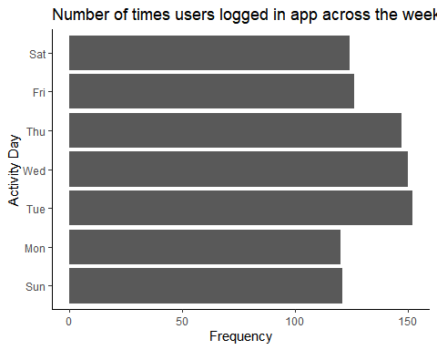

p + geom_point(mapping = aes(x= total_steps,y=calories)) +  
 geom_smooth(mapping=aes(x=total_steps,y=calories))

## `geom_smooth()` using method = 'loess' and formula 'y ~ x'

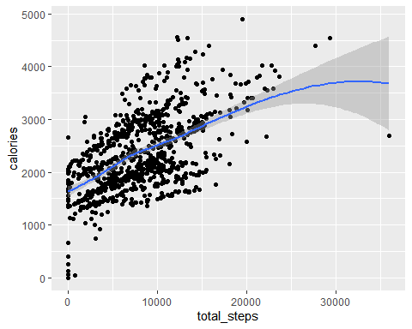

labs(title="Calories burned for every step taken", x = "Steps taken",y="Calories burned")

## $x  
## [1] "Steps taken"  
##   
## $y  
## [1] "Calories burned"  
##   
## $title  
## [1] "Calories burned for every step taken"  
##   
## attr(,"class")  
## [1] "labels"

p + geom_point(mapping = aes(x = totactive_Hours,y=calories)) +  
 labs(title="Calories burned for every hours logged", x = "Total Hours Logged ", y="Calories burned")

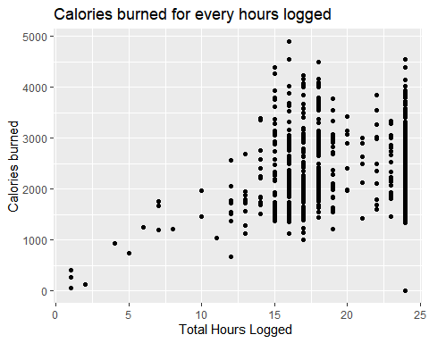

value<-c(sum(dataset$lightly_active_minutes) , sum(dataset$fairly_active_minutes), sum(dataset$very_active_minutes), sum(dataset$sedentary_minutes))  
group <- c(" Light active minutes" ,"Fairly active minutes" , "Very active minutes" , "Sedentary minutes")  
activity_data <- data.frame(group,value)   
treemap( activity_data,  
 index="group",  
 vSize = "value",  
 type = "index",  
 title="Percentage of Activity"  
 )

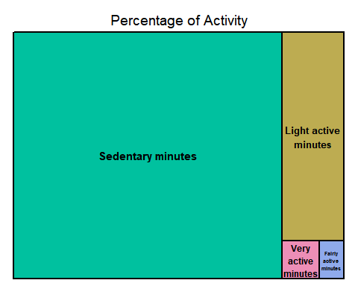

#### Step 6 Act

At the final phase, we will explain our findings and offer suggestions based on our study. Here, we go by our corporation queries once more and offer our top corporate suggestions to you

1. What patterns have been found?

The majority of users (nearly 80%)only use the FitBit app to monitor inactive activities rather than their daily exercise routines. Users prefer to keep track of their activities throughout the week as opposed to the weekend, possibly because they spend more time outdoors during the week and more time at home during the weekend.

1. How may Bellabeat customers be affected by these trends?

Both businesses create goods that encourage women to understand their existing habits and make healthy decisions by giving them information on their habits, fitness, and health. Customers of Bellabeat may very well apply these general trends in health and fitness.

1. How will these trends affect Bellabeat’s marketing plan?

The Bellabeat marketing team can encourage users by illuminating and empowering them with knowledge about the benefits of fitness, recommending diverse types of exercises (for example, a straightforward 10-minute exercise on weekdays and a more intense exercise on weekends), and providing information on calorie intake and burn rate on the Bellabeat app.

The Bellabeat app can also send out notifications on the weekends to urge users to work out.