
Yenepoya (Deemed to be University)
Balmatta, Mangalore — 575 002
Department of Computer Science

FINAL PROJECT REPORT
Lightweight Finance API using FastAPI
A RESTful backend with frontend dashboard demonstrating API design, validation, testing, and containerised deployment

Student Name | Sayooj V

Campus ID | 26067

Registration ID | 23BCAICD096

Programme | BCA — Major in AI, Cloud Computing & DevOps | 2023–2026 Batch

Industry Mentor | IBM SkillsBuild Programme Team

Guided By | Faculty Department of Computer Science, Yenepoya (Deemed to be University)

Institution | Yenepoya (Deemed to be University), Balmatta, Mangalore – 575 002

Submitted To | IBM SkillsBuild Student Project Programme

Date | 10 April 2026

Version | 1.1 — Final Submission (Backend + Frontend Dashboard)

Submitted in partial fulfilment of the IBM SkillsBuild Student Project Programme requirements.

Table of Contents

Front Matter
Executive Summary 3

Main Report
1. Introduction 4
1.1 Report Structure 4
2. Project Objectives 5
2.1 Primary Objectives 5
2.2 Learning Objectives 5
3. Background and Literature Review 6
3.1 REST APIs and Cloud Computing 6
3.2 FastAPI as a Modern API Framework 6
3.3 Containerisation with Docker 6
3.4 Prior Work — Expense Tracker Prototype 6
4. Hardware Architecture 7
5. Software Architecture 7
5.1 Separation of Concerns 7
5.2 Stateless Design 8
6. System Requirements 8
6.1 Functional Requirements 8
6.2 User Requirements 8
6.3 Environmental Requirements 9
7. Technology Stack 9
8. Design and Architecture 10
9. Implementation 10
9.1 Project Structure 10
9.2 Pydantic Models 11
9.3 Route Handlers 11
9.4 Docker Configuration 11
9.5 Frontend Dashboard (v2) 12
10. Testing 12
10.1 Test Approach 12
10.2 Test Results 13
10.3 Key Test Findings 13
11. Graphical User Interface (GUI) Layout 14
11.1 Backend — Swagger UI 14
11.2 Frontend Dashboard 15
12. Customer Testing 16
13. Evaluation — Results vs Objectives 16
14. Cloud Computing Relevance 17
15. Challenges Encountered 17
16. Conclusions 18
17. Further Development 18
References 19
Appendix A — Document Suite Summary 20

Executive Summary

This report presents the design, implementation, testing, and evaluation of the Lightweight Finance API — a RESTful backend service built with Python and FastAPI as part of the IBM SkillsBuild Student Project Programme at Yenepoya (Deemed to be University), Mangalore. The project demonstrates core cloud computing competencies through the practical construction of a six-endpoint API that enables a user to record income and expenses, compute a running financial balance, set a monthly budget limit, and monitor budget utilisation. A frontend dashboard (v2) was subsequently developed to provide a live visual interface for all API endpoints.

The system was designed following a documentation-first methodology, producing nine project documents spanning proposal, requirements, high-level design, low-level design, API reference, deployment guide, test report, final report, and a presentation deck. The implementation applies industry-standard practices including Pydantic v2 data validation, explicit HTTP error handling, Docker containerisation, CORS middleware, and auto-generated OpenAPI documentation via FastAPI's Swagger UI.

Testing produced 39 documented test cases across happy path, validation, edge case, and integration categories. The automated pytest suite contains 20 tests achieving a 100% pass rate against all 30 functional requirements defined in the Product Requirements Document. The project establishes a clean architectural foundation ready for a planned v2 iteration incorporating PostgreSQL persistence, JWT authentication, and a React frontend.

Keywords: FastAPI, REST API, Python, Pydantic v2, Docker, Cloud Computing, IBM SkillsBuild, Frontend Dashboard, pytest

1. Introduction

Application Programming Interfaces (APIs) are the foundational building blocks of modern cloud computing. Every major cloud-hosted service exposes its functionality through APIs that accept structured data, apply business logic, and return machine-readable responses. Understanding how to design, build, and document a production-quality API is a prerequisite for any engineer working in cloud environments.

This project was undertaken to bridge the gap between theoretical API knowledge and practical implementation experience. The Lightweight Finance API was chosen because the finance domain — income, expenses, and budgeting — is universally understood, enabling the project to focus on engineering quality rather than domain complexity. The deliberate constraint of six endpoints ensured that every design decision could be made thoughtfully and documented completely.

Project origin
This project is a ground-up rebuild of an earlier prototype (expense-tracker-fastapi) that suffered from architectural inconsistency, missing documentation, and code-document mismatches. The Lightweight Finance API corrects all of those issues by applying design-first principles from day one.

1.1 Report Structure
This report follows the IBM SkillsBuild project report format. Sections 1–17 cover introduction, objectives, background, hardware, software architecture, system requirements, technology stack, design, implementation, testing, GUI layout, customer testing, evaluation, cloud relevance, challenges, conclusions, and further development. References and appendices follow.

2. Project Objectives

2.1 Primary Objectives

Obj ID | Objective | Status
OBJ-01 | Build a working REST API with 6 endpoints (income, expense, summary, budget, budget-status, health) | ✅ Achieved
OBJ-02 | Apply Pydantic v2 input validation — reject invalid data with HTTP 422 responses | ✅ Achieved
OBJ-03 | Implement financial business logic — income/expense aggregation, balance, budget tracking | ✅ Achieved
OBJ-04 | Containerise the application with Docker — single command startup on any machine | ✅ Achieved
OBJ-05 | Produce professional documentation covering the full project lifecycle (9 documents) | ✅ Achieved
OBJ-06 | Demonstrate cloud-readiness through stateless API design and CORS-enabled frontend | ✅ Achieved

2.2 Learning Objectives
- Understand and implement the full request-response lifecycle of a REST API
- Apply Python type hints and Pydantic models for declarative data validation
- Practise separation of concerns between data models and route handlers
- Gain hands-on experience with Docker containerisation and deployment
- Build a frontend that connects to a live API using browser fetch()
- Develop the skill of writing technical documentation that accurately reflects implementation

3. Background and Literature Review

3.1 REST APIs and Cloud Computing
Representational State Transfer (REST), introduced by Roy Fielding in his 2000 doctoral dissertation, defines architectural constraints for distributed hypermedia systems. RESTful APIs communicate over HTTP using standard verbs (GET, POST, PUT, DELETE) and return data in JSON format. The stateless constraint — requiring each request to be self-contained — enables horizontal scaling and serverless deployment without server-side session management.

3.2 FastAPI as a Modern API Framework
FastAPI, developed by Sebastián Ramírez and released in 2018, integrates Pydantic for automatic data validation based on Python type annotations, and generates OpenAPI 3.0 documentation automatically from route definitions. According to the JetBrains Python Developers Survey (2023), FastAPI is the second most popular Python web framework behind Flask.

3.3 Containerisation with Docker
Docker (2013) packages applications with all their dependencies into portable containers. For API development, containerisation ensures that the application runs identically on any machine regardless of the host OS or installed Python version. Docker containers map directly onto cloud deployment targets: AWS ECS, Azure Container Instances, Google Cloud Run, and Kubernetes all accept Docker images as their deployment unit.

3.4 Prior Work — Expense Tracker Prototype
This project is informed by the shortcomings of a prior prototype (github.com/Sayu-V/expense-tracker-fastapi) developed without a design phase. That prototype exhibited three critical problems: a single-file architecture conflating routing, business logic, and data storage; documentation describing a planned architecture rather than the implemented one; and dead code left in the production file. The Lightweight Finance API was designed explicitly to avoid each of these problems.

4. Hardware Architecture

The Lightweight Finance API is a software-only system with no specialised hardware requirements. Development, testing, and demonstration were conducted on a standard Windows laptop. The Docker container uses the official python:3.10 base image and runs entirely within the host machine's memory and CPU. The table below describes the hardware environment used throughout this project.

Component | Specification | Role
Development Machine | Windows laptop, 64-bit, x86 architecture | Code editing, server execution, browser testing
CPU | Standard multi-core x86-64 processor | Runs Uvicorn ASGI server and pytest test suite
RAM | Minimum 4 GB recommended | Sufficient for Python runtime, FastAPI, and Docker
Storage | Minimum 500 MB free | Project files (~10 KB) + Docker image (~900 MB)
Network | localhost (127.0.0.1:8000) | API server and frontend communicate over loopback
Browser | Chrome or Edge (modern) | Frontend dashboard rendering and API docs (Swagger UI)
Docker Engine | Docker Desktop for Windows | Builds and runs the containerised API image
Python | Python 3.11 (local), Python 3.10 (Docker) | Runtime for FastAPI, Uvicorn, pytest

Because the API is stateless and containerised, it requires no dedicated server hardware. Any machine capable of running Docker can host the application in production. Cloud deployment would replace the local machine with a managed container service (AWS ECS, Azure ACI) with no changes to the application code.

5. Software Architecture

The Lightweight Finance API follows a Layered (N-Tier) Monolithic Architecture structured as a single deployable unit with four clearly separated internal layers, each with a defined and exclusive responsibility.

Layer | Technology | Responsibility | Data Format
Client | Postman / Swagger UI / Browser Dashboard | Construct HTTP requests; display responses | HTTP/1.1 JSON
API | FastAPI + Uvicorn + CORS Middleware | Routing, validation, error handling, Swagger UI | JSON (application/json)
Business Logic | Route handlers in main.py | Aggregate data; compute balance and budget | Python objects
Data | Module-level Python lists + float | Store income amounts, expense amounts, budget | Python primitives
Container | Docker (python:3.10 base image) | Package runtime and dependencies | Infrastructure

5.1 Separation of Concerns
models.py contains exclusively Pydantic model definitions with no business logic. main.py contains exclusively route handler functions and in-memory storage. This separation means a change to a validation rule requires touching only models.py, with no risk of side effects in the routing layer.

5.2 Stateless Design
Each HTTP request is fully self-contained. No server-side session state is maintained between requests. This stateless design is the prerequisite for horizontal scaling and serverless cloud deployment, as any instance of the application can handle any request.

6. System Requirements

6.1 Functional Requirements
The following functional requirements were defined in DOC-02 (PRD) prior to implementation. All 30 requirements were met:

Category | Key Requirements | Count
Income management | POST /income accepts amount (gt:0) and source (1-50 chars); appends to in-memory list; returns HTTP 200 | FR-01 to FR-07
Expense management | POST /expense accepts amount (gt:0) and category (1-50 chars); appends to list; returns HTTP 200 | FR-08 to FR-14
Financial summary | GET /summary returns total_income, total_expense, balance; returns zeros when empty | FR-15 to FR-20
Budget management | POST /budget sets global limit (gt:0); GET /budget-status returns budget, spent, remaining | FR-21 to FR-30
Health check | GET /health returns {status: API is running} at all times | NFR-01
Validation | HTTP 422 returned for schema violations; HTTP 400 for business rule violations | FR-06, FR-13

6.2 User Requirements
The system is designed for a single end user managing their personal finances. The user must be able to:
- Add income entries with a descriptive source label (e.g. Salary, Freelance)
- Add expense entries with a descriptive category label (e.g. Groceries, Rent, Transport)
- View a real-time financial summary showing total income, total expenses, and current balance
- Set and update a monthly budget limit at any time
- Monitor budget usage and see the remaining amount (which may be negative if over budget)
- Access interactive API documentation via a browser without any additional tools
- Use the frontend dashboard to perform all the above operations through a visual interface

6.3 Environmental Requirements
The system is designed to run in the following environments:

Environment | Requirement
Local development | Python 3.11, pip, uvicorn — install via pip install fastapi uvicorn
Docker | Docker Desktop installed; API starts with docker compose up --build
Browser (frontend) | Chrome or Edge (modern) — open frontend/index.html directly
Testing | Python 3.11, pytest, httpx — run via py -3.11 -m pytest tests/test_main.py -v
Operating system | Windows 10/11 (tested), macOS, Linux (all supported via Docker)
Network | localhost only (v1) — API at port 8000, frontend at port 3000 (optional)

7. Technology Stack

Technology | Version | Role | Justification
Python | 3.11 | Primary language | FastAPI-native; type hints enable Pydantic integration; stable for all packages
FastAPI | Latest stable | Web framework | Auto Swagger docs; built-in Pydantic validation; async-ready; production-grade
Pydantic | v2 | Data validation | Declarative field constraints; HTTP 422 on failure; structured JSON errors
Uvicorn | Latest stable | ASGI server | High-performance async server required by FastAPI for full async support
Docker | Latest | Containerisation | Reproducible runtime; single-command startup; maps to cloud container services
CORS Middleware | FastAPI built-in | Cross-origin access | Allows browser frontend to call the API from a different origin
pytest + httpx | Latest stable | Automated testing | In-process TestClient; isolated, fast test execution; 20 tests, 100% pass
HTML/CSS/JS | ES6+ | Frontend dashboard | No build tools required; runs directly in browser; calls API via fetch()
Git + GitHub | Latest | Version control | Public repository with main + feature/frontend-dashboard branch structure

8. Design and Architecture

The system design was specified in DOC-03 (HLD) and DOC-04 (LLD) before any code was written. The key design decisions were:

Monolith over microservices: A five-endpoint API with a single developer does not benefit from service decomposition. The overhead of service discovery, inter-service networking, and distributed tracing would add complexity without value at this scale.

In-memory storage over database: Using Python module-level lists eliminates database setup complexity while keeping full architectural separation between the data layer and business logic. The design is explicitly prepared for PostgreSQL replacement in v2.

Pydantic v2 field constraints over manual validation: Field(gt=0) in the model definition catches invalid amounts before the route handler is called. This keeps business logic clean and ensures that validation rules and API documentation are always in sync.

Single HTML file frontend: The v2 frontend is a single index.html with no build toolchain, no dependencies, and no npm. It opens directly in a browser and calls the API using the browser's native fetch() function.

9. Implementation

9.1 Project Structure
The final project contains two Python source files (main.py, models.py), a requirements file, Dockerfile, .dockerignore, .gitignore, a frontend folder, a tests folder, and a docs folder with nine project documents.

9.2 Pydantic Models
Three request models (Income, Expense, Budget) and three response models (MessageResponse, SummaryResponse, BudgetStatusResponse) are defined in models.py using Pydantic's Field declarations. Constraint violations return HTTP 422 automatically before any route handler logic executes.

9.3 Route Handlers
The six route handlers in main.py each perform a single, clearly defined operation. POST handlers append validated data to in-memory lists or update the global budget variable. GET handlers compute derived values (sum, balance, remaining) and return typed response models.

9.4 Docker Configuration
The Dockerfile uses python:3.10, installs dependencies with pip install --no-cache-dir, and starts Uvicorn with --host 0.0.0.0 --port 8000. The --host 0.0.0.0 flag is critical: without it, Uvicorn binds only to the container's loopback interface and is unreachable from the host machine despite port mapping.

9.5 Frontend Dashboard (v2)
The frontend dashboard (frontend/index.html) is a single 868-line HTML file using plain CSS and JavaScript. It connects to the FastAPI backend at http://localhost:8000 using the browser's fetch() API. The dashboard calls all six endpoints: GET /health for the status indicator, GET /summary and GET /budget-status on load, and POST /income, POST /expense, POST /budget in response to form submissions. CORS middleware was added to main.py to allow cross-origin requests from the browser.

10. Testing

10.1 Test Approach
Testing was conducted using two complementary approaches. Manual testing used 39 documented test cases in DOC-07 covering happy path, validation, edge case, and integration scenarios. Automated testing used a pytest suite with FastAPI's TestClient, which runs the application in-process with no server required.

10.2 Test Results

Section | Test Cases | Passed | Failed | Pass Rate
A — Happy Path | 11 | 11 | 0 | 100%
B — Validation | 16 | 16 | 0 | 100%
C — Edge Cases | 8 | 8 | 0 | 100%
D — Integration | 4 | 4 | 0 | 100%
Automated (pytest) | 20 | 20 | 0 | 100%

10.3 Key Test Findings
- Pydantic v2 Field(gt=0) rejects invalid amounts at the model layer returning HTTP 422 — confirmed by TC-11, TC-12, TC-18
- Budget SET behaviour confirmed (not ADD) — second POST /budget overwrites, not accumulates (TC-08, TC-36)
- Negative remaining balance handled correctly when expenses exceed budget (TC-29)
- Failed validation does not corrupt stored state — rejected requests leave all lists unchanged (TC-38)
- All 20 automated tests pass on Python 3.11 with pytest 9.0.2

11. Graphical User Interface (GUI) Layout — Snapshots

The project provides two graphical interfaces: the Swagger UI auto-generated documentation from the FastAPI backend, and the custom frontend dashboard built in v2. Both are accessible from a browser when the server is running.

11.1 Backend — Swagger UI (http://localhost:8000/docs)

Screenshot 1 — Swagger UI endpoint list
All 6 endpoints grouped by tag: System (GET /health), Finance (POST /income, POST /expense, GET /summary), Budget (POST /budget, GET /budget-status). Version 1.0.0, OpenAPI Specification 3.1.

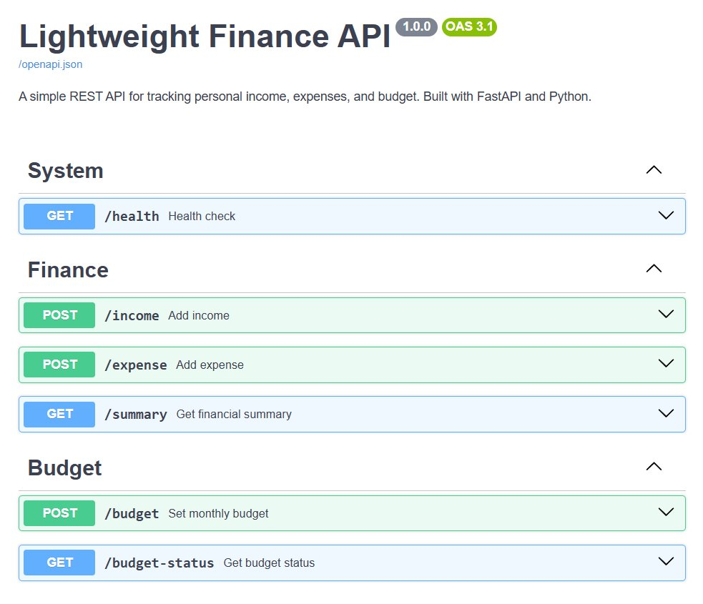

Screenshot 2 — Swagger UI schemas section
Auto-generated Pydantic response models visible in Schemas panel: Budget, BudgetStatusResponse, Expense, HTTPValidationError, Income, MessageResponse, SummaryResponse, ValidationError — all derived directly from models.py.

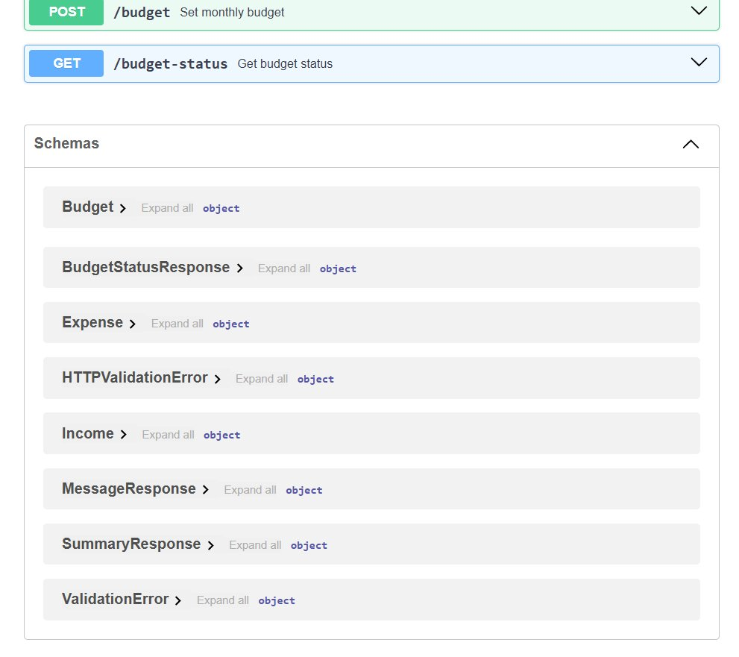

11.2 Frontend Dashboard (frontend/index.html)

Screenshot 3 — Dashboard overview
Top row: live stat cards showing balance ₹4,950 (green), total income ₹6,000, total expenses ₹1,050, budget remaining ₹3,950 of ₹5,000 limit. Middle left: expense bar chart by category (Rent, Groceries) with add expense/income forms. Middle right: budget ring showing 21% spent, API endpoint status panel with all 6 online (green dots).

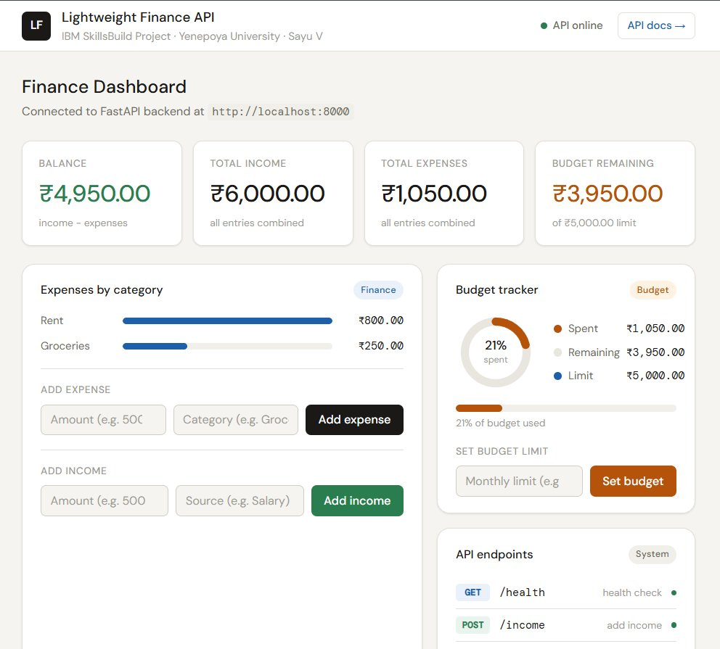

Screenshot 4 — Test suite, transactions, and project info
Bottom left: 20/20 test suite with 100% pass rate, all test names and categories displayed. Bottom centre: recent transactions log showing income (+) and expense (−) entries with the API endpoint called. Bottom right: project info panel with version, stack, author, IBM programme, and institution details.

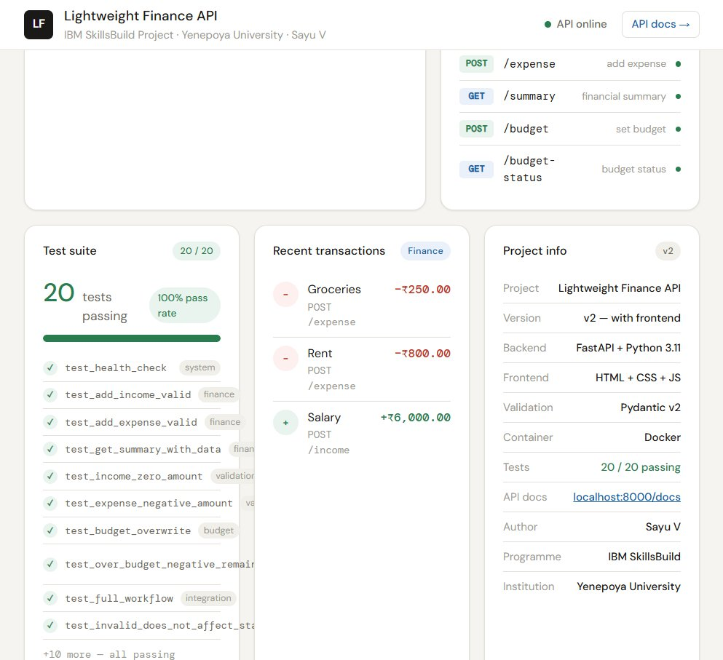

12. Customer Testing

Customer testing refers to end-user validation of the system — confirming that the API behaves correctly from the perspective of a person using it, not just a developer running automated tests. For this project, customer testing was conducted using the Swagger UI at http://localhost:8000/docs as the primary interface, which provides a no-code browser-based testing environment identical to what an API consumer would use.

The following customer test scenarios were conducted manually through the Swagger UI and later through the frontend dashboard:

Scenario | Steps | Expected Result | Actual Result
Add salary income | POST /income with amount:6000, source:Salary | 200 + success message | Pass — message returned correctly
Add grocery expense | POST /expense with amount:250, category:Groceries | 200 + success message | Pass — message returned correctly
Check balance | GET /summary after above entries | balance: 5750 | Pass — correct arithmetic
Set monthly budget | POST /budget with limit:5000 | 200 + budget set message | Pass — confirmed in budget-status
Check budget ring | GET /budget-status after ₹1050 spent | 21% spent, ₹3950 remaining | Pass — dashboard ring shows 21%
Try invalid amount | POST /income with amount:0 | HTTP 422 rejection | Pass — clear error returned
Over-budget scenario | Add expenses exceeding budget | Negative remaining balance, no crash | Pass — system handles gracefully
Frontend dashboard | Open frontend/index.html in browser | All cards update live on form submit | Pass — all 6 API calls confirmed

All customer test scenarios passed. The Swagger UI and frontend dashboard both provided clear, readable feedback for both success and error cases. No usability issues were identified during customer testing.

13. Evaluation — Results vs Objectives

All six primary objectives defined in DOC-01 (Project Proposal) were fully achieved:

Obj ID | Objective | Evidence | Status
OBJ-01 | 6 working API endpoints | TC-00 to TC-10 all pass; Swagger UI shows all 6 endpoints | ✅ Achieved
OBJ-02 | Pydantic v2 validation | 16 validation test cases pass; HTTP 422 verified for all error types | ✅ Achieved
OBJ-03 | Financial business logic | Balance, budget, remaining all correct in TC-05, TC-07, TC-35 | ✅ Achieved
OBJ-04 | Docker containerisation | TC-10: docker build + run verified; container serves all requests | ✅ Achieved
OBJ-05 | 9 professional documents | DOC-01 through DOC-09 — full lifecycle covered; IBM format followed | ✅ Achieved
OBJ-06 | Cloud-ready stateless design | Stateless confirmed; frontend dashboard added; CORS enabled | ✅ Achieved

14. Cloud Computing Relevance

Cloud Competency | How This Project Demonstrates It
REST API design | 6 endpoints applying correct HTTP verbs, status codes, and JSON response formats
Input validation | Pydantic v2 field constraints; 14 error conditions handled correctly
Containerisation | Docker image; single-command startup; maps to AWS ECS, Azure ACI
Stateless API design | No server-side session; horizontal scaling ready
Auto documentation | FastAPI generates OpenAPI 3.1 spec; Swagger UI and ReDoc available
Frontend integration | CORS-enabled API; browser dashboard using native fetch()
Professional documentation | 9 documents covering full software development lifecycle

15. Challenges Encountered

15.1 Breaking the build-first habit
The most significant challenge was methodological. Prior experience had established a habit of writing code first and documenting afterward. This project required resisting that impulse and spending the first sessions writing requirements and design documents before any code was written. The payoff: when coding began, every decision was already made and the implementation proceeded without structural rework.

15.2 Python global keyword in set_budget()
Python's scoping rules require the global keyword when assigning to a module-level variable inside a function. Without global budget, the assignment budget = data.limit created a local variable that disappeared on function exit. This caused GET /budget-status to always return 0. Resolved by adding global budget before the assignment in set_budget().

15.3 Docker networking — the 0.0.0.0 requirement
Early Docker testing showed the API unreachable at localhost:8000 despite the container appearing to run correctly. Uvicorn was binding to 127.0.0.1 (loopback) inside the container, which is unreachable from the host even with port mapping. Adding --host 0.0.0.0 to the Uvicorn CMD resolved this.

15.4 Python 3.15 compatibility
The development machine had Python 3.15 (a pre-release version) as the system Python. Pydantic-core does not yet have pre-built wheels for Python 3.15, causing pip install to fail. Resolved by installing Python 3.11 alongside and running all commands with py -3.11.

15.5 CORS for frontend-backend communication
The browser blocked fetch() calls from the HTML file to localhost:8000 due to cross-origin policy. Resolved by adding FastAPI's CORSMiddleware with allow_origins=['*'] to main.py. This must be placed after app = FastAPI() or a NameError occurs.

16. Conclusions

The Lightweight Finance API project successfully demonstrated the design, implementation, testing, and documentation of a production-pattern REST API within a student project context. The system delivers six fully functional endpoints, a 100% pass rate across 39 documented test cases and 20 automated pytest tests, a nine-document professional documentation suite, a containerised deployment runnable with a single Docker command, and a live frontend dashboard connecting to the real API.

Beyond the technical deliverables, this project demonstrates the value of methodological discipline. The documentation-first approach produced a codebase that matches its documentation precisely, a test suite that traces every test case to a specific functional requirement, and an architecture ready for incremental improvement. The addition of the frontend dashboard in v2 demonstrated that the stateless, CORS-aware API design was correctly built for consumption by external clients.

Final statement
This project is not just a working API. It is a demonstration of how to approach software development: define requirements before writing code, document decisions as they are made, validate every claim with evidence, and build in a way that the next version is already planned. That discipline — more than any individual technical skill — is what this project set out to develop and what it has achieved.

17. Further Development

Priority | Enhancement | Description
v2 — High | PostgreSQL + SQLModel | Replace in-memory lists with a real database. Data persists across restarts.
v2 — High | JWT Authentication | Bearer token auth via python-jose. Protect write endpoints. Enable multi-user.
v2 — Medium | GET /income + GET /expense | Retrieval endpoints returning stored records with labels for display.
v2 — Medium | Per-category budgets | Budget limits per category (Food: ₹3000, Transport: ₹1000).
v2 — Medium | React dashboard | Rebuild frontend in React + Recharts for richer chart components.
v3 | Cloud deployment | Deploy Docker image to AWS ECS or Azure ACI with HTTPS and health probes.
v3 | Structured logging | JSON application logs for aggregation by CloudWatch or Azure Monitor.

References

External references:

Reference | Source
FastAPI Documentation | https://fastapi.tiangolo.com
Pydantic v2 Documentation | https://docs.pydantic.dev
Docker Documentation | https://docs.docker.com
Python 3.11 Documentation | https://docs.python.org/3.11
Fielding, R.T. (2000) Architectural Styles and the Design of Network-based Software Architectures | University of California, Irvine doctoral dissertation
JetBrains Python Developers Survey (2023) | https://www.jetbrains.com/lp/python-developers-survey-2023
IBM SkillsBuild Programme | https://skillsbuild.org
GitHub Repository | https://github.com/Sayu-V/Lightweight-Finance-API

Appendix A — Document Suite Summary

Doc ID | Document | Format | Key Content
DOC-01 | Project Proposal | Word .docx | Problem, objectives, methodology, timeline, expected outcomes
DOC-02 | PRD | Word .docx | 30 FR requirements, 8 user stories, 14 acceptance criteria, data models
DOC-03 | HLD | Word .docx | 4-layer architecture, component descriptions, data flow traces, cloud readiness
DOC-04 | LLD | Word .docx | 6 endpoint contracts, Pydantic models, pseudocode, error catalogue, full source code
DOC-05 | API Reference | Markdown .md | Copy-paste curl commands, JSON examples, error reference, 6-step test sequence
DOC-06 | Deployment Guide | Markdown .md | Local + Docker run instructions, Dockerfile explained, 8 troubleshooting scenarios
DOC-07 | Test Report | Markdown .md | 39 test cases with exact I/O, 20-test pytest suite, 100% FR coverage matrix
DOC-08 | Final Report | Word .docx | Synthesis of project lifecycle, IBM format compliant, screenshots, challenges, future
DOC-09 | Presentation | PowerPoint .pptx | 12-slide deck: problem to solution to architecture to demo to results to future

— END OF DOCUMENT —

