ARCHITECTURE & TECH STACK
Expense & Income Tracker Application
Version 1.0 | Patterns · Stack Justification · ADRs · Deployment Design

Document | Architecture & Tech Stack Design
Project | Expense & Income Tracker — Full-Stack Rebuild
Version | 1.0 | Initial Release
Author | Sayu-V | Yenepoya University
Relates to | PRD v2.1 · HLD v1.0 · LLD v1.0 | IBM Student Project
Date | 19 March 2026
Status | APPROVED — Proceed to Build
Contents | Full-stack architecture · 4 architecture diagrams · Tech stack with justification · Technology comparison matrices · 8 architectural patterns · Architecture decision records (ADRs)

1. Purpose & Scope

This document provides the complete architectural view of the Expense & Income Tracker application. It explains not just what technologies were chosen, but why — with comparison matrices against alternatives. This document is intended for the IBM project reviewer, examiner, and any future developer who needs to understand the engineering rationale behind every major decision.

The document covers four perspectives:
- Structural — how the system is organised into tiers and layers
- Technology — what tools are used and why they beat their alternatives
- Pattern — which recognised software engineering patterns are applied
- Decision — formal Architecture Decision Records (ADRs) for key choices

2. Full Stack Architecture Overview

The system follows a three-tier architecture — Presentation, Application, and Data — each running as an isolated Docker container. Within the Application tier, a strict layered architecture further separates HTTP routing, schema validation, business logic, and data access. This dual layering (tier + layer) provides clean separation of concerns at both the deployment and code level.

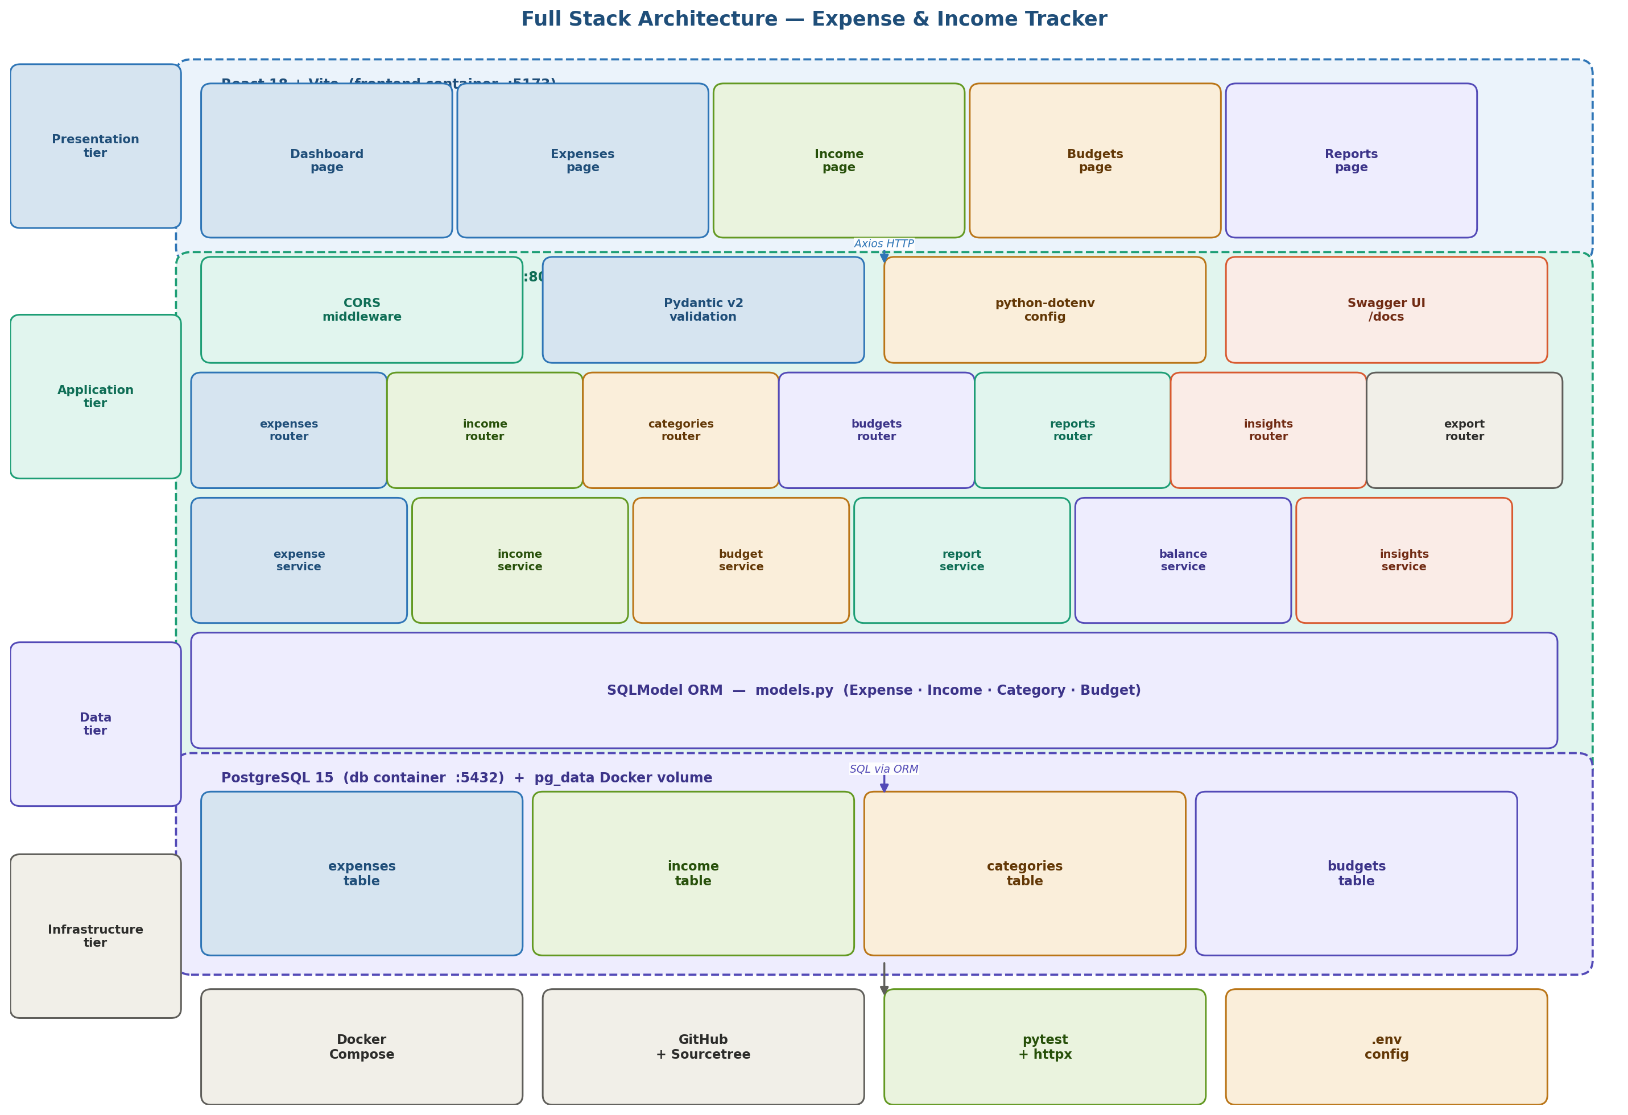
Figure 1: Full stack architecture — four tiers (Presentation, Application, Data, Infrastructure) with internal layer breakdown, Docker containers, and inter-tier communication paths.

2.1 Tier definitions
Tier | Container | Technology | Responsibility
Presentation | frontend :5173 | React 18 + Vite | All UI rendering, user interaction, charting, navigation
Application | backend :8000 | FastAPI + Python 3.11 | API routing, validation, all business logic, AI insights
Data | db :5432 | PostgreSQL 15 | Persistent storage of all expenses, income, categories, budgets
Infrastructure | Host machine | Docker Compose + GitHub | Container orchestration, version control, testing, config

3. Architectural Patterns Applied

Eight recognised software engineering patterns are applied in this project. Each pattern was chosen deliberately to solve a specific problem — not added for complexity. An IBM reviewer or examiner should be able to point to any part of the codebase and trace it back to one of these patterns.

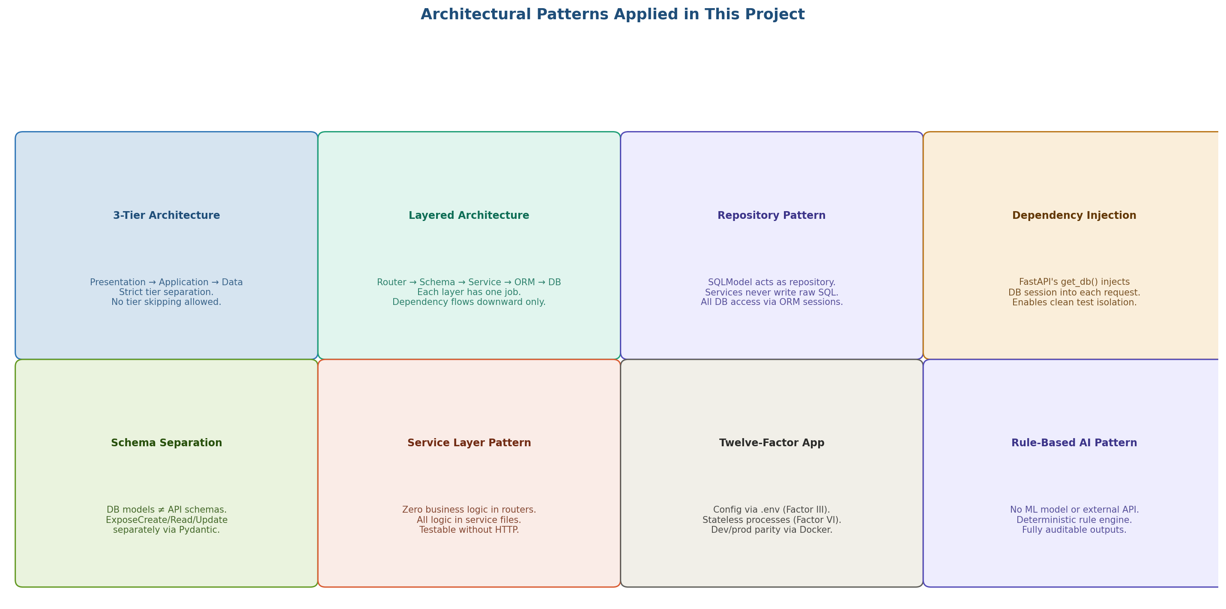
Figure 2: Eight architectural patterns applied in this project — each addresses a specific design concern.

Pattern | Where applied | Problem it solves
3-Tier Architecture | Frontend / Backend / Database containers | Separates UI, logic, and storage. Each tier deployable independently.
Layered Architecture | Router → Schema → Service → ORM → DB | Prevents spaghetti dependencies. Each layer has one job.
Repository Pattern | SQLModel ORM as the data access layer | Services never write raw SQL. All DB access via a consistent interface.
Dependency Injection | FastAPI get_db() injected into routes | DB sessions created per-request and automatically closed. Clean test isolation.
Schema Separation | Separate Create/Update/Read Pydantic models | DB shape ≠ API shape. Internal fields never accidentally exposed.
Service Layer Pattern | expense_service.py, income_service.py, etc. | Zero business logic in routers. Services testable without HTTP context.
Twelve-Factor App | .env config, Docker, stateless processes | Environment parity, externalized config, reproducible builds.
Rule-Based AI Pattern | insights_service.py — 11 deterministic rules | No external API dependency, no latency, fully auditable outputs for IBM review.

4. Technology Stack Map

The diagram below maps every tool in the stack by its role and category. Each technology serves exactly one purpose — there is no overlap and no redundancy.

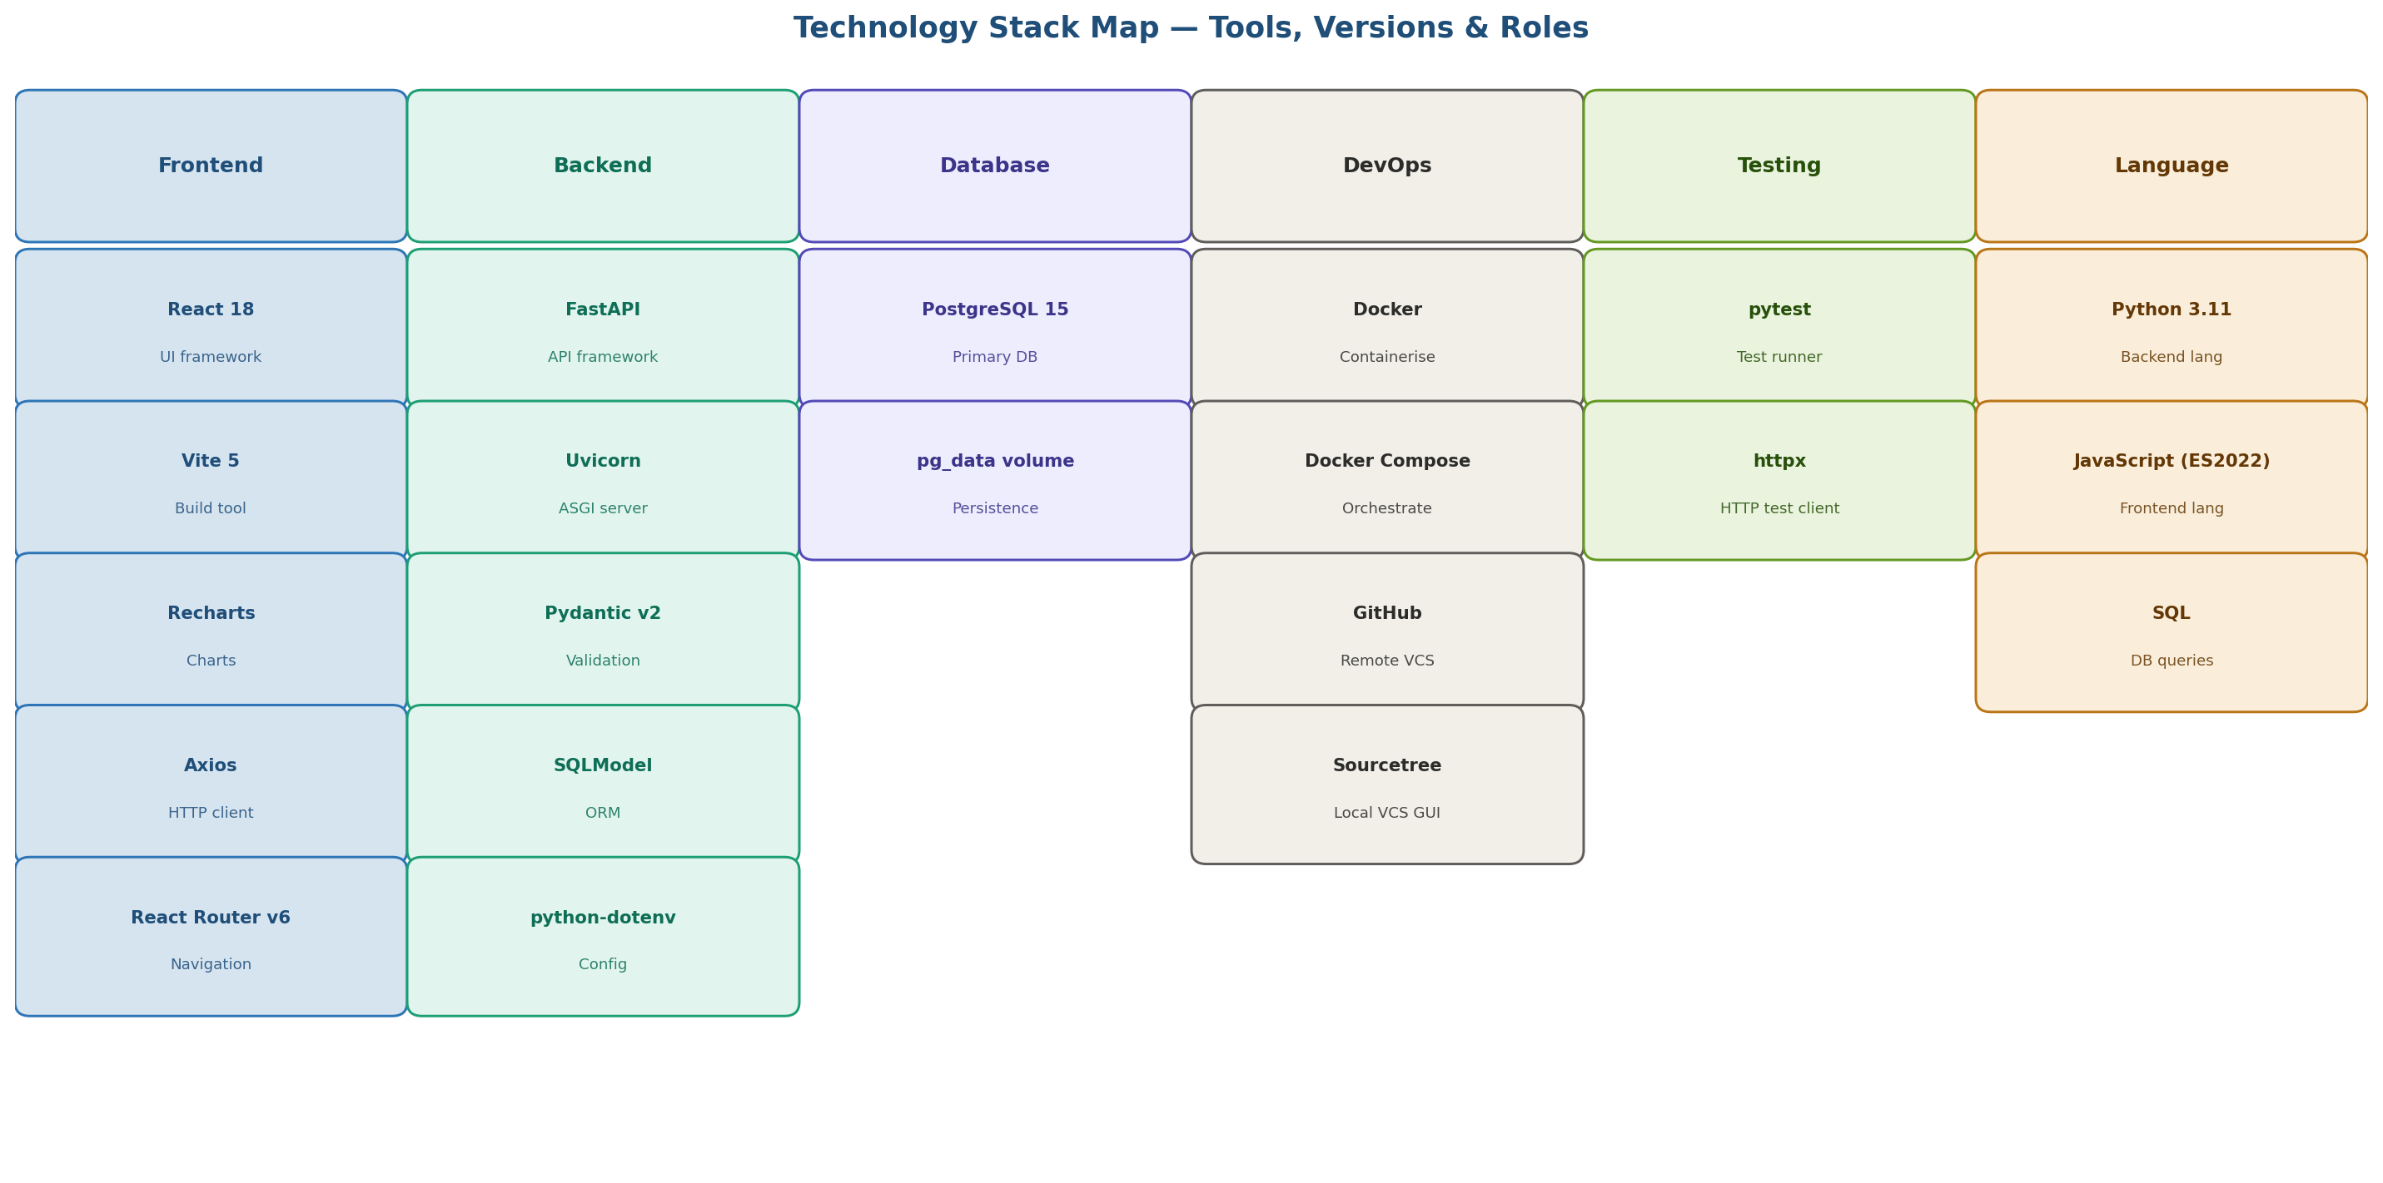
Figure 3: Technology stack map — all tools grouped by category (Frontend, Backend, Database, DevOps, Testing, Language) with their specific roles.

5. Complete Tech Stack — Justified Decisions

Every technology choice below was evaluated against at least two alternatives. The 'Why not' column records what was considered and rejected, which is as important as what was chosen.

5.1 Backend stack
Layer | Chosen | Version | Justification
API framework | FastAPI | 0.110+ | Async-native, automatic OpenAPI/Swagger docs, Pydantic integration, fastest Python framework for IBM review demonstrations. 3–5× faster than Flask in benchmarks.
ASGI server | Uvicorn | 0.29+ | Recommended by FastAPI. Handles concurrent requests via asyncio. Auto-reload in dev mode (--reload flag).
Validation | Pydantic v2 | 2.6+ | Built into FastAPI. Rust-compiled core (10× faster than v1). Field-level error messages. Powers both request validation and settings management.
ORM | SQLModel | 0.0.16+ | Single class definition serves as both Pydantic model and SQLAlchemy table. Eliminates the duplication present in using SQLAlchemy + marshmallow separately.
Config | python-dotenv | 1.0+ | Reads .env file into environment variables. Keeps all secrets out of source code. Gitignored by default.
Language | Python 3.11 | 3.11 | Native async/await. Fastest CPython release (25% speed gain over 3.10). Industry standard for backend APIs. IBM-approved language.

5.2 Frontend stack
Layer | Chosen | Version | Justification
UI framework | React 18 | 18.x | Component-based architecture. Largest ecosystem of any JS framework. Hooks provide clean state management without Redux at this scale. IBM familiarity.
Build tool | Vite 5 | 5.x | 10–100× faster than Webpack for development hot reload. Native ES modules. Production bundles optimised via Rollup.
Charts | Recharts | 2.x | Built specifically for React using SVG. Declarative API matches React's component model. Includes all chart types needed: pie, bar, line, progress. Lightweight (150KB).
HTTP client | Axios | 1.x | Interceptors allow centralised error handling. Automatic JSON parsing. Better error objects than native fetch. Widely understood.
Routing | React Router v6 | 6.x | Industry standard for React SPAs. Nested routes for Dashboard/Expenses/Income/Budgets/Reports pages.
Language | JavaScript ES2022 | ES2022 | TypeScript was considered but adds build complexity without significant benefit for a single-developer project at this scope.

5.3 Data & infrastructure stack
Layer | Chosen | Version | Justification
Database | PostgreSQL | 15 | ACID-compliant, relational, production-grade. Matches IBM submission requirements. Superior to MongoDB for structured financial data with relational queries (SUM by category, JOIN for budget status).
Containerisation | Docker | 24+ | Eliminates 'works on my machine' problem. Reproducible build for IBM submission. docker compose up --build is the single command that starts the entire stack.
Orchestration | Docker Compose | v2 | Manages three containers (frontend, backend, db) with dependency ordering, shared network, and volume management in a single YAML file.
VCS remote | GitHub | — | Provides cloud backup, commit history for IBM review, branching (main/dev/feature/*), and release tags (v0.1 → v1.0).
VCS GUI | Sourcetree | 4.x | Free Atlassian Git GUI. Visual branch management, commit staging, push/pull without CLI. Prevents accidental force-pushes to main.
Testing | pytest + httpx | latest | pytest is the Python testing standard. httpx's TestClient creates a real in-process FastAPI server for integration tests — no mock needed.

6. Technology Comparison — Why Not the Alternatives?

The scoring charts below compare the chosen technology against the two most common alternatives across five criteria scored 0–10. The chosen technology is shown in full colour; alternatives are dimmed.

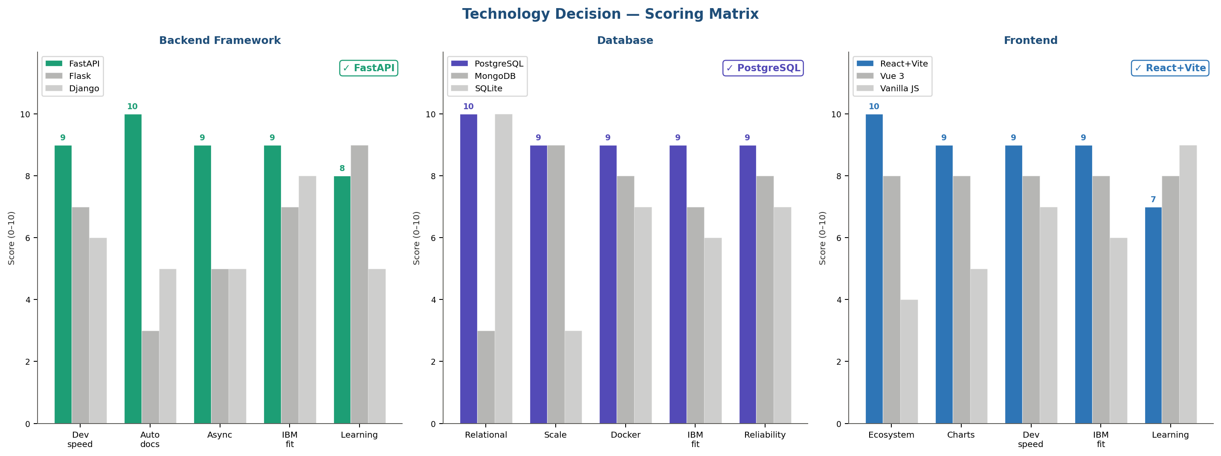
Figure 4: Technology scoring matrices — FastAPI vs Flask vs Django, PostgreSQL vs MongoDB vs SQLite, React+Vite vs Vue 3 vs Vanilla JS. Scores across Dev Speed, Auto Docs, Async, IBM Fit, and more.

6.1 Backend framework decision
Criterion | FastAPI (chosen) | Flask | Django
Auto Swagger docs | Built-in | Plugin needed | DRF addon needed
Async support | Native | With asyncio only | Limited
Pydantic integration | Native | Manual | Manual
Lines of code | Fewest | Medium | Most (ORM, admin, auth)
IBM suitability | High | High | High
Verdict | CHOSEN — best balance of speed and automatic documentation | Good, but requires more boilerplate | Overkill for single-user scope

6.2 Database decision
Criterion | PostgreSQL (chosen) | MongoDB | SQLite
ACID transactions | Full | Partial (WiredTiger) | Full
Financial queries | Excellent | Requires aggregation | Good
Docker image | Official :15 | Official | File-based
IBM match | Explicitly req. | Not mentioned | Not production-grade
Data structure | Relational (correct fit) | Document (poor fit) | Relational
Verdict | CHOSEN — relational data model, IBM requirement, Docker-native | Wrong data model for financial records | Not suitable for production submission

6.3 Frontend framework decision
Criterion | React + Vite (chosen) | Vue 3 | Vanilla JS
IBM recognition | Highest | Good | Universal
Chart ecosystem | Recharts (perfect fit) | Vue-chartjs | Chart.js (manual)
Component model | Excellent | Excellent | Manual DOM
Build speed (dev) | Vite: instant HMR | Vite compatible | No build needed
Talent pool | Largest | Growing | Universal
Verdict | CHOSEN — largest ecosystem, Recharts fit, IBM-familiar | Valid but smaller ecosystem | Insufficient for 9-widget dashboard

7. Frontend Architecture — React Component Design

The React frontend is structured around pages and reusable components. State is managed with local hooks — no global state manager is needed at this scope. All API calls are centralised in the /src/api/ folder so the base URL is configured in one place.

7.1 Page structure
Page / Route | File | Components / Widgets
Dashboard / | pages/Dashboard.jsx | TotalSpendCard · TotalIncomeCard · NetBalanceCard · SpendByCategoryChart · BudgetVsActualChart · MonthlyTrendChart · RecentExpensesTable · RecentIncomeTable · AIInsightsPanel
Expenses /expenses | pages/Expenses.jsx | ExpenseList · ExpenseForm · ExpenseFilters · DeleteConfirmModal
Income /income | pages/Income.jsx | IncomeList · IncomeForm · IncomeFilters [NEW v2.0]
Budgets /budgets | pages/Budgets.jsx | BudgetList · BudgetForm · BudgetStatusBar
Reports /reports | pages/Reports.jsx | MonthlySummaryCard · CategoryBreakdown · IncomeBySource · SavingsRateTrend · TopExpenses · ExportButton

7.2 API layer — src/api/
File | Functions exported
expenses.js | getExpenses(), createExpense(), updateExpense(), deleteExpense(), exportExpensesCSV()
income.js | getIncome(), createIncome(), updateIncome(), deleteIncome(), exportIncomeCSV() [NEW]
budgets.js | getBudgets(), setBudget(), getBudgetStatus()
reports.js | getMonthlySummary(), getByCategory(), getIncomeBySource(), getTrend(), getSavingsRate()
balance.js | getBalance(), getBalanceTrend() [NEW]
insights.js | getInsights()

8. Backend Architecture — FastAPI Application Structure

The FastAPI application is structured as a clean Python package. The entry point (main.py) wires together routers, middleware, and startup events. The factory pattern keeps configuration testable and avoids import-time side effects.

8.1 main.py responsibilities
- Creates the FastAPI app instance with title, version, and description
- Registers all routers under the /api/v1 prefix
- Configures CORS to allow requests from localhost:5173
- Registers the global exception handler for unhandled errors
- Registers the startup event that creates DB tables if they don't exist
- Registers the category seeder that populates default categories on first run

8.2 Dependency injection chain
FastAPI's Depends() system wires the database session into each endpoint automatically:
Component | Role in injection chain
get_db() in database.py | Generator function. Opens a Session, yields it, closes it when the request ends. Ensures sessions are never leaked.
db: Session = Depends(get_db) | FastAPI resolves this in each route function. The same session instance is used throughout the entire request.
Service methods | Accept db: Session as a parameter. They do not open sessions themselves — they receive the injected session and use it.
conftest.py in tests/ | Overrides get_db() to inject a test SQLite session. This makes the entire test suite run without touching the real PostgreSQL database.

9. Data Architecture

9.1 Data model relationships
All four tables are independent — there are no foreign key relationships at the database level. Relationships are enforced at the service layer through category name matching. This design choice was deliberate: it keeps the schema simple, avoids CASCADE complexity, and allows categories to be renamed without cascading updates.

Table | Rows expected | Key index | Notes
expenses | Hundreds per month | date (index) | category is a string FK to categories.name — enforced by service, not DB constraint.
income | Tens per month | date (index) | source is validated against INCOME_SOURCES enum in Pydantic, not a DB foreign key.
categories | ~15 (mostly seeded) | name (unique index) | is_default=True rows cannot be deleted. Enforced at service layer.
budgets | ~10 per month | category+month+year (unique) | Composite unique constraint prevents duplicate budgets per category per month.

9.2 Data persistence strategy
- pg_data named Docker volume mounted at /var/lib/postgresql/data inside the db container
- Volume persists across docker compose down and docker compose up cycles
- Volume is only deleted with docker compose down -v (intentional wipe)
- No data migration tooling (Alembic) in v1 — schema created fresh on first run via SQLModel.metadata.create_all()
- Demo seed data script available for IBM review: seeds 3 months of sample expenses, income, and budgets

10. DevOps Architecture

10.1 Docker Compose service definitions
Service | Image | Ports | Depends on / Health
db | postgres:15-alpine | 5432:5432 | Health check: pg_isready -U postgres every 5s. Starts first.
backend | python:3.11-slim (custom) | 8000:8000 | depends_on: db (condition: service_healthy). Starts after DB is ready.
frontend | node:18-alpine (custom) | 5173:5173 | depends_on: backend. Starts last. VITE_API_URL injected as env.

10.2 Environment variables (.env)
Variable | Example value | Used by | Secret?
DATABASE_URL | postgresql://user:pass@db:5432/tracker | backend — SQLModel engine | Yes
POSTGRES_USER | tracker_user | db container — init | Yes
POSTGRES_PASSWORD | securepassword | db container — init | Yes
POSTGRES_DB | tracker_db | db container — init | No
VITE_API_URL | http://localhost:8000 | frontend — Axios base URL | No

.env file is gitignored. An .env.example file (no real values) is committed to the repository as a setup reference.

11. Architecture Decision Records (ADRs)

An Architecture Decision Record (ADR) documents a significant decision, the context that drove it, the options considered, and the rationale for the choice. ADRs provide a permanent record for IBM reviewers and future developers.

ADR-001 — Use FastAPI over Flask
Field | Detail
Status | Accepted
Context | Need a Python backend framework. Project requires auto-generated API documentation for IBM review demonstration.
Decision | Use FastAPI with Uvicorn as the ASGI server.
Alternatives | Flask (no auto-docs, sync-only by default), Django (full ORM + admin = overkill for single user, no auto OpenAPI)
Consequences | Swagger UI available at /docs automatically. Pydantic validation built in. All team members must use Python 3.11+.

ADR-002 — Use SQLModel over raw SQLAlchemy
Field | Detail
Status | Accepted
Context | FastAPI uses Pydantic for request/response models. SQLAlchemy is the standard Python ORM. Maintaining two separate model classes for the same entity causes duplication.
Decision | Use SQLModel — a library built by the FastAPI author that merges SQLAlchemy ORM and Pydantic into a single class definition.
Alternatives | SQLAlchemy + Pydantic separately (more code, sync issues), Tortoise ORM (async but less mature), Peewee (no Pydantic integration)
Consequences | Single model class per table. Less code. Minor: SQLModel is less mature than SQLAlchemy; some advanced SQLAlchemy features require workarounds.

ADR-003 — Separate Income as a distinct model (not a flag on Expense)
Field | Detail
Status | Accepted
Context | v2.0 adds income tracking. Option A: add a type='income'|'expense' flag to the existing transactions table. Option B: separate income table.
Decision | Option B — separate income table with its own fields (source vs category), its own service, its own router, and its own Pydantic schemas.
Alternatives | Single transactions table with type flag — simpler schema but forces nullable fields (source required for income, category required for expenses), messy queries.
Consequences | Slightly more code (one extra router, service, test file). Cleaner queries, no nulls, independently extensible, easier to add income-specific fields later.

ADR-004 — Rule-based AI insights over LLM API
Field | Detail
Status | Accepted
Context | PRD requires AI-based insights. Options: (A) call an external LLM API (OpenAI/Anthropic), (B) implement rule-based logic in Python.
Decision | Rule-based engine (Option B) — 11 deterministic rules implemented as pure Python in insights_service.py.
Alternatives | LLM API — requires API key, adds latency, costs money, non-deterministic outputs, fails without internet. Not appropriate for a local Docker submission.
Consequences | Outputs are fully deterministic and auditable for IBM review. No API key needed. Works offline. Slightly less flexible than an LLM, but more reliable and faster.

ADR-005 — No authentication in v1
Field | Detail
Status | Accepted
Context | PRD defines a single-user app running locally. IBM submission does not require multi-user support.
Decision | No JWT, no sessions, no login in v1. API is open on localhost.
Alternatives | JWT + FastAPI security — adds 2–3 days of development time, adds complexity to frontend, and provides no practical security benefit for a local single-user demo.
Consequences | Faster delivery. Simpler frontend (no auth context). Architecture is designed to accept auth as a middleware layer in v2 without touching services or DB schema.

12. Document Sign-Off

Role | Name | Date | Status
Author | Sayu-V | 19/3/2026 | ✅ Approved
Reviewer | IBM Project Guide | Pending | ⏳ Pending

Next documents: Security Design, then Database Design — both complete the planning phase before coding begins.

END OF DOCUMENT

