DATABASE DESIGN
Expense & Income Tracker Application
Version 1.0 | ERD · Table Schemas · Indexes · Constraints · Queries · Normalisation

Document | Database Design
Project | Expense & Income Tracker — Full-Stack Rebuild
Version | 1.0 | Initial Release
Author | Sayu-V | Yenepoya University
Relates to | PRD v2.1 · HLD v1.0 · LLD v1.0 · Architecture v1.0 · Security Design v1.0
Database | PostgreSQL 15 | SQLModel ORM | Docker pg_data volume
Date | 19 March 2026
Status | APPROVED — Proceed to Build
Contents | ERD (Entity Relationship Diagram) · 4 table schemas with all columns · Index strategy · Constraints & integrity rules · Key SQL queries · Default seed data · Data volume estimates · Normalisation analysis (1NF/2NF/3NF) · Persistence & backup strategy · SQLModel CREATE TABLE statements

1. Purpose & Database Overview

This document defines the complete database design for the Expense & Income Tracker application. It covers every table, every column, every index, and every constraint. A developer should be able to create the entire database schema from this document alone without reading any code.

Property | Value
Database engine | PostgreSQL 15
ORM | SQLModel 0.0.16+ (SQLAlchemy + Pydantic unified)
Number of tables | 4 — expenses, income, categories, budgets
Persistence | Docker named volume: pg_data (survives container restarts)
Schema creation | SQLModel.metadata.create_all(engine) on first startup — no manual migration needed
Character set | UTF-8 (PostgreSQL default)
Timezone | UTC for all TIMESTAMP columns — converted to local in frontend
DB user permissions | SELECT, INSERT, UPDATE, DELETE only — not SUPERUSER, CREATE, DROP

2. Entity Relationship Diagram

The ERD below shows all four tables with their columns, data types, and key constraints. Relationships between tables are logical (enforced at the service layer) rather than physical foreign keys — a deliberate design decision explained in Section 7.

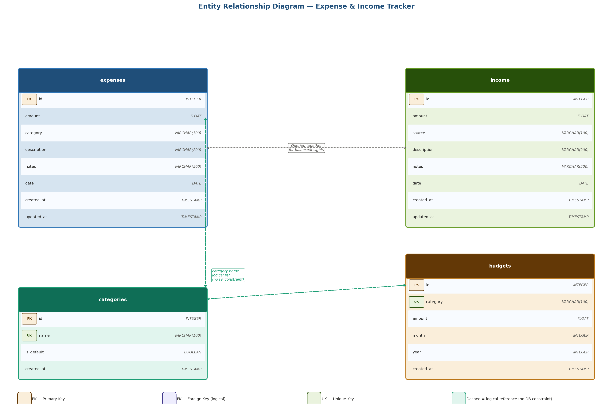
Figure 1: Entity Relationship Diagram — expenses, income, categories, budgets. Dashed lines show logical relationships enforced by the service layer, not database foreign key constraints.

2.1 Relationship summary
Relationship | Type | Enforcement | Rationale
expenses.category → categories.name | Many-to-one (logical) | Service layer validation | No FK — allows category rename without cascades
budgets.category → categories.name | Many-to-one (logical) | Service layer validation | Same rationale — avoids cascade complexity
expenses ↔ income (by date) | No join — queried together | UNION in balance queries | Independent records, combined only in reports
budgets ↔ expenses (by category+month) | Aggregated join | LEFT JOIN in budget status query | Budget status = budget.amount vs SUM(expenses)

3. Table Schemas — Complete Column Definitions

3.1 expenses
Stores all expense records. The primary table for the application's core functionality.

Column | Type | Null? | Default | Constraint / Notes
id | INTEGER | NOT NULL | AUTO-INCREMENT | Primary key. Auto-generated by PostgreSQL sequence.
amount | FLOAT | NOT NULL | — | Must be > 0. Max 10 digits, 2 decimal places. Validated by Pydantic before insert.
category | VARCHAR(100) | NOT NULL | — | Must match an existing category name. Validated at service layer. Indexed for GROUP BY queries.
description | VARCHAR(200) | NOT NULL | — | Short description of the expense. Min length 1, max 200.
notes | VARCHAR(500) | NULL | NULL | Optional free-text notes field. Stored as NULL when not provided.
date | DATE | NOT NULL | — | The date of the expense (YYYY-MM-DD). Cannot be in the future. Indexed for date range queries.
created_at | TIMESTAMP | NOT NULL | NOW() | Server-side timestamp when record was created. Set automatically — cannot be overridden via API.
updated_at | TIMESTAMP | NOT NULL | NOW() | Server-side timestamp of last update. Refreshed on every PUT request.

-- PostgreSQL DDL (generated by SQLModel)
CREATE TABLE expenses (
id SERIAL PRIMARY KEY,
amount FLOAT NOT NULL CHECK (amount > 0),
category VARCHAR(100) NOT NULL,
description VARCHAR(200) NOT NULL,
notes VARCHAR(500),
date DATE NOT NULL,
created_at TIMESTAMP NOT NULL DEFAULT NOW(),
updated_at TIMESTAMP NOT NULL DEFAULT NOW()
);
CREATE INDEX ix_expenses_date ON expenses (date);
CREATE INDEX ix_expenses_category ON expenses (category);

3.2 income [NEW — v2.0]
Stores all income records. Structurally mirrors the expenses table with source replacing category.

Column | Type | Null? | Default | Constraint / Notes
id | INTEGER | NOT NULL | AUTO-INCREMENT | Primary key. Auto-generated.
amount | FLOAT | NOT NULL | — | Must be > 0. Pydantic validated. Max 10 digits, 2 decimal places.
source | VARCHAR(100) | NOT NULL | — | Income source type. Must be one of: Salary, Freelance, Business, Investment, Gift, Other. Validated by Pydantic @field_validator.
description | VARCHAR(200) | NOT NULL | — | Short description of the income. Min length 1, max 200.
notes | VARCHAR(500) | NULL | NULL | Optional notes. Stored as NULL when not provided.
date | DATE | NOT NULL | — | The date the income was received. Indexed for balance queries and trend reports.
created_at | TIMESTAMP | NOT NULL | NOW() | Auto-set at creation. Cannot be overridden via API.
updated_at | TIMESTAMP | NOT NULL | NOW() | Refreshed on every PUT request.

CREATE TABLE income (
id SERIAL PRIMARY KEY,
amount FLOAT NOT NULL CHECK (amount > 0),
source VARCHAR(100) NOT NULL,
description VARCHAR(200) NOT NULL,
notes VARCHAR(500),
date DATE NOT NULL,
created_at TIMESTAMP NOT NULL DEFAULT NOW(),
updated_at TIMESTAMP NOT NULL DEFAULT NOW()
);
CREATE INDEX ix_income_date ON income (date);
CREATE INDEX ix_income_source ON income (source);

3.3 categories
Stores the valid expense category names. Seeded with defaults on first startup. Custom categories can be added via the API.

Column | Type | Null? | Default | Constraint / Notes
id | INTEGER | NOT NULL | AUTO-INCREMENT | Primary key.
name | VARCHAR(100) | NOT NULL | — | Unique category name. Unique index enforces no duplicates. Used as the reference value in expenses.category and budgets.category.
is_default | BOOLEAN | NOT NULL | FALSE | TRUE for seeded categories (Food, Transport, etc.). Default categories cannot be deleted — enforced at service layer.
created_at | TIMESTAMP | NOT NULL | NOW() | Auto-set at creation.

CREATE TABLE categories (
id SERIAL PRIMARY KEY,
name VARCHAR(100) NOT NULL,
is_default BOOLEAN NOT NULL DEFAULT FALSE,
created_at TIMESTAMP NOT NULL DEFAULT NOW()
);
CREATE UNIQUE INDEX ix_categories_name ON categories (name);

3.4 budgets
Stores monthly budget amounts per category. The composite unique constraint ensures one budget per category per month/year combination.

Column | Type | Null? | Default | Constraint / Notes
id | INTEGER | NOT NULL | AUTO-INCREMENT | Primary key.
category | VARCHAR(100) | NOT NULL | — | The category this budget applies to. Must match a valid category name. Part of the composite unique constraint.
amount | FLOAT | NOT NULL | — | The budget amount for this category in this month. Must be > 0.
month | INTEGER | NOT NULL | — | Month number 1–12. Pydantic validates ge=1, le=12. Part of composite unique constraint.
year | INTEGER | NOT NULL | — | 4-digit year. Pydantic validates ge=2020. Part of composite unique constraint.
created_at | TIMESTAMP | NOT NULL | NOW() | Auto-set at creation. Updated on upsert.

CREATE TABLE budgets (
id SERIAL PRIMARY KEY,
category VARCHAR(100) NOT NULL,
amount FLOAT NOT NULL CHECK (amount > 0),
month INTEGER NOT NULL CHECK (month BETWEEN 1 AND 12),
year INTEGER NOT NULL CHECK (year >= 2020),
created_at TIMESTAMP NOT NULL DEFAULT NOW()
);
CREATE UNIQUE INDEX ix_budgets_cat_month_year
ON budgets (category, month, year);

The budgets table uses an upsert pattern: if a budget already exists for a category+month+year, the PUT /api/v1/budgets endpoint updates the amount rather than creating a duplicate. This is enforced by the unique index and handled in budget_service.py.

4. Index Strategy

Indexes are the primary mechanism for query performance. Each index below was chosen based on the actual query patterns used by the application — not added speculatively.

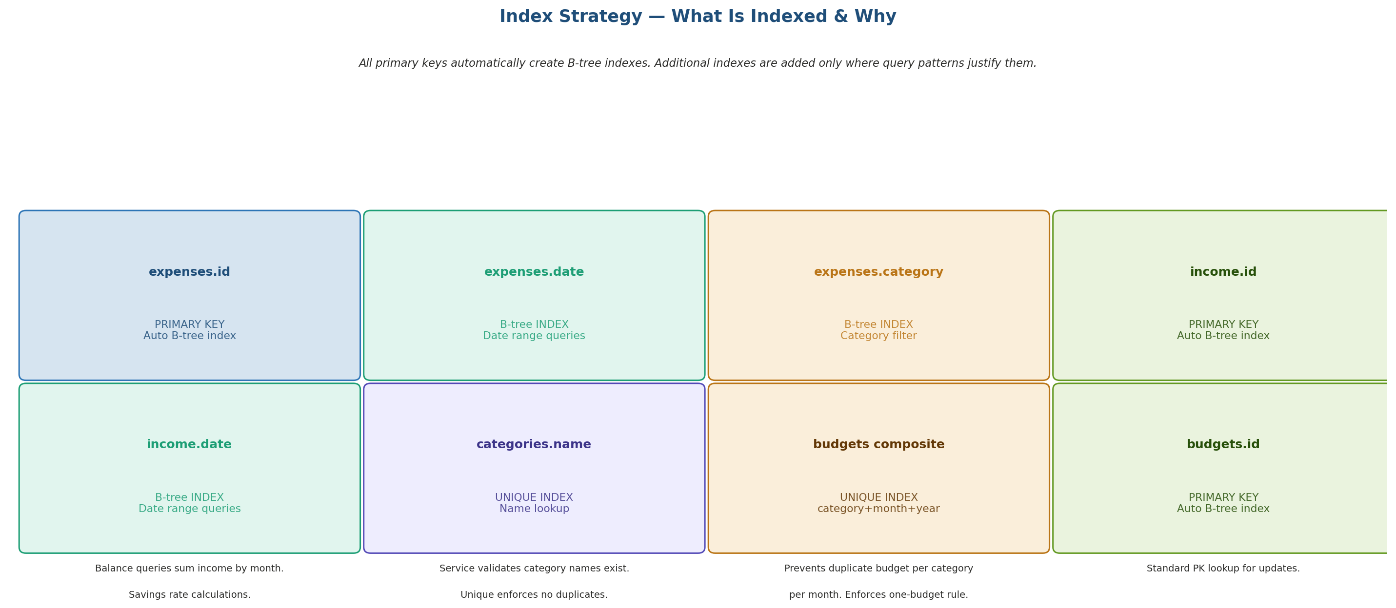
Figure 2: Index strategy — 8 indexes across 4 tables. Primary key indexes are automatic. Additional indexes target date range queries, category grouping, and unique enforcement.

4.1 Index register
Index name | Table | Type | Query it optimises
expenses_pkey | expenses | B-tree (PK) | GET /expenses/{id}, DELETE /expenses/{id} — O(log n) lookup by primary key
ix_expenses_date | expenses | B-tree | All date-range queries: monthly summaries, trend reports, date_from/date_to filters. Most frequently hit index.
ix_expenses_category | expenses | B-tree | GROUP BY category in budget status query and category breakdown reports. Insights engine category iteration.
income_pkey | income | B-tree (PK) | GET /income/{id}, DELETE /income/{id}
ix_income_date | income | B-tree | Balance queries SUM income by month. Savings rate trend. Same pattern as ix_expenses_date.
ix_income_source | income | B-tree | GET /reports/income-by-source — GROUP BY source.
ix_categories_name | categories | Unique B-tree | Service-layer category name validation lookups. UNIQUE constraint prevents duplicates.
ix_budgets_cat_month_year | budgets | Composite Unique | Upsert check: does budget exist for this category+month+year? UNIQUE enforces one-budget-per-period rule.

5. Constraints & Data Integrity

Constraints are enforced at two levels: at the database level (CHECK constraints, UNIQUE constraints, NOT NULL) and at the application level (Pydantic validators, service layer checks). This two-layer approach means invalid data is caught as early as possible — ideally at the API boundary before it ever reaches the database.

5.1 Database-level constraints
Table.Column | Constraint | Value | Why
expenses.amount | CHECK | amount > 0 | Prevents zero or negative expense entries which would corrupt analytics calculations.
income.amount | CHECK | amount > 0 | Same rationale — income must be a positive value.
budgets.amount | CHECK | amount > 0 | A budget of zero has no meaning — prevents accidental zero budget creation.
budgets.month | CHECK | 1 ≤ month ≤ 12 | Prevents invalid month values that would corrupt trend queries.
budgets.year | CHECK | year ≥ 2020 | Prevents obviously wrong year values.
categories.name | UNIQUE | Unique per row | A category name must be unique. Prevents duplicate 'Food' categories.
budgets(category,month,year) | UNIQUE composite | Unique combination | One budget per category per month. Enforces the upsert rule at DB level.
All tables — id | PRIMARY KEY | Unique, NOT NULL | Standard PK — guarantees each row has a unique identifier.
All tables — required cols | NOT NULL | Non-nullable | Core fields (amount, category/source, description, date) cannot be NULL — enforces data completeness.

5.2 Application-level constraints (Pydantic)
Field | Validator | Rule
expenses.date | @field_validator | date <= today — expense date cannot be in the future. Database CHECK cannot enforce this (requires NOW()).
income.source | @field_validator | Must be in INCOME_SOURCES list: [Salary, Freelance, Business, Investment, Gift, Other]. Controlled vocabulary enforcement.
description | min_length=1 | Non-empty string. Database NOT NULL alone allows empty strings — min_length=1 catches them at API boundary.
category (service) | Service check | category_service.exists(name) called before expense/budget creation. Returns 400 if category not found.
categories.is_default | Service check | DELETE /categories/{id} blocked if is_default=True. Returns 400: 'Cannot delete a default category'.

6. Key SQL Queries

These are the most important SQL queries executed by the application. All queries are generated by SQLModel — the SQL below shows what SQLModel produces. Parameterised placeholders ($1, $2 etc.) are used for all user input — never string interpolation.

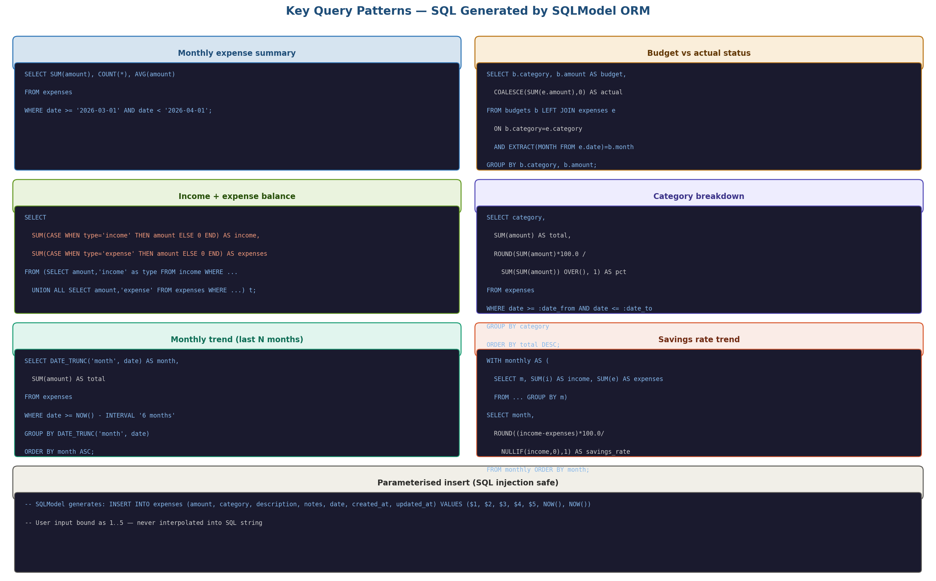
Figure 3: Key SQL query patterns — monthly summary, budget vs actual join, income+expense balance union, category breakdown, monthly trend, and savings rate. All use parameterised inputs.

6.1 Monthly expense summary
-- Used by: GET /api/v1/reports/monthly-summary
SELECT
COUNT(*) AS expense_count,
SUM(amount) AS total_expenses,
AVG(amount) AS avg_expense,
MAX(amount) AS max_expense
FROM expenses
WHERE date >= $1 -- first day of month (e.g. 2026-03-01)
AND date < $2; -- first day of next month (e.g. 2026-04-01)

6.2 Budget vs actual status
-- Used by: GET /api/v1/budgets/status
SELECT
b.category,
b.amount AS budget,
COALESCE(SUM(e.amount), 0) AS actual,
b.amount - COALESCE(SUM(e.amount),0) AS remaining,
ROUND(COALESCE(SUM(e.amount),0) * 100.0 / b.amount, 1) AS pct_used
FROM budgets b
LEFT JOIN expenses e
ON e.category = b.category
AND EXTRACT(MONTH FROM e.date) = b.month
AND EXTRACT(YEAR FROM e.date) = b.year
WHERE b.month = $1 AND b.year = $2
GROUP BY b.category, b.amount
ORDER BY pct_used DESC;

6.3 Net balance (income minus expenses) [NEW]
-- Used by: GET /api/v1/balance
WITH monthly_income AS (
SELECT COALESCE(SUM(amount), 0) AS total
FROM income
WHERE date >= $1 AND date < $2
),
monthly_expenses AS (
SELECT COALESCE(SUM(amount), 0) AS total
FROM expenses
WHERE date >= $1 AND date < $2
)
SELECT
i.total AS total_income,
e.total AS total_expenses,
i.total - e.total AS net_balance,
CASE WHEN i.total > 0
THEN ROUND((i.total - e.total)*100.0 / i.total, 1)
ELSE 0
END AS savings_rate
FROM monthly_income i, monthly_expenses e;

6.4 Category breakdown with percentage
-- Used by: GET /api/v1/reports/by-category
SELECT
category,
SUM(amount) AS total,
ROUND(SUM(amount)*100.0 / SUM(SUM(amount)) OVER(), 1) AS pct_of_total
FROM expenses
WHERE date >= $1 AND date <= $2
GROUP BY category
ORDER BY total DESC;

6.5 Monthly trend — last N months
-- Used by: GET /api/v1/reports/trend (N=6 default)
SELECT
DATE_TRUNC('month', date) AS month,
SUM(amount) AS total_expenses
FROM expenses
WHERE date >= (CURRENT_DATE - INTERVAL '5 months')
AND date < DATE_TRUNC('month', CURRENT_DATE) + INTERVAL '1 month'
GROUP BY DATE_TRUNC('month', date)
ORDER BY month ASC;
-- Same query runs for income to produce dual-line chart data

7. Design Decision — Logical vs Physical Relationships

A deliberate decision was made to enforce category relationships at the service layer rather than using PostgreSQL foreign key constraints. This section documents the rationale.

Option | Foreign key approach | Service-layer approach (chosen)
Category rename | Requires UPDATE CASCADE — every expense row updated | Only categories row updated — expenses reference by name
Category delete | Blocked by RESTRICT or cascades DELETE of all expenses | Service checks is_default; custom categories delete cleanly
Query complexity | JOIN needed for every expense query to resolve category_id | category is already a readable string — no JOIN needed
Data integrity | DB-enforced — strongest guarantee | Service-enforced — requires disciplined service code
Verdict | Correct for large multi-user systems | Correct for this single-user, small-scale application

If this application were to scale to multi-user with millions of rows, introducing a category_id foreign key would be the right evolution. The current schema is designed to make that migration straightforward.

8. Default Seed Data

On first application startup, the backend checks if the categories table is empty and seeds it with the default categories below. This happens via a FastAPI startup event in main.py — no separate migration script is needed.

8.1 Default expense categories
name | is_default | Typical use cases
Food | TRUE | Groceries, restaurants, takeaway, coffee
Transport | TRUE | Fuel, public transit, ride-hailing, parking
Housing | TRUE | Rent, utilities, maintenance, repairs
Health | TRUE | Medical, pharmacy, dental, gym
Entertainment | TRUE | Streaming, cinema, events, hobbies
Education | TRUE | Courses, books, subscriptions, tuition
Utilities | TRUE | Electricity, water, internet, phone
Shopping | TRUE | Clothing, electronics, household items
Other | TRUE | Catch-all for uncategorised expenses

8.2 Seed implementation
# app/main.py — startup event
@app.on_event('startup')
async def seed_categories():
with Session(engine) as db:
existing = db.exec(select(Category)).first()
if existing:
return # already seeded
defaults = [
'Food','Transport','Housing','Health','Entertainment',
'Education','Utilities','Shopping','Other'
]
for name in defaults:
db.add(Category(name=name, is_default=True))
db.commit()

9. Data Volume Estimates

The following estimates are based on realistic single-user usage over a 12-month period. They confirm that the current schema and index strategy are more than sufficient for the expected data volume.

Table | Rows/month | 12-month total | Est. size | Notes
expenses | ~60 | ~720 | < 1 MB | ~2 per day. Well within single B-tree index range.
income | ~5 | ~60 | < 0.1 MB | Salary, occasional freelance. Very low volume.
categories | ~1 (custom) | ~15 total | Negligible | 9 defaults + occasional custom categories.
budgets | ~9 | ~108 | < 0.1 MB | One per category per month. Very low volume.
TOTAL | ~75 | ~900 | < 2 MB | PostgreSQL comfortably handles millions of rows — this is trivially small.

At this data volume, query performance will be instant regardless of indexes. Indexes are included as engineering best practice and to demonstrate production-grade design to the IBM reviewer.

10. Normalisation Analysis

Database normalisation is the process of organising a relational database schema to reduce redundancy and improve data integrity. The three most important normal forms are 1NF, 2NF, and 3NF.

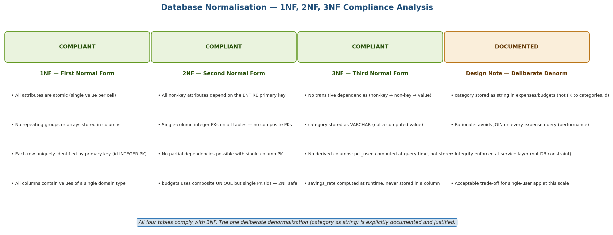
Figure 4: Normalisation analysis — all four tables comply with 1NF, 2NF, and 3NF. The one deliberate denormalisation (category as string) is documented and justified.

Normal Form | Requirement | This database | Verdict
1NF | Atomic values, no repeating groups, unique rows | All columns store single values. No arrays in columns. All rows uniquely identified by INTEGER PK. | COMPLIANT
2NF | No partial dependencies on composite PK | All tables use single-column INTEGER PK. No composite PKs — partial dependency is structurally impossible. | COMPLIANT
3NF | No transitive dependencies (A→B→C where B is non-key) | No derived or computed columns stored. pct_used, savings_rate, net_balance computed at query time. No non-key determines another non-key. | COMPLIANT
Deliberate denorm | category stored as VARCHAR, not category_id FK | Violates strict 3NF (category name in expenses depends on categories table). Documented ADR decision — justified by query simplicity at this scale. | DOCUMENTED

11. Persistence & Backup Strategy

11.1 Docker volume persistence
- The PostgreSQL data directory /var/lib/postgresql/data inside the db container is mounted to a named Docker volume: pg_data
- Named volumes persist across docker compose down and docker compose up — data is not lost when containers restart
- Data is only wiped with docker compose down -v — this is a deliberate explicit action
- The pg_data volume is stored in Docker's volume storage: /var/lib/docker/volumes/pg_data on Linux

11.2 Backup approach for IBM submission
Method | Command / Detail
pg_dump (logical backup) | docker exec <db_container> pg_dump -U tracker_user tracker_db > backup.sql
pg_restore | docker exec -i <db_container> psql -U tracker_user tracker_db < backup.sql
Demo seed script | python scripts/seed_demo_data.py — seeds 3 months of sample data for IBM review demonstration
Volume snapshot | docker run --rm -v pg_data:/data -v $(pwd):/backup alpine tar czf /backup/pg_data_backup.tar.gz /data

12. Document Sign-Off

Role | Name | Date | Status
Author | Sayu-V | 19/3/2026 | ✅ Approved
Reviewer | IBM Project Guide | Pending | ⏳ Pending

All 6 planning documents are now complete. Next: Proposal → Final Report → Viva Questions → Handover → then BUILD.

END OF DOCUMENT

