HIGH LEVEL DESIGN
Expense & Income Tracker Application
Version 1.0 | System Architecture, Components, Data Flow & Deployment

Document | High Level Design (HLD)
Project | Expense & Income Tracker — Full-Stack Rebuild
Version | 1.0 | Initial HLD
Author | Sayu-V | Yenepoya University
Relates to | PRD v2.1 | IBM Student Project
Date | 19 March 2026
Status | APPROVED — Proceed to LLD
Contents | System architecture · Component breakdown · Request lifecycle · Technology layer map · Docker deployment · API surface · Data flow · Non-functional mapping

1. Purpose & Scope

This High Level Design document describes the overall system architecture of the Expense & Income Tracker application. It defines how the major components interact, how data flows through the system, and how the application is deployed. This document sits between the PRD (what to build) and the LLD (how to build each piece in detail).

This HLD answers four questions:
- What are the major components and what does each one do?
- How do requests flow from the browser to the database and back?
- Where does each technology sit in the stack?
- How are containers arranged and networked at deployment time?

2. System Architecture Overview

The system follows a classic three-tier architecture: a React frontend, a FastAPI backend, and a PostgreSQL database. All three tiers run as Docker containers on the developer's local machine, orchestrated by Docker Compose. GitHub + Sourcetree provides version control and backup outside the container network.

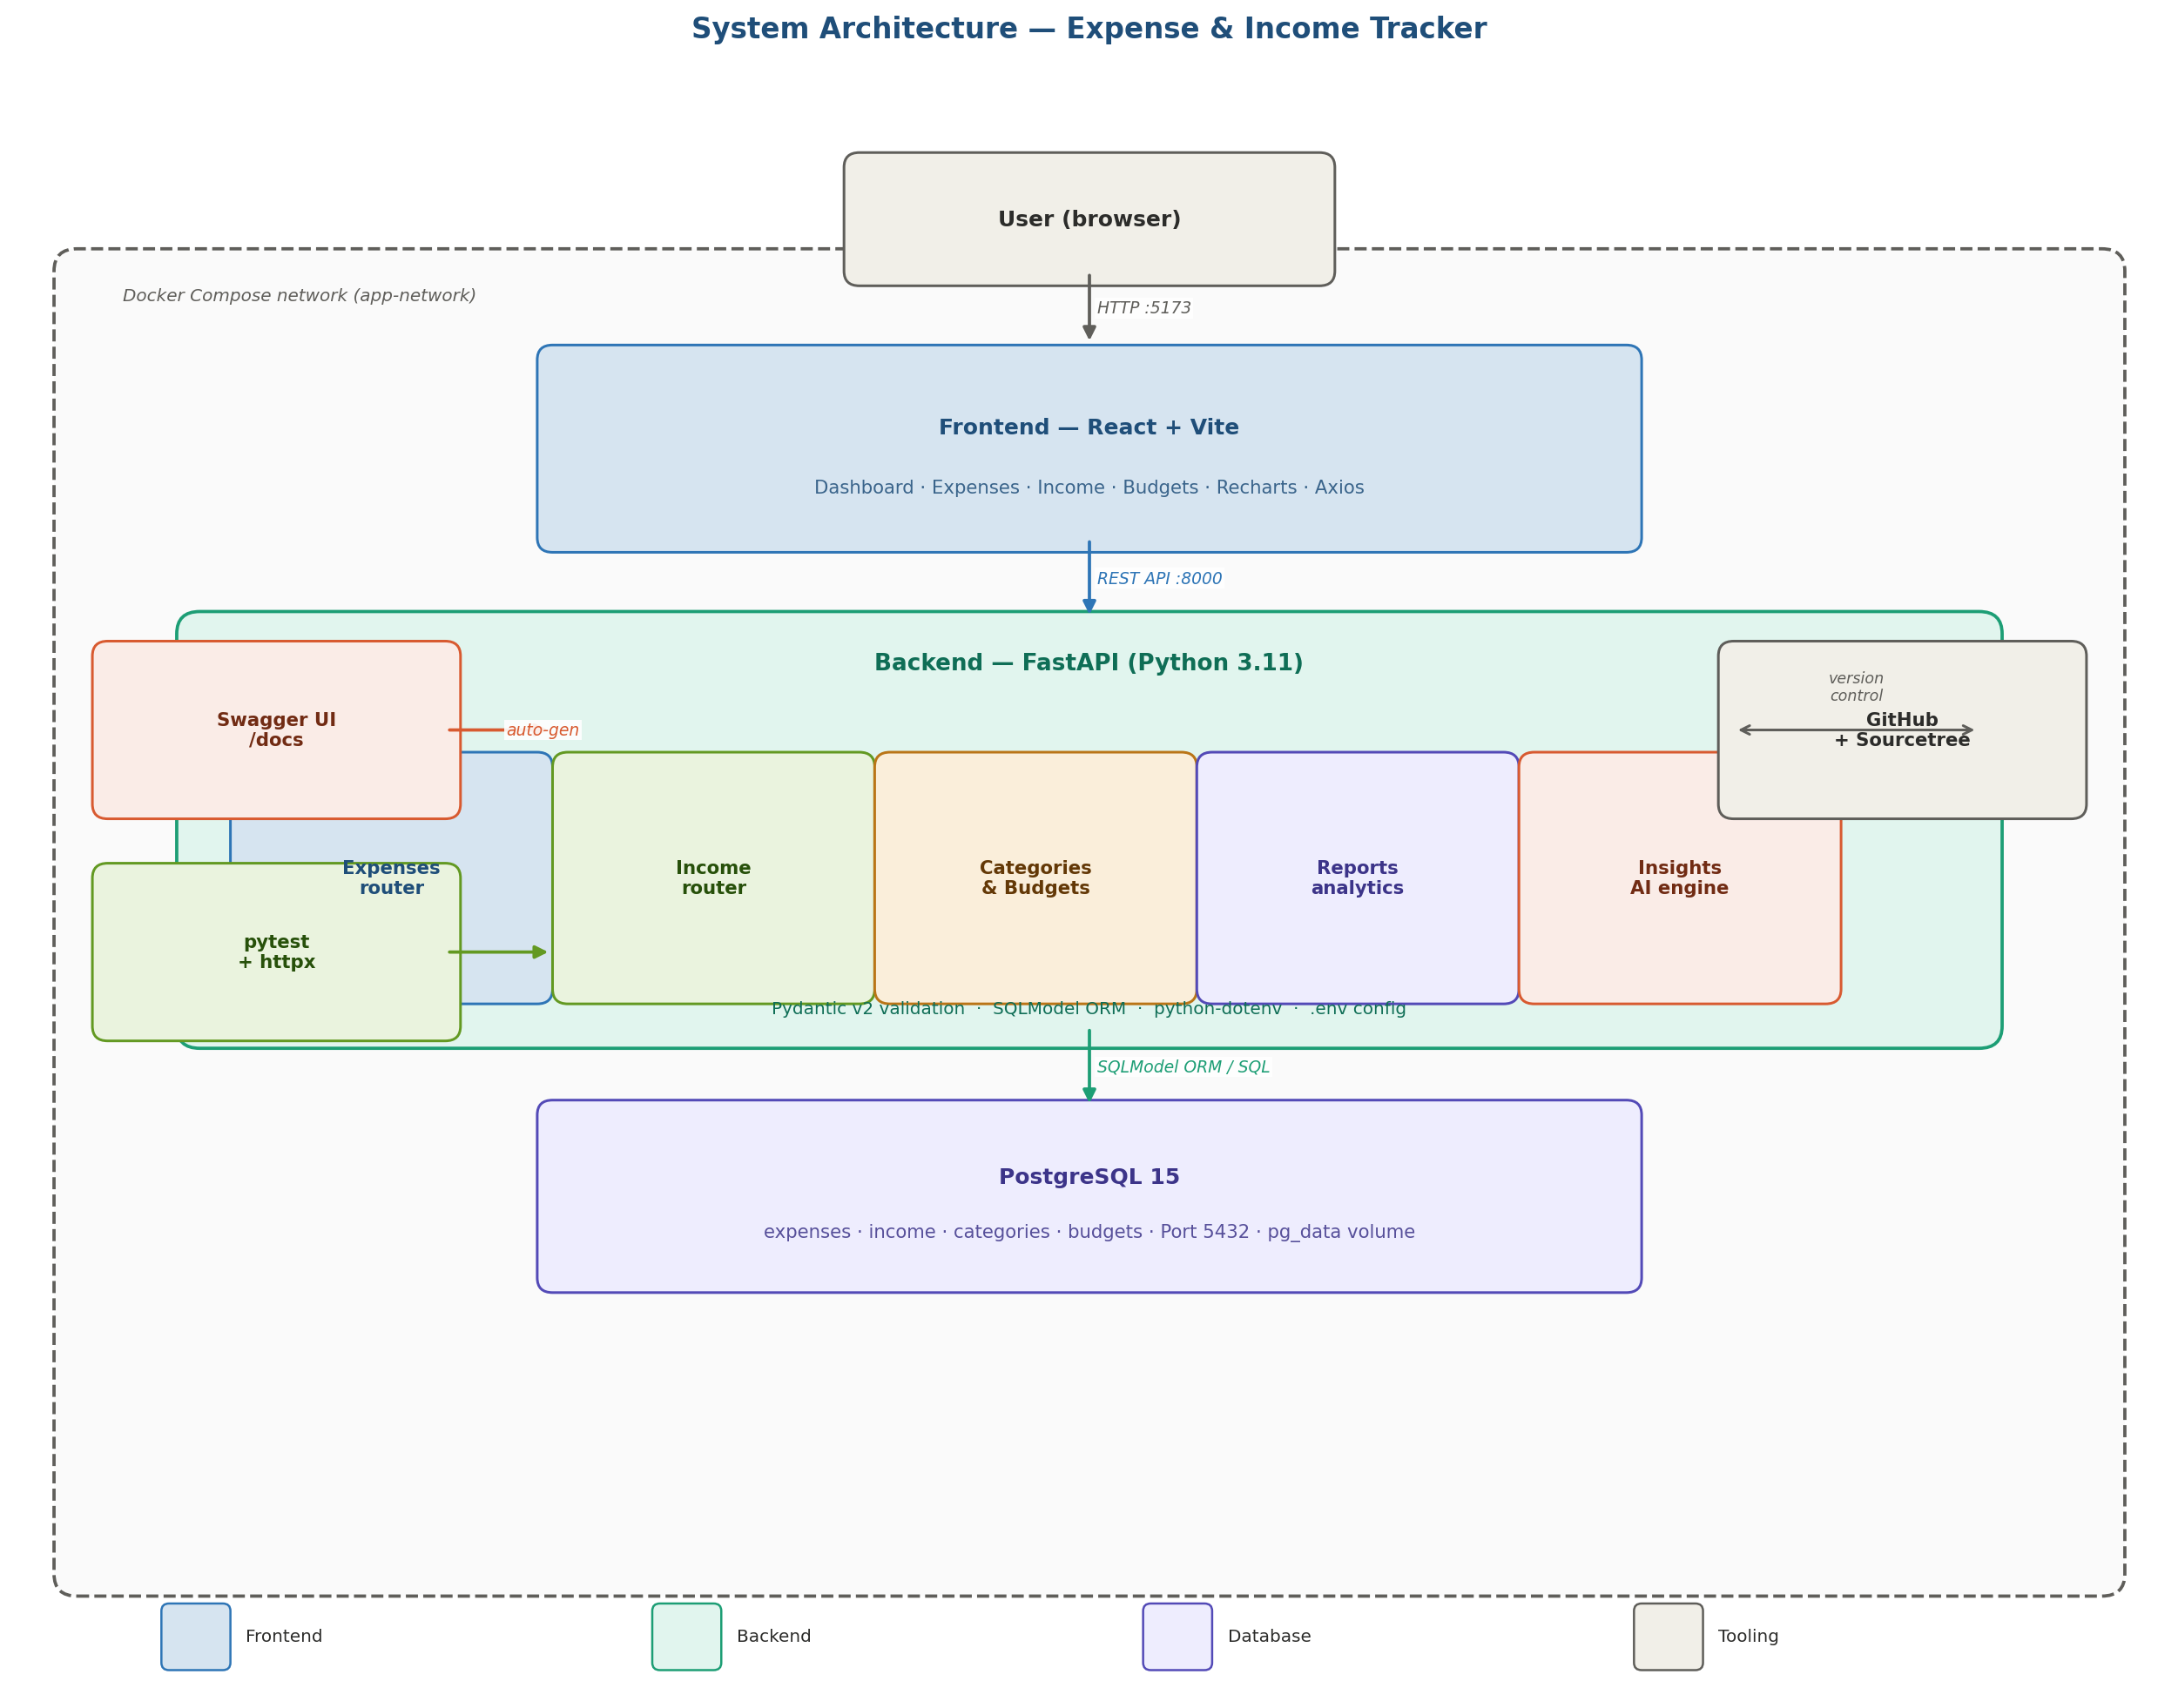
Figure 1: Full system architecture — browser, frontend container, backend container (with all routers), database container, tooling, and version control.

2.1 Component Summary

Component | Technology | Responsibility
User interface | React 18 + Vite | Renders dashboard, forms, charts. Sends HTTP requests via Axios.
Chart library | Recharts | Pie, bar, line, and progress charts for dashboard widgets.
HTTP client | Axios | Wraps all REST calls from frontend to backend. Handles errors centrally.
API server | FastAPI + Uvicorn | Defines all REST endpoints, validates requests, calls services.
Validation | Pydantic v2 | Enforces request/response schemas. Rejects invalid data with 422.
Service layer | Pure Python | Business logic for expenses, income, budgets, reports, insights. Isolated from routers and ORM.
ORM | SQLModel | Maps Python models to DB tables. Manages sessions and transactions.
Database | PostgreSQL 15 | Stores all expenses, income, categories, budgets. Persisted via Docker volume.
Containerisation | Docker + Compose | Isolates each tier. Manages start-up order: db → backend → frontend.
Version control | GitHub + Sourcetree | Remote backup, branching strategy, release tagging, commit history for IBM review.
Testing | pytest + httpx | Integration tests against the FastAPI app. 15+ test cases.
API docs | Swagger UI | Auto-generated at /docs. Used for manual testing and IBM review demonstration.

3. Technology Layer Map

The application is structured in six horizontal layers. Each layer has a single responsibility and communicates only with the layer directly above or below it — no layer skipping.

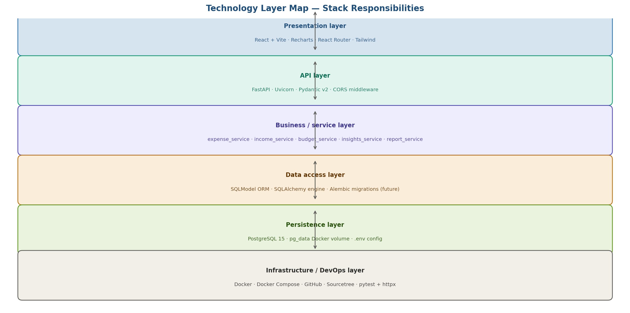
Figure 2: Technology layer map showing each tier, the technologies it uses, and its responsibility.

3.1 Layer Descriptions
Presentation layer
React handles all UI rendering. Vite provides the build toolchain. Recharts renders all charts. React Router manages client-side navigation between Dashboard, Expenses, Income, Budgets, and Reports pages. State is managed locally via React hooks — no Redux needed for this scope.

API layer
FastAPI defines all REST endpoints grouped by resource: /expenses, /income, /categories, /budgets, /reports, /insights, /balance. Uvicorn is the ASGI server. CORS middleware is configured to allow requests from the React frontend at localhost:5173.

Business / service layer
Five service modules contain all business logic. The router never computes anything — it only calls services. This separation means services can be unit-tested without touching the database or HTTP layer.

Data access layer
SQLModel provides the ORM. Each model class is both a Pydantic model (for validation) and a SQLAlchemy table definition. This single-model approach eliminates duplication. Database sessions are injected via FastAPI's dependency injection system.

Persistence layer
PostgreSQL 15 stores all application data. Data is persisted across container restarts via a named Docker volume (pg_data). The database URL, username, and password are injected via environment variables from the .env file — never hardcoded.

Infrastructure / DevOps layer
Docker Compose orchestrates all three containers. GitHub stores the complete project history. Sourcetree provides the visual Git interface. pytest + httpx runs the automated test suite against the live FastAPI application.

4. Request Lifecycle — End to End

The diagram below traces the complete journey of a POST /api/v1/expenses request — from the user clicking 'Save' in the React form, through validation, business logic, ORM, and database write, and back as a 201 response that triggers a dashboard refresh.

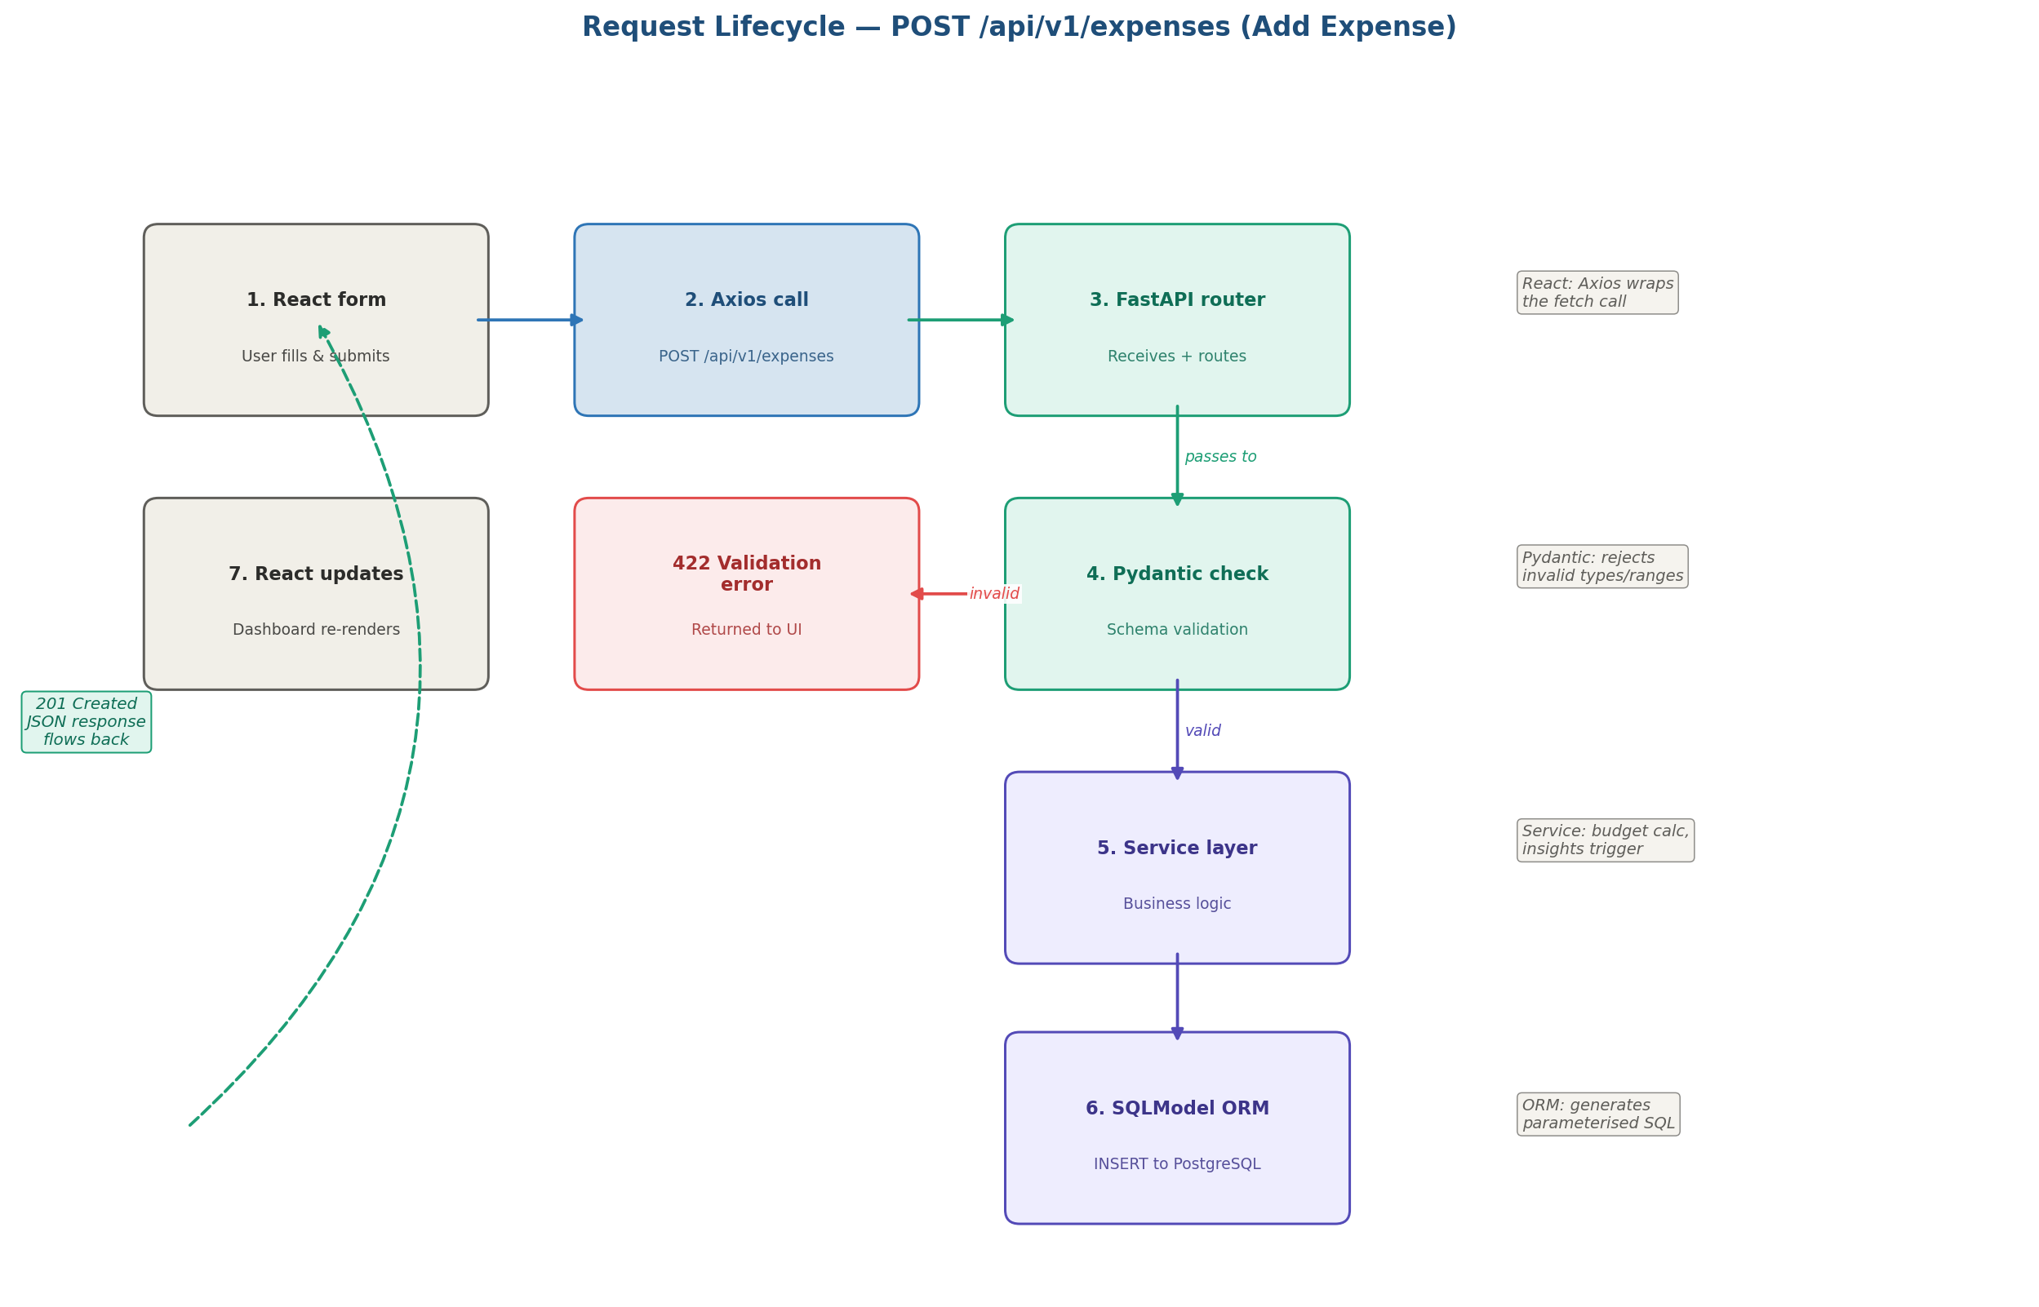
Figure 3: Request lifecycle for POST /api/v1/expenses. Invalid requests are rejected at the Pydantic layer with a 422 before touching the database. Successful writes return 201 and trigger a React re-render.

4.1 Step-by-Step Description

# | Layer | What happens
1 | React form | User fills amount, category, date, description. Clicks Save. Axios sends POST /api/v1/expenses with JSON body.
2 | FastAPI router | expenses.py router receives the request. Calls the Pydantic schema to validate the body.
3a | Pydantic — invalid | If validation fails (e.g. amount ≤ 0, missing category), FastAPI returns 422 Unprocessable Entity with field-level error details. Nothing written to DB.
3b | Pydantic — valid | If validation passes, the router calls expense_service.create_expense(data, db).
4 | Service layer | expense_service checks business rules (e.g. no future dates). After any pre-insert logic, calls the ORM.
5 | SQLModel ORM | Creates an Expense model instance. Calls db.add(expense) and db.commit(). PostgreSQL executes INSERT INTO expenses.
6 | Response | FastAPI returns HTTP 201 Created with the new expense record as JSON (including server-generated id, created_at).
7 | React update | Axios resolves the promise. React invalidates the expense list query and re-fetches. Dashboard charts update automatically.

5. API Surface — All Endpoints

All endpoints are prefixed with /api/v1. FastAPI auto-generates Swagger documentation at http://localhost:8000/docs.

5.1 Expense endpoints
Method | Endpoint | Description
POST | /api/v1/expenses | Create a new expense record
GET | /api/v1/expenses | List all expenses (optional filters: category, date range, amount range)
GET | /api/v1/expenses/{id} | Get a single expense by ID
PUT | /api/v1/expenses/{id} | Update an existing expense record
DELETE | /api/v1/expenses/{id} | Delete an expense record by ID

5.2 Income endpoints [NEW v2.0]
Method | Endpoint | Description
POST | /api/v1/income | Create a new income record
GET | /api/v1/income | List all income records (optional filters: source, date range)
GET | /api/v1/income/{id} | Get a single income record by ID
PUT | /api/v1/income/{id} | Update an existing income record
DELETE | /api/v1/income/{id} | Delete an income record by ID

5.3 Categories, Budgets & Balance
Method | Endpoint | Description
GET | /api/v1/categories | List all categories
POST | /api/v1/categories | Create a custom category
DELETE | /api/v1/categories/{id} | Delete a custom category
POST | /api/v1/budgets | Set a monthly budget for a category
GET | /api/v1/budgets | List all budgets for current month
GET | /api/v1/budgets/status | Get actual spend vs budget per category
GET | /api/v1/balance | Net balance: total income minus total expenses for a given month
GET | /api/v1/balance/trend | Monthly net balance over past N months

5.4 Reports & Insights
Method | Endpoint | Description
GET | /api/v1/reports/monthly-summary | Total income, expenses, net balance, count, avg per month
GET | /api/v1/reports/by-category | Expense breakdown by category for a period
GET | /api/v1/reports/income-by-source | Income breakdown by source for a period
GET | /api/v1/reports/trend | Monthly income + expense totals over past N months
GET | /api/v1/reports/top-expenses | Top 5 highest expenses in a period
GET | /api/v1/reports/savings-rate | Monthly savings rate % over past N months
GET | /api/v1/insights | Returns all active AI insight messages as JSON array with type, severity, message
GET | /api/v1/export/expenses | Export expenses as CSV for a date range
GET | /api/v1/export/income | Export income as CSV for a date range

6. Docker Compose Deployment View

The entire application runs via a single docker compose up --build command. Three containers start in dependency order: db first, then backend (which waits for PostgreSQL to be ready), then frontend.

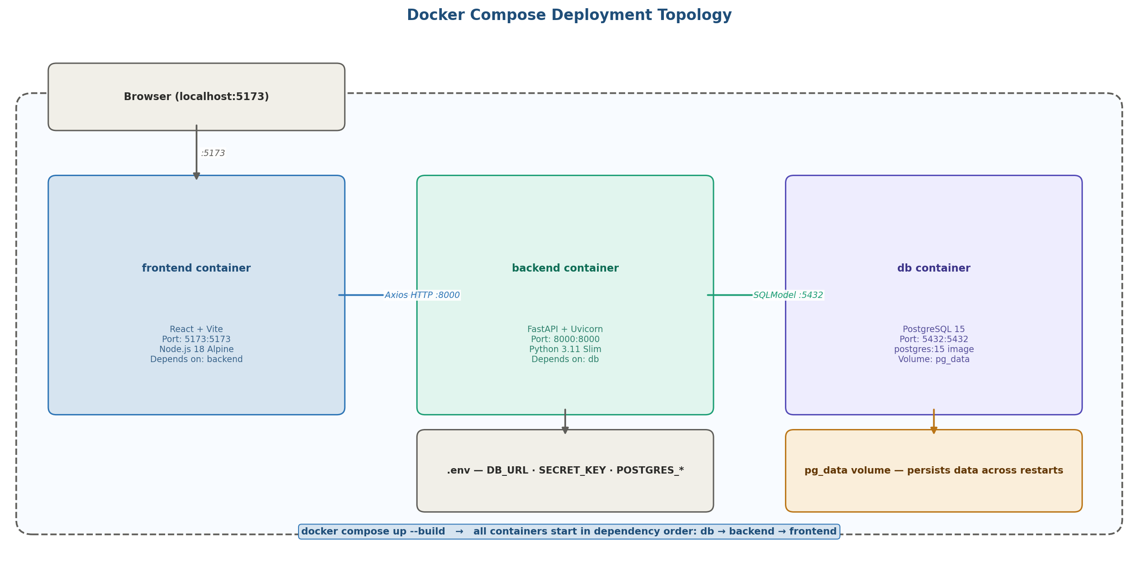
Figure 4: Docker Compose topology — frontend (port 5173), backend (port 8000), and db (port 5432) containers on a shared network. pg_data volume persists database across restarts.

6.1 Container Specifications

Container | Image | Port | Key config
frontend | node:18-alpine | 5173:5173 | VITE_API_URL=http://localhost:8000 — injected as build arg
backend | python:3.11-slim | 8000:8000 | DATABASE_URL, SECRET_KEY from .env; uvicorn --reload in dev
db | postgres:15 | 5432:5432 | POSTGRES_USER, POSTGRES_PASSWORD, POSTGRES_DB from .env; pg_data volume mounted at /var/lib/postgresql/data

6.2 Startup & Health Check
- db container starts first. Backend has a depends_on: db with condition: service_healthy
- PostgreSQL health check: pg_isready -U postgres every 5 seconds
- Backend waits for healthy db before starting Uvicorn
- Frontend depends_on: backend (no health check needed — API calls simply retry on load)
- Single command to start: docker compose up --build
- Single command to stop: docker compose down (add -v to also wipe the database volume)

7. Non-Functional Requirements — Architecture Mapping

NFR | Target | How the architecture addresses it
Performance | < 300ms API response | FastAPI async handlers. PostgreSQL indexed queries. No N+1 ORM queries in services.
Reliability | 100% uptime during demo | Docker Compose keeps all containers running. pg_data volume prevents data loss on restart.
Maintainability | Separation of concerns | Strict layering: routers call services, services call ORM. No business logic in routers.
Testability | 15+ pytest tests | Service layer is independently testable. httpx TestClient tests full request cycle without a real server.
Security | No exposed secrets | .env file gitignored. Never committed. All secrets injected at runtime via Docker env.
Portability | docker compose up | All dependencies containerised. No local Python/Node/Postgres installs required.
Scalability | Future multi-user ready | Layered architecture means auth can be added as middleware without touching services or DB schema.

8. Key Design Decisions

Decision | Chosen approach | Rationale
ORM choice | SQLModel (not raw SQLAlchemy) | Single model definition for both DB table and Pydantic schema. Less code, fewer sync bugs.
Separate income model | Dedicated income table, not a flag on expenses | Different fields (source vs category). Cleaner queries. Easier to extend independently.
No global state manager | React hooks only (useState, useEffect) | App is single-user, single-page. Redux would add complexity with no benefit at this scale.
Rule-based AI insights | Pure Python logic, no external API | No latency, no cost, no API key. Works offline. Deterministic outputs for IBM review.
Single Docker Compose file | One docker-compose.yml, no env overrides | Simplest path to docker compose up --build for a single-developer project.

9. Document Sign-Off

Role | Name | Date | Status
Author | Sayu-V | 19/3/2026 | ✅ Approved
Reviewer | IBM Project Guide | Pending | ⏳ Pending

Next document: Low Level Design (LLD) — detailed endpoint contracts, service method signatures, schema definitions, and business logic per module.

END OF DOCUMENT

