LOW LEVEL DESIGN
Expense & Income Tracker Application
Version 1.0 | Models · Schemas · Services · Routers · AI Engine · Error Handling

Document | Low Level Design (LLD)
Project | Expense & Income Tracker — Full-Stack Rebuild
Version | 1.0 | Initial LLD
Author | Sayu-V | Yenepoya University
Relates to | PRD v2.1 | HLD v1.0 | IBM Student Project
Date | 19 March 2026
Status | APPROVED — Proceed to Build
Contents | SQLModel DB models · Pydantic schemas · Service method signatures · Router contracts · AI insights engine · Error handling · File structure

1. Purpose & Scope

This Low Level Design document specifies every implementation detail needed to write the code. A developer should be able to implement any module by reading only this document and the PRD. This LLD does not repeat the architecture — it goes one level deeper, defining exact field names, types, method signatures, business logic rules, and error conditions for every module.

2. Module Interaction Diagram

All five layers — Routers, Schemas, Services, Models, and PostgreSQL — interact in a strict top-down call chain. No layer is allowed to skip a level. The diagram below shows how each router module calls its corresponding service, which in turn uses the SQLModel ORM to read/write PostgreSQL.

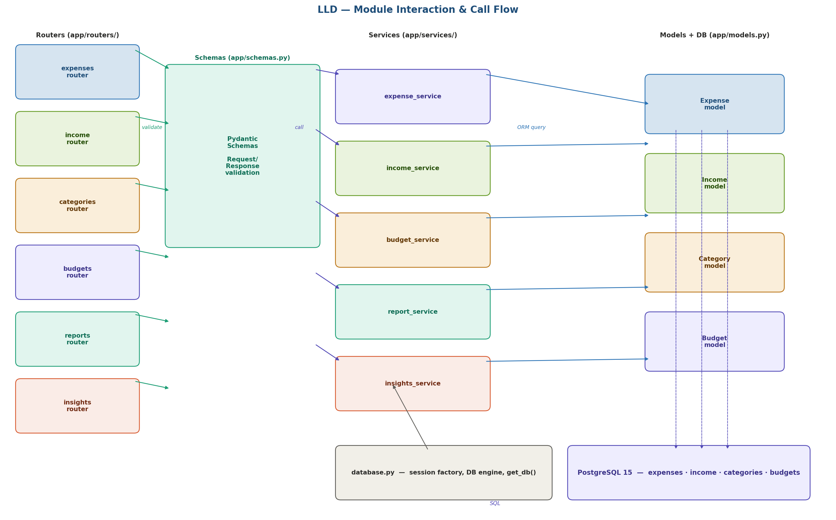
Figure 1: Module interaction — routers call schemas for validation, then delegate to services, which call models via SQLModel ORM.

3. Database Models — app/models.py

All models are defined using SQLModel, which makes each class simultaneously a Pydantic model and an SQLAlchemy table definition. The table=True flag creates a physical table in PostgreSQL.

3.1 Expense model
# app/models.py
from sqlmodel import SQLModel, Field
from datetime import date, datetime
from typing import Optional

class Expense(SQLModel, table=True):
__tablename__ = "expenses"

id: Optional[int] = Field(default=None, primary_key=True)
amount: float = Field(gt=0, max_digits=10, decimal_places=2)
category: str = Field(max_length=100)
description: str = Field(max_length=200)
notes: Optional[str] = Field(default=None, max_length=500)
date: date = Field(index=True)
created_at: datetime = Field(default_factory=datetime.utcnow)
updated_at: datetime = Field(default_factory=datetime.utcnow)

3.2 Income model [NEW v2.0]
class Income(SQLModel, table=True):
__tablename__ = "income"

id: Optional[int] = Field(default=None, primary_key=True)
amount: float = Field(gt=0, max_digits=10, decimal_places=2)
source: str = Field(max_length=100) # Salary|Freelance|Business|Investment|Gift|Other
description: str = Field(max_length=200)
notes: Optional[str] = Field(default=None, max_length=500)
date: date = Field(index=True)
created_at: datetime = Field(default_factory=datetime.utcnow)
updated_at: datetime = Field(default_factory=datetime.utcnow)

3.3 Category model
class Category(SQLModel, table=True):
__tablename__ = "categories"

id: Optional[int] = Field(default=None, primary_key=True)
name: str = Field(max_length=100, unique=True, index=True)
is_default: bool = Field(default=False) # True = seeded, not deletable
created_at: datetime = Field(default_factory=datetime.utcnow)

3.4 Budget model
class Budget(SQLModel, table=True):
__tablename__ = "budgets"

id: Optional[int] = Field(default=None, primary_key=True)
category: str = Field(max_length=100, index=True)
amount: float = Field(gt=0)
month: int = Field(ge=1, le=12) # 1–12
year: int = Field(ge=2020) # e.g. 2026
created_at: datetime = Field(default_factory=datetime.utcnow)

# Composite unique constraint: one budget per category per month/year
__table_args__ = (UniqueConstraint("category","month","year"),)

3.5 Default category seeds
On first startup the backend seeds the categories table with predefined values if empty:
- Expense categories: Food, Transport, Housing, Health, Entertainment, Education, Utilities, Shopping, Other
- Income sources (held as categories with type flag or as enum in Income.source): Salary, Freelance, Business, Investment, Gift, Other

4. Pydantic Schemas — app/schemas.py

Schemas are separate from models — they define what the API accepts and returns. Request schemas validate incoming JSON; response schemas control what fields are serialised back to the client. This separation means internal fields (like created_at) are never accidentally exposed or accepted via the API.

4.1 Expense schemas
# app/schemas.py
from pydantic import BaseModel, Field, field_validator
from datetime import date, datetime
from typing import Optional

class ExpenseCreate(BaseModel):
amount: float = Field(gt=0, description='Must be > 0')
category: str = Field(min_length=1, max_length=100)
description: str = Field(min_length=1, max_length=200)
notes: Optional[str] = Field(default=None, max_length=500)
date: date

@field_validator('date')
def date_not_future(cls, v):
if v > date.today():
raise ValueError('Expense date cannot be in the future')
return v

class ExpenseUpdate(BaseModel): # all fields optional for PATCH-style updates
amount: Optional[float] = Field(default=None, gt=0)
category: Optional[str] = Field(default=None, max_length=100)
description: Optional[str] = Field(default=None, max_length=200)
notes: Optional[str] = Field(default=None, max_length=500)
date: Optional[date] = None

class ExpenseRead(BaseModel): # response shape
id: int
amount: float
category: str
description: str
notes: Optional[str]
date: date
created_at: datetime
updated_at: datetime
model_config = ConfigDict(from_attributes=True)

4.2 Income schemas [NEW v2.0]
INCOME_SOURCES = ['Salary','Freelance','Business','Investment','Gift','Other']

class IncomeCreate(BaseModel):
amount: float = Field(gt=0)
source: str = Field(min_length=1, max_length=100)
description: str = Field(min_length=1, max_length=200)
notes: Optional[str] = Field(default=None, max_length=500)
date: date

@field_validator('source')
def validate_source(cls, v):
if v not in INCOME_SOURCES:
raise ValueError(f'source must be one of {INCOME_SOURCES}')
return v

class IncomeUpdate(BaseModel):
amount: Optional[float] = Field(default=None, gt=0)
source: Optional[str] = None
description: Optional[str] = Field(default=None, max_length=200)
notes: Optional[str] = Field(default=None, max_length=500)
date: Optional[date] = None

class IncomeRead(BaseModel):
id: int; amount: float; source: str; description: str
notes: Optional[str]; date: date; created_at: datetime; updated_at: datetime
model_config = ConfigDict(from_attributes=True)

4.3 Budget, Balance & Insight schemas
class BudgetCreate(BaseModel):
category: str; amount: float = Field(gt=0); month: int; year: int

class BudgetStatus(BaseModel): # response for /budgets/status
category: str; budget: float; actual: float
remaining: float; percent_used: float

class BalanceResponse(BaseModel): # response for /balance
month: int; year: int
total_income: float; total_expenses: float; net_balance: float
savings_rate: float # (net_balance / total_income) * 100

class InsightItem(BaseModel):
type: str # e.g. 'budget_overspend'
message: str # human-readable message
severity: str # 'info' | 'warning' | 'alert'
category: Optional[str] = None # relevant category if applicable

5. Service Layer — app/services/

Each service module contains all business logic for its domain. Services accept validated Pydantic data and a SQLModel database session. They return domain objects or raise HTTPException for error conditions. Services never import from routers and never know about HTTP.

5.1 expense_service.py — method signatures
Method | Returns | Logic / error conditions
create_expense(data: ExpenseCreate, db) | ExpenseRead | Validates category exists. Inserts record. Returns created object.
get_expenses(db, category, date_from, date_to, amount_min, amount_max) | list[ExpenseRead] | Builds dynamic WHERE clause from optional filters. Returns ordered by date DESC.
get_expense_by_id(id, db) | ExpenseRead | Raises HTTPException 404 if not found.
update_expense(id, data: ExpenseUpdate, db) | ExpenseRead | Applies only provided fields (partial update). Updates updated_at. 404 if missing.
delete_expense(id, db) | None | Hard delete. Returns 204. 404 if not found.

5.2 income_service.py — method signatures [NEW]
Method | Returns | Logic / error conditions
create_income(data: IncomeCreate, db) | IncomeRead | Validates source is in INCOME_SOURCES. Inserts. Returns created.
get_income(db, source, date_from, date_to) | list[IncomeRead] | Dynamic filter by source and/or date range. Date DESC.
get_income_by_id(id, db) | IncomeRead | 404 if not found.
update_income(id, data: IncomeUpdate, db) | IncomeRead | Partial update. Updates updated_at. 404 if missing.
delete_income(id, db) | None | Hard delete. 204. 404 if missing.

5.3 budget_service.py — method signatures
Method | Returns | Logic
set_budget(data: BudgetCreate, db) | BudgetRead | Upsert: if budget exists for category+month+year, update amount. Else insert.
get_budgets(month, year, db) | list[BudgetRead] | Returns all budgets for the given month and year.
get_budget_status(month, year, db) | list[BudgetStatus] | Joins budgets with sum(expenses) per category. Computes remaining and percent_used.

5.4 report_service.py — method signatures
Method | Returns | Logic
monthly_summary(month, year, db) | dict | Returns total_income, total_expenses, net_balance, savings_rate, expense_count, avg_expense for specified month.
expenses_by_category(month, year, db) | list[dict] | GROUP BY category, SUM(amount). Returns category + total + percent of total spend.
income_by_source(month, year, db) | list[dict] | GROUP BY source, SUM(amount). Returns source + total + percent of total income.
monthly_trend(months, db) | list[dict] | Last N months: income total, expense total, net balance per month. Used for line chart.
top_expenses(month, year, limit, db) | list[ExpenseRead] | ORDER BY amount DESC LIMIT limit. Default limit=5.
savings_rate_trend(months, db) | list[dict] | Last N months: savings_rate = (income-expenses)/income*100 per month.

6. Router Endpoint Contracts — app/routers/

Each router file defines HTTP routes using FastAPI decorators. Routers handle HTTP concerns only — they call the service layer for all logic. Every endpoint is documented via FastAPI's OpenAPI integration and visible at /docs.

6.1 expenses.py
Method | Path | Request body | Response | Status codes
POST | /api/v1/expenses | ExpenseCreate | ExpenseRead | 201, 422
GET | /api/v1/expenses | Query params: category, date_from, date_to, amount_min, amount_max | list[ExpenseRead] | 200
GET | /api/v1/expenses/{id} | — | ExpenseRead | 200, 404
PUT | /api/v1/expenses/{id} | ExpenseUpdate | ExpenseRead | 200, 404, 422
DELETE | /api/v1/expenses/{id} | — | None | 204, 404

6.2 income.py [NEW v2.0]
Method | Path | Request body | Response | Status codes
POST | /api/v1/income | IncomeCreate | IncomeRead | 201, 422
GET | /api/v1/income | Query: source, date_from, date_to | list[IncomeRead] | 200
GET | /api/v1/income/{id} | — | IncomeRead | 200, 404
PUT | /api/v1/income/{id} | IncomeUpdate | IncomeRead | 200, 404, 422
DELETE | /api/v1/income/{id} | — | None | 204, 404

6.3 reports.py & balance.py
Method | Path | Query params | Response | Codes
GET | /api/v1/reports/monthly-summary | month, year | dict | 200
GET | /api/v1/reports/by-category | month, year | list[dict] | 200
GET | /api/v1/reports/income-by-source | month, year | list[dict] | 200
GET | /api/v1/reports/trend | months (default 6) | list[dict] | 200
GET | /api/v1/reports/top-expenses | month, year, limit | list[ExpenseRead] | 200
GET | /api/v1/reports/savings-rate | months (default 6) | list[dict] | 200
GET | /api/v1/balance | month, year | BalanceResponse | 200
GET | /api/v1/balance/trend | months (default 6) | list[BalanceResponse] | 200
GET | /api/v1/insights | — | list[InsightItem] | 200
GET | /api/v1/export/expenses | date_from, date_to | CSV file | 200
GET | /api/v1/export/income | date_from, date_to | CSV file | 200

7. AI Insights Engine — app/services/insights_service.py

The insights engine is a pure Python rule evaluator. It loads the current month's data from PostgreSQL once, then evaluates all 11 rules against it sequentially. Each triggered rule appends an InsightItem to the result list. The entire evaluation runs server-side on each GET /api/v1/insights call — no caching, no ML model, no external API.

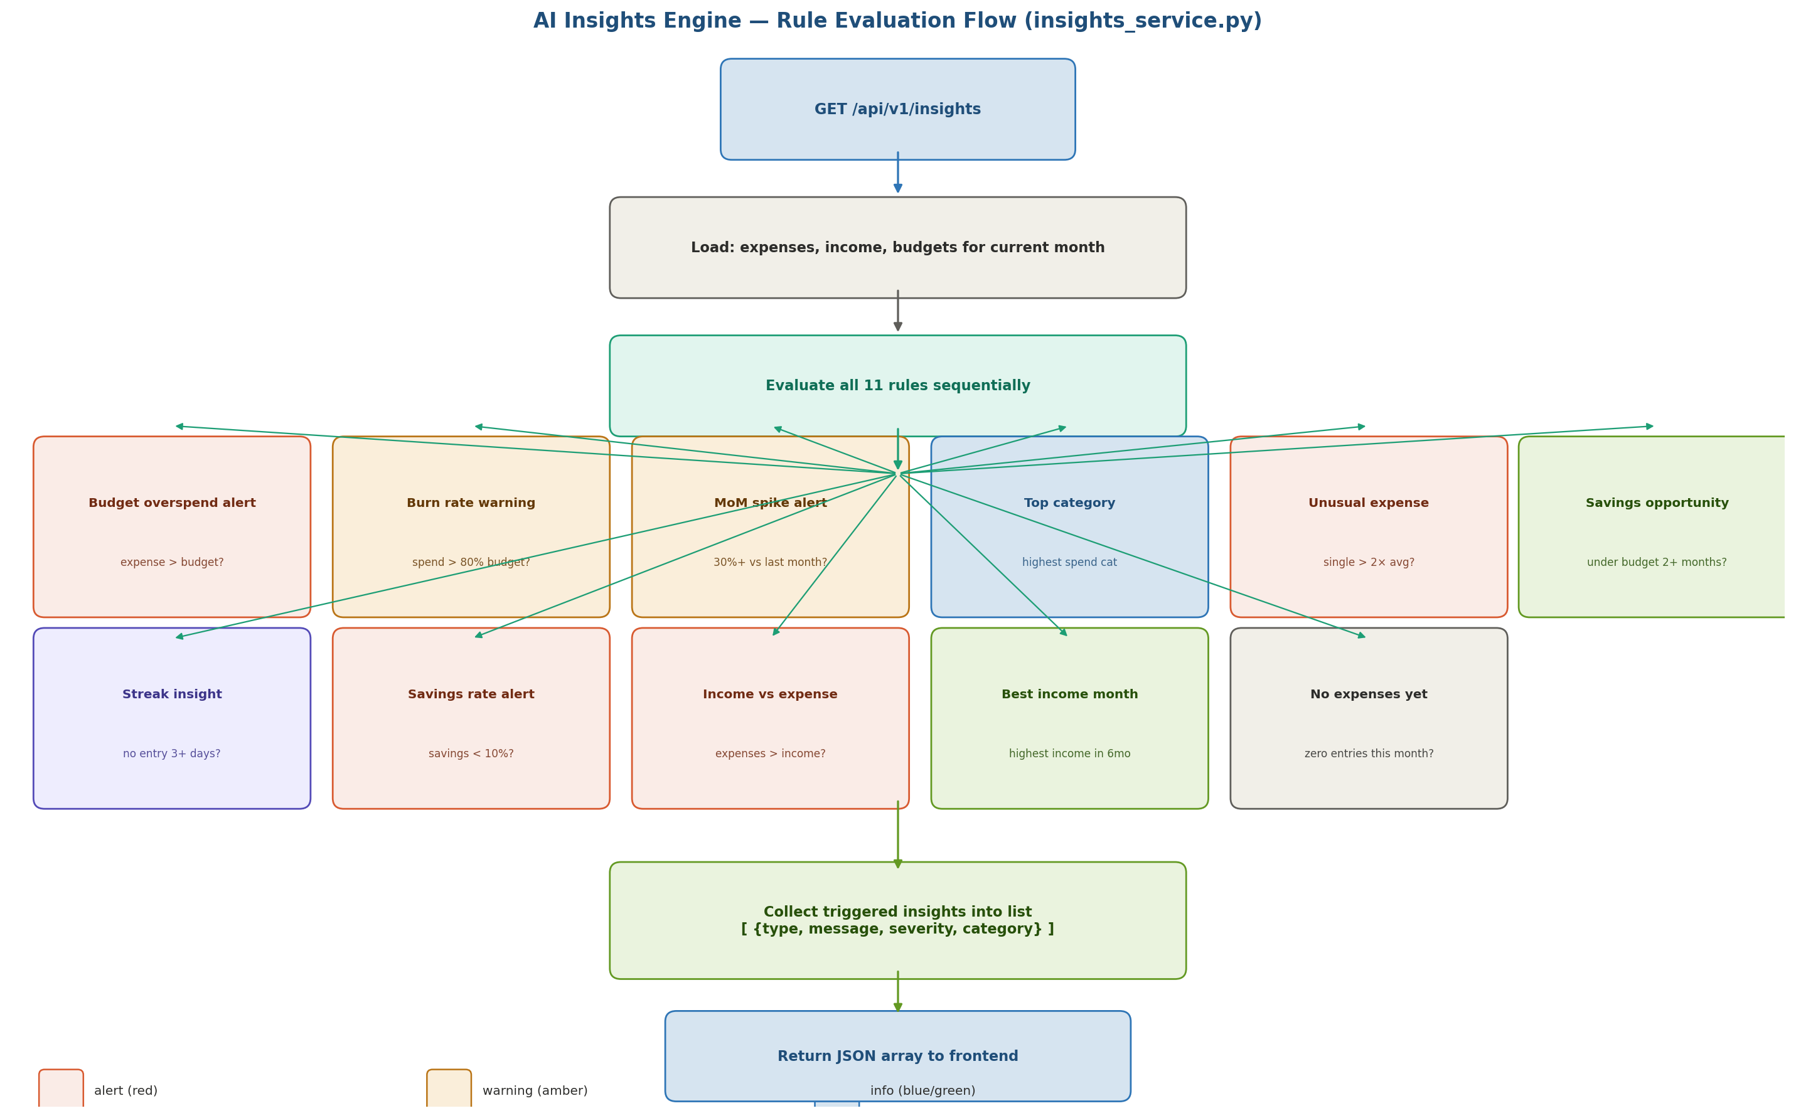
Figure 2: AI insights engine evaluation flow — data is loaded once, all 11 rules evaluated, triggered insights collected and returned as JSON.

7.1 Rule specifications
# | Insight type | Trigger condition | Message template | Severity
1 | budget_overspend | actual_spend > budget for any category | 'You overspent {cat} by {pct}% this month' | alert
2 | burn_rate_warning | actual_spend > 80% of budget AND days_left > 5 | 'You are {pct}% through your {cat} budget with {days} days left' | warning
3 | mom_spike | this_month_cat > last_month_cat * 1.30 | '{cat} spending is up {pct}% vs last month' | warning
4 | top_category | Always runs — identifies highest spend category | 'Your top spend this month is {cat} at {amount}' | info
5 | unusual_expense | single expense > 2 × mean(category expenses) | 'Unusual {cat} expense of {amount} detected ({pct}% above average)' | warning
6 | savings_opportunity | category actual < budget for 2+ consecutive months | 'You consistently underspend {cat}. Consider lowering the budget.' | info
7 | streak_insight | no expense entries in last 3+ days | 'No expenses logged in {days} days. Are your records up to date?' | info
8 | savings_rate_low [NEW] | savings_rate < 10% (income > 0) | 'Your savings rate this month is only {pct}%. Target 20%+' | alert
9 | expenses_exceed_income [NEW] | total_expenses > total_income (income > 0) | 'Expenses exceed income this month by {amount}. Review spending.' | alert
10 | best_income_month [NEW] | this month income = max over last 6 months | 'This is your best income month in 6 months at {amount}!' | info
11 | no_expenses_yet | expense count for current month = 0 | 'No expenses recorded yet this month. Start tracking!' | info

7.2 insights_service.py — method signature
# app/services/insights_service.py
from typing import List
from sqlmodel import Session
from app.schemas import InsightItem

def get_insights(db: Session) -> List[InsightItem]:
"""
Loads current month data, evaluates all 11 rules,
returns list of triggered InsightItem objects.
"""
insights: List[InsightItem] = []
month, year = _current_month_year()
expenses = _load_expenses(db, month, year)
income = _load_income(db, month, year)
budgets = _load_budgets(db, month, year)
prev_exp = _load_expenses(db, *_prev_month(month, year))
# Rule 1 — budget overspend
for cat, budget in budgets.items():
actual = sum(e.amount for e in expenses if e.category == cat)
if actual > budget:
pct = round((actual - budget) / budget * 100, 1)
insights.append(InsightItem(
type='budget_overspend',
message=f'You overspent {cat} by {pct}% this month.',
severity='alert', category=cat
))
# ... rules 2–11 follow same pattern ...
return insights

8. Error Handling Strategy

All errors follow a consistent JSON format so the React frontend can handle them uniformly. FastAPI's HTTPException is used for all application-level errors. Pydantic handles schema validation errors automatically and returns 422 with field-level detail.

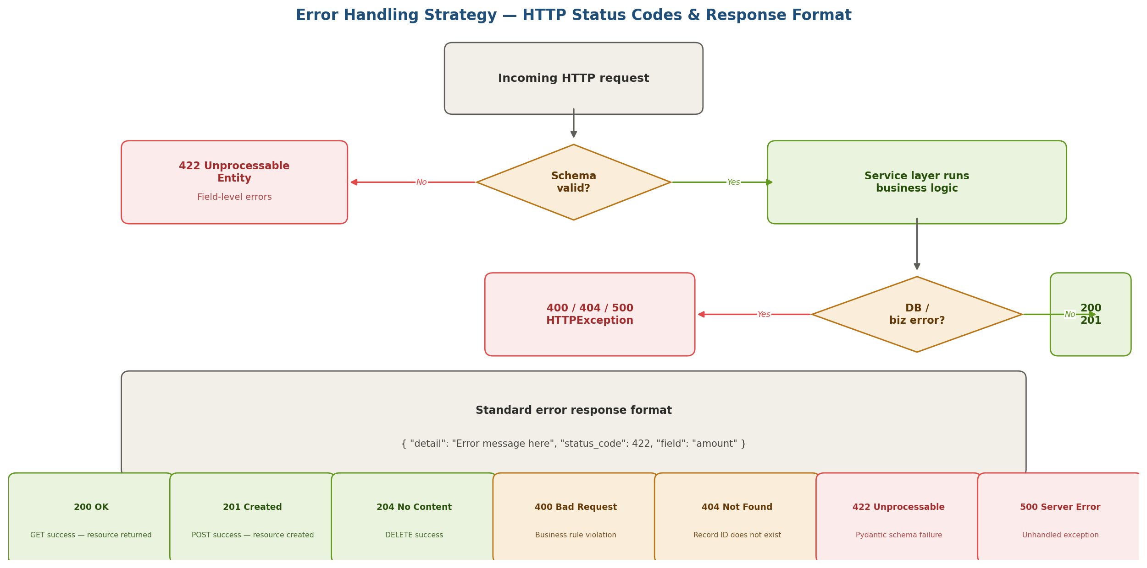
Figure 3: Error handling flow — schema errors return 422, business logic errors raise HTTPException (400/404/500), success returns 200 or 201.

8.1 Standard error response format
# All errors return this JSON shape:
{
"detail": "Expense with id 42 not found",
"status_code": 404
}

# Pydantic 422 errors add field-level detail:
{
"detail": [
{
"loc": ["body", "amount"],
"msg": "Input should be greater than 0",
"type": "greater_than"
}
]
}

8.2 HTTP status code reference
Code | Status | When used
200 | OK | Successful GET, PUT. Returns the resource.
201 | Created | Successful POST. Returns the newly created resource.
204 | No Content | Successful DELETE. No body returned.
400 | Bad Request | Business rule violation (e.g. deleting a default category, duplicate budget for month).
404 | Not Found | Resource ID does not exist in the database.
422 | Unprocessable | Pydantic schema validation failure. Includes field-level errors.
500 | Server Error | Unhandled exception. Logged server-side. Generic message returned to client.

8.3 FastAPI exception handler registration
# app/main.py
from fastapi import FastAPI, Request
from fastapi.responses import JSONResponse

app = FastAPI(title='Expense & Income Tracker', version='1.0')

@app.exception_handler(Exception)
async def global_exception_handler(request: Request, exc: Exception):
return JSONResponse(
status_code=500,
content={"detail": "An unexpected error occurred.", "status_code": 500}
)

9. Database Session — app/database.py

# app/database.py
from sqlmodel import SQLModel, create_engine, Session
from app.config import settings

engine = create_engine(settings.DATABASE_URL, echo=False)

def create_db_and_tables():
SQLModel.metadata.create_all(engine)

def get_db():
"""FastAPI dependency — yields a DB session, closes after request."""
with Session(engine) as session:
yield session

# app/config.py
from pydantic_settings import BaseSettings

class Settings(BaseSettings):
DATABASE_URL: str
model_config = SettingsConfigDict(env_file='.env')

settings = Settings()

10. Complete File Structure — Frozen

Every file below must be created exactly as named. No renaming, no merging, no extra files without updating this document.

backend/app/
├── main.py # FastAPI app factory, CORS, startup event, exception handler
├── config.py # Pydantic settings — reads .env
├── database.py # Engine, session factory, get_db() dependency
├── models.py # Expense, Income, Category, Budget SQLModel classes
├── schemas.py # All Pydantic request/response models
├── routers/
│ ├── __init__.py
│ ├── expenses.py # CRUD: POST GET GET/{id} PUT DELETE
│ ├── income.py # CRUD: POST GET GET/{id} PUT DELETE [NEW]
│ ├── categories.py # GET POST DELETE/{id}
│ ├── budgets.py # POST GET GET/status
│ ├── reports.py # GET monthly-summary by-category trend top-expenses savings-rate
│ ├── balance.py # GET balance GET balance/trend [NEW]
│ ├── insights.py # GET insights
│ └── export.py # GET export/expenses GET export/income (CSV)
└── services/
├── __init__.py
├── expense_service.py
├── income_service.py [NEW]
├── budget_service.py
├── report_service.py
├── balance_service.py [NEW]
└── insights_service.py

backend/tests/
├── conftest.py # TestClient fixture, in-memory SQLite for tests
├── test_expenses.py # CRUD + validation tests (7 test cases)
├── test_income.py # CRUD + validation tests (5 test cases) [NEW]
├── test_budgets.py # Set + status tests (2 test cases)
└── test_insights.py # Insight trigger tests (3 test cases)

11. Document Sign-Off

Role | Name | Date | Status
Author | Sayu-V | 19/3/2026 | ✅ Approved
Reviewer | IBM Project Guide | Pending | ⏳ Pending

Next documents: Architecture + Tech Stack deep-dive, then Security Design, then Database Design.

END OF DOCUMENT

