PRODUCT REQUIREMENTS DOCUMENT
Expense & Income Tracker Application
Version 2.1 | Gantt Chart + Flowcharts + GitHub Strategy
19 March 2026 | IBM Student Project | Yenepoya University

Project | Expense & Income Tracker — Full-Stack Rebuild
Version | 2.1 | Gantt chart + flowcharts + GitHub backup strategy added
Author | Sayu-V | Yenepoya University
Submission | IBM Student Project | 2023–2026 Batch
Project Start | 9 March 2026
Deadline | 10 April 2026 (or earlier)
PRD Date | 19 March 2026
Status | APPROVED — Proceed to Design Phase
v2.1 Additions | Gantt chart (Mar 9 – Apr 10) | App flowchart | GitHub + Sourcetree VC strategy | Commit conventions

1. Executive Summary

This document defines the complete product requirements for the Expense & Income Tracker Application — a full-stack personal finance management system built with FastAPI (backend) and React (frontend), backed by a PostgreSQL database via SQLModel ORM.

Version 2.1 additions:
- Gantt chart showing all milestones from project start (9 March) to deadline (10 April 2026)
- Application user flowchart showing all feature paths through the system
- GitHub + Sourcetree version control and backup strategy with branch naming, commit conventions, and sync schedule
- Income tracking as a first-class feature alongside existing expense tracking

2. Project Overview

2.1 Problem Statement
Managing personal finances manually is error-prone and time-consuming. Spreadsheets lack structure, real-time awareness, and insight into spending patterns. This application provides a structured, smart tool that tracks both income and expenses, enabling users to understand their complete financial picture.

2.2 Proposed Solution
A full-stack web application providing:
- Clean REST API (FastAPI) for all financial data operations
- Responsive React dashboard with 9 widgets for financial visualisation
- Rule-based AI insights engine (11 insights, including income-aware analysis)
- PostgreSQL as the persistent data store modelled with SQLModel
- Docker-based deployment — runnable with a single command

2.3 Project Constraints
- Delivery timeline: 30 days — 9 March 2026 to 10 April 2026
- No external AI/ML APIs — all insights are rule-based and server-side
- Single user, no authentication required in this version
- Web only — responsive design, no mobile app
- Must be fully containerized with Docker Compose

3. Project Timeline — Gantt Chart

The Gantt chart below covers the complete project timeline from 9 March 2026 to 10 April 2026. The red TODAY marker shows the current progress position as of 19 March 2026. Green bars = completed, light green = in progress, light blue = upcoming, dark green = Income feature tasks.

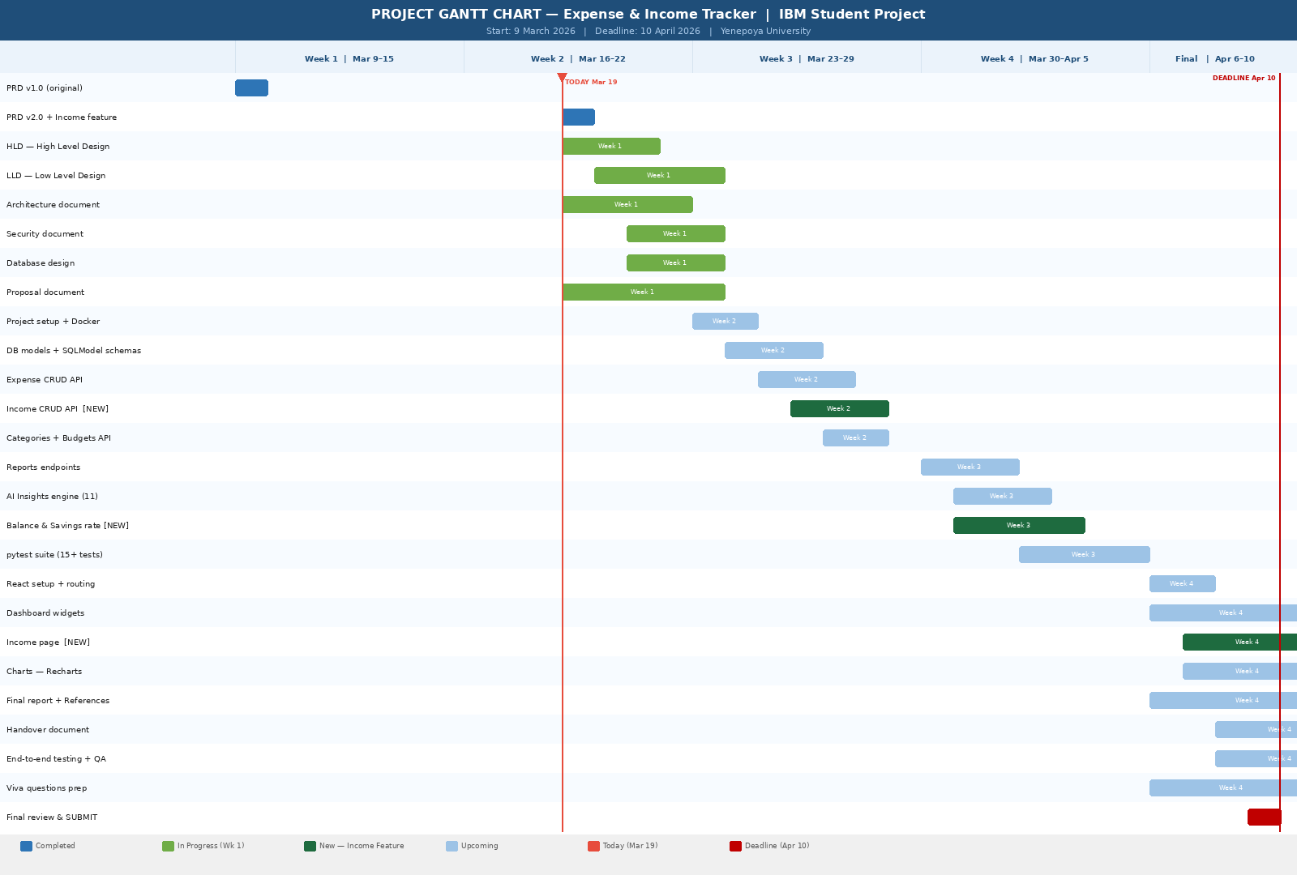
Figure 1: Project Gantt Chart — 9 March to 10 April 2026 (TODAY = Mar 19)

3.1 Four-Week Milestone Plan
Milestone | Period | Deliverables
Documentation | Mar 9–15 | PRD v2.1, HLD, LLD, Architecture, Database schema, Security doc, Proposal
Backend Foundation | Mar 16–22 | Project setup, Docker, DB models, Expense CRUD, Income CRUD [NEW], Categories, Budgets
Analytics & Tests | Mar 23–29 | Reports, AI Insights (11), Balance endpoints [NEW], CSV export, pytest suite (15+ tests)
Frontend & Submit | Mar 30–Apr 10 | React dashboard (9 widgets), Income page [NEW], Final report, Handover, Viva prep, Submission

4. Application User Flowchart

The flowchart below shows how a user interacts with the application from opening the browser through to completing any financial management task. Four main branches are shown: Add Expense, Add Income (new), View Reports, and Manage Budgets. All paths converge back to an updated dashboard view.

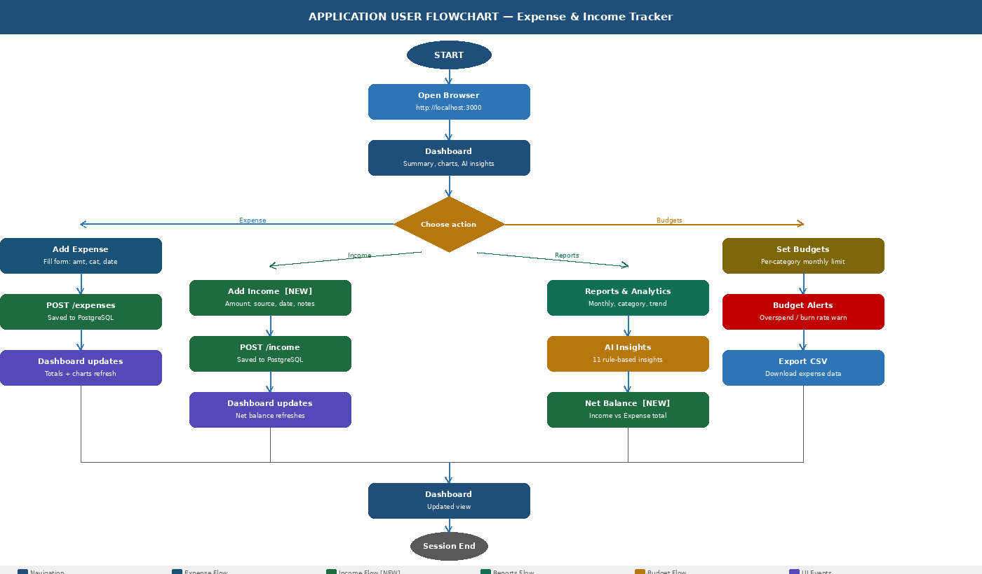
Figure 2: Application User Interaction Flowchart — All Feature Paths

5. Version Control & GitHub Backup Strategy

This project uses Git for version control, GitHub as the remote backup and proof-of-work platform, and Sourcetree as the graphical interface for managing branches and history. This setup ensures the IBM reviewer and examiner can see full commit history, dated progress, and all branches used throughout the project.

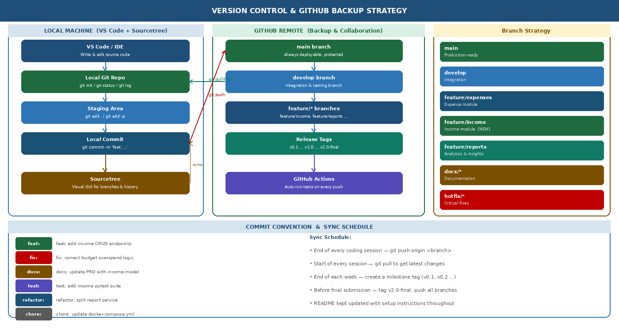
Figure 3: Version Control & GitHub Backup Strategy — Local + Remote + Branch Strategy

5.1 Tools Used
Tool | Purpose | Usage
Git | Version control | Local repo — tracks all changes, branches, and history
GitHub | Remote backup & submission proof | Cloud-hosted repo — visible commit history with timestamps for IBM reviewer
Sourcetree | Git GUI client | Visual branch management, commit log viewer, diff — makes Git accessible without CLI

5.2 Branch Strategy
Branch | Purpose
main | Production-ready code only. Protected — merged via Pull Request after testing.
develop | Integration branch. All feature branches merge here before going to main.
feature/expenses | Expense CRUD module development.
feature/income [NEW] | Income CRUD module — new feature in v2.0.
feature/reports | Analytics, reports, AI insights, balance endpoints.
docs/* | Documentation updates — PRD, HLD, LLD, Final Report, etc.
hotfix/* | Critical bug fixes applied directly when needed.

5.3 Commit Message Convention
All commits follow the Conventional Commits standard for a clean, searchable history:
- feat: — New feature e.g. feat: add income CRUD endpoints
- fix: — Bug fix e.g. fix: correct budget overspend calculation
- docs: — Documentation e.g. docs: update PRD with income data model
- test: — Tests e.g. test: add 15 pytest cases for income module
- refactor: — Code cleanup e.g. refactor: split report_service into modules
- chore: — Setup/config e.g. chore: update docker-compose.yml

5.4 Sync Schedule
When | Action
End of every coding session | git add . && git commit -m 'feat: ...' && git push origin <branch>
Start of every session | git pull origin <branch> — always fetch latest before editing
End of each week | Create milestone tag: git tag v0.x && git push --tags
Feature complete | Open Pull Request on GitHub: feature/* → develop → main
Pre-submission (9 April) | Final tag: git tag v2.0-final && git push --tags — all branches pushed
Submission day (10 April) | Share GitHub repo URL with IBM reviewer — full commit history visible

5.5 Release Tags (Evidence of Progress)
Git tags mark each milestone and provide the examiner with clear, timestamped evidence of progress:
- v0.1 — End of Week 1 (all documentation complete)
- v0.2 — End of Week 2 (backend CRUD complete)
- v0.3 — End of Week 3 (analytics + tests complete)
- v1.0 — End of Week 4 (full stack working)
- v2.0-final — Pre-submission (polished, all features, final tests passed)

6. Functional Requirements

6.1 Core Features

Feature | Description | Module | Priority
Expense CRUD | Create, read, update, delete expense records with amount, category, date, notes | Expenses | Must Have
Income CRUD [NEW] | Create, read, update, delete income records with source, amount, date, notes | Income | Must Have
Net Balance [NEW] | Dashboard card: total income minus total expenses for current month | Dashboard | Must Have
Category Management | Predefined + custom categories for expenses | Categories | Must Have
Budget Tracking | Set monthly budget per category; track actual vs budgeted spend | Budgets | Must Have
Reports & Analytics | Monthly summary, category breakdown, income vs expense trend, savings rate | Reports | Must Have
AI Insights (11 rules) | Rule-based smart tips including savings rate and income vs expense balance | Insights | Must Have
Dashboard UI | React frontend with 9 widgets and charts | Frontend | Must Have
CSV Export | Export expenses or income for a date range | Reports | Should Have
Filtering & Search | Filter by category, date range, amount, type | All | Should Have

6.2 API Endpoints
- Expenses: POST / GET / GET{id} / PUT{id} / DELETE{id} → /api/v1/expenses
- Income [NEW]: POST / GET / GET{id} / PUT{id} / DELETE{id} → /api/v1/income
- Balance [NEW]: GET monthly / GET trend → /api/v1/balance
- Categories: GET / POST / DELETE{id} → /api/v1/categories
- Budgets: POST / GET / GET status → /api/v1/budgets
- Reports: monthly-summary / by-category / income-by-source / trend / savings-rate → /api/v1/reports
- Insights: GET all active → /api/v1/insights

7. Non-Functional Requirements

Category | Requirement | Target
Performance | API response time for all endpoints | < 300ms (local)
Testability | Minimum test coverage for API endpoints | 15+ pytest tests
Portability | Must run on any machine with Docker installed | docker compose up --build
Usability | Frontend responsive on desktop | 1280px+ screen width
Documentation | All endpoints self-documented via Swagger | FastAPI Swagger UI
Data Integrity | Invalid inputs rejected with clear error messages | Pydantic v2 validation
Code Quality | No hardcoded secrets or DB URLs | .env config required
Version Control | All code must be tracked in GitHub with meaningful commits | Git + GitHub required

8. Tech Stack

Layer | Technology | Justification
Backend | FastAPI (Python) | Modern, async-ready, auto Swagger docs, fast to build
ORM | SQLModel | Combines Pydantic + SQLAlchemy; one model for DB + validation
Database | PostgreSQL | Production-grade relational DB; matches IBM requirements
Frontend | React + Vite | Fast build tooling, component model, wide ecosystem
Charts | Recharts | Lightweight, React-native charting library
Containers | Docker + Compose | Reproducible local environment; single-command startup
Testing | pytest + httpx | Industry standard for FastAPI; async-compatible
Version Control | Git + GitHub | Source control, backup, timestamped evidence for IBM reviewer
Git GUI | Sourcetree | Visual branch management and commit history viewer
Config | .env + python-dotenv | Keeps secrets out of code; standard practice

9. Document Control & Sign-Off

Role | Name | Date | Status
Author | Sayu-V | 19/3/2026 | Approved
Version | v2.1 — Charts + GitHub strategy added | 19/3/2026 | Updated
IBM Reviewer | IBM Project Guide | Pending | Pending

This PRD v2.1 is the single source of truth. No feature may be added, removed, or changed without updating this document first.

END OF DOCUMENT

