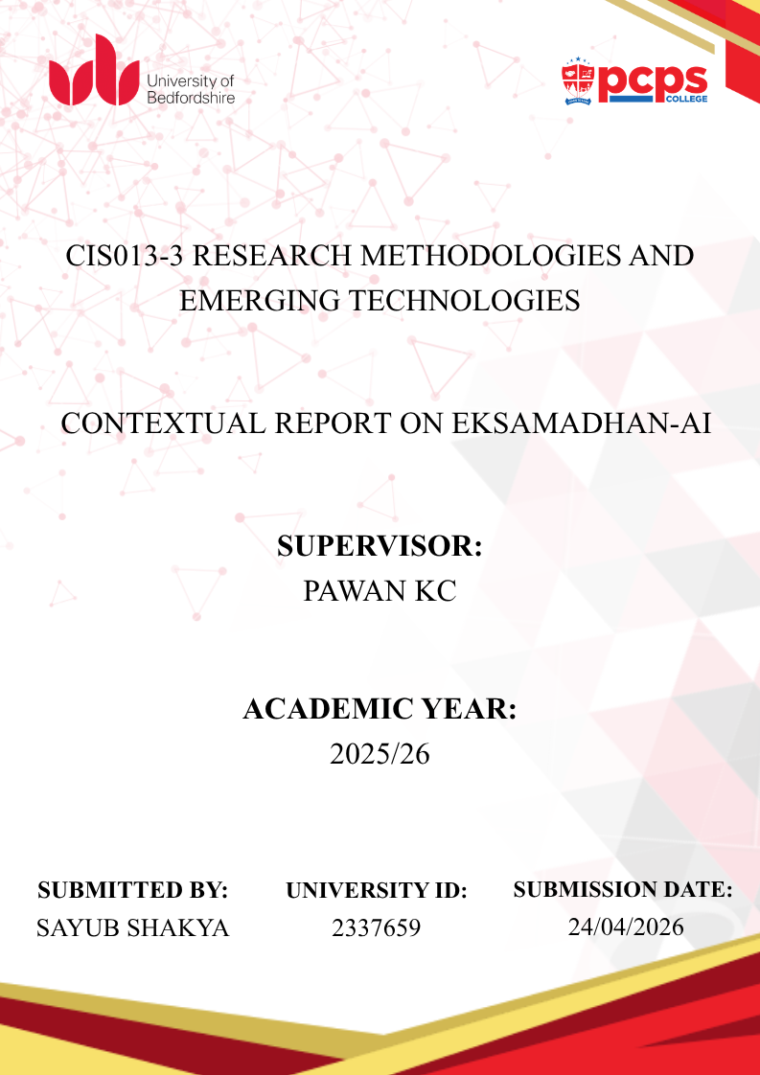

ABSTRACT
Every online business receives customer inquiries daily on Facebook, Instagram, and web chat. They respond to these messages manually, but only a few use AI chatbots (Tidio, 2023). However, these AI chatbot responses often hallucinate. Frequently, customers do not understand the company's reply. AI may answer the question, but its response is unrelated to the company's information. Furthermore, even when a customer is frustrated, the AI responds in a negative tone and cannot detect anger. This caused canceled orders, a poor experience, and lost sales for the company.
To fill this gap, EkSamadhan-AI uses a hybrid approach. When customers ask questions, EkSamadhan-AI responds based on the company's product information and replies. If a customer is frustrated, it is handed over to a human agent for a response. Only the most basic and common questions are handled by AI, while emotional sentiments are passed on to humans. Although AI hallucinations can occur, the system uses Retrieval-Augmented Generation (RAG) to reduce this risk by allowing businesses to upload their product information in a sidebar menu and store it in the Pinecone vector database, enabling accurate product details in responses. When RAG determines that a query requires human attention, it alerts a human agent and passes control. While existing solutions like Zendesk and Intercom are often expensive and used by large enterprises, Eksamadhan-AI aims to offer a similar but more affordable solution for small and medium businesses.
The idea behind this project is to develop a system to meet the needs of SMEs to review the purchase order. To achieve this, background research on AI tools for customer support, a review of the existing platform, and then testing gaps to provide solutions was done this semester 1 and covered in this 12-week plan and artifact design.
Keywords: [Customer Support, RAG, LLM, FCM, AI chatbot to human agent, Emotion detection analysis, SaaS, E-Commerce]

ACKNOWLEDGEMENT
I am grateful to my supervisor, Pawan KC, for guiding my plan and providing feedback that shaped my idea from a business perspective, motivating me to develop a functional application and value my project choice.
I thank all business owners who filled out the survey form. Their input helped me understand real-world business needs and the necessity to review EkSamadhan-AI.
I am also thankful to my senior and coworker, as I shared ideas and they were patient with me after discussing it with them. This idea would not have taken shape if all these people had not given feedback. By gathering all the suggestions, I came up with this idea, which will help many SMEs.

TABLE OF CONTENTS
ABSTRACT ii
ACKNOWLEDGEMENT iii
LIST OF FIGURES viii
LIST OF TABLES ix
LIST OF ABBREVIATIONS x
CHAPTER 1: INTRODUCTION 11
1.1. Background 11
1.2. Problem Statement 11
1.3. Proposed Solution 2
1.4. Aim and Objectives 2
1.5. Scope 3
1.6. Intellectual Challenge 3
1.7. Rationale 3
1.8. Contribution 3
1.9. Structure of Thesis 3
CHAPTER 2: LITERATURE REVIEW 4
2.1. Overview/Background 4
2.2. Review of Existing Project 4
2.3. Literature Review 5
2.3.1. L-R 1: The Legal Risk of Autonomy 5
2.3.2. L-R 2: The Cost of Forced Automation 5
2.3.3. L-R 3: AI as a Helpful Assistant 5
2.3.4. L-R 4: Deflection Rate Baselines 5
2.3.5. L-R 5: Strict Confidence Thresholds 6
2.3.6. L-R 6: Prompt Injunction Mitigation 6
2.3.7. L-R 7: Retrieval-Augmented Generation 6
2.3.8. L-R 8: Spatial Vector Databases 6
2.3.9. L-R 9: API Token Economy 6
2.3.10. L-R 10: Omnichannel Traffic Paralysis 7
2.3.11. L-R 11: Categorising E-commerce Intent 7
2.3.12. L-R 12: Extracting Operational Data 7
2.3.13. L-R 13: Algorithmic Chat Routing 7
2.3.14. L-R 14: Latency and Revenue Conversion 7
2.3.15. L-R 15: Threaded Backend Runtimes 8
2.3.16. L-R 16: Asynchronous Webhook Integration 8
2.3.17. L-R 17: Push Notifications vs. WebSockets 8
2.3.18. L-R 18: Psychological Pacing and Trust 8
2.3.19. L-R 19: Foundational Authentication Architecture 8
2.3.20. L-R 20: Regulatory Compliance and Deletion 8
2.4. Summary of Findings 9
2.5. Justification 9
CHAPTER 3: PRIMARY RESEARCH 9
3.1. Objective of Primary Research 9
3.1.1. Market Research 9
3.2. Survey Questionnaire 10
3.3. Data Collection and Analysis 10
CHAPTER 4: PROJECT PLAN 16
4.1. Gantt Chart, Semester 1 and Semester 2 16
4.2. Risk Analysis 16
4.3. Workflow Diagram 17
CHAPTER 5: ARTEFACT PLANNING 18
5.1. Requirement Analysis 18
5.1.1. Functional Requirement 19
5.1.2. Non-Functional Requirement 19
5.1.3. Usability Requirement 20
5.2. Software Requirement 20
5.3. Hardware requirement 21
5.3.1. For Development 21
5.3.2. For Deployment 21
5.4. Feasibility Study 21
5.4.1. Technical Feasibility 21
5.4.2. Economic Feasibility 21
5.4.3. Legal Feasibility 22
5.4.4. Operational Feasibility 22
5.4.5. Scheduling Feasibility 22
5.5. System Design 23
5.5.1. Use Case 23
5.5.2. ER Diagram 24
5.5.3. System Architecture 25
CHAPTER 6: EVALUATION / QUALITY ASSURANCE 26
6.1. Technical Testing Strategy / Plan 26
6.2. Evaluation Strategy / Plan 27
6.2.1. Evaluation Objectives 27
6.2.2. Evaluation Limitations 27
CHAPTER 7: CRITICAL ANALYSIS AND IMPLEMENTATIONAL PLAN 28
7.1. Critical Analysis 28
7.2. Implementation Plan (12-Week Roadmap) 29
CHAPTER 8: CONCLUSION 30
REFERENCES 31
APPENDICES 35
Appendix A: Project Proposal (Scanned) 35
Appendix B: Ethics Form (Scanned) 43
Appendix C: Literature Review Resources (Screenshots) 45
Appendix D: Survey Questionnaire and Report 51
Appendix E: Raw Data 51
Appendix F: Weekly Progress Reports (Scanned) 53

LIST OF FIGURES
Figure 1: Participating in Businesses 10
Figure 2: Platforms Used for Online Selling 10
Figure 3: Daily Customer Message Volume 11
Figure 4: Primary Contact Methods Used 11
Figure 5: Average Reply Speed to Customers 11
Figure 6: Frequency of Repetitive Customer Questions 12
Figure 7: Difficulty in Managing Multiple Channels 12
Figure 8: Importance of Having a Human Assistant 12
Figure 9: Demand for a Single Unified Inbox 13
Figure 10: User Trust in Monitored AI Systems 13
Figure 11: Most Requested System Features 13
Figure 12: Semester 1 Gantt Chart 15
Figure 13: Semester 2 Gantt Chart 15
Figure 14: Level 0 Data Flow Diagram 16
Figure 15: Level 1 Data Flow Diagram 16
Figure 17: Usability and Interface Requirements 22
Figure 18: Entity Relationship Diagram (ERD) 23
Figure 19: System Architecture 24

LIST OF TABLES
Table 1: Thesis Structure 3
Table 2: Market Gap Analysis 4
Table 3: Mapping Customer Needs to Project Features 14
Table 4: Summary of Key Findings 14
Table 5: Risk Analysis 15
Table 6: Requirement Justification 17
Table 7: Functional Requirements 18
Table 8: Non-Functional and Technical Requirements 18
Table 9: Usability and Interface Requirements 19
Table 10: Testing Strategy and Plan Overview 25
Table 11: System Evaluation Objectives 26
Table 12: Evaluation Limitations and Constraints 26
Table 13: Implementation Plan (12-Week Roadmap) 28

LIST OF ABBREVIATIONS
- API: Application Programming Interface
- SME: Small and Medium Enterprises
- SaaS: Software as a Service
- LLM: Large Language Model
- RAG: Retrieval-Augmented Generation
- FCM: Firebase Cloud Messagin

CHAPTER 1: INTRODUCTION

Background
Online shopping is a growing market, with total sales of 6.3 trillion US dollars in 2024 (Statista, 2025). People used to go to the market to purchase goods and services, but now most shops are based online. As a result, businesses receive many inquiries on Facebook and Instagram, making it hard to reply to the same questions that come in every day. For large-scale companies, an AI chatbot handles most of the queries, so they do not need to reply to common ones, but for small businesses, buying that platform is expensive, and they get 100 messages each day. They cannot afford that system and find it hard to manage all of them. Even if they manage to use a cheap AI chatbot system, the replies can hallucinate and customers lose interest in buying product (Ji, et al., 2023).
If the AI receives negative comments or emotional messages, it will pass and alert the human agent. For this, 20 research papers were studied, and 11 businesses were contacted to get feedback and review the application's ideas.

Problem Statement
Existing applications like Zendesk and Intercom are very expensive, which costs small-scale businesses a lot of money. When using cheaper applications like Tidio, they hallucinate and give wrong answers to customers, and neither can the application escalate to a human agent when needed. Currently, there is neither a cheaper nor a more reliable tool in the market.
      - Too Many Messages: When a product is launched, many customer inquiries for the same product come across different handles, like Facebook and Instagram. Replying to all of them can be time-consuming, and without a reply, customers may lose interest and leave (Tidio, 2023).
      - Chatbot Hallucinations: When using a cheap AI chatbot, it sometimes gives incorrect replies to customers, making it more confusing, losing the customer and might stop buying (Zendesk, Inc., 2024).

Proposed Solution
EkSamadhan-AI is a SaaS application that centralizes and automates customer inquiries for online businesses, using both humans and AI when needed.
- This application uses a Hybrid Support Model and resolves queries using the Retrieval-Augmented Generation (RAG).
- It centralizes social handles like Facebook, Instagram, and a website chatbot.
- It stores product information and uses its own file to reply to customers.
- If a common question is asked, "How much is this product?", “Price,” it replies immediately.
- If AI detects negative sentiment and anger, it hands over to human agents.

Aim and Objectives
Aim:
Develop an affordable, reliable system that helps online businesses manage inquiries and automate responses with hybrid human and AI support.
Objectives:
- Centralize Facebook and Instagram, fetch replies in less than 2 seconds on the backend using Java
- Set up AI chatbot replies correctly using an uploaded file and achieve 85% accuracy rate
- Build a feature, when negative or anger is detected, hands over to a human and alerts within 3 seconds
- Create an interactive user interface (UI) using React and a user experience
- Use a fake account to stress-test the system until it works as planned

Scope
Includes: Centralized chatbot across Facebook, Instagram, and website that provides hybrid support with AI and human agents, automates replies for an online business, uses minimal UI components, and seamlessly hands over to a human when AI detects negative conversation.
Excludes: Voice call/video call notifications, TikTok, and WhatsApp chatbot.

Intellectual Challenge
The primary challenge of this project is ensuring ease of use for end-users. If only the developer understands how to operate the system, and users struggle or have a poor experience, the project fails. A key challenge is designing an AI-based system to prevent incorrect responses, properly understand customer inquiries, and seamlessly transfer conversations to a human agent to preserve user trust.

Rationale
The rationale is that several online businesses are tired of pending replies and of customers waiting too long, which is stopping them from getting orders. If small businesses use this tool, it reduces manual replies and provides instant responses. EkSamadhan-AI plays a minor role but resolves a larger issue than expected.

Contribution
This contributes to a customer support system that provides timely responses by automating common queries, listing products online, and reducing manual workload, while customers receive quick responses and may decide to buy the product because it saves time instead of waiting for a reply, by combining AI and a human agent and integrating this into one platform.

Structure of Thesis
The structure of each chapter is outlined below in a table:
Table 1: Thesis Structure
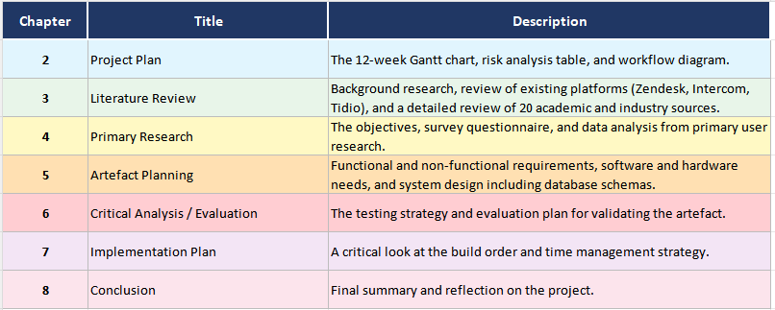

CHAPTER 2: LITERATURE REVIEW

Overview/Background
This literature reviews 20 research papers on AI, its benefits for humans, and project gaps for businesses. It focuses on five areas: AI-human collaboration, AI hallucinations, a centralized social media app, user data protection, and system speed enhancement.

Review of Existing Project
Large companies use expensive AI chatbots, while small businesses use cheaper ones. There is a huge difference between them. The expensive ones have strong security features to protect user data, but they cost too much. Cheap ones sometimes give wrong answers, hallucinate, and lack user data protection.
Table 2: Market Gap Analysis
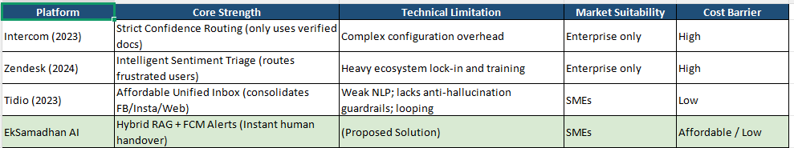
To solve this, EkSamadhan-AI studies the market gap and fills it, so every business can use it.

Literature Review
A literature review summarizes sources and findings, information about what others have said and why this research is needed (Editage, 2024) where experts faced a problem, found a solution, and agreed.

L-R 1: The Legal Risk of Autonomy
(Zanzotto, 2019) warns that letting AI act without humans is dangerous. If the AI makes a mistake and takes the wrong decision, the human will be responsible, not the AI. So, a human must be in the loop with AI to check its actions. For this, EkSamadhan-AI keeps a handover feature so that when the AI makes a mistake, the human can stop at any time. If anything goes wrong, the human can fix the mistake.

L-R 2: The Cost of Forced Automation
(Zendesk, Inc., 2024) shows that when an emotional customer talks with a chatbot, AI cannot detect the customer's emotion, the customer feels ignored and may not return to making a purchase. To solve this, in EkSamadhan-AI, it passes to a human when the conversation begins with sentimentality.

L-R 3: AI as a Helpful Assistant
(Salesforce, 2024) states that AI is for helping humans, not for replacing them. This research shows that when AI summarizes long chats, it is helpful to humans while still allowing them to maintain control. When AI briefly explains what the customer wants, humans do not need to read the entire conversation. This also makes it easier for humans to take control and avoid rereading all the previous messages between the customer and AI.

L-R 4: Deflection Rate Baselines
(Ada, 2023) says the AI deflection rate should stay between 60% and 70% because when AI automates 100% of the conversation, customer happiness drops. This calls for serious discussion. EkSamadhan-AI targets up to 65% accuracy in handling customer inquiries and replying to them, and when the question is confusing, a human takes control over AI.

L-R 5: Strict Confidence Thresholds
(Intercom, 2023) reports that when the company uploads a document to the system, the AI should respond based on that document. The bot must not reply based on online search or anything else. In EkSamadhan-AI, there will be a Hybrid Support Model. When the AI confidence is low, there is nothing written about that question in the document, the AI will notify the human and not reply to the customer. Later, the human will reply.

L-R 6: Prompt Injunction Mitigation
(Ji, et al., 2023) says that prompt injunctions help prevent hallucinated replies. To do this, the agent should be instructed to reply with I do not know instead of giving random answers to customers or lying. This research understands the safety rules, and in EkSamadhan-AI, this will be implemented when the customer asks a question. It alerts the human instead of hallucinating.

L-R 7: Retrieval-Augmented Generation
(Lewis, et al., 2020) explained Retrieval-Augmented Generation (RAG) as a two-step process: first, retrieving only the relevant text stored in the database, and then using AI to respond to the customer with that information. Second, against providing false information. For example, when a customer asks, how much is it for a MacBook Pro? The associate should look up product details in the system's database and find the actual price before replying.

L-R 8: Spatial Vector Databases
(Wang, et al., 2024) found that Pinecone is suitable for small teams. Big companies use Milvus. For a single developer, Pinecone is preferred because it delivers fast text search performance. Based on this, EkSamadhan-AI decides to use the Pinecone database, which feels quick and provides a natural, conversational tone in responses to customers.

L-R 9: API Token Economy
(OpenAI, 2025) notes that when too much context is read by AI, the AI's token count will be consumed quickly. Sending the entire chat history as a reply is not suitable for now. For EkSamadhan-AI, this will be used to summarize old messages. This helps make the AI smarter and reduces costs and token waste.

L-R 10: Omnichannel Traffic Paralysis
(Tidio, 2023) highlights that switching between social media platforms to reply to a message and then switching back to another is time-consuming. This switching causes messages to get lost and finding them takes hours. EkSamadhan-AI centralizes the platform and can switch the handles by filtering, like Facebook or Instagram. This saves a lot of time and stress-free.

L-R 11: Categorising E-commerce Intent
(Gorgias, 2025) argues that general chatbots do not understand the intent behind refunds. AI does not know how to handle it. This suggests categorizing the reason for that message. To tackle this, Eksamadhan-AI defines an intent recognition system that, whenever urgent messages escalate to a human.

L-R 12: Extracting Operational Data
(Zhang & Liu, 2024) found that when a specific ID, such as an order number, is used in chat conversations, it allows humans to process the chat 50% faster with a quick tag. In EkSamadhan-AI, when a customer refers to an order ID, the system automatically searches for and highlights it, saving time and removing the need for manual searching.

L-R 13: Algorithmic Chat Routing
(Kaur & Kaur, 2021) Instead of using a first-come, first-served method, the routing engine helps manage the team's workload. This keeps the workload fair. In EkSamadhan-AI, the routing engine will escalate chats and distribute an equal number of new chat messages to those with fewer chats.

L-R 14: Latency and Revenue Conversion
(Chari, 2022) shows that if the business replies within 5 minutes, the customer has a 70% chance of buying the product. But when it takes time, they will be uninterested. Manually replying to customers can be tough, so a chatbot can respond instantly. Eksamadhan-AI will utilize an AI chatbot to provide customers with instant replies, thereby boosting sales growth.

L-R 15: Threaded Backend Runtimes
(Wyciślik, et al., 2023) found that Java Spring Boot can handle concurrent tasks and is superior for benchmarked server runtime. EkSamadhan-AI will be using Java as the backend for technical stability and scalability

L-R 16: Asynchronous Webhook Integration
(Meta for Developers, 2024) Facebook API requires that responses be sent quickly. If a response is too slow or too lengthy, the system may become blocked. To implement in EkSamadhan-AI, responses to Meta must be sent within milliseconds to prevent being blocked due to slow response times.

L-R 17: Push Notifications vs. WebSockets
(Google Firebase, 2025) Leaving the web socket open for 24 hours drains the battery and turning it off prevents it from working. But a Push Notification using Google Firebase will ensure EkSamanadhan-AI delivers alerts even when the browser is closed or the computer is away. The notification wakes up the system with a DING, ensuring no alerts are missed, and is a reliable solution.

L-R 18: Psychological Pacing and Trust
(Gnewuch, et al., 2018) found that when an AI bot replies instantly, customers lose interest. It feels fake and decreases user trust. They suggest adding at least a 2-second pause to make it feel as if talking to a human. EkSamadhan-AI will keep typing animation for a few seconds, making it feel like human interaction through the conversation.

L-R 19: Foundational Authentication Architecture
(Hardt, 2012) explains the rules of OAuth 2.0 for securely sharing login data when a company uses their social media to log in to EkSamadhan-AI without sharing their passwords. This helps secure the meta-account and protect private data in the system.

L-R 20: Regulatory Compliance and Deletion
(European Parliament and Council of the European Union, 2026) states that a customer has the right to request deletion of their account. The account must be deleted securely, without leaking private data or compromising the account. EkSamadhan-AI will be built to ensure safety with a single click, keep the business account safe, and comply with these rules.

Summary of Findings
By reviewing these, I realized that most companies ignore small businesses and make their tools costly. This insight guided my efforts to build trust and reduce AI costs in my system. These reviews also helped me gain valuable knowledge for EkSamadhan-AI and inspired its design and ideas.

Justification
When high-cost AI tools are utilized, they deliver strong performance. However, large companies can afford them, but small businesses cannot. Low-cost AI tools often produce inaccurate results due to hallucination. This leaves a gap in the market that EkSamadhan-AI solves by using RAG, it delivers only information from uploaded business PDFs and uses FCM to notify humans when the AI is unable to resolve customer issues. EkSamadhan-AI enables organizations of all sizes to ensure private data and deliver consistent, reliable customer service, making it the trusted solution for modern business needs.

CHAPTER 3: PRIMARY RESEARCH

3.1. Objective of Primary Research
This data survey was done to get an idea of what the business owners need and where they are struggling, so I gathered the information and plan to build EkSamadhan-AI.
- To analyze how many messages businesses get in a day
- To evaluate whether to centralize the social media handles in one single inbox
- To check on the business owner's need to automate the message for simple queries
- To verify if they want to hand over to human features when AI makes wrong decisions

Market Research
My research showed that business owners reply to customers messages one by one, even if there is a huge list of inquiries coming from different social media applications, and there is no AI tool that is cheap and reliable to use by local sellers. By switching from one app to another, owners get exhausted, and messages may get lost, and take time to give a reply to each customer. I looked at this and decided to solve this problem by EkSamadhan-AI, which acts as a smart assistant.

3.2. Survey Questionnaire
The data survey questions were created to gather knowledge about what others think about this idea. A survey was requested by all the business owners, and 11 business owners filled out the survey. They sell clothes, groceries, electronics, and many more. This feedback helped to structure the system.

3.3. Data Collection and Analysis
The results of the data survey are shown below with their responses:
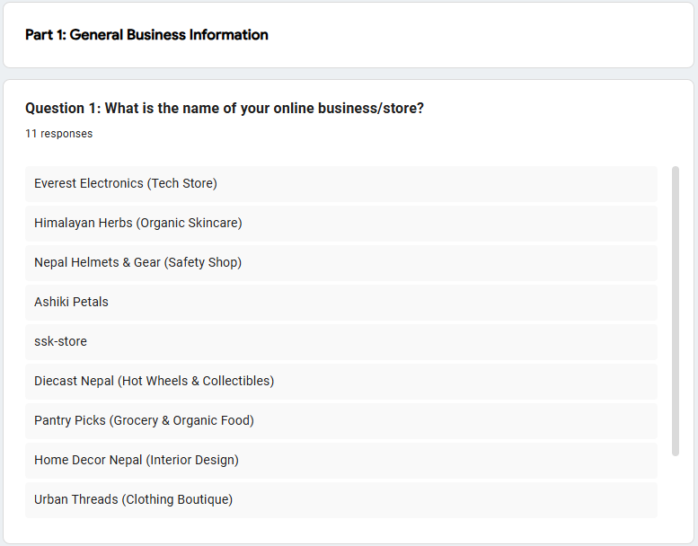
Figure 1: Participating in Businesses
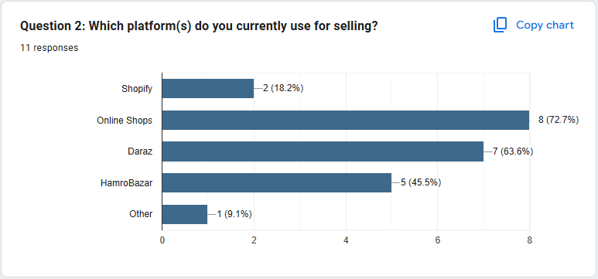
Figure 2: Platforms Used for Online Selling

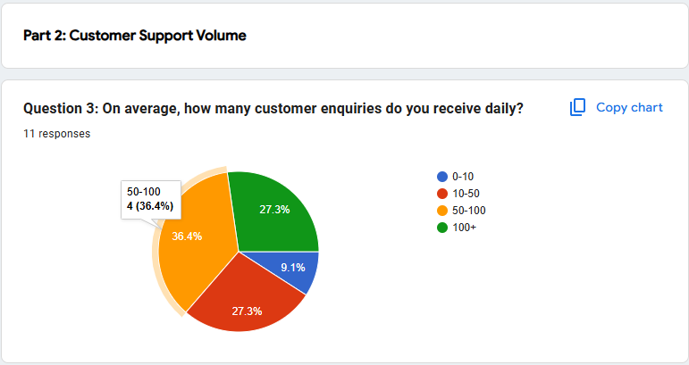
Figure 3: Daily Customer Message Volume
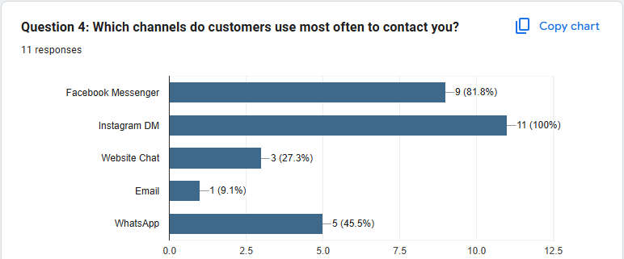
Figure 4: Primary Contact Methods Used
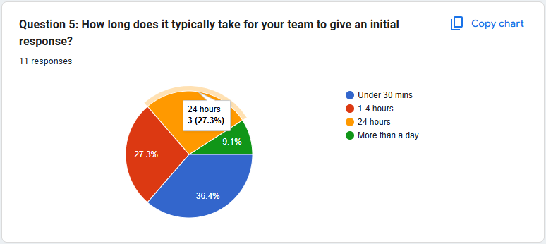
Figure 5: Average Reply Speed to Customers
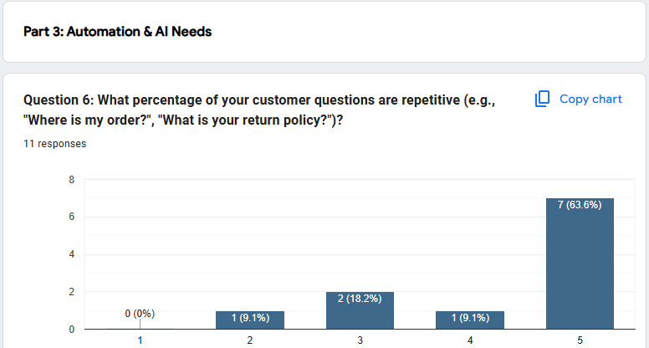
Figure 6: Frequency of Repetitive Customer Questions
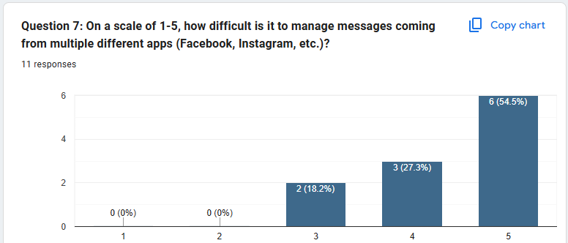
Figure 7: Difficulty in Managing Multiple Channels
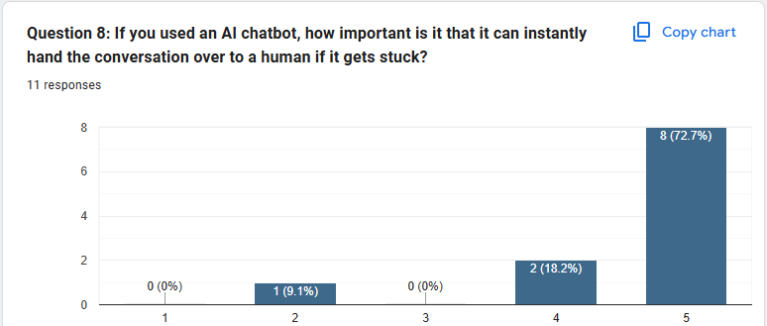
Figure 8: Importance of Having a Human Assistant
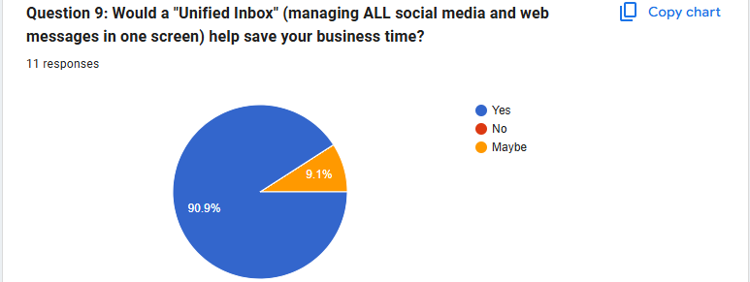
Figure 9: Demand for a Single Unified Inbox
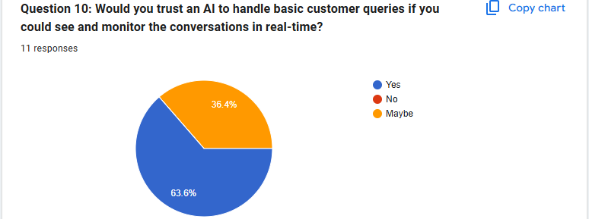
Figure 10: User Trust in Monitored AI Systems
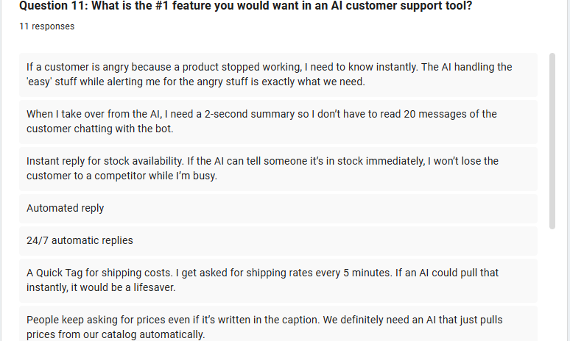
Figure 11: Most Requested System Features
Table 3: Mapping Customer Needs to Project Features
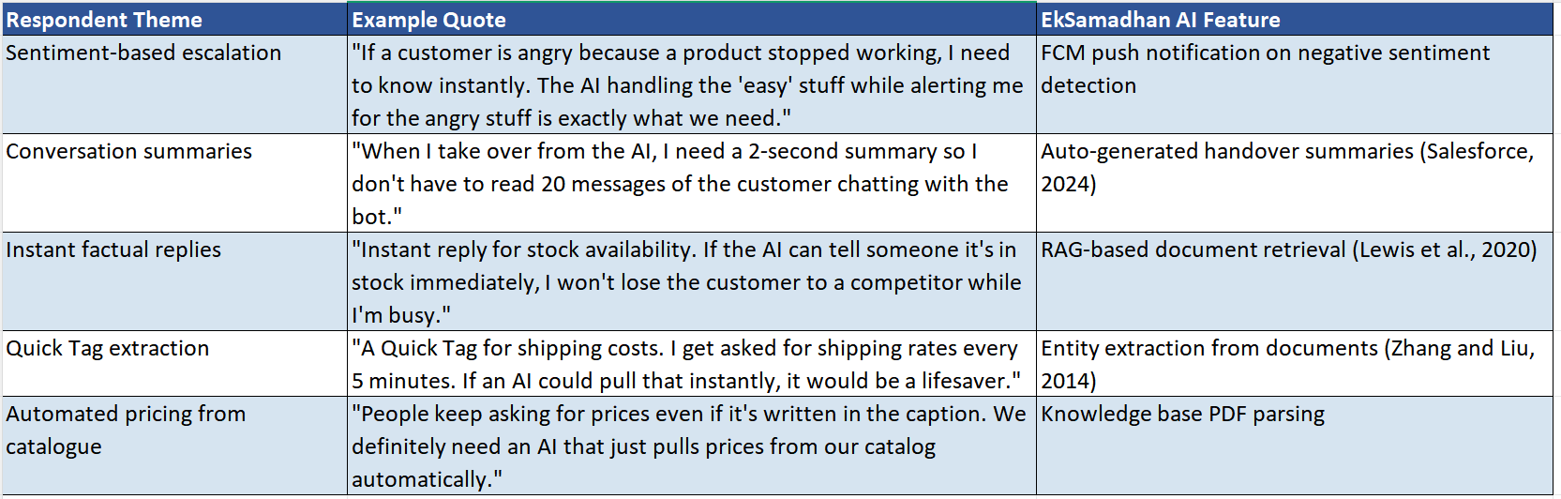
Table 4: Summary of Key Findings
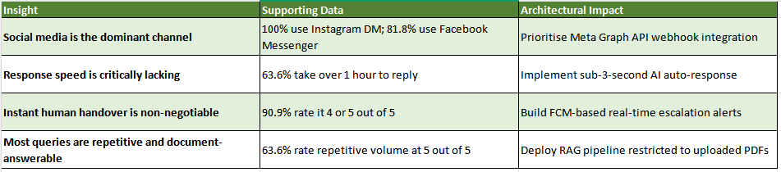
Most of the businesses sell their product online on different platforms. Businesses get 50 to 100+ messages daily, and replying to each of them is overwhelming. Not replying to customers feels ignored, and replying to all of them takes time. They need centralized handles by bringing all messages from Instagram and Facebook. Most businesses demand automation, so when businesses upload the PDF file of their business information, AI searches for related questions and answers for like price, colors, and AI replies. If anything goes wrong, humans can take control.

CHAPTER 4: PROJECT PLAN

Gantt Chart, Semester 1 and Semester 2
This project is divided into two semesters. Semester 1 is for researching and planning the chosen topic, and Semester 2 is for fully building the software.
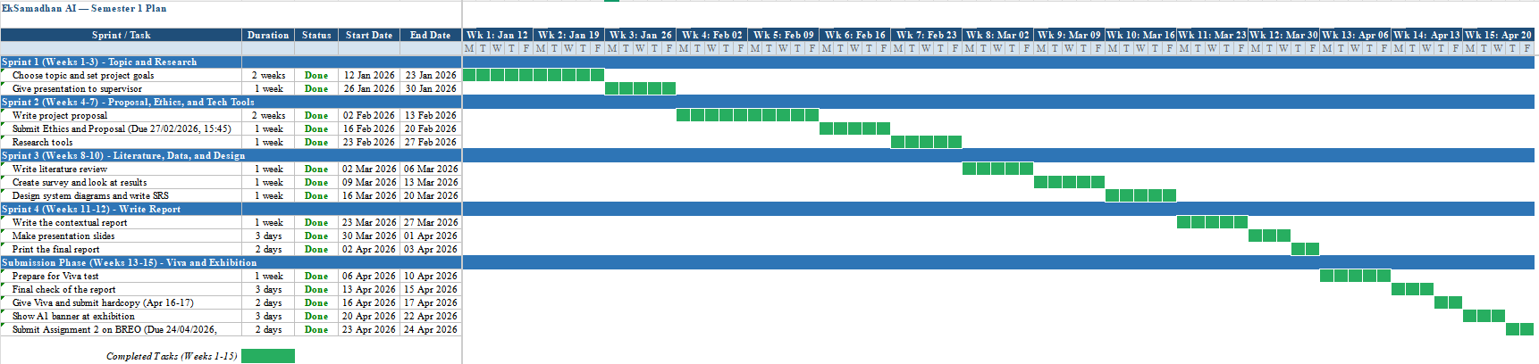
Figure 12: Semester 1 Gantt Chart
These tables show the Gantt chart of a weekly plan in semester 1. The green mark indicates the completed task.
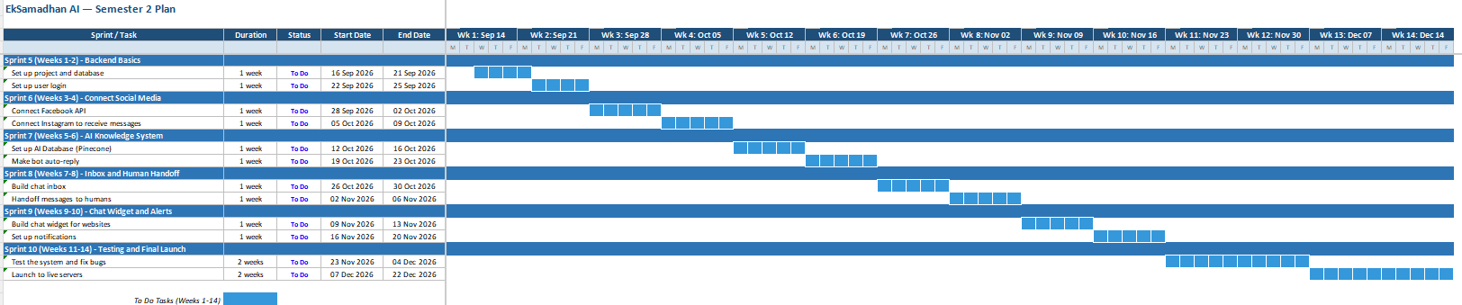
Figure 13: Semester 2 Gantt Chart
These tables show the Gantt chart for weekly plan in the upcoming semester 2. The blue mark indicates the To DO task.

Risk Analysis
While developing software, it comes to planning possible risks and ways to fix them:
Table 5: Risk Analysis
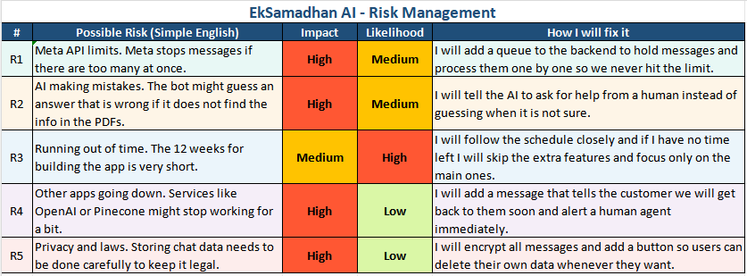

Workflow Diagram
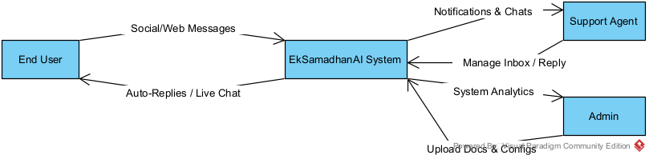
Figure 14: Level 0 Data Flow Diagram
This level 0 diagram shows how the EkSamadhan-AI systems data flows from the End user for sending messages, the Support Agent for helping customers, and the admin for setting up accounts.
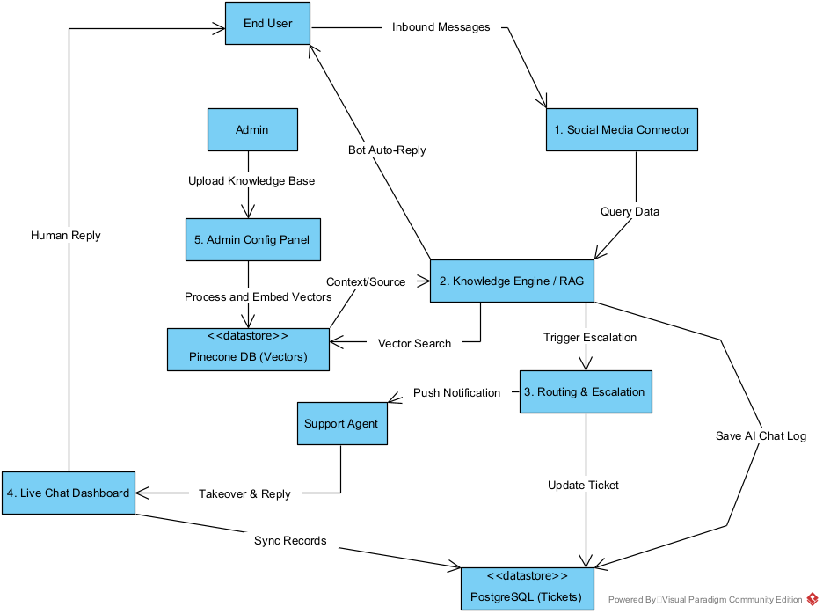
Figure 15: Level 1 Data Flow Diagram
This level 1 diagram shows how data flows within the system. When a message comes from Facebook or Instagram, it searches for a company's business file to reply to. If it finds, it replies automatically or detects an angry customer, then it saves the chat and alerts the human agents.

CHAPTER 5: ARTEFACT PLANNING
This covers the rule for building the system based on the system requirements, the feasibility study and the system diagrams to keep the project organized, meet the deadline, and ensure everything connects while nothing is missing in this process.

Requirement Analysis
Requirements analysis shows what the system must do before building, so that no unnecessary features are added, and the team understands the goal (Awati, 2023).
Table 6: Requirement Justification
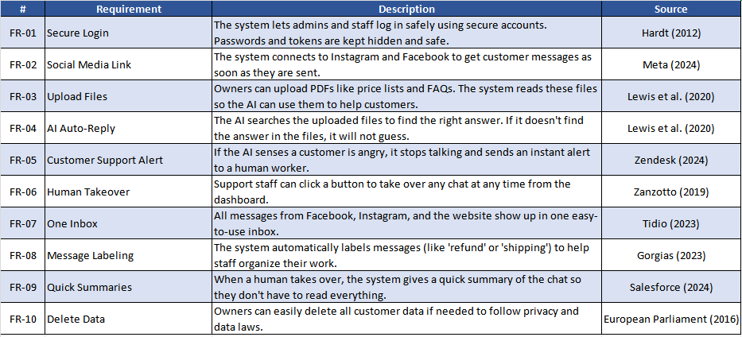
These are the collection of features the system requires. This shows the user’s requirements and provides a basis to build the system correctly.

Functional Requirement
Functional requirements are tasks that the system must perform to run the application. It is a priority in MOSCOW to fulfill these features (Wright, 2025).
Table 7: Functional Requirements
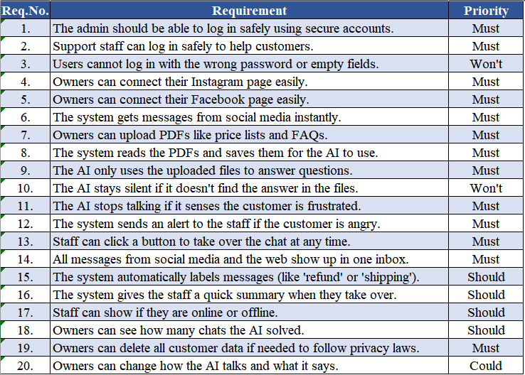
This table shows the system's requirements and priorities. These are the features to check to make the system perform.

Non-Functional Requirement
Non-Functional requirements describe how the system works rather than defining what it does. This shows the behavior of the system (Krüger, 2025).
Table 8: Non-Functional and Technical Requirements
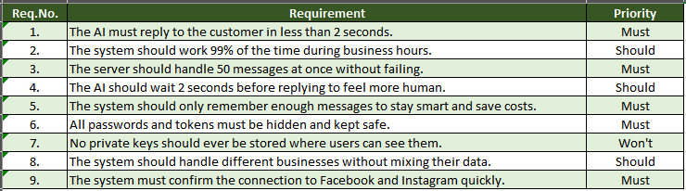
This table shows how well the system works. These are the quality checks to make the system work.

Usability Requirement
Usability requirements make the system easy to use and improve the quality of the user’s experience (Elsevier, n.d.).
Table 9: Usability and Interface Requirements
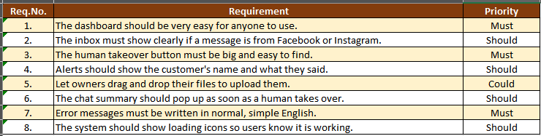
This table shows how easy it will be to use this system. These are the quality checks to make it easy to use.

Software Requirement
While building EkSamadhan-AI, I will be using these tools:
  - Java (Spring Boot): Java is chosen for the backend over Node.js for this project because Java is better at handling complex systems, while Node.js is used for fast development and lightweight projects. But this project needs multithreaded support to handle the many incoming messages, to provide scalability, and to be reliable, safe, and trusted. It has better memory management and is stable for long-term, even at an enterprise-level system.
  - React.js (Vite): React with Vite for the frontend because it provides fast building components, hot reload, increases speed, and is used for modern UI website design.
  - OpenAI API: Latest GPT models will be used to answer customer queries and find the best replies.
  - Pinecone: Rather than matching the keywords, this database searches for the meaning, and while the business file is uploaded, it searches semantically, so this is used to store product details.
  - Firebase: Every time the screen cannot stay on display, it drains battery, so FCM will be used to send an alert to the worker's device instantly.
  - PostgreSQL: This manages and stores data safely better than SQL and non-SQL. It is free and open source, which can handle complex data and is reliable, secure, and stable for a large-scale system.

Hardware requirement

For Development
A device with at least 16GB of RAM and a processor with an i5 or M1 chip set.

For Deployment
PrabhuHost will be used as a deployment because of 99.9% uptime, fast performance, security, easy to use, and deploy at an affordable price.

Feasibility Study
A feasibility study plans whether the idea is worth doing to avoid investing in bad ideas and whether it will succeed. This requires analysis of resources and risk, which is done before starting the project (Team, 2026).

Technical Feasibility
To develop EkSamadhan-AI uses Java as a backend, React with Vite as a frontend, and store data in Pinecone as vector storage. These are high-level tools to handle logic, building a user interface, and AI-based search to reply to customers, which ensure that technical challenges can be faced and resolved with research knowledge. The RAG and OpenAI models are supported by SDKs. My implementation skills will be focused on these technical tools for developing API integration and connecting everything.

Economic Feasibility
To maintain affordability and be budget-friendly for small local owners by focusing on deploying the system in PrabhuHost and choosing the simple but more efficient AI model like free models, giving the limited AI Tokens, storing common questions in cache, and later, AI will answer, so it does not have to re-check for everything helps in reduce load and stores data in temoprary memory to reuse. Finally, this system will be less costly than Zendesk, which is expensive and only affordable by a large company.

Legal Feasibility
To protect the data of users, a privacy standard will be applied by covering sensitive data and encrypting only authorized users can read, authentication while users login system, and use JWT, password, OTP method, and SSF login access control. Only authorized users can use the dashboard of users who are allowed and mainly encrypting data between the server and the user while it redirects and sends an HTTP request. Since this application uses OAuth 2.0 for authentication, it blocks another user from viewing the password. It does not store data like passwords. This maintains security and is legally protected while using the meta pre-owned platform.

Operational Feasibility
To check whether this works in real life, the system uses a meta-API for integrating social media handles like Instagram, Facebook, and website chat in a centralized single inbox to reply to customers, and easy answers are replied by AI, and only negative tone answers come as an alert to workers' devices. This helps reduce the owner's workload of replying to everyone, and even if typing one message, 3 other customers get bored and leave to buy from another store. If they do not get a reply within 5 minutes. So, this solves the current problem.

Scheduling Feasibility
To successfully develop the application, it is structured in a 12-week timeline and divided into 4 weekly phases. Each phase has weekly deadlines, all of which are tracked through and uses the agile project management method. This phase considers continuing the development, testing bugs, gathering feedback, deploying, and ensuring that EkSamadhan-AI meets the requirements at the end.

System Design
System design is a method for planning the flow of data to understand how the system works and communicates with its components (Singour, 2025).

Use Case
A Use case diagram shows the relationship between actors that are present in the system, and how the flow works through the diagram (Visual Paradigm, n.d.).
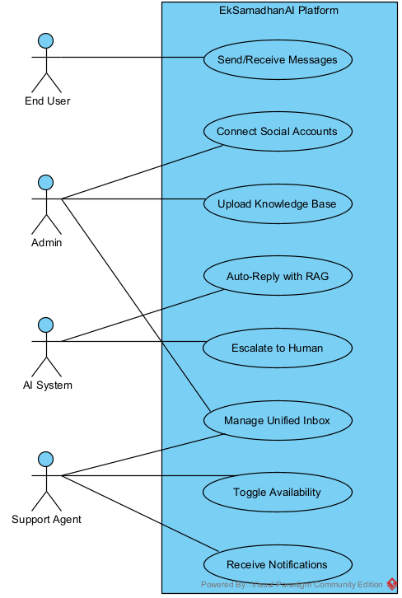
Figure 17: Usability and Interface Requirements
This use case diagram is created in a visual paradigm and illustrates four actors: the end user sends and receives messages, Admin manages the settings to connect social accounts, upload knowledge base, and unified inbox, AI system gives replies to customers by auto reply with RAG, and if the conversation feels emotional, it is passed to a support agent, they take control and manages the unified inbox when needed.

ER Diagram
An Entity Relationship Diagram represents the connection between the classes with entities, attributes, and relationships. This diagram shows all the entities that will later be created in the DB schema (Visual Paradigm, 2025).
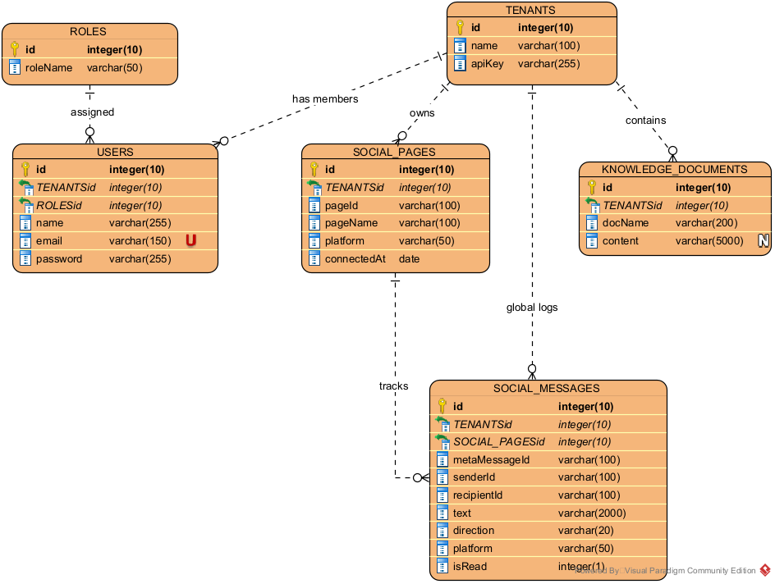
Figure 18: Entity Relationship Diagram (ERD)
This ER diagram is created in a visual paradigm and stores information about six entities: roles, users, tenants, social pages, knowledge documents, and social messages. Each entity's connection has a relationship, while this diagram shows attributes that fields are required or nullable, primary keys, foreign keys, and that email is unique.

System Architecture
System architecture is the planning of the system that defines its structure, behavior, and interaction, so that later components fit together piece by piece (Tiwari, 2025).
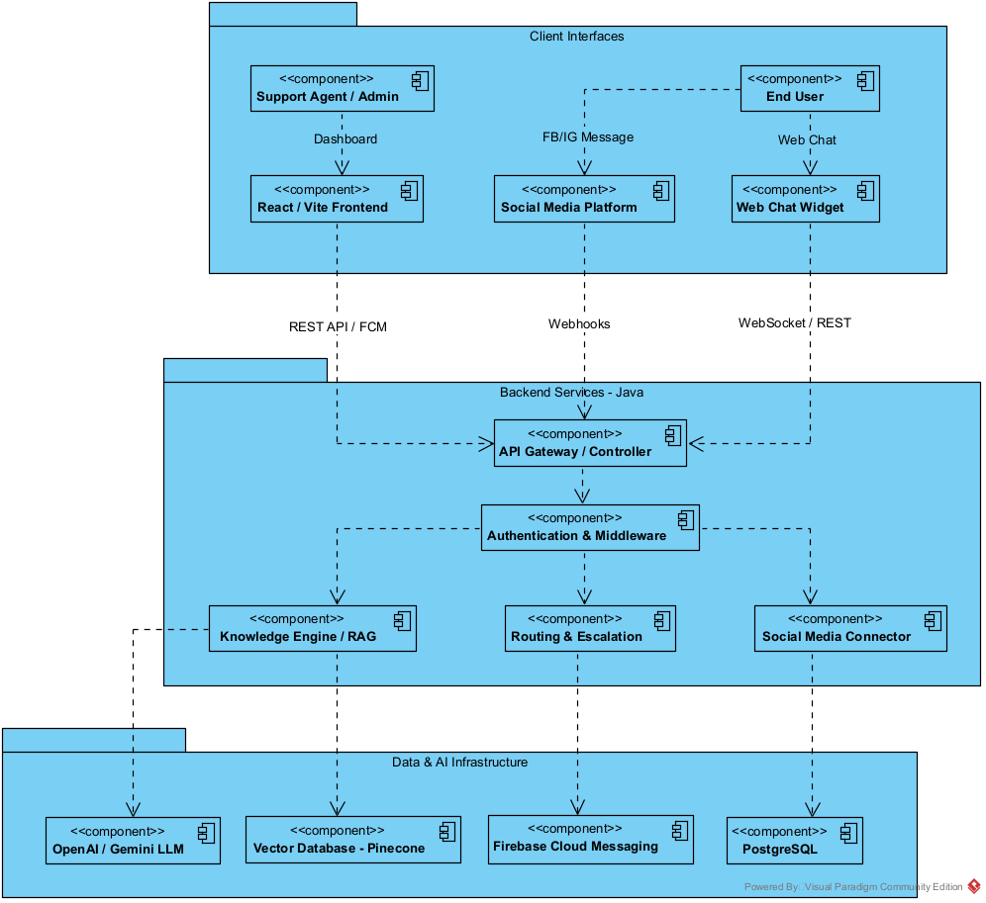
Figure 19: System Architecture
This architecture is created in a visual paradigm. It shows customer support using an AI chatbot and is split into three parts: a client interface for user interaction, backend services to handle logic, and data and AI infrastructure to store information. Customers send messages and chats through Facebook and Instagram. Those messages go to the backend, where LLMs like GPT models answer easy questions. Humans can take over or pass on when a negative tone is present and respond to the customer as a support agent.

CHAPTER 6: EVALUATION / QUALITY ASSURANCE
Quality assurance means preventing bugs and improving the quality of the system, and it is done during development (Hashemi-Pour & Gillis, 2024).

6.1. Technical Testing Strategy / Plan
A technical testing strategy is used to plan testing step by step to ensure the software does not have errors early and works correctly by using these methods:
  - Unit Testing: Checking the small feature to see if those individual components work (Miecznik, 2023).
  - Integration Testing: Different modules are combined to ensure they work together by interacting with components (testRigor, 2024).
  - API Testing: Testing the APIs to ensure that when sending a correct request, it must respond with a correct status code, error handling, and check the accuracy of the data (China & Goodwin, 2025).
  - E2E Testing: Using a fake account and testing the entire system of flow, whether all the components work together from start to end (Schmitt, 2026).
Table 10: Testing Strategy and Plan Overview
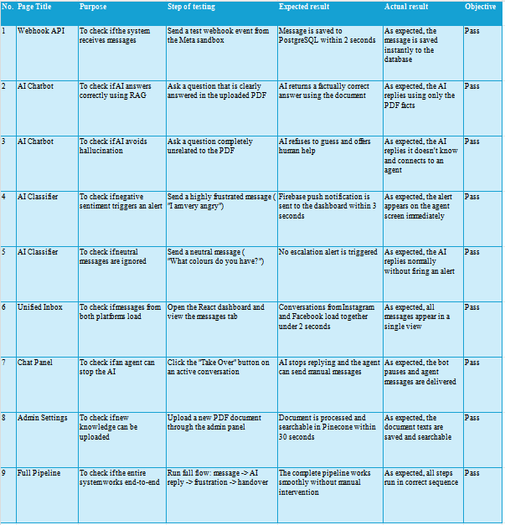

6.2. Evaluation Strategy / Plan
Strategy Evaluation is a process of reviewing and evaluating effective plans to check the strategy's performance and ensure everything aligns with the company's goals (Quantive, 2022).

6.2.1. Evaluation Objectives
These are the goals and aims of the system to collect the data, analyze the system, and make decisions effectively for sustainability.
Table 11: System Evaluation Objectives
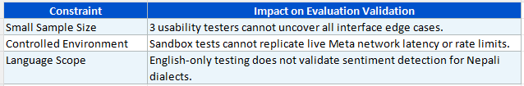

6.2.2. Evaluation Limitations
These show some limitations that may affect the evaluation process, but the plan gives a clear way to evaluate if the system is successful.
Table 12: Evaluation Limitations and Constraints
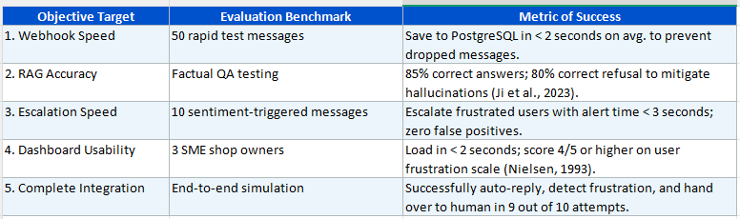
These are the testing strategies for finding bugs, making sure each unit works together, checking if the API runs well, testing performance under heavy use, and testing everything to be sure the system works.
This ensures everything works perfectly and will be implemented during the development phase to meet the system requirements. In case anything breaks, using stargies to improve quality and detect mismatches between the system's actual and expected behavior. This will later confirm that the system is ready.

CHAPTER 7: CRITICAL ANALYSIS AND IMPLEMENTATIONAL PLAN
This chapter provides how the development will be successful by identifying the risk plan and a 12-week road map timeline for building the EkSamadhan-AI.

7.1. Critical Analysis
First, the POC will be tested. I will try to check whether the social media connector works. I will try with Node.js because it is the fastest development tool, then connect to social media like Facebook and Instagram. I have gained knowledge of Meta documentation using GraphQL to fetch and manage the data for the APIs. I will centralize social media handles in a single inbox. After I develop that POC, I will move on to the AI system and make a POC of that and then integrate it all.
- API Risk: If Facebook or OpenAI decided to block APIs and stopped working, that would be a huge problem, but I will save all the data beforehand and have a backup of the information, so no data will be lost, even if AI fails temporarily.
- Scope Risk: Trying to build all features will be hard, but not impossible. I will break tasks into small parts and try to implement POC first, and later, when the POC is successfully built, I will integrate them one by one, like solving a puzzle.
- AI Risk: AI is not always right, and it might give wrong answers as well. To prevent that, RAG is used to search the database and answer customers. If there is no answer related to the product, then the AI will say, “I do not know” immediately. I will set up the prompt system so that it will give the answer that is inside the business file. If there is no answer, then the human will get an alert on the device, and the human can take over the AI instantly.
- Privacy Risk: I will encrypt the sensitive data and apply a one-click delete feature, in case there is a need to wipe out their data by following the GDPR rule (European Parliament and Council of the European Union, 2016).
These are the risks that may come, but I am prepared for them. Besides that, I am still building my knowledge in LLM, RAG, and webhook. These topics are very vast right now, but I will take the help of my senior and supervisor and research these topics so I can successfully achieve my project goal.

7.2. Implementation Plan (12-Week Roadmap)
To meet the deadline, the table below is the estimated 12-week timeline to complete this project on time:
Table 13: Implementation Plan (12-Week Roadmap)
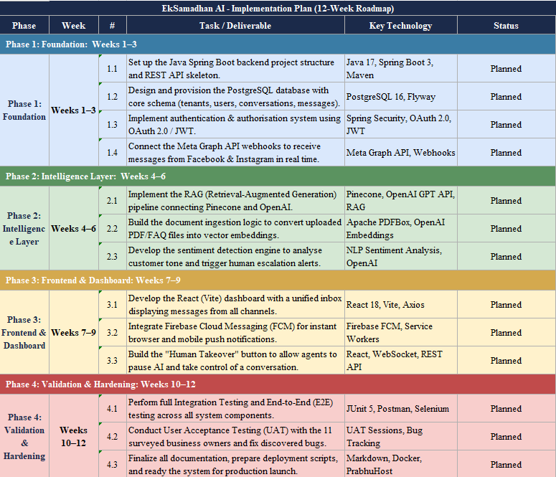
In this roadmap, phase 1 (week 1-3) is for the foundation, where it focuses on building the Spring Boot server, PostgreSQL database, OAuth 2.0 authentication, and Meta Graph API integration. Phase 2 (week 4-6) is for the intelligence layer, which is focused on the RAG pipeline, vector database, and sentiment detection when customer tone is negative, and alerts the support agent. Phase 3 (week 7-9) is for building the frontend in React and improving UI. Finally, phase 4 (week 10-12) is for testing the entire application, deployment, getting feedback, and doing a data survey, documentation, prepared for the project expo demonstration and presentation. By the end of 12 weeks, my goal is to complete the EkSamamdhan-AI application successfully.

CHAPTER 8: CONCLUSION
EkSamadhan-AI helps business owners by acting as a smart assistant and customer support system where social media handles like Facebook and Instagram are centralized in a single inbox. When a customer inquires about a product, the AI chatbot gives answers automatically, but when a negative tone is detected, it alerts the support agent, and a human can take control whenever it is needed. This idea helps online sellers who receive 50-100+ messages. Replying to everyone is time-consuming, and when typing replies to one customer, the other 10 customers get bored and leave to buy from another store. The plan is to build this Saas application that helps grow business with AI and provide fast replies with affordable pricing. The goal is to make a tool that online business owners can use and do not feel overwhelmed by growing their own business. This follows a 12-week plan to build and deliver a complete project for replying fast, centralizing handles, and cutting the fear of AI giving wrong answers.

REFERENCES
Ada, 2023. The State of Automated Customer Experience. [Online]
Available at: https://www.ada.cx/
[Accessed 15 April 2026].
Awati, R., 2023. What is requirements analysis (requirements engineering)?. [Online]
Available at: https://www.techtarget.com/searchsoftwarequality/definition/requirements-analysis
[Accessed 18 April 2026].
Chari, S., 2022. The Rise of Conversational Commerce on Messaging Platforms. Journal of Retail Technology, 2(pp. 112-126), p. 14.
China, C. & Goodwin, M., 2025. What is API testing?. [Online]
Available at: https://www.ibm.com/think/topics/api-testing
[Accessed 17 April 2026].
Editage, 2024. What is Literature Review? Definition, Types and Examples. [Online]
Available at: https://www.editage.com/blog/what-is-literature-review-definition-types-and-examples/
[Accessed 15 April 2026].
Elsevier, n.d. Usability Requirement. [Online]
Available at: https://www.sciencedirect.com/topics/computer-science/usability-requirement
[Accessed 18 April 2026].
European Parliament and Council of the European Union, 2016. Regulation (EU) 2016/679 on the protection of natural persons with regard to the processing of personal data and on the free movement of such data (General Data Protection Regulation). [Online]
Available at: https://eur-lex.europa.eu/eli/reg/2016/679/oj
[Accessed 18 April 2026].
European Parliament and Council of the European Union, 2026. Regulation (EU) 2016/679 of the European Parliament and of the Council on the protection of natural persons with regard to the processing of personal data and on the free movement of such data, and repealing Directive 95/46/EC (General Data Protection Reg. [Online]
Available at: https://eur-lex.europa.eu/eli/reg/2016/679/oj
[Accessed 15 April 2026].
Gnewuch, U., Morana, S., Adam, M. & Maedche, A., 2018. Faster Is Not Always Better: Understanding the Effect of Dynamic Response Delays in Human-Chatbot Interaction. s.l., Association for Information Systems.
Google Firebase, 2025. FCM Architectural Overview and Service Workers. [Online]
Available at: https://firebase.google.com/docs/cloud-messaging/fcm-architecture
[Accessed 15 April 2026].
Gorgias, 2025. Automate your work using Customer Intents. [Online]
Available at: https://docs.gorgias.com/en-US/use-intents-and-sentiments-to-prioritize-and-route-tickets-81924
[Accessed 15 April 2026].
Hardt, D., 2012. The OAuth 2.0 Authorization Framework. [Online]
Available at: https://datatracker.ietf.org/doc/html/rfc6749
[Accessed 15 April 2026].
Hashemi-Pour, C. & Gillis, A., 2024. What is quality assurance (QA)?. [Online]
Available at: https://www.techtarget.com/searchsoftwarequality/definition/quality-assurance
[Accessed 17 April 2026].
Intercom, 2023. The State of AI in Customer Service 2023. [Online]
Available at: https://www.intercom.com/why-choose-intercom?redirect_from=/resources
[Accessed 15 April 2026].
Ji, Z. et al., 2023. Survey of Hallucination in Natural Language Generation. ACM Computing Surveys, 55(12), pp. 1-18.
Ji, Z. et al., 2023. Survey of Hallucination in Natural Language Generation. ACM Computing Surveys, 55(12), pp. pp. 1-38.
Kaur, H. & Kaur, K., 2021. Load Balancing and Its Challenges in Cloud Computing: A Review. s.l., Springer.
Krüger, G., 2025. Non-Functional Requirements: Tips, Tools, and Examples. [Online]
Available at: https://www.perforce.com/blog/alm/what-are-non-functional-requirements-examples
[Accessed 18 April 2026].
Lewis, P. et al., 2020. Retrieval-Augmented Generation for Knowledge-Intensive NLP Tasks. s.l., s.n., pp. pp. 9459-9474.
Meta for Developers, 2024. Messenger Platform and Instagram Graph API Guidelines. [Online]
Available at: https://developers.facebook.com/docs/messenger-platform
[Accessed 15 April 2026].
Miecznik, R., 2023. The importance and benefits of unit testing. [Online]
Available at: https://codilime.com/blog/unit-testing/
[Accessed 17 2023 2023].
OpenAI, 2025. Optimizing Prompt Context Windows and Token Usage. [Online]
Available at: https://developers.openai.com/api/docs
[Accessed 15 April 2026].
Quantive, 2022. Strategy evaluation process: Definition, key steps, & best practices. [Online]
Available at: https://quantive.com/resources/articles/strategy-evaluation
[Accessed 17 April 2026].
Salesforce, 2024. Human-in-the-Loop AI for Customer Success. [Online]
Available at: https://www.salesforce.com/ap/?ir=1
[Accessed 15 April 2026].
Schmitt, J., 2026. What is E2E? A guide to end-to-end testing. [Online]
Available at: https://circleci.com/blog/what-is-end-to-end-testing/
[Accessed 17 April 2026].
Singour, H., 2025. How I Learned System Design. [Online]
Available at: https://medium.com/@himanshusingour7/how-i-learned-system-design-d7444d454367
[Accessed 18 April 2026].
Statista, 2025. E-commerce worldwide, Statistics and Facts. [Online]
Available at: https://www.statista.com/topics/871/online-shopping/
[Accessed 14 April 2026].
Team, T. I., 2026. The Investopedia Team. [Online]
Available at: https://www.investopedia.com/terms/f/feasibility-study.asp
[Accessed 18 April 2026].
testRigor, 2024. Integration testing: Definition, types, tools, and best practices. [Online]
Available at: https://testrigor.com/blog/integration-testing/
[Accessed 17 April 2026].
Tidio, 2023. Launching Tidio AI to empower SMBs with AI features. [Online]
Available at: https://www.tidio.com/blog/tidio-ai-features/
[Accessed 14 April 2026].
Tiwari, V., 2025. Understanding System Architecture: A Beginner's Guide. [Online]
Available at: https://medium.com/@vaibhavtiwari.945/understanding-system-architecture-a-beginners-guide-d2aad48f0007
[Accessed 18 April 2026].
Visual Paradigm, 2025. What is Entity Relationship Diagram (ERD)?. [Online]
Available at: https://www.visual-paradigm.com/guide/data-modeling/what-is-entity-relationship-diagram/
[Accessed 18 April 2026].
Visual Paradigm, n.d. What is Use Case Diagram?. [Online]
Available at: https://www.visual-paradigm.com/guide/uml-unified-modeling-language/what-is-use-case-diagram/
[Accessed 18 April 2026].
Wang, Y., Zhang, L., Chen, H. & Miller, J., 2024. A Comparative Analysis of Vector Databases for Real-Time AI Inference. Journal of Cloud Computing, 13(1), pp. pp. 42-58.
Wright, G., 2025. What are functional requirements?. [Online]
Available at: https://www.techtarget.com/whatis/definition/functional-requirements
[Accessed 18 April 2026].
Wyciślik, Ł., Latusik, Ł. & Kamińska, A., 2023. A Comparative Assessment of JVM Frameworks to Develop Microservices. Applied Sciences, 13(3), p. 1343.
Zanzotto, F. M., 2019. Human-in-the-loop Artificial Intelligence. Journal of Artificial Intelligence Research, Volume 64, pp. pp. 243-252.
Zendesk, Inc., 2024. Zendesk Launches New Customer Sentiment and Intent Functionality Powered by Machine Learning. [Online]
Available at: https://www.advfn.com/stock-market/NYSE/ZEN/stock-news/89063000/zendesk-launches-new-customer-sentiment-and-intent
[Accessed 14 April 2026].
Zhang, L. & Liu, B., 2024. Aspect and Entity Extraction for Opinion Mining. In: W. Chu, ed. Data Mining and Knowledge Discovery for Big Data. s.l.:Springer, pp. pp. 1-40.

APPENDICES

Appendix A: Project Proposal (Scanned)
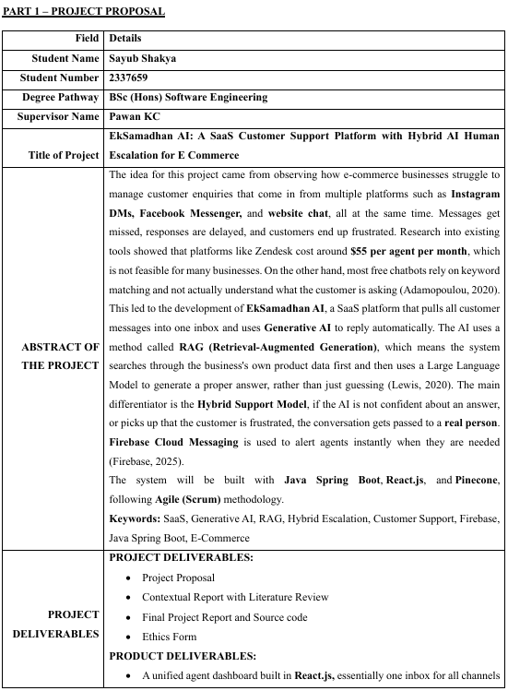

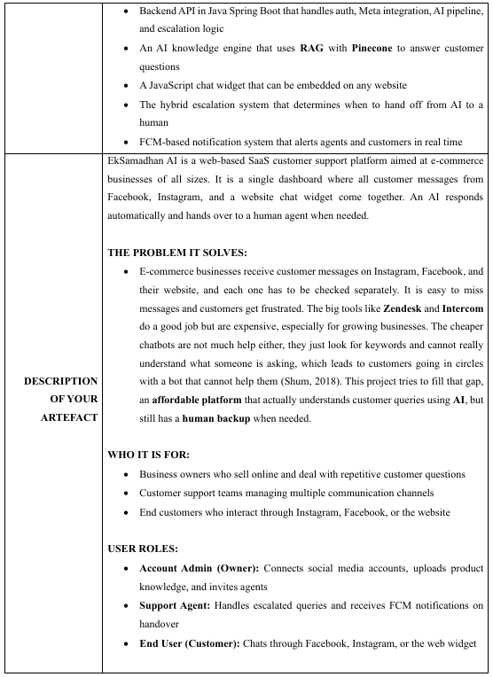

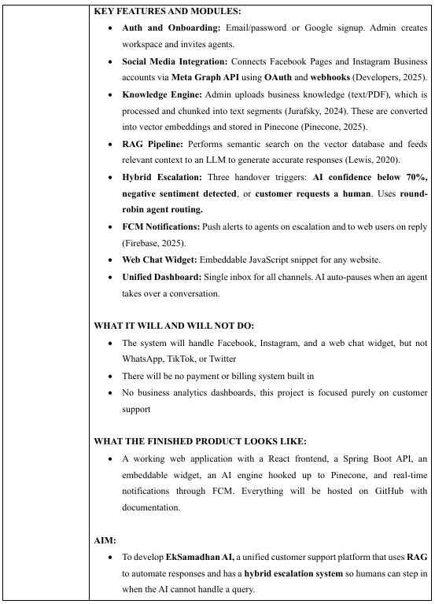

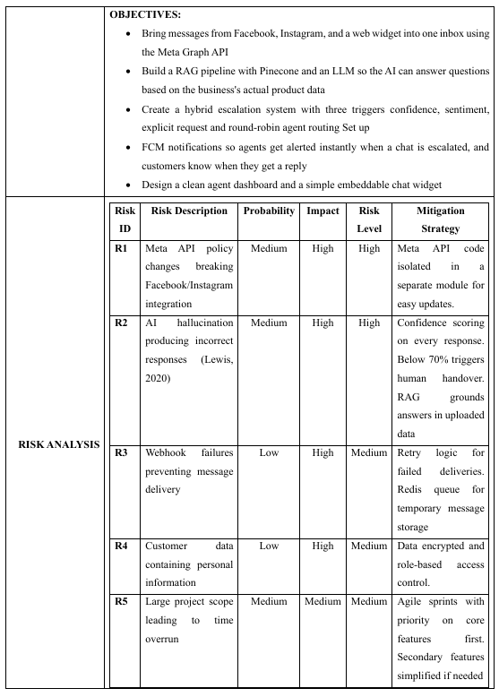

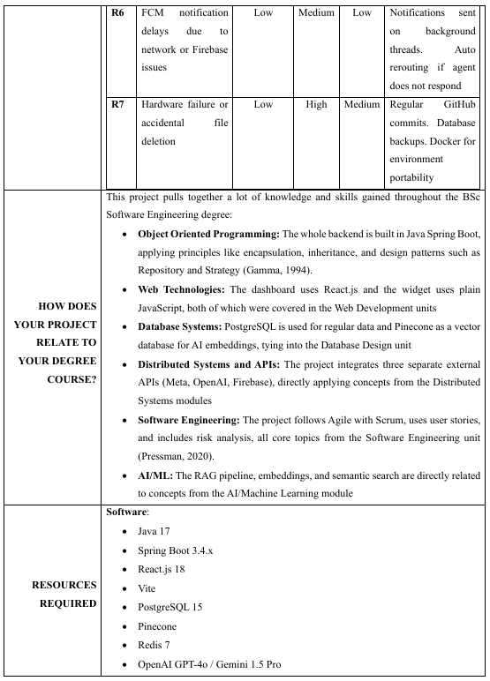

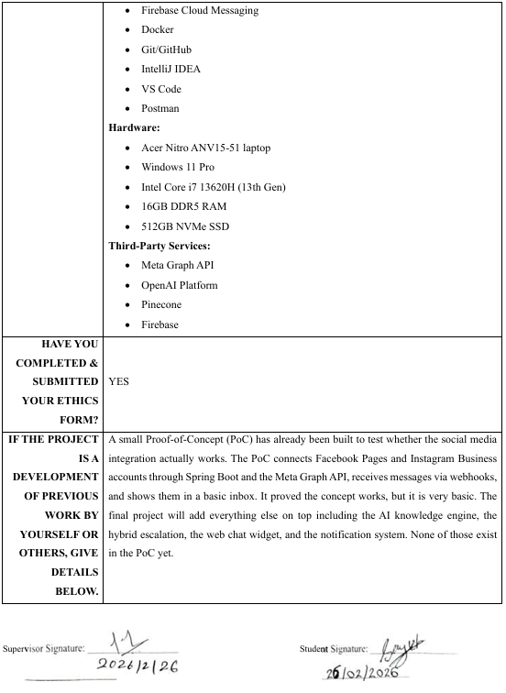

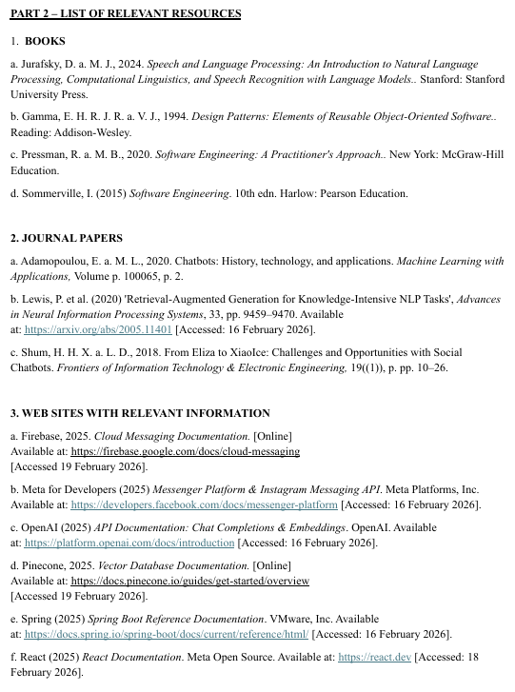

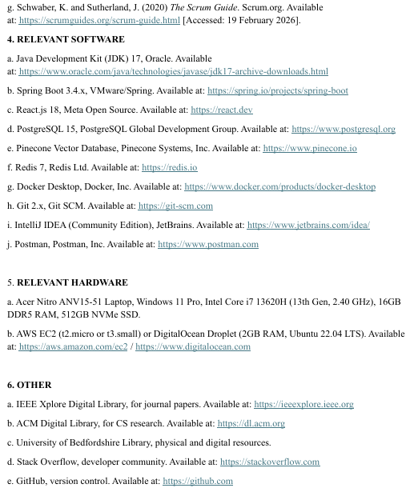

Appendix B: Ethics Form (Scanned)
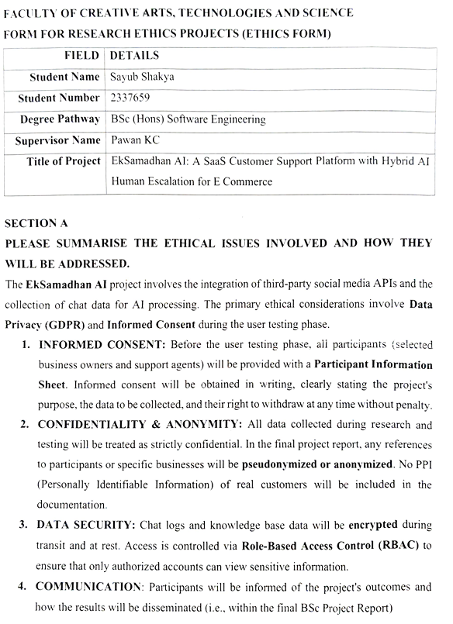

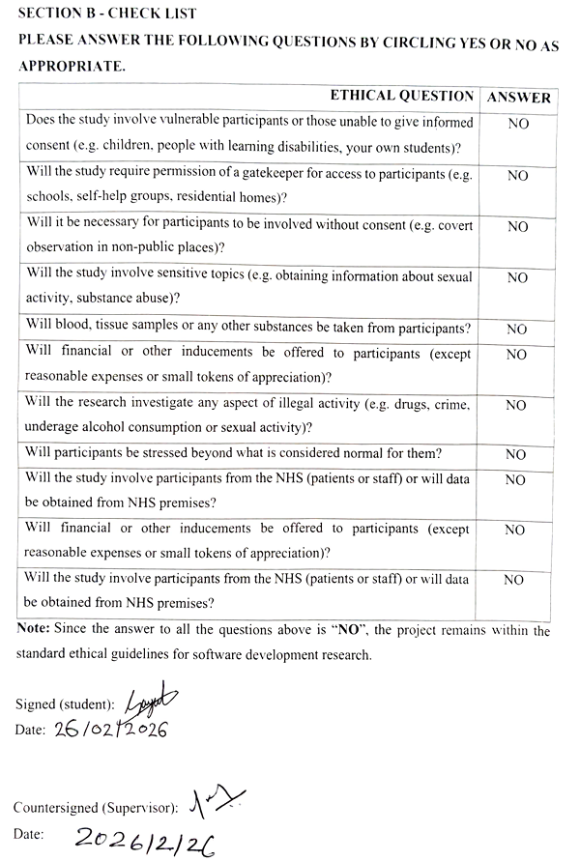

Appendix C: Literature Review Resources (Screenshots)
- Lewis et al. (2020): Retrieval-Augmented Generation (RAG)
Link: https://arxiv.org/abs/2005.11401
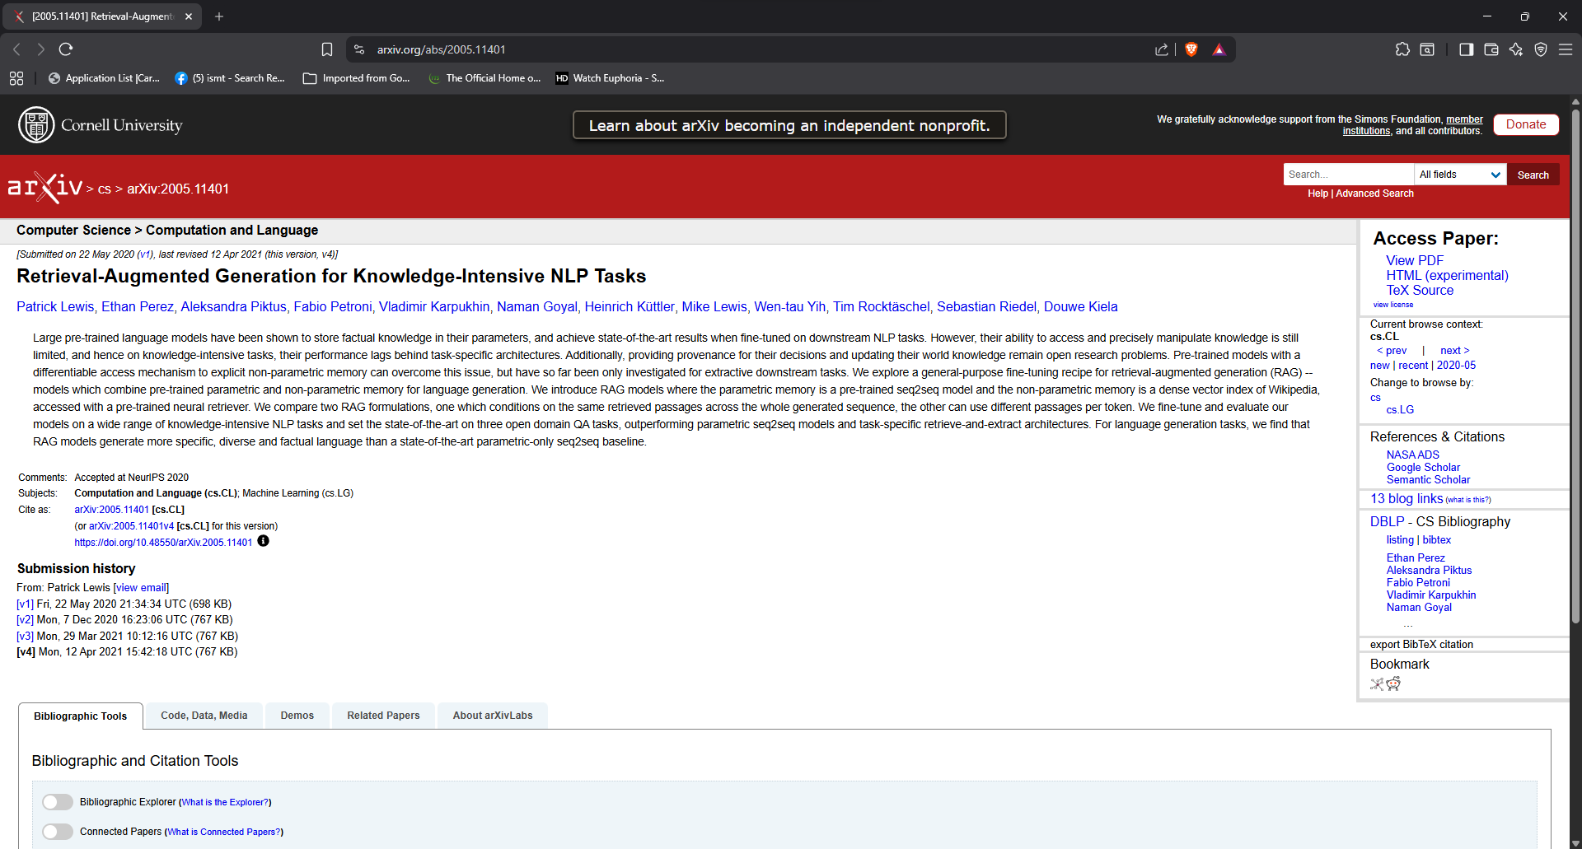
- Ji et al. (2023): Survey of Hallucination in NLP
Link: https://dl.acm.org/doi/10.1145/3571730
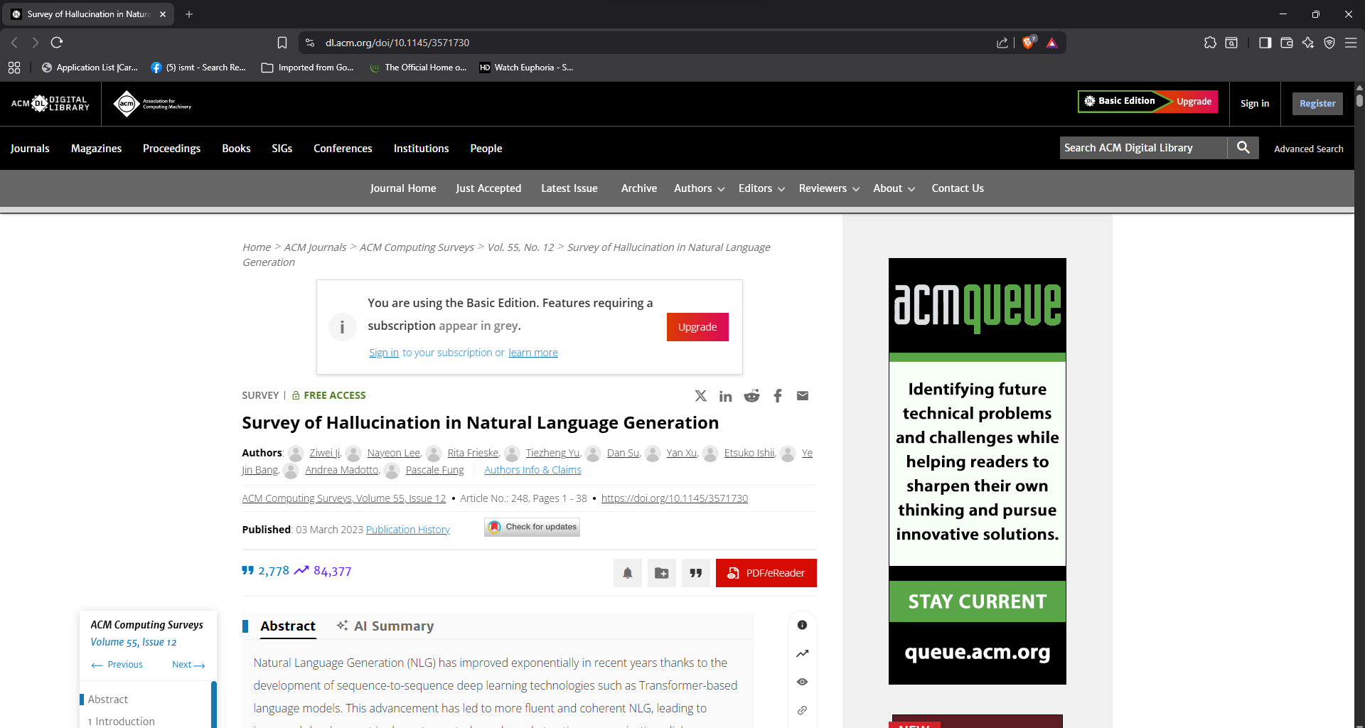

- Zanzotto (2019): Human-in-the-loop Artificial Intelligence
Link: https://www.jair.org/index.php/jair/article/view/11303
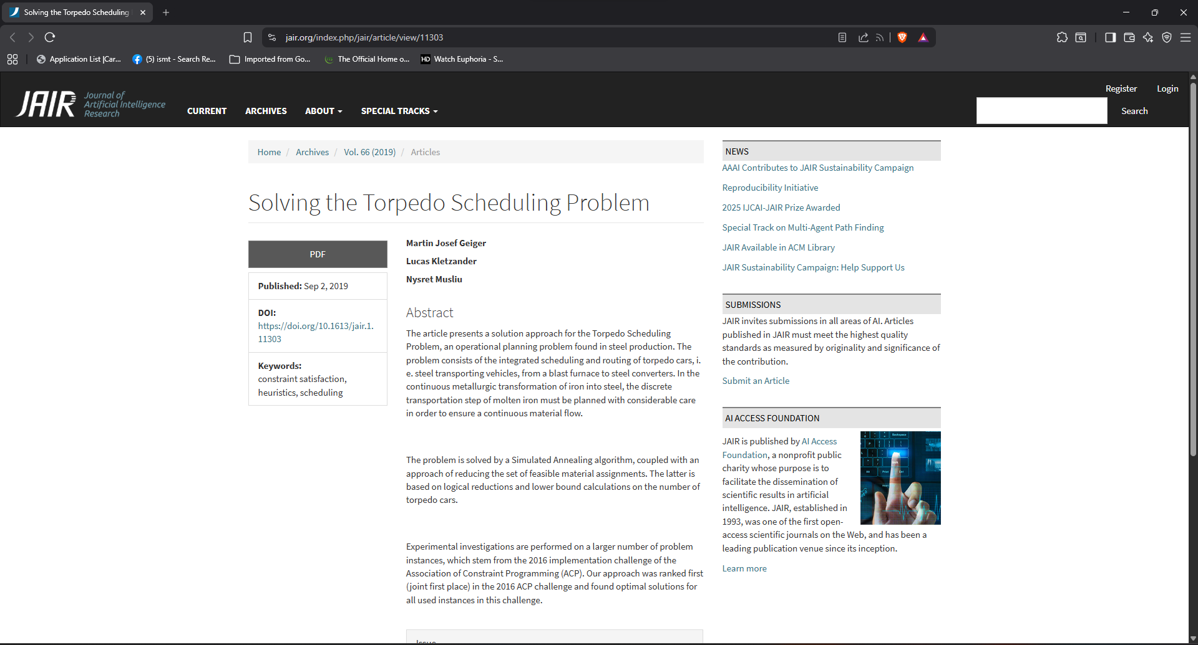

- Zendesk (2024): Intelligent Triage and Sentiment Analysis
Link: https://www.zendesk.com/customer-experience-trends/
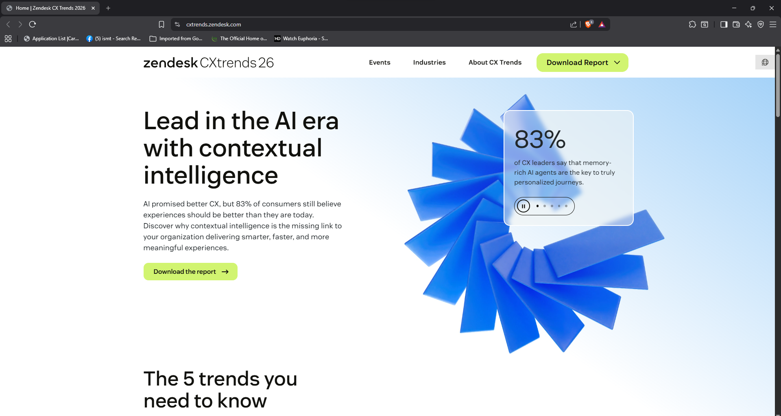

- Meta for Developers (2024): Messenger and Instagram API
Link: https://developers.facebook.com/docs/messenger-platform/
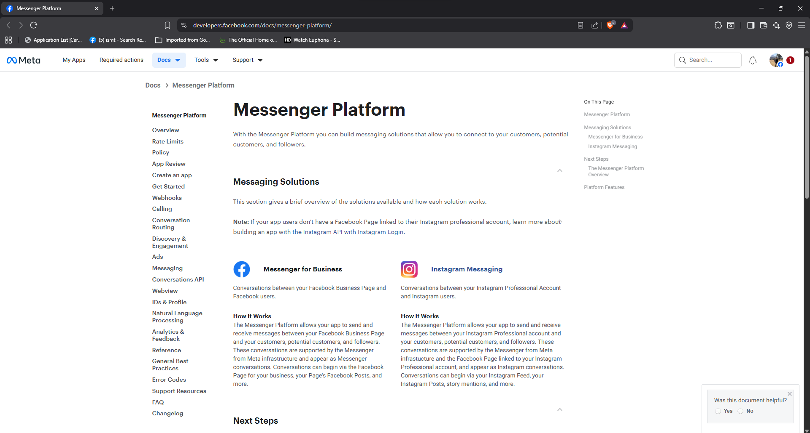
- Google Firebase (2025): FCM Push Notifications Documentation
Link: https://firebase.google.com/docs/cloud-messaging
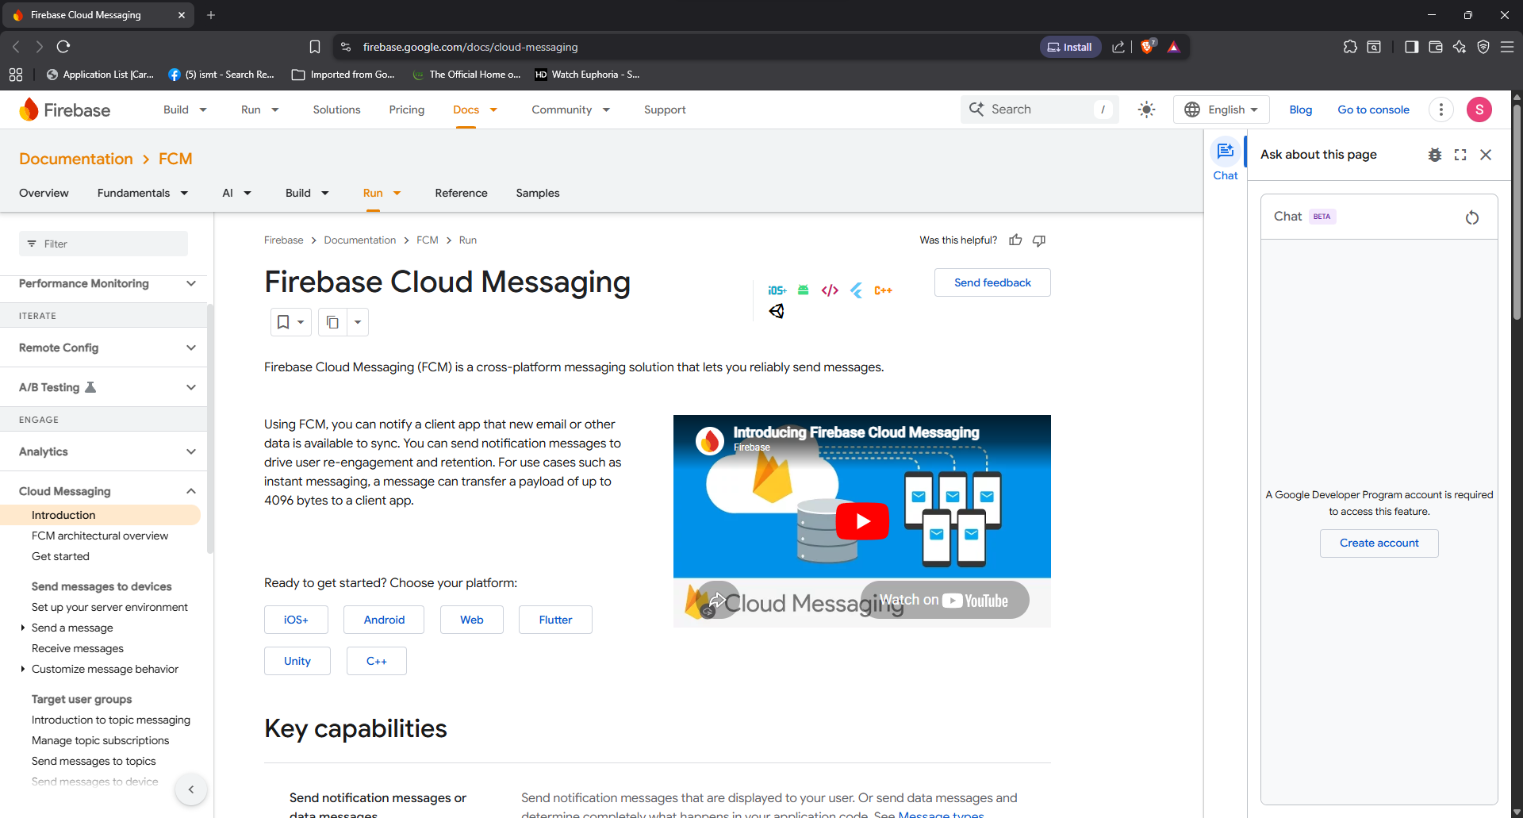

- Salesforce (2024): Human-in-the-Loop for Customer Success
Link: https://www.salesforce.com/products/service-cloud/overview/
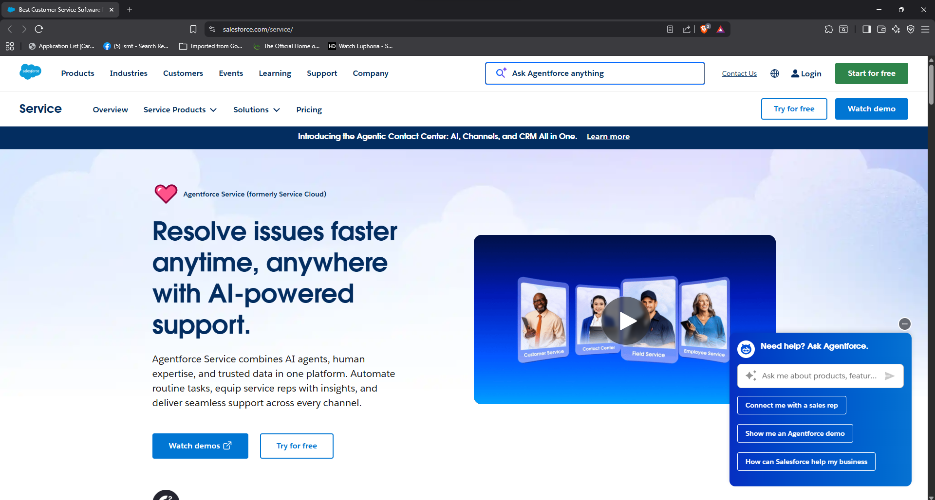
- Ada (2023): The State of Automated Customer Experience
Link: https://www.ada.cx/resource-center
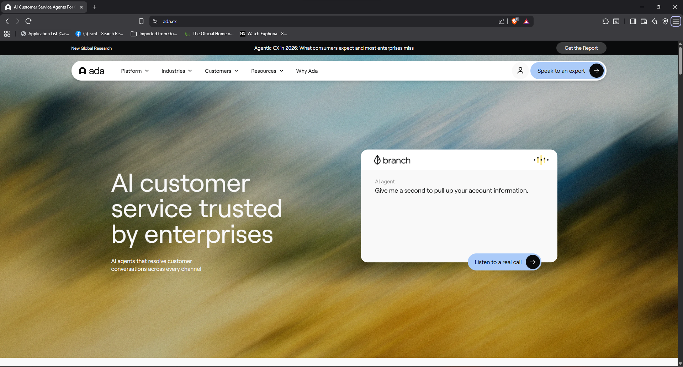

- Intercom (2023): Fin AI Bot and Customer Trust
Link: https://www.intercom.com/blog/announcing-fin/
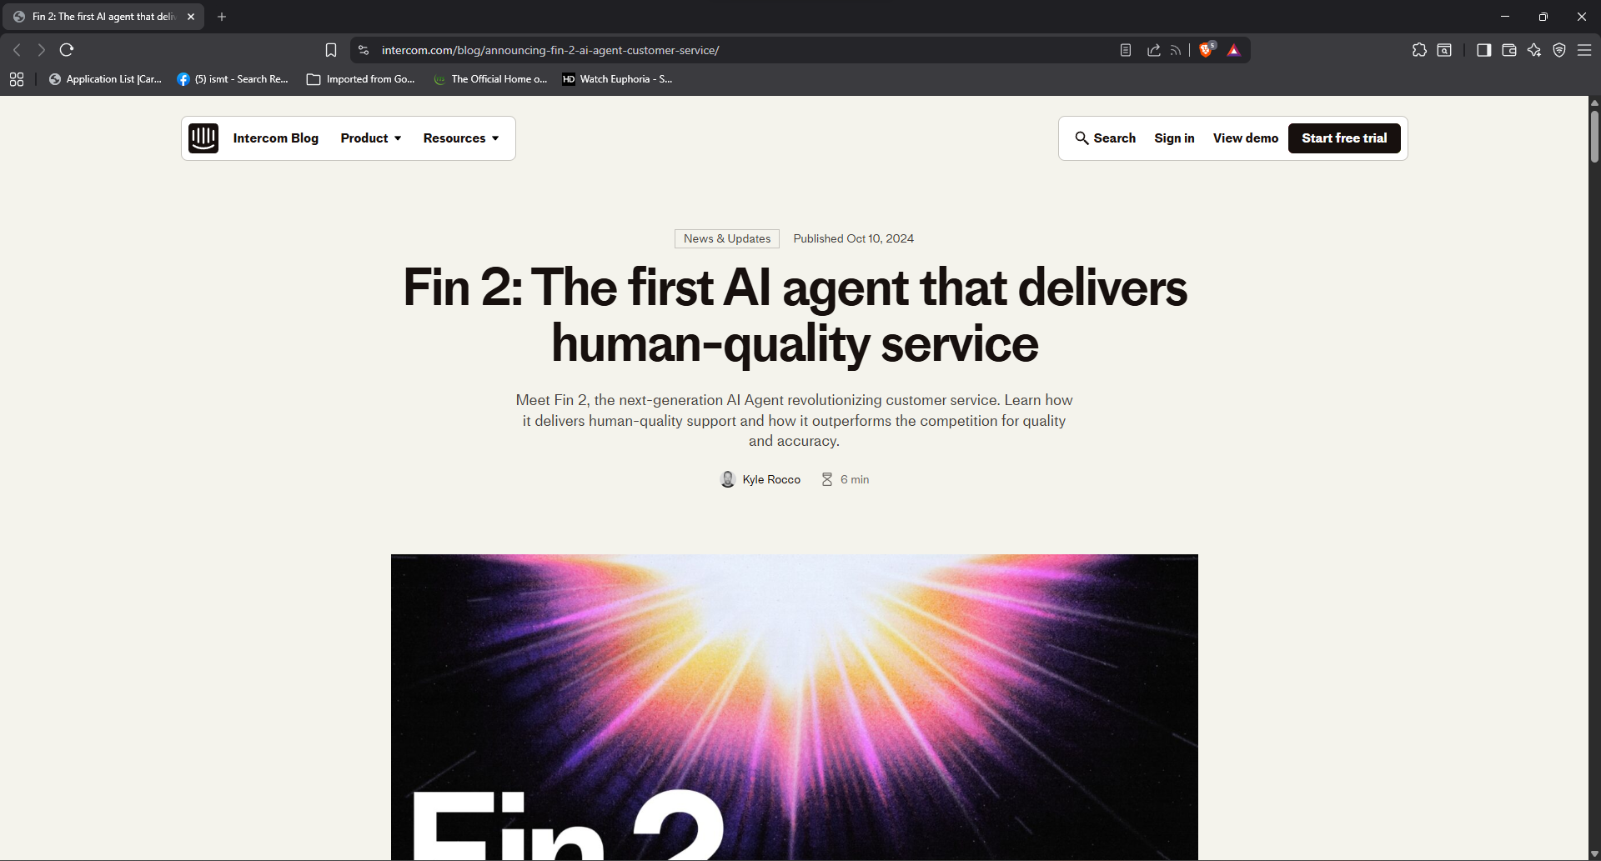

- OpenAI (2025): ptimizing Prompt Context and Token Usage
Link: https://platform.openai.com/docs/guides/optimization
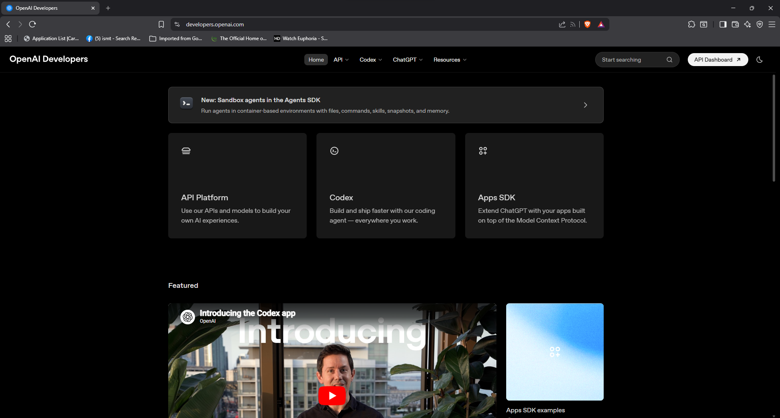

- Tidio (2023): Omnichannel Customer Experience for SMEs
Link: https://www.tidio.com/blog/omnichannel-customer-service/
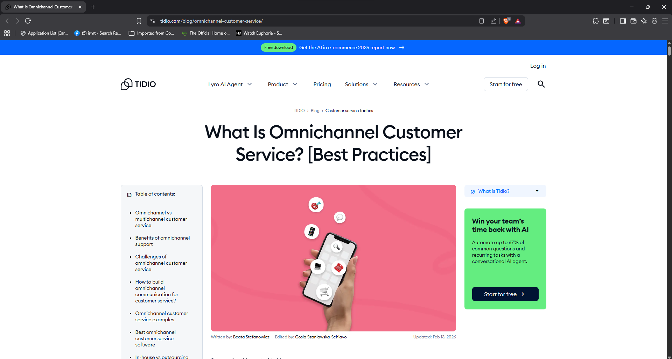
- European Parliament (2016): GDPR Data Privacy Regulations
Link: https://gdpr-info.eu/
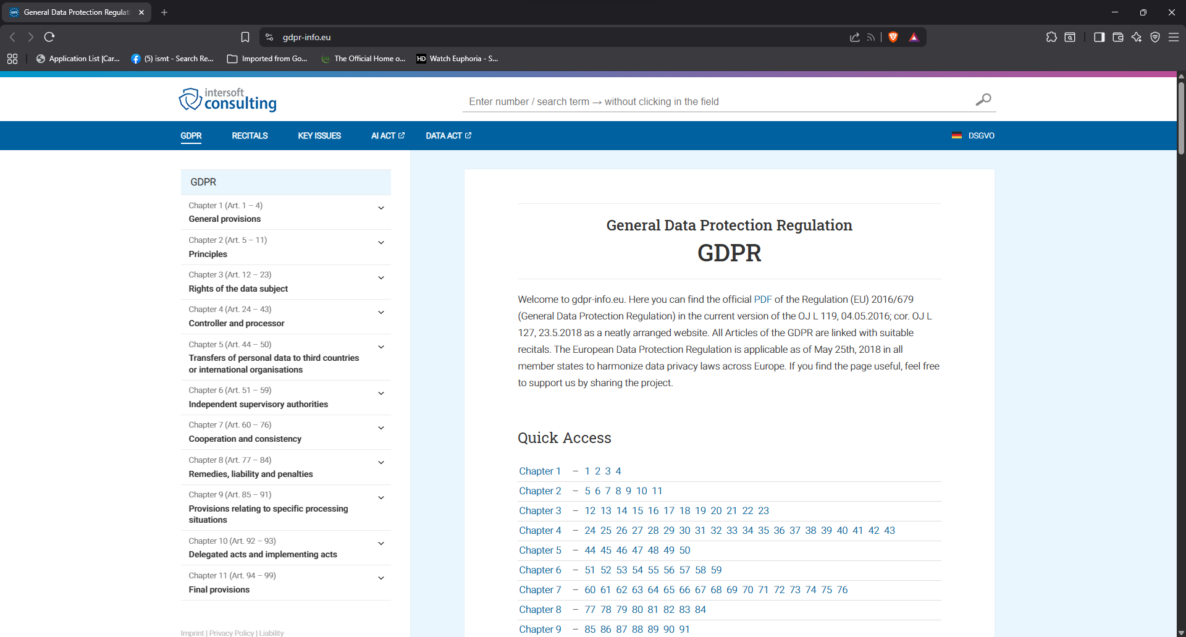

Appendix D: Survey Questionnaire and Report
Source Evidence: Survey Form
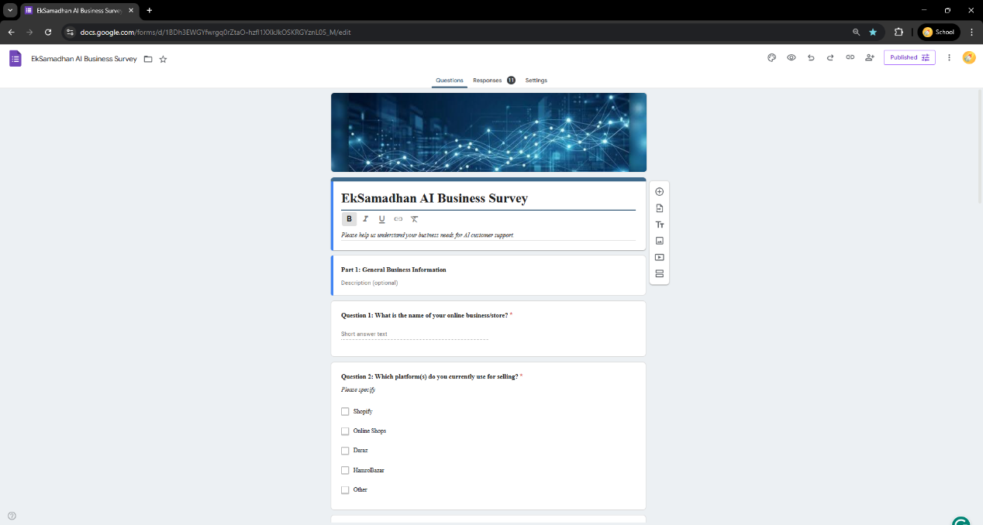
Source Evidence: Authentic Responses (11 Responses)
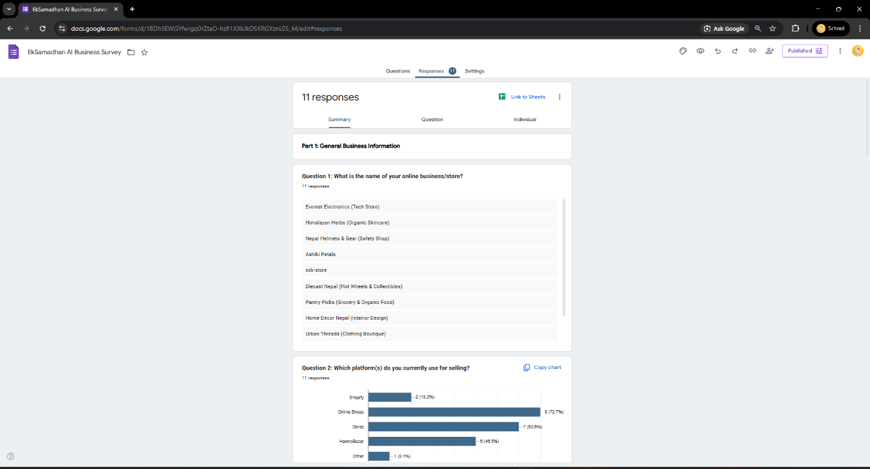

Appendix E: Raw Data
Survey Raw Data Export (Google Sheets)
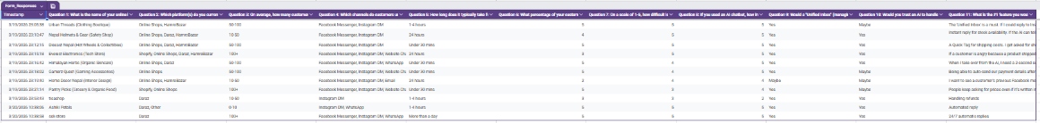

Burndown Sprint Chart
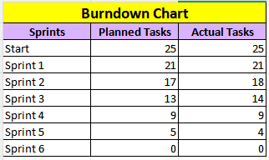
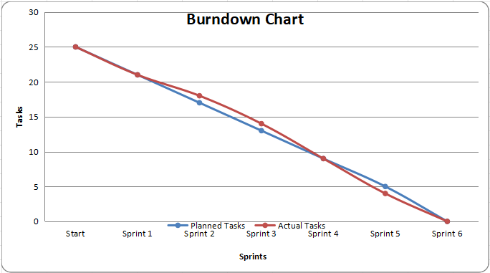

Appendix F: Weekly Progress Reports (Scanned)
Appendix F.1: Report No.: 1 (Week 6)
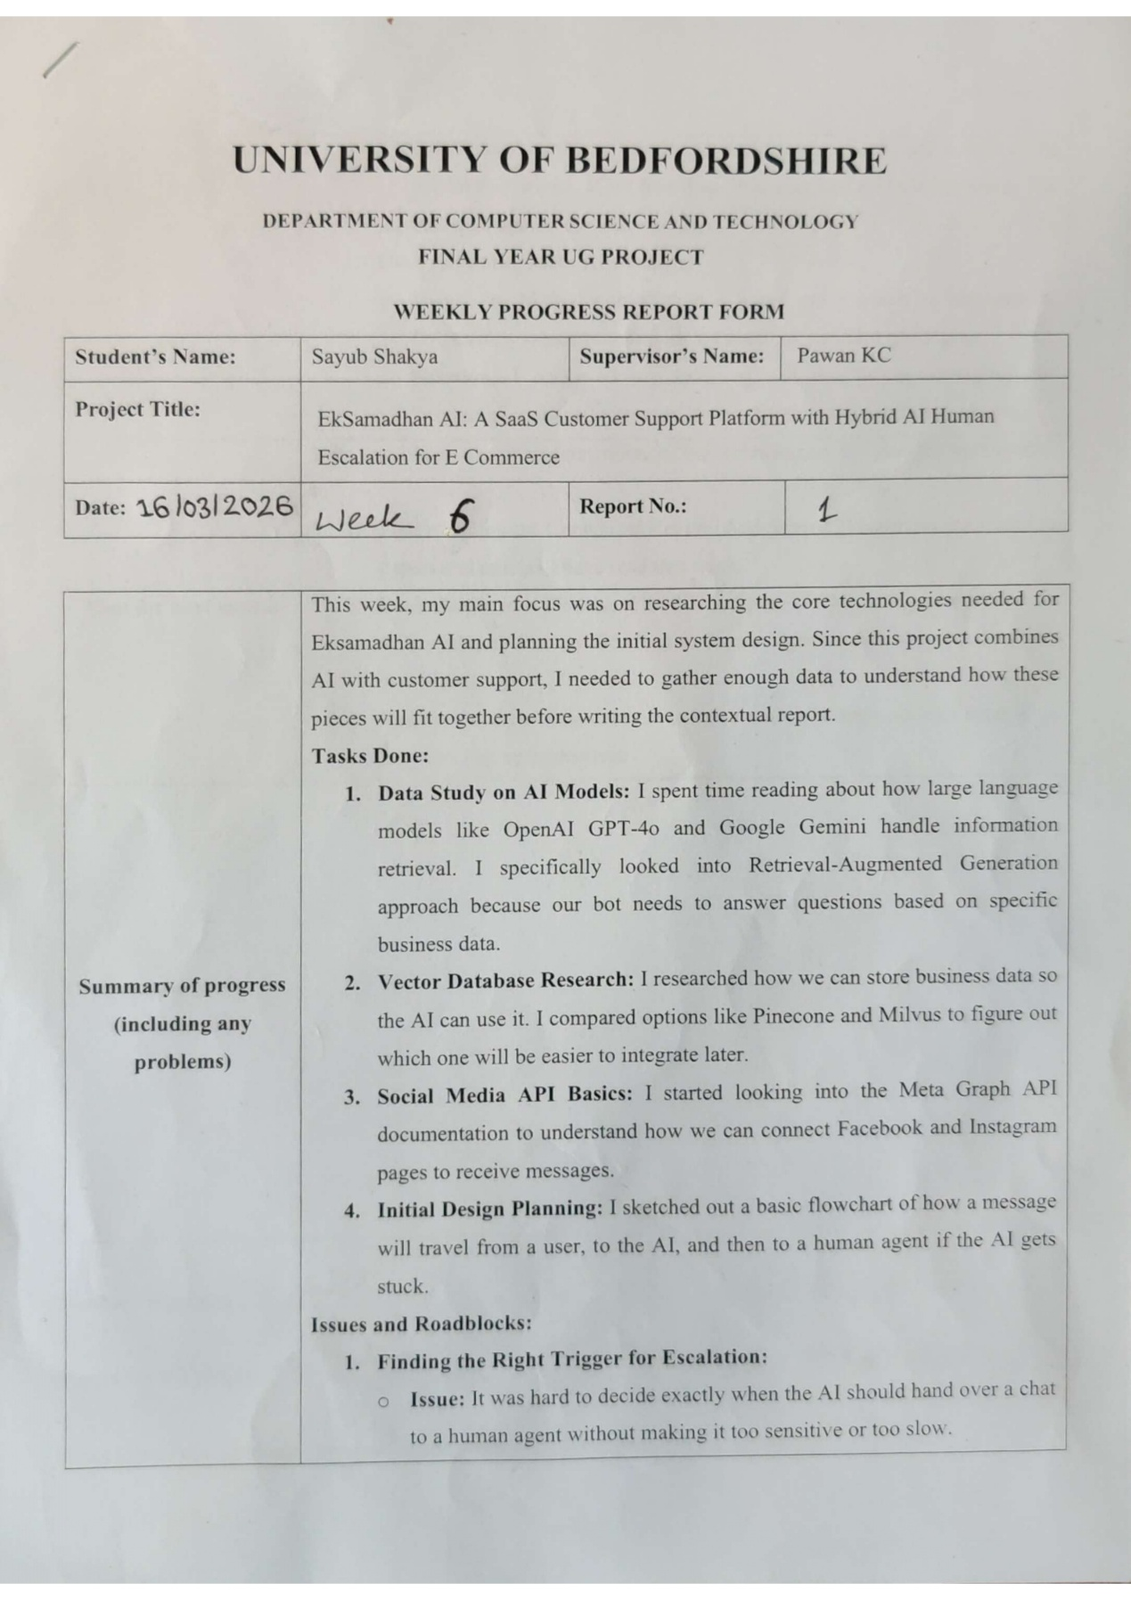

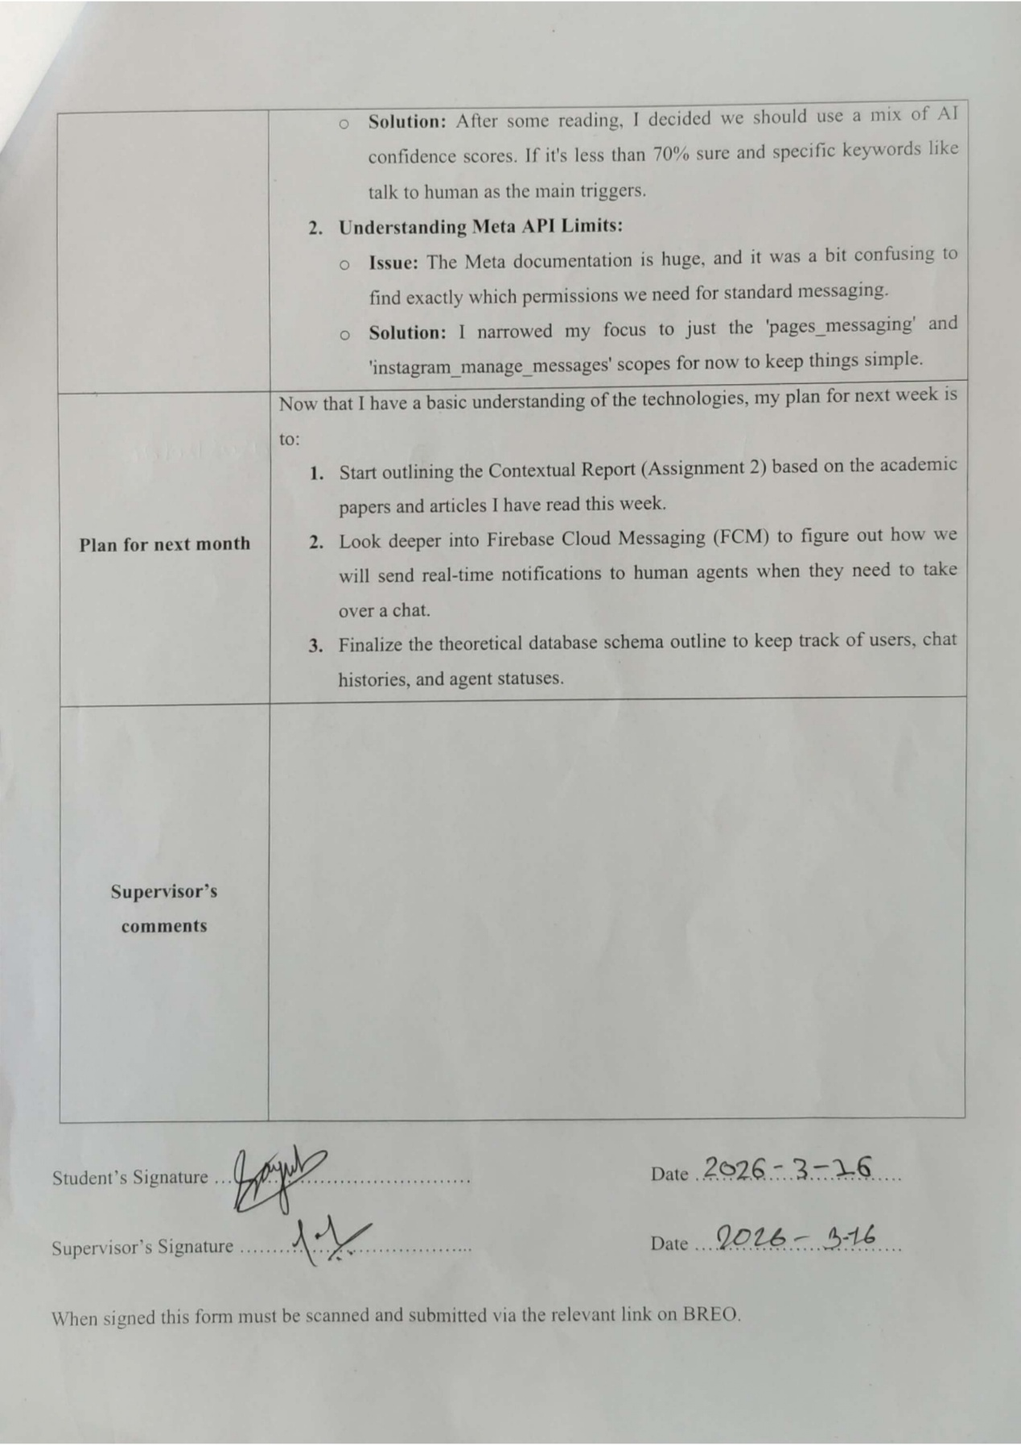

Appendix F.2: Report No.: 2 (Week 7)
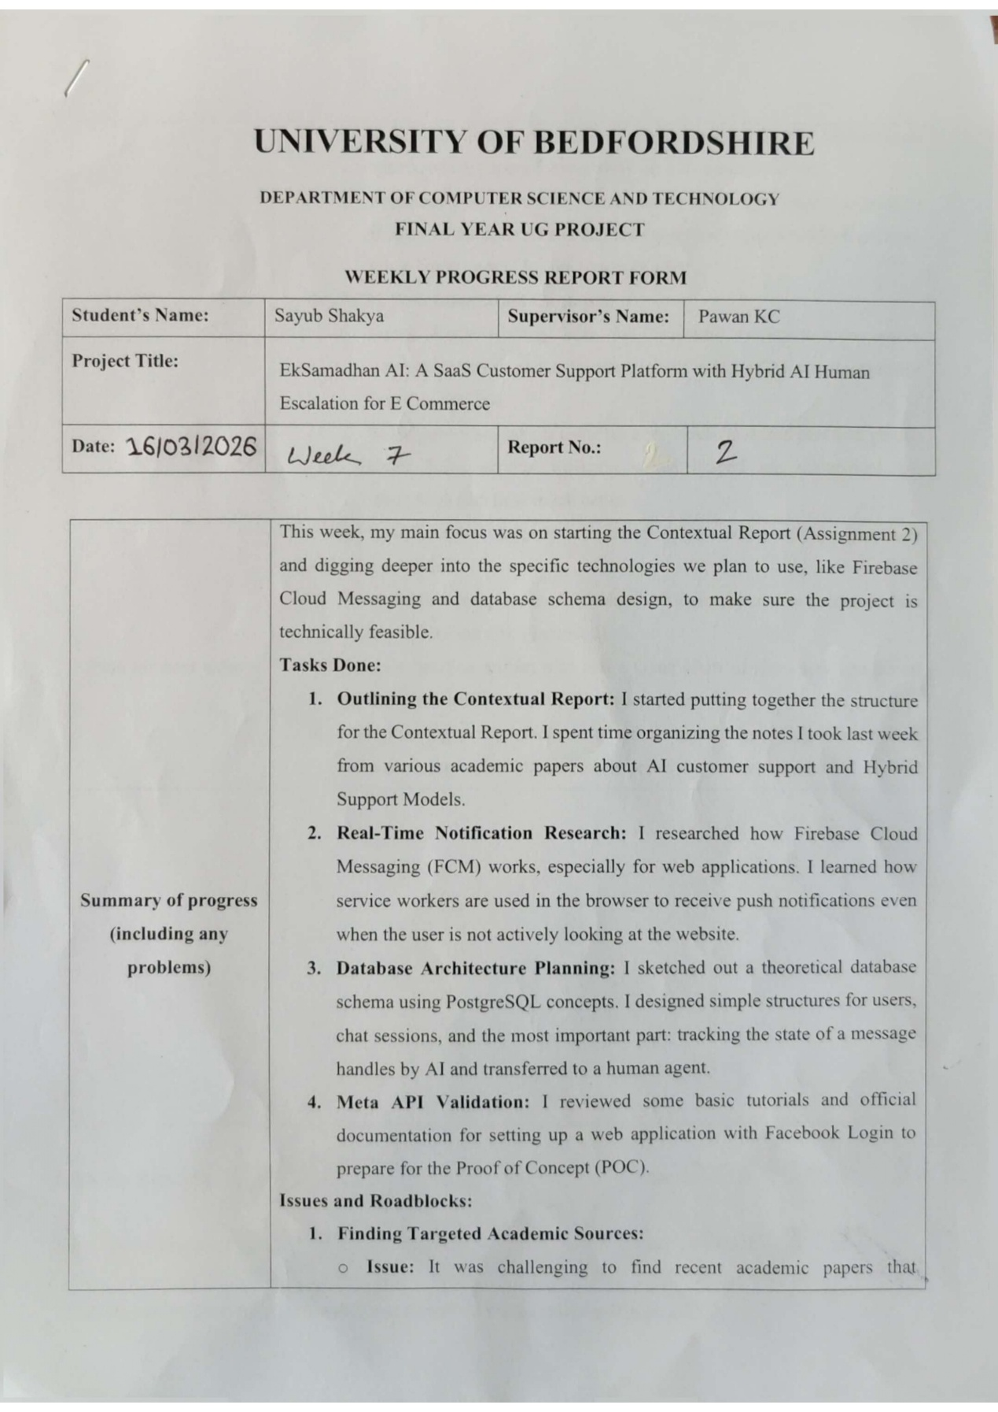

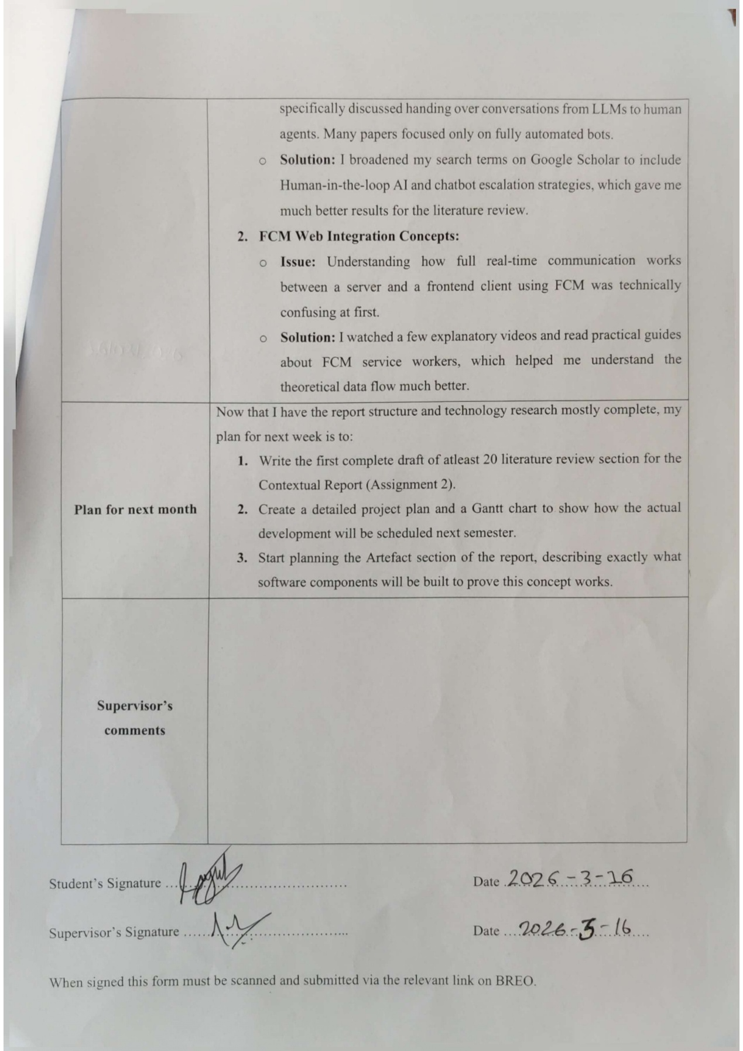

Appendix F.3: Report No.: 3 (Week 8)
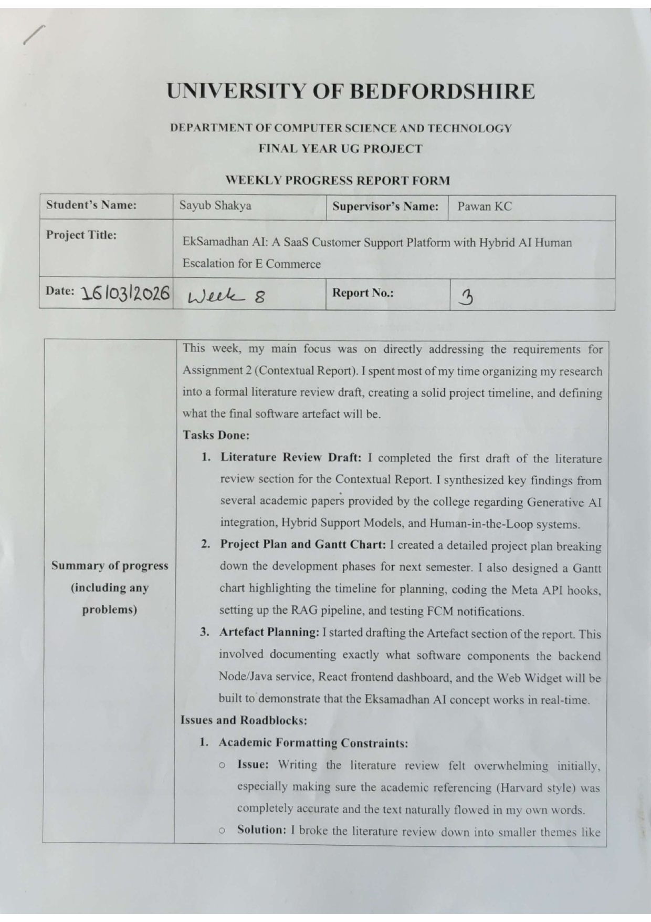

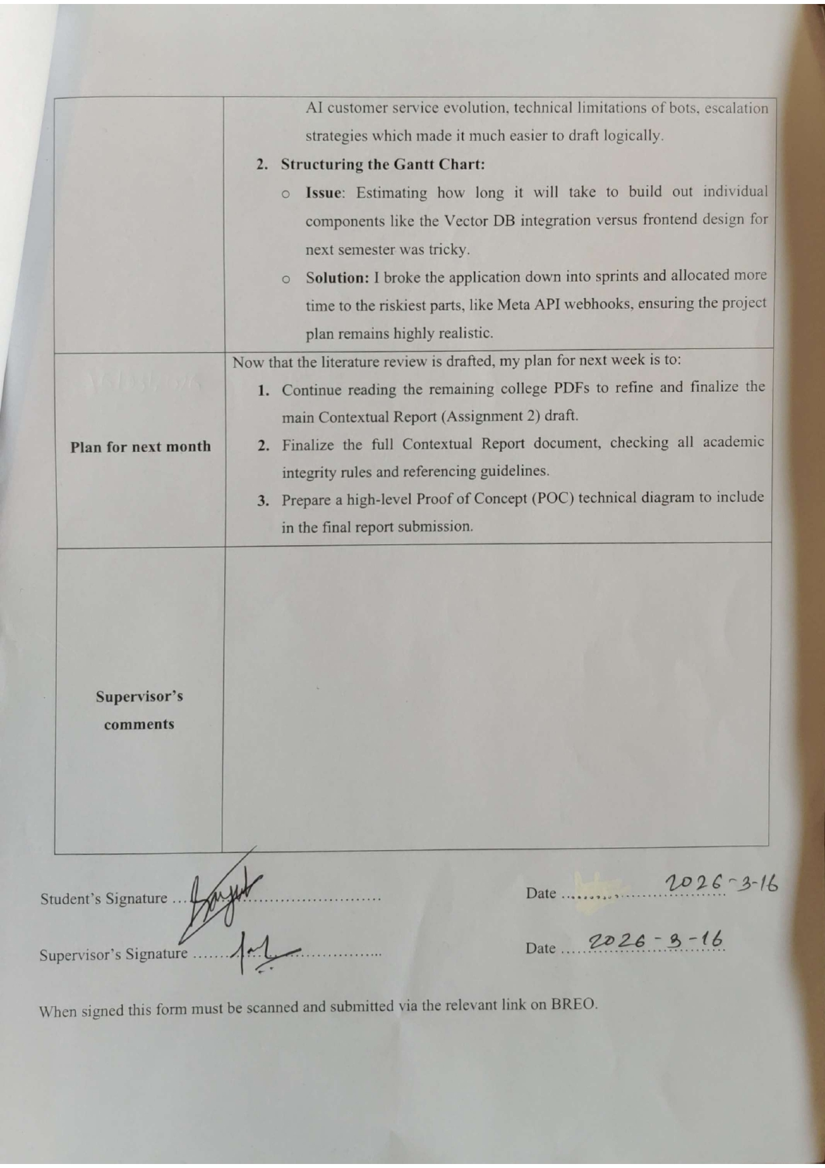

Appendix F.4: Report No.: 4 (Week 9)
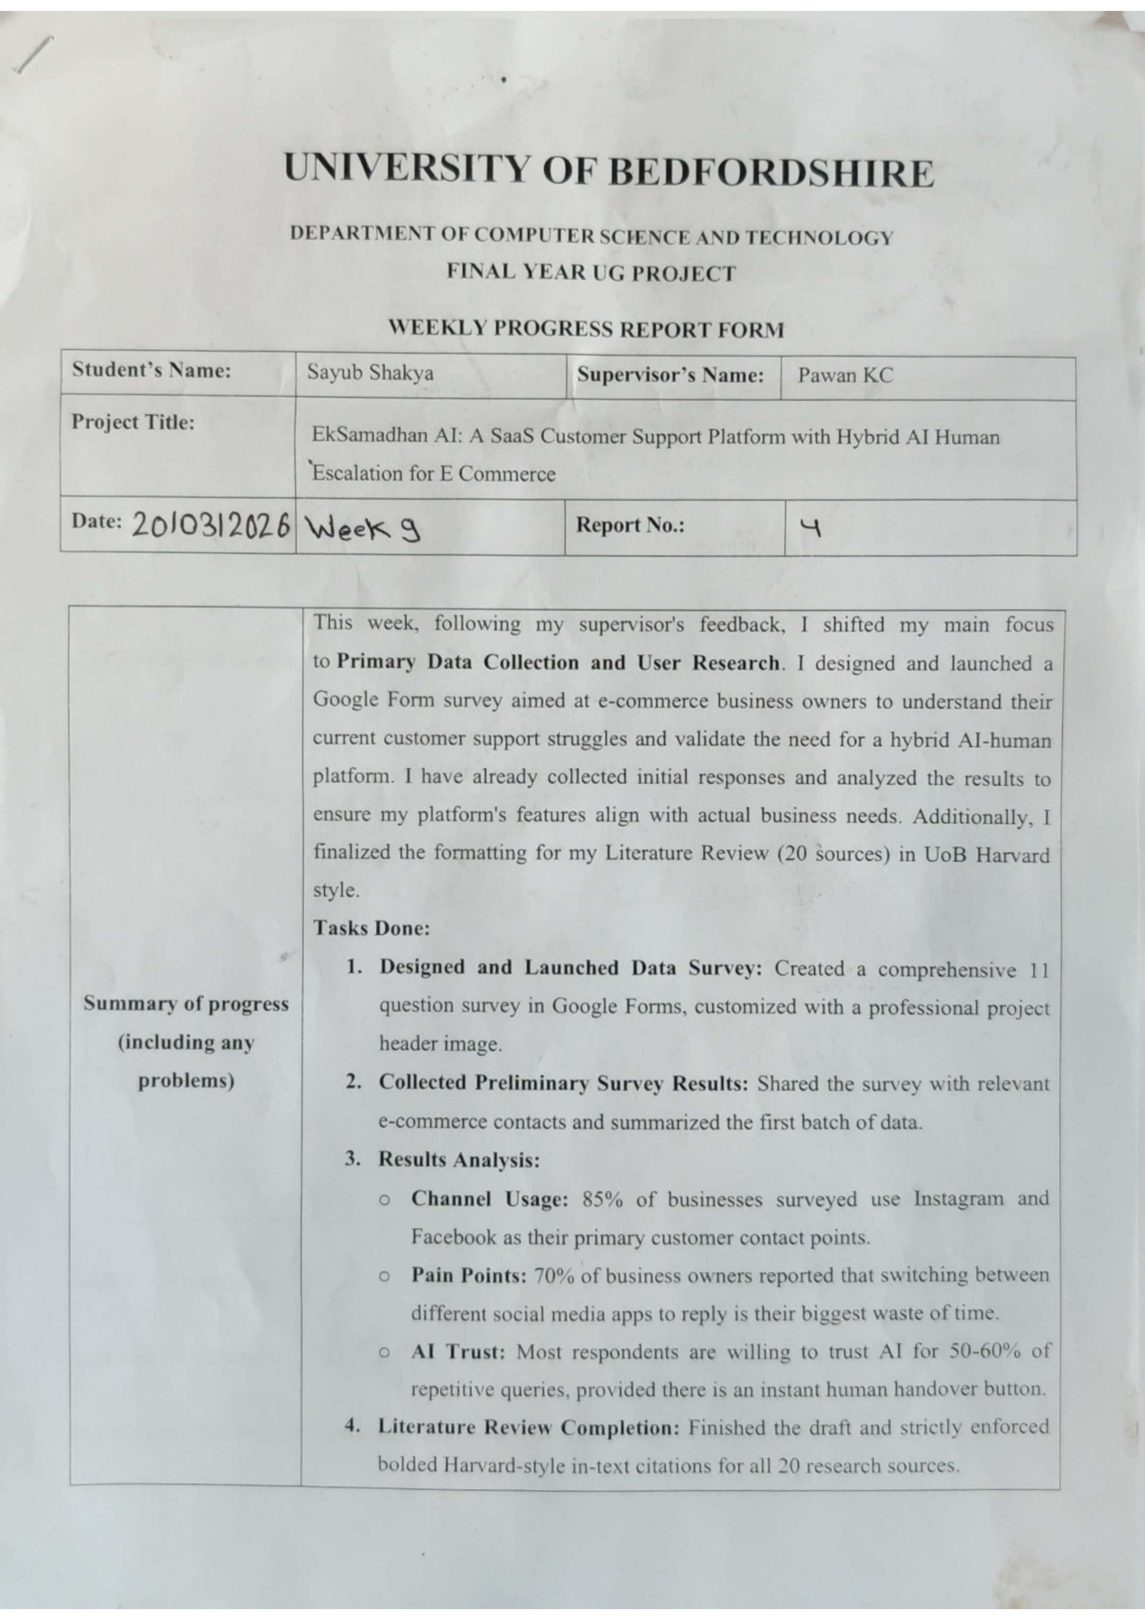

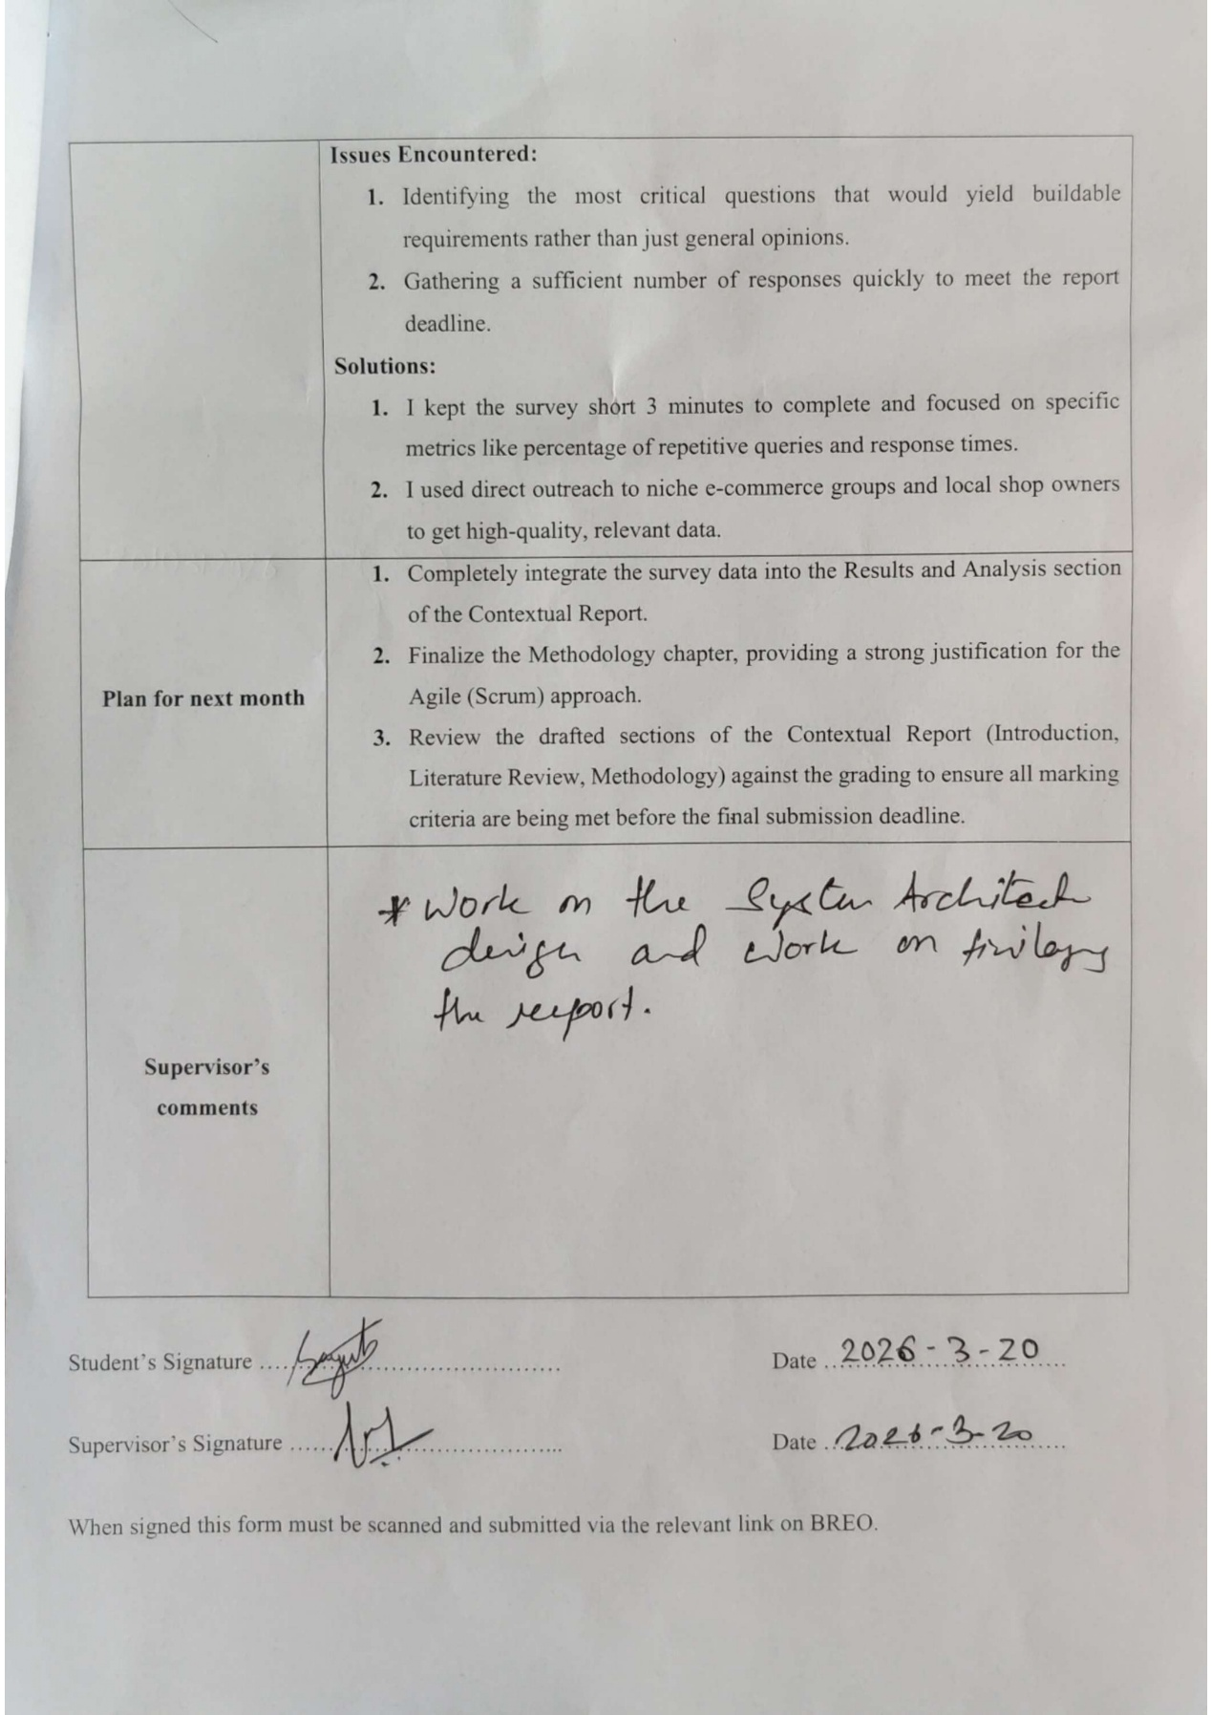

Appendix F.5: Report No.: 5 (Week 10)
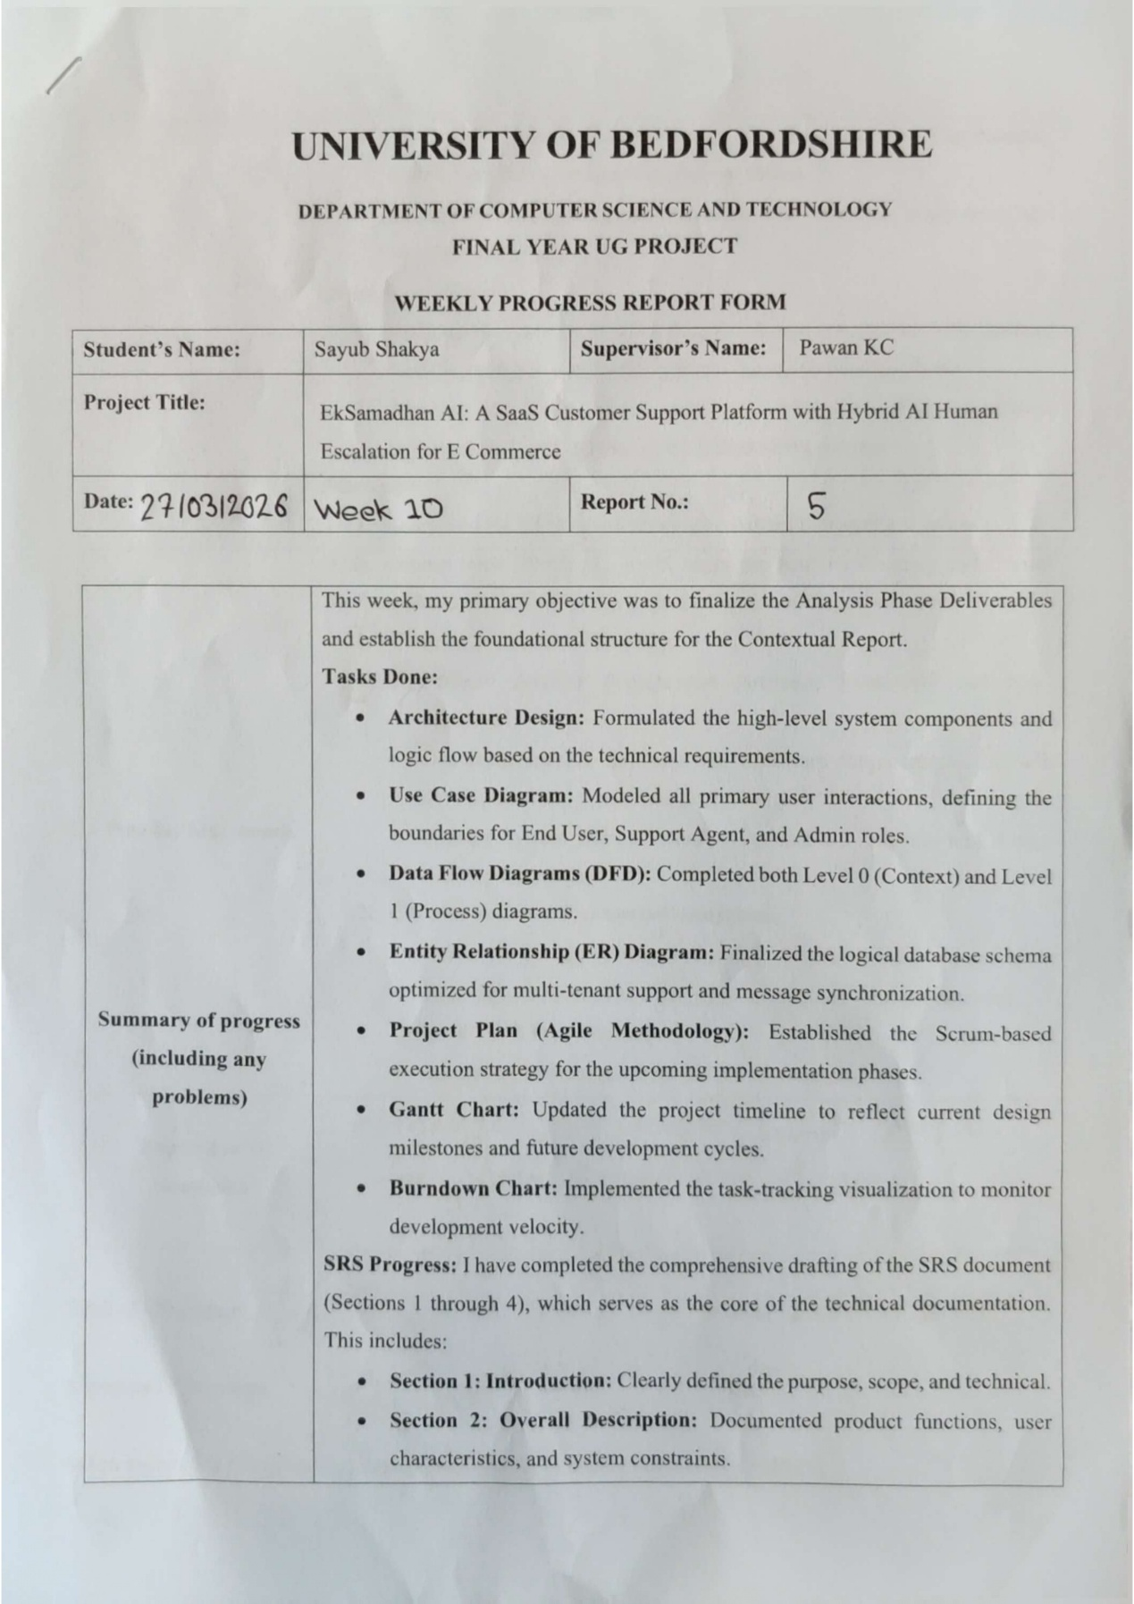

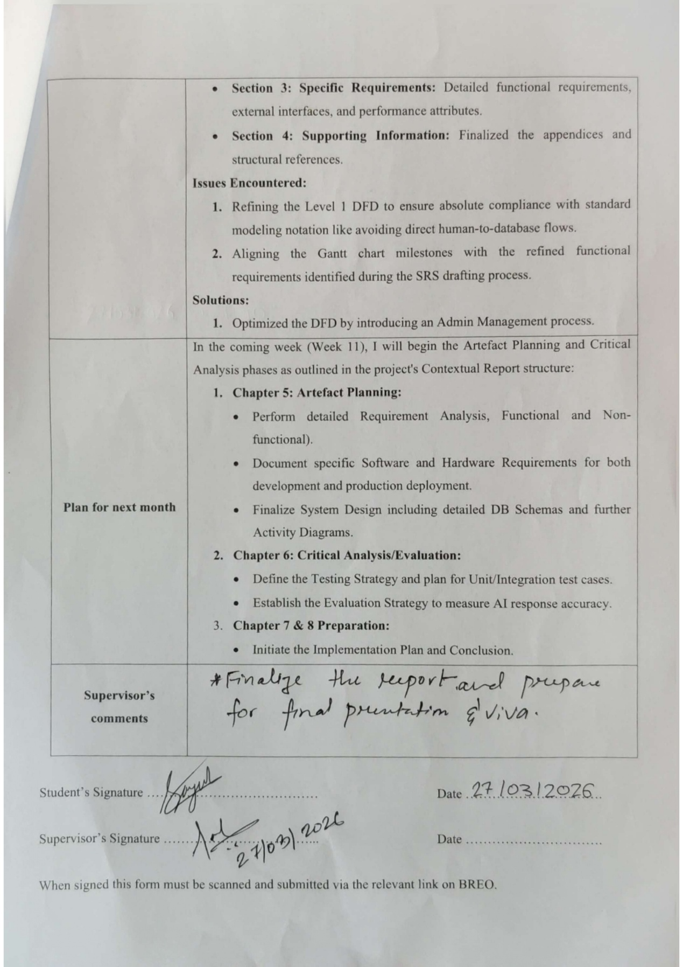

Appendix F.6: Report No.: (Week 11)
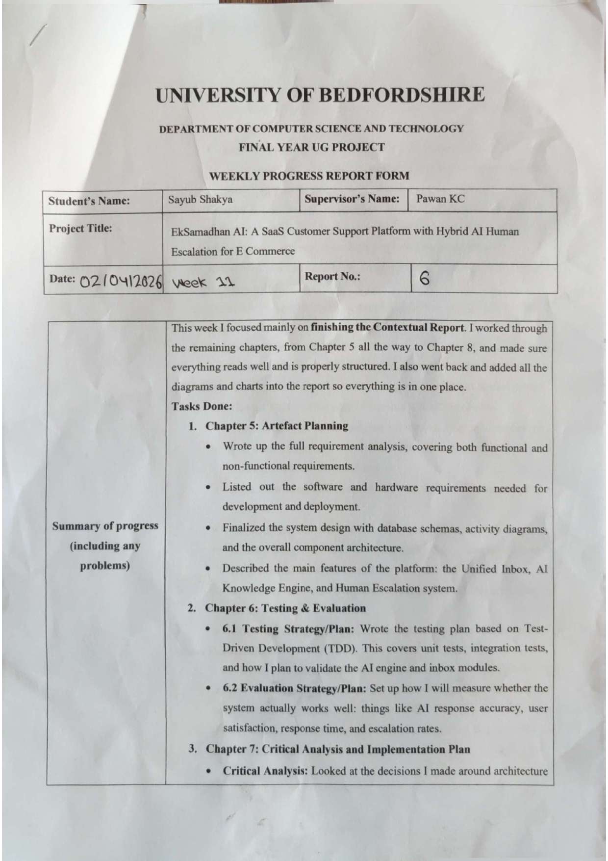

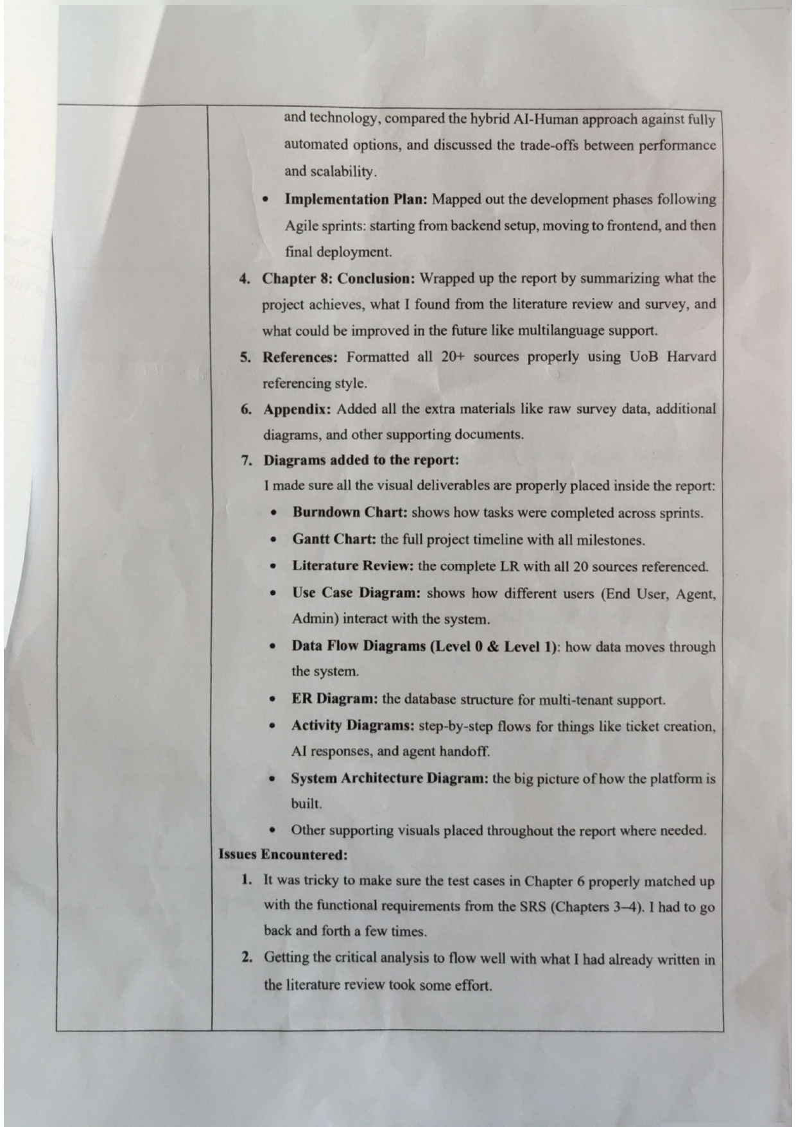
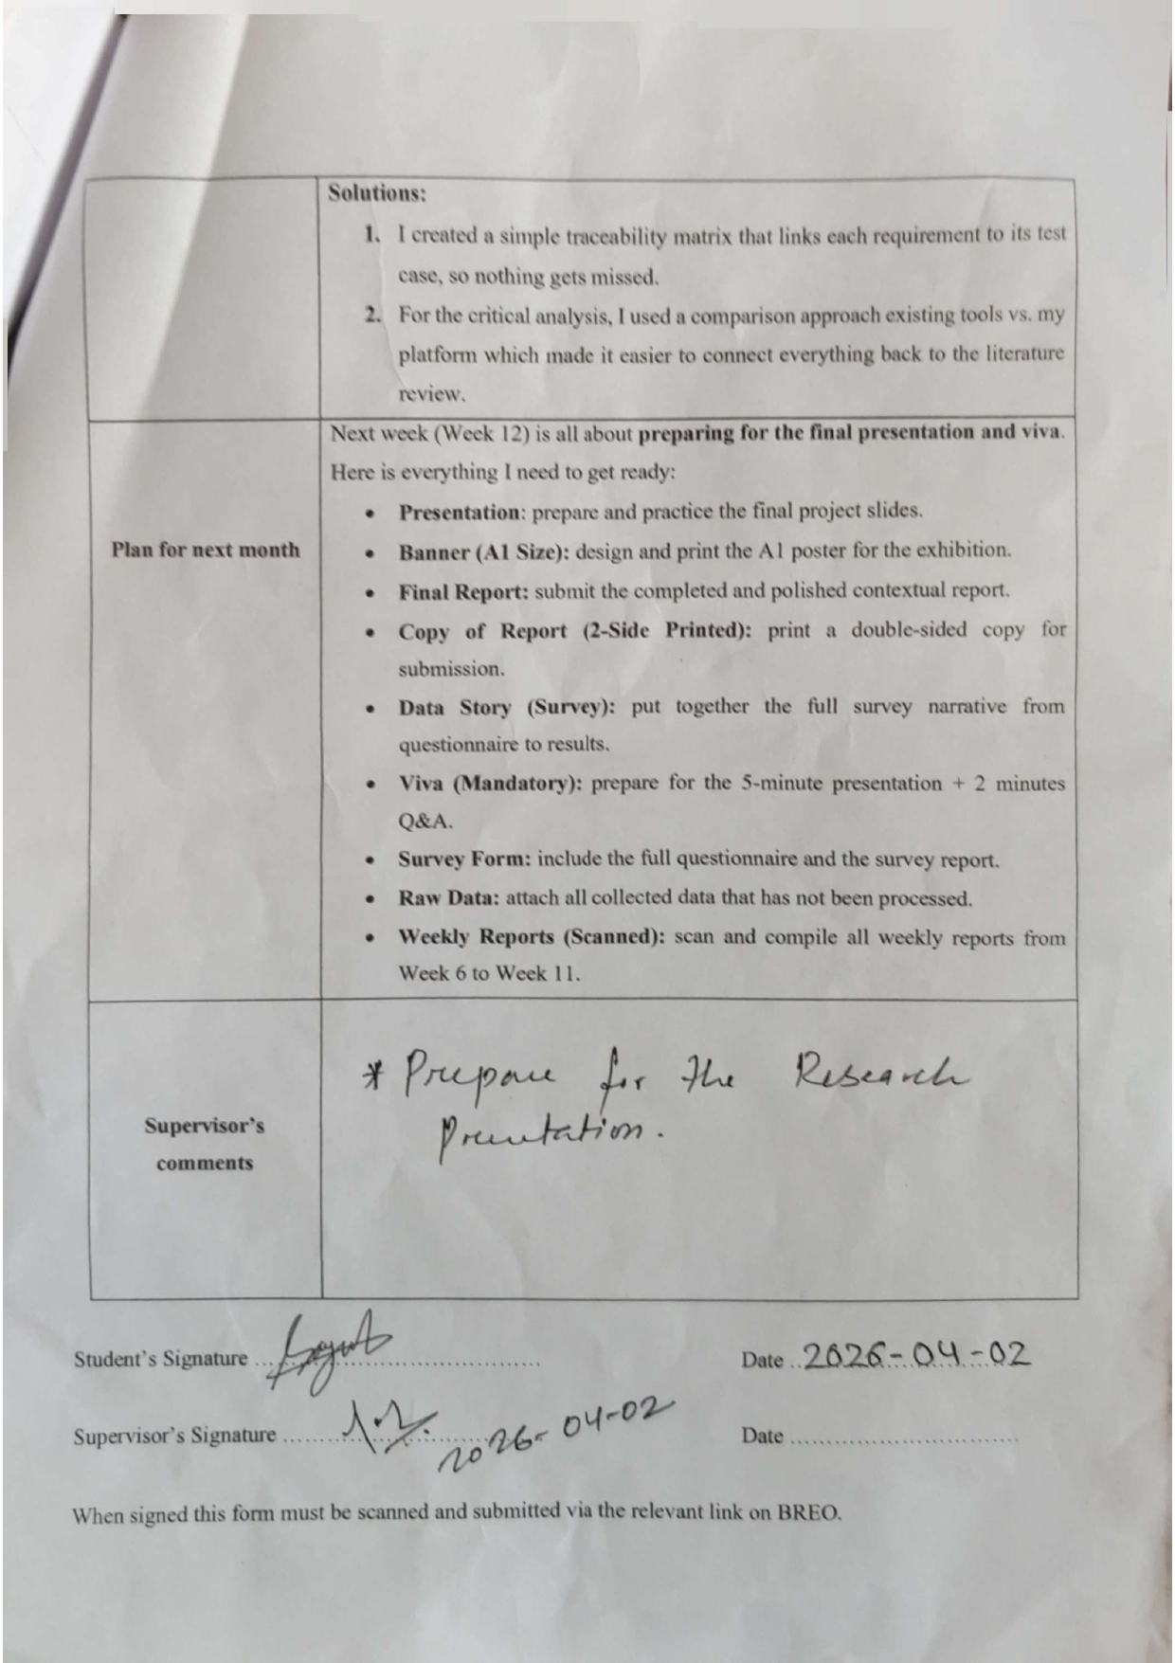

Appendix F.7: Report No.: 7 (Week 12)
