Name: Sayyad Faizan
Roll No.:25DCO11
Experiment No.9
Aim :
To understand and implement routing and navigation in React JS using React Router, and create a multi-page-style Single Page Application (SPA) without performing full browser page reloads.

Objectives
1. Understand routing in React applications.
2. Install and configure React Router.
3. Create multiple routes.
4. Navigate between components using links.
5. Use BrowserRouter, Routes, and Route.
6. Use Link and NavLink.
7. Create nested routes.
8. Create dynamic routes using URL parameters.
9. Navigate programmatically using useNavigate.
10. Handle a 404 / invalid route.
11. Pass route parameters to components.
12. Build a basic multi-page-style React application.

Prerequisites
• HTML
• CSS
• JavaScript
• React components
• JSX
• useState
• Event handling
• Basic npm commands

What is React Router?
React Router is a routing library for React applications. It allows developers to associate URL paths with React components. It is used to create a multi-page-style Single Page Application (SPA), where the URL and displayed component can change without a complete browser page reload.
For example:
/ Home
/about About
/students Students
/contact Contact
When the user visits http://localhost:5173/about, React Router renders the About component.

Important React Router Concepts
• BrowserRouter
• Routes
• Route
• Link
• NavLink
• useNavigate
• useParams
• Outlet

Install React Router
Install react-router-dom using command
npm install react-router-dom
If dependency resolution requires it, the force option can be used:
npm install react-router-dom --force
Bootstrap can be imported in the project for styling:
import '/node_modules/bootstrap/dist/css/bootstrap.min.css'

Menu.js
Use the Bootstrap navbar and replace internal <a> tags with React Router <Link> tags. Replace href with to and import Link from react-router-dom.
import React from "react";
import { Link } from "react-router-dom";

export default function Menu() {
return (
<div>
<nav className="navbar navbar-expand-lg bg-dark">
<div className="container-fluid">
<Link className="navbar-brand text-warning" to="/">
AIKTC
</Link>

<button
className="navbar-toggler"
type="button"
data-bs-toggle="collapse"
data-bs-target="#navbarNavAltMarkup"
aria-controls="navbarNavAltMarkup"
aria-expanded="false"
aria-label="Toggle navigation"
>
<span className="navbar-toggler-icon"></span>
</button>

<div className="collapse navbar-collapse" id="navbarNavAltMarkup">
<div className="navbar-nav">
<Link className="nav-link text-warning" to="/welcome">
Welcome
</Link>
<Link className="nav-link text-warning" to="/about">
About
</Link>
</div>
</div>
</div>
</nav>
</div>
);
}

Welcome.js
import React from "react";

export default function Welcome() {
return (
<div className="container mt-4">
<div className="row">
<div className="col-md-12">
<h1>Welcome Page</h1>
<p>
Lorem Ipsum is simply dummy text of the printing and typesetting
industry. It is used as placeholder content in web pages.
</p>
</div>
</div>
</div>
);
}

About.js
import React from "react";

export default function About() {
return (
<div className="container mt-4">
<h1>About Page</h1>
<p>This page is displayed using React Router.</p>
</div>
);
}

App.js
import React from "react";
import Menu from "./Pages/Menu";
import { BrowserRouter, Route, Routes } from "react-router-dom";
import Welcome from "./Pages/Welcome";
import About from "./Pages/About";
import Dashboard from "./Pages/Dashboard";

function App() {
return (
<div>
<BrowserRouter>
<Menu />
<Routes>
<Route path="/" element={<Dashboard />} />
<Route path="/welcome" element={<Welcome />} />
<Route path="/about" element={<About />} />
</Routes>
</BrowserRouter>
</div>
);
}

export default App;

Working of Basic Routing
BrowserRouter enables routing for the application. Routes contains the route definitions and each Route maps a URL path to a React component.
<BrowserRouter>
<Routes>
<Route path="/" element={<Dashboard />} />
<Route path="/welcome" element={<Welcome />} />
<Route path="/about" element={<About />} />
</Routes>
</BrowserRouter>

Using Link
The Link component changes the route without performing a complete browser page reload.
<Link to="/welcome">Welcome</Link>
<Link to="/about">About</Link>

Using NavLink
NavLink works like Link and can apply styling to the currently active route.
import { NavLink } from "react-router-dom";

<NavLink
to="/about"
className={({ isActive }) => isActive ? "active" : ""}
>
About
</NavLink>

Nested Routes
Nested routes allow a parent page to contain child pages. Outlet renders the matching child route.
import { Routes, Route, Outlet, Link } from "react-router-dom";

function Dashboard() {
return (
<div>
<h1>Dashboard</h1>
<nav>
<Link to="profile">Profile</Link>
<Link to="settings">Settings</Link>
</nav>
<Outlet />
</div>
);
}

<Routes>
<Route path="/dashboard" element={<Dashboard />}>
<Route path="profile" element={<h2>Profile</h2>} />
<Route path="settings" element={<h2>Settings</h2>} />
</Route>
</Routes>

Dynamic Routes using URL Parameters
A dynamic route uses a parameter such as :id. The useParams() Hook reads the parameter value from the URL.
import React from "react";
import { useParams } from "react-router-dom";

function Student() {
const { id } = useParams();

return <h2>Student ID: {id}</h2>;
}

<Routes>
<Route path="/student/:id" element={<Student />} />
</Routes>
For example, /student/24 displays the value 24 as the student ID.

Programmatic Navigation using useNavigate
useNavigate() is used when navigation should occur from an event or program logic.
import React from "react";
import { useNavigate } from "react-router-dom";

function Login() {
const navigate = useNavigate();

const handleLogin = () => {
navigate("/welcome");
};

return <button onClick={handleLogin}>Login</button>;
}

Handling 404 / Invalid Routes
A wildcard route can display a 404 page when no defined route matches the requested URL.
function NotFound() {
return (
<div className="container mt-4">
<h1>404 - Page Not Found</h1>
<p>The requested page does not exist.</p>
</div>
);
}

<Routes>
<Route path="/" element={<Dashboard />} />
<Route path="/welcome" element={<Welcome />} />
<Route path="/about" element={<About />} />
<Route path="*" element={<NotFound />} />
</Routes>

Practical Output / Screenshot
The following screenshot shows the React Router application with the navigation menu and the /welcome route rendered without a full browser page reload.
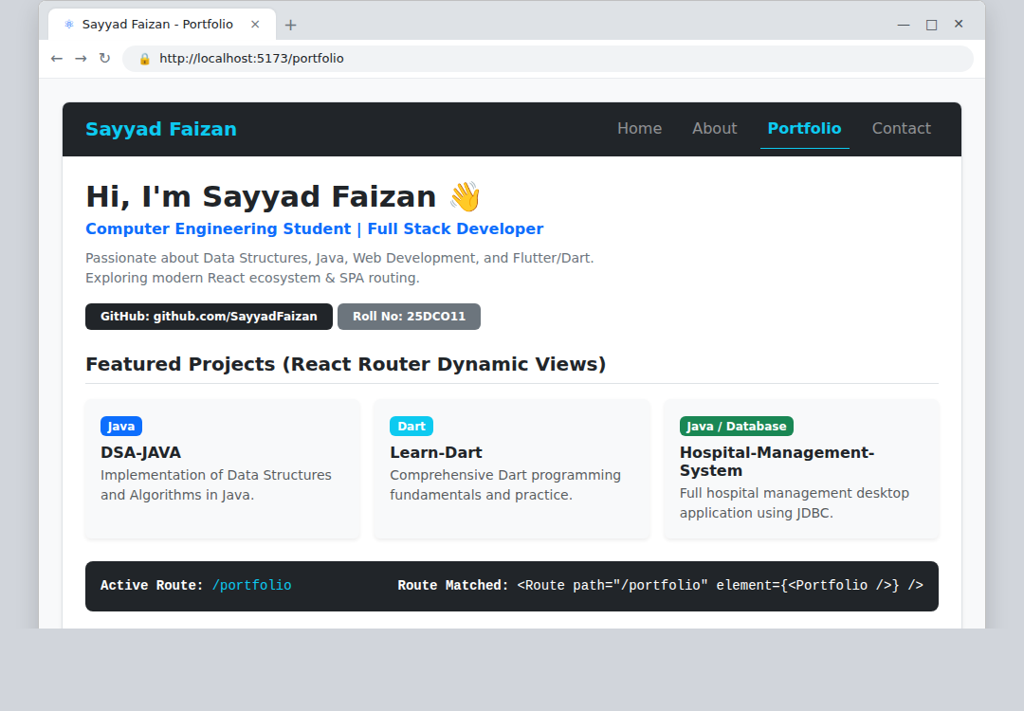

Working of the Example
Initially, the application loads the route /. BrowserRouter keeps track of the current URL and Routes selects the matching Route. When the user clicks Welcome or About, Link changes the URL and React Router renders the corresponding component without a full browser page reload.
For a dynamic route such as /student/:id, useParams() reads the value from the URL. For event-based navigation, useNavigate() changes the route programmatically. If no route matches, the wildcard route displays the 404 page.

Three Important Forms of Navigation
1. Link: Used for normal internal navigation between React routes.
2. NavLink: Used for internal navigation with active-route styling.
3. useNavigate(): Used for navigation triggered programmatically by application logic.

Conclusion
Routing and navigation were successfully demonstrated in React JS using React Router. The experiment showed how BrowserRouter, Routes, Route, Link, NavLink, useParams, useNavigate, and Outlet can be used to build a multi-page-style Single Page Application. The practical example demonstrated navigation between pages without full browser page reloads, along with nested routes, dynamic parameters, programmatic navigation, and 404 route handling.

