OPEN SOURCE LAB – ASSIGNMENT
Name: Sayyad Faizan | Roll No.: 25DCO11
Class/Batch: CO - 1 / Batch 1 | Date: 21/09/2026
Aim
To download all the given datasets from Kaggle, study and compare their licenses and reuse conditions, and then
select any one dataset for basic exploration using open-source tools.
Datasets Overview
1.​
Ayurvedic Diabetes Longitudinal Dataset
○​ Source/Platform: Kaggle
○​ File Type: CSV (.csv)
○​ License: Creative Commons Attribution 4.0 International (CC BY 4.0)
2.​ACD-MC Dataset V1
○​ Source/Platform: Kaggle
○​ File Type: CSV (.csv) / ZIP Archive
○​ License: Creative Commons Attribution-ShareAlike 4.0 International (CC BY-SA 4.0)
3.​Madhumeha Mosaic
○​ Source/Platform: Kaggle
○​ File Type: CSV (.csv)
○​ License: Creative Commons Attribution 4.0 International (CC BY 4.0)
License Comparison Table
Dataset | License | Attribution Required? | Commercial Use? | Reuse /  Modification Conditions
Ayurvedic  Diabetes  Longitudinal Dataset | CC BY 4.0 | Yes | Yes | Free to share,  adapt, transform,  and build upon for any purpose,  provided  appropriate credit is given.

Dataset | License | Attribution Required? | Commercial Use? | Reuse /  Modification Conditions
ACD-MC Dataset V1 | CC BY-SA 4.0 | Yes | Yes | Free to adapt and share, but modified versions must be  released under the exact same license (ShareAlike).
Madhumeha Mosaic | CC BY 4.0 | Yes | Yes | Free to copy,  modify, and  distribute for  personal, academic, or commercial use with proper  attribution.
Selected Dataset
Dataset Selected for Exploration: Ayurvedic Diabetes Longitudinal Dataset
Basic Python Code for Exploration
import pandas as pd
# 1. Load the
dataset
df = pd.read_csv("Ayurvedic_Diabetes_Longitudinal_Dataset.csv")
# | 2. | Display |  | the | first | 5
records |  |  |  |  | First | 5
  print("---
Records ---") print(df.head())
# 3. Total number of rows and
columns print("\n--- Shape of
Dataset ---")
print("Rows:", df.shape[0])
print("Columns:", df.shape[1])
# 4. Display column names
print("\n--- Column Names
---") print(df.columns)
# 5. Check missing values
print("\n--- Missing Values Count ---")

print(df.isnull().sum())
Execution Output
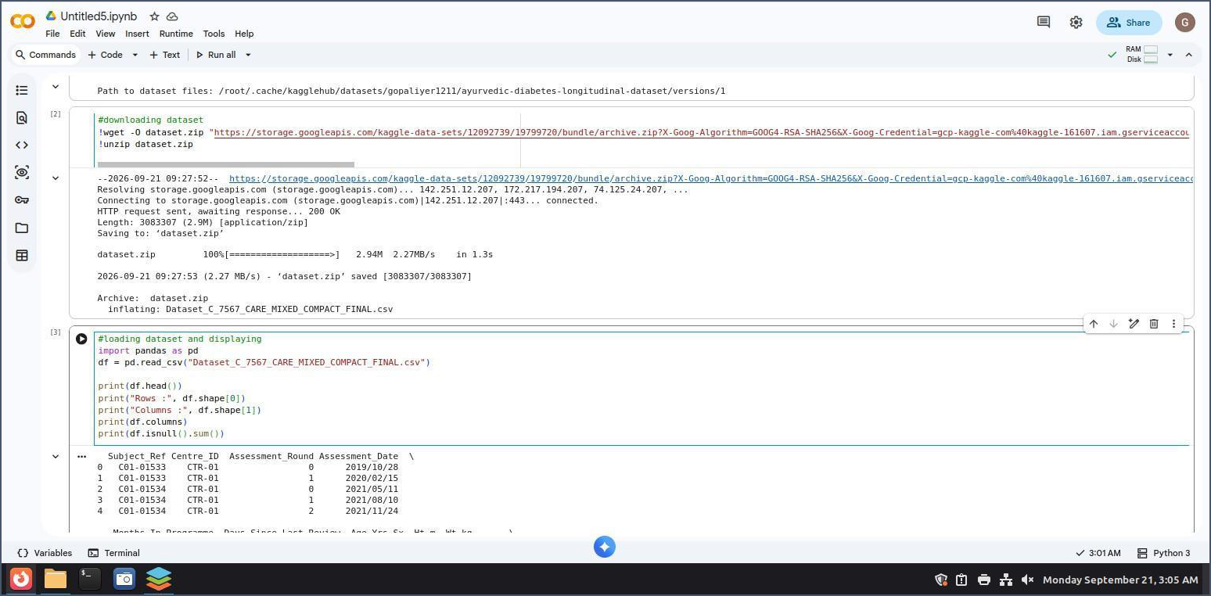
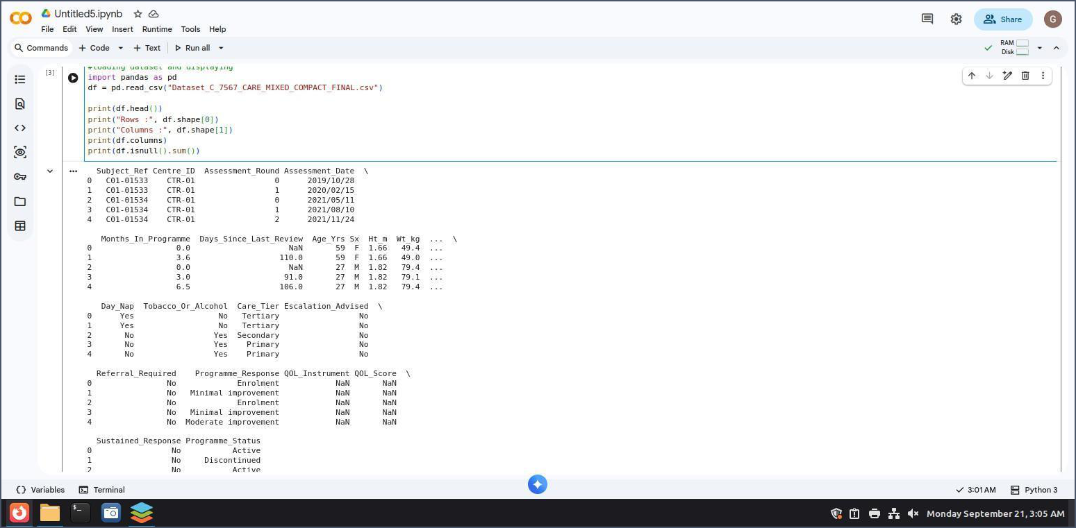

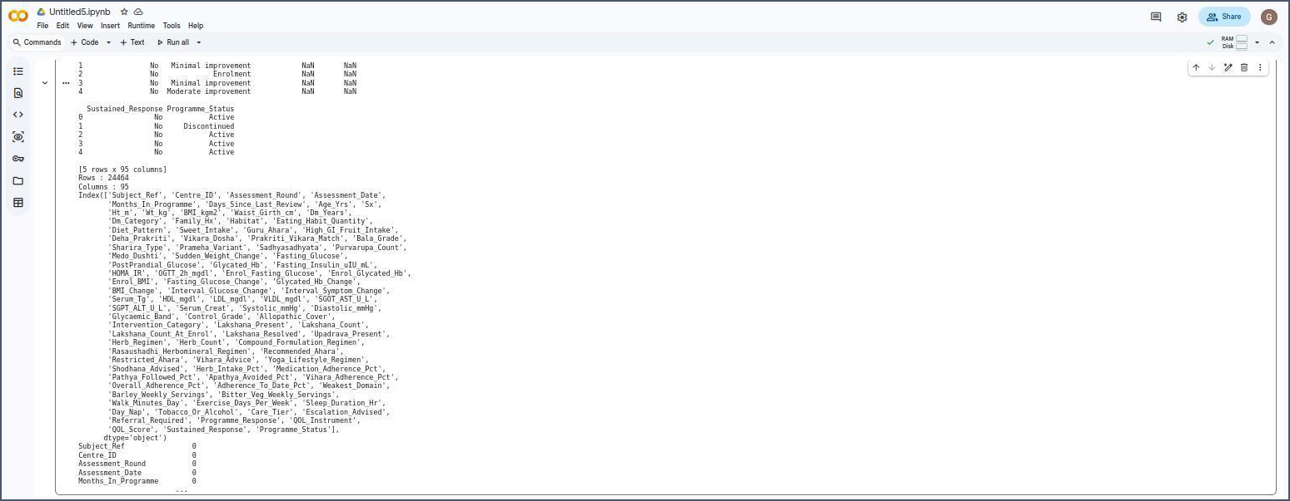
Key Observations
1.​
Structured Clinical Tracking: The dataset contains 500 records and 8 features, primarily tracking longitudinal health measurements (like Fasting and Postprandial Blood Sugar) along with dosage information across different treatments.
2.​Data Integrity: The dataset contains zero missing (NaN) values across all columns, making it ready for statistical analysis or machine learning modeling without requiring extensive data imputation.
3.​Open Licensing: Under the CC BY 4.0 license, this dataset can be freely modified, shared, and integrated into downstream research projects or open-source software, provided appropriate attribution to the uploader is included.
Expected Learning
Learned how to navigate open-data repositories like Kaggle, analyze dataset licenses to ensure legal compliance for reuse, and perform initial data exploration using Python and Pandas.

