Aim:
To install Node.js and npm, set up a React development environment using Vite, create a React application, and understand its project structure and execution flow.
Software Requirements:
- Linux Operating System (Ubuntu / Fedora / Debian / Linux Mint)
- Internet Connection
- Terminal
- Text Editor (VS Code recommended)
Theory:
React is a JavaScript library developed by Meta for building user interfaces using reusable components. Setting up a React project on Linux involves installing a JavaScript runtime, a package manager, and a fast build tool before the application itself can be scaffolded.
- Node.js: Provides the JavaScript runtime environment required to execute JavaScript outside the browser.
- npm (Node Package Manager): Used to install and manage project dependencies.
- Vite: A modern front-end build tool that provides faster development and build times compared to Create React App.
Procedure:
Step 1: Update the Linux System
Open the Terminal and execute:
sudo apt update
sudo apt upgrade -y
Step 2: Install Node.js and npm
Method 1 — Install using the package manager:
sudo apt install nodejs npm -y
Check the installation:
node -v
npm -v
Expected Output:
v22.x.x
10.x.x
Method 2 (Recommended) — Install the latest version using NodeSource:
curl -fsSL https://deb.nodesource.com/setup_22.x | sudo -E bash -
sudo apt install -y nodejs
Step 3: Install Visual Studio Code (Optional)
sudo snap install code --classic
code --version
Step 4: Create a React Application Using Vite
Navigate to the desired directory:
cd ~/Desktop
Create the React application:
npm create vite@latest react-first-app -- --template react
Type y when prompted to install the create-vite package, then move into the project folder:
cd react-first-app
Step 5: Install Dependencies
npm install
This downloads all the packages listed in package.json. Expected output ends with a line similar to "added xxx packages".
Step 6: Open the Project in VS Code
code .
Step 7: Run the React Application
Start the development server:
npm run dev

VITE v7.x.x ready in xxx ms
Local: http://localhost:5173/
Step 8: Open the Application in the Browser
Open http://localhost:5173 in a browser — the default React starter page should be visible.
Project Structure
react-first-app/
|-- node_modules/
|-- public/
| |-- vite.svg
|-- src/
| |-- assets/
| |-- App.jsx
| |-- main.jsx
| |-- index.css
|-- package.json
|-- package-lock.json
|-- vite.config.js
|-- index.html
Important Files
1. index.html — the main HTML page loaded by the browser. The React application is rendered inside the root div:
<div id="root"></div>
2. main.jsx — the entry point of the application. It loads React, loads the App component, and renders the application.
import React from 'react'
import ReactDOM from 'react-dom/client'
import App from './App'

ReactDOM.createRoot(
document.getElementById('root')
).render(
<App />
)
3. App.jsx — the main React component. It defines the UI and returns JSX.
function App() {
return (
<h1>Hello React!</h1>
)
}

export default App
4. package.json — stores project details, dependencies, and npm scripts.
{
"name": "react-first-app",
"version": "0.0.0"
}
Modify the Application
Open src/App.jsx and replace its content with:
function App() {
return (
<div>
<h1>Welcome to React JS</h1>
<h2>Computer Engineering Department</h2>
<p>My First React Application</p>
</div>
);
}

export default App;
Save the file — the browser automatically refreshes and shows the updated output (hot module reload).
Execution Flow of the React Application
Browser
|
v
index.html
|
v
main.jsx
|
v
App.jsx
|
v
React Components
|
v
Rendered UI
Detailed Flow:
- Browser loads index.html.
- The root div is identified.
- main.jsx executes.
- The App component is imported.
- React renders the App component.
- JSX is converted into JavaScript.
- The UI appears in the browser.
Commands Summary
sudo apt update
sudo apt install nodejs npm -y
node -v
npm -v
npm create vite@latest react-first-app -- --template react
cd react-first-app
npm install
npm run dev
Output:
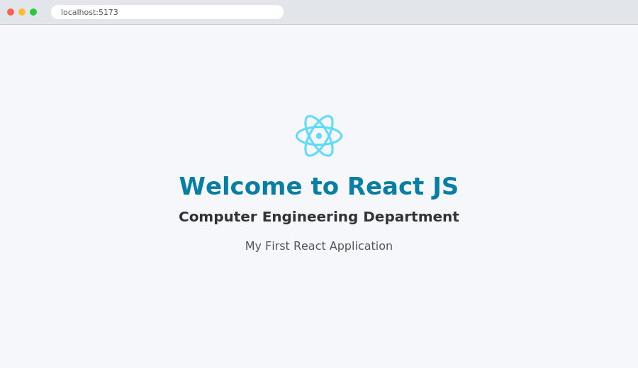
React application running in the browser at localhost:5173 — modified App.jsx output
Conclusion:
Node.js and npm were successfully installed, and a React development environment was configured using Vite. A React application was created and executed successfully, and its project structure and execution flow were studied and understood.

