Aim:
To create functional components using JSX in React and compose a page out of independent Header, Body, and Footer components, styled using Bootstrap.
Theory:
- Functional Component: A plain JavaScript function that accepts props and returns JSX describing what should appear on the screen. It is the standard way of writing components in modern React.
- JSX: A syntax extension for JavaScript that lets HTML-like markup be written directly inside JavaScript code. It is compiled into React.createElement() calls under the hood.
- Component Composition: Building a page by combining several small, independent, reusable components (e.g. Header, Body, Footer) inside a single parent component (App).
Procedure:
- Create the components folder inside src/ and create Header.js, Body.js, and Footer.js.
- Write a functional component in each file that returns JSX for that section of the page.
- Import and render Header, Body, and Footer inside App.js.
- Use Bootstrap classes (navbar, carousel, footer utility classes) for styling.
- Run the application and verify that the header navigation, the body carousel, and the footer all render correctly.
Header.js — Navigation Bar Component
import React from 'react'

function Header() {
return (
<div>
<nav class="navbar navbar-expand-lg bg-body-tertiary">
<div class="container-fluid">
<a class="navbar-brand" href="#">Mukhtar Ansari</a>
<button class="navbar-toggler" type="button"
data-bs-toggle="collapse" data-bs-target="#navbarNav">
<span class="navbar-toggler-icon"></span>
</button>
<div class="collapse navbar-collapse" id="navbarNav">
<ul class="navbar-nav">
<li class="nav-item">
<a class="nav-link active" href="#">Home</a>
</li>
<li class="nav-item">
<a class="nav-link" href="#">Features</a>
</li>
<li class="nav-item">
<a class="nav-link" href="#">Pricing</a>
</li>
<li class="nav-item">
<a class="nav-link disabled">Disabled</a>
</li>
</ul>
</div>
</div>
</nav>
</div>
)
}

export default Header
Body.js — Carousel / Main Content Component
import React from 'react'

function Body() {
return (
<div>
<h1>Welcome to Mukhtar's Website</h1>
<p>Explore, Enhance and go through the various services available.</p>
<p>Feel free to customize this component to suit your needs.</p>
<>
<div id="carouselExampleIndicators" className="carousel slide" data-bs-ride="carousel">
{/* Indicators */}
<div className="carousel-indicators">
<button type="button" data-bs-target="#carouselExampleIndicators"
data-bs-slide-to="0" className="active" aria-label="Slide 1"></button>
<button type="button" data-bs-target="#carouselExampleIndicators"
data-bs-slide-to="1" aria-label="Slide 2"></button>
<button type="button" data-bs-target="#carouselExampleIndicators"
data-bs-slide-to="2" aria-label="Slide 3"></button>
</div>
{/* Slides */}
<div className="carousel-inner">
<div className="carousel-item active">
<img src="..." className="d-block w-100" alt="Computer"
style={{ height: "600px", objectFit: "cover" }} />
</div>
<div className="carousel-item">
<img src="..." className="d-block w-100" alt="Programming"
style={{ height: "600px", objectFit: "cover" }} />
</div>
<div className="carousel-item">
<img src="..." className="d-block w-100" alt="Technology"
style={{ height: "600px", objectFit: "cover" }} />
</div>
</div>
{/* Previous / Next controls */}
<button className="carousel-control-prev" type="button"
data-bs-target="#carouselExampleIndicators" data-bs-slide="prev">
<span className="carousel-control-prev-icon"></span>
</button>
<button className="carousel-control-next" type="button"
data-bs-target="#carouselExampleIndicators" data-bs-slide="next">
<span className="carousel-control-next-icon"></span>
</button>
</div>
</>
</div>
)
}

export default Body
Footer.js — Footer Component
import React from 'react'

function Footer() {
return (
<div>
<footer class="text-center text-lg-start bg-body-tertiary text-muted">
<section class="d-flex justify-content-center justify-content-lg-between p-4 border-bottom">
<div>
<a href="" class="me-4 text-reset"><i class="fab fa-facebook-f"></i></a>
<a href="" class="me-4 text-reset"><i class="fab fa-twitter"></i></a>
<a href="" class="me-4 text-reset"><i class="fab fa-instagram"></i></a>
<a href="" class="me-4 text-reset"><i class="fab fa-linkedin"></i></a>
<a href="" class="me-4 text-reset"><i class="fab fa-github"></i></a>
</div>
</section>
<section>
<div class="container text-center text-md-start mt-5">
<div class="row mt-3">
<div class="col-md-3 mx-auto mb-4">
<h6 class="text-uppercase fw-bold mb-4">Company name</h6>
<p>Here you can use rows and columns to organize footer content.</p>
</div>
<div class="col-md-2 mx-auto mb-4">
<h6 class="text-uppercase fw-bold mb-4">Products</h6>
<p><a href="#!" class="text-reset">Angular</a></p>
<p><a href="#!" class="text-reset">React</a></p>
<p><a href="#!" class="text-reset">Vue</a></p>
</div>
<div class="col-md-3 mx-auto mb-4">
<h6 class="text-uppercase fw-bold mb-4">Useful links</h6>
<p><a href="#!" class="text-reset">Pricing</a></p>
<p><a href="#!" class="text-reset">Settings</a></p>
<p><a href="#!" class="text-reset">Orders</a></p>
</div>
<div class="col-md-4 mx-auto mb-4">
<h6 class="text-uppercase fw-bold mb-4">Contact</h6>
<p><i class="fas fa-home me-3"></i> New York, NY 10012, US</p>
<p><i class="fas fa-envelope me-3"></i> info@example.com</p>
</div>
</div>
</div>
</section>
<div class="text-center p-4">
<a class="text-reset fw-bold" href="#">mukhtarerp.com</a>
</div>
</footer>
</div>
)
}

export default Footer
App.js — Composing the Components
import "./App.css";
import Body from "./components/Body";
import Footer from "./components/Footer";
import Header from "./components/Header";

function App() {
return (
<div className="App">
<div className="border border-dark"><Header /></div>
<div className="border border-dark"><Body /></div>
<div className="border border-dark"><Footer /></div>
</div>
);
}

export default App;
Output:
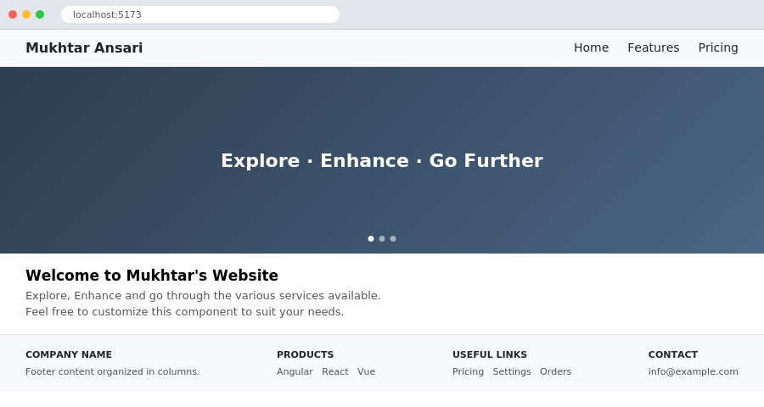
Composed page — Header (navbar), Body (carousel) and Footer components rendered together
Conclusion:
Independent functional components (Header, Body, and Footer) were created using JSX and successfully composed together inside a single App component. This demonstrated how React applications are built by combining small, reusable pieces of UI, each responsible for one part of the page.

